Git & Git Hub:

* VCS & Git Repo
* Staging Area & Commits
* Branches
* Issues & PRs

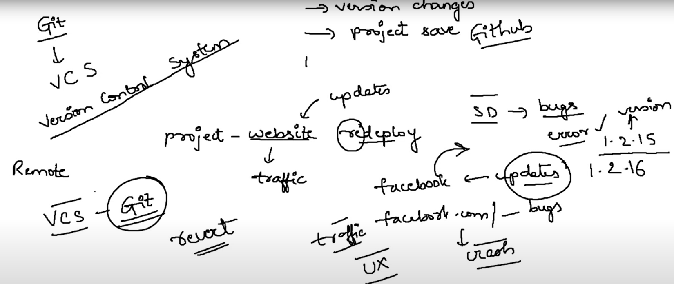Git is a Version Control System, whose main purpose is to maintain the version changes and keep a backup of the project

GitHub is one example of a remote repository hosting service.

We can send the files individually from the working directory to the Staging Area, whereas we will send them together from the Staging Area to the Local Repository/ from LR to RR.

Git commit, should always go with the message [what and why are you committing] - m ”message”

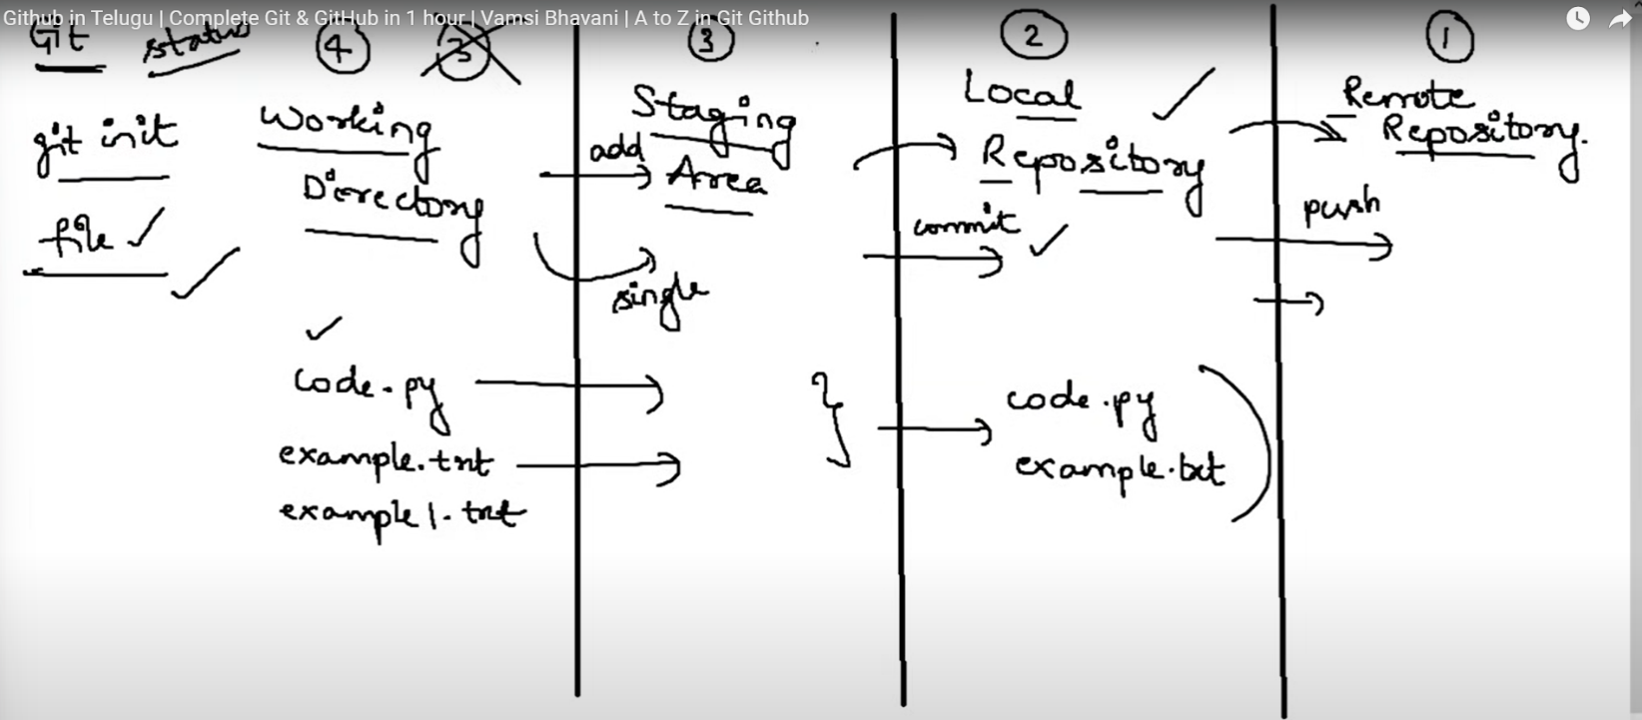

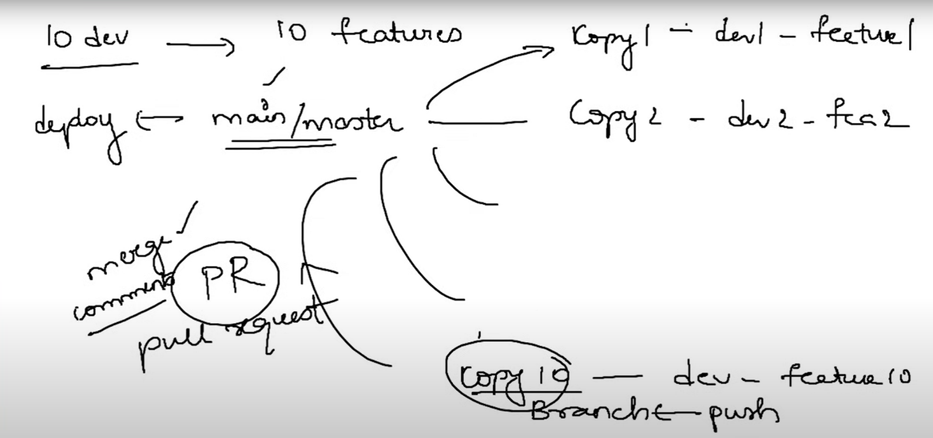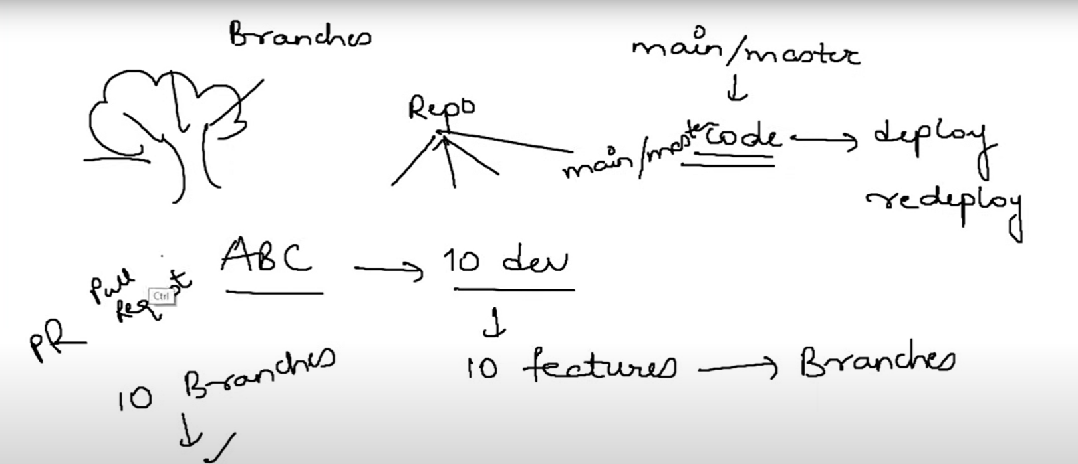Branches:

After we make the changes in the working directory on a specific feature, we push it to our branch and raise a PR (pull request), if the team lead is ok with the changes he will merge with the master branch.

After we make the changes in the working directory on a specific feature, we push it to our branch and raise a PR (pull request), if the team lead is ok with the changes he will merge with the master branch.

**git-checkout** is used to jump between the branches.

**git-checkout -**b is to create new branch