Superstore sales performance dashboard

# Superstore Sales Performance Dashboard

## Overview

The Superstore Sales Performance Dashboard provides a comprehensive view of sales data, helping stakeholders to analyze performance trends, identify opportunities, and make informed decisions. This dashboard aggregates key metrics and visualizations to illustrate the health of the business.

## Key Metrics

- **Total Sales:** $ 733.22K

- **Total Profit:** $ 93.44K

- **Total profit Margin:** $ 12.74%

## Dashboard Components

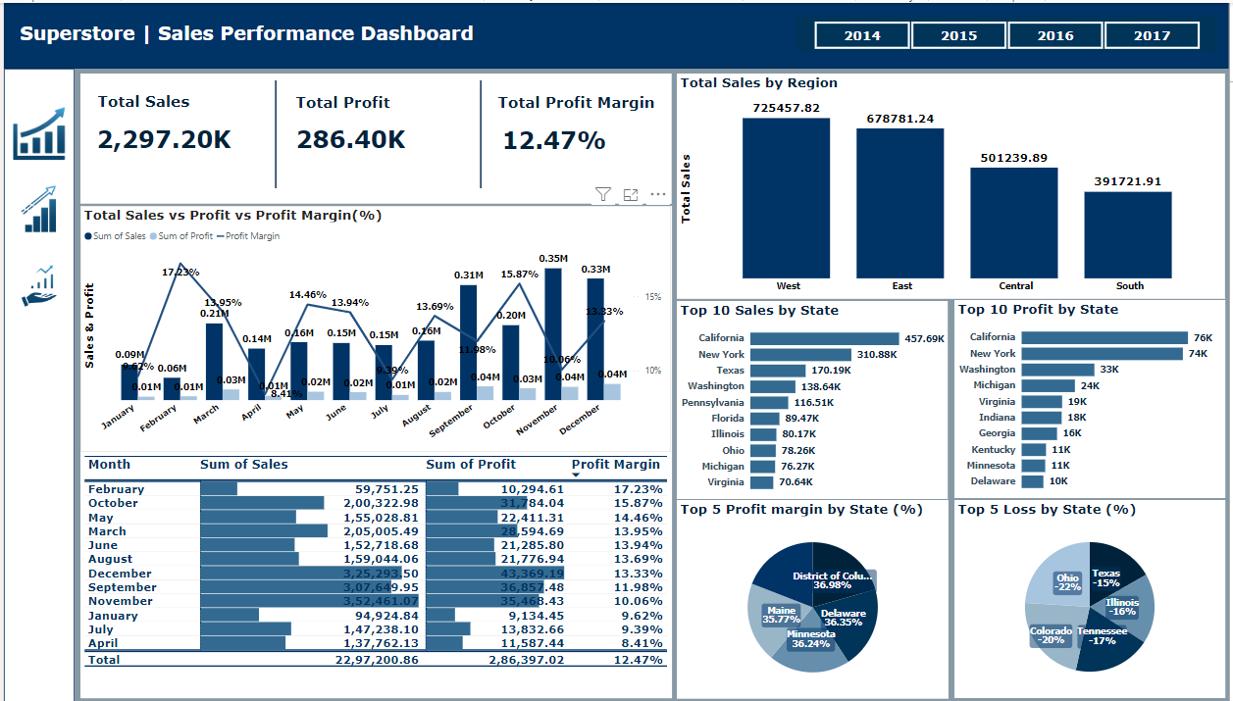

### 1. **Total Sales vs. Profit Margin**

The **Total Sales vs. Profit Margin** visual is created using a combination of a line and stacked column chart, displaying data on a month-by-month basis. Each month is represented by two columns: one indicating the total sales for that month and the other showing the profit generated. Additionally, a line graph overlays the columns, illustrating the profit margin for each month. This dual representation allows for a clear comparison between sales and profit, while also highlighting the overall profitability trend over time.

**### Table format**

This component features a table view displaying month-wise values for sales, profit, and profit margin. Each row represents a month, with corresponding columns for total sales, profit, and profit margin percentages. Additionally, a set of horizontal bars visually represents these values, with the length of each bar proportional to its value. This bar visualization allows for a quick comparison across months, highlighting the highest values and providing an immediate visual representation of performance.

### 2. **Total Sales by Region**

The **Total Sales by Region** component is presented as a bar chart that illustrates sales figures segmented by geographic region. Each bar represents the total sales for a specific region, allowing for straightforward comparisons across different areas. This visualization effectively highlights regional performance, making it easy to identify high-performing regions as well as those that may require additional focus or resources.

### 3. **Top 10 Sales by state**

The **Top 10 Sales by State** component is represented as a horizontal bar chart that displays the ten states with the highest overall sales figures. Each bar indicates the total sales for a specific state, allowing for easy comparison among the top performers. This visualization clearly highlights the leading states in terms of sales, providing valuable insights for targeted marketing and resource allocation strategies.

### 4. **Top 10 Profit by state**

The **Top 10 Profit by State** component is illustrated as a horizontal bar chart that showcases the ten states with the highest profit figures. Each bar represents the total profit generated in a specific state, allowing for straightforward comparisons among the top-performing regions. This visualization effectively highlights the states contributing the most to overall profitability, providing key insights for strategic planning and performance improvement initiatives.

### 5. **Top 5 Profit margin by state**

The **Top 5 Profit Margin by State** component is displayed as a pie chart, illustrating the five states with the highest profit margins. Each segment of the pie represents a state, with the size of each slice corresponding to its profit margin relative to the others. This visualization provides a clear and concise view of the top-performing states in terms of profitability, allowing stakeholders to quickly identify areas with the best profit margins for potential focus and investment.

### 6. **Lowest 5 Profit Margin by State**

The Lowest 5 Profit Margin by State component is displayed as a pie chart, showcasing the five states with the lowest profit margins. Each segment of the pie represents a state, with the size of each slice reflecting its profit margin relative to the others. This visualization effectively highlights the states with the least profitability, allowing stakeholders to quickly identify areas that may require strategic adjustments or targeted improvement initiatives.

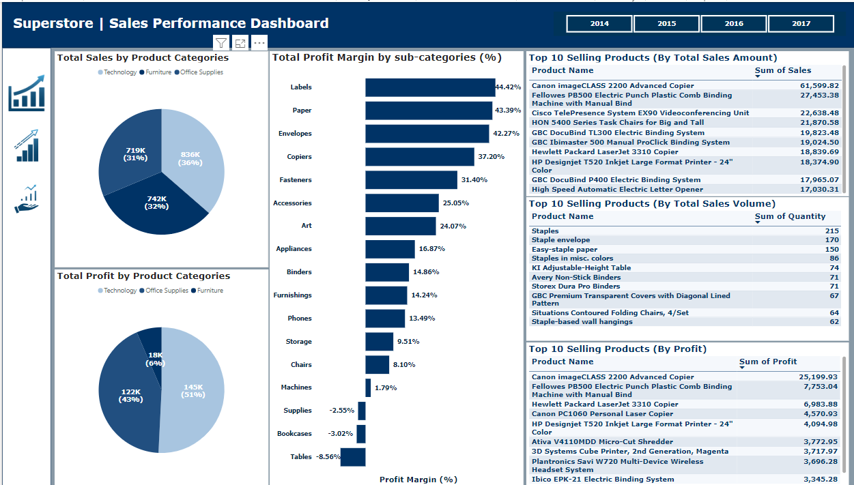

### 7. **Total sales by product categories**

The **Total Sales by Product Categories** component is displayed as a pie chart that illustrates the distribution of total sales across various product categories. Each segment of the pie represents a specific category, with the size of each slice reflecting its contribution to overall sales. This visualization provides a clear view of which categories are performing well and highlights the relative share of each category within the total sales, enabling stakeholders to identify key areas for focus and investment.

### 8. **Total Profit by product categories**

The Total Profit by Product Categories component is displayed as a pie chart that showcases the distribution of total profit across various product categories. Each segment of the pie represents a specific category, with the size of each slice indicating its contribution to overall profit. This visualization provides a clear understanding of which product categories are generating the most profit, allowing stakeholders to identify high-margin areas and make informed decisions regarding inventory and marketing strategies.

### 9. **Total Profit margin by product sub-categories**

The **Total Profit Margin by Subcategories** component is presented as a horizontal bar chart that displays the profit margins for various product subcategories. Each bar represents the profit margin percentage for a specific subcategory, extending to the right for positive margins and to the left for negative margins. This visualization effectively highlights both profitable and underperforming subcategories, enabling stakeholders to quickly identify areas that may require strategic adjustments or enhanced cost management efforts.

### 10. **Top 10 selling products (By Total Sales Amount)**

The **Top 10 Selling Products** component is displayed as a table that lists the ten products with the highest total sales amounts. Each row includes the product name alongside its corresponding sales figure, allowing for easy comparison of performance among the top sellers. This table provides valuable insights into which products are driving revenue, helping stakeholders make informed decisions regarding inventory management, marketing strategies, and promotional efforts.

### 11. **Top 10 selling products (By Total Sales Volume)**

The **Top 10 Selling Products** component is presented as a table that lists the ten products with the highest total sales volume, defined as the sum of the quantity sold. Each row includes the product name alongside its corresponding sales volume, allowing for straightforward comparisons of the most popular items. This table provides valuable insights into which products are being purchased in the greatest quantities, enabling stakeholders to make informed decisions regarding inventory management, restocking, and marketing strategies.

### 12. **Top 10 selling products (By Total Sales Profit)**

The **Top 10 Selling Products** component is displayed as a table that highlights the ten products generating the highest total sales profit. Each row includes the product name along with its corresponding profit figure, allowing for easy comparison of profitability among the top items. This table provides critical insights into which products are not only popular but also contribute significantly to overall profitability, enabling stakeholders to refine their strategies for inventory management, pricing, and promotional efforts.

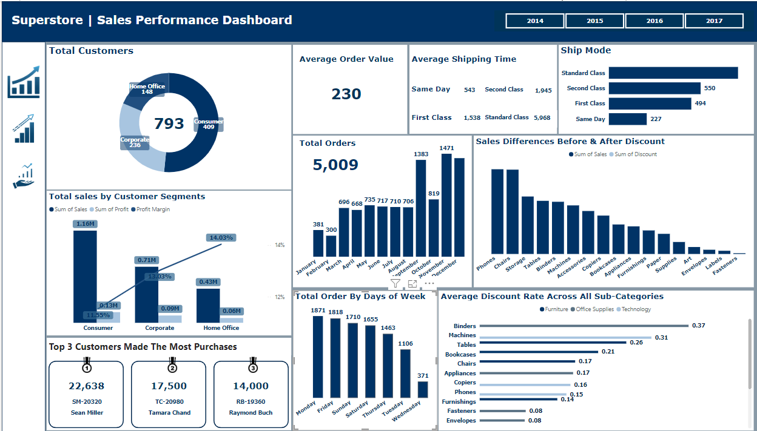

### 13. **Total Customers**

The **Total Customers Based on Segments** component is displayed as a donut chart that illustrates the distribution of total customers across various segments. Each segment of the donut represents a specific customer segment, with the size of each slice reflecting the proportion of customers within that segment. This visualization provides a clear understanding of customer distribution across different segments, enabling stakeholders to identify trends and tailor marketing strategies effectively.

### 14. **Total sales by customer segments**

The **Total Sales by Customer Segments** component is presented as a line and clustered column chart that displays total sales and profit figures for various customer segments. The clustered columns represent the total sales and profit for each segment, while a line overlays the columns to illustrate the profit margin. This dual visualization allows stakeholders to easily compare both sales performance and profitability across customer segments, providing valuable insights for developing targeted strategies and optimizing resource allocation.

### 15. **Top 3 Customers made the most purchases**

The **Top 3 Customers by Purchases** component is displayed as three distinct boxes, each representing one of the top customers based on sales value. Each box includes a ranking medal to indicate the customer's position (1st, 2nd, or 3rd) alongside their total sales value, customer name, and customer code. This visual representation highlights the customers who have made the most purchases, providing valuable insights into key accounts and enabling targeted marketing and relationship management strategies.

### 16. **Total Orders by Month**

The **Total Orders by Month** component is presented as a vertical bar chart that illustrates the number of orders placed each month. Each bar represents a specific month, with the height of the bar corresponding to the total number of orders received during that period. This visualization allows stakeholders to easily identify trends in order volume over time, highlighting seasonal patterns and helping to inform inventory management and sales strategies.

### ??. **Year Slicer**

Each page of the dashboard includes a year slicer located in the top right corner. This interactive feature allows users to select a specific year, and all visualizations on the page will dynamically update to reflect data from that selected year. By filtering the information based on the chosen year, stakeholders can gain insights tailored to specific time frames, enabling more focused analysis and decision-making.