PROJECT REPORT
EDUGENIE
Your Personal AI Tutor for Learning Support
AI-BASED PERSONALIZED LEARNING ASSISTANT
Submitted By | ________________________________
Register Number | ________________________________
Department | ________________________________
Institution | ________________________________
Academic Year | ________________________________

ABSTRACT
EduGenie is presented in the source material as a personal AI tutor for learning support. The project provides learning-oriented functions including question answering, concept explanation, paragraph summarization, quiz generation, and learning recommendations.
The demonstrated application includes an interactive learning interface and API-based processing. The supplied screenshots document example answers, explanations, summaries, quizzes, learning paths, and the corresponding Python implementation.

1. OBJECTIVES
- Provide an AI-based learning-support interface.
- Answer learner questions through a question-and-answer function.
- Generate simple explanations of concepts.
- Summarize longer text into simpler content.
- Generate quizzes from supplied learning material.
- Provide learning recommendations for a selected topic.

2. MAJOR FEATURES
Feature | Description
Question & Answer | GET API demonstrated for answering a supplied question.
Concept Explanation | POST API demonstrated for explaining a supplied topic.
Text Summarization | POST API demonstrated for summarizing supplied text.
Quiz Generation | POST API demonstrated for generating a quiz from supplied text.
Learning Recommendations | GET API demonstrated for generating topic-based learning recommendations.

3. IMPLEMENTATION OVERVIEW
The supplied project material contains Python implementation screenshots and a project file structure. The visible structure includes a main application file, explanation, learning-path, question-answering and summarization modules, templates, a stylesheet, and a requirements file.

3.1 API ENDPOINTS SHOWN
- GET /qna – question answering
- POST /explain/ – concept explanation
- POST /summarize/ – text summarization
- POST /quiz – quiz generation
- GET /learn/recommendations – learning recommendations

3.2 AI MODELS SHOWN
The explanation-module screenshot shows the Transformers model "MBZUAI/LaMini-Flan-T5-783M". The summarization code screenshot shows "models/gemini-1.5-pro" being used for summary generation.

4. PROJECT STRUCTURE
- static/
- templates/
- style.css
- index.html
- explanation_module.py
- learning_path.py
- main.py
- qna.py
- requirements.txt
- summary_module.py

5. FUNCTIONAL WORKFLOW
1. Learner enters a question, topic, or text in the EduGenie interface.
2. The corresponding API receives the input.
3. The relevant AI/model function processes the request.
4. The generated answer, explanation, summary, quiz, or recommendation is returned to the interface.

6. IMPLEMENTATION AND OUTPUT SCREENSHOTS
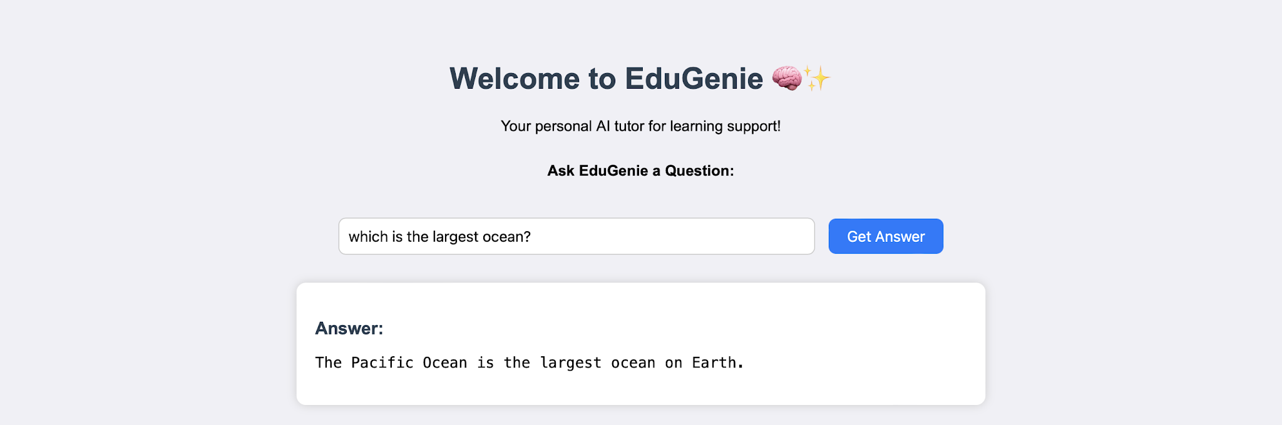
Figure 6.1 – EduGenie question-answering interface
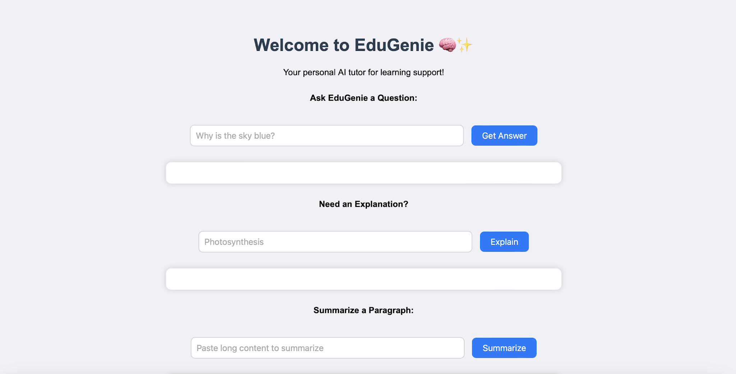
Figure 6.2 – EduGenie interface showing explanation and summarization options
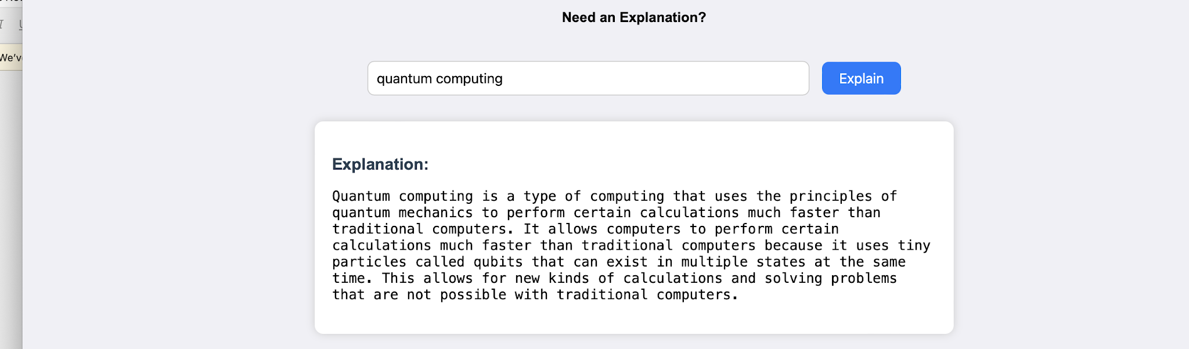
Figure 6.3 – Example explanation for quantum computing
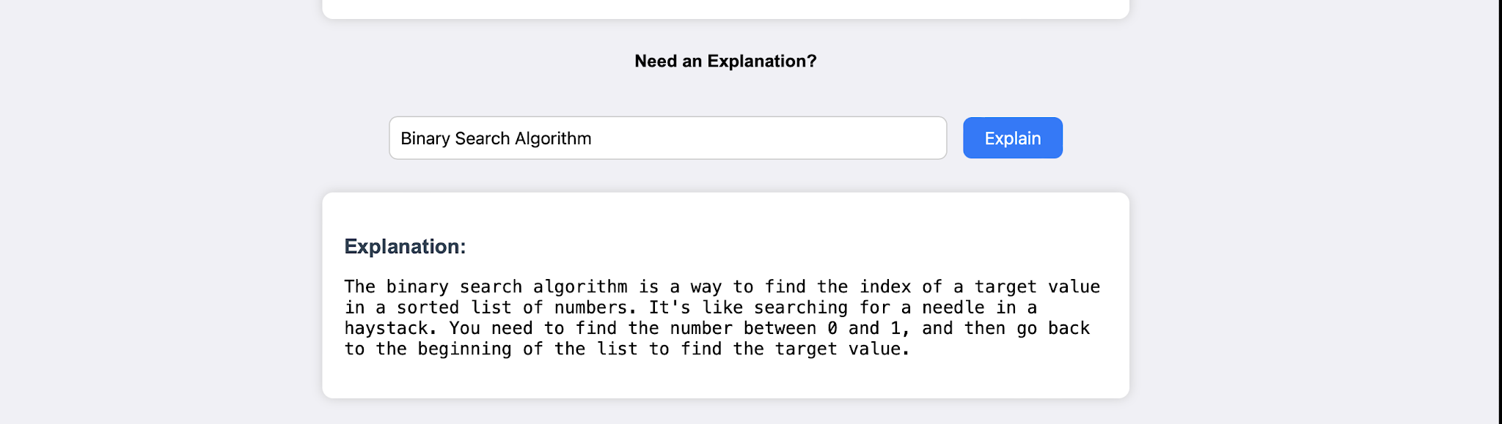
Figure 6.4 – Example explanation for binary search
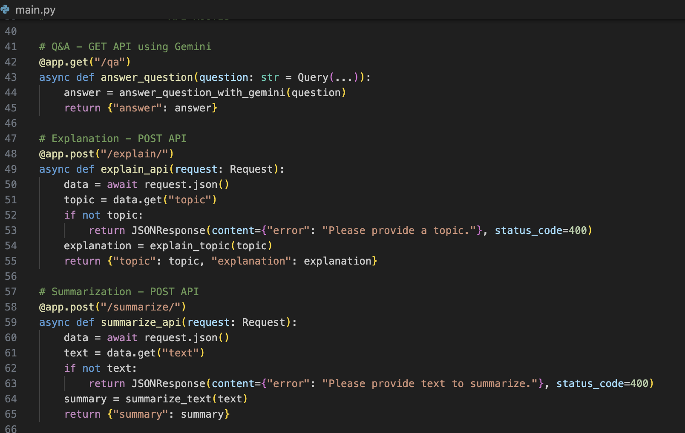
Figure 6.5 – API implementation
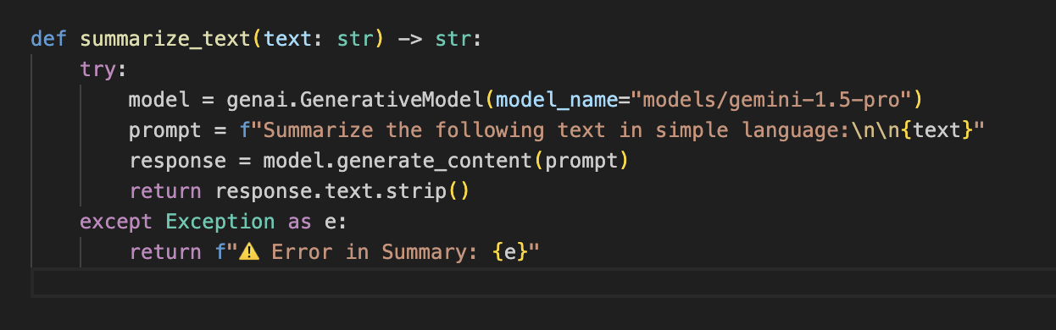
Figure 6.6 – Summarization function
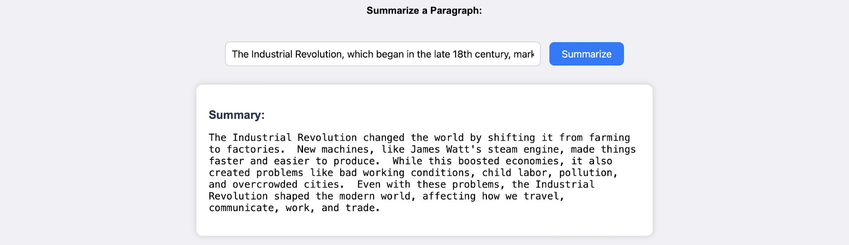
Figure 6.7 – Example summary output
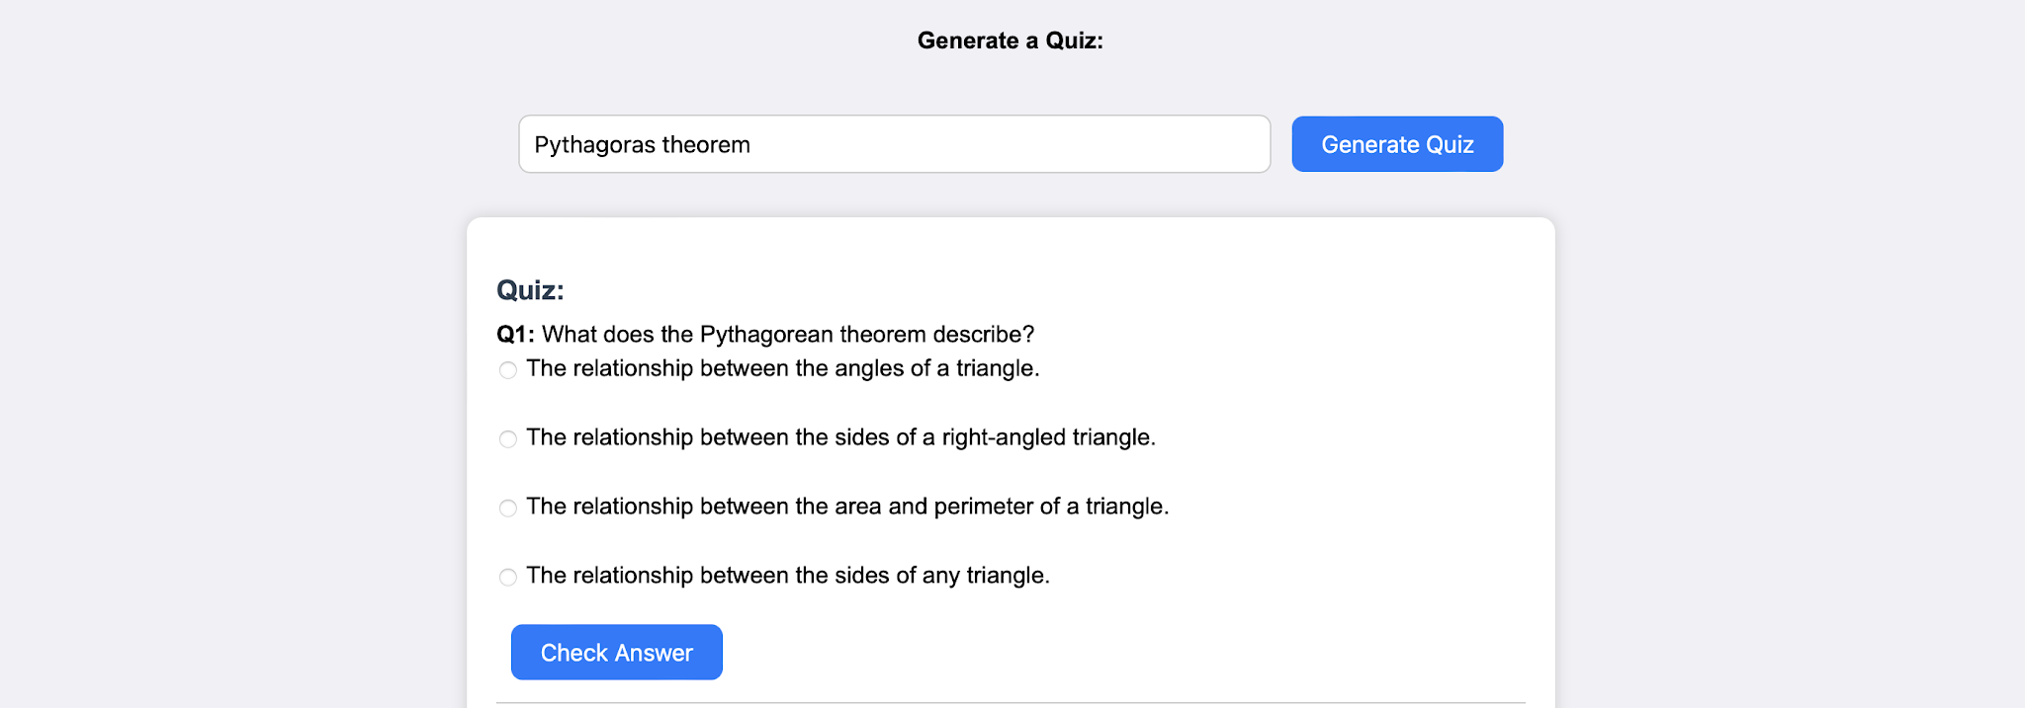
Figure 6.8 – Quiz generation interface
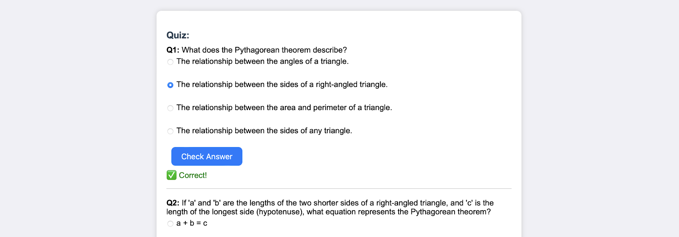
Figure 6.9 – Example Pythagorean-theorem quiz
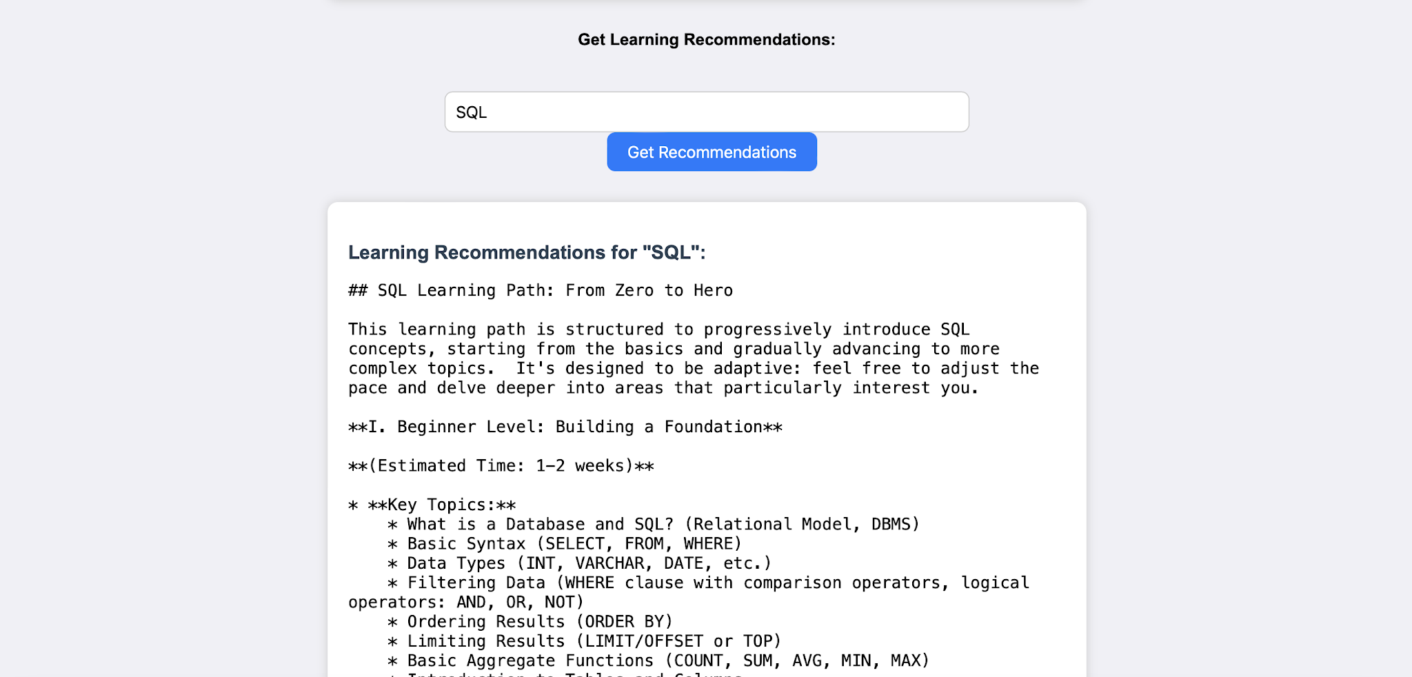
Figure 6.10 – SQL learning recommendation output
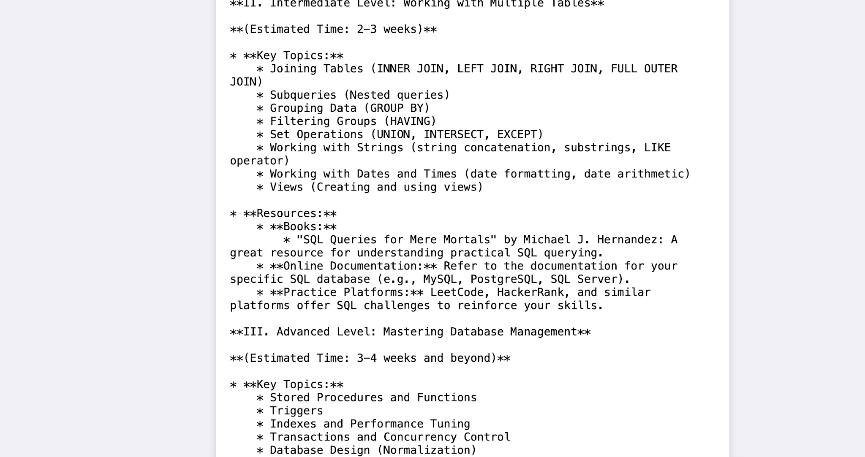
Figure 6.11 – SQL learning path
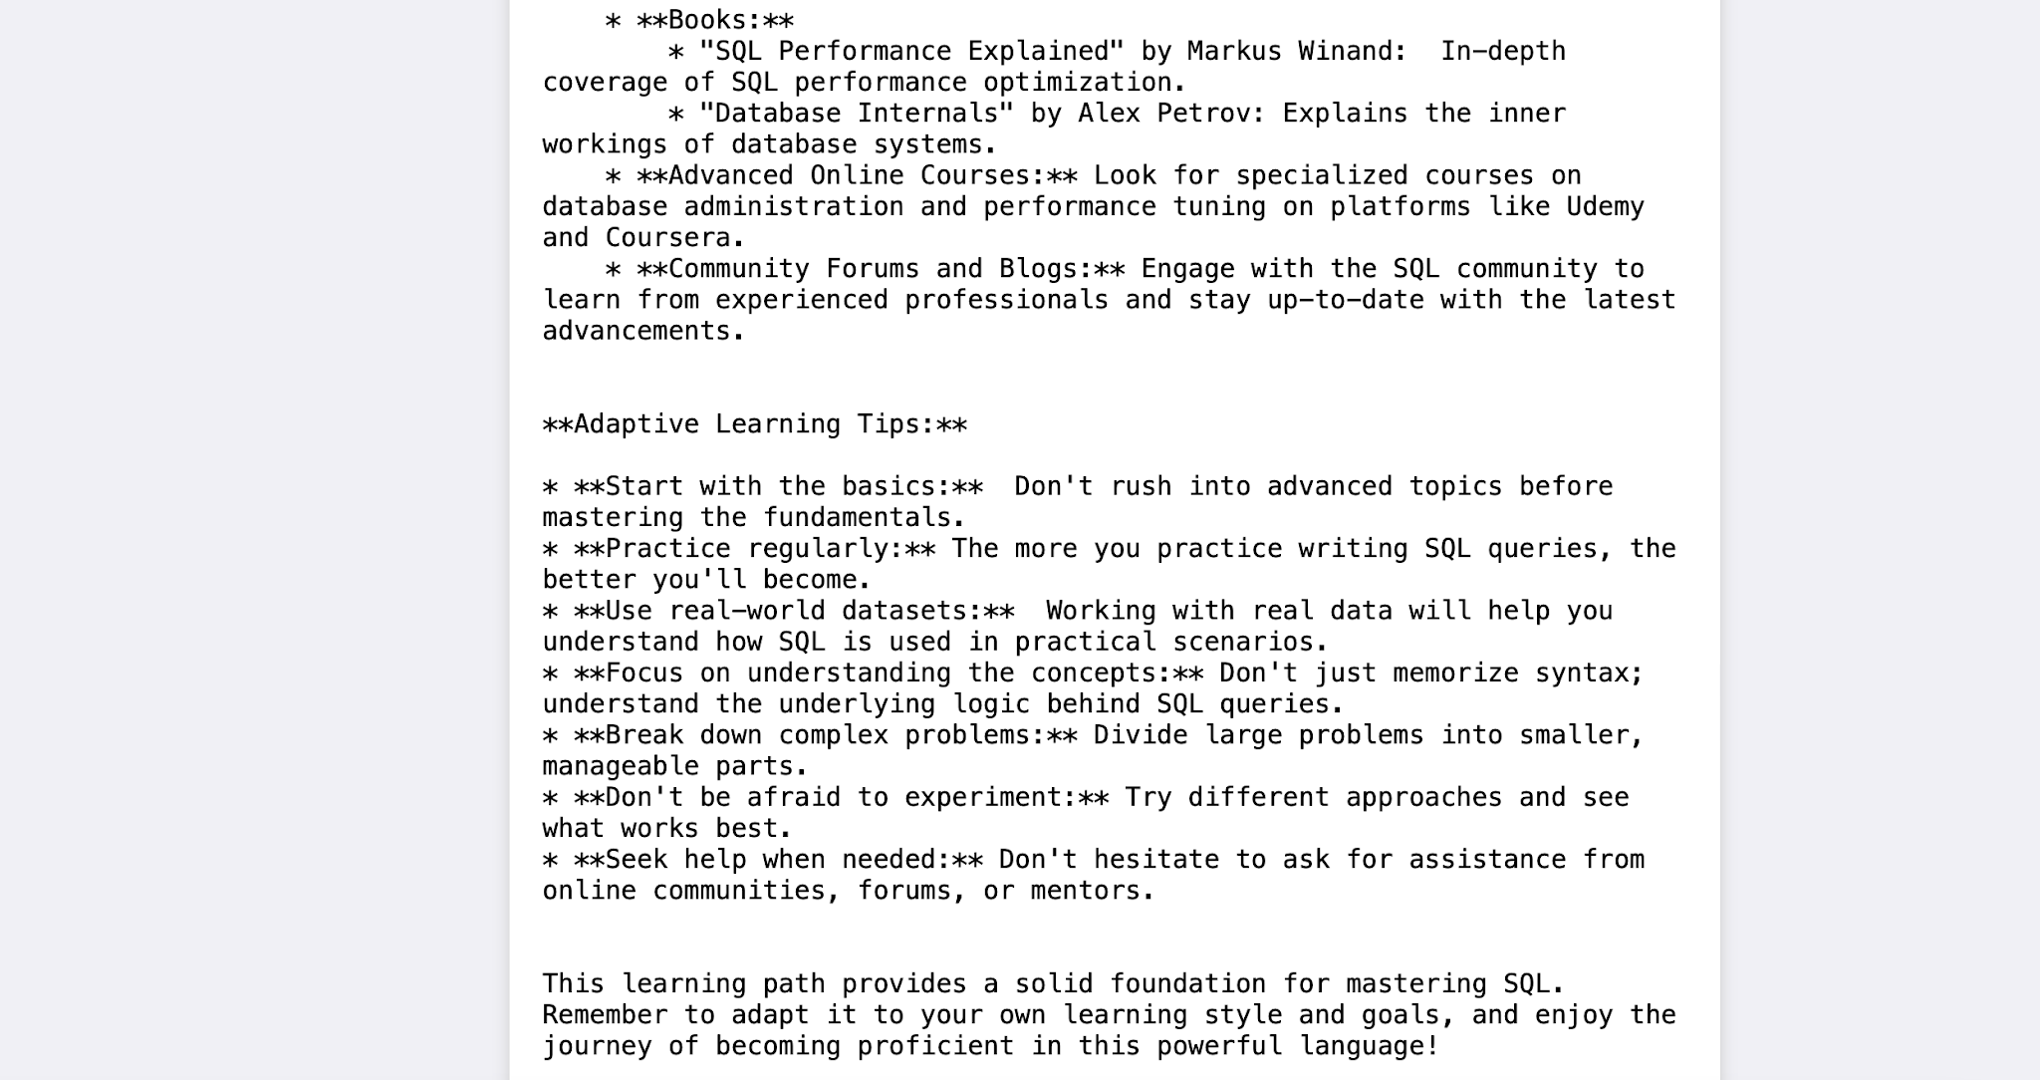
Figure 6.12 – SQL resources and adaptive learning tips
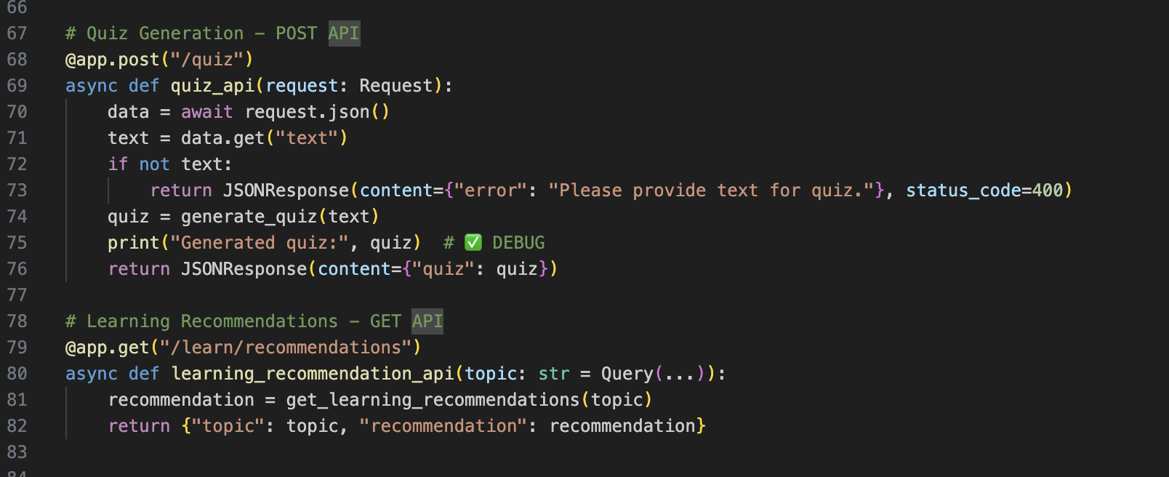
Figure 6.13 – Quiz API implementation
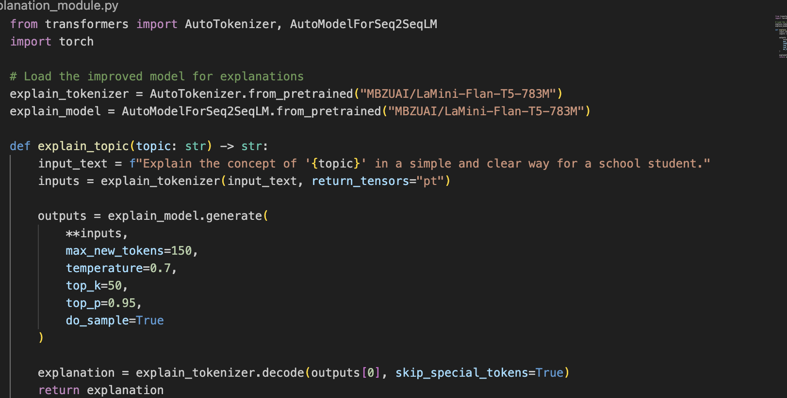
Figure 6.14 – Explanation module implementation
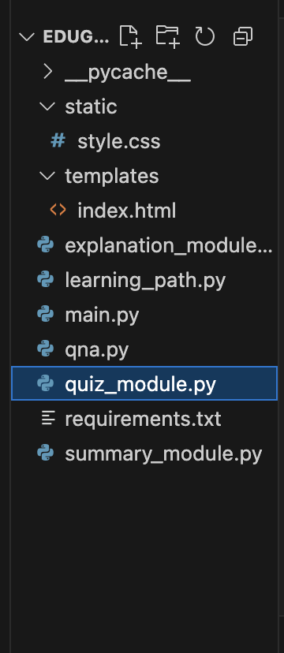
Figure 6.15 – Project file structure

7. OBSERVED OUTPUTS
- The question-answering demonstration returns an answer to a general knowledge question.
- The explanation demonstration produces a simplified explanation for a supplied concept.
- The summarization demonstration converts a paragraph about the Industrial Revolution into a shorter summary.
- The quiz demonstration generates multiple-choice questions related to the Pythagorean theorem.
- The learning recommendation demonstration produces a structured SQL learning path with levels, resources, and adaptive learning tips.

8. CONCLUSION
The supplied project material demonstrates EduGenie as an AI-supported learning application with multiple learning-assistance functions. The project combines an interactive interface with API-based processing for questions, explanations, summaries, quizzes, and learning recommendations.

9. REFERENCES / RESOURCES MENTIONED IN THE PROJECT
- SQLZoo – interactive SQL practice resource.
- Khan Academy SQL course – introductory SQL learning resource.
- Codecademy Learn SQL – interactive SQL lessons.
- freeCodeCamp SQL Tutorial – SQL learning resource.
- "SQL Queries for Mere Mortals" by Michael J. Hernandez.
- "SQL Performance Explained" by Markus Winand.
- "Database Internals" by Alex Petrov.
- LeetCode and HackerRank – practice platforms mentioned in the learning recommendations.
- Udemy and Coursera – online-course platforms mentioned in the project.

APPENDIX
The original project document contains the implementation and output screenshots used in this formatted report. They have been reordered into a conventional project-report sequence for easier presentation.

