Session 2

Assignment -4

Code :

/*Write a program to print total number of days in the given month. */

**import** java.util.Scanner;

**public** **class** DaysInMonth {

**public** **static** **void** main(String[] args) {

Scanner input = **new** Scanner(System.***in***);

System.***out***.println("Please Enter Month (Ex: Jan): ");

String month=input.nextLine();

**switch**(month.toLowerCase())

{

**case** "jan": System.***out***.println("No of days in Jan Month is 31");**break**;

**case** "feb":{

**int** year;

System.***out***.print("Please Enter Year: ");

year =input.nextInt();

**if** ((year%400)==0 ||(year%4)==0)

System.***out***.println("Given year is Leap year so No of days in Feb Month is 29");

**else**

System.***out***.println("Given year is not Leap year so No of days in Feb Month is 28");

**break**;}

**case** "mar": System.***out***.println("No of days in Mar Month is 31");**break**;

**case** "apr": System.***out***.println("No of days in Apr Month is 30");**break**;

**case** "may": System.***out***.println("No of days in May Month is 31");**break**;

**case** "jun": System.***out***.println("No of days in Jun Month is 30");**break**;

**case** "jul": System.***out***.println("No of days in Jul Month is 31");**break**;

**case** "aug": System.***out***.println("No of days in Aug Month is 31");**break**;

**case** "sep": System.***out***.println("No of days in Sep Month is 30");**break**;

**case** "oct": System.***out***.println("No of days in Oct Month is 31");**break**;

**case** "nov": System.***out***.println("No of days in Nov Month is 30");**break**;

**case** "dec": System.***out***.println("No of days in Dec Month is 31");**break**;

**default**: System.***out***.println("Invalid Input.. Please enter valid month. Ex.,Jan");**break**;

}

}

}

Output1:

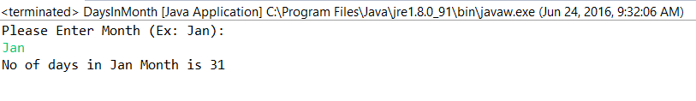

Output2:

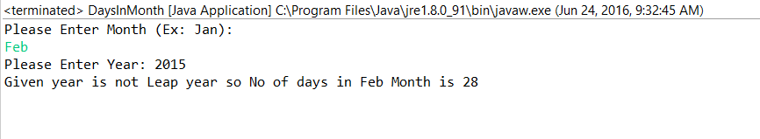

Output 3:

