Code:

/*Write a simple Java program to check whether a given number is a prime number or not. */

**import** java.util.Scanner;

**public** **class** PrimeNumberFinder {

**public** **static** **void** primeCheck(**int** num){

**int** count=0;

**for** (**int** j=2;j<=num;j++)

{

**if**(num%j==0)

{

count++;

}

}

**if** (count==1)

System.***out***.print("Given Number "+ num+ " is prime number.. ");

**else**

System.***out***.print("Given Number "+ num+ " is not prime number.. ");

}

**public** **static** **void** main(String[] args) {

**int** num;

Scanner input=**new** Scanner(System.***in***);

System.***out***.print("Please Enter Number:");

num=input.nextInt();

*primeCheck*(num);

}

}

Output1:

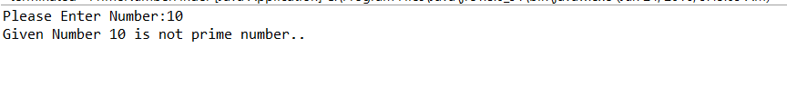

Output2:

