Code:

/*Design a very basic calculator having features like add, subtract, multiply and division. */

**import** java.util.Scanner;

**public** **class** BasicCalcualator {

**public** **static** **double** addition(**double** num1,**double** num2)

{

**double** res=num1+num2;

**return** res;

}

**public** **static** **double** subtraction(**double** num1,**double** num2)

{

**double** res=num1-num2;

**return** res;

}

**public** **static** **double** multiplication(**double** num1,**double** num2)

{

**double** res=num1*num2;

**return** res;

}

**public** **static** **double** division(**double** num1,**double** num2)

{

**double** res=num1/num2;

**return** res;

}

**public** **static** **void** main(String[] args) {

Scanner input = **new** Scanner (System.***in***);

System.***out***.println("Please Enter Simple Arithmatic expression: (Give # at the end for calculation) ");

**double** num1;

**double** num2;

**char** operator;

num1=input.nextInt();

**while**(**true**)

{

operator=input.next().charAt(0);

**if** (operator=='#') **break**;

num2=input.nextInt();

**switch**(operator)

{

**case** '+':{ num1=*addition*(num1,num2);num2=0;**break**;}

**case** '-':{ num1=*subtraction*(num1,num2);num2=0;**break**;}

**case** '*':{ num1=*multiplication*(num1,num2);num2=0;**break**;}

**case** '/':{ num1=*division*(num1,num2);num2=0;**break**;}

}

}

System.***out***.print("Result: "+num1);

}

}

Output1:

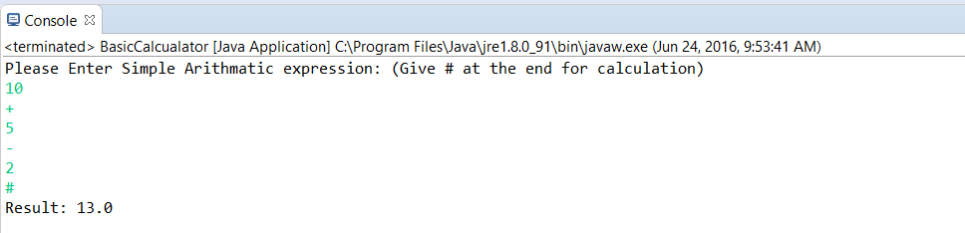

Output2:

