Data set considered & stored into Stud_Data relation as below having SNo : chararray,FName:chararray,LName:chararray,Age:int,Mobile:chararray,City:chararray,GPA:float

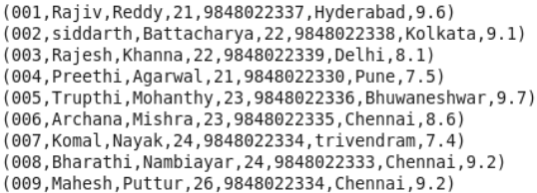

1. Concat:

Performed concatenation on FName & Lname and formed Full Name as below

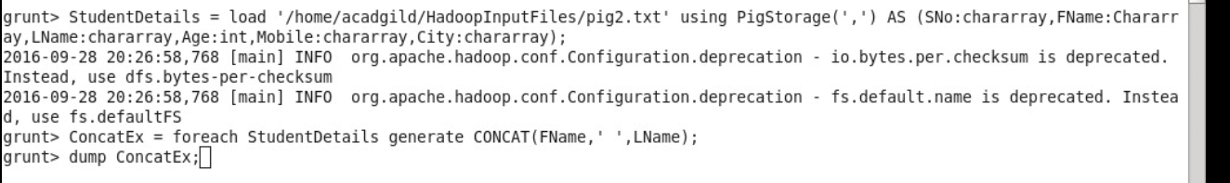

Output:

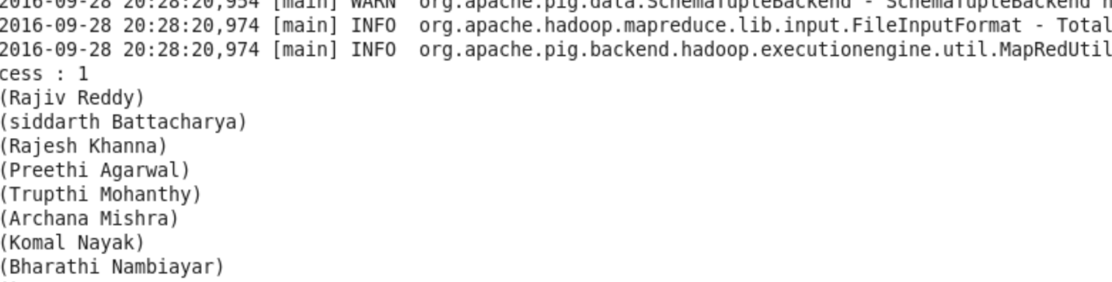

1. Tokenize



Output:

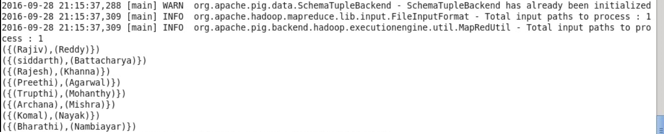

3)Sum

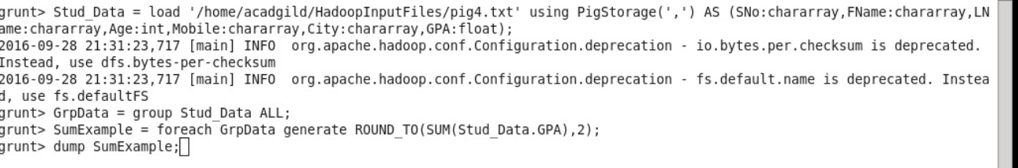

Output:



4)Max

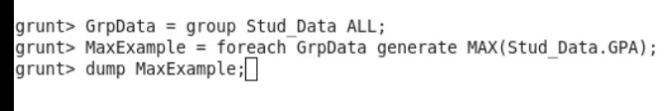

Output:



5) Min

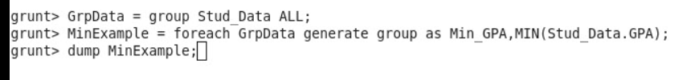

Output:

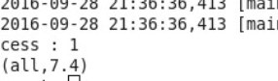

6) Limit

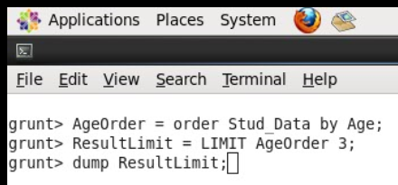

Output:

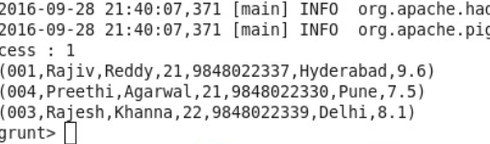

7) Store



Output:

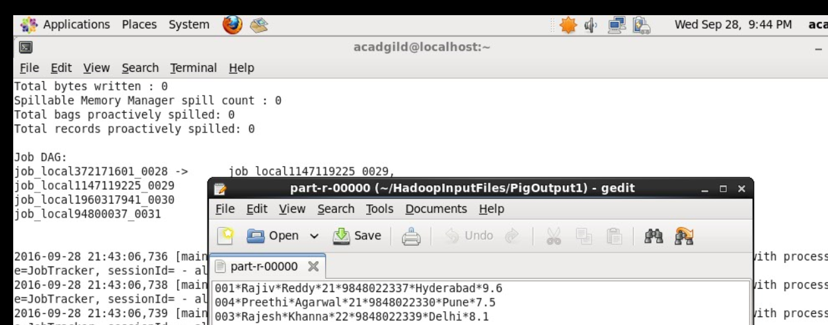

8) DISTINCT



Output:

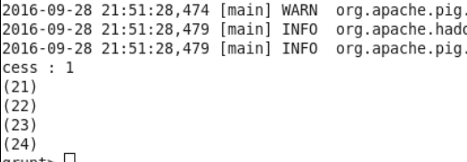

9) FLATTEN



Output:

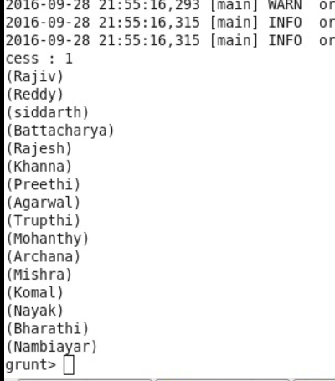

10) IsEmpty

Here, we considered two relations ie Stud_Data& Stud_Data1 having below data sets

DataSet for Stud_Data as below,

,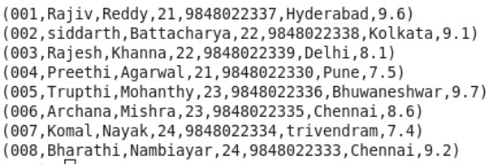

DataSet for Stud_Data1 as below,

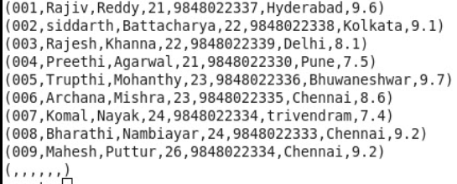

And then performed CoGroup on these two relations & verified if any empty bags found on result relation as below

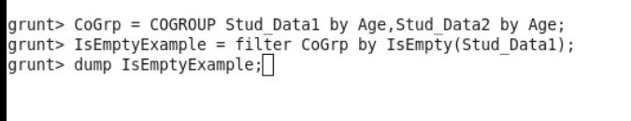

Output:

