EX NO. 1. NETWORKING COMMANDS

AIM:

To study and execute various networking commands and analyze their outputs.

Software Required

Windows Operating System

Command Prompt (CMD)

Theory

Networking commands are utility programs used to diagnose, monitor, and troubleshoot network connections. They help users obtain information about IP addresses, connectivity, routing tables, and active network sessions.

Commands Used

1. ipconfig

Purpose:

The ipconfig command is used to display the current TCP/IP network configuration of a computer. It is useful for troubleshooting network connectivity issues.

Syntax:

ipconfig

Description:

ipconfig displays basic network configuration information.

ipconfig /all displays detailed information such as IP address, subnet mask, MAC address, DNS server, DHCP server, and default gateway.

ipconfig /renew renews the IP address assigned by the DHCP server.

ipconfig /release releases the DHCP-assigned IP address.

Sample Output:

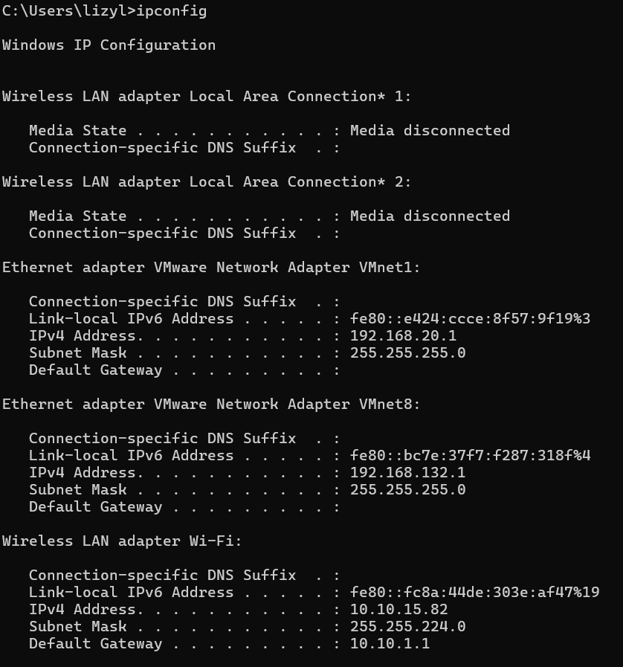

2. netstat

Purpose:

The netstat command is used to display active network connections, listening ports, routing tables, and network interface statistics. It is useful for monitoring and troubleshooting network connectivity.

Syntax:

netstat

Description:

netstat displays the active TCP connections.

netstat -a displays all active connections and listening ports.

netstat -n displays addresses and port numbers in numerical form.

netstat -r displays the routing table.

netstat -s displays protocol statistics for TCP, UDP, IPv4, and ICMP.

Sample Output:

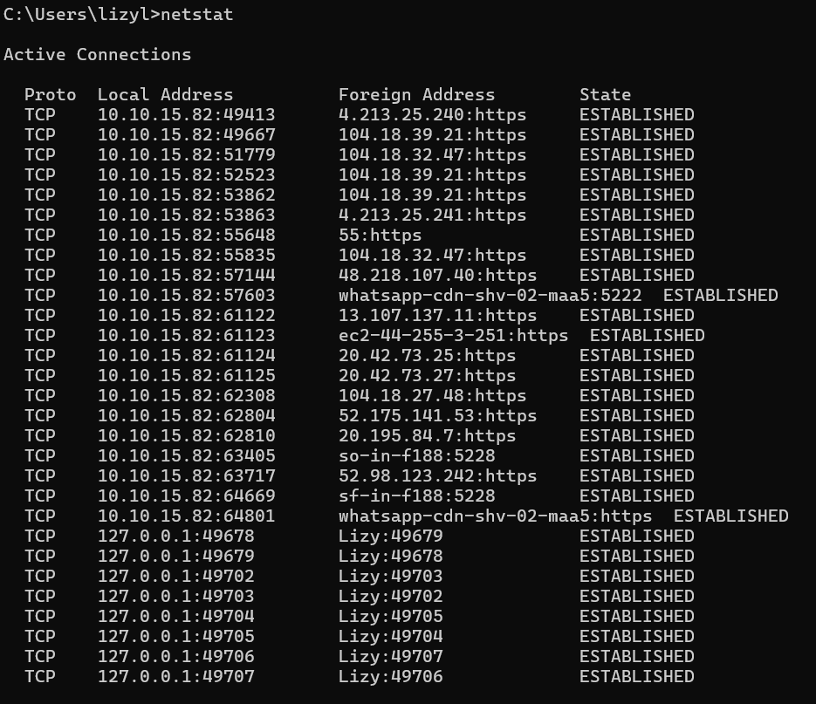

Observation:

The netstat command displays information about active network connections, listening ports, routing tables, and protocol statistics, which helps in analyzing network activity and troubleshooting connectivity problems.

3. nslookup

Purpose:

The nslookup command is used to query the Domain Name System (DNS) and obtain the IP address corresponding to a domain name or the domain name associated with an IP address. It is useful for diagnosing DNS-related problems.

Syntax:

nslookup <domain_name>

Description:

nslookup displays the DNS server information and the IP address associated with a specified domain name.

It can also be used to find the domain name corresponding to a given IP address.

It is commonly used for troubleshooting DNS resolution issues.

Sample Output:

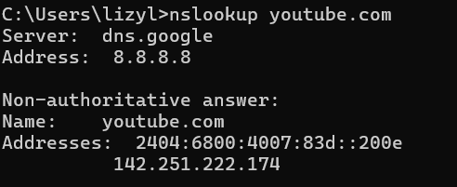

Observation:

The nslookup command successfully resolves a domain name into its corresponding IP address and provides information about the DNS server used for the query.

4. tracert

Purpose:

The tracert command is used to trace the route taken by packets from the source computer to a destination host. It helps identify the intermediate routers and measure the time taken to reach each hop, making it useful for diagnosing network connectivity problems.

Syntax:

tracert <hostname or IP address>

Description:

tracert displays the path followed by packets to reach a destination.

It shows the list of intermediate routers (hops) between the source and destination.

It provides the round-trip time for each hop.

It is commonly used to troubleshoot network delays and routing issues.

Sample Output

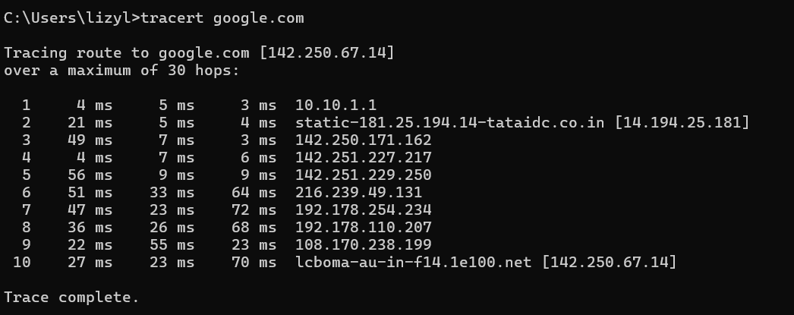

Observation:

The tracert command traces the path taken by packets from the source to the destination and displays the intermediate routers and response times for each hop.

5. ping

Purpose:

The ping command is used to test the connectivity between two devices on a network. It sends Internet Control Message Protocol (ICMP) Echo Request packets to a specified host and measures the time taken to receive the corresponding Echo Reply packets. It is commonly used to diagnose network connectivity problems.

Syntax:

ping <hostname or IP address>

Description:

ping verifies whether a remote host is reachable.

It measures the round-trip time (RTT) of packets sent to the destination.

It helps identify packet loss and network delays.

It is widely used for troubleshooting network connectivity issues.

Sample Output:

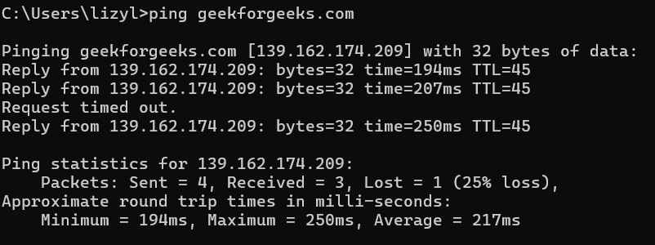

Observation:

The ping command successfully checks the connectivity between the source and destination hosts and provides information about packet transmission, packet loss, and round-trip time.

RESULT

Thus, the TCP/IP network command utilities such as ipconfig, netstat, nslookup, tracert, and ping were studied in detail and their outputs were observed successfully.

