EX. NO. 2: HTTP WEB CLIENT PROGRAM

AIM:

To develop a Java HTTP web client program that downloads a web page using TCP socket communication.

ALGORITHM:
Step 1: Start the program.
Step 2: Set a server port as 80.
Step 3: Create a socket for the server by specifying the host name and port number.
Step 4: Establish an HTTP connection between the client and the server.
Step 5: Use a BufferedReader to read the response received from the server and display it on the client console.
Step 6: Close the input stream, output stream, and socket connection after receiving the server response. Handle exceptions such as IOException during communication.
Step 7: Stop the program.

PROGRAM:

import java.io.*;
import java.net.*;

public class WebClient {

public static void main(String[] args) {

try {
// Establish connection with the web server
Socket clientSocket = new Socket("example.com", 80);

// Create output stream to send HTTP request
PrintWriter writer =
new PrintWriter(clientSocket.getOutputStream(), true);

// Send HTTP GET request
writer.println("GET / HTTP/1.1");
writer.println("Host: example.com");
writer.println();

// Create input stream to receive response
BufferedReader reader =
new BufferedReader(
new InputStreamReader(clientSocket.getInputStream()));

// Display server response
String line;

while ((line = reader.readLine()) != null) {
System.out.println(line);
}

// Close streams and socket
reader.close();
writer.close();
clientSocket.close();
}
catch (IOException e) {
System.out.println("Error in connecting to the server.");
System.out.println(e.getMessage());
}
}
}
EXECUTION:
Step 1: Save the Java program as WebClient.java.
Step 2: Open command prompt.
Step 3: Set the path for the Java compiler and interpreter as follows:
set path=” C:\Program Files\Java\jdk1.7.0_79\bin”;
Step 4: Compile the program using the following command:
Javac WebClient.java
This generates the bytecode file WebClient.class.
Step 5: Execute the program using the following command:
java WebClient

OUTPUT:

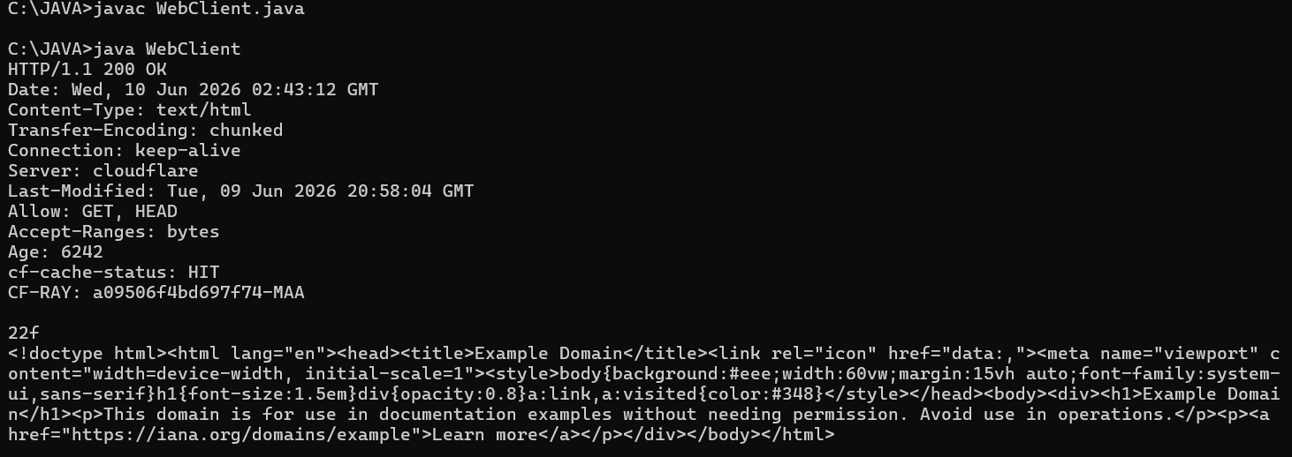

RESULT:
Thus, the Java HTTP web client program was developed using TCP socket communication and executed successfully. The web page content received from the server was displayed and verified.

