TASK 4
Simulation of DNS using UDP Sockets.
AIM
To simulate the working of the Domain Name System (DNS) using UDP sockets in Java, where a client sends a domain name to a DNS server and receives the corresponding IP address.

Algorithm
DNS SERVER
- Create a UDP socket and bind it to a port (e.g., 9876).
- Maintain a table containing domain names and corresponding IP addresses.
- Wait for DNS queries from clients.
- Receive the domain name sent by the client.
- Search for the domain name in the DNS table.
- If found, retrieve the corresponding IP address; otherwise, return "Domain Not Found".
- Send the response back to the client using UDP.
- Repeat the process for subsequent requests.
DNS CLIENT
- Create a UDP socket.
- Accept a domain name as input from the user.
- Convert the domain name into bytes.
- Send the query to the DNS server using UDP.
- Wait for the server's response.
- Display the received IP address.
- Close the socket.
DNS Server
import java.net.*;
import java.util.HashMap;

public class DNSServer {
public static void main(String[] args) throws Exception {

DatagramSocket serverSocket = new DatagramSocket(9876);

HashMap<String, String> dnsTable = new HashMap<>();
dnsTable.put("www.google.com", "142.250.183.14");
dnsTable.put("www.yahoo.com", "98.137.11.163");
dnsTable.put("www.facebook.com", "157.240.229.35");
dnsTable.put("www.amazon.com", "205.251.242.103");

byte[] receiveData = new byte[1024];
byte[] sendData;

System.out.println("DNS Server is running...");

while (true) {

DatagramPacket receivePacket =
new DatagramPacket(receiveData, receiveData.length);

serverSocket.receive(receivePacket);

String domain =
new String(receivePacket.getData(), 0,
receivePacket.getLength());

System.out.println("Query Received: " + domain);

String ipAddress =
dnsTable.getOrDefault(domain, "Domain Not Found");

sendData = ipAddress.getBytes();

InetAddress clientIP = receivePacket.getAddress();
int clientPort = receivePacket.getPort();

DatagramPacket sendPacket =
new DatagramPacket(sendData, sendData.length,
clientIP, clientPort);

serverSocket.send(sendPacket);
}
}
}

DNS Client
import java.net.*;
import java.util.Scanner;

public class DNSClient {
public static void main(String[] args) throws Exception {

DatagramSocket clientSocket = new DatagramSocket();

Scanner sc = new Scanner(System.in);

System.out.print("Enter Domain Name: ");
String domain = sc.nextLine();

byte[] sendData = domain.getBytes();
byte[] receiveData = new byte[1024];

InetAddress serverIP = InetAddress.getByName("localhost");

DatagramPacket sendPacket =
new DatagramPacket(sendData, sendData.length,
serverIP, 9876);

clientSocket.send(sendPacket);

DatagramPacket receivePacket =
new DatagramPacket(receiveData, receiveData.length);

clientSocket.receive(receivePacket);

String result =
new String(receivePacket.getData(), 0,
receivePacket.getLength());

System.out.println("IP Address: " + result);

clientSocket.close();
}
}

OUTPUT
DNS Server

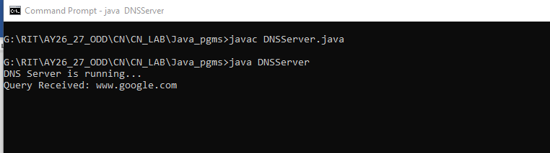

DNS Client

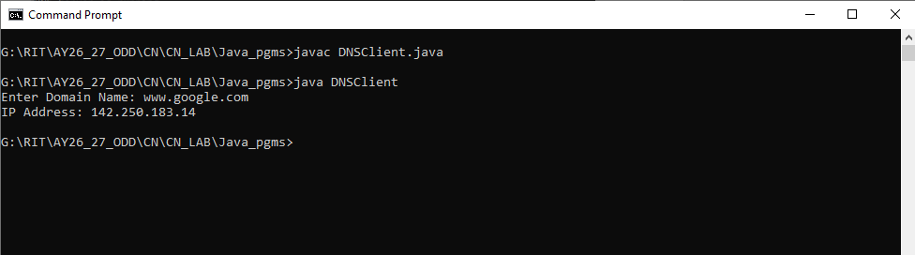

RESULT
Thus, the simulation of DNS using UDP sockets in Java was successfully implemented. The client sends a domain name request to the DNS server, and the server returns the corresponding IP address using the UDP communication protocol.

