Week-7

1. Coders here is a simple task for you, Given string str. Your task is to check whether it is a binary string or not by using python set.

Examples:

Input: str = "01010101010"

Output: Yes

Input: str = "REC101"

Output: No

**For example:**

| **Input** | **Result** |
| --- | --- |
| 01010101010 | Yes |
| 010101 10101 | No |

Program:

s = str(input())

set_s = set(s)

if set_s == {'0', '1'}:

print('Yes')

else:

print('No')

Output:

|  | **Input** | **Expected** | **Got** |  |
| --- | --- | --- | --- | --- |
|  | 01010101010 | Yes | Yes |  |
|  | REC123 | No | No |  |
|  | 010101 10101 | No | No |  |

Passed all tests!

**Correct**

2. Given an array of strings words, return *the words that can be typed using letters of the alphabet on only one row of American keyboard like the image below*.

In the **American keyboard**:

* the first row consists of the characters "qwertyuiop",
* the second row consists of the characters "asdfghjkl", and
* the third row consists of the characters "zxcvbnm".

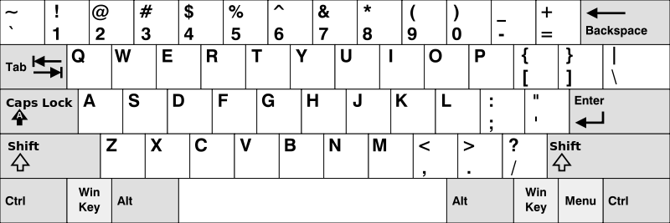

**Example 1:**

**Input:** words = ["Hello","Alaska","Dad","Peace"]

**Output:** ["Alaska","Dad"]

**Example 2:**

**Input:** words = ["omk"]

**Output:** []

**Example 3:**

**Input:** words = ["adsdf","sfd"]

**Output:** ["adsdf","sfd"]

**For example:**

| **Input** | **Result** |
| --- | --- |
| 4  Hello  Alaska  Dad  Peace | Alaska  Dad |
| 2  adsfd  afd | adsfd  afd |

Program:

def find_words(words):

row1 = set("qwertyuiop")

row2 = set("asdfghjkl")

row3 = set("zxcvbnm")

def check_word(word):

w = set(word.lower())

return w.issubset(row1) or w.issubset(row2) or w.issubset(row3)

return [word for word in words if check_word(word)]

# Test the function with examples

words= tuple(input().split())

print(find_words(words))

Output:

|  | **Input** | **Expected** | **Got** |  |
| --- | --- | --- | --- | --- |
|  | 4  Hello  Alaska  Dad  Peace | Alaska  Dad | Alaska  Dad |  |
|  | 1  omk | No words | No words |  |
|  | 2  adsfd  afd | adsfd  afd | adsf  afd |  |

3. Given an array of integers nums containing n + 1 integers where each integer is in the range [1, n] inclusive.There is only **one repeated number** in nums, return *this repeated number*. Solve the problem using set.

**Example 1:**

**Input:** nums = [1,3,4,2,2]

**Output:** 2

**Example 2:**

**Input:** nums = [3,1,3,4,2]

**Output:** 3

**For example:**

| **Input** | **Result** |
| --- | --- |
| 1 3 4 4 2 | 4 |

Program:

def find_duplicate(nums):

# Create an empty set to store the unique elements in nums

unique_nums = set()

# Iterate through the elements in nums

for num in nums:

# If an element is already in the set, return it as the duplicate

if num in unique_nums:

return num

# Otherwise, add the element to the set

unique_nums.add(num)

# If no duplicate is found, return -1

return -1

# Example usage:

nums = list(input().split())

print(find_duplicate(nums))

output:

|  | **Input** | **Expected** | **Got** |  |
| --- | --- | --- | --- | --- |
|  | 1 3 4 4 2 | 4 | 4 |  |
|  | 1 2 2 3 4 5 6 7 | 2 | 2 |  |

Passed all tests!

**Correct**

4. There is a malfunctioning keyboard where some letter keys do not work. All other keys on the keyboard work properly.

Given a string text of words separated by a single space (no leading or trailing spaces) and a string brokenLetters of all distinct letter keys that are broken, return the number of words in text you can fully type using this keyboard.

Example 1:

Input: text = "hello world", brokenLetters = "ad"

Output:

1

Explanation: We cannot type "world" because the 'd' key is broken.

**For example:**

| **Input** | **Result** |
| --- | --- |
| hello world  ad | 1 |
| Faculty Upskilling in Python Programming  ak | 2 |

Program:

def canType(text, brokenLetters):

words = text.split(' ')

count = 0

broken_set = set(brokenLetters)

for word in words:

if not any(char.lower() in broken_set for char in word):

count += 1

return count

# Input from the us()

text = input()

brokenLetters = input()

print(canType(text, brokenLetters))

output:

|  | **Input** | **Expected** | **Got** |  |
| --- | --- | --- | --- | --- |
|  | hello world  ad | 1 | 1 |  |
|  | Welcome to REC  e | 1 | 1 |  |
|  | Faculty Upskilling in Python Programming  ak | 2 | 2 |  |

Passed all tests!

**Correct**

5. The **DNA sequence** is composed of a series of nucleotides abbreviated as 'A', 'C', 'G', and 'T'.

* For example, "ACGAATTCCG" is a **DNA sequence**.

When studying **DNA**, it is useful to identify repeated sequences within the DNA.

Given a string s that represents a **DNA sequence**, return all the **10-letter-long** sequences (substrings) that occur more than once in a DNA molecule. You may return the answer in **any order**.

**Example 1:**

**Input:** s = "AAAAACCCCCAAAAACCCCCCAAAAAGGGTTT"

**Output:** ["AAAAACCCCC","CCCCCAAAAA"]

**Example 2:**

**Input:** s = "AAAAAAAAAAAAA"

**Output:** ["AAAAAAAAAA"]

**For example:**

| **Input** | **Result** |
| --- | --- |
| AAAAACCCCCAAAAACCCCCCAAAAAGGGTTT | AAAAACCCCC  CCCCCAAAAA |

Program:

def findRepeatedDnaSequences(s):

sequences = {}

result = []

for i in range(len(s) - 9):

sequence = s[i:i+10]

if sequence in sequences:

if sequences[sequence] == 1:

result.append(sequence)

sequences[sequence] += 1

else:

sequences[sequence] = 1

return "\n".join(result)

# Example usage:

s = input()

print(findRepeatedDnaSequences(s))

output:

|  | **Input** | **Expected** | **Got** |  |
| --- | --- | --- | --- | --- |
|  | AAAAACCCCCAAAAACCCCCCAAAAAGGGTTT | AAAAACCCCC  CCCCCAAAAA | AAAAACCCCC  CCCCCAAAAA |  |
|  | AAAAAAAAAAAAA | AAAAAAAAAA | AAAAAAAAAA |  |

Passed all tests!

**Correct**