

|  |  |
| --- | --- |
| **EXP NO: 1** | **Install Apache Hadoop** |
| **Date:** |

**AIM:** To Install Apache Hadoop software on Windows.

Hadoop software can be installed in three modes of Hadoop is a Java-based programming framework that supports the processing and storage of extremely large datasets on a cluster of inexpensive machines. It was the first major open-source project in the big data playing field and is sponsored by the Apache Software Foundation.

Hadoop-2.7.3 is comprised of four main layers:

* + - **Hadoop Common** is the collection of utilities and libraries that support other Hadoop modules.
    - **HDFS**, which stands for Hadoop Distributed File System, is responsible for persisting data to disk.
    - **YARN**, short for Yet Another Resource Negotiator, is the "operating system" for HDFS.
    - **MapReduce** is the original processing model for Hadoop clusters. It distributes work within the cluster or map, then organizes and reduces the results from the nodes into a response to a query. Many other processing models are available for the 2.x version of Hadoop.

Hadoop clusters are relatively complex to set up, so the project includes a stand-alone mode which is suitable for learning about Hadoop, performing simple operations, and debugging.

#### **Procedure:**

we'll install Hadoop in stand-alone mode and run one of the example MapReduce programs it includes to verify the installation.

#### **Prerequisites:**

**Step1: Installing Java 8 version**.

**Openjdk version "1.8.0_91"**

OpenJDK Runtime Environment (build 1.8.0_91-8u91-b14-3ubuntu1~16.04.1-b14) OpenJDK 64-Bit Server VM (build 25.91-b14, mixed mode)

This output verifies that OpenJDK has been successfully installed.

**Note:** To set the path for environment variables. i.e. JAVA_HOME

## **Step2: Installing Hadoop**

With Java in place, we'll visit the Apache Hadoop Releases page to find the most recent stable release. Follow the binary for the current release:

Download Hadoop from [www.hadoop.apache.org](http://www.hadoop.apache.org/)

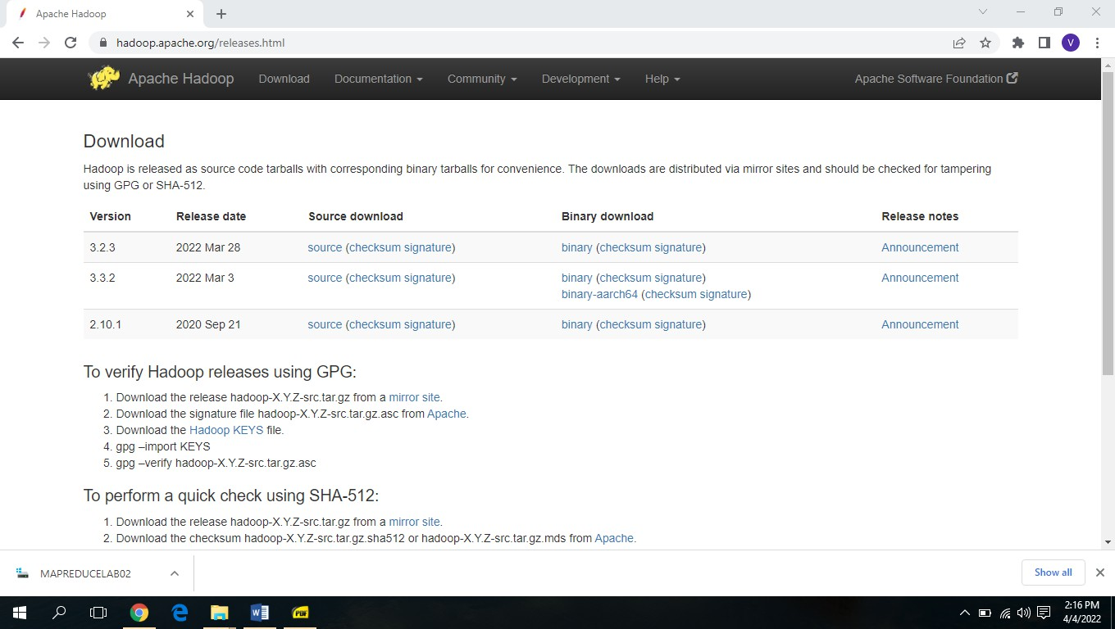



## **Procedure to Run Hadoop**

1. Install Apache Hadoop 2.2.0 in Microsoft Windows OS

If Apache Hadoop 2.2.0 is not already installed then follow the post Build, Install, Configure and Run Apache Hadoop 2.2.0 in Microsoft Windows OS.

1. Start HDFS (Namenode and Datanode) and YARN (Resource Manager and Node Manager)

Run following commands. *Command Prompt* C:\Users\abhijitg>cd c:\hadoop c:\hadoop>sbin\start-dfs c:\hadoop>sbin\start-yarn

starting yarn daemons

**Namenode**, **Datanode**, **Resource Manager** and **Node Manager** will be started in few minutes and ready to execute Hadoop **MapReduce** job in the Single Node (pseudo-distributed mode) cluster.

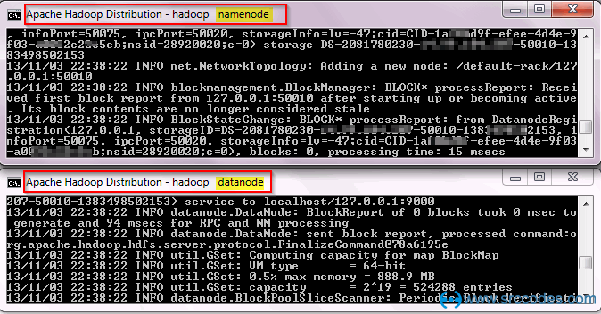

*Resource Manager & Node Manager:*

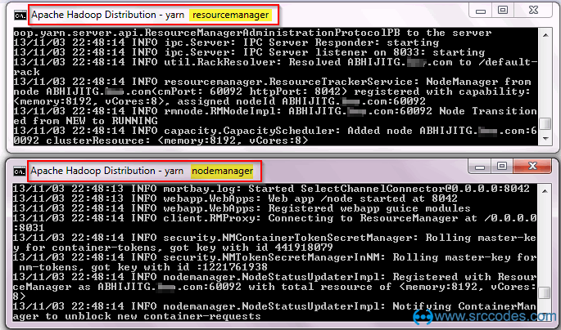

# Run wordcount MapReduce job

Now we'll run **wordcount** MapReduce job available in

**%HADOOP_HOME%\share\hadoop\mapreduce\hadoop-mapreduce-examples- 2.2.0.jar**

Create a text file with some content. We'll pass this file as input to the **wordcount** MapReduce job for counting words.

*C:\file1.txt*

Run Hadoop Wordcount Mapreduce Example

Install Hadoop

Create a directory (say 'input') in HDFS to keep all the text files (say 'file1.txt') to be used for counting words.

## **C:\Users\abhijitg>cd c:\hadoop**

## **C:\hadoop>bin\hdfs dfs -mkdir input**

Copy the text file (say 'file1.txt') from local disk to the newly created 'input' directory in HDFS

## **C:\hadoop>bin\hdfs dfs -copyFromLocal c:/file1.txt input**

Check content of the copied file.

**C:\hadoop>hdfs dfs -ls input**

Found 1 items

-rw-r--r-- 1 ABHIJITG supergroup 55 2014-02-03 13:19 input/file1.txt

**C:\hadoop>bin\hdfs dfs -cat input/file1.txt**

Install Hadoop

Run Hadoop Wordcount Mapreduce Example

Run the wordcount MapReduce job provided

in %HADOOP_HOME%\share\hadoop\mapreduce\hadoop-mapreduce-examples-2.2.0.jar

C:\hadoop>bin\yarn jar share/hadoop/mapreduce/hadoop-mapreduce-examples- 2.2.0.jar

wordcount input output

14/02/03 13:22:02 INFO client.RMProxy: Connecting to ResourceManager at

/0.0.0.0:8032

14/02/03 13:22:03 INFO input.FileInputFormat: Total input paths to process: 1 14/02/03 13:22:03 INFO mapreduce.JobSubmitter: number of splits:1

:

:

14/02/03 13:22:04 INFO mapreduce.JobSubmitter: Submitting tokens for job: job_1391412385921_0002

14/02/03 13:22:04 INFO impl.YarnClientImpl: Submitted application application_1391412385921_0002 to ResourceManager at /0.0.0.0:8032 14/02/03 13:22:04 INFO mapreduce.Job: The url to track the job: http://ABHIJITG:8088/proxy/application_1391412385921_0002/

14/02/03 13:22:04 INFO mapreduce.Job: Running job: job_1391412385921_0002 14/02/03 13:22:14 INFO mapreduce.Job: Job job_1391412385921_0002 running in uber mode: false

14/02/03 13:22:14 INFO mapreduce.Job: map 0% reduce 0%

14/02/03 13:22:22 INFO mapreduce.Job: map 100% reduce 0%

14/02/03 13:22:30 INFO mapreduce.Job: map 100% reduce 100%

14/02/03 13:22:30 INFO mapreduce.Job: Job job_1391412385921_0002 completed successfully

14/02/03 13:22:31 INFO mapreduce.Job: Counters: 43 File System Counters

FILE: Number of bytes read=89

FILE: Number of bytes written=160142 FILE: Number of read operations=0 FILE: Number of large read operations=0 FILE: Number of write operations=0

HDFS: Number of bytes read=171 HDFS: Number of bytes written=59 HDFS: Number of read operations=6

HDFS: Number of large read operations=0 HDFS: Number of write operations=2

Job Counters

Launched map tasks=1 Launched reduce tasks=1 Data-local map tasks=1

Total time spent by all maps in occupied slots (ms)=5657 Total time spent by all reduces in occupied slots (ms)=6128

Map-Reduce Framework Map input records=2 Map output records=7 Map output bytes=82

Map output materialized bytes=89 Input split bytes=116

Combine input records=7 Combine output records=6 Reduce input groups=6 Reduce shuffle bytes=89 Reduce input records=6 Reduce output records=6 Spilled Records=12 Shuffled Maps =1

Failed Shuffles=0 Merged Map outputs=1

GC time elapsed (ms)=145 CPU time spent (ms)=1418

Physical memory (bytes) snapshot=368246784 Virtual memory (bytes) snapshot=513716224 Total committed heap usage (bytes)=307757056

Shuffle Errors

BAD_ID=0 CONNECTION=0 IO_ERROR=0 WRONG_LENGTH=0 WRONG_MAP=0 WRONG_REDUCE=0

File Input Format Counters Bytes Read=55

File Output Format Counters

Bytes Written=59

*http://abhijitg:8088/cluster*

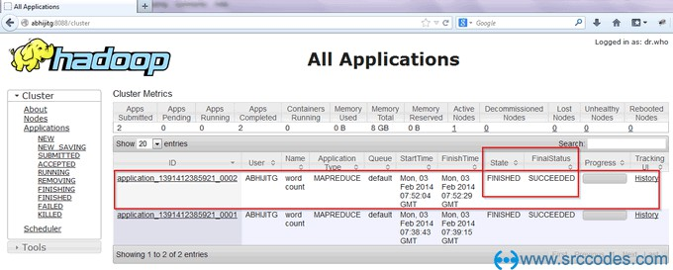

**Result:** We has been successfully installed Hadoop in stand-alone mode and verified it by running an example program which is provided.

|  |  |
| --- | --- |
| **EXP NO: 2** | **MapReduce program to calculate the frequency** |
| **Date:** |

**AIM:** To Develop a MapReduce program to calculate the frequency of a given word in a given file **Map Function** – It takes a set of data and converts it into another set of data, where individual elements are broken down into tuples (Key-Value pair).

**Example –** (Map function in Word Count)

#### **Input**

Set of data

Bus, Car, bus, car, train, car, bus, car, train, bus, TRAIN, BUS, buS, caR, CAR, car, BUS, TRAIN

#### **Output**

Convert into another set of data (Key,Value)

(Bus,1), (Car,1), (bus,1), (car,1), (train,1), (car,1), (bus,1), (car,1), (train,1), (bus,1),

(TRAIN,1), (BUS,1), (buS,1), (caR,1), (CAR,1), (car,1), (BUS,1), (TRAIN,1)

**Reduce Function –** Takes the output from Map as an input and combines those data tuples into a smaller set of tuples.

Example – (Reduce function in Word Count)

**Input** Set of Tuples (output of Map function)

(Bus,1), (Car,1), (bus,1), (car,1), (train,1), (car,1), (bus,1), (car,1), (train,1), (bus,1), (TRAIN,1), (BUS,1), (buS,1), (caR,1), (CAR,1), (car,1), (BUS,1), (TRAIN,1)

**Output Converts into smaller set of tuples**

### (BUS,7), (CAR,7), (TRAIN,4)

#### **Workflow of Program**

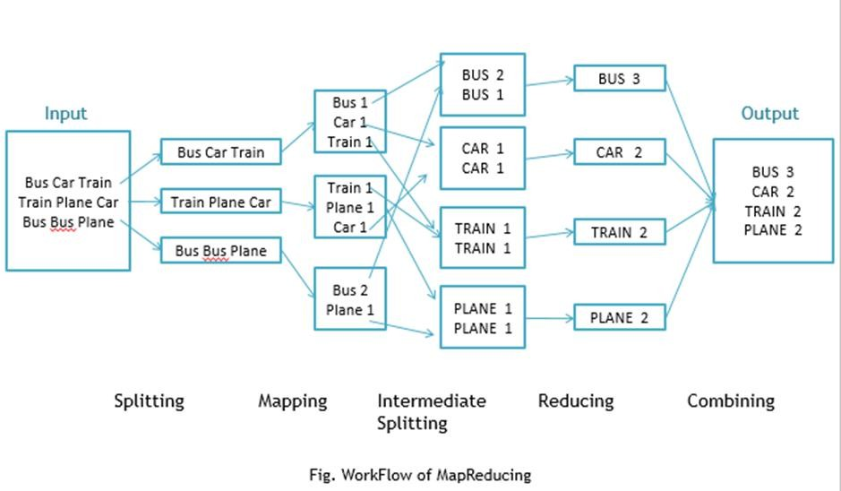

## **Workflow of MapReduce consists of 5 steps**

1. **Splitting –** The splitting parameter can be anything, e.g. splitting by space, comma, semicolon, or even by a new line (‘\n’).
2. **Mapping –** as explained above
3. Intermediate splitting – the entire process in parallel on different clusters. In order to group them in “Reduce Phase” the similar KEY data should be on same cluster.
4. **Reduce –** it is nothing but mostly group by phase
5. **Combining –** The last phase where all the data (individual result set from each cluster) is combined together to form a Result

**Now Let’s See the Word Count Program in Java**

**Make sure that Hadoop is installed on your system with java idk Steps to follow**

**Step 1. Open Eclipse> File > New > Java Project > (Name it – MRProgramsDemo) > Finish**

**Step 2. Right Click > New > Package (Name it - PackageDemo) > Finish**

**Step 3. Right Click on Package > New > Class (Name it - WordCount)**

**Step 4. Add Following Reference Libraries –**

## **Right Click on Project > Build Path> Add External Archivals**

* /usr/lib/hadoop-0.20/hadoop-core.jar
* Usr/lib/hadoop-0.20/lib/Commons-cli-1.2.jar

## **Program: Step 5. Type following Program:**

package Packaged Emo; import java.io.IOException;

import org.apache.hadoop.conf.Configuration; import org.apache.hadoop.fs.Path;

import org.apache.hadoop.io.IntWritable;

import org.apache.hadoop.io.LongWritable;

import org.apache.hadoop.io.Text;

import org.apache.hadoop.mapreduce.Job;

import org.apache.hadoop.mapreduce.Mapper; import org.apache.hadoop.mapreduce.Reducer;

import org.apache.hadoop.mapreduce.lib.input.FileInputFormat;

import org.apache.hadoop.mapreduce.lib.output.FileOutputFormat;

import org.apache.hadoop.util.GenericOptionsParser;

public class WordCount {

public static void main (String [] args) throws Exception

{

Configuration c=new Configuration ();

String [] files=new GenericOptionsParser(c,args).getRemainingArgs();

Path input=new Path (files [0]);

Path output=new Path (files [1]);

Job j=new Job(c,"wordcount"); j.setJarByClass(WordCount.class);

j.setMapperClass(MapForWordCount.class); j.setReducerClass(ReduceForWordCount.class);

j.setOutputKeyClass(Text.class); j.setOutputValueClass(IntWritable.class);

FileInputFormat.addInputPath(j, input); FileOutputFormat.setOutputPath(j, output); System.exit(j.waitForCompletion(true)?0:1);

}

public static class MapForWordCount extends Mapper<LongWritable, Text, Text, IntWritable> {

public void map (LongWritable key, Text value, Context con) throws IOException, InterruptedException

{

String line = value.toString();

String [] words=line.split(",");

for (String word: words)

{

Text outputKey = new Text(word.toUpperCase(). trim ()); IntWritable outputValue = new IntWritable(1); con.write(outputKey, outputValue);

}

}

}

public static class ReduceForWordCount extends Reducer<Text, IntWritable, Text, IntWritable>

{

public void reduces (Text word, Iterable<IntWritable> values, Context con) throws IOException,

InterruptedException

{

int sum = 0;

for (IntWritable value: values)

{

sum += value.get();

}

con.write(word, new IntWritable(sum));

}

}

}

## **Make Jar File**

Right Click on Project> Export> Select export destination as Jar File > next> Finish

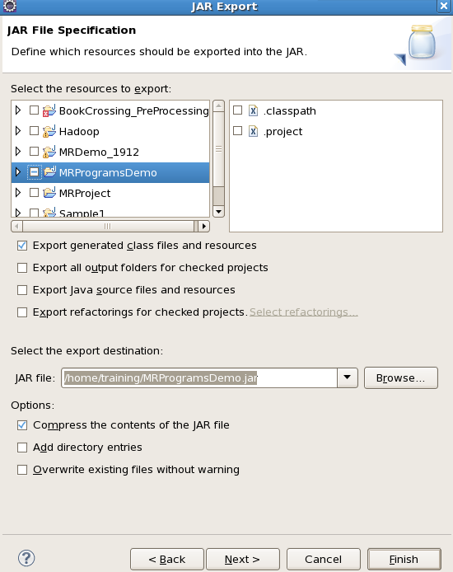

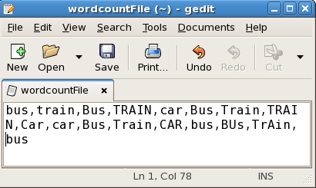

To Move this into Hadoop directly, open the terminal and enter the following commands:

**[training@localhost ~] $ hadoop fs -put wordcountFile wordCountFile**

## **Run Jar file**

(Hadoop jar jarfilename.jar packageName.ClassName PathToInputTextFile PathToOutputDirectry)

## **[training@localhost ~] $ Hadoop jar MRProgramsDemo.jar PackageDemo.WordCount wordCountFile MRDir1**

**Result: Open Result**

**[training@localhost ~] $ hadoop fs -ls MRDir1**

Found 3 items

-rw-r--r-- 1 training supergroup

0 2016-02-23 03:36 /user/training/MRDir1/_SUCCESS

drwxr-xr-x - training supergroup

0 2016-02-23 03:36 /user/training/MRDir1/_logs

-rw-r--r-- 1 training supergroup

20 2016-02-23 03:36 /user/training/MRDir1/part-r-00000

**[training@localhost ~] $ hadoop fs -cat MRDir1/part-r-00000**

BUS 7

CAR 4

TRAIN 6

**Result:** MapReduce program to calculate the frequency is executed successfully.

|  |  |
| --- | --- |
| **EXP NO: 3** | **Implement MapReduce program that processes a weather dataset** |
| **Date:** |

**AIM:** The aim is to Implement MapReduce program that processes a weather dataset.

**Procedure:**

* The code simulates weather data with random temperature and humidity values.
* It defines map functions to categorize temperature and humidity data into key-value pairs.
* A reduce function aggregates the mapped data by summing up the values for each key.
* The MapReduce function combines mapping and reducing operations:
* It maps the data using a specified mapper function.
* It groups the mapped data by keys.
* It reduces each group using a reducer function.
* In the main execution:
* Simulated weather data is generated.
* MapReduce is performed separately for temperature and humidity.
* The counts of temperature and humidity values are printed as output.

**Program:**

import random

from multiprocessing import Pool

# Simulated weather data generator

def generate_weather_data(num_records):

weather_data = []

for _ in range(num_records):

temperature = random.randint(-20, 40)

humidity = random.randint(0, 100)

weather_data.append((temperature, humidity))

return weather_data

# Map function to process temperature data

def map_temperature(data):

temperature, humidity = data

return temperature, 1

#Map function to process humidity data

def map_humidity(data):

temperature, humidity = data

return humidity, 1

# Reduce function to aggregate counts

def reduce_counts(data):

key, counts = data

return key, sum(counts)

# MapReduce function

def map_reduce(data, mapper, reducer):

mapped_data = [mapper(item) for item in data]

grouped_data = {}

for key, value in mapped_data:

grouped_data.setdefault(key, []). append(value)

reduced_data = [reducer ((key, value)) for key, value in grouped_data.items()]

return reduced_data

if __name__ == '__main__':

# Simulate weather dataset

weather_data = generate_weather_data(1000)

# Run MapReduce for temperature

temperature_counts = map_reduce(weather_data, map_temperature, reduce_counts)

print ("Temperature counts:")

print(temperature_counts)

# Run MapReduce for humidity

humidity_counts = map_reduce(weather_data, map_humidity, reduce_counts)

print ("Humidity counts:")

print(humidity_counts)

**OUTPUT:**

**Temperature counts:**

[(-8, 15), (22, 18), (30, 13), (4, 18), (15, 12), (36, 17), (17, 17), (-13, 20), (39, 18), (3, 13), (27, 13), (-2, 12), (7, 18), (0, 15), (-16, 15), (-20, 20), (-9, 22), (16, 22), (28, 16), (40, 15), (23, 13), (-11, 19), (1, 24), (2, 24), (8, 23), (-18, 24), (-19, 16), (11, 17), (-10, 26), (-7, 17), (19, 15), (-4, 12), (6, 21), (-3, 16), (31, 15), (-14, 14), (12, 20), (-6, 19), (18, 10), (26, 13), (5, 9), (-1, 15), (29, 14), (20, 19), (-12, 14), (32, 13), (-15, 18), (9, 22), (14, 15), (38, 13), (13, 21), (33, 20), (25, 13), (35, 16), (10, 11), (37, 18), (21, 14), (24, 16), (34, 15), (-17, 7), (-5, 10)]

**Humidity counts:**

[(27, 10), (49, 9), (98, 13), (5, 10), (86, 12), (43, 7), (42, 10), (54, 11), (62, 8), (77, 16), (12, 13), (55, 16), (65, 16), (70, 17), (45, 8), (83, 6), (0, 10), (52, 7), (66, 8), (4, 11), (74, 13), (61, 10), (13, 16), (48, 13), (6, 4), (87, 8), (99, 8), (8, 8), (79, 8), (80, 6), (91, 10), (16, 10), (30, 15), (89, 11), (20, 12), (46, 13), (56, 7), (69, 7), (60, 7), (40, 14), (63, 12), (14, 10), (58, 10), (57, 13), (71, 7), (85, 7), (35, 6), (51, 12), (9, 9), (97, 7), (17, 13), (18, 13), (32, 8), (28, 15), (50, 8), (47, 9), (78, 11), (29, 5), (100, 9), (96, 8), (92, 13), (37, 9), (53, 11), (76, 13), (75, 10), (31, 14), (2, 16), (68, 14), (34, 7), (94, 10), (10, 8), (39, 10), (90, 9), (64, 7), (1, 9), (7, 10), (33, 15), (21, 5), (26, 6), (81, 8), (15, 7), (72, 13), (23, 15), (93, 5), (82, 13), (95, 10), (59, 9), (88, 8), (24, 11), (19, 13), (36, 6), (41, 8), (11, 8), (22, 6), (44, 10), (84, 3), (73, 9), (3, 7), (25, 9), (38, 9), (67, 7)]

**Result:** Implementing MapReduce program that processes a weather dataset is executed successfully.

|  |  |
| --- | --- |
| **EXP NO: 4** | **Collect sensor data from any real time application and apply preprocessing techniques** |
| **Date:** |

**Aim:** The aim is to Collect sensor data from any real time application and apply preprocessing techniques.

**Procedure:**

Preprocessing sensor data is a crucial step in preparing it for further analysis or machine learning. Let’s walk through the process using Python:

1. **Import Necessary Libraries**: First, import the required libraries such as Pandas, NumPy, and Scikit-Learn. [These will help you manipulate and preprocess the data effectively](https://www.geeksforgeeks.org/data-preprocessing-machine-learning-python/)
2. **Python**

*import pandas as pd*

*import numpy as np*

*from sklearn.preprocessing import MinMaxScaler*

*import seaborn as sns*

*import matplotlib.pyplot as plt*

1. **Load the Dataset**: Load your sensor data into a Pandas DataFrame. For example, if you have a CSV file, you can read it like this:

**Python**

*df = pd.read_csv('path/to/your/sensor_data.csv')*

*print(df.head())*

This will display the first few rows of your dataset.

1. **Data Cleaning and Preprocessing**:
   * Handle missing values: Identify and handle any missing data (e.g., replace with mean, median, or drop rows/columns).
   * Remove irrelevant columns: Drop any columns that aren’t useful for your analysis.
   * Convert data types: Ensure that data types are appropriate for each feature (e.g., numeric, categorical).
2. **Feature Scaling**: Normalize or standardize your features to bring them to a similar scale. For example, use Min-Max scaling:
3. **Exploratory Data Analysis (EDA)**: Visualize your data using libraries like Seaborn and Matplotlib. Explore relationships between features and identify outliers.
4. **Feature Engineering**: Create new features if needed. For instance, derive additional features from existing ones (e.g., ratios, averages).
5. **Handling Categorical Variables**: If your data contains categorical variables, encode them.
6. **Split Data into Training and Test Sets**: Divide your dataset into training and test subsets for model evaluation.

**Code:**

import random

# Function to generate a simple weather dataset

def generate_weather_data(num_records):

weather_data = []

for _ in range(num_records):

temperature = random.randint(-20, 40) # Temperature in Celsius

humidity = random.randint(0, 100) # Humidity in percentage

weather_data.append((temperature, humidity))

return weather_data

# Function to apply preprocessing techniques

def preprocess(data):

preprocessed_data = []

for temperature, humidity in data:

# Example preprocessing: Filtering out temperatures below 0

if temperature >= 0:

# Example preprocessing: Normalizing humidity to range [0, 1]

humidity_normalized = humidity / 100.0

preprocessed_data.append((temperature, humidity_normalized))

return preprocessed_data

if __name__ == '__main__':

# Generate a simple weather dataset

weather_data = generate_weather_data(1000)

# Apply preprocessing techniques

preprocessed_data = preprocess(weather_data)

# Print preprocessed data

print ("Preprocessed Weather Data:")

for temperature, humidity in preprocessed_data:

print (f"Temperature: {temperature}°C, Humidity: {humidity}")

# Additional preprocessing or analysis can be performed here

**OUTPUT:**

**Preprocessed Weather Data:**

Temperature: 37°C, Humidity: 0.68

Temperature: 39°C, Humidity: 0.31

Temperature: 33°C, Humidity: 0.76

Temperature: 24°C, Humidity: 0.88

Temperature: 21°C, Humidity: 0.06

Temperature: 24°C, Humidity: 0.83

Temperature: 38°C, Humidity: 0.31

Temperature: 22°C, Humidity: 0.84

Temperature: 0°C, Humidity: 0.11

Temperature: 35°C, Humidity: 0.95

Temperature: 10°C, Humidity: 0.7

Temperature: 0°C, Humidity: 0.53

Temperature: 12°C, Humidity: 0.94

Temperature: 12°C, Humidity: 0.9

Temperature: 28°C, Humidity: 0.18

Temperature: 34°C, Humidity: 0.79

Temperature: 6°C, Humidity: 0.28

Temperature: 40°C, Humidity: 0.96

Temperature: 5°C, Humidity: 0.5

Temperature: 22°C, Humidity: 0.68

Temperature: 17°C, Humidity: 0.74

Temperature: 33°C, Humidity: 0.72

Temperature: 29°C, Humidity: 0.97

Temperature: 4°C, Humidity: 0.96

Temperature: 3°C, Humidity: 0.52

Temperature: 7°C, Humidity: 0.35

Temperature: 11°C, Humidity: 0.02

Temperature: 34°C, Humidity: 0.25

Temperature: 21°C, Humidity: 0.77

Temperature: 40°C, Humidity: 0.07

Temperature: 31°C, Humidity: 0.14

Temperature: 36°C, Humidity: 0.15

Temperature: 6°C, Humidity: 0.51

Temperature: 22°C, Humidity: 0.26

Temperature: 3°C, Humidity: 0.77

**Result:** Collecting sensor data from any real time application and apply preprocessing techniques is executed successfully.

|  |  |
| --- | --- |
| **EXP NO: 5** | **Collect sensor data and do Prediction using linear regression** |
| **Date:** |

**Aim:** The aim is to Collect sensor data and do Prediction using linear regression.

**Procedure:**

* We load the weather dataset using **pd.read_csv()** from **pandas**.
* We extract the humidity as the feature (**X**) and temperature as the target variable (**y**).
* We split the dataset into training and testing sets using **train_test_split** from **scikit-learn**.
* We produce relationship between one or more variables using Linear Regression.
* We train a model using a linear regression.
* We use the trained model to make predictions on the test data.
* Finally, we plot the actual vs. predicted values to visualize the performance of the Linear regression model.

**Code:**

import pandas as pd

from sklearn.model_selection import train_test_split

from sklearn.linear_model import LinearRegression

import matplotlib.pyplot as plt

# Load weather dataset

weather_data = pd.read_csv('weather_data.csv')

# Extract features (humidity) and target variable (temperature)

X = weather_data[['Humidity']]

y = weather_data['Temperature']

# Split dataset into training and testing sets

X_train, X_test, y_train, y_test = train_test_split(X, y, test_size=0.2, random_state=42)

# Train linear regression model

lin_reg = LinearRegression()

lin_reg.fit(X_train, y_train)

# Make predictions

y_pred = lin_reg.predict(X_test)

# Plot the actual vs. predicted values

plt.scatter(X_test, y_test, color='blue', label='Actual')

plt.plot(X_test, y_pred, color='red', label='Predicted')

plt.xlabel('Humidity')

plt.ylabel('Temperature')

plt.title('Linear Regression: Actual vs. Predicted')

plt.legend()

plt.show()

**OUTPUT:**

**Result:** Collecting sensor data and predicting using linear regression is executed successfully.

|  |  |
| --- | --- |
| **EXP NO: 6** | **Collect sensor data and Implement Support Vector Machine** |
| **Date:** |

**Aim:** The aim is to collect sensor data from the IoT devices and Implement SVM for classification or prediction.

**Procedure:**

* We load the weather dataset using **pd.read_csv()** from **pandas**.
* We extract the humidity as the feature (**X**) and temperature as the target variable (**y**).
* We split the dataset into training and testing sets using **train_test_split** from **scikit-learn**.
* We standardize the features using **StandardScaler** to ensure that each feature has a mean of 0 and a standard deviation of 1.
* We train a Support Vector Machine (SVM) model with a linear kernel (**kernel='linear'**).
* We use the trained model to make predictions on the test data.
* Finally, we plot the actual vs. predicted values to visualize the performance of the SVM model.

**Note:** Make sure to replace **'weather_data.csv'** with the path to your weather dataset CSV file.

**Code**:

import pandas as pd

from sklearn.model_selection import train_test_split

from sklearn.svm import SVR

from sklearn.preprocessing import StandardScaler

import matplotlib.pyplot as plt

# Load weather dataset

weather_data = pd.read_csv('weather_data.csv')

# Extract features (humidity) and target variable (temperature)

X = weather_data[['Humidity']]

y = weather_data['Temperature']

# Split dataset into training and testing sets

X_train, X_test, y_train, y_test = train_test_split(X, y, test_size=0.2, random_state=42)

# Standardize features

scaler = StandardScaler()

X_train_scaled = scaler.fit_transform(X_train)

X_test_scaled = scaler.transform(X_test)

# Train Support Vector Machine (SVM) model

svm_model = SVR (kernel='linear') # Linear kernel

svm_model.fit(X_train_scaled, y_train)

# Make predictions

y_pred = svm_model.predict(X_test_scaled)

# Plot the actual vs. predicted values

plt.scatter(X_test, y_test, color='blue', label='Actual')

plt.scatter(X_test, y_pred, color='red', label='Predicted')

plt.xlabel('Humidity')

plt.ylabel('Temperature')

plt.title('Support Vector Machine: Actual vs. Predicted')

plt.legend()

plt.show()

**OUTPUT:**

**Result:** Collecting sensor data and Implementing Support Vector Machine

is executed successfully.

|  |  |
| --- | --- |
| **EXP NO: 7** | **Collect sensor data and Implement Decision tree classification technique** |
| **Date:** |

**AIM**: The aim is to collect sensor data and Implement Decision tree Classification.

**Procedure:**

* We load the weather dataset using **pd.read_csv()** from **pandas**.
* We define the features (**X**) as 'Temperature' and 'Humidity', and the target variable (**y**) as 'Weather'.
* We split the dataset into training and testing sets using **train_test_split** from **scikit-learn**.
* We train a Decision Tree classifier using **DecisionTreeClassifier**.
* We make predictions on the test data using the trained model.
* We evaluate the model's performance using accuracy, classification report, and confusion matrix.

**Code:**

import pandas as pd

from sklearn.model_selection import train_test_split

from sklearn.tree import DecisionTreeClassifier

from sklearn.metrics import accuracy_score, classification_report, confusion_matrix

# Load weather dataset

weather_data = pd.read_csv('weather_data.csv')

# Define features (X) and target variable (y)

X = weather_data[['Temperature', 'Humidity']]

y = weather_data['Weather']

# Split dataset into training and testing sets

X_train, X_test, y_train, y_test = train_test_split(X, y, test_size=0.2, random_state=42)

# Train Decision Tree classifier

dt_classifier = DecisionTreeClassifier(random_state=42)

dt_classifier.fit(X_train, y_train)

# Make predictions

y_pred = dt_classifier.predict(X_test)

# Evaluate the model

accuracy = accuracy_score(y_test, y_pred)

print("Accuracy:", accuracy)

# Display classification report

print("Classification Report:")

print(classification_report(y_test, y_pred))

# Display confusion matrix

print("Confusion Matrix:")

print(confusion_matrix(y_test, y_pred))

**OUTPUT:**

**Result:** Collecting sensor data and Implementing Decision tree classification technique is executed successfully.

|  |  |
| --- | --- |
| **EXP NO: 8** | **Collect sensor data and Implement clustering algorithm** |
| **Date:** |

**AIM:** The aim is to collect sensor data and Implement clustering algorithm.

Procedure:

* We load the weather dataset using **pd.read_csv()**.
* We select features such as temperature and humidity.
* We standardize the features using **StandardScaler** to ensure that each feature has a mean of 0 and a standard deviation of 1.
* We use the Elbow method to determine the optimal number of clusters.
* Based on the Elbow method, we choose the optimal number of clusters.
* We apply KMeans clustering with the chosen number of clusters.
* We add cluster labels to the dataset.
* Finally, we plot the clusters and centroids using matplotlib.

**Code:**

import pandas as pd

import numpy as np

import matplotlib.pyplot as plt

from sklearn.cluster import KMeans

from sklearn.preprocessing import StandardScaler

# Load weather dataset

weather_data = pd.read_csv('weather_data.csv')

# Select features (e.g., Temperature and Humidity)

X = weather_data[['Temperature', 'Humidity']]

# Standardize the features

scaler = StandardScaler()

X_scaled = scaler.fit_transform(X)

# Determine the optimal number of clusters using the Elbow method

inertia = []

for n_clusters in range(1, 11):

kmeans = KMeans(n_clusters=n_clusters, random_state=42)

kmeans.fit(X_scaled)

inertia.append(kmeans.inertia_)

# Plot the Elbow method to determine the optimal number of clusters

plt.plot(range(1, 11), inertia, marker='o')

plt.xlabel('Number of Clusters')

plt.ylabel('Inertia')

plt.title('Elbow Method for Optimal K')

plt.show()

# Based on the Elbow method, let's choose the optimal number of clusters (e.g., 3 or 4)

# Apply KMeans clustering

n_clusters = 3

kmeans = KMeans(n_clusters=n_clusters, random_state=42)

kmeans.fit(X_scaled)

labels = kmeans.labels_

centers = kmeans.cluster_centers_

# Add cluster labels to the dataset

weather_data['Cluster'] = labels

# Plot the clusters

plt.figure(figsize=(8, 6))

for cluster in range(n_clusters):

cluster_data = weather_data[weather_data['Cluster'] == cluster]

plt.scatter(cluster_data['Temperature'], cluster_data['Humidity'], label=f'Cluster {cluster}')

plt.scatter(centers[:, 0], centers[:, 1], color='black', marker='x', label='Centroids')

plt.xlabel('Temperature')

plt.ylabel('Humidity')

plt.title('Clustering of Weather Data')

plt.legend()

plt.show()

**OUTPUT:**

**Result:** Collecting sensor data and Implementing clustering algorithm is executed successfully.

|  |  |
| --- | --- |
| **EXP NO: 9** | **Visualize data using visualization techniques** |
| **Date:** |

**AIM**: The aim is to visualize data using visualization techniques.

**Procedure:**

* We load the weather dataset using **pd.read_csv()** from **pandas**.
* We display the first few rows of the dataset and summary statistics of numerical variables using **head()** and **describe()** functions, respectively.
* We visualize the distribution of temperature and humidity using histograms.
* We create a scatter plot of temperature vs. humidity to explore their relationship.
* We plot box plots to visualize the distribution of temperature for different weather conditions.
* We use a pairplot to visualize pairwise relationships between different variables in the dataset.

**Code:**

import pandas as pd

import matplotlib.pyplot as plt

import seaborn as sns

# Load weather dataset

weather_data = pd.read_csv('weather_data.csv')

# Display the first few rows of the dataset

print("First few rows of the dataset:")

print(weather_data.head())

# Summary statistics of numerical variables

print("\nSummary statistics of numerical variables:")

print(weather_data.describe())

# Histogram of temperature distribution

plt.figure(figsize=(8, 6))

sns.histplot(weather_data['Temperature'], bins=20, kde=True, color='blue')

plt.xlabel('Temperature')

plt.ylabel('Frequency')

plt.title('Temperature Distribution')

plt.show()

# Histogram of humidity distribution

plt.figure(figsize=(8, 6))

sns.histplot(weather_data['Humidity'], bins=20, kde=True, color='green')

plt.xlabel('Humidity')

plt.ylabel('Frequency')

plt.title('Humidity Distribution')

plt.show()

# Scatter plot of temperature vs. humidity

plt.figure(figsize=(8, 6))

sns.scatterplot(x='Temperature', y='Humidity', data=weather_data, color='red')

plt.xlabel('Temperature')

plt.ylabel('Humidity')

plt.title('Temperature vs. Humidity')

plt.show()

# Box plot of temperature by weather condition

plt.figure(figsize=(10, 6))

sns.boxplot(x='Weather', y='Temperature', data=weather_data)

plt.xlabel('Weather Condition')

plt.ylabel('Temperature')

plt.title('Temperature by Weather Condition')

plt.show()

# Pairplot to visualize pairwise relationships

sns.pairplot(weather_data, diag_kind='kde')

plt.suptitle('Pairwise Relationships')

plt.show()

**OUTPUT:**

**Result:** Visualizing data using visualization techniques is executed successfully.

|  |  |
| --- | --- |
| **EXP NO: 10** | **Model Time series data** |
| **Date:** |

**AIM:** The aim is to analyze the Time series data by using ARIMA Model.

**Procedure:**

Modeling time series data involves analyzing and forecasting data points based on their temporal order. One popular method for time series forecasting is using Autoregressive Integrated Moving Average (ARIMA) models.

* We load the time series data from a CSV file using **pd.read_csv()** from **pandas**.
* We convert the 'Date' column to datetime format and set it as the index of the DataFrame.
* We plot the time series data to visualize its pattern and trends.
* We plot autocorrelation and partial autocorrelation plots to determine the appropriate parameters for the ARIMA model.
* We fit an ARIMA model to the time series data using the specified order **(p, d, q)**.
* We print the summary of the ARIMA model to examine its coefficients and statistical information.
* We plot the residuals of the model to check for any patterns or trends.
* We forecast future values using the trained ARIMA model and plot the original data along with the forecasted values.

**Code:**

import pandas as pd

import numpy as np

import matplotlib.pyplot as plt

from statsmodels.tsa.arima.model import ARIMA

from statsmodels.graphics.tsaplots import plot_acf, plot_pacf

# Load time series data

data = pd.read_csv('time_series_data.csv')

# Convert the 'Date' column to datetime format and set it as the index

data['Date'] = pd.to_datetime(data['Date'])

data.set_index('Date', inplace=True)

# Plot the time series data

plt.figure(figsize=(10, 6))

plt.plot(data)

plt.title('Time Series Data')

plt.xlabel('Date')

plt.ylabel('Value')

plt.show()

# Plot autocorrelation and partial autocorrelation plots

plt.figure(figsize=(14, 5))

plt.subplot(1, 2, 1)

plot_acf(data, lags=30, ax=plt.gca())

plt.title('Autocorrelation Plot')

plt.subplot(1, 2, 2)

plot_pacf(data, lags=30, ax=plt.gca())

plt.title('Partial Autocorrelation Plot')

plt.show()

# Fit ARIMA model

order = (2, 1, 1) # (p, d, q)

model = ARIMA(data, order=order)

result = model.fit()

# Print model summary

print(result.summary())

# Plot model residuals

plt.figure(figsize=(10, 6))

plt.plot(result.resid)

plt.title('Model Residuals')

plt.xlabel('Date')

plt.ylabel('Residual')

plt.show()

# Forecast future values

forecast_steps = 12 # Number of steps to forecast

forecast = result.forecast(steps=forecast_steps)

# Plot original data and forecasted values

plt.figure(figsize=(10, 6))

plt.plot(data, label='Original Data')

plt.plot(np.arange(len(data), len(data) + forecast_steps), forecast, label='Forecasted Values', linestyle='--')

plt.title('Original Data vs Forecasted Values')

plt.xlabel('Date')

plt.ylabel('Value')

plt.legend()

plt.show()

**OUTPUT:**

**Result:** Modeling time series data involves analyzing and forecasting data points based on their temporal order is executed successfully.

|  |  |
| --- | --- |
| **EXP NO: 11** | **Implement an application that stores big data in HBase/ MongoDB/ Pig** |
| **Date:** |

**Aim: Aim to implement** an application that stores big data in Hbase/ MongoDB/ Pig.

**Procedure:**

1. **Installation**:
   * First, ensure you have access to a MongoDB database. You can download a free MongoDB database from [here](https://www.mongodb.com/) or use a MongoDB cloud service like [MongoDB Atlas](https://www.mongodb.com/cloud/atlas).
   * Next, install the **PyMongo** driver using pip. If you haven’t already, open your command line and run the following command:
   * python -m pip install pymongo
2. **Test PyMongo**:
   * To verify that the installation was successful, create a Python file (let’s call it demo_mongodb_test.py) with the following content:

**Python**

# demo_mongodb_test.py

import pymongo

# Test if pymongo is installed

print("PyMongo is installed and ready to be used.")

* + Execute the above code. If no errors occur, you’re all set to use PyMongo!

1. **Basic CRUD Operations**:
   * With PyMongo, you can perform the following operations:
     1. **Create**: Insert data into MongoDB.
     2. **Read**: Retrieve data from MongoDB.
     3. **Update**: Modify existing data.
     4. **Delete**: Remove data from MongoDB.

**Example Usage**:

Here’s a simple example of inserting data into a MongoDB collection:

import pymongo

# Connect to MongoDB

client =pymongo.MongoClient("mongodb://localhost:27017/")

db = client["mydatabase"]

collection = db["mycollection"]

# Insert a document

data = {"name": "John", "age": 30}

collection.insert_one(data)

**OUTPUT:**

|  |  |
| --- | --- |
| **EXP NO: 12** | **Implement an application for predicting air pollution level using gas sensors.** |
| **Date:** |

**Aim:** The aim is to Implement an application for predicting air pollution level using gas sensors.

**Procedure:**

Step 1: Prepare Your Environment

First, ensure you have the necessary libraries installed. If not, install them using pip:

pip install numpy pandas scikit-learn matplotlib

Step 2: Sample Dataset

Imagine we have a CSV file named **air_quality.csv** with sensor readings for CO, NO2, and O3, alongside the target variable PM2.5 (particulate matter size 2.5 which is a common measure for air pollution levels).

CO,NO2,O3,PM2.5

0.4,0.02,0.03,12

0.25,0.01,0.02,9

0.5,0.03,0.04,15

...

**Python Code:**

import pandas as pd

from sklearn.model_selection import train_test_split

from sklearn.linear_model import LinearRegression

from sklearn.metrics import mean_squared_error

import numpy as np

import matplotlib.pyplot as plt

# Load the dataset

df = pd.read_csv('air_quality.csv')

# Select features and target

X = df[['CO', 'NO2', 'O3']] # Features: Sensor readings

y = df['PM2.5'] # Target: PM2.5 levels

# Split the dataset into training and testing sets

X_train, X_test, y_train, y_test = train_test_split(X, y, test_size=0.2, random_state=42)

# Initialize and train the linear regression model

model = LinearRegression()

model.fit(X_train, y_train)

# Make predictions

y_pred = model.predict(X_test)

# Evaluate the model

mse = mean_squared_error(y_test, y_pred)

rmse = np.sqrt(mse)

print(f"Mean Squared Error: {mse}")

print(f"Root Mean Squared Error: {rmse}")

# Plotting actual vs. predicted values

plt.scatter(y_test, y_pred)

plt.xlabel("Actual PM2.5")

plt.ylabel("Predicted PM2.5")

plt.title("Actual vs Predicted PM2.5 Levels")

plt.show()

**OUTPUT:**

**Result:**  Implementing an application for predicting air pollution level using gas sensors is executed successfully.