CREATE STUDENT TABLE:

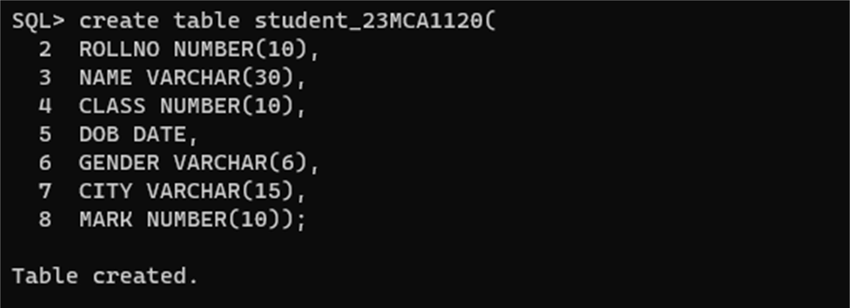

VIEW COLUMN NAME AND DATA TYPE:

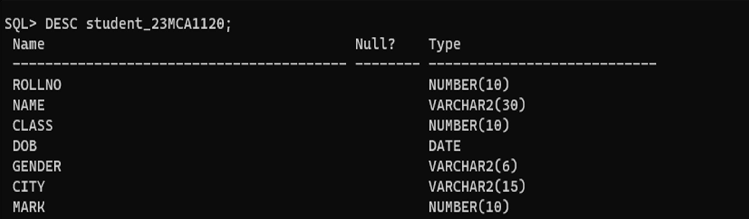

INSERT VALUE IN STUDENT TABLE:

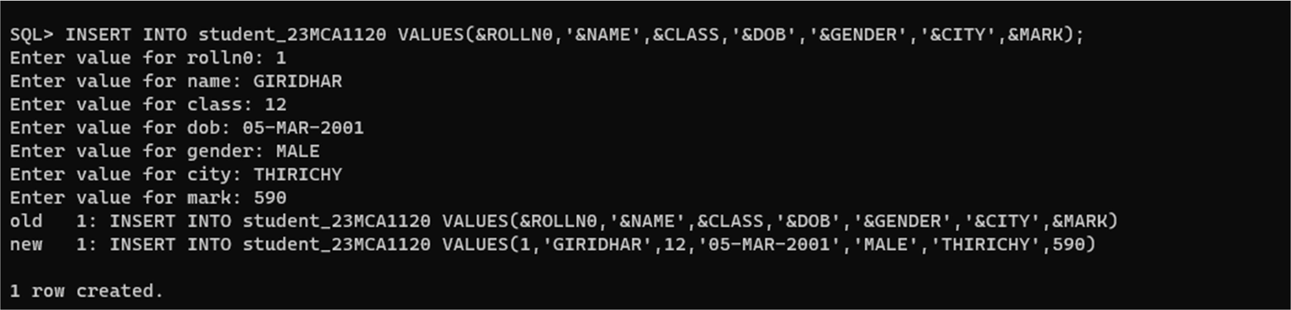

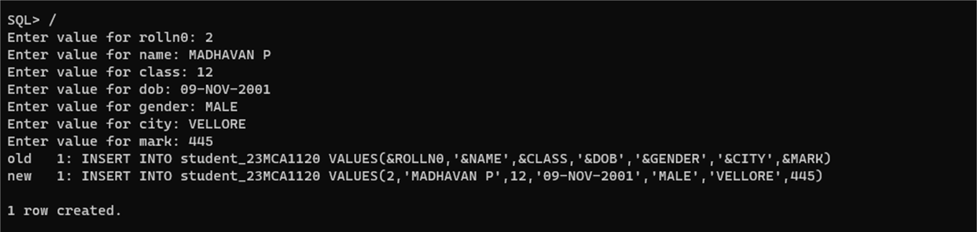

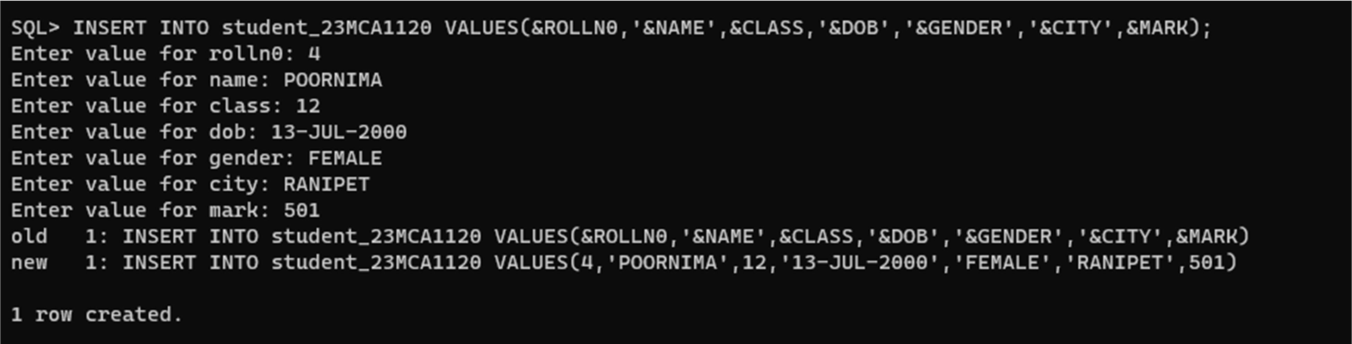

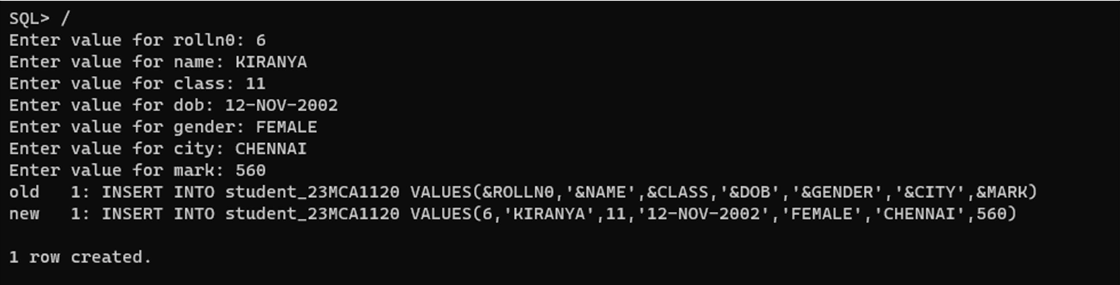

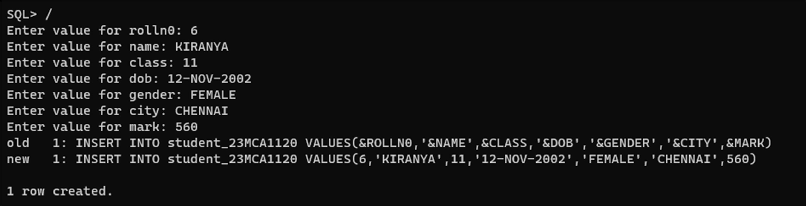

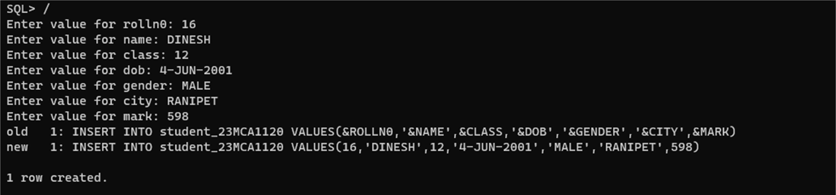

VIEW STUDENT TABLE RECORD:

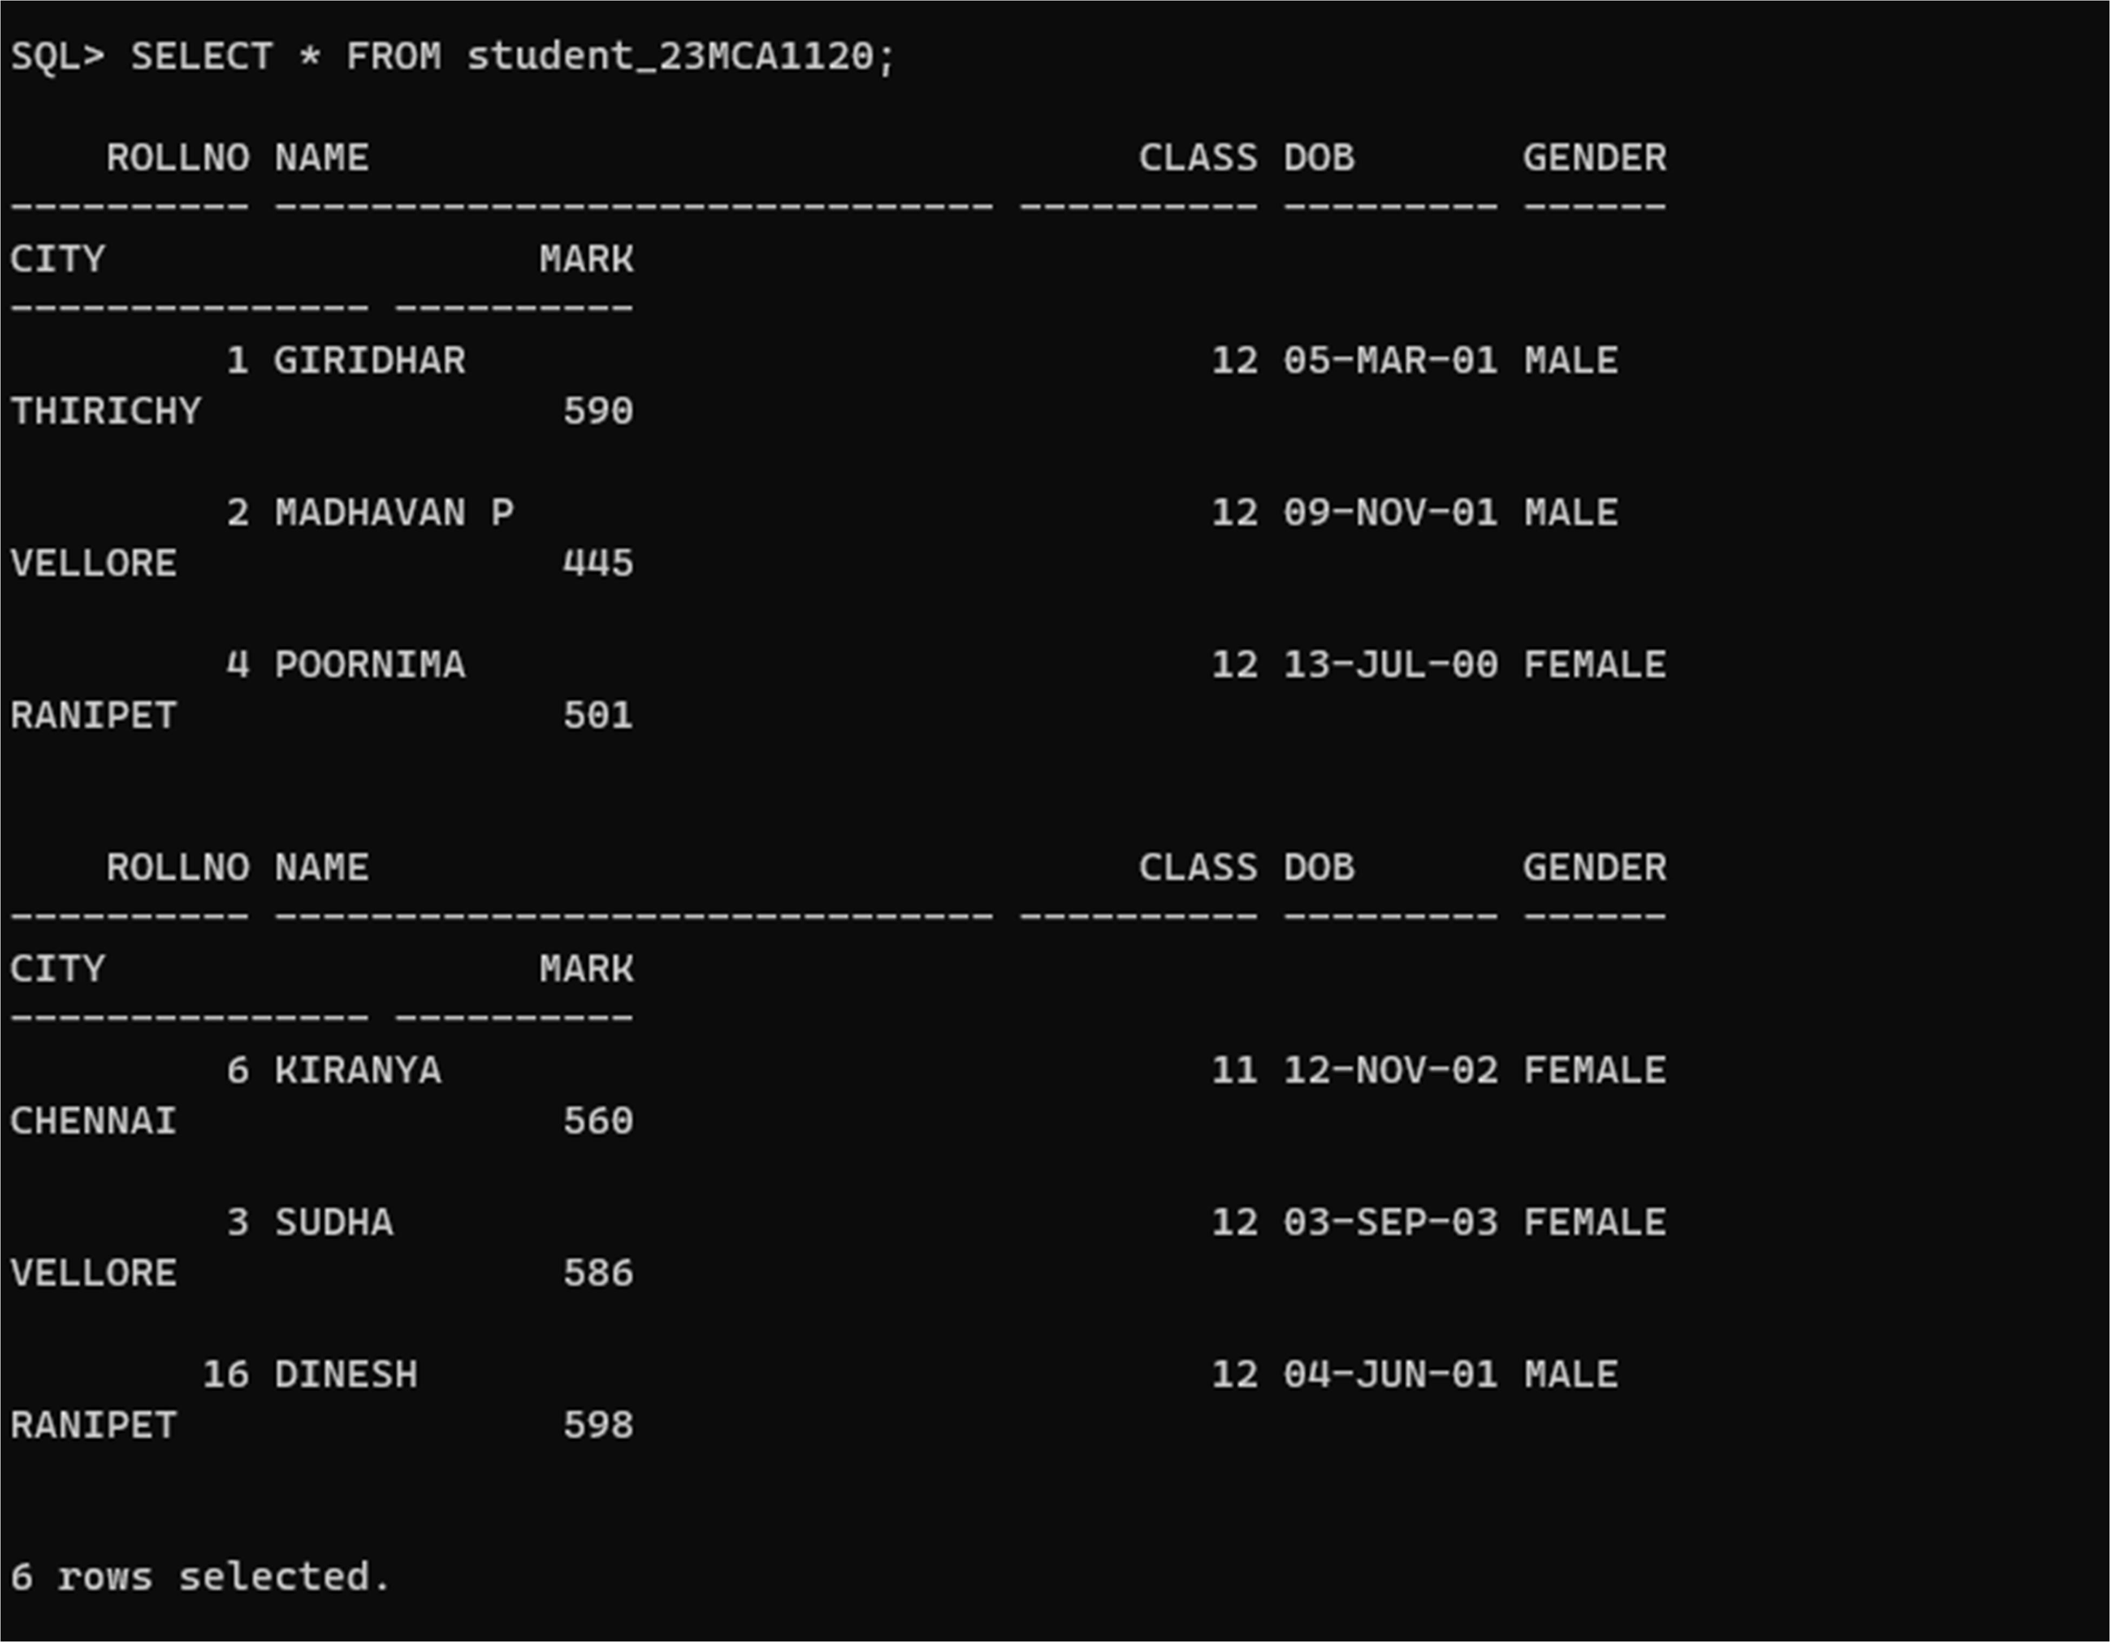



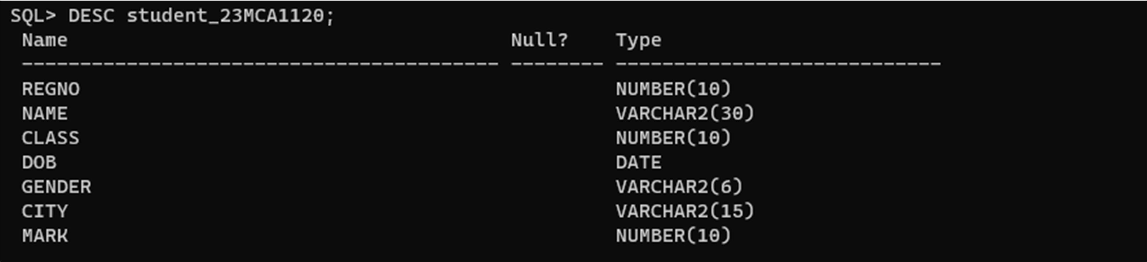

SUB-QURIES OR NESTED QUERIES

**ORDER CLAUSE**

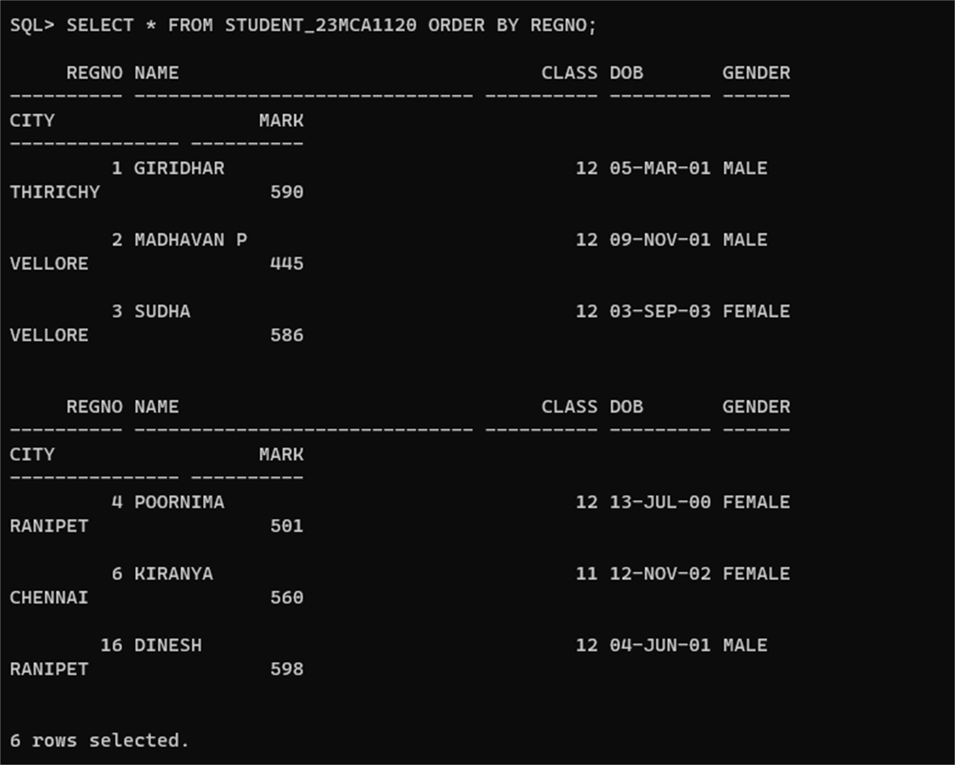

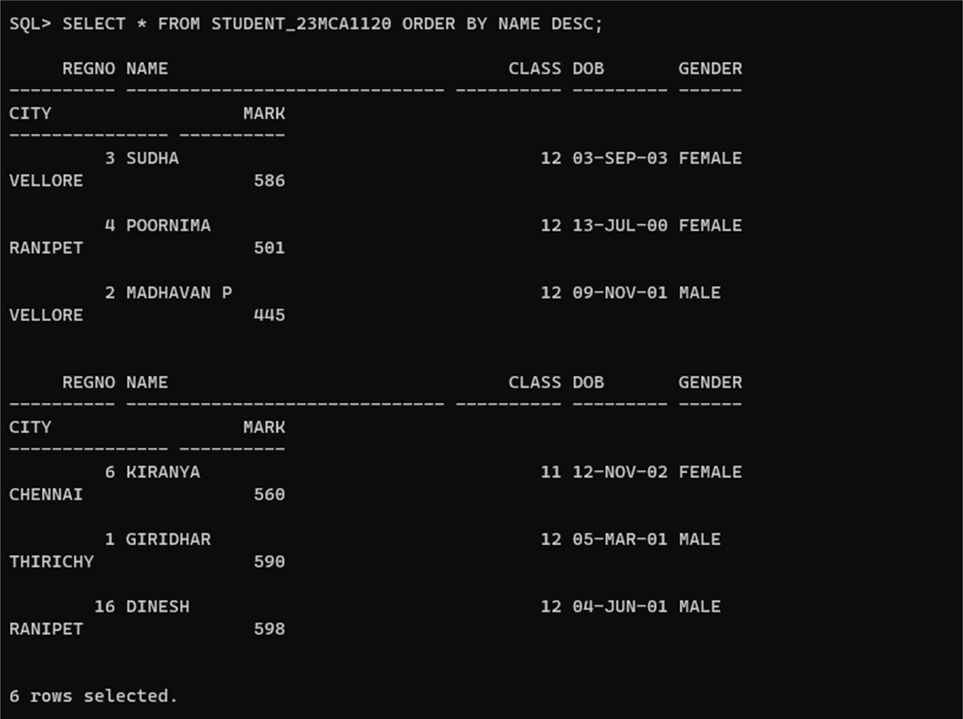

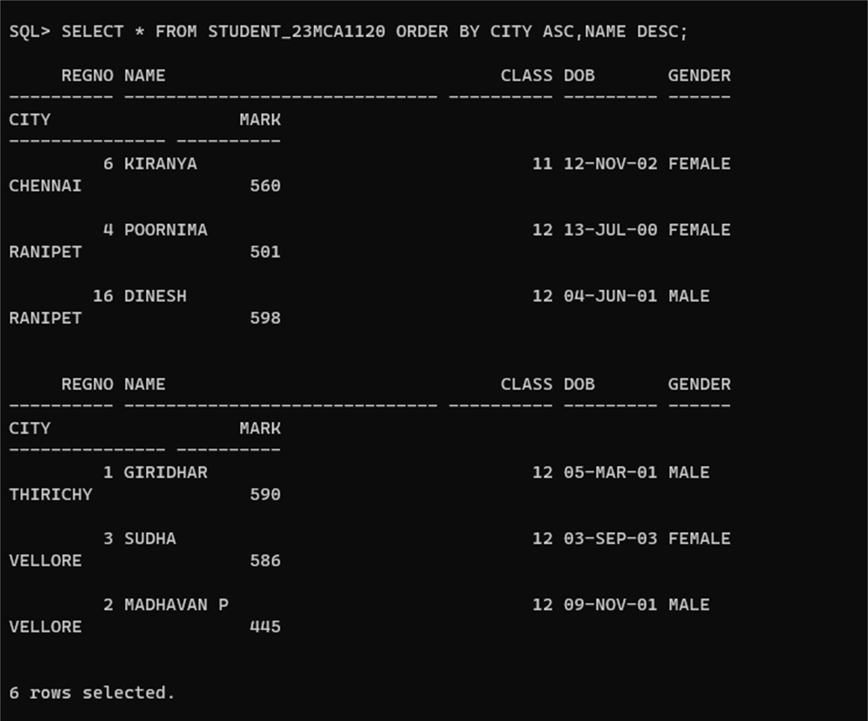

**GROUP BY CLAUSE**

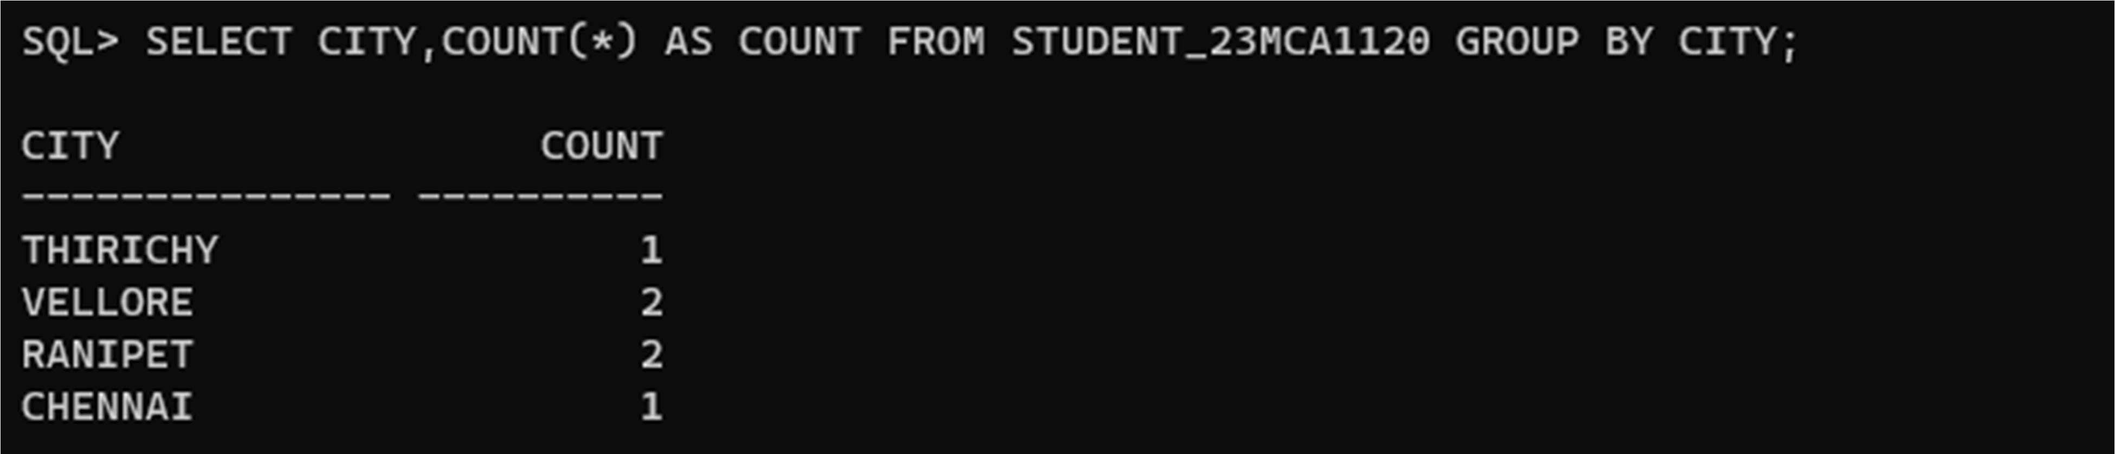

**HAVING CLAUSE**

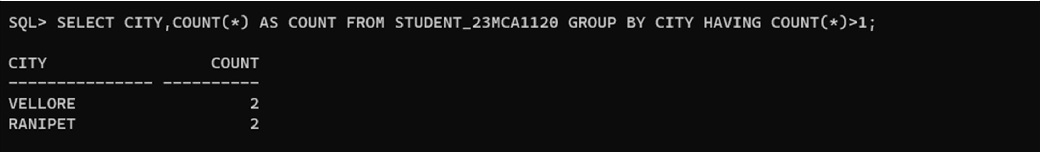

CONSTRAINTS:

**PRIMARY KEY CONSTRAINTS**

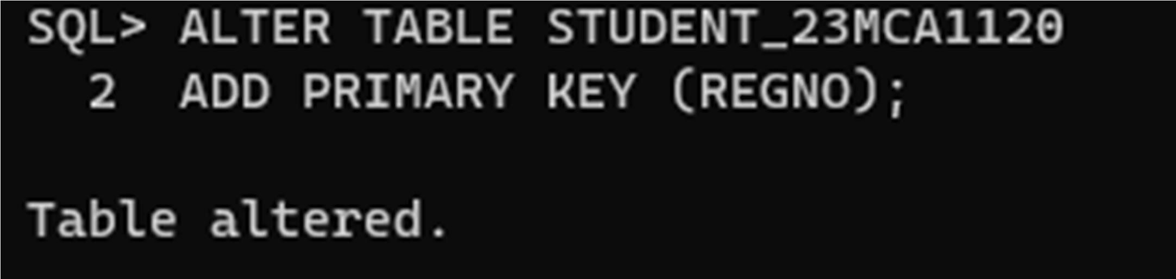

**NOT NULL CONSTRAINTS**

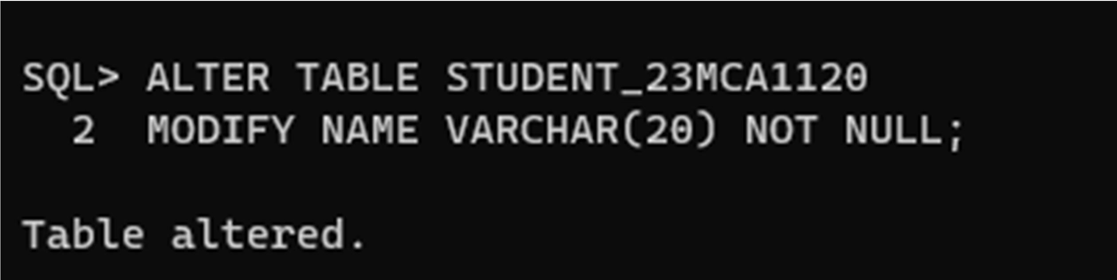

**CHECK CONSTRAINTS**

