**CREATE STUDENT TABLE:**



# VIEW COLUMN NAME AND DATA TYPE:

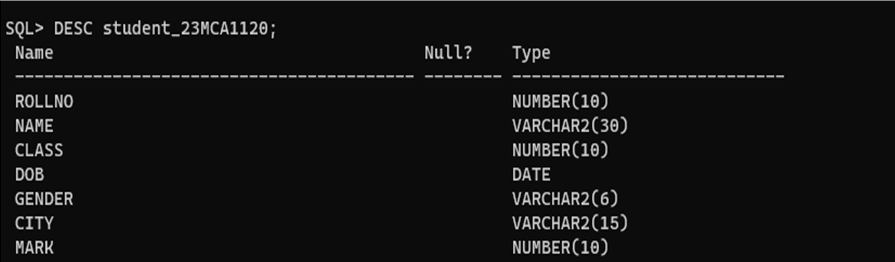

**INSERT VALUE IN STUDENT TABLE:**

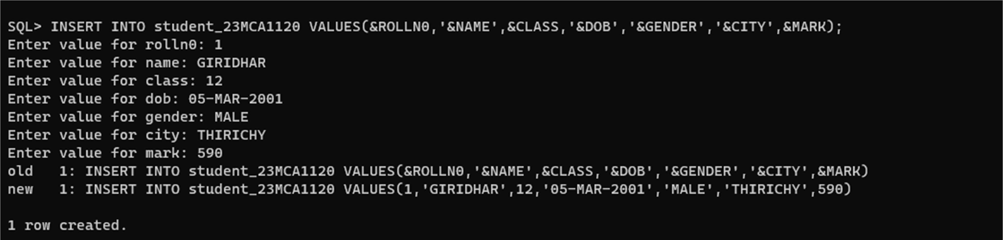

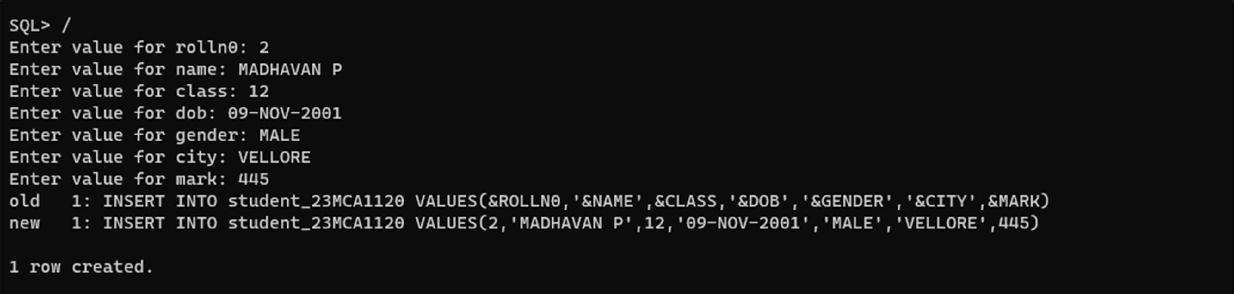

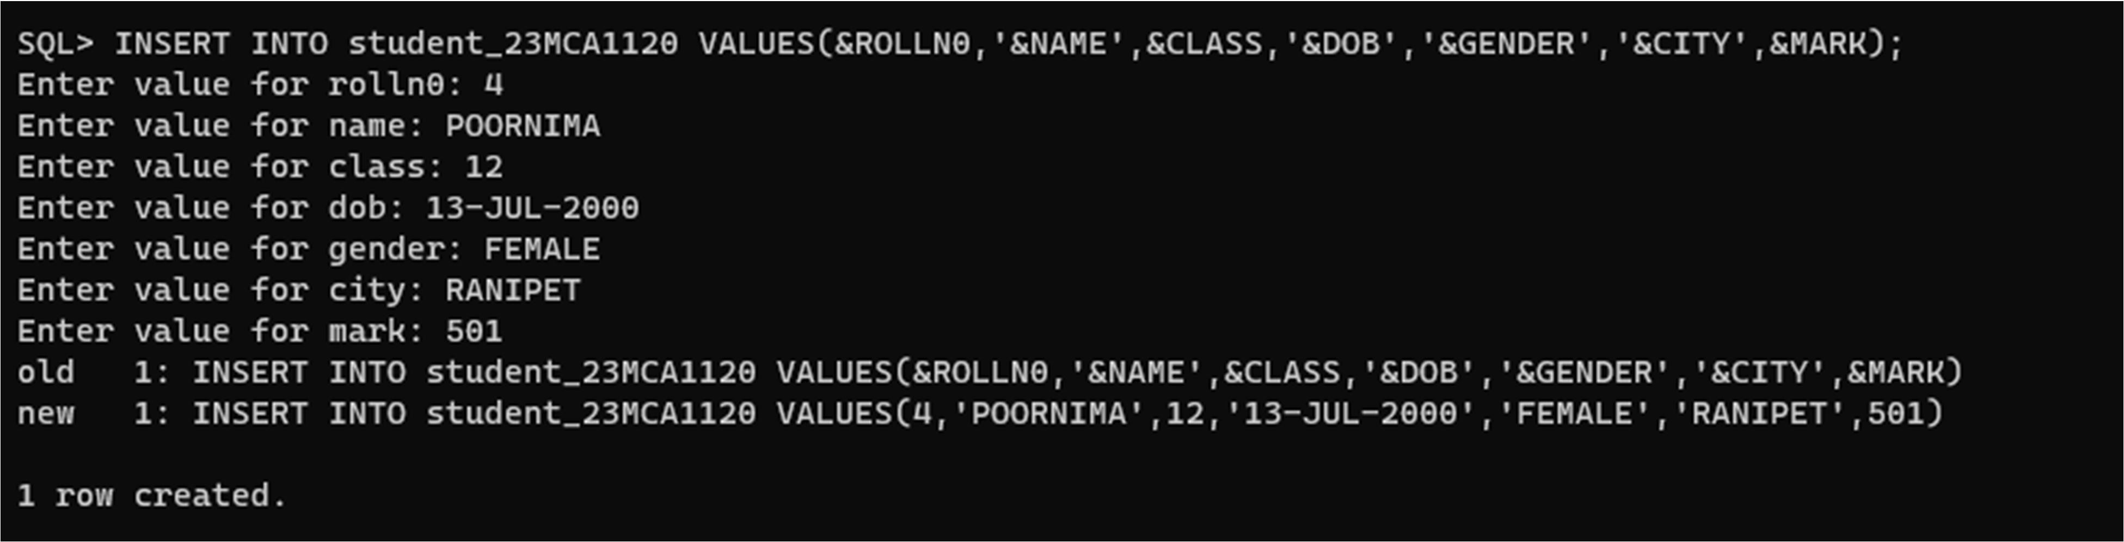

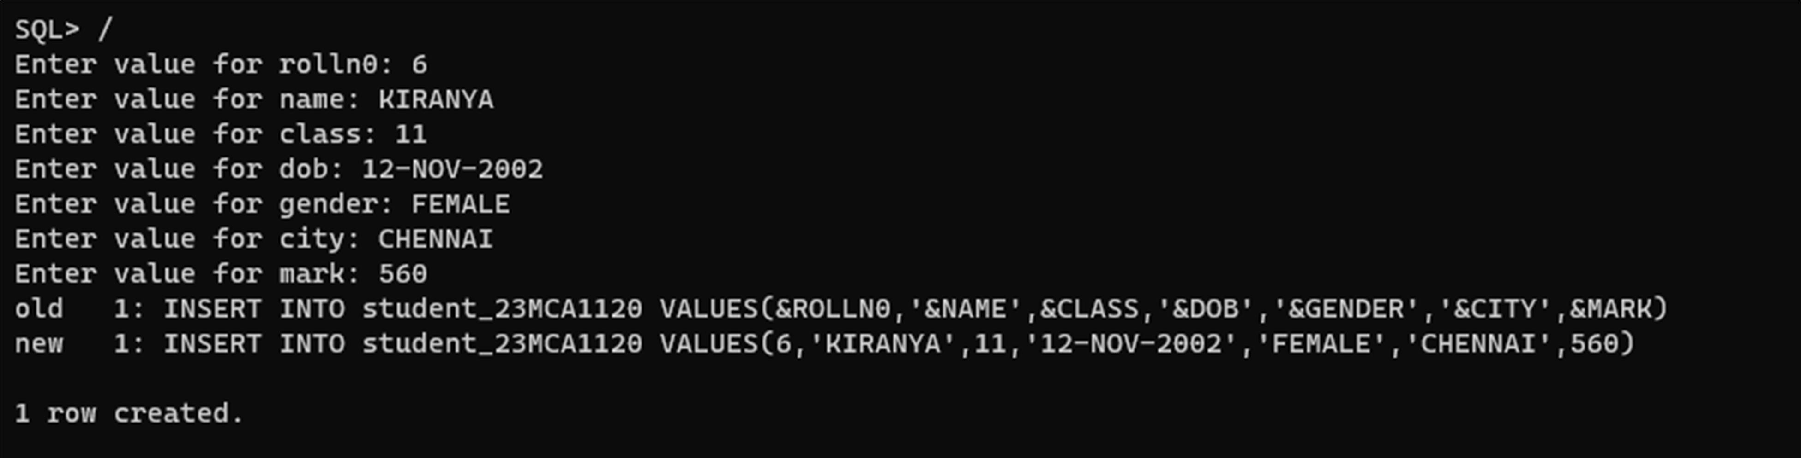

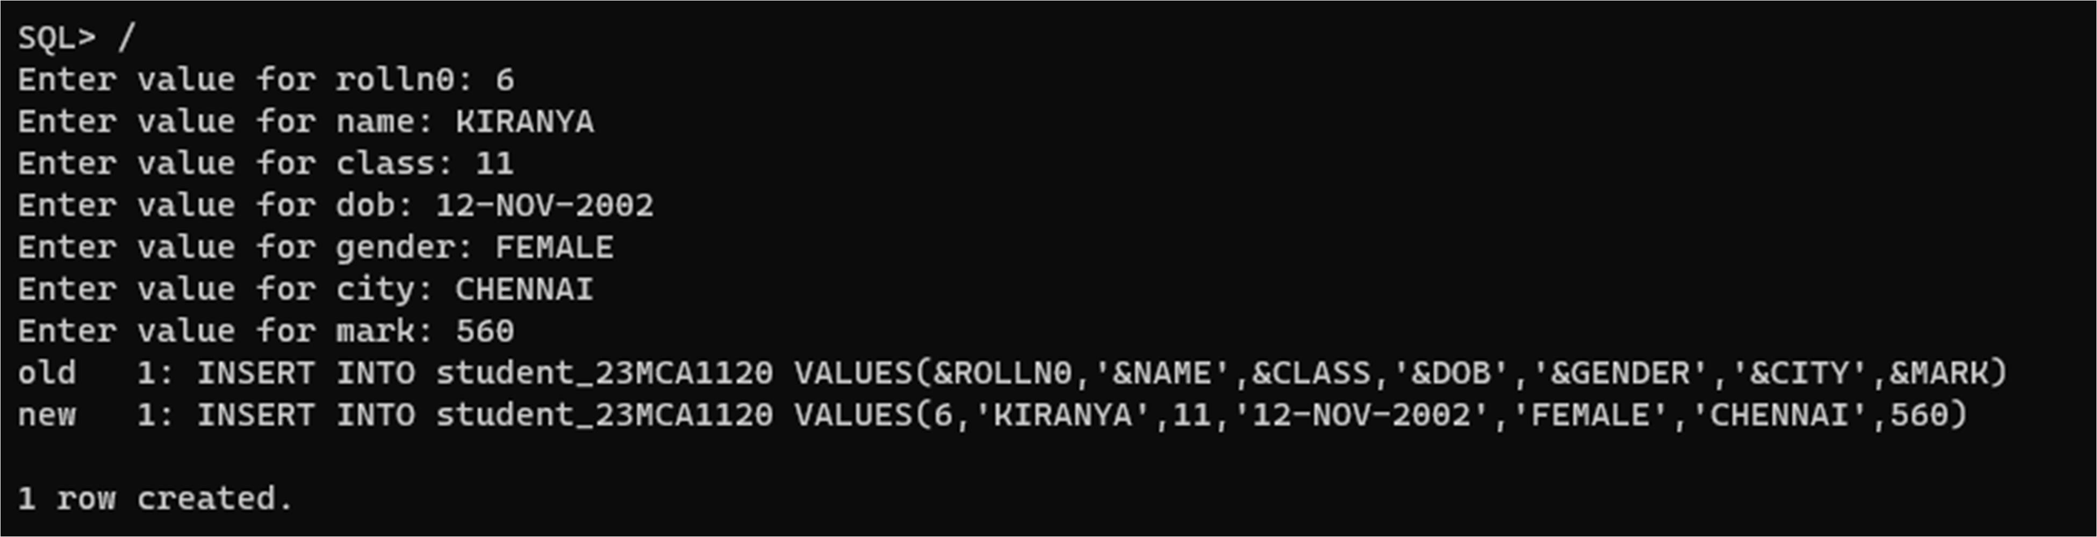

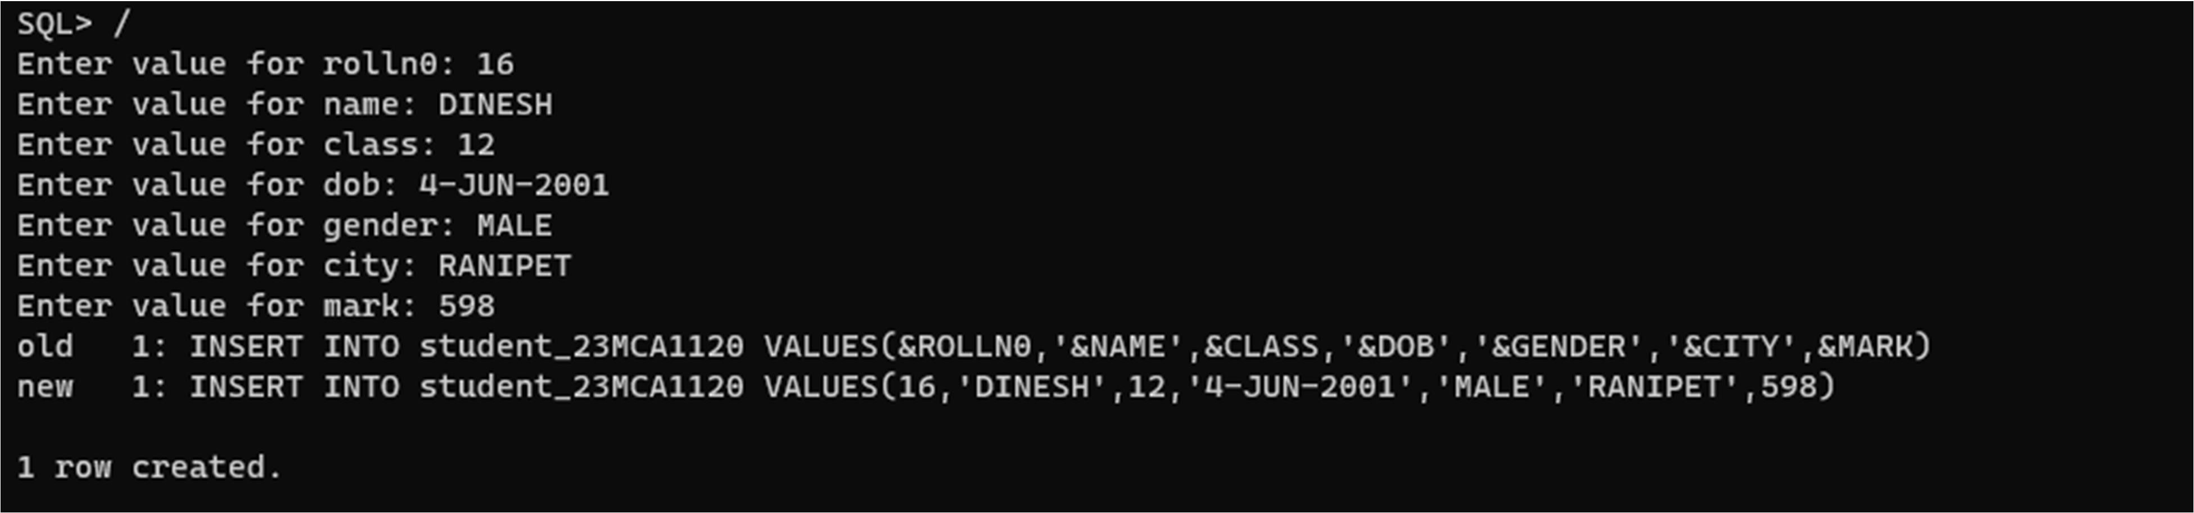

# VIEW STUDENT TABLE RECORD:

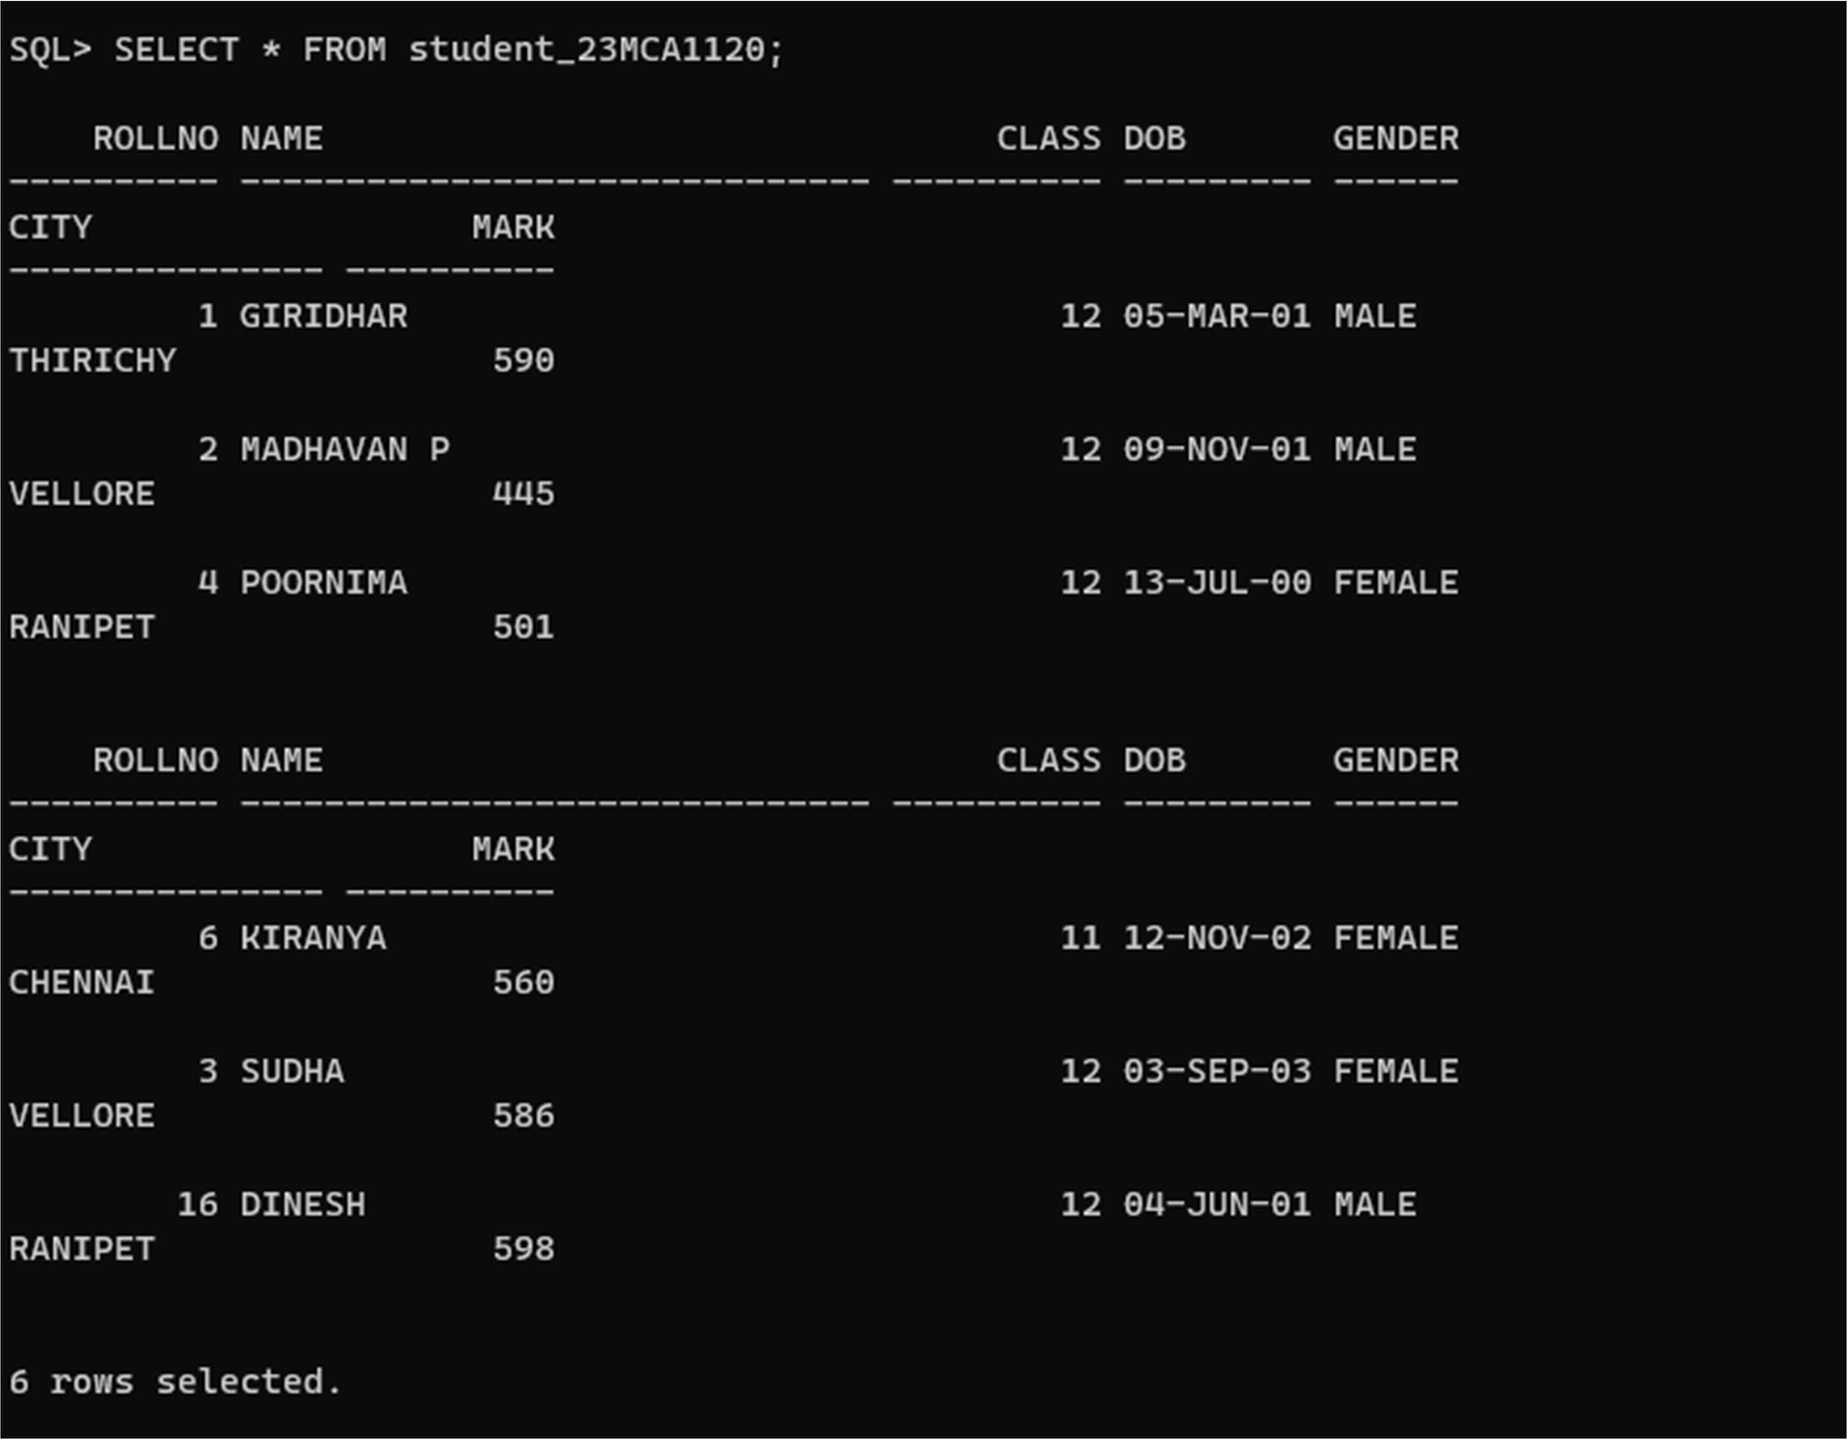

**BUILT IN FUNCTION**

# Max()

1. **display the maximum mark of the student.**

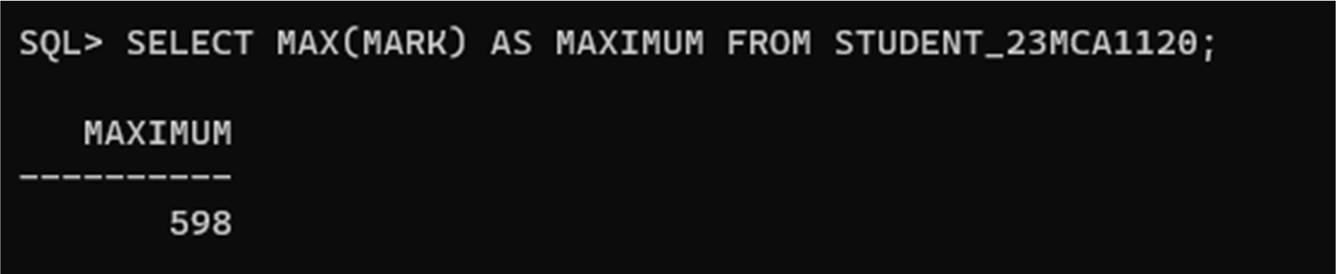

# MIN()

1. **display the minimum mark of the student.**

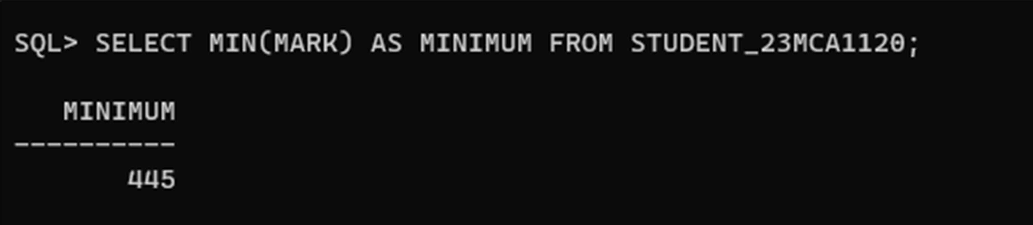

# AVG()

1. **display the average mark of the student.**

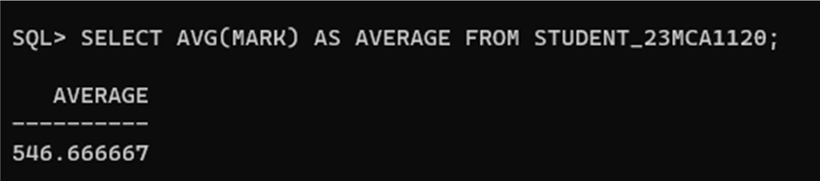

# COUNT()

1. **count the number student in student_23MCA1120 table .**

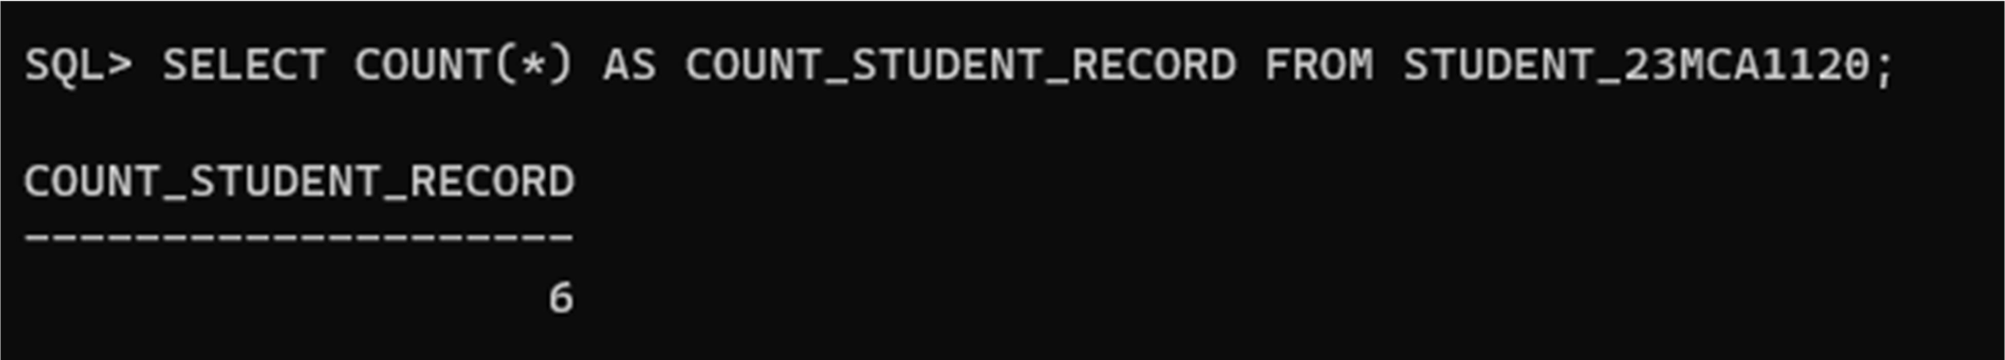

# SUM()

1. **sum of the marks in student_23MCA1120 table.**

