CREATING A TABLE

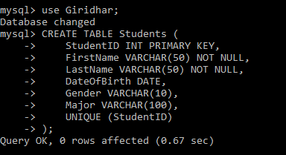

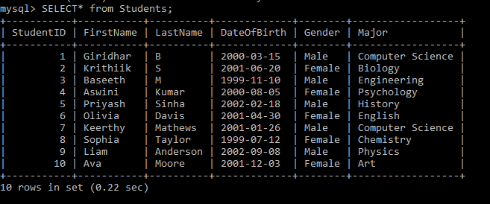

START A TRANSACTION



INSERTING



SAVEPOING



UPDATE THE A RECOURD



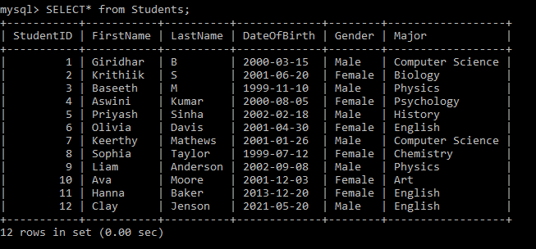

ROLLBACK TO THE SAVEPOINT

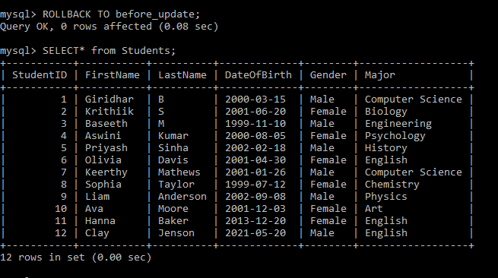

INSERT A NEW RECORD AND COMMIT THE CHANGES

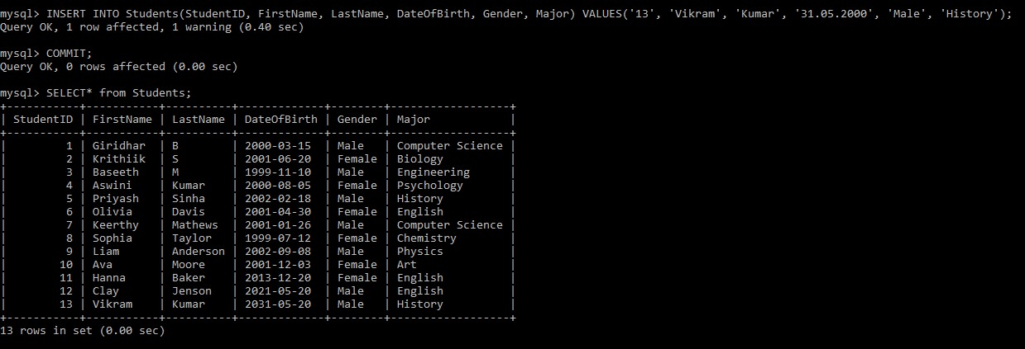

IN CLAUSE

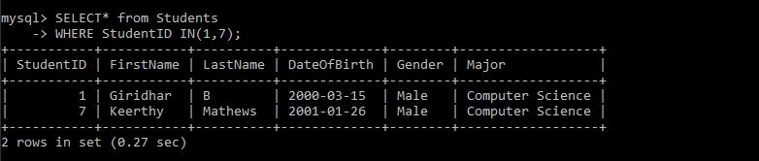

EXISTS CLAUSE

