**IMPLICITY CURSOR:**

-- Create the Employees table

CREATE TABLE Employees (

EmployeeID NUMBER PRIMARY KEY,

FirstName VARCHAR2(50),

LastName VARCHAR2(50),

Salary NUMBER(10, 2)

);

-- Insert values into the Employees table

INSERT INTO Employees (EmployeeID, FirstName, LastName, Salary)

VALUES

(1, 'John', 'Doe', 50000.00),

(2, 'Jane', 'Smith', 55000.00),

(3, 'Bob', 'Johnson', 60000.00),

(4, 'Alice', 'Brown', 52000.00);

-- PL/SQL block with an implicit cursor to fetch and display data

DECLARE

v_EmployeeID NUMBER;

v_FirstName VARCHAR2(50);

v_LastName VARCHAR2(50);

v_Salary NUMBER(10, 2);

BEGIN

-- Open the implicit cursor by executing the SQL query

FOR rec IN (SELECT EmployeeID, FirstName, LastName, Salary FROM Employees) LOOP

-- Fetch data into variables

v_EmployeeID := rec.EmployeeID;

v_FirstName := rec.FirstName;

v_LastName := rec.LastName;

v_Salary := rec.Salary;

-- Display the fetched data

DBMS_OUTPUT.PUT_LINE('Employee ID: ' || v_EmployeeID);

DBMS_OUTPUT.PUT_LINE('First Name: ' || v_FirstName);

DBMS_OUTPUT.PUT_LINE('Last Name: ' || v_LastName);

DBMS_OUTPUT.PUT_LINE('Salary: ' || v_Salary);

DBMS_OUTPUT.PUT_LINE(''); -- Add a line break

END LOOP;

END;

/

**OUTPUT:**

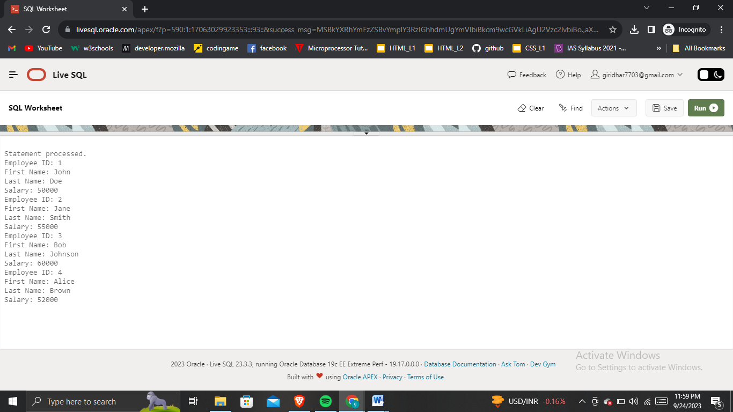

**EXPLICIT CURSOR:**

-- Create the Employees table

CREATE TABLE Employees (

EmployeeID NUMBER PRIMARY KEY,

FirstName VARCHAR2(50),

LastName VARCHAR2(50),

Salary NUMBER(10, 2)

);

-- Insert values into the Employees table

INSERT INTO Employees (EmployeeID, FirstName, LastName, Salary)

VALUES

(1, 'John', 'Doe', 50000.00),

(2, 'Jane', 'Smith', 55000.00),

(3, 'Bob', 'Johnson', 60000.00),

(4, 'Alice', 'Brown', 52000.00);

-- PL/SQL block with an explicit cursor to fetch and display data

DECLARE

CURSOR emp_cursor IS

SELECT EmployeeID, FirstName, LastName, Salary FROM Employees;

v_EmployeeID NUMBER;

v_FirstName VARCHAR2(50);

v_LastName VARCHAR2(50);

v_Salary NUMBER(10, 2);

BEGIN

-- Open the explicit cursor

OPEN emp_cursor;

-- Fetch data from the cursor

LOOP

FETCH emp_cursor INTO v_EmployeeID, v_FirstName, v_LastName, v_Salary;

-- Exit the loop when no more rows are available

EXIT WHEN emp_cursor%NOTFOUND;

-- Display the fetched data

DBMS_OUTPUT.PUT_LINE('Employee ID: ' || v_EmployeeID);

DBMS_OUTPUT.PUT_LINE('First Name: ' || v_FirstName);

DBMS_OUTPUT.PUT_LINE('Last Name: ' || v_LastName);

DBMS_OUTPUT.PUT_LINE('Salary: ' || v_Salary);

DBMS_OUTPUT.PUT_LINE(''); -- Add a line break

END LOOP;

-- Close the cursor

CLOSE emp_cursor;

END;

/

**OUTPUT:**

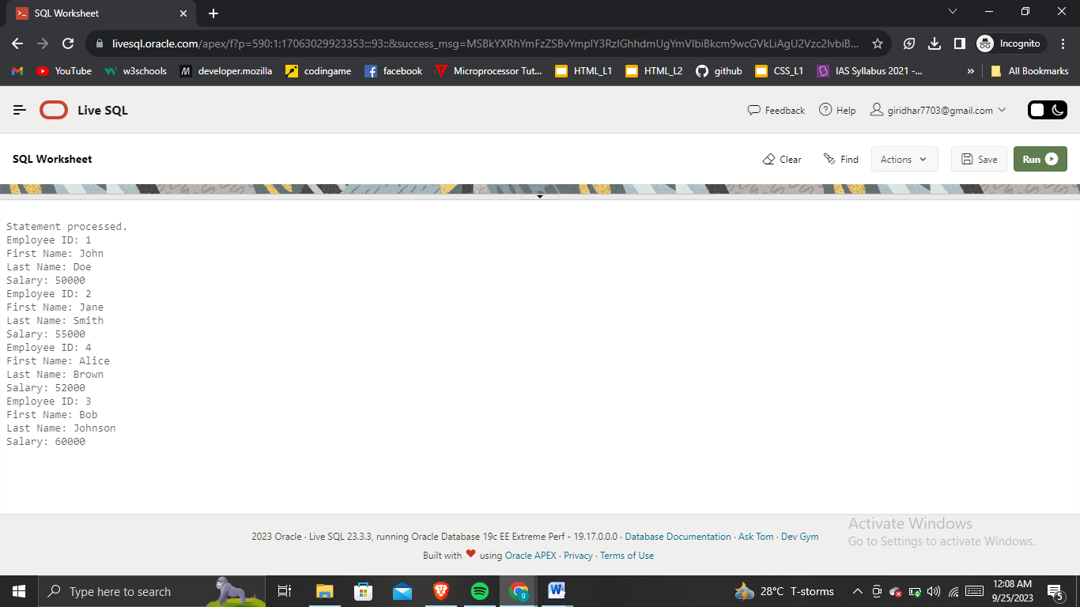

TRIGGER:

