**1.Design a webpage for an online Pizza Delivery system using HTML5.**

**CODE:**

<!DOCTYPE html>

<html lang="en">

<head>

<meta charset="UTF*-*8">

<meta name="viewport" content="width=device-width, initial-scale=1.0">

<title>Pizza Delivery System</title>

</head>

<body>

<header>

<h1>Welcome to Pizza Delivery</h1>

<nav>

<ul>

<li><a href="#">Home</a></li>

<li><a href="#">Menu</a></li>

<li><a href="#">Order Online</a></li>

<li><a href="#">Contact Us</a></li>

</ul>

</nav>

</header>

<hr>

<section id="menu">

<h2>Menu</h2>

<ul>

<li>

<h3>Margherita Pizza</h3>

<p>Fresh tomatoes, mozzarella cheese, basil, and olive oil.</p>

<p>Price: $10.99</p>

</li>

<li>

<h3>Pepperoni Pizza</h3>

<p>Tomato sauce, mozzarella cheese, and pepperoni slices.</p>

<p>Price: $12.99</p>

</li>

<li>

<h3>Hawaiian Pizza</h3>

<p>Tomato sauce, mozzarella cheese, ham, and pineapple.</p>

<p>Price: $11.99</p>

</li>

<li>

<h3>Veggie Supreme Pizza</h3>

<p>Tomato sauce, mozzarella cheese, mushrooms, bell peppers, onions, and black

olives.</p>

<p>Price: $13.99</p>

</li>

<li>

<h3>BBQ Chicken Pizza</h3>

<p>BBQ sauce, mozzarella cheese, grilled chicken, red onions, and cilantro.</p>

<p>Price: $14.99</p>

</li>

<li>

<h3>Supreme Pizza</h3>

<p>Tomato sauce, mozzarella cheese, pepperoni, sausage, mushrooms, bell peppers,

onions, and black olives.</p>

<p>Price: $15.99</p>

</li>

</ul>

</section>

<hr>

<section id="order">

<h2>Order Online</h2>

<form action="order.php" method="post">

<label for="pizza-type">Select Pizza:</label>

<select id="pizza-type" name="pizza-type">

<option value="margherita">Margherita</option>

<option value="pepperoni">Pepperoni</option>

<option value="Hawaiian Pizza">Hawaiian Pizza</option>

<option value="Veggie Supreme Pizza">Veggie Supreme Pizza</option>

<option value="BBQ Chicken Pizza">BBQ Chicken Pizza</option>

<option value="Supreme Pizza">Supreme Pizza</option>

</select>

<label for="quantity">Quantity:</label>

<input type="number" id="quantity" name="quantity" min="1" value="1">

<label for="delivery-address">Delivery Address:</label>

<input type="text" id="delivery-address" name="delivery-address" required>

<button type="submit">Place Order</button>

</form>

</section>

<hr>

<section id="contact">

<h2>Contact Us</h2>

<p>If you have any questions or feedback, please feel free to reach out to us:</p>

<ul>

<li>Email: info@pizzadelivery.com</li>

<li>Phone: +1-123-456-7890</li>

<li>Address: 123 Pizza Street, Pizza Town</li>

</ul>

</section>

<hr>

<footer>

<p>&copy; 2023 Pizza Delivery System</p>

</footer>

</body>

</html>

**OUTPUT:**

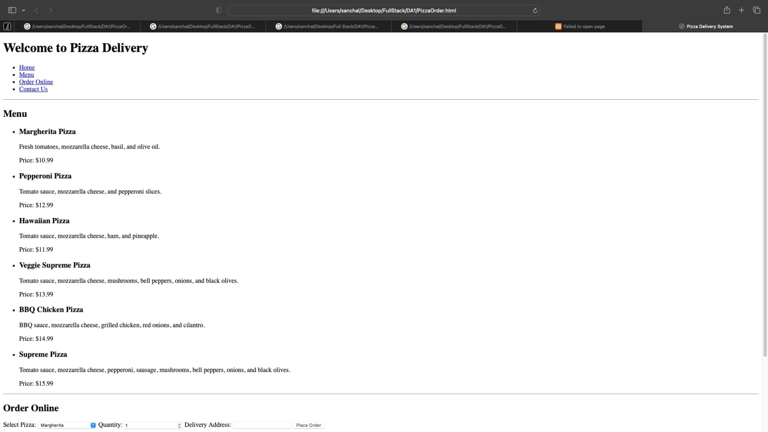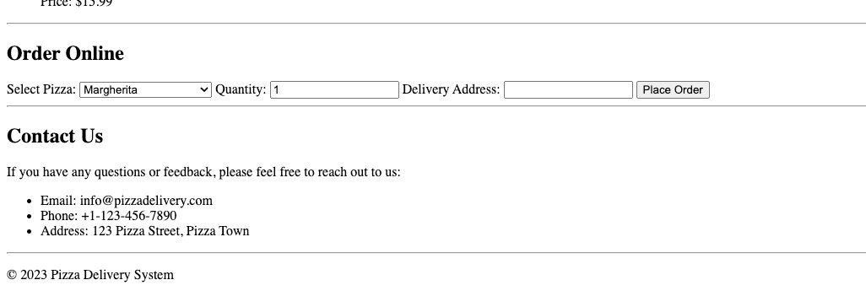

**2.** **Develop an online COVID-19 tracker using HTML and JavaScript. Design the web page with three textboxes to fetch the number of newly infected cases on a particular day corresponding to three states. Create a button to add the count to the existing cases of the three states. Use DOM property event handling to update the count when the button is clicked and alert which state has maximum cases for every submission of the button. The total number of cases could be the same for any two or all the three states. In such case it should alert the name of all the states with similar count. Both name and count must be displayed..**

**CODE:**

<!DOCTYPE html>

<html lang="en">

<head>

<meta charset="UTF-8" />

<meta name="viewport" content="width=device-width, initial-scale=1.0" />

<title>COVID-19 Tracker</title>

</head>

<body>

<form id="myform"> West Bengal:<input name="wb" type="number"

placeholder="Enter newly infected cases"

/>

<br />

Madhya Pradesh:<input id="mp" type="number"

placeholder="Enter newly infected cases"

/>

<br />

Tamil Nadu:<input type="number"

id="tn"

placeholder="Enter newly infected cases"

/>

<br />

<button type="submit">Add</button>

</form>

<script>

var wb_count = []; var Tn_count = []; var Mp_count = []; var wb_total = 0; var mp_total = 0; var tn_total = 0;

document.getElementById("myform").addEventListener("submit", (e) => { e.preventDefault();

var wbdata = parseInt(document.getElementById("myform").wb.value); var mpdata = parseInt(document.getElementById("mp").value);

var tndata = parseInt(document.getElementById("tn").value);

if (!isNaN(wbdata)) { wb_count.push(wbdata);

}

if (!isNaN(mpdata)) { Mp_count.push(mpdata);

}

if (!isNaN(tndata)) { Tn_count.push(tndata);

}

wb_total = wb_count.reduce((acc, current) => acc + current, 0); tn_total = Tn_count.reduce((acc, current) => acc + current, 0); mp_total = Mp_count.reduce((acc, current) => acc + current, 0);

console.log("West Bengal Total Cases:", wb_total);

console.log("Madhya Pradesh Total Cases:", mp_total); console.log("Tamil Nadu Total Cases:", tn_total);

if (wb_total == mp_total && mp_total == tn_total) { alert(

"West Bengal, Madhya Pradesh, and Tamil Nadu all have the same amount of cases: " + tn_total +

" cases"

);

} else if (wb_total == tn_total && tn_total > mp_total) { alert(

"West Bengal and Tamil Nadu both have the maximum cases: " + wb_total +

" cases"

);

} else if (tn_total == mp_total && tn_total > wb_count) { alert(

"Madhya Pradesh and Tamil Nadu both have the maximum cases: " + tn_total +

" cases"

);

} else if (wb_total == mp_total && mp_total > tn_total) { alert(

"West Bengal and Madhya Pradesh both have the maximum cases: " + mp_total +

" cases"

);

} else {

if (wb_total > tn_total && wb_total > mp_total) {

alert("West Bengal has the maximum cases: " + wb_total + " cases");

} else if (tn_total > wb_total && tn_total > mp_total) {

alert("Tamil Nadu has the maximum cases: " + tn_total + " cases");

} else { alert(

"Madhya Pradesh has the maximum cases: " + mp_total + " cases"

);

}}

document.getElementById("myform").reset();

});

</script>

</body>

</html>

**OUTPUT:**

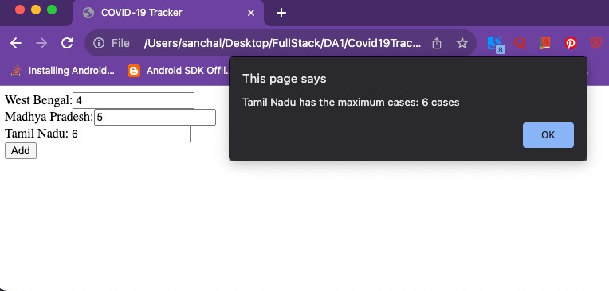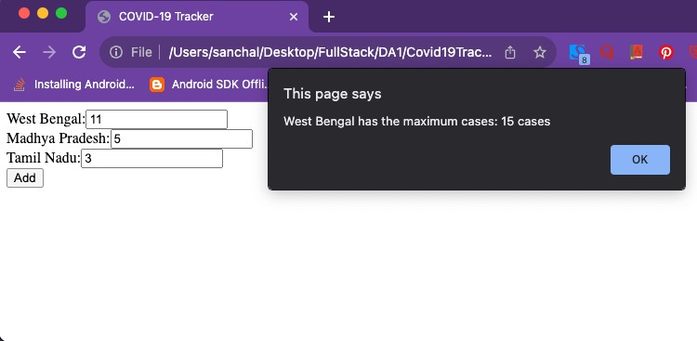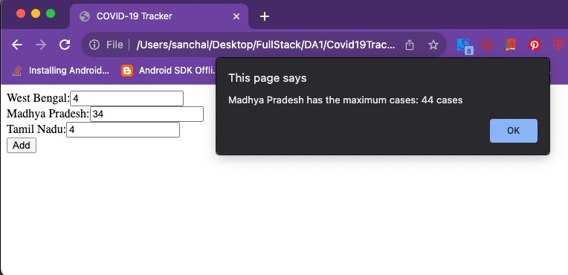

**3.** **Develop an online application for Indian Premier League – 2021 Auction Process using HTML, JavaScript and DOM. The application is an editor for IPL auction result for Chennai Super Kings. The webpage has a heading section with heading “IPL Auction 2021”. Create a button “EditDate” that appends current date to the heading using TextNode method. The webpage also has three**

**<div> sections for player list, newly added batsmen and dropped bowler. Fetch the current set of players from a textbox and add it to the ﬁrst <div> as a child element using <p> tag when “Add Player” button is clicked. Assume in second <div> there is an unordered list of two batsmen who are to be replaced. Fetch the names of the two new batsmen from two textboxes and on clicking “Replace batsmen” button, replace the previous two batsmen from the unordered list. Assume that the third <div> has an unordered list of 3 bowlers in descending order of performance. Create a button “DropBowler” that deletes the last bowler in the list..**

**CODE:**

<!DOCTYPE html>

<html lang="en">

<head>

<meta charset="UTF-8" />

<meta name="viewport" content="width=device-width, initial-scale=1.0" />

<title>IPL AUCTION 2021</title>

</head>

<body>

<h1 id="h1">IPL Auction 2021</h1>

<button id="btn" onclick="update()" type="submit">Edit Date</button>

<hr />

<div id="plst">

<h1>Add players</h1>

<input type="text" id="pname" placeholder="Enter player name" />

<button id="adpl" type="submit">Add Player</button>

</div>

<hr />

<div>

<h1>Replace player name</h1>

<input type="text" id="nm1"

placeholder="Input 1st player name" required

/>

<input type="text" id="nm2"

placeholder="Input 2nd player name" required

/>

<button id="rpl" type="submit">Add Player</button>

<ul>

<li>Sachin</li>

<li>Dhoni</li>

</ul>

</div>

<hr />

<h1>Drop Bowler</h1>

<ul id="lsti">

<li>Mohammad Siraj</li>

<li>Ravendra Jadeja</li>

<li>Jasprtin Bumrah</li>

</ul>

<button type="submit" id="db">Drop Bowler</button>

</body>

<script>

function update() {

const crntDate = new Date();

let month = crntDate.getMonth() + 1; let year = crntDate.getFullYear();

let date = crntDate.getDate();

let newDate = ` ${date}-${month}-${year}`; console.log(newDate);

document

.getElementById("h1")

.appendChild(document.createTextNode(newDate));

}

document.getElementById("adpl").addEventListener("click", () => { console.log("hello");

const inputval = document.getElementById("pname").value; if (inputval) {

newLi = document.createElement("p"); newLi.appendChild(document.createTextNode(inputval)); document.getElementById("plst").appendChild(newLi);

}

});

document.getElementById("rpl").addEventListener("click", () => { console.log("hello1");

const inputval1 = document.getElementById("nm1").value; const inputval2 = document.getElementById("nm2").value; if (inputval1 && inputval2) {

const myNodeList = document.querySelectorAll("li"); myNodeList[0].innerHTML = inputval1; myNodeList[1].innerHTML = inputval2;

}

});

document.getElementById("db").addEventListener("click", (e) => { const tbld = document.getElementById("lsti"); tbld.removeChild(tbld.lastElementChild);

});

</script>

</html>

**OUTPUT:**

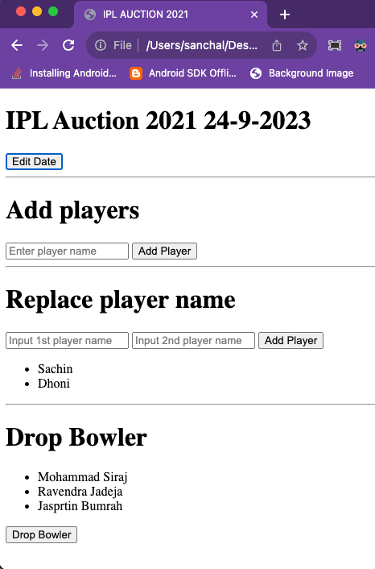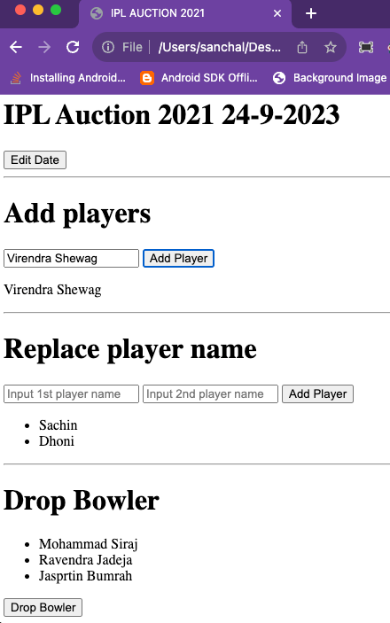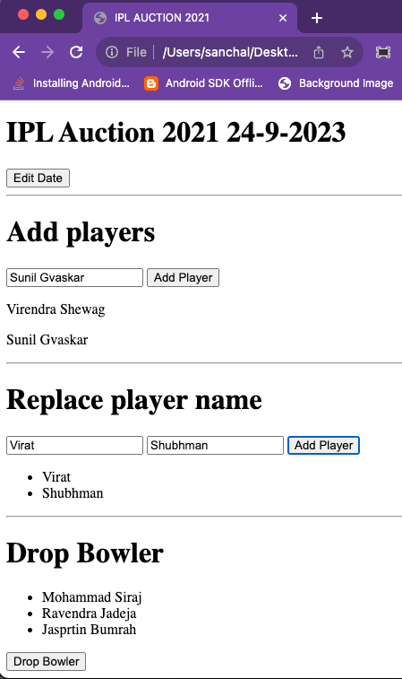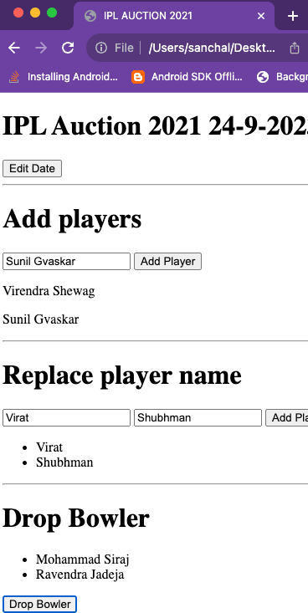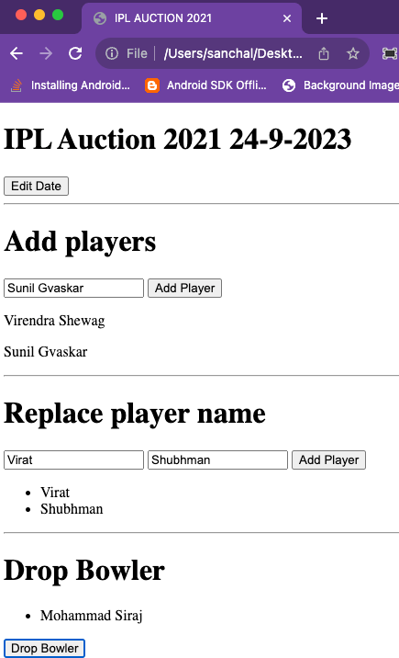

**4.** **CMF Hospital wants you to develop an online application to analyze the cognitive ability of geriatric patients using HTML and JavaScript. To analyze the cognitive ability a simple online test is done to determine memory and basic problem solving skills. Design the web from of the analyzer and implement validations as follows:**

**Design a form with 8 textboxes, 8 div (for displaying error messages) and a button. The patient has to enter details in the form.**

**The entries in the textbox is as follows: Textbox 1 = name**

**Textbox 2 = number of brothers of patient + 2 Textbox 3 = Textbox 2 value X 2**

**Textbox 4 = Textbox 3 value + 1**

**Textbox 5 = Textbox 4 value X 5**

**Textbox 6 = Textbox 5 value + number of sisters the patient has Textbox 7 = Number of brothers the patient has**

**Textbox 8 = Number of sister the patient has**

**Textboxes from 3 to 5 must hold the correct numeric value corresponding to the operation speciﬁed. Incase case of error an error message must be displayed in the corresponding <div>. As long as valid entry is given in any textbox the focus must remain in the textbox.**

**To check the ability of the patient deduct 25 from the value in the sixth textbox. If the diﬀerence is a two digit number then the ﬁrst digit is the number of brothers and second digit is the number of sisters. If the diﬀerence is one digit non-zero value then the number of sisters is the one digit diﬀerence value and the number of brothers is zero. If the diﬀerence is zero then the patient has no brothers and sisters.**

**Validate the derived count of brothers and sisters from previous step with the values entered 7th and 8th textboxes. If it is a match set the div next to 8th textbox as “Good memory and problem solving skills” else “Retardation is memory and problem solving skills”.**

**For example:**

**If I have 1 brother and 0 sister then**

**Textbox 2 = 1 + 2 = 3**

**Textbox 3 = 3 X 2 = 6 (Validate that correct product is entered here) Textbox 4 = 6 + 1 = 7 (Validate that correct sum is entered here) Textbox 5 = 7 X 5 = 35 (Validate that correct product is entered here)**

**Textbox 6 = 35 + 0 = 35 (35-25=10) So no of brothers (ﬁrst digit) - 1 and no of sisters (second digit) - 0 Textbox 7 = Number of brothers the patient has**

**Textbox 8 = Number of sister the patient has**

**If 7th textbox has 1 and 8th textbox is 0 then the div text is “Good memory and problem solving skills” else “Retardation is memory and problem solving skills”.**

**Note: Assume maximum number of brothers is 5 and maximum number of sisters is 5.**

**CODE:**

<!DOCTYPE html>

<html lang="en">

<head>

<meta charset="UTF-8">

<meta name="viewport" content="width=device-width, initial-scale=1.0">

<title>Cognitive Ability Test</title>

<style>

.error {

color: red;

}

</style>

</head>

<body>

<h1>Cognitive Ability Test</h1>

<form id="cognitiveTestForm">

<label for="name">Name:</label>

<input type="text" id="name" required><br>

<label for="numBrothers">Number of Brothers:</label>

<input type="number" id="numBrothers"><br>

<label for="numSisters">Number of Sisters:</label>

<input type="number" id="numSisters"><br>

<label for="result2">Result 2:</label>

<input type="number" id="result2"><span class="error" id="error2"></span><br>

<label for="result3">Result 3:</label>

<input type="number" id="result3"><span class="error" id="error3"></span><br>

<label for="result4">Result 4:</label>

<input type="number" id="result4"><span class="error" id="error4"></span><br>

<label for="result5">Result 5:</label>

<input type="number" id="result5"><span class="error" id="error5"></span><br>

<label for="result6">Result 6:</label>

<input type="number" id="result6"><span class="error" id="error6"></span><br>

<div id="error7" class="error"></div>

<div id="error8" class="error"></div>

<div id="cognitiveAssessment" class="assessment"></div>

<button type="button" onclick="validateInputs()">Submit</button>

</form>

<script>

function validateInputs() {

const name = document.getElementById("name").value;

const numBrothers = parseInt(document.getElementById("numBrothers").value); const numSisters = parseInt(document.getElementById("numSisters").value); const result2 = parseFloat(document.getElementById("result2").value);

const result3 = parseFloat(document.getElementById("result3").value); const result4 = parseFloat(document.getElementById("result4").value); const result5 = parseFloat(document.getElementById("result5").value); const result6 = parseFloat(document.getElementById("result6").value);

validateTextbox(2, result2, "error2", numBrothers + 2); validateTextbox(3, result3, "error3", result2 * 2); validateTextbox(4, result4, "error4", result3 + 1); validateTextbox(5, result5, "error5", result4 * 5); validateTextbox(6, result6, "error6", result5 + numSisters);

validateTextbox(7, numBrothers, "error7", numBrothers); validateTextbox(8, numSisters, "error8", numSisters);

const cognitiveAssessment = document.getElementById("cognitiveAssessment");

skills";

if (numBrothers === 1 && numSisters === 0) {

cognitiveAssessment.textContent = "Good memory and problem-solving skills";

} else {

cognitiveAssessment.textContent = "Retardation in memory and problem-solving

}

}

function validateTextbox(textboxNumber, inputValue, errorId, expectedValue) { const errorSpan = document.getElementById(errorId);

if (isNaN(inputValue) || inputValue !== expectedValue) { errorSpan.textContent = "Invalid input.";

} else {

errorSpan.textContent = "";

}

}

</script>

</body>

</html>

**OUTPUT:**

