Improving Retrieval Reliability in Local-First Personal Memory RAG Through Hybrid Retrieval, Reranking, and Abstention
Giridhar.B.M
Department of Computer Science and Technology
Dayananda Sagar University, Bangalore, Karnataka, India
giridharbm6868@gmail.com
Mentored by: Dr.Santhosh Kumar J, Dr.Hemachandra Reddy
Abstract—Personal knowledge management systems based on retrieval-augmented generation (RAG) must not only retrieve relevant information but also determine whether the retrieved evidence is sufficient to support an answer. This study evaluates retrieval reliability in PAM, a local-first personal-memory RAG system, with particular emphasis on this distinction. PAM combines dense vector retrieval, BM25 lexical retrieval, and Reciprocal Rank Fusion for heterogeneous personal knowledge sources. A frozen evaluation corpus containing 24 sources, 195 indexed chunks, and 199 queries was used to evaluate retrieval effectiveness, abstention, reranking, and evidence-verification mechanisms under predefined effectiveness, false-negative, false-positive, and latency constraints. The frozen hybrid baseline achieved Hit@5 of 0.9236, MRR of 0.8773, and p95 retrieval latency of 47.1 ms, with zero false negatives under the evaluated configuration. However, its false-positive rate on negative queries was 0.8571. Failure analysis showed that 31 of 36 false positives were cases in which retrieved information was topically relevant but insufficient to answer the query. Cross-encoder reranking and LLM-based evidence verification were subsequently evaluated. Reranking did not provide a sufficient overall improvement, while verification reduced false positives at the cost of unacceptable false-negative rates and/or latency under the study constraints. The results indicate that retrieval relevance and answer sufficiency constitute distinct reliability problems in local-first personal RAG. The study therefore identifies evidence sufficiency as a key boundary for future abstention mechanisms rather than treating retrieval confidence alone as evidence that an answer is supported.
Index Terms—retrieval-augmented generation, personal knowledge management, hybrid retrieval, BM25, dense retrieval, reranking, abstention, evidence sufficiency, local-first AI.

I. INTRODUCTION
Personal information is increasingly distributed across notes, documents, source code, research material, transcripts, and other heterogeneous files. Retrieval-augmented generation (RAG) provides a practical way to combine a knowledge store with language generation by retrieving relevant evidence at query time rather than relying only on information encoded in model parameters [1]. For personal knowledge systems, however, retrieval quality alone is not sufficient: a retrieved passage may be highly relevant to the topic of a question while still failing to contain the specific fact required to answer it.
This distinction creates a reliability problem for personal RAG. A system that always returns its highest-scoring passages may perform well on in-scope queries while still accepting queries for which the requested information is absent from the knowledge base. Dense retrieval captures semantic similarity [2], while lexical methods such as BM25 provide sensitivity to exact or overlapping terms [3]. Hybrid retrieval can combine these complementary signals, and Reciprocal Rank Fusion (RRF) provides a score-independent method for combining ranked lists [4]. However, these mechanisms primarily estimate retrieval relevance; they do not directly determine whether the retrieved evidence is sufficient to support a particular answer.
PAM (Personal AI Memory) is used in this study as a controlled local-first RAG system for investigating this boundary. Its evaluated retrieval pipeline combines 768-dimensional embeddings from nomic-embed-text with BM25 retrieval and RRF, followed by an abstention gate before grounded question answering with a local Ollama model. Optional cross-encoder reranking and evidence-verification mechanisms were evaluated as candidate interventions for improving reliability.
The study addresses four research questions. RQ1 asks how effectively hybrid dense and lexical retrieval retrieves relevant information from a heterogeneous personal knowledge base. RQ2 asks whether retrieval-based abstention can distinguish clearly irrelevant queries from queries whose requested information is absent from the knowledge base. RQ3 asks whether reranking and evidence-verification mechanisms can reduce false-positive acceptance while satisfying predefined effectiveness, false-negative, and latency constraints. RQ4 asks what the observed failure patterns reveal about the boundary between retrieval relevance and answer sufficiency.
The principal contribution is empirical rather than a claim of a novel retrieval algorithm. The study provides (i) a local-first hybrid personal-memory RAG architecture, (ii) a frozen evaluation of dense-plus-lexical retrieval and cosine-based abstention, (iii) controlled evaluation of reranking and answerability mechanisms under explicit guardrails, and (iv) a failure analysis showing that the dominant false-positive mode is content insufficiency rather than simple topic irrelevance. The findings are presented as evidence from a controlled personal-memory corpus and are not intended to establish universal performance across RAG systems or domains.

II. RELATED WORK
The cited literature establishes the principal components used in PAM—retrieval-augmented generation, dense retrieval, BM25, rank fusion, neural reranking, and evidence sufficiency—but these components do not by themselves resolve the boundary between relevance and answerability in a personal-memory setting. This study contributes an empirical evaluation of that boundary. It first measures a frozen hybrid retrieval baseline, then evaluates abstention, reranking, and evidence-verification interventions under explicit guardrails. The resulting analysis is intended to identify which reliability failures can be addressed by retrieval and which require evidence-sufficiency reasoning at the answering layer.
G. Positioning of This Study
A separate line of work considers whether a RAG system should answer when the retrieved evidence is insufficient. Evidence-sufficiency research highlights the need to calibrate answer-abstention behavior rather than treating generation as mandatory [6]. This perspective is directly relevant to personal memory systems, where a question can be topically related to stored material even when the requested fact is absent from the corpus. PAM's abstention and answerability experiments operationalize this distinction by evaluating not only whether retrieval is relevant, but whether the available evidence supports answering.
F. Evidence Sufficiency and Abstention
Neural rerankers provide a second-stage relevance model by evaluating a query and candidate passage jointly. BERT-based passage reranking demonstrated the value of such query-passage interaction for information retrieval [5]. PAM therefore evaluates cross-encoder reranking as an optional intervention after hybrid retrieval. Importantly, the study does not assume that a stronger relevance model necessarily improves system reliability; reranking is judged against predefined retrieval, false-negative, false-positive, and latency constraints.
E. Neural Reranking
Hybrid retrieval combines candidate rankings from different retrieval mechanisms. Reciprocal Rank Fusion (RRF) provides a simple rank-based method for combining such lists without requiring the component scores to share a common numerical scale [4]. PAM applies RRF with k=60 to merge dense and BM25 rankings. In this study, hybrid retrieval is evaluated as the primary retrieval mechanism, while later interventions test whether additional ranking or verification stages can address its false-positive acceptance behavior.
D. Hybrid Retrieval and Rank Fusion
BM25 is a probabilistic lexical retrieval function that incorporates term frequency, inverse document frequency, and document-length normalization [3]. Lexical retrieval remains useful when exact terms, identifiers, names, or domain-specific wording carry important information. PAM combines BM25 with dense retrieval using k1=1.5 and b=0.75. This complementary design is important for personal corpora, where some questions are semantic while others depend on precise terminology.
C. Lexical Retrieval and BM25
Dense retrieval represents queries and passages in a learned vector space and ranks candidates according to embedding similarity [2]. Its principal advantage is semantic matching when relevant passages do not share exact vocabulary with the query. PAM uses local embedding inference with nomic-embed-text and 768-dimensional representations. Dense retrieval therefore supplies the semantic component of the evaluated hybrid search pipeline, but its similarity score is treated as a retrieval signal rather than as direct evidence of answerability.
B. Dense Retrieval
Retrieval-augmented generation (RAG) combines a parametric language model with an external non-parametric memory so that responses can be conditioned on retrieved evidence [1]. This architecture is attractive for personal knowledge systems because the external memory can be updated without retraining the language model and retrieved passages can provide provenance for generated answers. The present study adopts this architecture but focuses on a reliability question that occurs after retrieval: whether the retrieved evidence is actually sufficient to answer the user's question.
A. Retrieval-Augmented Generation

III. PAM SYSTEM ARCHITECTURE
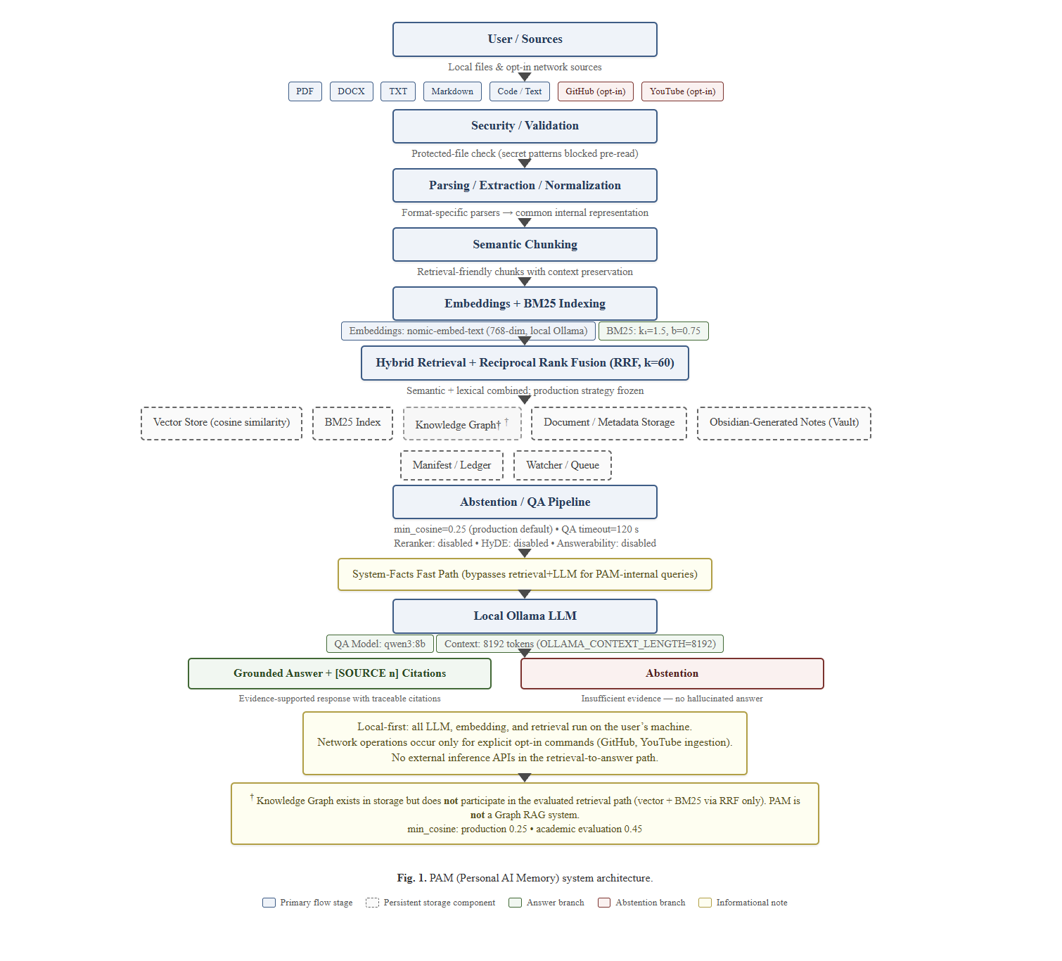
Fig. 1. PAM (Personal AI Memory) system architecture.
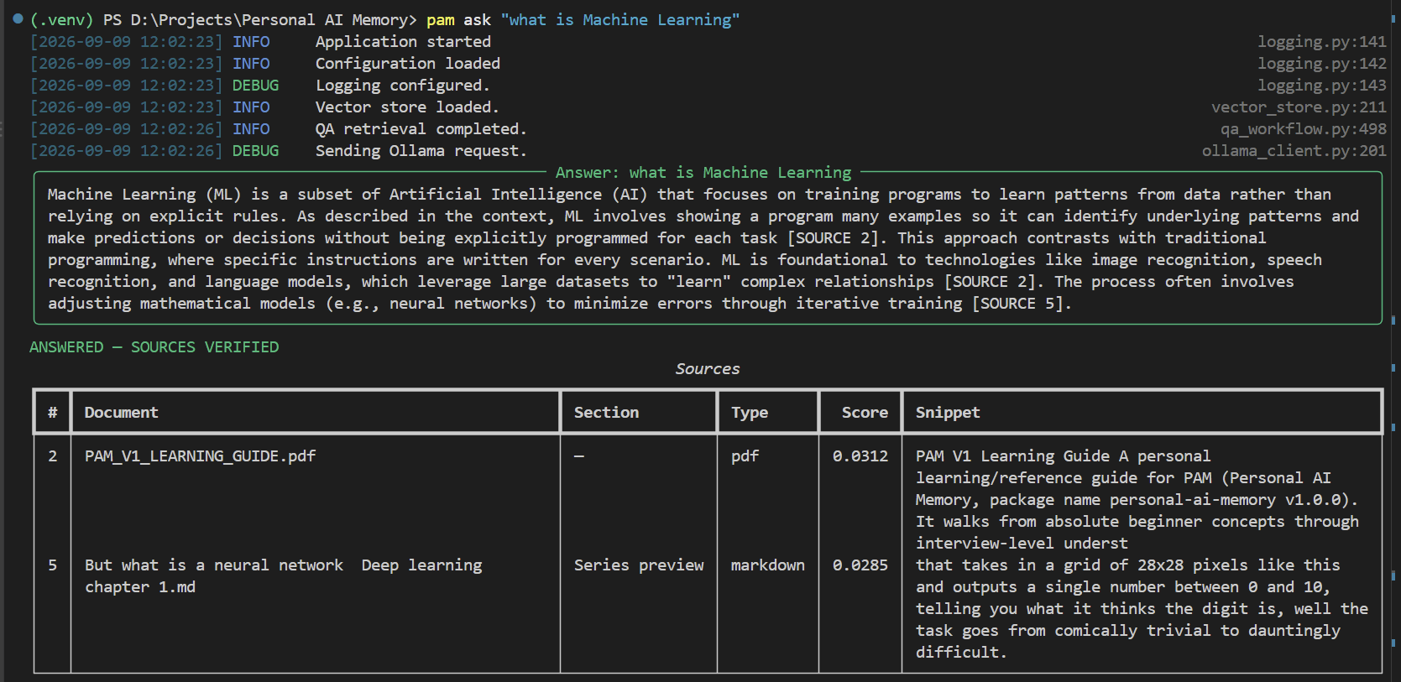
Fig. 2. PAM ask command showing a grounded answer with [SOURCE N] citations.
PAM is local-first rather than universally offline. Inference in the retrieval-to-answer path is performed locally, while explicit ingestion of network sources can contact external services when the user requests those operations. This distinction is important for interpreting the system's privacy boundary. The architecture therefore emphasizes local storage and local inference without making the stronger and unsupported claim that no information can ever leave the machine.
E. Local-First Boundary
The QA workflow uses the local qwen3:8b Ollama model for grounded generation. Retrieved context is assembled with source identifiers, and the prompting procedure instructs the model to ground its answer in the supplied evidence. The workflow can route PAM-internal system-facts questions through a deterministic fast path. For ordinary knowledge questions, the retrieval results are evaluated by the abstention logic before context construction and generation. Optional cross-encoder reranking, HyDE, and answerability mechanisms exist as experimental components but are disabled by default in the shipped configuration.
D. Question Answering and Abstention
For an ordinary knowledge query, PAM retrieves candidates using both dense similarity and BM25 lexical matching. The two ranked lists are combined using Reciprocal Rank Fusion (RRF), after which the highest-ranked candidates are passed to the downstream reliability and question-answering stages. This architecture separates retrieval from later acceptance decisions: a passage can be highly ranked because it is relevant to the query without necessarily containing the requested answer.
C. Hybrid Retrieval
The system maintains several local representations of the knowledge base. Text is transformed into semantic chunks and represented by 768-dimensional embeddings generated with the local nomic-embed-text model. A BM25 index provides lexical retrieval over the same corpus. The vector store uses cosine similarity and persistent local storage rather than an external vector database in the evaluated configuration. PAM also constructs and stores a knowledge graph during ingestion; however, that graph is not queried by the evaluated retrieval path and is therefore not treated as Graph RAG in this study.
B. Representation and Local Storage
PAM accepts heterogeneous personal-knowledge sources through format-specific ingestion and normalization components. Local files are the primary source, while GitHub and YouTube are explicit network-source operations initiated by the user. Before content processing, the ingestion path applies security and validation checks. Extracted content is normalized into retrieval-oriented representations while retaining provenance metadata such as source path, heading, and chunk index.
A. Ingestion and Normalization
The evaluation is intentionally staged. Early retrieval and reranking experiments use the 50-query v1 corpus; later answerability experiments use a 160-query v2 corpus; the final frozen academic baseline and banded-verifier experiment use the v3.0 frozen corpus containing 199 queries, with 157 positive and 42 negative queries, over 24 sources and 195 chunks. Results from different corpora are not presented as directly interchangeable measurements. The final 199-query baseline is reproduced from the frozen evaluation artifact, while later runtime corpus drift is treated separately from the academic result.
J. Experimental Comparison and Dataset Discipline
The study evaluates interventions against explicit constraints established before the final comparison: FNR ≤ 0.033, Hit@5 ≥ 0.93, MRR ≥ 0.88, and retrieval-side p95 latency below 500 ms. For the later reliability target, FPR ≤ 0.50 was used as the desired rejection objective. An intervention is not considered successful merely because it improves one metric; it must be interpreted against the full set of relevant constraints and its evaluation dataset.
I. Evaluation Guardrails
Retrieval effectiveness is measured using Hit@K, Recall@K, and Mean Reciprocal Rank (MRR). Reliability is measured using false-positive rate (FPR) = accepted negative queries / all negative queries and false-negative rate (FNR) = rejected positive queries / all positive queries. Negative rejection rate is the fraction of negative queries rejected. Latency is reported using p50, p95, and maximum observed query latency where available. FPR is not treated as an accuracy measure.
H. Evaluation Metrics
Two evidence-verification approaches were evaluated. A strict verifier was evaluated on the v2 160-query corpus. A banded verifier was evaluated on the frozen 199-query corpus and invoked additional evidence checking for an intermediate confidence band while auto-accepting higher-confidence cases. These mechanisms were assessed on false-positive reduction, false-negative rate, and latency rather than on FPR alone.
G. Answerability Verification
The academic frozen configuration applies a cosine-based abstention threshold of 0.45 before downstream answer generation. A query is accepted when the retrieval evidence satisfies the configured acceptance condition; otherwise the system abstains. This mechanism is intended primarily to reject clearly out-of-scope queries while preserving positive-query recall. The threshold is an academic evaluation setting and should not be confused with the shipped runtime default, which uses a lower min_cosine value.
F. Retrieval-Based Abstention
Cross-encoder reranking was evaluated as an optional second-stage intervention using a local ms-marco-MiniLM-L-12-v2 model. The cross-encoder evaluates the query and candidate passage jointly and produces a reranking score. Reranking was not assumed to improve reliability a priori; it was evaluated against the predefined guardrails. Importantly, the reported reranker experiments used earlier evaluation corpora rather than the final frozen 199-query corpus, and are therefore reported as intervention evidence rather than as final-corpus baseline comparisons.
E. Cross-Encoder Reranking
The frozen academic baseline uses top_k=5 final retrieval results. Experimental reranking stages operate on a larger candidate pool before final selection. For grounded QA, retrieved evidence is supplied with source identifiers and provenance information, and the context is bounded before generation. These settings separate candidate retrieval from the later acceptance decision.
D. Candidate Selection and Context Construction
The dense and BM25 ranked lists are combined using Reciprocal Rank Fusion with k=60. For a document d, the fused score is RRF(d) = Σr∈R 1/(k + rankr(d)), where the summation is over the contributing ranked lists. RRF operates on rank positions rather than requiring dense and BM25 scores to be directly calibrated against one another.
C. Reciprocal Rank Fusion
Lexical retrieval is implemented using BM25 with k1=1.5 and b=0.75. BM25 ranks chunks using term frequency, inverse document frequency, and document-length normalization. Its role in the experimental design is complementary to dense retrieval: exact or overlapping terminology can remain informative even when semantic similarity is imperfect.
B. Lexical Retrieval
Each document chunk is represented by a 768-dimensional embedding generated locally with nomic-embed-text. Given query embedding q and chunk embedding d, dense retrieval ranks candidates by cosine similarity, sim(q,d) = (q·d)/(||q|| ||d||). The retrieval implementation uses this signal as one component of the hybrid candidate-generation stage.
A. Dense Retrieval

IV. METHODOLOGY
PAM performs model inference locally through Ollama in the evaluated retrieval-to-answer path. Retrieval latency and downstream answer-generation latency are treated as distinct measurements; the principal performance guardrail concerns retrieval-side p95 latency. Reported latency statistics are taken from the corresponding evaluation runs, with the maximum value shown separately rather than treated as representative normal retrieval latency.
F. Runtime Environment and Measurement Scope
The frozen baseline is reproducible when the frozen corpus and evaluation configuration are restored. The audited frozen state contains 24 sources and 195 chunks, whereas the subsequent live vector store contained 30 sources and 299 entries. Current runtime status is therefore not used as evidence for the academic baseline. This separation prevents later ingestion activity from changing the corpus denominator or retrieval population of the reported frozen result.
E. Reproducibility and Corpus Drift
The principal guardrails are FNR ≤ 0.033, Hit@5 ≥ 0.93, MRR ≥ 0.88, and retrieval-side p95 latency below 500 ms. The later reliability objective targets FPR ≤ 0.50. These constraints make false-negative control a first-class requirement: reducing false positives by rejecting a substantial fraction of valid queries is not considered an acceptable reliability improvement.
D. Experimental Guardrails
Queries are evaluated individually against the labeled corpus. Retrieval effectiveness is computed from ranked results, while reliability metrics classify acceptance or rejection under the configured abstention behavior. The frozen baseline was independently reproduced in a later experiment, providing a direct reproducibility check. Intervention results retain their original dataset version and are not merged into the frozen baseline statistics.
C. Evaluation Protocol
The frozen academic baseline uses 768-dimensional nomic-embed-text embeddings, BM25 with k1=1.5 and b=0.75, and RRF with k=60. The academic abstention threshold is min_cosine=0.45 and the final retrieval depth is top_k=5. Cross-encoder reranking, HyDE, and answerability verification are disabled for the frozen baseline. These values define the evaluation configuration and are not a description of every shipped runtime default.
B. Frozen Baseline Configuration
The final academic evaluation uses dataset v3.0, containing 199 queries: 157 positive queries for which supporting information is expected in the corpus and 42 negative queries for which the requested information should not be accepted as answerable. The corpus contains 24 sources and 195 chunks. The query set spans factoid, negative, comparison, cross-document, tricky, precise-detail, and multi-chunk categories, with easy, medium, and hard difficulty levels. Three queries were flagged in the audit as having unreliable ground truth and are retained with that caveat.
A. Frozen Corpus and Query Set

V. EXPERIMENTAL SETUP
Metric | Value
Queries | 199
Corpus | 24 / 195
Hit@1 | 0.8408
Hit@3 | 0.9108
Hit@5 | 0.9236
Hit@10 | 0.9236
MRR | 0.8773
FPR | 0.8571
FNR | 0.0000
Negative rejection | 0.1429
Abstention rate | 0.0302
Latency p50 | 37.4 ms
Latency p95 | 47.1 ms
Latency maximum | 7299.3 ms

VI. RESULTS
Metric | Frozen v3.0 baseline
Queries | 199 (157 positive / 42 negative)
Corpus | 24 sources / 195 chunks
Hit@1 | 0.8408
Hit@3 | 0.9108
Hit@5 | 0.9236
Hit@10 | 0.9236
MRR | 0.8773
FPR | 0.8571 (36/42)
FNR | 0.0000
Negative rejection | 0.1429 (6/42)
Abstention rate | 0.0302
Latency p50 | 37.4 ms
Latency p95 | 47.1 ms
Latency maximum | 7299.3 ms
TABLE I. FROZEN V3.0 BASELINE RESULTS
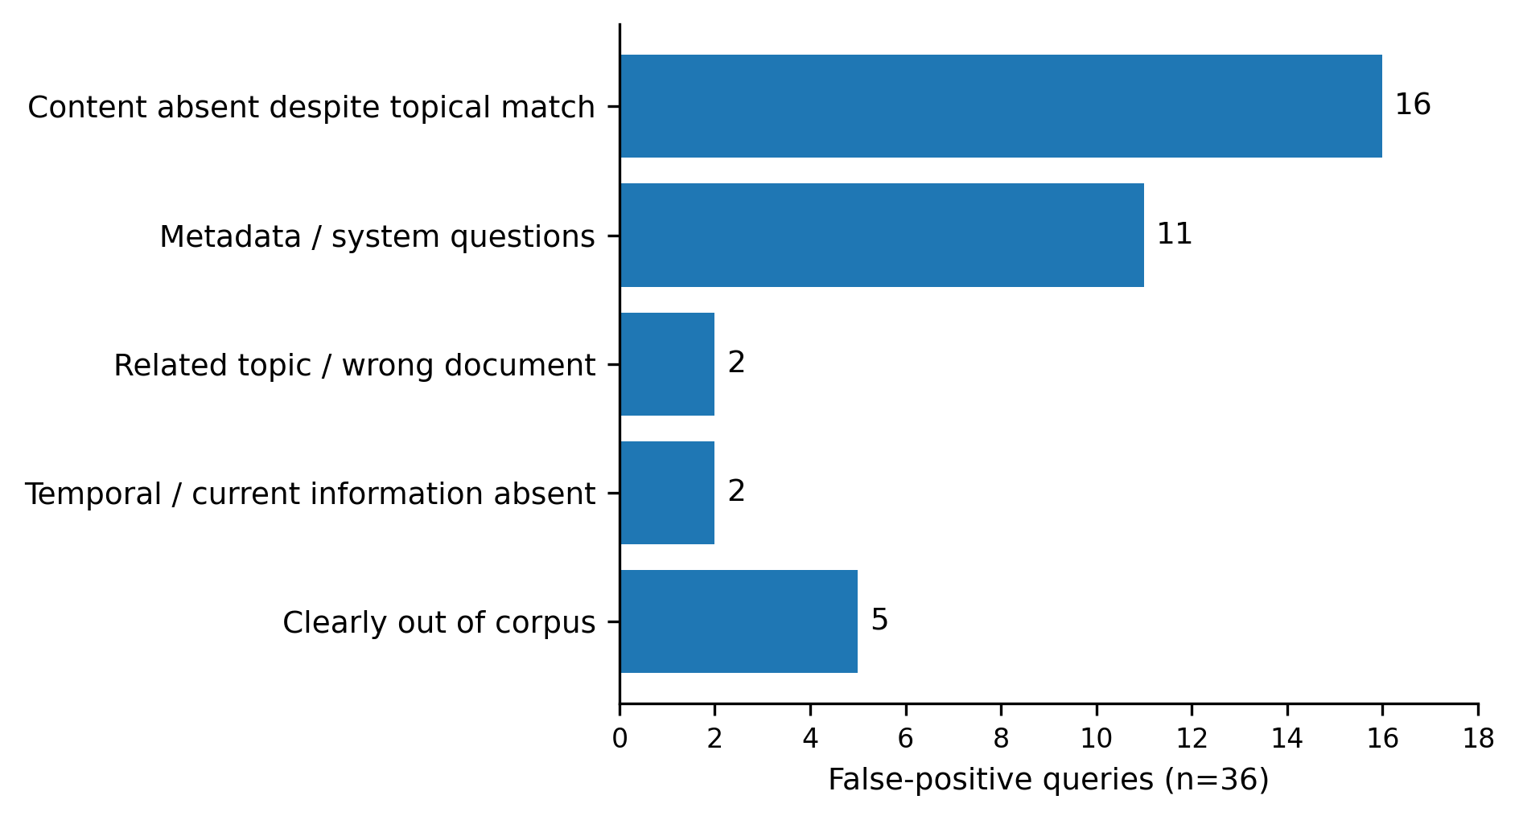
Fig. 3. Failure analysis of false positives among negative queries.
TABLE II
Mechanism | Dataset | FPR | FNR | Latency | Decision
Frozen hybrid + cosine gate | 199q | 0.8571 | 0.000 | 47.1 ms p95 | Baseline
Cross-encoder, no gate | 50q v1 | 1.000 | 0.000 | ~850 ms | Rejected
Cross-encoder gate, t=0.125 | 160q v2 | 0.351 | 0.203 | ~644 ms | Rejected
Strict evidence verifier | 160q v2 | ~0.243 | ~0.098 | ~2.9 s avg | Rejected
Banded evidence verifier | 199q frozen | 0.405 | 0.070 | 14.1 s avg; ~17.3 s p95 | Rejected
TABLE II. SUMMARY OF MEASURED RELIABILITY INTERVENTIONS. The datasets differ across experiments; values are not treated as a single head-to-head final-corpus comparison.
Taken together, the experiments show a consistent boundary between retrieval quality and answerability. The frozen hybrid retriever is fast and retrieves relevant information reliably, but the retrieval signals do not provide sufficient evidence that the requested fact is present. Reranking and evidence verification can change the acceptance trade-off, but the evaluated interventions do not satisfy the complete guardrail bundle. The results therefore support the study's central finding that the dominant reliability problem lies in determining evidence sufficiency rather than merely improving topical retrieval.
F. Overall Reliability Result
The strict answerability verifier reduced false-positive acceptance on the v2 corpus to approximately 0.243, but FNR increased to approximately 0.098 and average latency was about 2.9–3.0 seconds. The banded verifier, evaluated on the frozen 199-query corpus, reduced FPR to 0.405 but produced FNR=0.070 and approximately 14.1 seconds average latency, with p95 latency around 17.3 seconds. These results show that stronger evidence checking can reject more unsupported queries, but the observed configurations violate the study's false-negative and latency constraints.
E. Evidence-Verification Interventions
Cross-encoder reranking did not establish a reliable improvement under the evaluated constraints. On the earlier 50-query v1 evaluation, Hit@1 decreased from 0.907 to 0.837 and MRR decreased from 0.940 to 0.895, while Hit@5 remained 0.953. The reranker therefore did not improve the principal retrieval metrics in that experiment. Threshold sweeps on the later v2 corpus demonstrated an FPR/FNR trade-off: at a threshold of 0.125, FPR was approximately 0.351 but FNR rose to approximately 0.203. Because the reranker experiments were not performed on the final frozen 199-query corpus, these results are reported as intervention evidence rather than as a replacement for the frozen baseline.
D. Cross-Encoder Reranking
The 36 false positives were manually classified to determine why high-ranking evidence was accepted for negative queries. Five were clearly out-of-corpus requests. Sixteen concerned information that was absent even though retrieved material was topically related. Eleven were metadata or system-oriented questions, two involved a related topic or wrong document, and two required temporal or current information absent from the corpus. Thus, 31 of 36 false positives were content-sufficiency failures: the retrieved material was not simply irrelevant, but insufficient to support the requested answer.
C. Failure Analysis of Negative Queries
The frozen baseline was reproduced in a later evaluation using the same frozen corpus and configuration, matching the authoritative baseline values. This supports the claim that the reported retrieval measurements are reproducible under the specified evaluation state. The reproduction is distinct from the later live runtime corpus, which had grown beyond the frozen 24-source, 195-chunk state.
B. Reproducibility of the Baseline
The frozen v3.0 baseline demonstrates strong retrieval performance on positive queries while providing limited rejection of negative queries. Hit@1 is 0.8408, Hit@3 is 0.9108, and Hit@5 is 0.9236; Hit@10 is also 0.9236. MRR is 0.8773. The positive-query FNR is 0, indicating that none of the 157 positive queries was rejected by the evaluated abstention configuration. However, the FPR is 0.8571 (36 of 42 negative queries), and only 6 of 42 negative queries are rejected. Retrieval latency is low, with p50=37.4 ms and p95=47.1 ms.
A. Frozen Hybrid Retrieval Baseline

VII. DISCUSSION
RQ1: Hybrid dense-plus-lexical retrieval provides strong positive-query retrieval performance, with frozen Hit@5=0.9236 and MRR=0.8773. RQ2: retrieval-based abstention rejects some clearly irrelevant queries without false-negative loss in the frozen evaluation, but it does not reliably reject queries whose requested information is absent from a related topic. RQ3: reranking and evidence verification improve selected reliability measures but, in the evaluated configurations, fail the combined FNR, effectiveness, and latency constraints. RQ4: the dominant failure pattern identifies a boundary between retrieval relevance and answer sufficiency, with content-sufficiency failures accounting for 31 of 36 false positives.
F. Answers to the Research Questions
For personal-memory systems, the findings imply that reliability evaluation should distinguish at least three cases: clearly irrelevant queries, relevant queries with answer-bearing evidence, and relevant queries for which the requested information is absent. A retrieval score is naturally suited to the first distinction but is insufficient for the second and third. This suggests that future reliability mechanisms should evaluate evidence sufficiency explicitly while preserving the low-latency retrieval layer rather than repeatedly strengthening retrieval ranking alone.
E. Implications for Local-First Personal RAG
The evidence-verification experiments more directly target answer sufficiency and consequently reduce false-positive acceptance more than retrieval-only interventions. However, both evaluated approaches incur substantial costs. The strict verifier lowers FPR on v2 but exceeds the allowed FNR and introduces multi-second latency. The banded verifier lowers frozen-corpus FPR to 0.405, but FNR rises to 0.070 and average latency reaches approximately 14.1 seconds. Under the study's guardrails, the problem is therefore not simply finding a verifier that rejects more queries; it is finding one that can do so without rejecting valid answers or making the system impractically slow.
D. Evidence Verification Trades False Positives for False Negatives and Latency
Cross-encoder reranking evaluates query-passage relevance more directly than the first-stage hybrid ranker, but the measured results show that improved second-stage relevance scoring does not automatically translate into improved reliability. On the early v1 corpus, reranking reduced Hit@1 and MRR. On the later v2 threshold sweep, stronger rejection reduced FPR but introduced unacceptable FNR at useful thresholds. These findings suggest that reranking can refine ordering while still operating on the same underlying evidence; it does not create missing information.
C. Reranking Improves a Different Objective
The cosine threshold is useful for clearly out-of-scope queries because unrelated queries can receive weaker retrieval evidence. However, topical adjacency produces high enough similarity to pass the same threshold even when the requested fact is absent. The 31/36 content-sufficiency false positives demonstrate that this is not primarily a threshold-calibration problem: the system can be confidently relevant to the topic while remaining unable to support the requested answer. Lowering or raising a retrieval threshold alone therefore cannot fully resolve the boundary.
B. Why Cosine Abstention Has a Limited Boundary
The frozen baseline demonstrates that strong retrieval ranking and reliable positive-query recall do not imply reliable negative-query rejection. Hit@5 reaches 0.9236 and FNR remains 0, yet 36 of 42 negative queries are accepted. The failure taxonomy explains this apparent contradiction: many negative queries retrieve passages that are semantically or lexically related to the requested topic, but those passages do not contain the specific fact required by the query. Retrieval therefore answers the question “what is related?” more reliably than the question “is the requested answer present?”
A. Retrieval Relevance Is Not Answer Sufficiency

VIII. LIMITATIONS AND THREATS TO VALIDITY
The study evaluates several retrieval and answering interventions, including abstention, cross-encoder reranking, and evidence verification, but does not exhaust the entire design space of answerability methods. The conclusion that the tested retrieval-side levers were insufficient applies to the measured experiments and guardrails, not to every possible future retrieval or verification technique.
G. Intervention Coverage
Latency measurements depend on the local execution environment, model loading state, and configuration. The reported retrieval p95 of 47.1 ms demonstrates the measured behavior of the frozen setup rather than a hardware-independent guarantee. The multi-second costs observed for answerability verification are likewise implementation- and environment-dependent, although their order of magnitude is relevant to the studied reliability trade-off.
F. Latency and Hardware Dependence
The knowledge graph is stored by PAM but does not participate in the evaluated retrieval path. The conclusions therefore do not establish the effectiveness of graph-based retrieval. Similarly, the study evaluates a local-first implementation and specific local models and configurations; different embedding models, language models, rerankers, or retrieval stores may produce different results.
E. System and Architecture Scope
The live PAM runtime changed after the academic corpus was frozen. The audited live vector store contained 30 sources and 299 entries, compared with 24 sources and 195 chunks in the frozen evaluation state. This drift is a practical limitation of evaluating a mutable personal-memory system. The paper addresses it by treating the frozen evaluation artifact as authoritative and reporting current runtime state separately.
D. Corpus Drift
Not all interventions were evaluated on the final frozen 199-query corpus. Reranking results include experiments on the 50-query v1 corpus and threshold-sweep results on the 160-query v2 corpus. The strict verifier was also evaluated on v2, while the banded verifier was evaluated on the frozen 199-query corpus. Because these datasets differ, intervention metrics are interpreted within their respective experiments rather than treated as a single controlled leaderboard.
C. Cross-Experiment Comparability
The query set is manually constructed and includes positive and negative cases intended to probe retrieval and answerability behavior. Three queries were flagged during the audit as having unreliable ground truth. This introduces uncertainty into category-level interpretation and limits how strongly individual query outcomes should be generalized. The study retains these cases rather than silently altering the frozen dataset.
B. Dataset and Ground-Truth Limitations
The evaluation is based on a personal-memory corpus rather than a large public benchmark. The frozen corpus contains 24 sources and 195 chunks, and the query set contains 199 labeled queries. Consequently, the measured retrieval and reliability values should be interpreted as evidence for this controlled evaluation rather than as estimates of general RAG performance across domains, users, or corpora.
A. Corpus Scope and Generalization

IX. CONCLUSION
This study evaluated reliability in a local-first personal-memory RAG system by separating retrieval relevance from answer sufficiency. The frozen hybrid dense-plus-lexical baseline achieved Hit@5=0.9236, MRR=0.8773, FNR=0, and retrieval p95 latency of 47.1 ms, demonstrating that the retrieval layer can provide strong positive-query performance with low latency. At the same time, FPR remained 0.8571, showing that relevance-based retrieval and cosine abstention do not reliably determine whether the requested information is actually present in the knowledge base.
Failure analysis identified content sufficiency as the dominant source of false-positive acceptance: 31 of 36 false positives involved evidence that was topically related but insufficient to support the requested answer. Cross-encoder reranking and evidence-verification mechanisms changed the false-positive/false-negative trade-off, but the evaluated configurations did not satisfy the complete reliability and latency guardrails.
The resulting contribution is an empirical characterization of a reliability boundary in personal-memory RAG. The findings suggest that improving retrieval ranking alone is insufficient when the central failure is absence of answer-bearing evidence. Future work should therefore investigate evidence-sufficiency mechanisms that preserve the low latency and low false-negative behavior of the retrieval layer while improving rejection of unsupported queries.

ACKNOWLEDGMENT
The author gratefully acknowledges the mentorship and academic guidance of Santhosh Kumar J and Hemachandra Reddy during the development and evaluation of PAM.

REFERENCES
[1] P. Lewis et al., “Retrieval-Augmented Generation for Knowledge-Intensive NLP Tasks,” in Proc. NeurIPS, 2020, arXiv:2005.11401.
[2] V. Karpukhin et al., “Dense Passage Retrieval for Open-Domain Question Answering,” in Proc. EMNLP, 2020, pp. 6769–6781, doi: 10.18653/v1/2020.emnlp-main.550.
[3] S. Robertson and H. Zaragoza, “The Probabilistic Relevance Framework: BM25 and Beyond,” Foundations and Trends in Information Retrieval, vol. 3, no. 4, pp. 333–389, 2009, doi: 10.1561/1500000019.
[4] G. V. Cormack, C. L. A. Clarke, and S. Büttcher, “Reciprocal Rank Fusion Outperforms Condorcet and Individual Rank Learning Methods,” in Proc. SIGIR, 2009, pp. 758–759, doi: 10.1145/1571941.1572114.
[5] R. Nogueira and K. Cho, “Passage Re-ranking with BERT,” arXiv:1901.04085, 2019.
[6] H. Zhang and W. Wu, “Do LLMs Know When Evidence Is Insufficient? An Evidence Sufficiency Benchmark for Answer-Abstention Calibration in Retrieval-Augmented Generation,” Computers, Materials & Continua, vol. 89, no. 1, art. 69, 2026, doi: 10.32604/cmc.2026.086343.

APPENDIX A
PAM CLI AND OPERATIONAL SCREENSHOTS
This appendix provides visual evidence of the implemented PAM command-line interface and operational workflow. The screenshots are demonstrations of the current runtime and are not used to compute the frozen academic evaluation metrics.


Fig. A1. PAM command-line help showing the available operational commands.

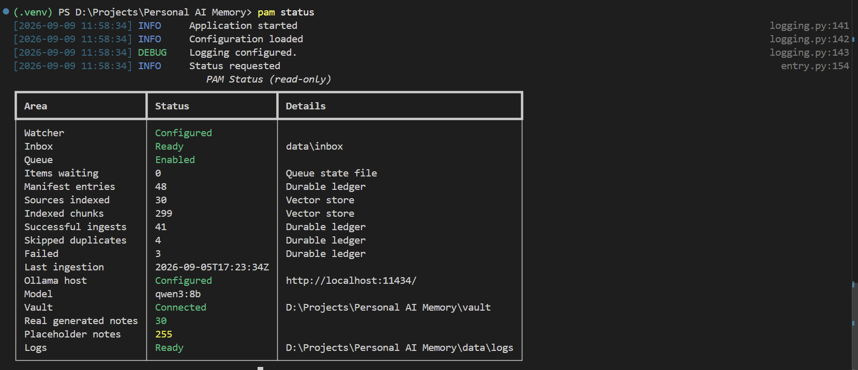
Fig. A2. PAM status output showing the current local runtime state.

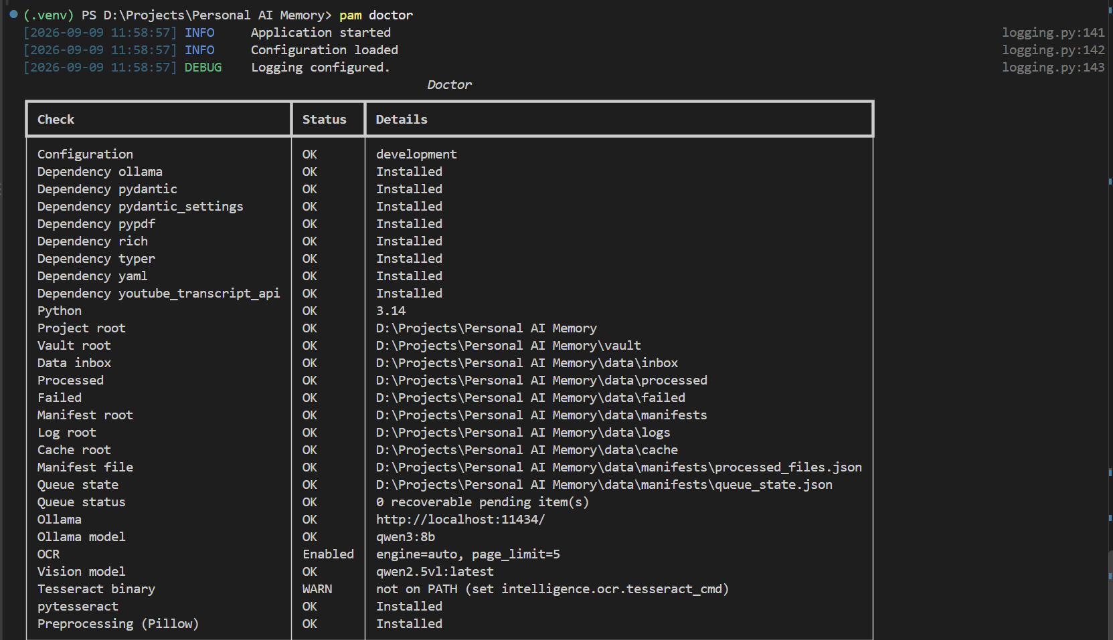
Fig. A3. PAM doctor output validating local configuration, dependencies, and runtime readiness.

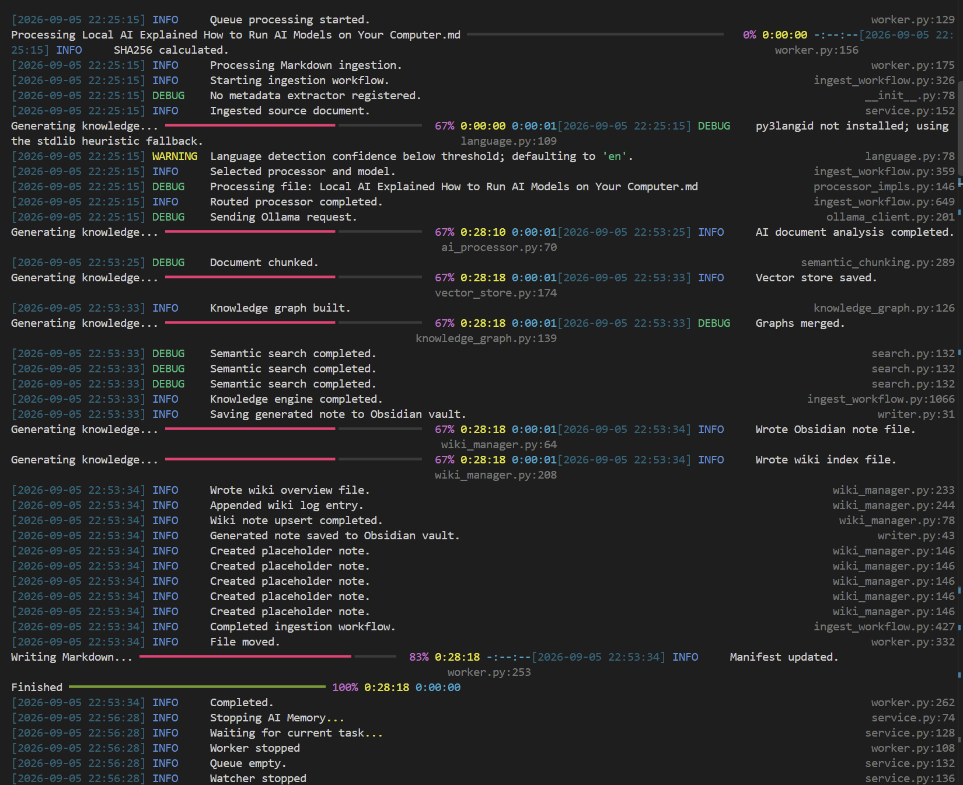
Fig. A4. PAM ingestion workflow showing processing, AI analysis, chunking, and vector-store persistence.

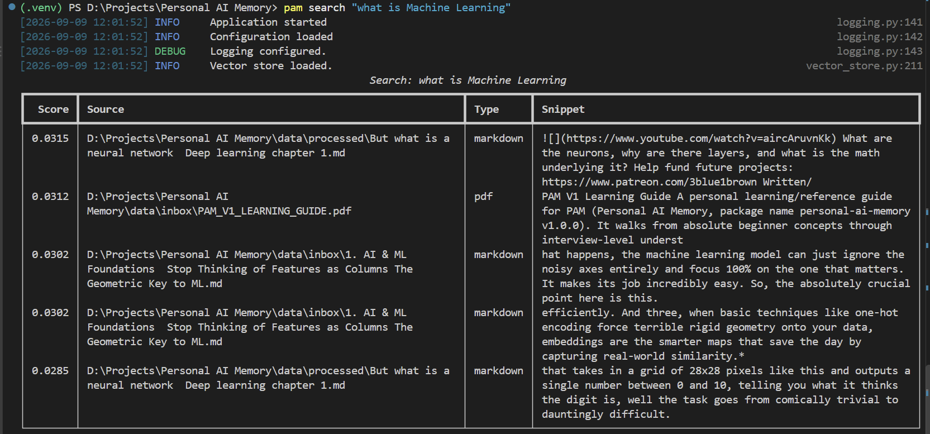
Fig. A5. PAM search command showing ranked retrieval results for a natural-language query.

