|  |  |
| --- | --- |
| Ticket reservation for on campus events Description: Online student campus activities and ticket reservation website. | Group 5 Akshay Bhat Giridhar Chalumuri Shivangi Gaur Aditi Nitin Ghamandi Dedipya Jain |

**Table of Contents**

1. **Project Description**
   1. **Scope**
2. **Requirements**
3. **Domain Model**
4. **Use Case Model**

**4.1. Admin UCD**

**4.2. Student UCD**

**4.3. Expanded Use Case**

**4.4. Traceability Matrix**

**4.5. Successful/Unsuccessful Scenarios**

**5. Class Diagram**

**6. Screenshots**

**7. Testing**

**8. Plan: Next Iterations**

**9. Code**

1. **Project Description**

To design and create a centralized platform to provide students access to all the events happening on campus and book advanced tickets for those events.

There are lots of events going on in the campus. To keep track of these events is a big workload. Our event system keeps track of these events. Moreover, many events have limited seats and our ticket reservation will help the student to pick a spot for the event. Many a times, if it’s a new student, they have very limited resources and are particularly clueless about what’s happening in the college. These events may be sporting or educational. This system also helps the staff and students to reduce the hassle during the event while buying tickets. The student can view all events happening like sports, educational lectures, movies, fun activities near library among others. They can see its timings and book seats according to their liking. We are helping to bridge the gap between the college events and students. The application provides a good opportunity to students to keep track of the events happing on campus and RSVP for them. It also provides opportunity to all the event managers to reach out to the students.

* 1. **Scope**

The application provides a good opportunity to students to keep track of the events happing on campus and RSVP for them. It also provides opportunity to all the event managers to reach out to the students.

1. **Requirements**

R1- The system must provide students/ administrator to login into an account.

R2- System must display all the current on-campus events.

R3- System must provide search based on different criteria (event type, date, price)

R4-System must display search results based on selected criteria

R5-System must provide the details of selected event.

R6-System must provide a shopping cart to add multiple event tickets.

R7-System must display details of shopping cart to checkout.

R8-System must generate a receipt for successful checkout.

R9-System must generate an email confirmation to the student.

R10-System must provide students to modify their existing reservation.

R11-System must provide a way to administrator to add and modify events.

1. **Domain Model**

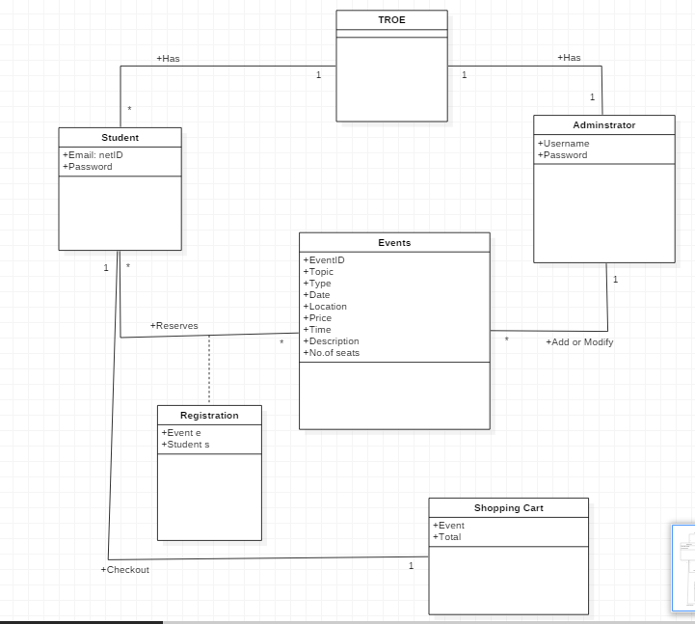

1. **Use Case Model**
   1. **Admin UCD**

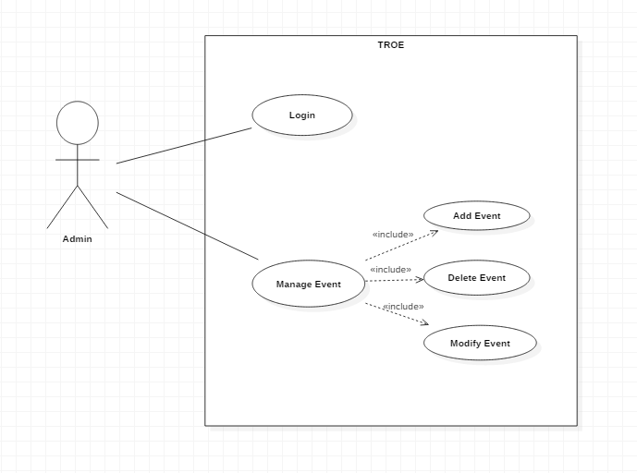

* 1. **Student UCD**

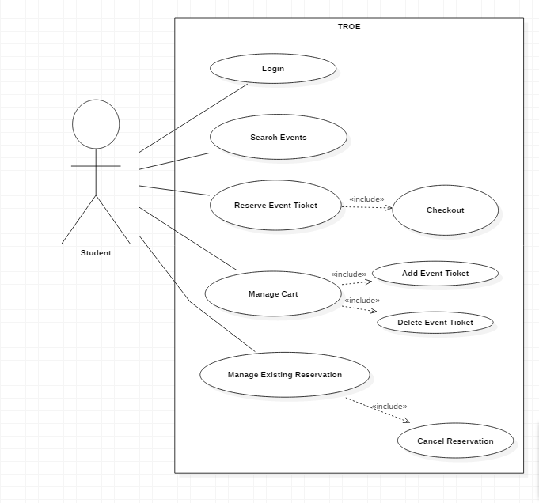

* 1. **Expanded Use Cases**

UC1 & UC3: Login

|  |  |
| --- | --- |
| Precondition: System should be up and running | |
| Actor: Student/Administrator | System: TROE |
| 1. TUCBW, User will enter username and password. | 1. System will authenticate the credentials. |
| 1. TUCEW, User will see the welcome page |  |

UC4: Search for events

|  |  |
| --- | --- |
| Precondition: System should have list of current events | |
| Actor: Student | System: TROE |
| 1. TUCBW, Student will search program based on different criteria (event type, date, price). | 1. System will display all the programs according to search criteria. |
| 1. TUCEW, Student can select the desired events. |  |

* 1. **Traceability Matrix**

|  |  |  |  |  |  |  |  |  |
| --- | --- | --- | --- | --- | --- | --- | --- | --- |
|  | Priority Weight | UC1 | UC2 | UC3 | UC4 | UC5 | UC6 | UC7 |
| R1 | 3 | X |  | X |  |  |  |  |
| R2 | 2 |  |  |  | X |  |  |  |
| R3 | 2 |  |  |  | X |  |  |  |
| R4 | 2 |  |  |  | X |  |  |  |
| R5 | 2 |  |  |  |  | X |  |  |
| R6 | 2 |  |  |  |  | X |  |  |
| R7 | 2 |  |  |  |  | X |  |  |
| R8 | 1 |  |  |  |  |  | X |  |
| R9 | 1 |  |  |  |  |  | X |  |
| R10 | 1 |  |  |  |  |  |  | X |
| R11 | 1 |  | X |  |  |  |  |  |
| Score | | 3 | 1 | 3 | 6 | 6 | 2 | 1 |

**4.5.** **Successful/Unsuccessful Scenarios**

1. The student enters his/her login credentials.

2. Validate the student.

2.1 Invalid User

Ask the user to enter again.

3. The system will display list of current on-campus events.

4. Student will search the events based on different criteria.

4.1 The search results are empty.

5. Student selects the event.

6. The system will display the details of the event.

7. Student will add the event in the cart.

8. Student will checkout his cart.

8.1 The event is full, and no seats are left.

Display the event is full and the student cannot register for the event.

9. Receipt will be generated for the registered events.

10. Success email is send to the student.

**5. Class Diagram**

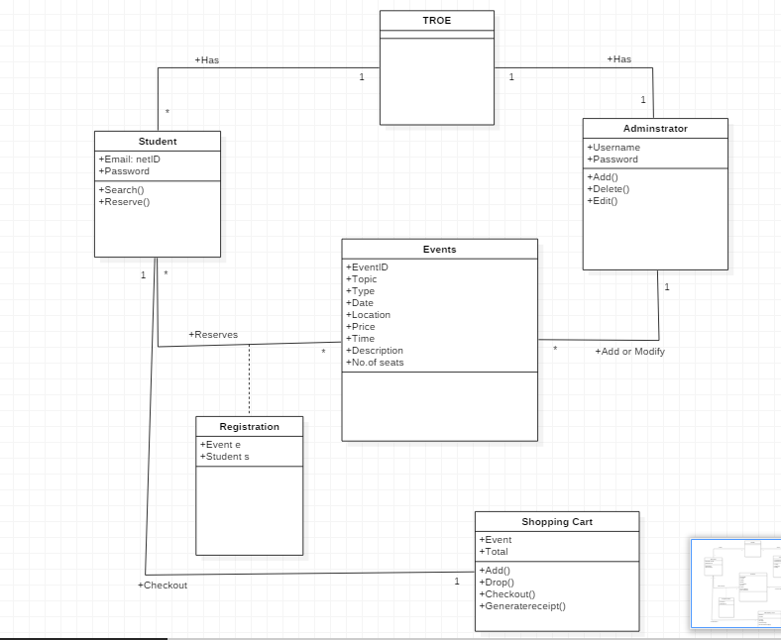

**6. Screenshots**

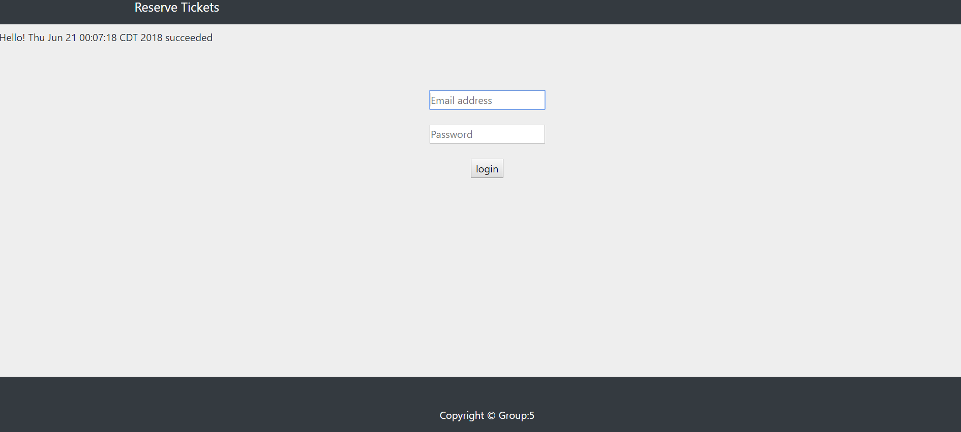

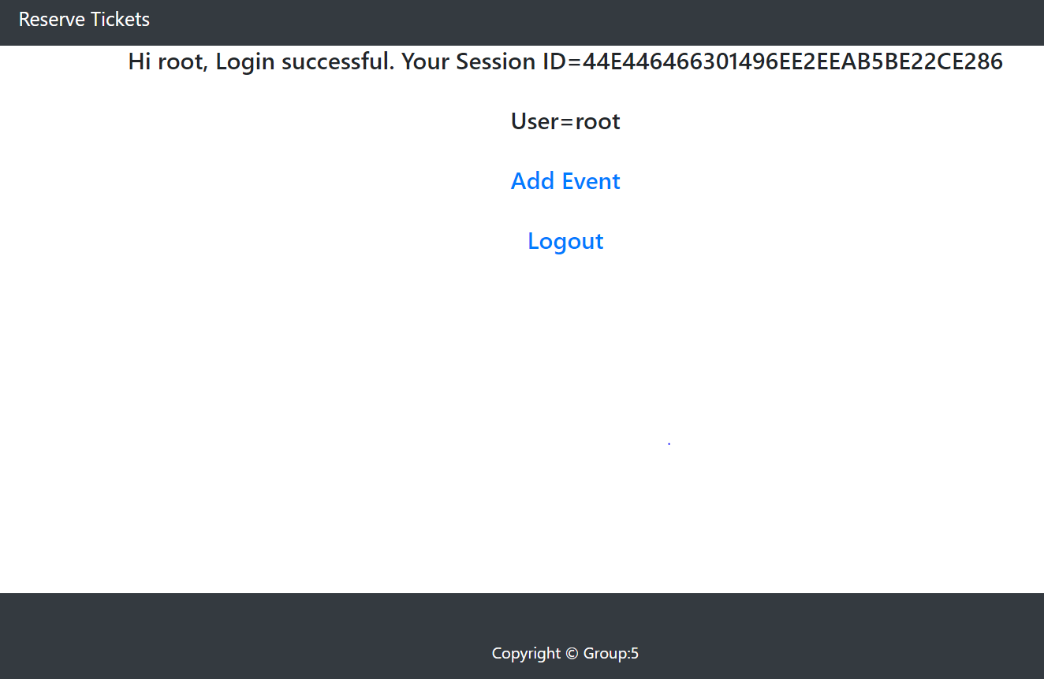

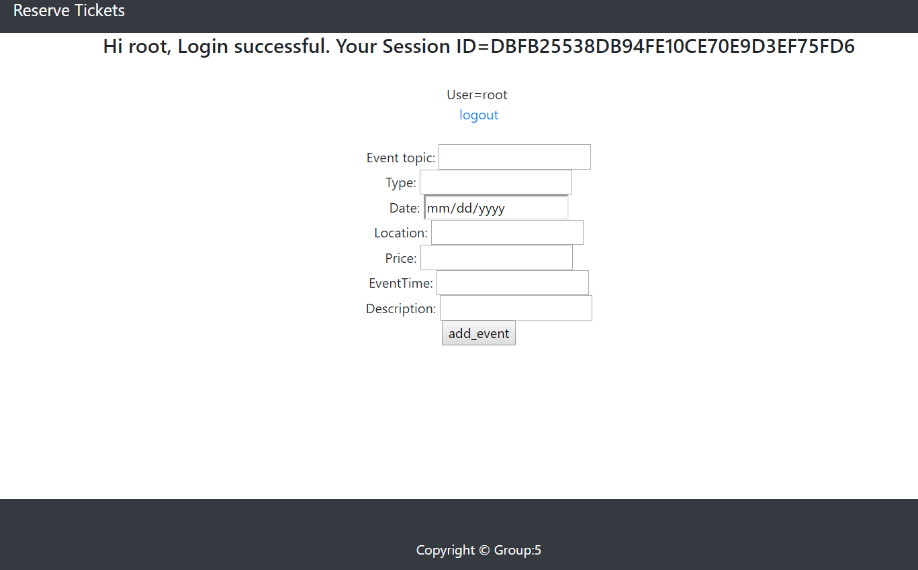

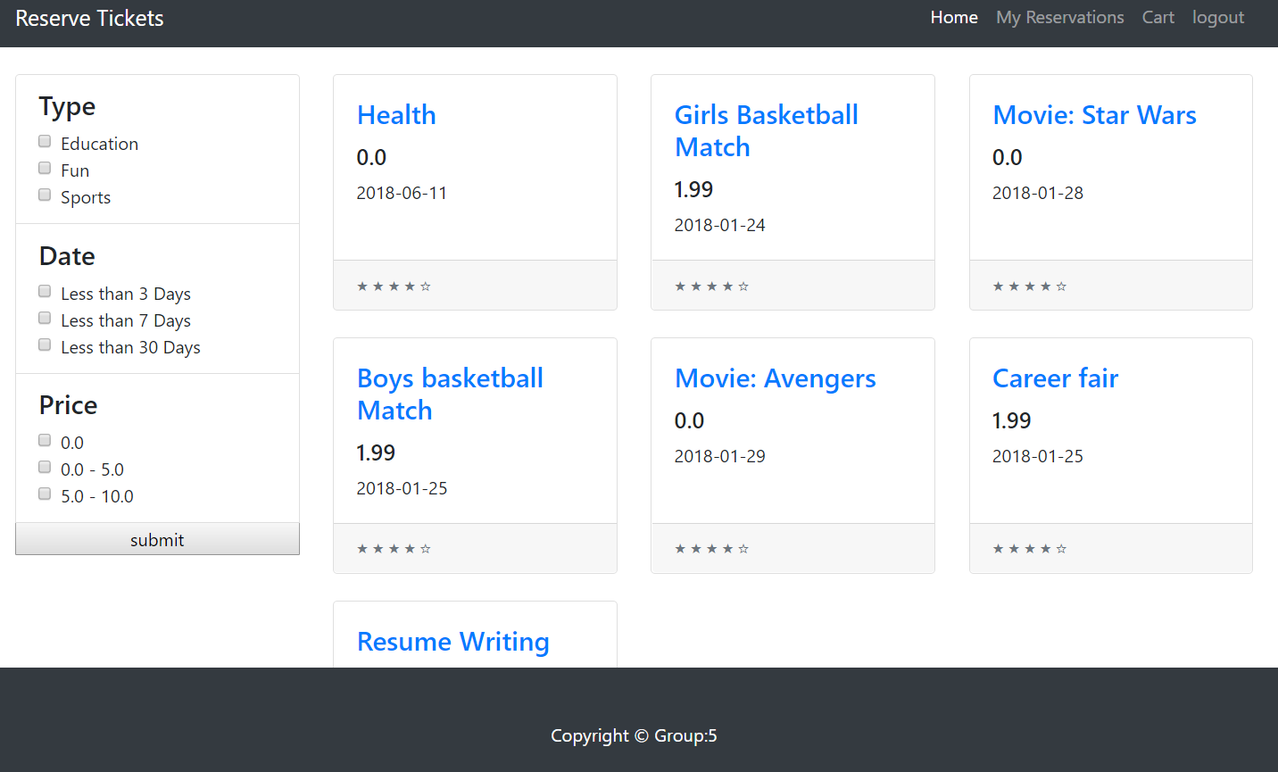

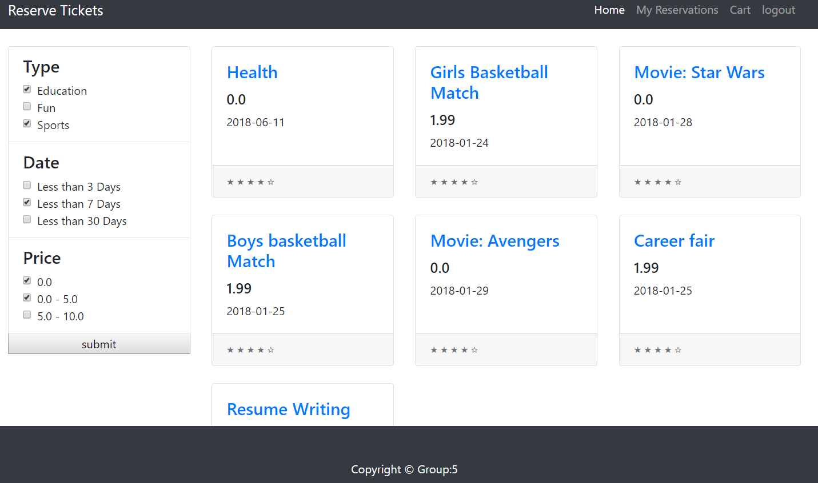

**7. Testing**

* Testing is done on the system to check if the system can finish tasks according to the requirements stated earlier successfully and smoothly.
* Facilitate users to finish desired tasks.
* Respond to user’s requests within specific time.
* System can run on IE, Chrome, and Firefox.

**Testing plan**

The following activities and test cases are used to check the quality and to map the implementation with the requirements of the system:

|  |  |  |  |  |
| --- | --- | --- | --- | --- |
| S.No. | Test Case | Test Case Description | Expected Output | Observed Output |
| 1. | Login (Student) | 1. Student enters email address and password to login.  2. Student information is fetched from the database. | Validates the current student and the welcome page is displayed. | Student can see the welcome page displaying all the current events. |
| 2. | Login (Admin) | 1. Admin enters email address and password to login.  2. Admin information is fetched from the database. | Validates the admin and admin dashboard is displayed. | Admin can login and the dashboard are displayed. |
| 3. | Manage Events (Admin) | 1. Admin can add and edit the current list of events. | Event details to be added in the database. | A success message after the addition of current event and details are reflected in the database. |

**8. Plan: Next Iterations**

Iteration 2

Iteraiton1 + Interaction diagram with operation contracts. Students can view all the current events and filter them according to event type, date, and price. Student can add the tickets for selected events to their shopping cart for checkout. The previous reservations can be cancelled. Databases for the events and the students is developed. Unit testing and integration testing will also be done.

Iteration 3

Iteraiton1 + Iteration2 + Optimized UI + A receipt is generated at the end of the checkout. The students will receive an email confirmation after the rsvp of the event. Database of the students and the current events are modified according to the changed specifications. Unit testing and integration testing is done on the final product.

**9. Code**

**login.jsp**

<%@page import=*"db.DbManager"*%>

<%@page import=*"java.sql.Connection"*%>

<%@ page language=*"java"* contentType=*"text/html; charset=UTF-8"*

pageEncoding=*"UTF-8"*%>

<!DOCTYPE html PUBLIC "-//W3C//DTD HTML 4.01 Transitional//EN" "http://www.w3.org/TR/html4/loose.dtd">

<html>

<head>

<!-- Start Changed -->

<meta charset=*"utf-8"*>

<meta http-equiv=*"X-UA-Compatible"* content=*"IE=edge"*>

<meta name=*"viewport"* content=*"width=device-width, initial-scale=1"*>

<!-- The above 3 meta tags *must* come first in the head; any other head content must come *after* these tags -->

<meta charset=*"utf-8"*>

<meta name=*"viewport"* content=*"width=device-width, initial-scale=1, shrink-to-fit=no"*>

<meta name=*"description"* content=*""*>

<meta name=*"author"* content=*""*>

<!-- bootstrap general -->

<!-- <link href="bootstrap/css/bootstrap.min.css" rel="stylesheet" type="text/css" /> -->

<script type=*"text/javascript"* src=*"bootstrap/js/bootstrap.min.js"*></script>

<meta http-equiv=*"Content-Type"* content=*"text/html; charset=ISO-8859-1"*>

<meta http-equiv=*"Content-Type"* content=*"text/html; charset=UTF-8"*>

<meta name=*"description"* content=*""*>

<meta name=*"author"* content=*""*>

<link rel=*"icon"* href=*"../../favicon.ico"*>

<!-- End Changed -->

<script type=*"text/javascript"* src=*"script.js"*></script>

<meta http-equiv=*"Content-Type"* content=*"text/html; charset=UTF-8"*>

<title>Login Page</title>

<!-- Bootstrap core CSS -->

<link href=*"bootstrap/css/bootstrap.min.css"* rel=*"stylesheet"*>

<!-- Custom styles for this template -->

<link href=*"bootstrap/css/shop-homepage.css"* rel=*"stylesheet"*>

<%

session.invalidate();

response.setHeader("Cache-Control", "no-cache, no-store, must-revalidate"); // HTTP 1.1.

response.setHeader("Pragma", "no-cache"); // HTTP 1.0.

response.setHeader("Expires", "0");

response.setHeader("Vary", "*");

%>

<!-- Start Change -->

<!-- Bootstrap core CSS -->

<link href=*"bootstrap/css/bootstrap.min.css"* rel=*"stylesheet"*>

<!-- IE10 viewport hack for Surface/desktop Windows 8 bug -->

<link href=*"bootstrap/css/ie10-viewport-bug-workaround.css"* rel=*"stylesheet"*>

<!-- Custom styles for this template -->

<link href=*"bootstrap/css/signin.css"* rel=*"stylesheet"*>

<!-- Just for debugging purposes. Don't actually copy these 2 lines! -->

<!--[if lt IE 9]><script src="../../assets/js/ie8-responsive-file-warning.js"></script><![endif]-->

<script src=*"bootstrap/js/ie-emulation-modes-warning.js"*></script>

<!-- HTML5 shim and Respond.js for IE8 support of HTML5 elements and media queries -->

<!--[if lt IE 9]>

<script src="https://oss.maxcdn.com/html5shiv/3.7.3/html5shiv.min.js"></script>

<script src="https://oss.maxcdn.com/respond/1.4.2/respond.min.js"></script>

<![endif]-->

<!-- End Change -->

</head>

<body>

<!-- Navigation -->

<nav class=*"navbar navbar-expand-lg navbar-dark bg-dark fixed-top"*>

<div class=*"container"*>

<a class=*"navbar-brand"* href=*"#"*>Reserve Tickets</a>

</div>

</nav>

</br>

<%out.print("Hello!"); %>

<%= **new** java.util.Date() %>

<%

response.addHeader("Cache-Control", "no-cache,no-store,private,must-revalidate,max-stale=0,post-check=0,pre-check=0");

response.addHeader("Pragma", "no-cache");

response.addDateHeader ("Expires", 0);

%>

<%! **int** number1, number2; %>

<%

DbManager db = **new** DbManager();

Connection conn = (Connection) db.getConnection();

**if**(conn == **null**)

out.print("failed");

**else**

out.print("succeeded");

%>

<br/>

<!-- IE10 viewport hack for Surface/desktop Windows 8 bug -->

<script src=*"bootstrap/js/ie10-viewport-bug-workaround.js"*></script>

<form name=*"loginform"* action=*"LoginController"* method=*"post"* onsubmit="return loginValidate()" >

<br>

${message}<br>

${successMessage}<br>

<center>

<label for=*"inputEmail"* class=*"sr-only"*>Email address</label>

<input type=*"text"* name=*"email"* id=*"email"* placeholder=*"Email address"* required autofocus><br>

</br>

<label for=*"inputPassword"* class=*"sr-only"*>Password</label>

<input type=*"password"* name=*"password"* id=*"password"* placeholder=*"Password"* required><br>

</br>

<input type=*"submit"* name=*"submit"* value=*"login"*><br>

</center>

</form>

<footer class=*"py-5 bg-dark fixed-bottom"*>

<div class=*"container"*>

<p class=*"m-0 text-center text-white"*>Copyright &copy; Group:5</p>

</div>

</footer>

<!-- Bootstrap core JavaScript -->

<script src=*"bootstrap/js/jquery.min.js"*></script>

<script src=*"bootstrap/js/bootstrap.bundle.min.js"*></script>

</body>

</html>

**admin.jsp**

<%@ page language=*"java"* contentType=*"text/html; charset=US-ASCII"*

pageEncoding=*"US-ASCII"*%>

<!DOCTYPE html PUBLIC "-//W3C//DTD HTML 4.01 Transitional//EN" "http://www.w3.org/TR/html4/loose.dtd">

<html>

<head>

<meta charset=*"utf-8"*>

<meta name=*"viewport"*

content=*"width=device-width, initial-scale=1, shrink-to-fit=no"*>

<meta name=*"description"* content=*""*>

<meta name=*"author"* content=*""*>

<!-- bootstrap general -->

<!-- <link href="bootstrap/css/bootstrap.min.css" rel="stylesheet" type="text/css" /> -->

<script type=*"text/javascript"* src=*"bootstrap/js/bootstrap.min.js"*></script>

<meta http-equiv=*"Content-Type"* content=*"text/html; charset=ISO-8859-1"*>

<meta http-equiv=*"Content-Type"* content=*"text/html; charset=UTF-8"*>

<meta http-equiv=*"Content-Type"* content=*"text/html; charset=UTF-8"*>

<meta http-equiv=*"Content-Type"* content=*"text/html; charset=US-ASCII"*>

<title>Login Success Page</title>

<!-- Bootstrap core CSS -->

<link href=*"bootstrap/css/bootstrap.min.css"* rel=*"stylesheet"*>

<!-- Custom styles for this template -->

<link href=*"bootstrap/css/shop-homepage.css"* rel=*"stylesheet"*>

</head>

<body>

<!-- Navigation -->

<nav class=*"navbar navbar-expand-lg navbar-dark bg-dark fixed-top"*>

<div class=*"container"*>

<a class=*"navbar-brand"* href=*"#"*>Reserve Tickets</a>

</div>

</nav>

<%

//allow access only if session exists

String user = **null**;

**if**(session.getAttribute("user") == **null**){

response.sendRedirect("login.html");

}**else** user = (String) session.getAttribute("user");

String userName = **null**;

String sessionID = **null**;

Cookie[] cookies = request.getCookies();

**if**(cookies !=**null**){

**for**(Cookie cookie : cookies){

**if**(cookie.getName().equals("user")) userName = cookie.getValue();

**if**(cookie.getName().equals("JSESSIONID")) sessionID = cookie.getValue();

}

}

%>

<center>

<h4>Hi <%=userName %>, Login successful. Your Session ID=<%=sessionID %></h4>

<br>

<h4>User=<%=user %></h4>

<br>

<h4><a href=*"add_event.jsp"*>Add Event</a></h4>

<br>

<h4><a href=*"logout.jsp"*>Logout</a></h4>

</center>

<!-- Footer -->

<footer class=*"py-5 bg-dark fixed-bottom"*>

<div class=*"container"*>

<p class=*"m-0 text-center text-white"*>Copyright &copy; Group:5</p>

</div>

<!-- /.container -->

</footer>

<!-- Bootstrap core JavaScript -->

<script src=*"bootstrap/js/jquery.min.js"*></script>

<script src=*"bootstrap/js/bootstrap.bundle.min.js"*></script>

</body>

</html>

**add_event.jsp**

<%@ page language=*"java"* contentType=*"text/html; charset=ISO-8859-1"*

pageEncoding=*"ISO-8859-1"*%>

<!DOCTYPE html PUBLIC "-//W3C//DTD HTML 4.01 Transitional//EN" "http://www.w3.org/TR/html4/loose.dtd">

<html>

<head>

<meta charset=*"utf-8"*>

<meta name=*"viewport"*

content=*"width=device-width, initial-scale=1, shrink-to-fit=no"*>

<meta name=*"description"* content=*""*>

<meta name=*"author"* content=*""*>

<!-- bootstrap general -->

<!-- <link href="bootstrap/css/bootstrap.min.css" rel="stylesheet" type="text/css" /> -->

<script type=*"text/javascript"* src=*"bootstrap/js/bootstrap.min.js"*></script>

<meta http-equiv=*"Content-Type"* content=*"text/html; charset=ISO-8859-1"*>

<meta http-equiv=*"Content-Type"* content=*"text/html; charset=UTF-8"*>

<meta http-equiv=*"Content-Type"* content=*"text/html; charset=UTF-8"*>

<meta http-equiv=*"Content-Type"* content=*"text/html; charset=ISO-8859-1"*>

<title>Add events</title>

<!-- Bootstrap core CSS -->

<link href=*"bootstrap/css/bootstrap.min.css"* rel=*"stylesheet"*>

<!-- Custom styles for this template -->

<link href=*"bootstrap/css/shop-homepage.css"* rel=*"stylesheet"*>

</head>

<body>

<!-- Navigation -->

<nav class=*"navbar navbar-expand-lg navbar-dark bg-dark fixed-top"*>

<div class=*"container"*>

<a class=*"navbar-brand"* href=*"#"*>Reserve Tickets</a>

</div>

</nav>

<%

//allow access only if session exists

String user = **null**;

**if**(session.getAttribute("user") == **null**){

response.sendRedirect("login.html");

}**else** user = (String) session.getAttribute("user");

String userName = **null**;

String sessionID = **null**;

Cookie[] cookies = request.getCookies();

**if**(cookies !=**null**){

**for**(Cookie cookie : cookies){

**if**(cookie.getName().equals("user")) userName = cookie.getValue();

**if**(cookie.getName().equals("JSESSIONID")) sessionID = cookie.getValue();

}

}

%>

<center>

<h4>Hi <%=userName %>, Login successful. Your Session ID=<%=sessionID %></h4>

<br>

User=<%=user %>

<br>

<a href=*"logout.jsp"*>logout</a>

<form name=*"addform"* action=*"AdminController"* method=*"post"* onsubmit="" >

<br>

Event topic: <input type=*"text"* name=*"title"* id=*"title"*><br>

Type: <input type=*"text"* name=*"type"* id=*"type"*><br>

Date: <input type=*"date"* pattern=*"yyyy/MM/dd"* name=*"date"* id=*"date"*><br>

Location: <input type=*"text"* name=*"loc"* id=*"loc"*><br>

Price: <input type=*"text"* name=*"price"* id=*"price"*><br>

EventTime: <input type=*"text"* name=*"time"* id=*"time"*><br>

Description: <input type=*"text"* name=*"desc"* id=*"desc"*><br>

<input type=*"submit"* name=*"submit"* value=*"add_event"*><br>

</form>

</center>

<!-- Footer -->

<footer class=*"py-5 bg-dark fixed-bottom"*>

<div class=*"container"*>

<p class=*"m-0 text-center text-white"*>Copyright &copy; Group:5</p>

</div>

<!-- /.container -->

</footer>

<!-- Bootstrap core JavaScript -->

<script src=*"bootstrap/js/jquery.min.js"*></script>

<script src=*"bootstrap/js/bootstrap.bundle.min.js"*></script>

</body>

</html>

**welcome.jsp**

<%@ page language=*"java"* contentType=*"text/html; charset=UTF-8"*

pageEncoding=*"UTF-8"*%>

<%@ taglib prefix=*"c"* uri=*"http://java.sun.com/jsp/jstl/core"* %>

<!DOCTYPE html PUBLIC "-//W3C//DTD HTML 4.01 Transitional//EN" "http://www.w3.org/TR/html4/loose.dtd">

<html>

<head>

<meta charset=*"utf-8"*>

<meta name=*"viewport"*

content=*"width=device-width, initial-scale=1, shrink-to-fit=no"*>

<meta name=*"description"* content=*""*>

<meta name=*"author"* content=*""*>

<!-- bootstrap general -->

<!-- <link href="bootstrap/css/bootstrap.min.css" rel="stylesheet" type="text/css" /> -->

<script type=*"text/javascript"* src=*"bootstrap/js/bootstrap.min.js"*></script>

<meta http-equiv=*"Content-Type"* content=*"text/html; charset=ISO-8859-1"*>

<meta http-equiv=*"Content-Type"* content=*"text/html; charset=UTF-8"*>

<meta http-equiv=*"Content-Type"* content=*"text/html; charset=UTF-8"*>

<title>Welcome Page</title>

<!-- Bootstrap core CSS -->

<link href=*"bootstrap/css/bootstrap.min.css"* rel=*"stylesheet"*>

<!-- Custom styles for this template -->

<link href=*"bootstrap/css/shop-homepage.css"* rel=*"stylesheet"*>

<script>

**var** type = document.getElementByName('type');

alert(type.value);

</script>

</head>

<body>

<!-- Navigation -->

<nav class=*"navbar navbar-expand-lg navbar-dark bg-dark fixed-top"*>

<div class=*"container"*>

<a class=*"navbar-brand"* href=*"#"*>Reserve Tickets</a>

<button class=*"navbar-toggler"* type=*"button"* data-toggle=*"collapse"* data-target=*"#navbarResponsive"* aria-controls=*"navbarResponsive"* aria-expanded=*"false"* aria-label=*"Toggle navigation"*>

<span class=*"navbar-toggler-icon"*></span>

</button>

<div class=*"collapse navbar-collapse"* id=*"navbarResponsive"*>

<ul class=*"navbar-nav ml-auto"*>

<li class=*"nav-item active"*>

<a class=*"nav-link"* href=*"#"*>Home

<span class=*"sr-only"*>(current)</span>

</a>

</li>

<li class=*"nav-item"*>

<a class=*"nav-link"* href=*"#"*>My Reservations</a>

</li>

<li class=*"nav-item"*>

<a class=*"nav-link"* href=*"#"*>Cart</a>

</li>

<li class=*"nav-item"*>

<a class=*"nav-link"* href=*"logout.jsp"*>logout</a>

</li>

</ul>

</div>

</div>

</nav>

</br>

<!-- Page Content -->

<div class=*"container"*>

<div class=*"row"*>

<div class=*"col-lg-3"*>

<form name=*"searchForm"* action=*"SearchController"* method=*"post"* onSubmit="">

<div class=*"list-group"*>

<a class=*"list-group-item"*><h4>Type</h4>

<div class=*"form-check"*>

<input type=*"checkbox"* class=*"form-check-input"* id=*"checkbox100"* name = *"type"* value = *"Education"* onchange = *"onChecked()"*>

<label class=*"form-check-label"* for=*"checkbox100"*>Education</label>

</div>

<div class=*"form-check"*>

<input type=*"checkbox"* class=*"form-check-input"* id=*"checkbox101"* name = *"type"* value= *"Fun"* onchange = *"onChecked()"*>

<label class=*"form-check-label"* for=*"checkbox100"*>Fun</label>

</div>

<div class=*"form-check"*>

<input type=*"checkbox"* class=*"form-check-input"* id=*"checkbox102"* name = *"type"* value = *"Sports"* onchange = *"onChecked()"*>

<label class=*"form-check-label"* for=*"checkbox100"*>Sports</label>

</div> </a> <a class=*"list-group-item"*><h4>Date</h4>

<div class=*"form-check"*>

<input type=*"checkbox"* class=*"form-check-input"* id=*"checkbox103"* name= *"date"* value = *"Less than 3 Days"* onchange = *"onChecked()"*>

<label class=*"form-check-label"* for=*"checkbox100"*>Less

than 3 Days</label>

</div>

<div class=*"form-check"*>

<input type=*"checkbox"* class=*"form-check-input"* id=*"checkbox104"* name= *"date"* value = *"Less than 7 Days"* onchange = *"onChecked()"*>

<label class=*"form-check-label"* for=*"checkbox100"*>Less

than 7 Days</label>

</div>

<div class=*"form-check"*>

<input type=*"checkbox"* class=*"form-check-input"* id=*"checkbox105"* name= *"date"* value = *"Less than 30 Days"* onchange = *"onChecked()"*>

<label class=*"form-check-label"* for=*"checkbox100"*>Less

than 30 Days</label>

</div> </a> <a class=*"list-group-item"*><h4>Price</h4>

<div class=*"form-check"*>

<input type=*"checkbox"* class=*"form-check-input"* id=*"checkbox106"* name= *"price"* value = *"0.0"* onchange = *"onChecked()"*>

<label class=*"form-check-label"* for=*"checkbox100"*>0.0</label>

</div>

<div class=*"form-check"*>

<input type=*"checkbox"* class=*"form-check-input"* id=*"checkbox107"* name= *"price"* value = *"0.0 - 5.0"* onchange = *"onChecked()"*>

<label class=*"form-check-label"* for=*"checkbox100"*>0.0 -

5.0</label>

</div>

<div class=*"form-check"*>

<input type=*"checkbox"* class=*"form-check-input"* id=*"checkbox108"* name= *"price"* value = *"5.0 - 10.0"* onchange = *"onChecked()"*>

<label class=*"form-check-label"* for=*"checkbox100"*>5.0 -

10.0</label>

</div> </a>

<input type=*"submit"* value = *"submit"* name = *"submit"*>

</div>

</form>

<!-- /.col-lg-2 -->

</div>

<p id = *results*></p>

<div class=*"col-lg-9"*>

<div class=*"row"*>

<c:forEach items=*"*${events}*"* var=*"event"*>

<div class=*"col-lg-4 col-md-6 mb-4"*>

<div class=*"card h-100"*>

<div class=*"card-body"*>

<h4 class=*"card-title"*>

<a href=*"#"*><c:out value=*"*${event.topic}*"* /></a>

</h4>

<h5><c:out value=*"*${event.price}*"* /></h5>

<p class=*"card-text"*><c:out value=*"*${event.eventDate}*"* /></p>

</div>

<div class=*"card-footer"*>

<small class=*"text-muted"*>&#9733; &#9733; &#9733; &#9733; &#9734;</small>

</div>

</div>

</div>

</c:forEach>

</div>

<!-- /.row -->

</div>

<!-- /.col-lg-9 -->

</div>

<!--/.row -->

</div>

<!-- /.container -->

<!-- Footer -->

<footer class=*"py-5 bg-dark fixed-bottom"*>

<div class=*"container"*>

<p class=*"m-0 text-center text-white"*>Copyright &copy; Group:5</p>

</div>

<!-- /.container -->

</footer>

<!-- Bootstrap core JavaScript -->

<script src=*"bootstrap/js/jquery.min.js"*></script>

<script src=*"bootstrap/js/bootstrap.bundle.min.js"*></script>

</body>

</html>