**TESTING SCREENSHOTS OF POSTMAN AND SWAGGER**

**Test Case - 1 :** To test the POST API of 'Everything about Pets' and check if the record is getting created with response status 200.

**Swagger:**

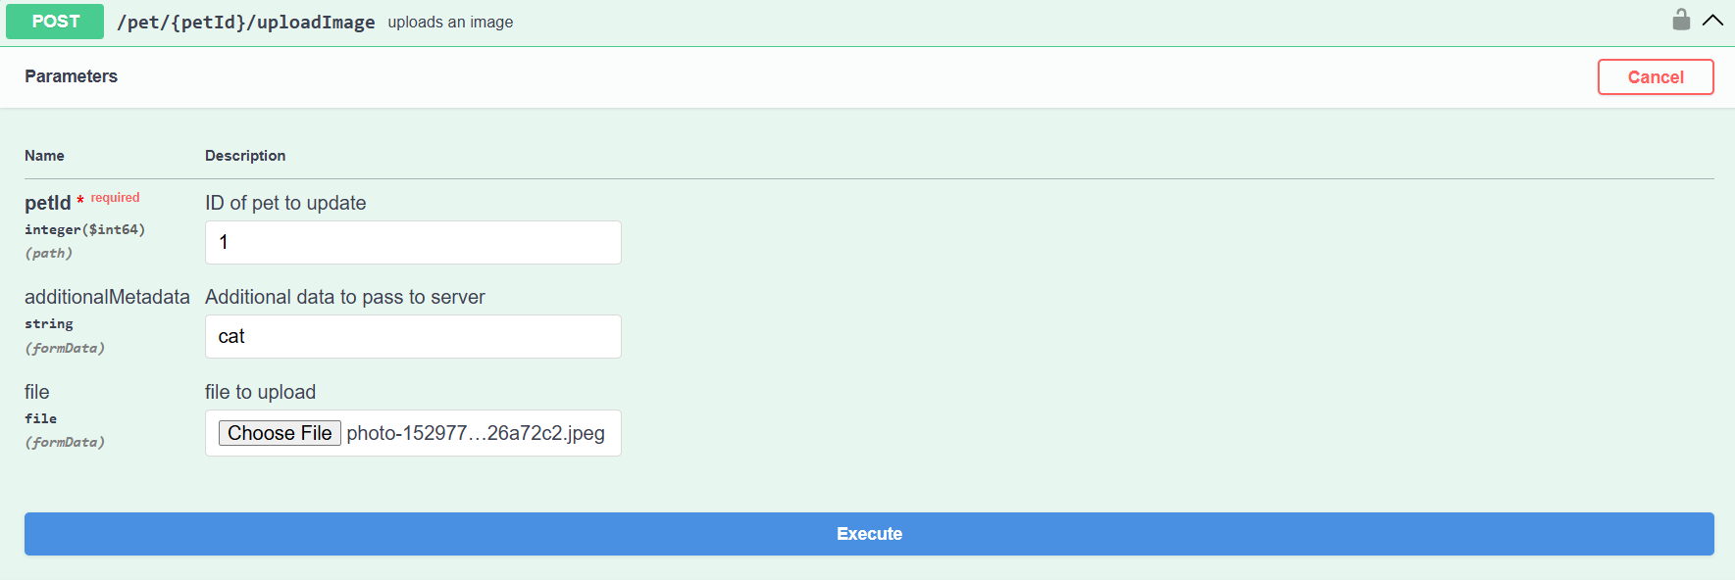

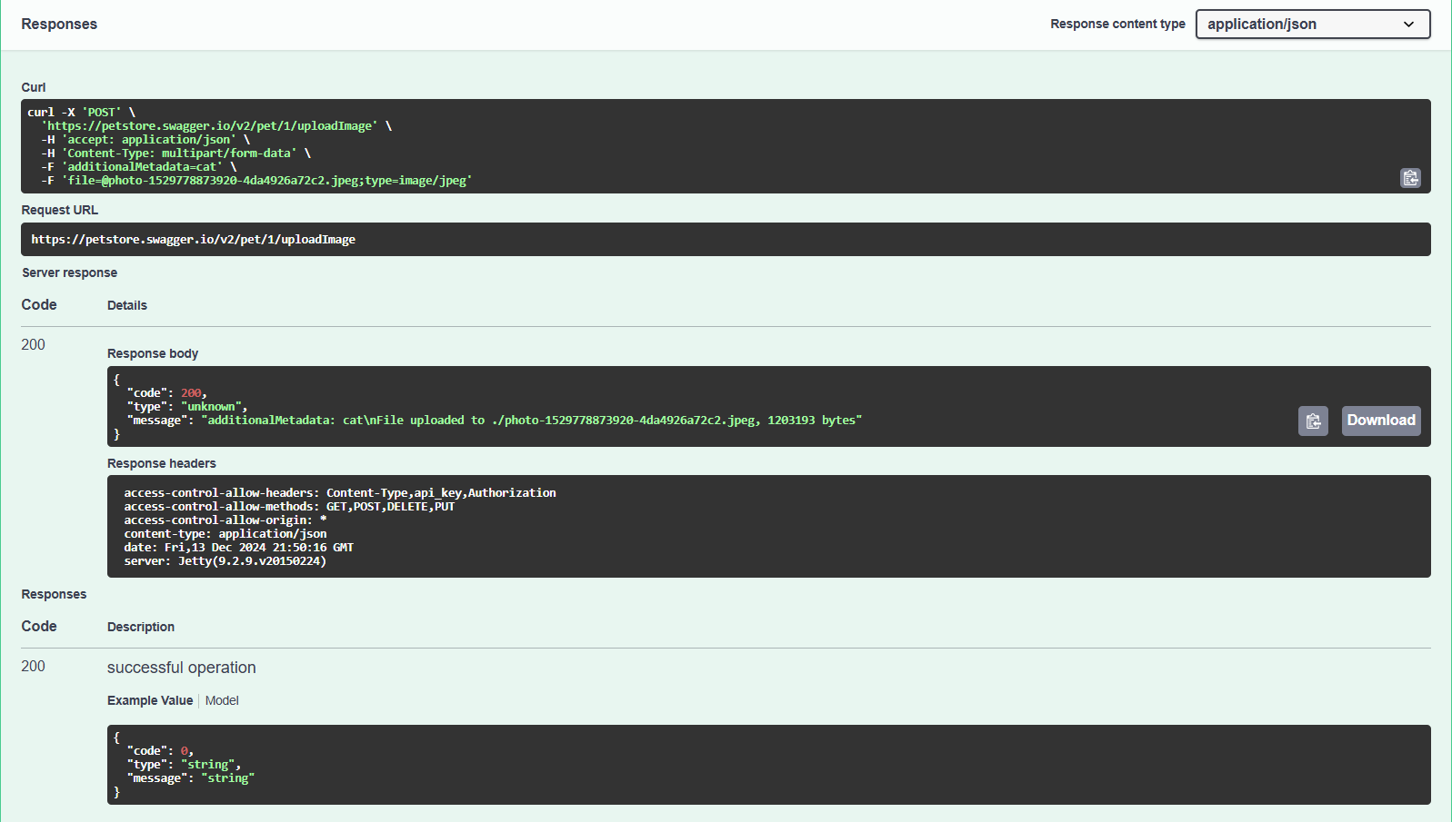

**Postman:**

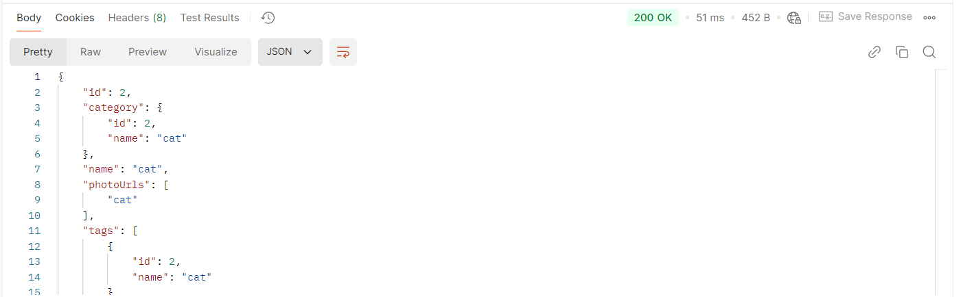

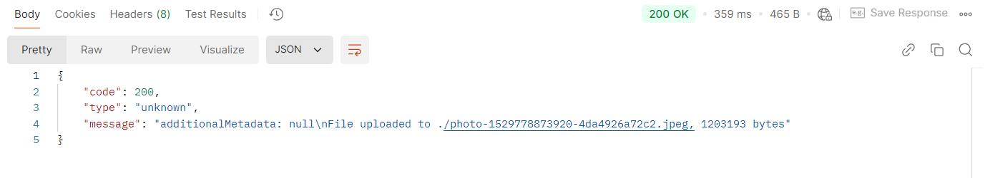

**Test Case - 2 :** To test the POST API of 'Everything about Pets' by ignoring the additionalMetadata field and checking for successful response.

**Swagger:**

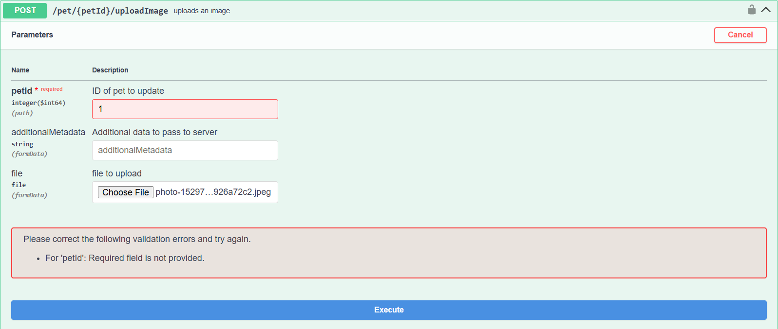

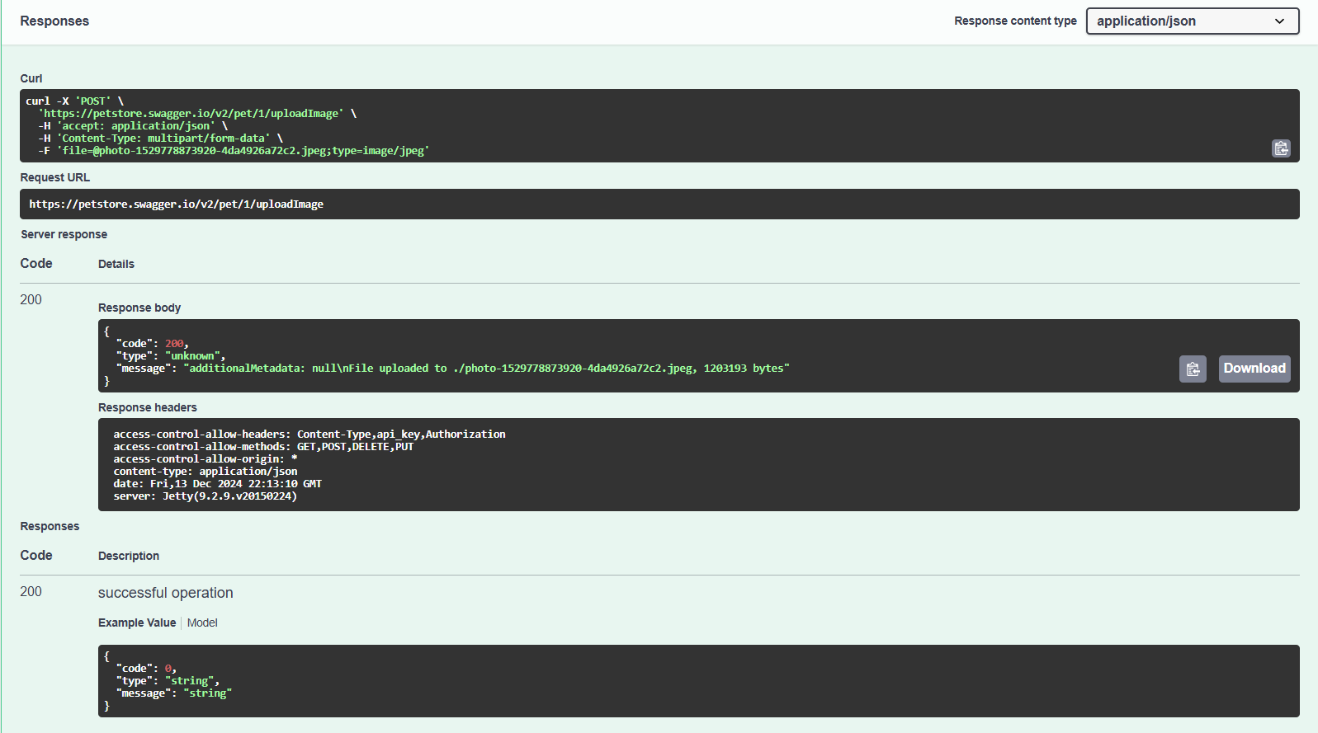

**Postman:**

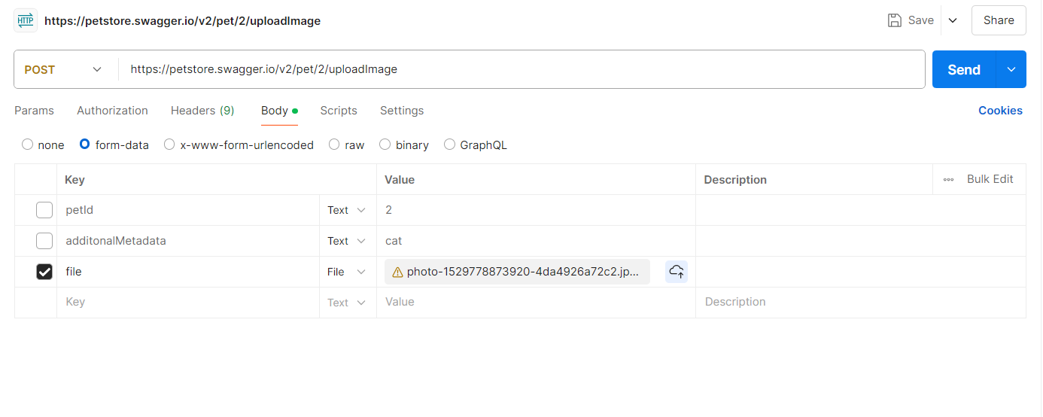



**Test Case - 3 :** To test the POST API of 'Everything about Pets' by not attaching the file and checking for bad response.

**Swagger:**

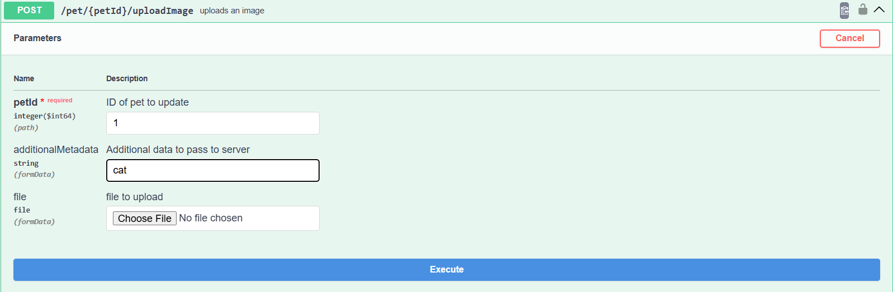

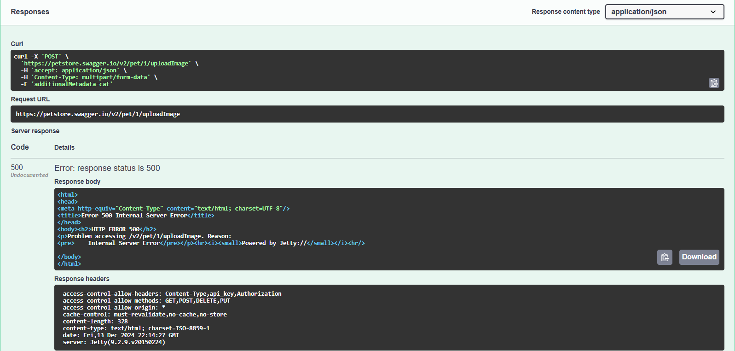

**Postman:**

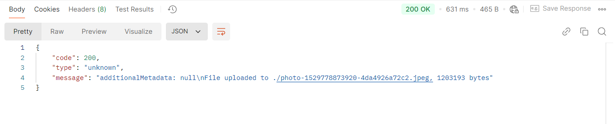

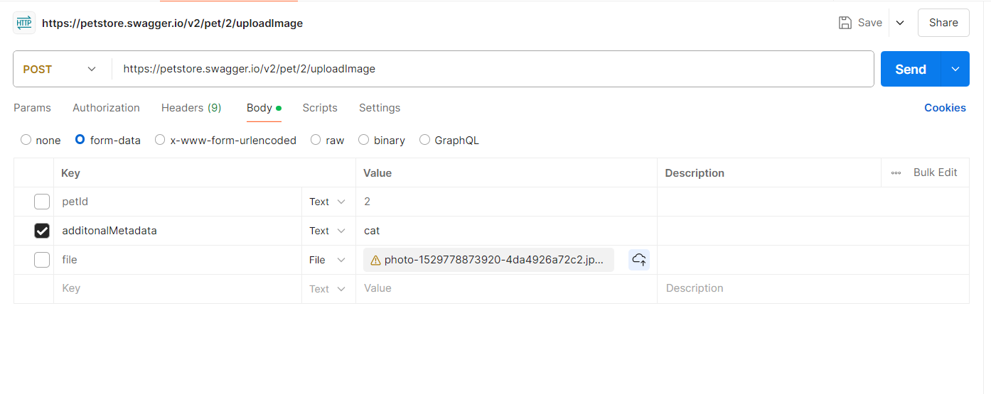

**Test Case - 4 :** To test the POST API of 'Everything about Pets' by adding a new pet to the store and checking for successful response.

**Swagger:**

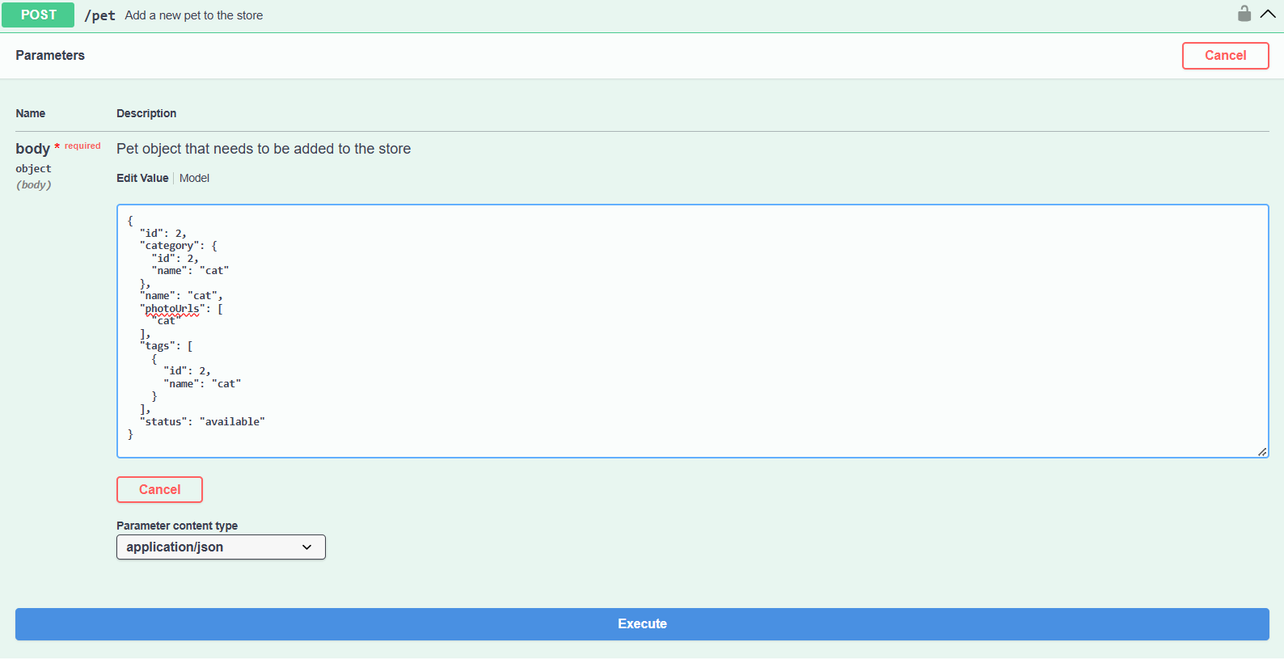

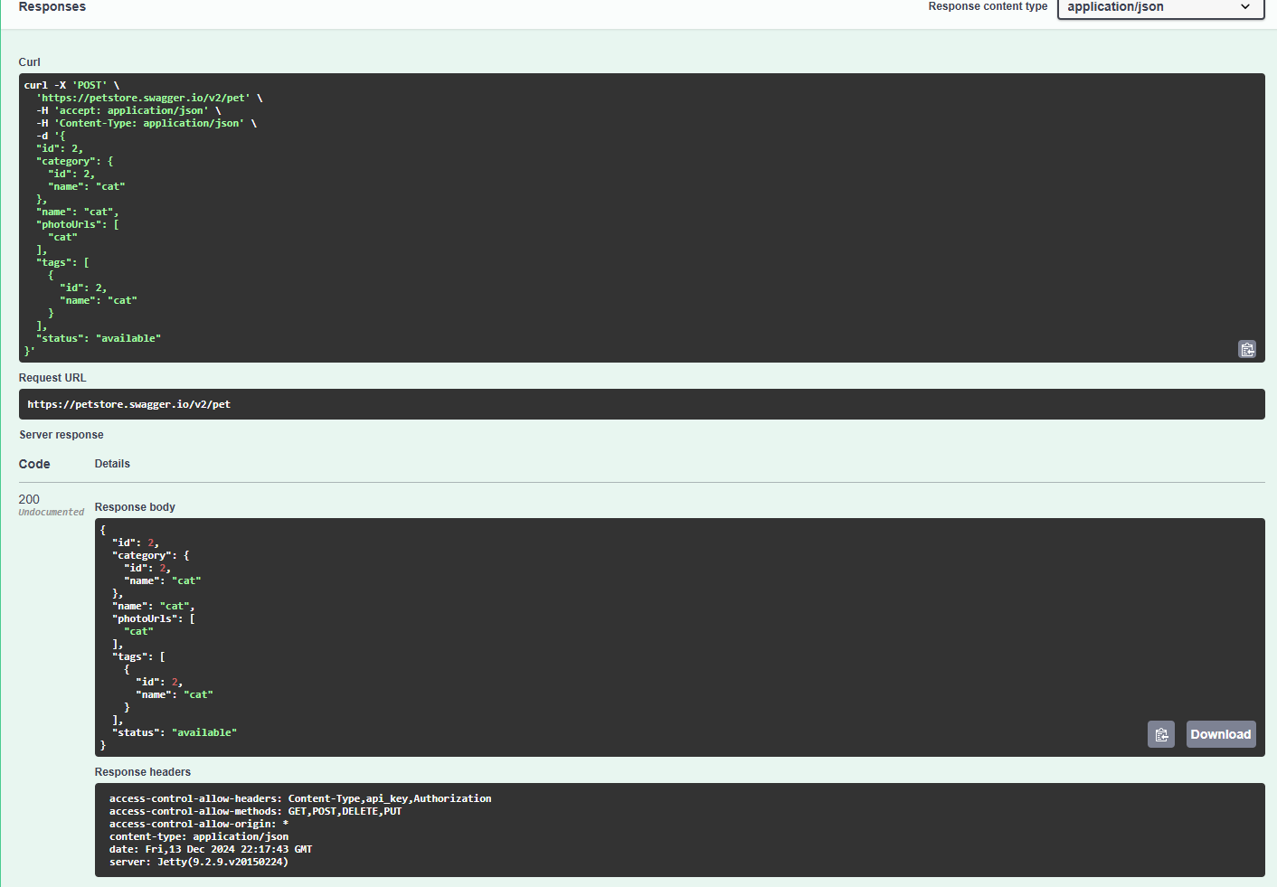

**Postman:**

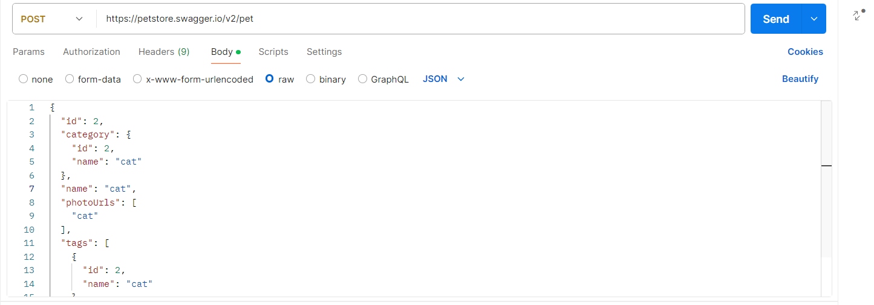



**Test Case - 5 :** To test the PUT API of 'Everything about Pets' by editing the already created pet record and checking for successful response

**Swagger:**

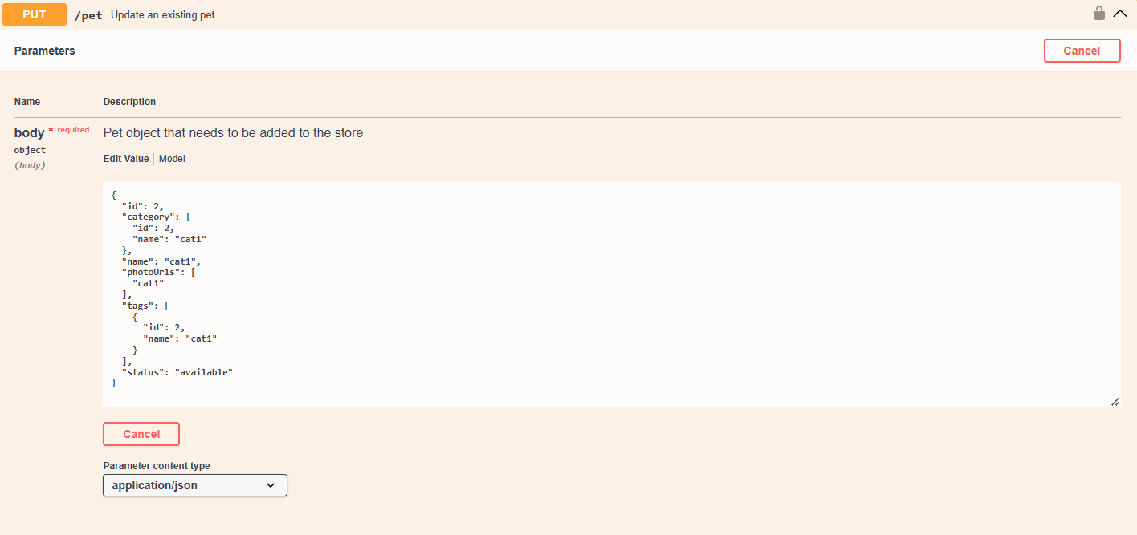

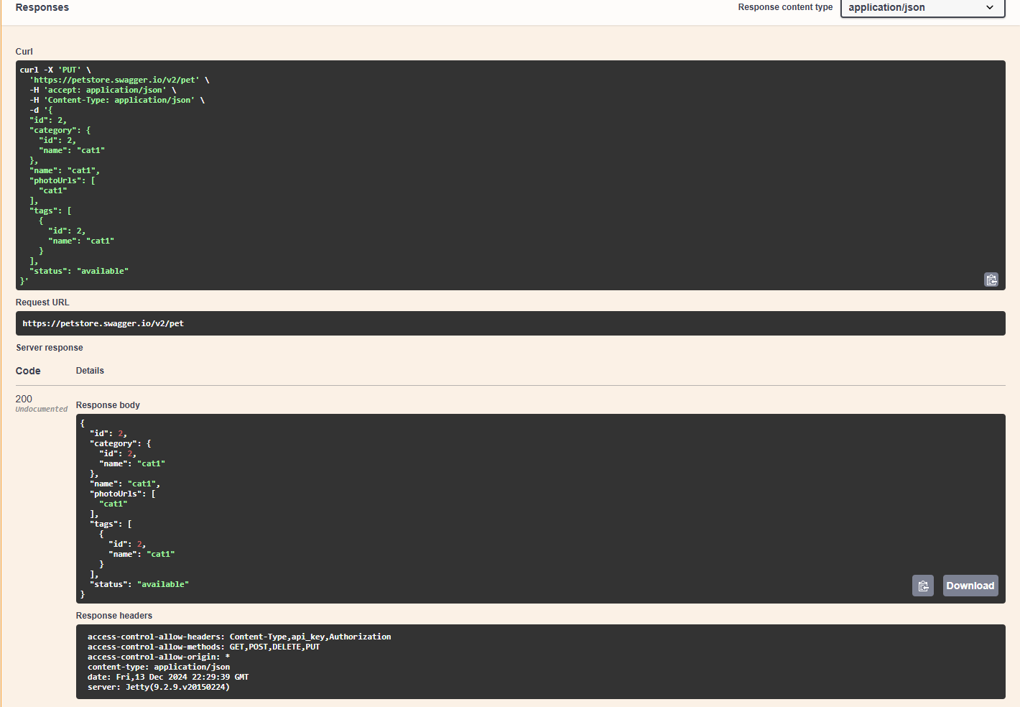

**Postman:**

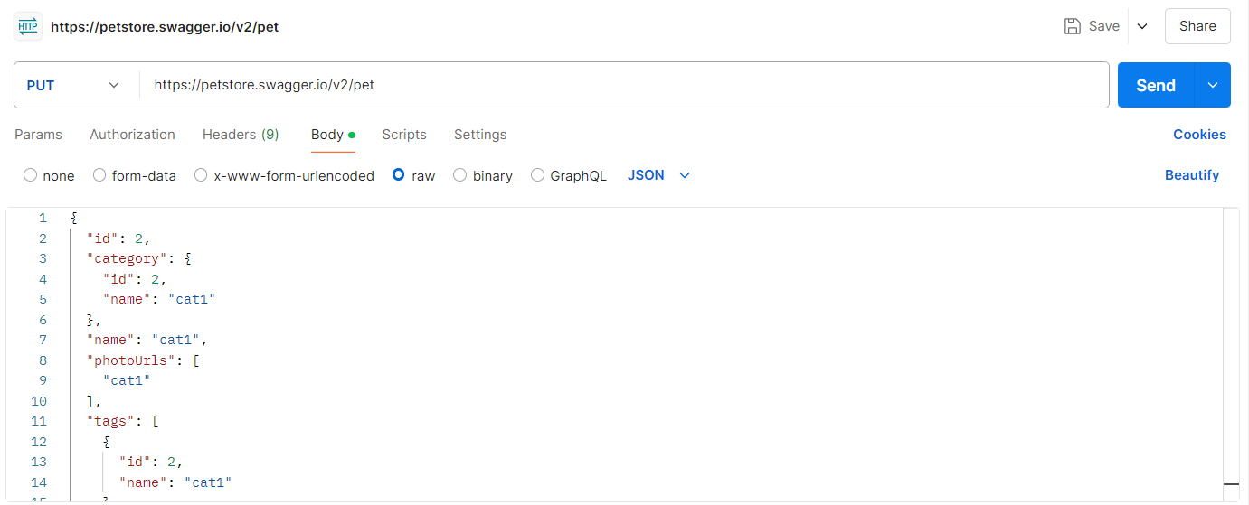

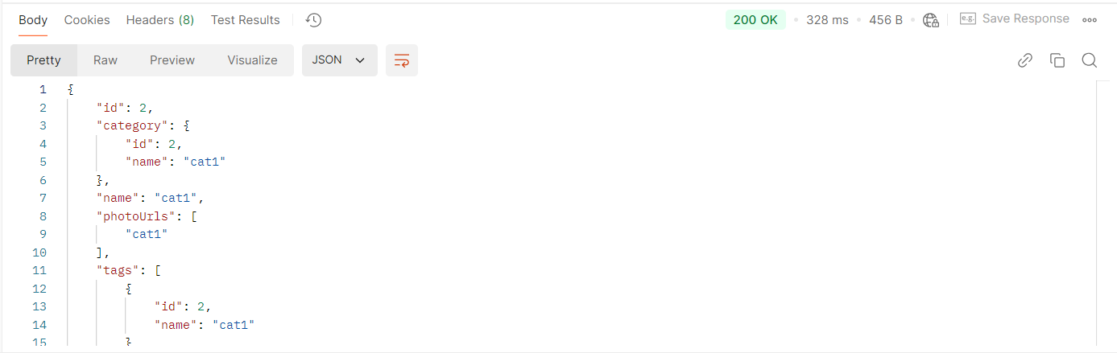

**Test Case - 6 :** To test the GET API of 'Everything about Pets' by sorting the pet record based on status field and checking for successful response.

**Swagger:**

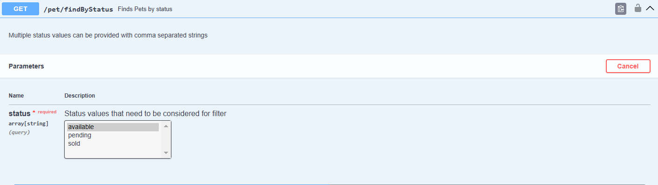

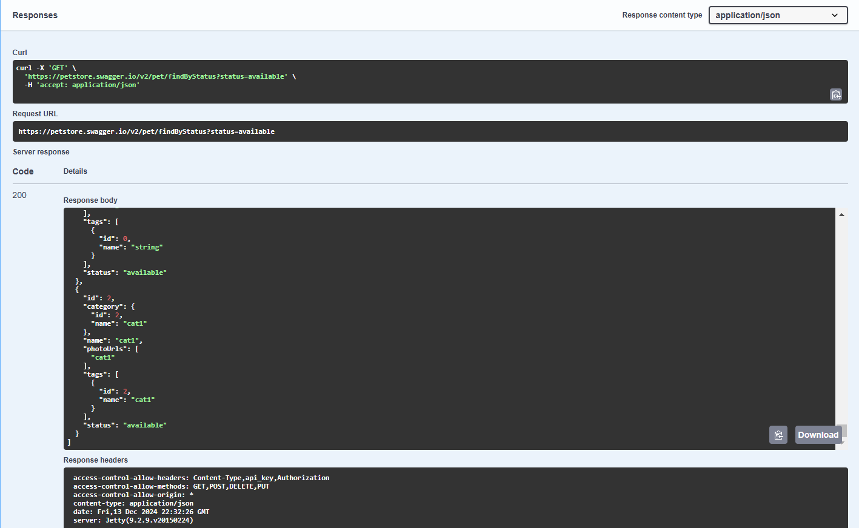

**Postman:**

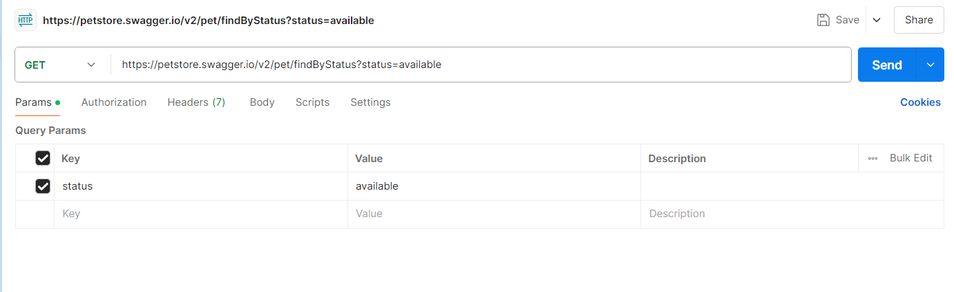

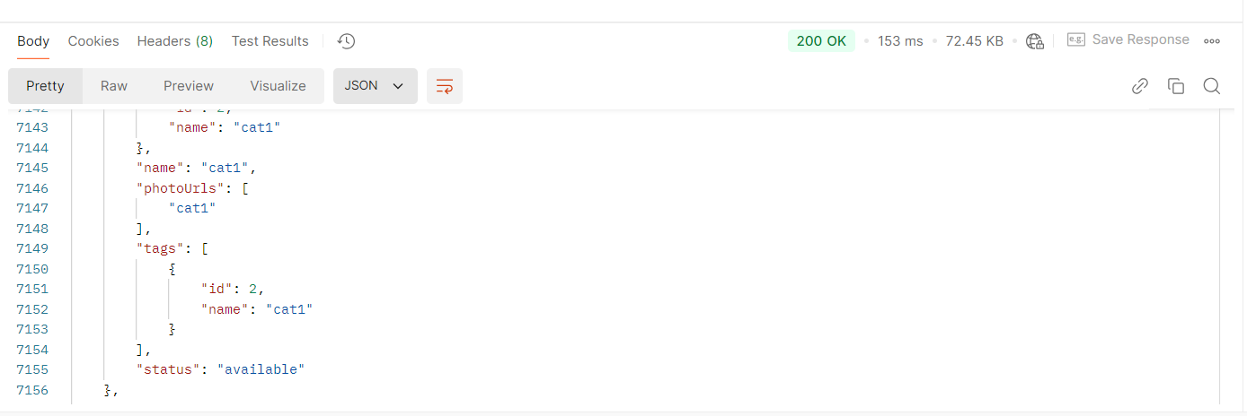

**Test Case - 7 :** To test the POST API of 'Everything about Pets' by adding a new pet to the store and checking for successful response

**Swagger:**

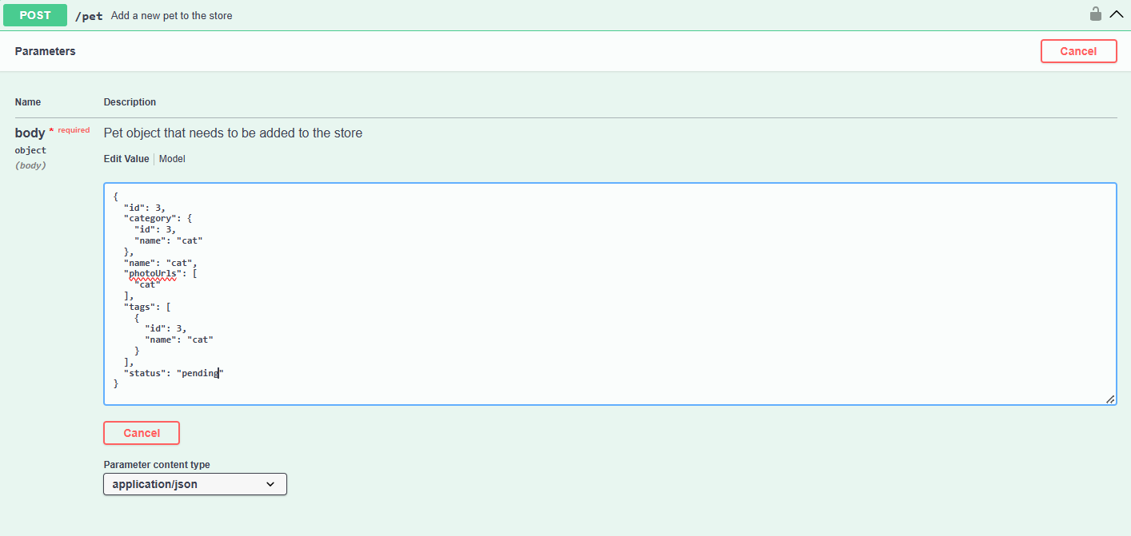

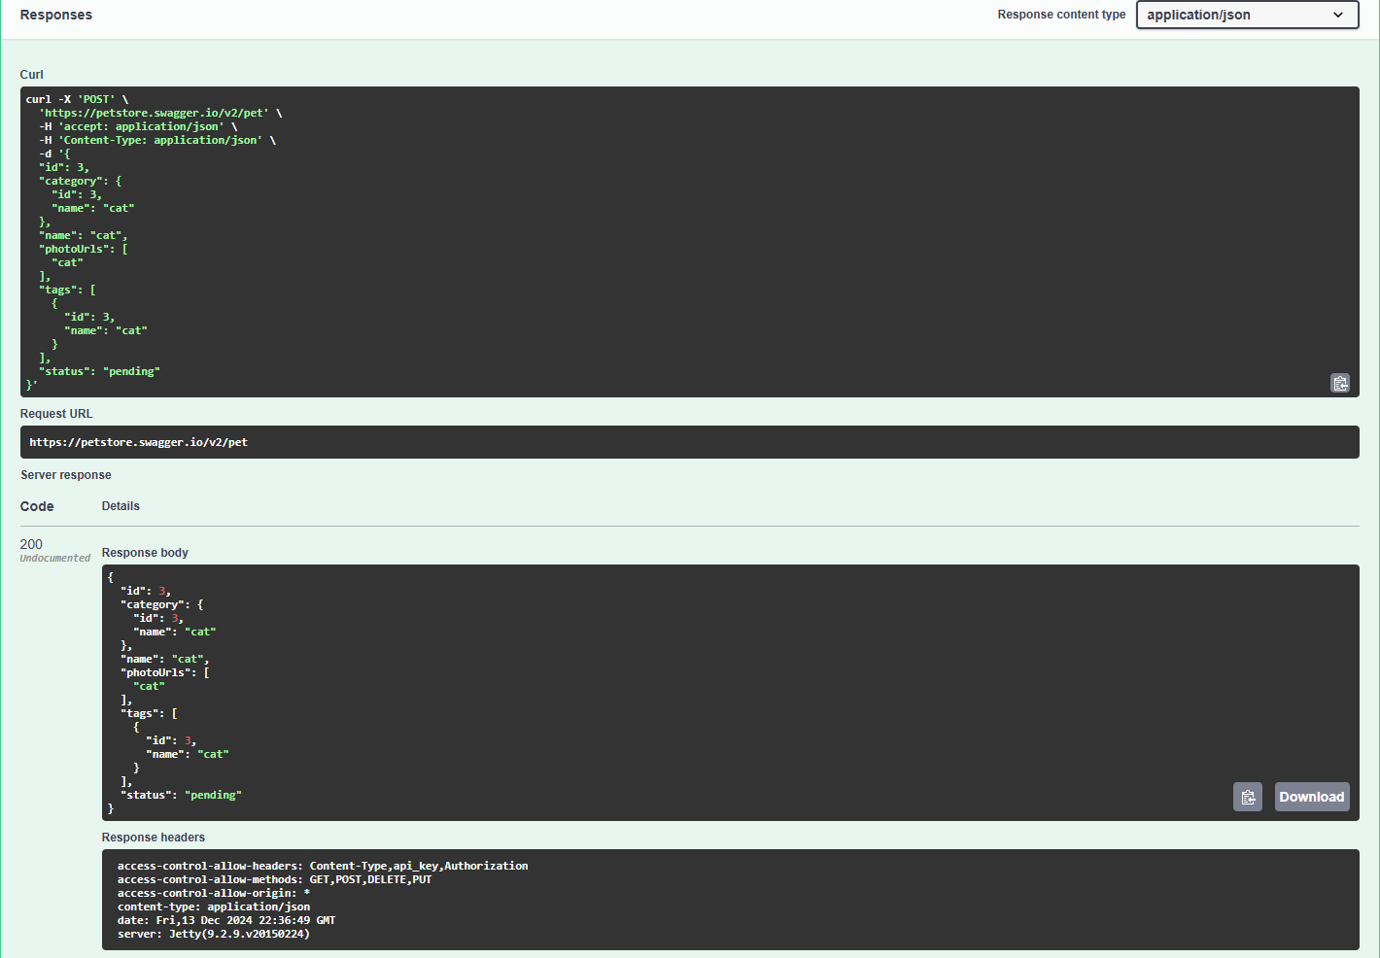

**Postman:**

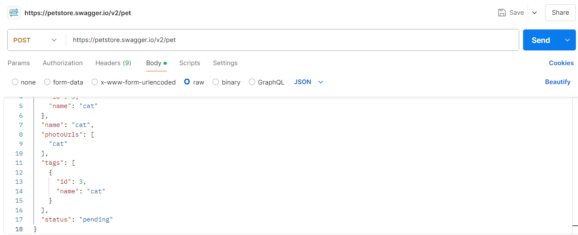

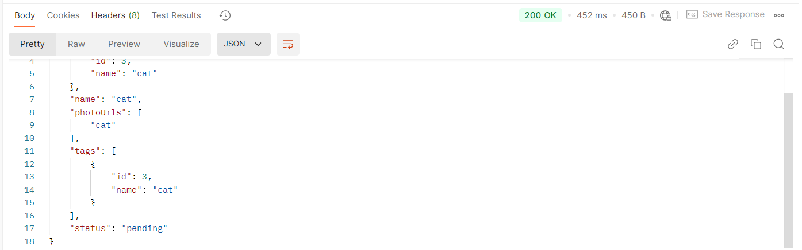

**Test Case - 8 :** To test the PUT API of 'Everything about Pets' by editing the already created pet record and checking for successful response

**Swagger:**

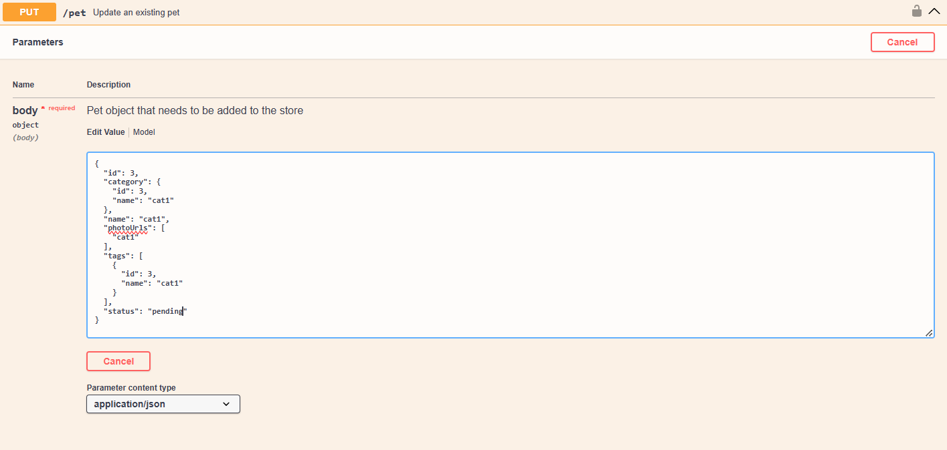



**Postman:**

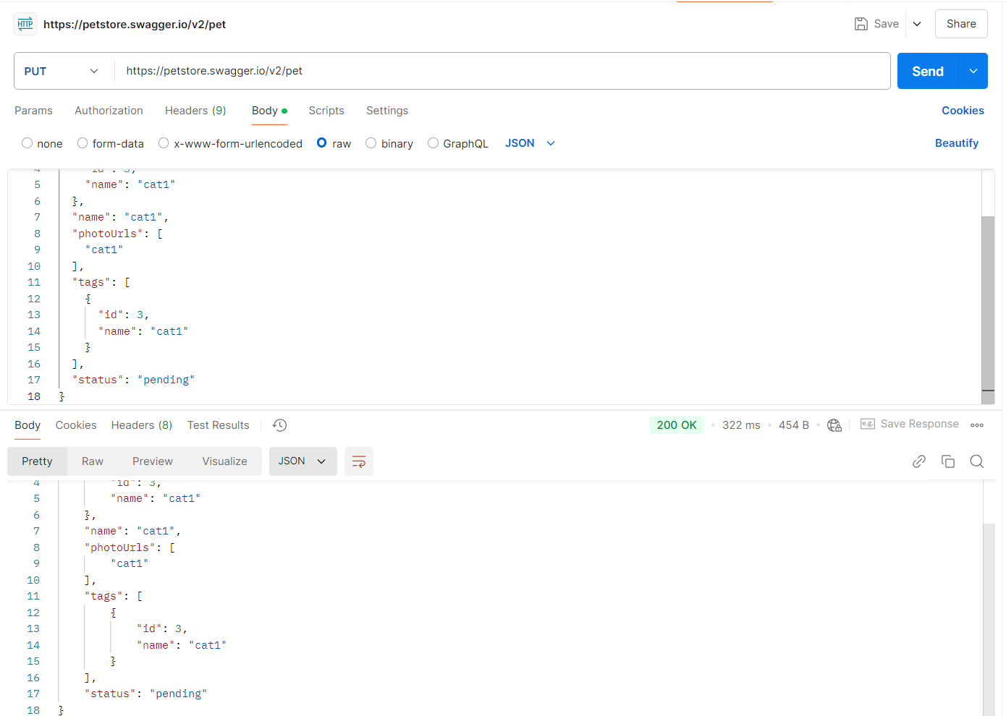

**Test Case - 9 :** To test the GET API of 'Everything about Pets' by sorting the pet record based on status field and checking for successful response.

**Swagger:**

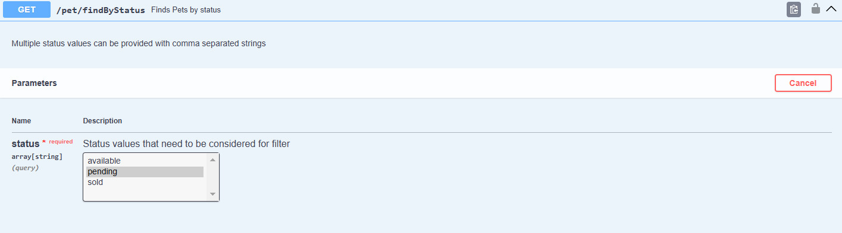

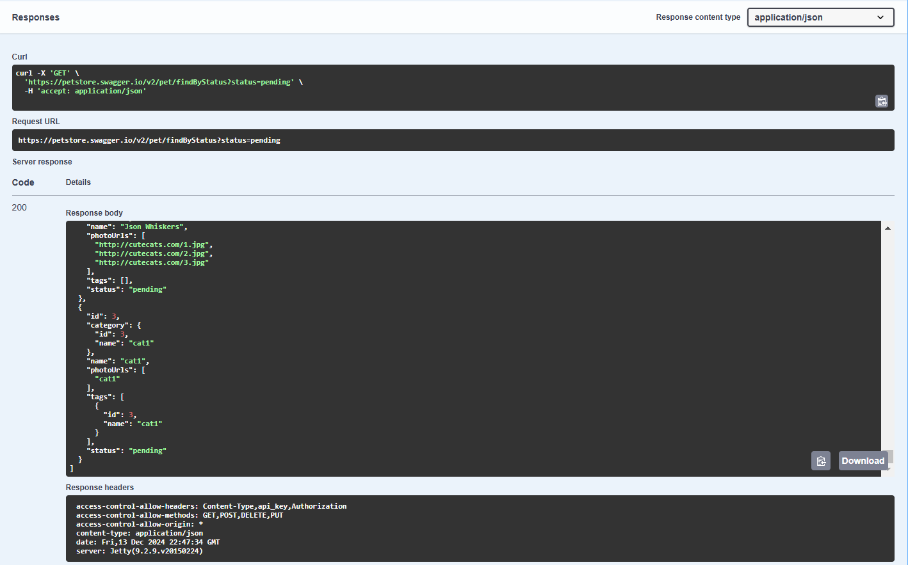

**Postman:**

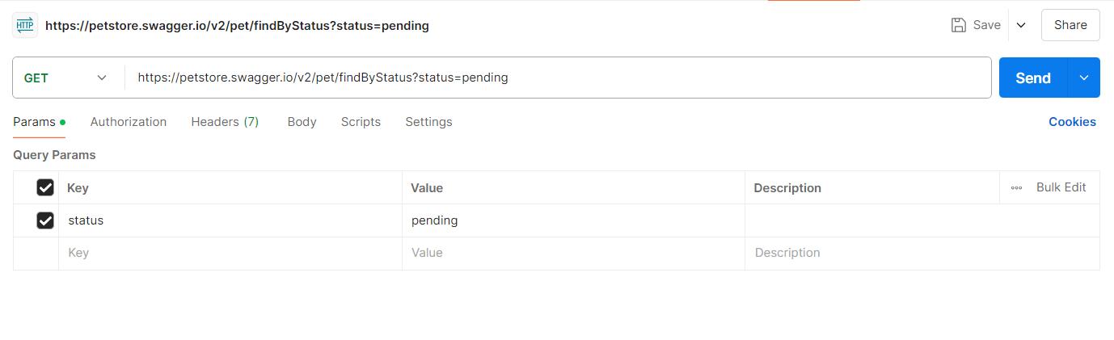

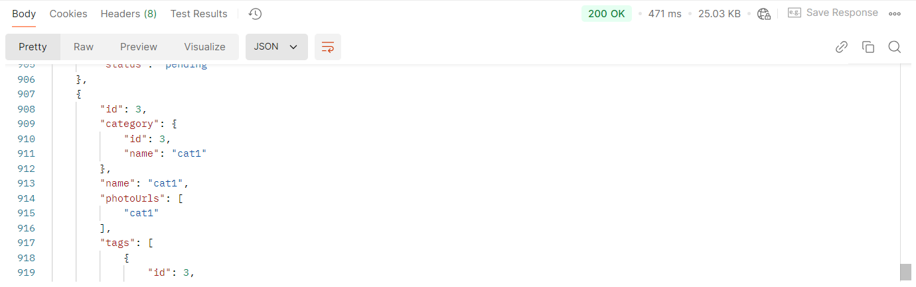

**Test Case - 10 :** To test the POST API of 'Everything about Pets' by adding a new pet to the store and checking for successful response.

**Swagger:**

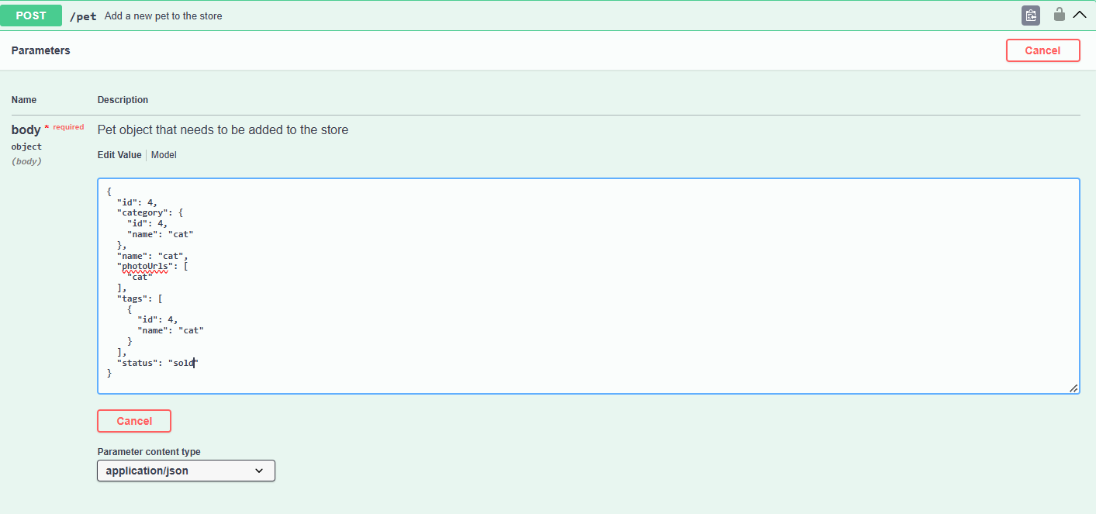

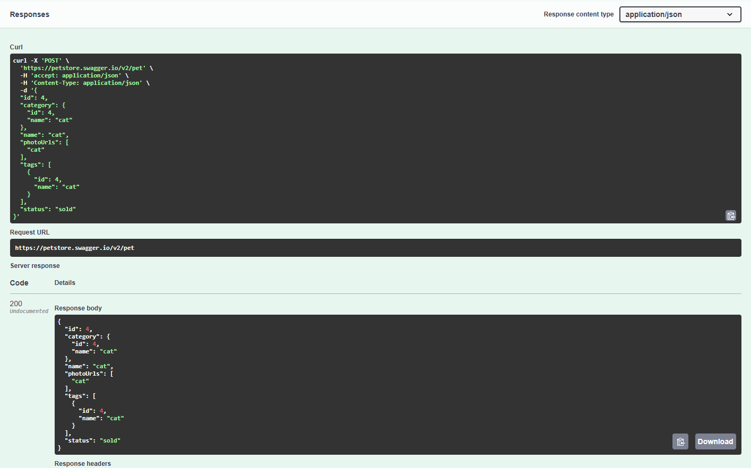

**Postman:**

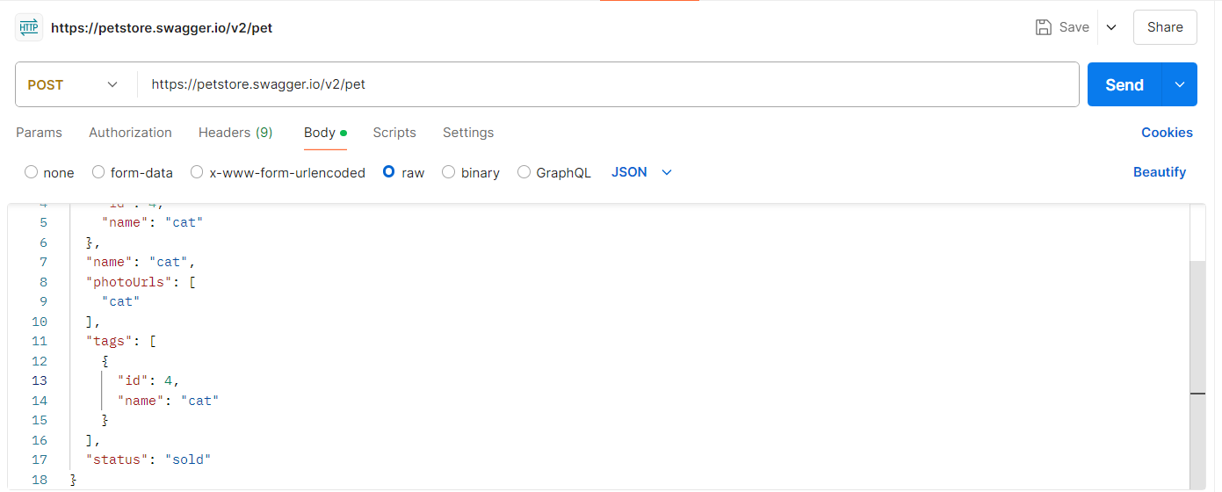

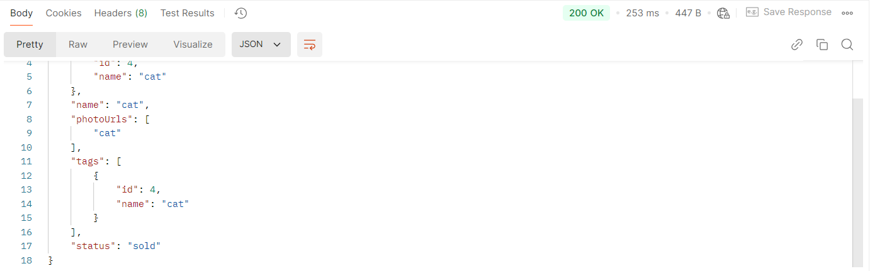

**Test Case - 11 :** To test the PUT API of 'Everything about Pets' by editing the already created pet record and checking for successful response

**Swagger:**

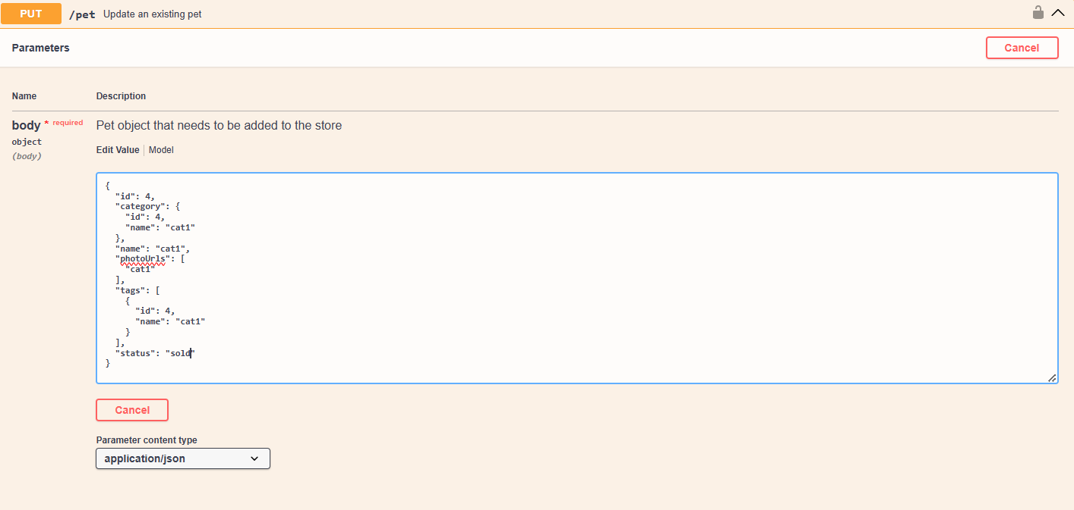

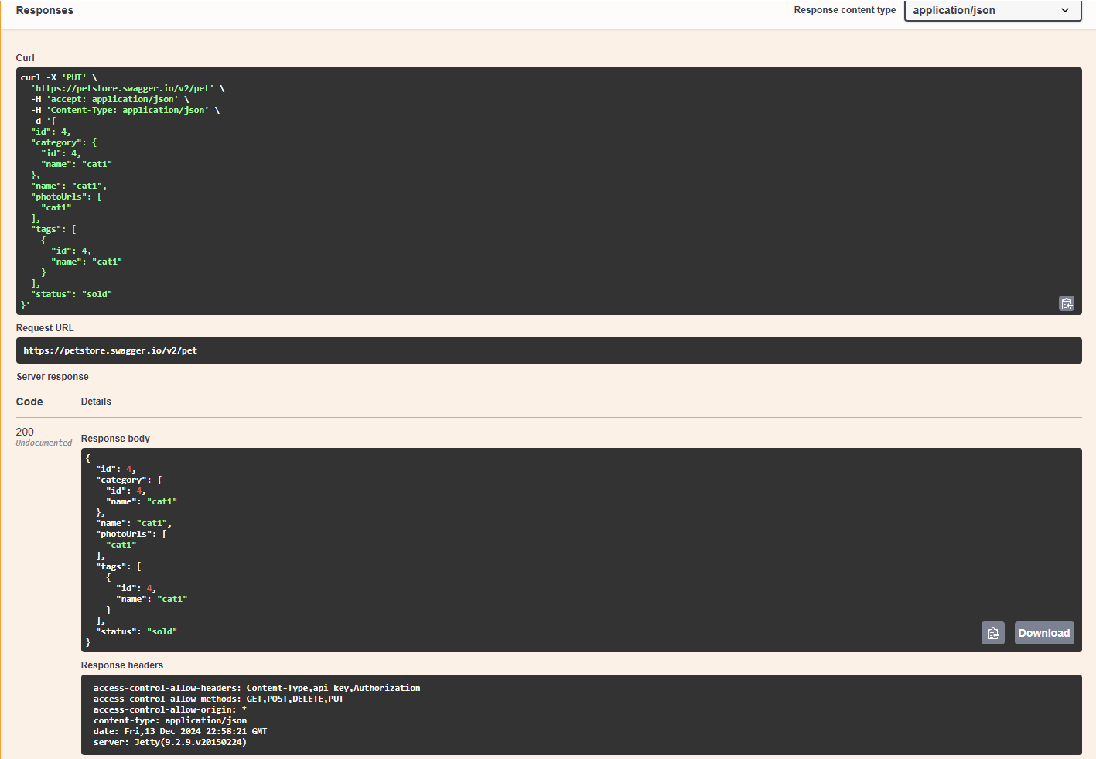

**Postman:**

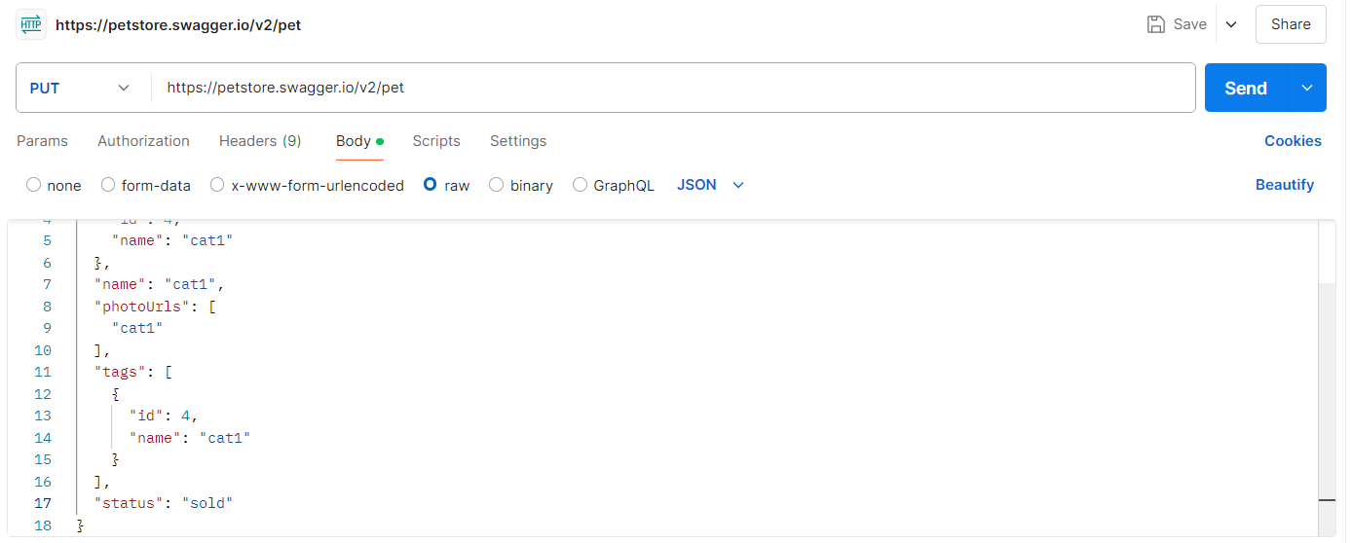

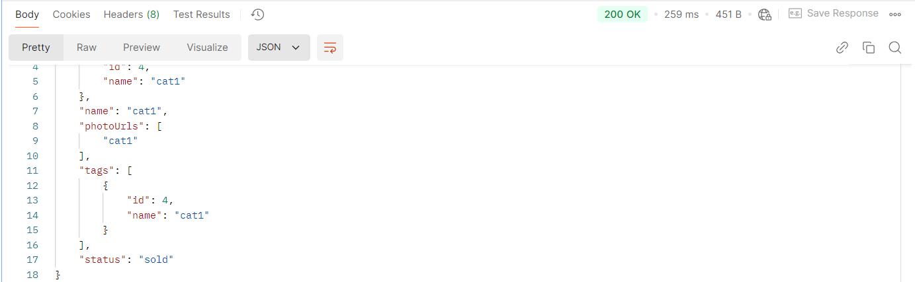

**Test Case - 12 :** To test the GET API of 'Everything about Pets' by sorting the pet record based on status field and checking for successful response.

**Swagger:**

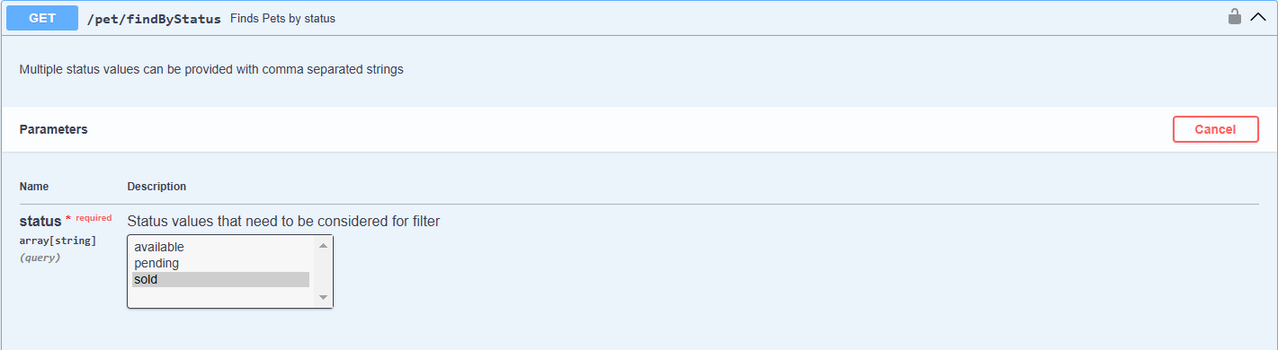

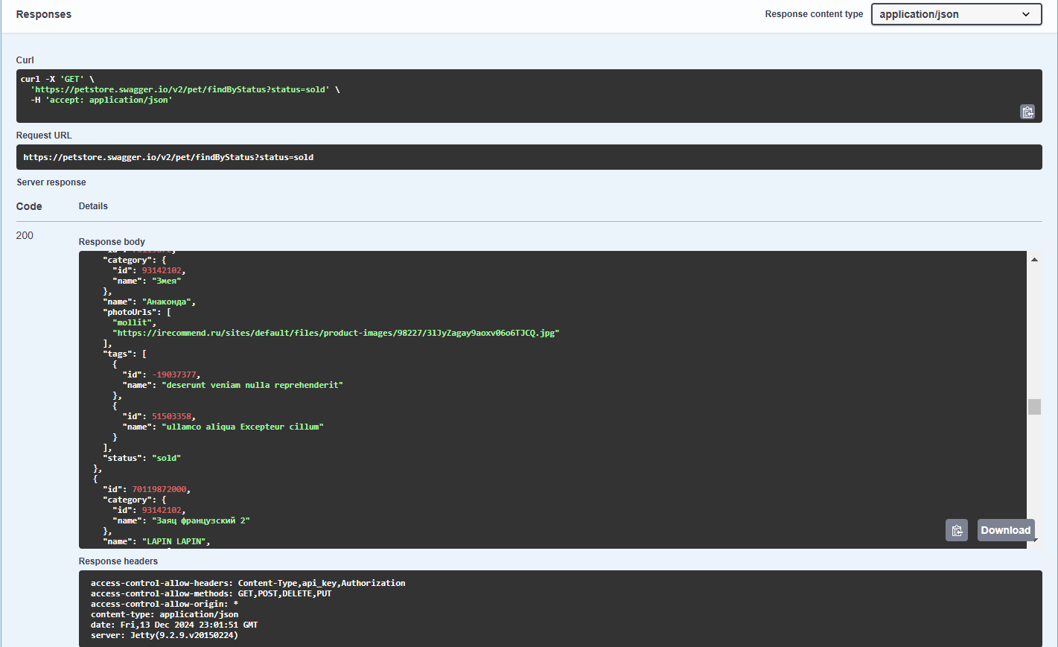

**Postman:**

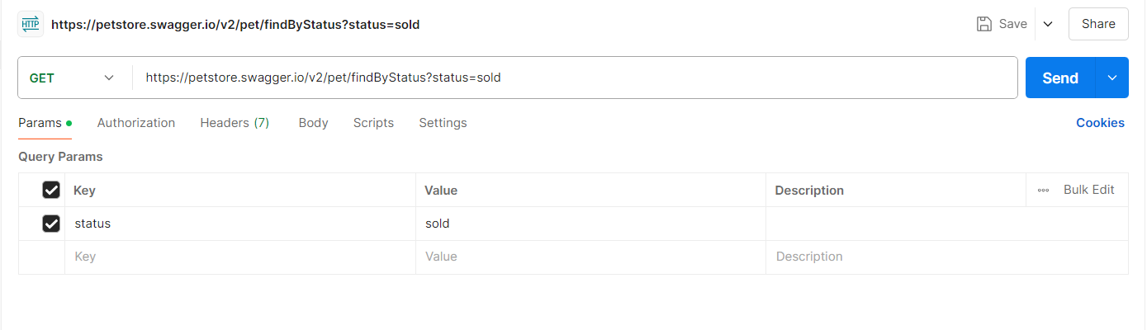



**Test Case - 13 :** To test the GET API of 'Everything about Pets' by sorting the pet record based on petId and checking for successful response

**Swagger:**

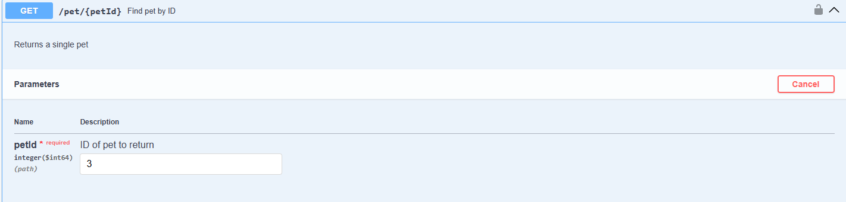

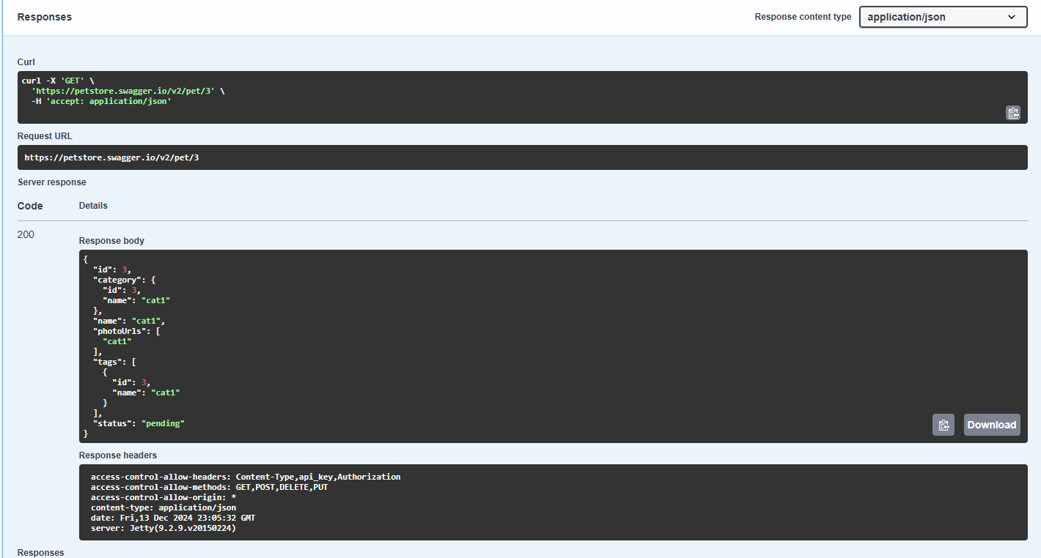

**Postman:**

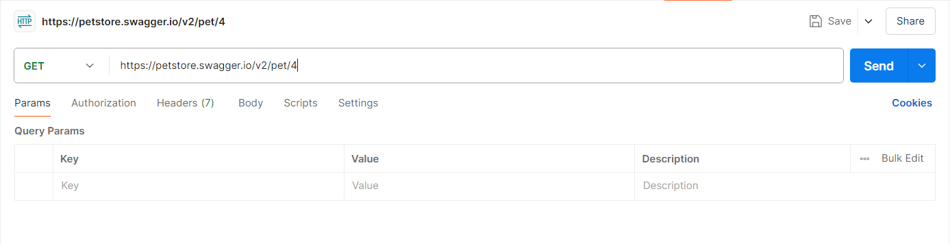

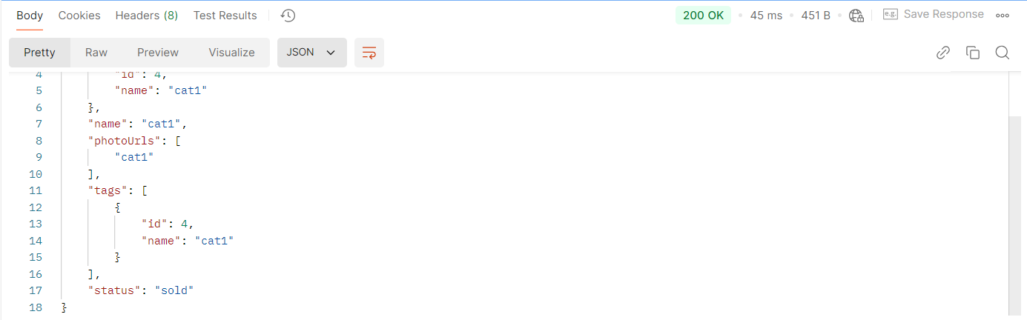

**Test Case - 14 :** To test the PUT API of 'Everything about Pets' by editing the already created pet record using Id by changing the name and status and checking for successful response

**Swagger:**

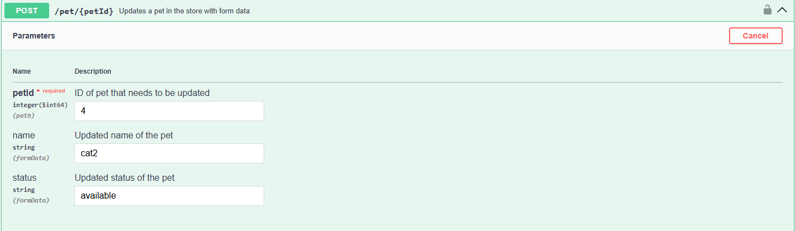

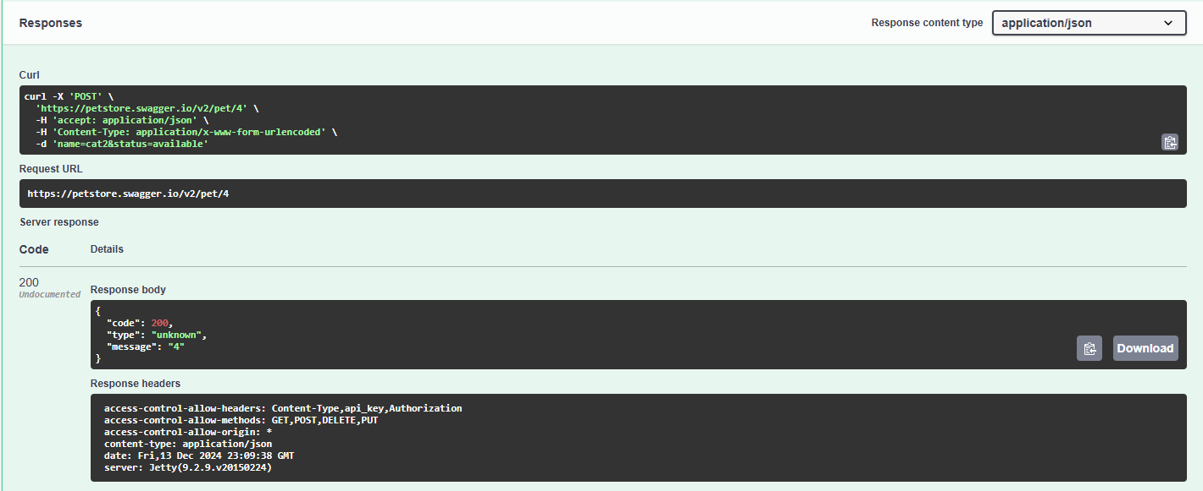

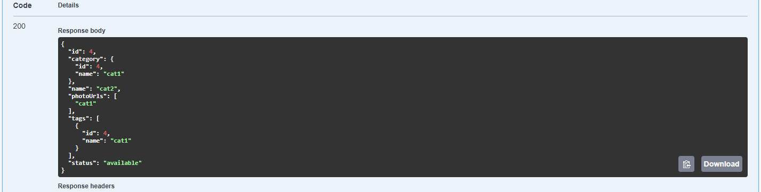

**Postman:**

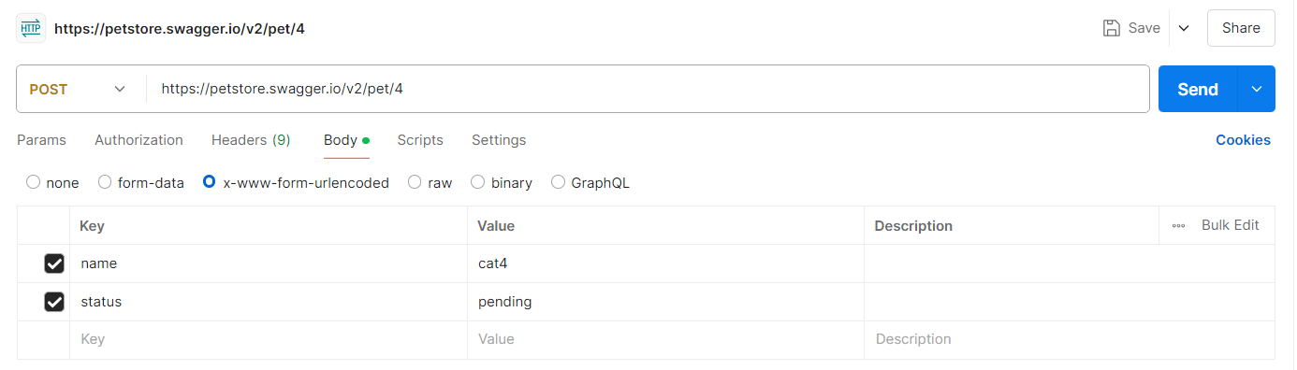

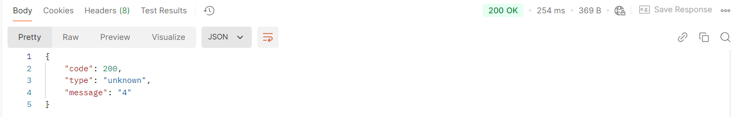

**Test Case - 15 :** To test the PUT API of 'Everything about Pets' by editing the already created pet record using an unknown Id by changing the name and status and checking for bad response

**Swagger:**

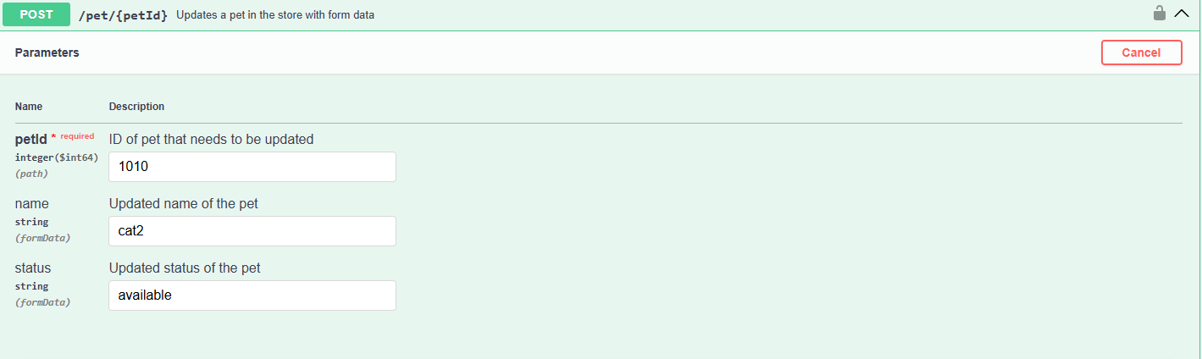

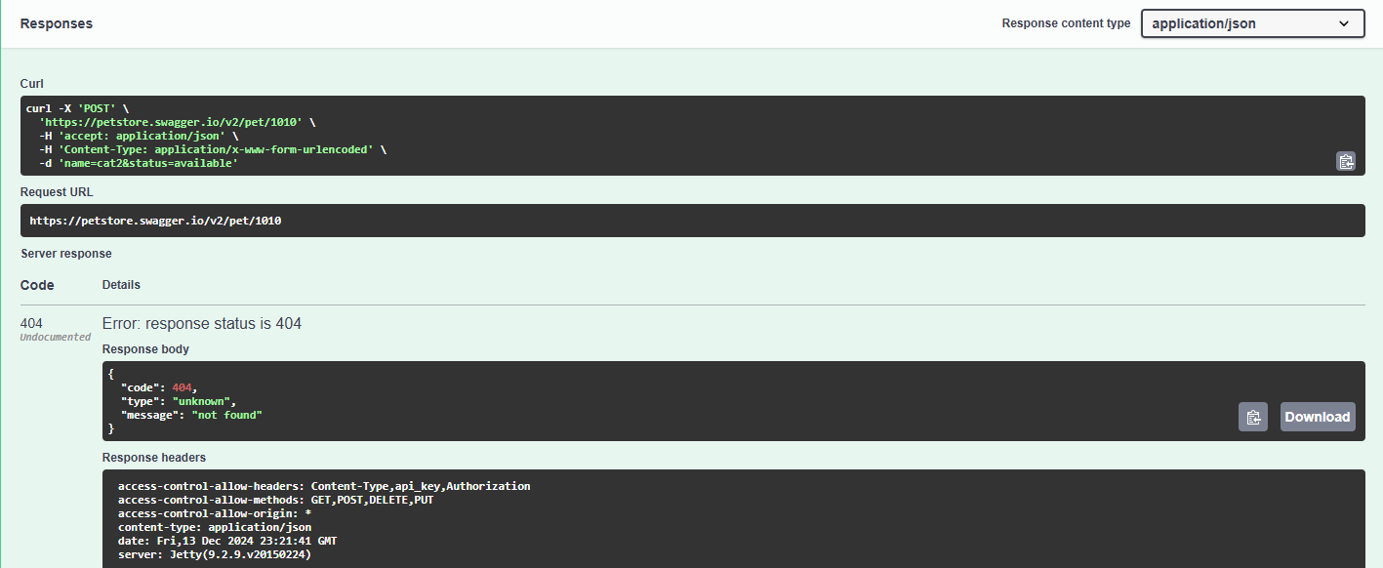

**Postman:**

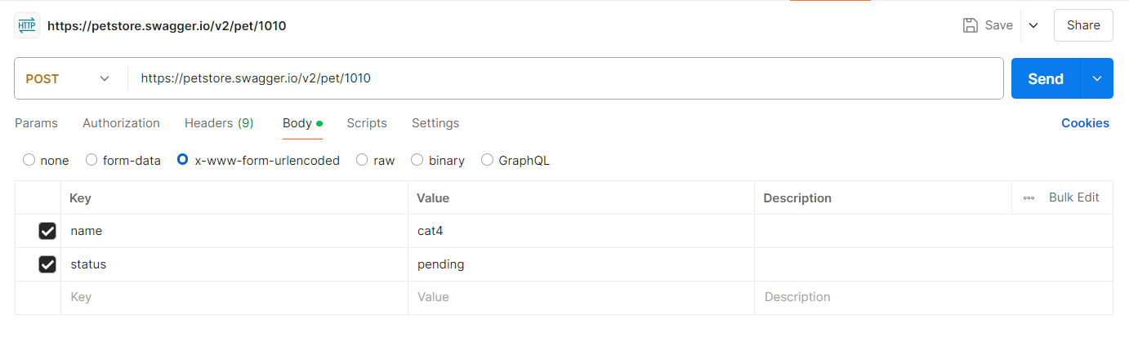

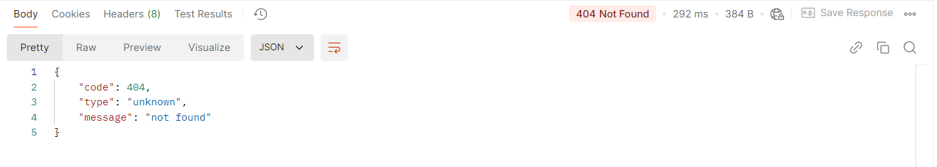

**Test Case - 16 :** To test the DELETE API of 'Everything about Pets' by inputting the petId and check for successful response.

**Swagger:**

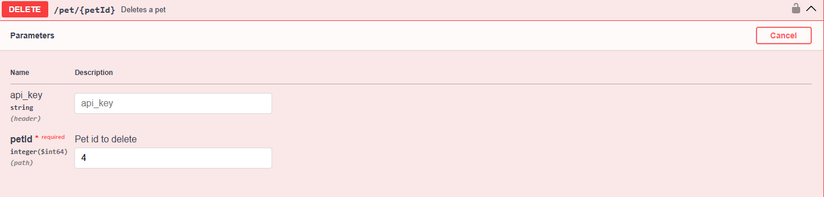

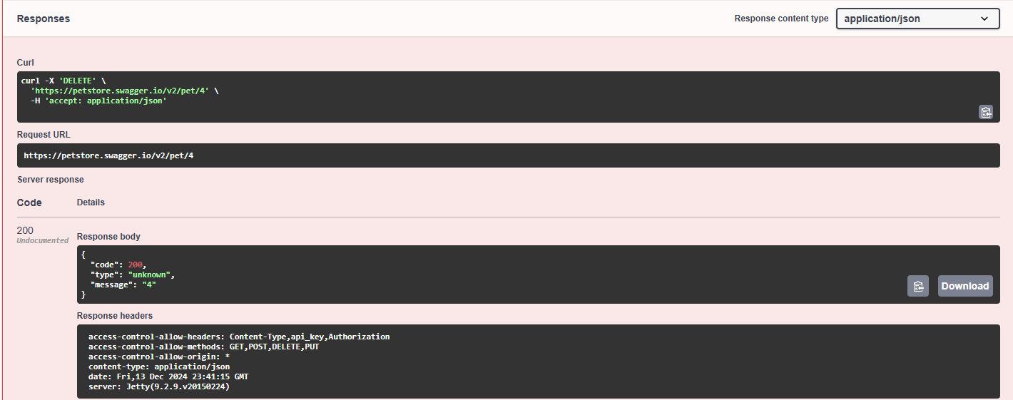

**Postman:**

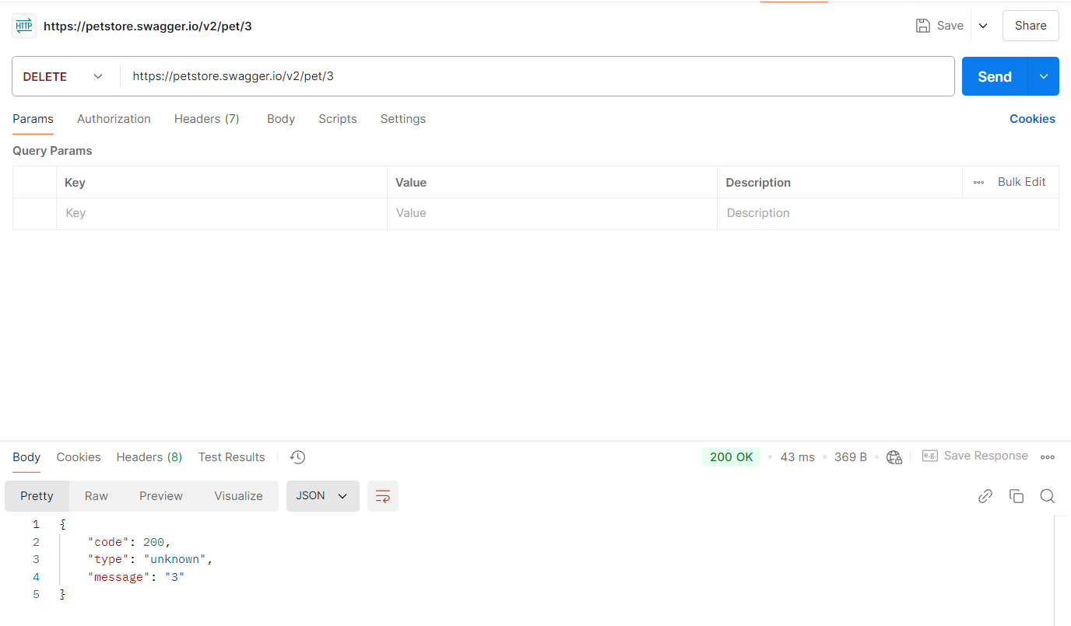

**Test Case - 17 :** To test the DELETE API of 'Everything about Pets' by inputting the invalid petId and check for bad response.

**Swagger:**

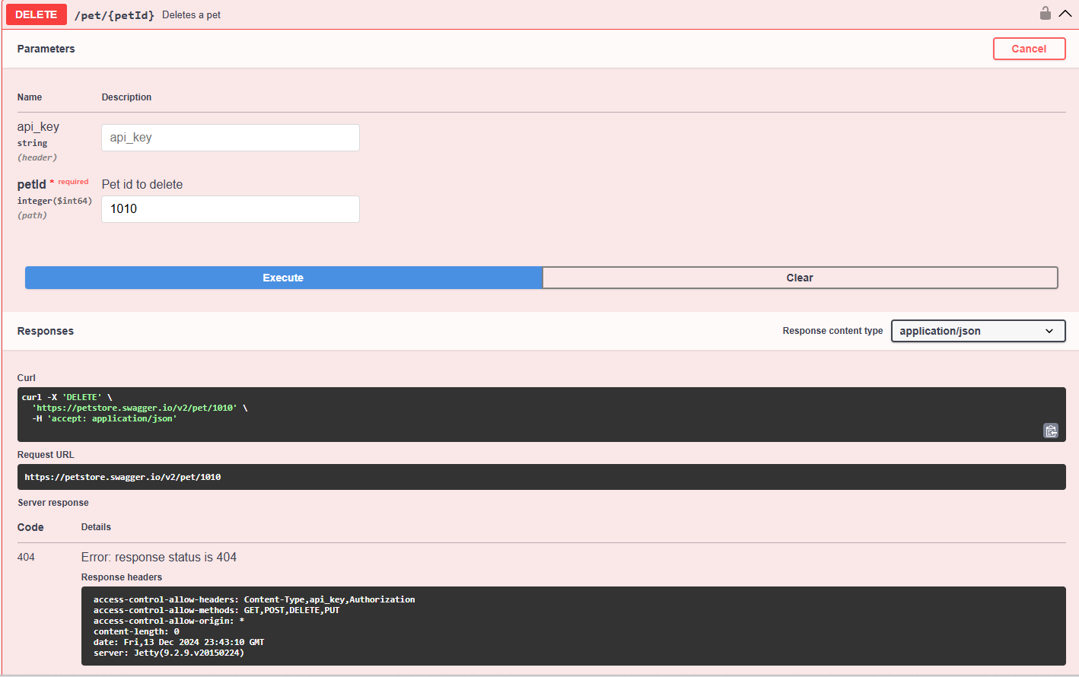

**Postman:**

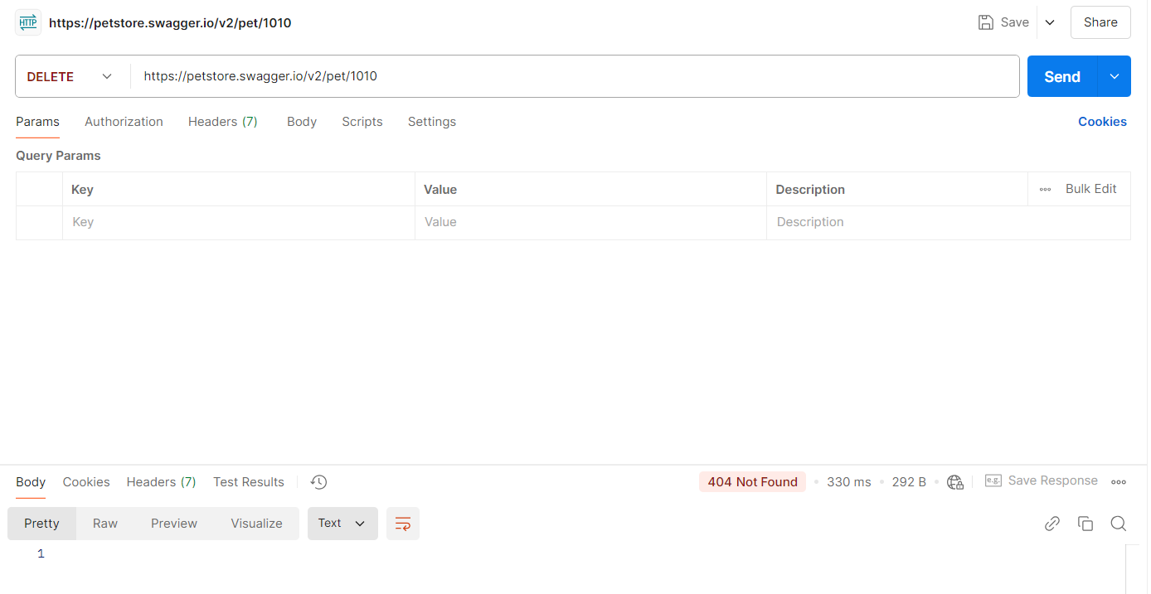

**Test Case - 18 :** To test the GET API of 'Access to Petstore orders' to return all pet inventories by status and checking for successful response.

**Swagger:**

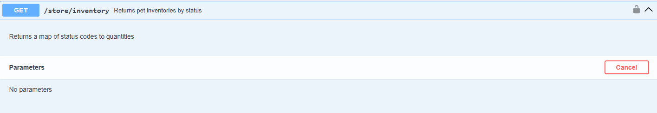

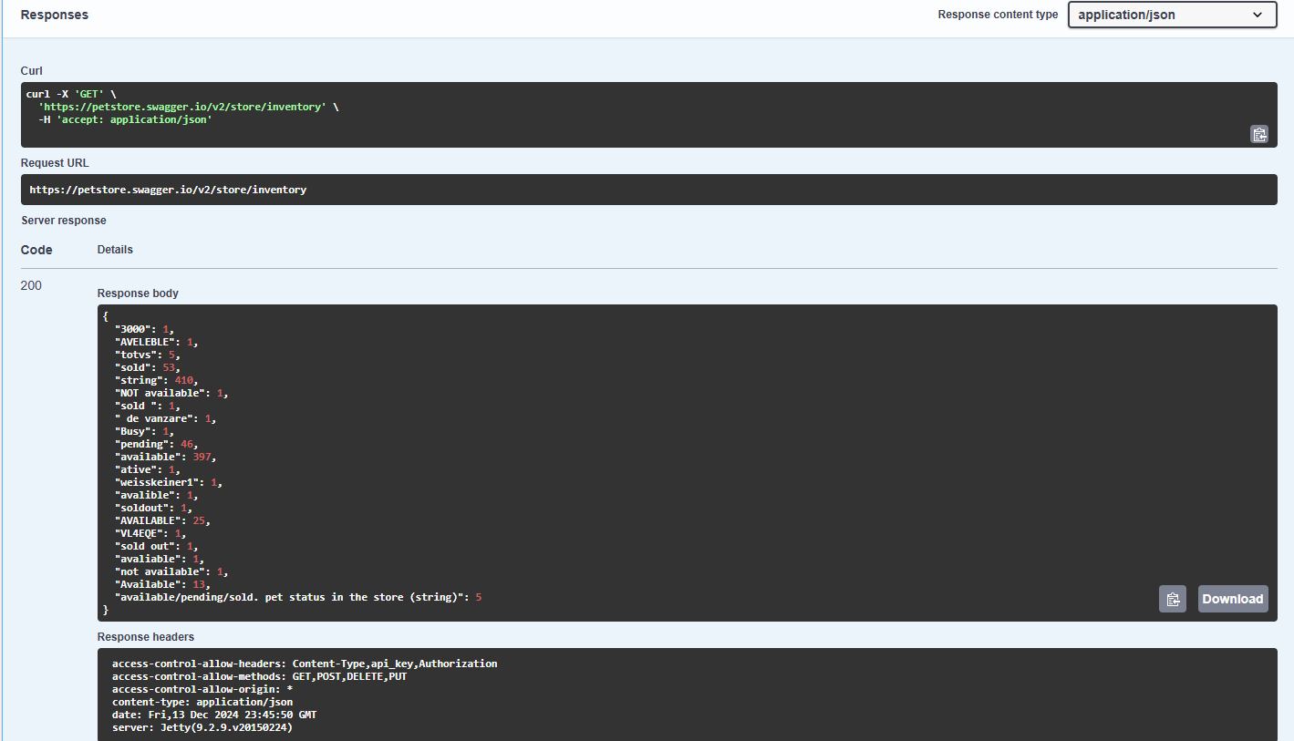

**Postman:**

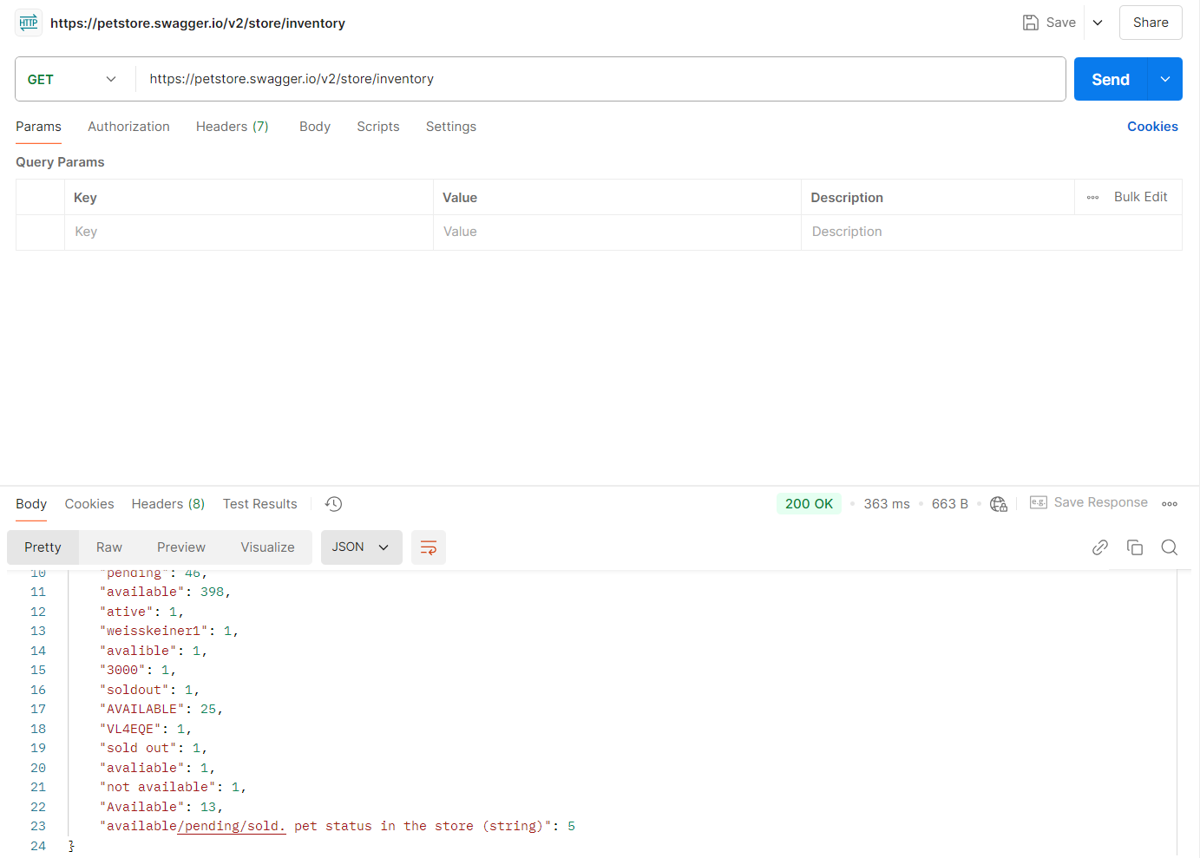

**Test Case - 19 :** To test the POST API of 'Access to Petstore orders' to order a pet by inputting the details and checking for successful response.

**Swagger:**

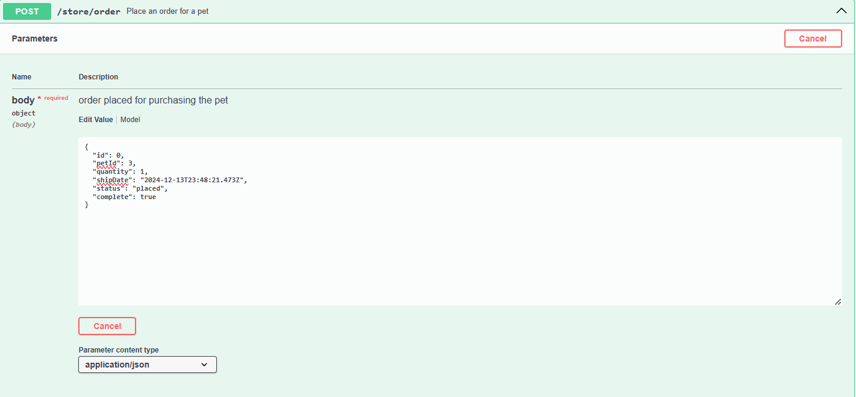

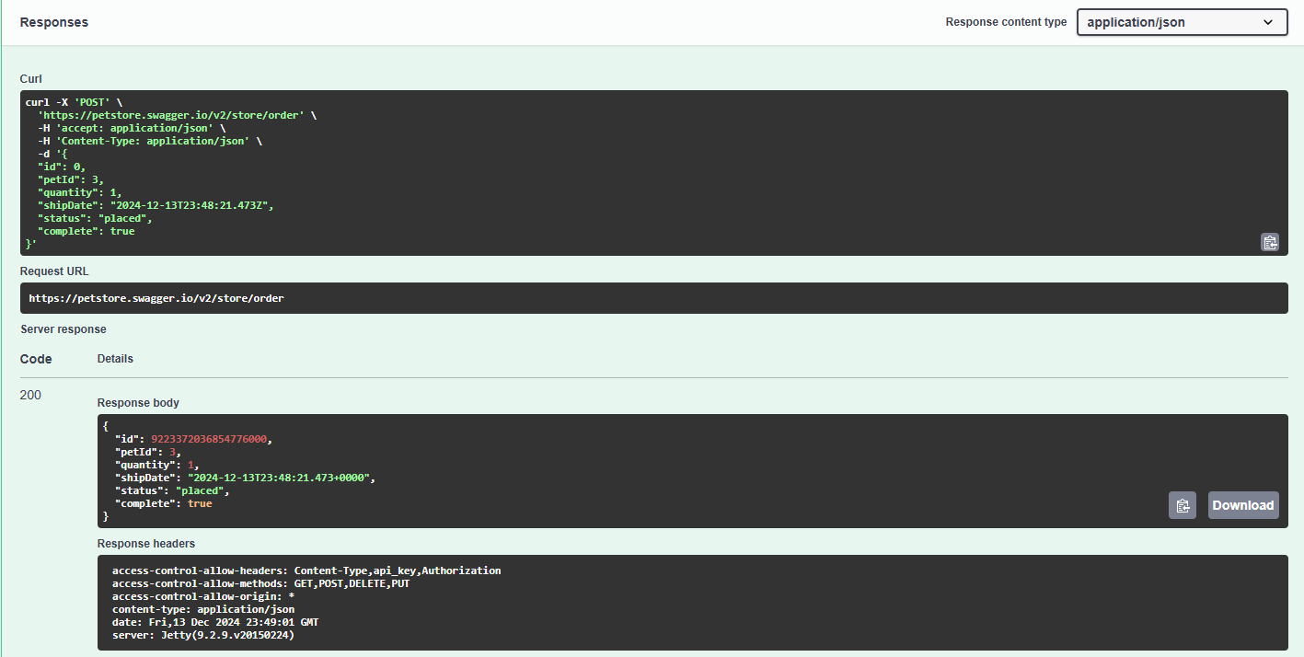

**Postman:**

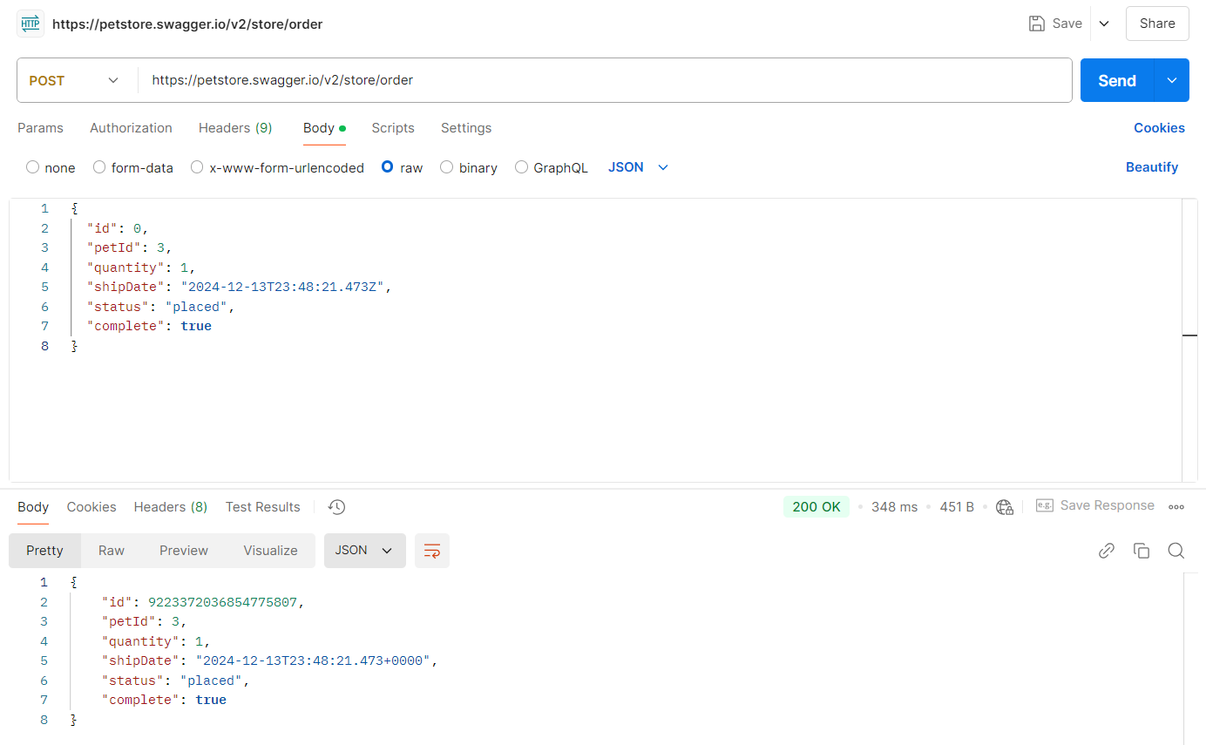

**Test Case - 20 :** To test the GET API of 'Access to Petstore orders' to return purchase order by ID and checking for successful response

**Swagger:**

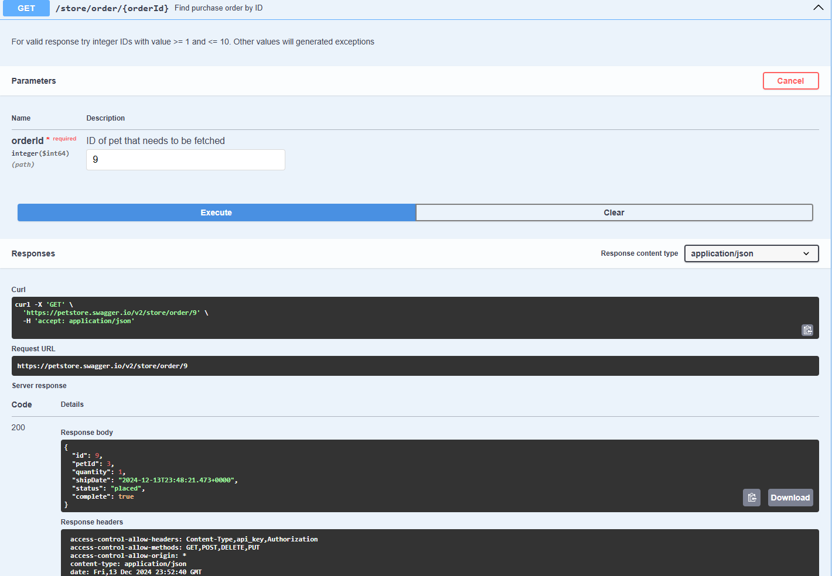

**Postman:**

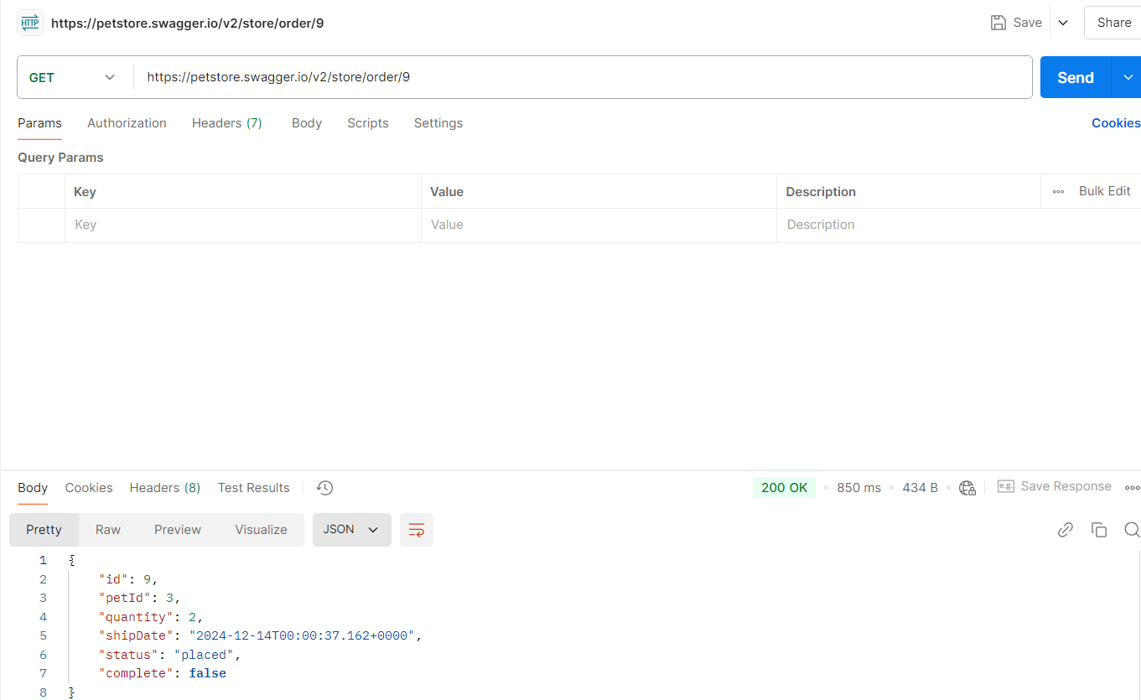

**Test Case - 21 :** To test the DELETE API of 'Access to Petstore orders' to delete purchase order by ID and checking for successful response

**Swagger:**

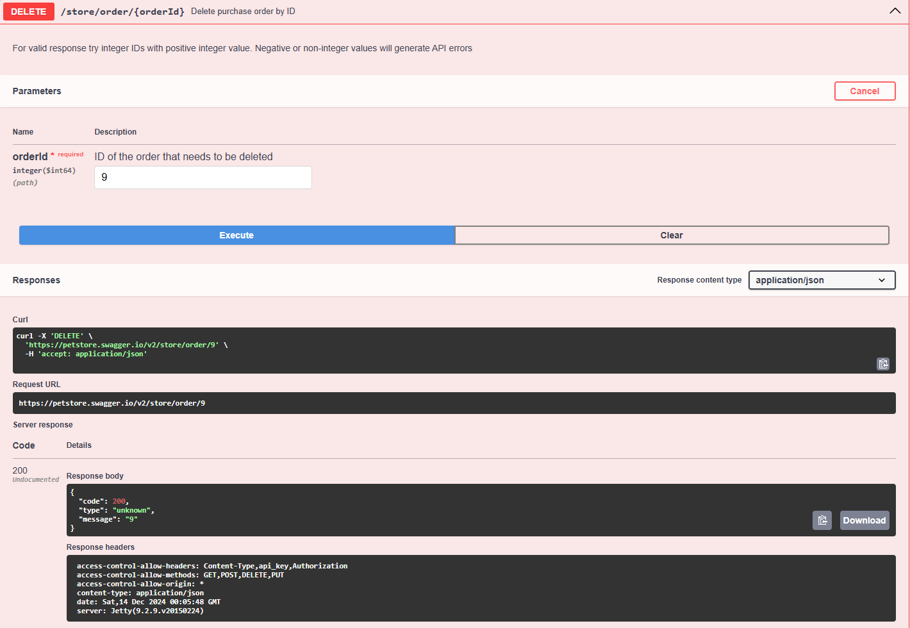

**Postman:**

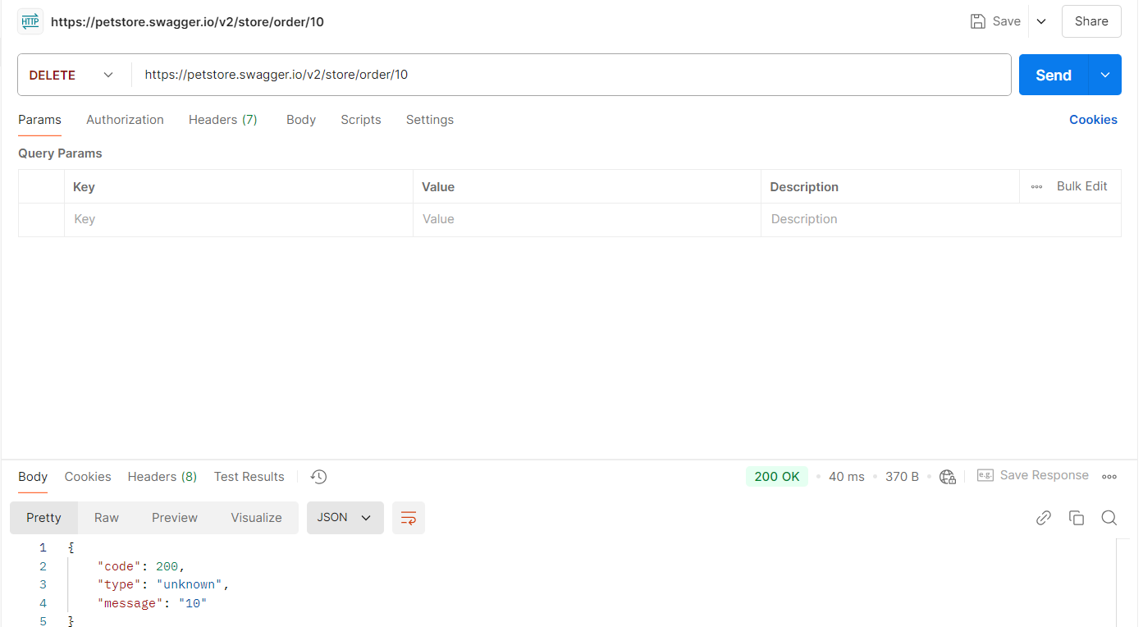

**Test Case - 22 :** To test the GET API of 'Access to Petstore orders' to return purchase order by Invalid ID and checking for bad response

**Swagger:**

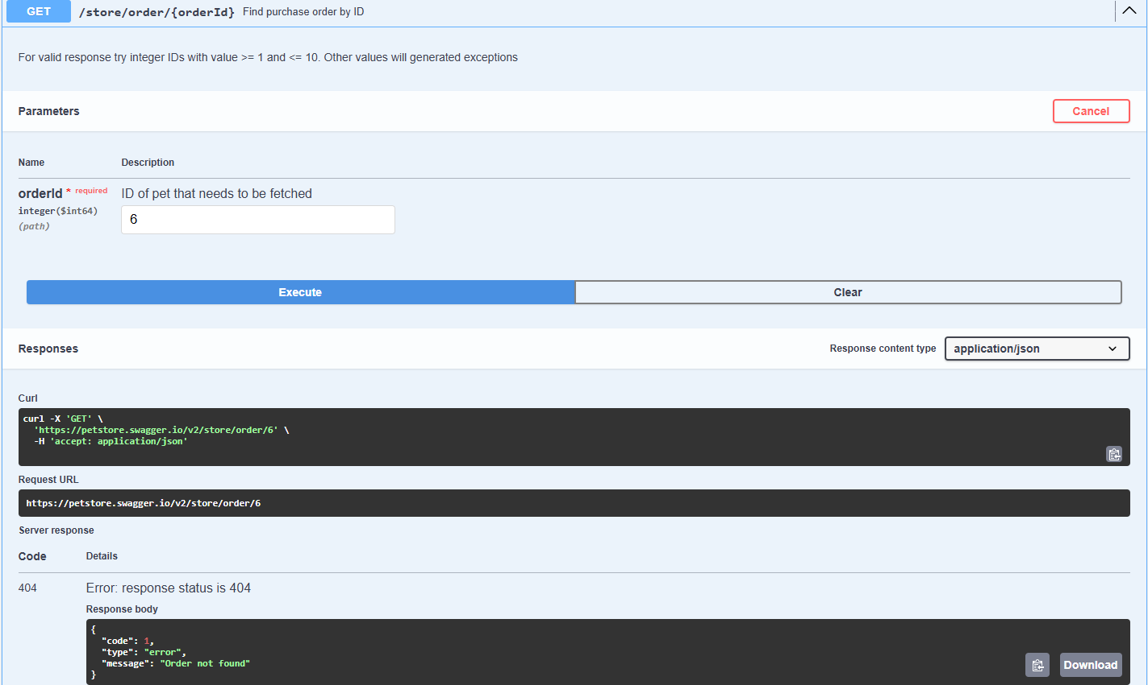

**Postman:**

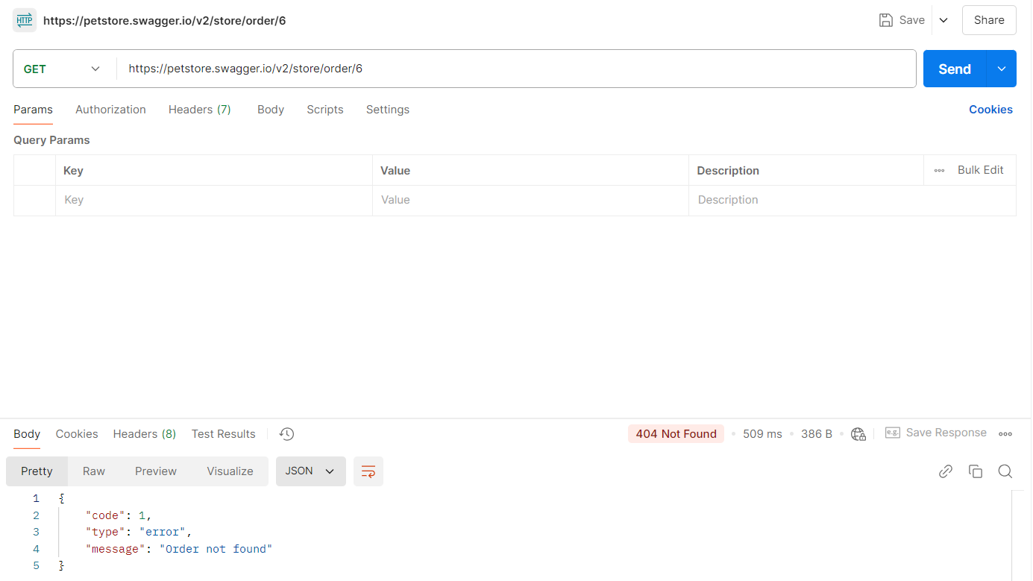

**Test Case - 23 :** To test the DELETE API of 'Access to Petstore orders' to delete purchase order by invalid ID and checking for bad response

**Swagger:**

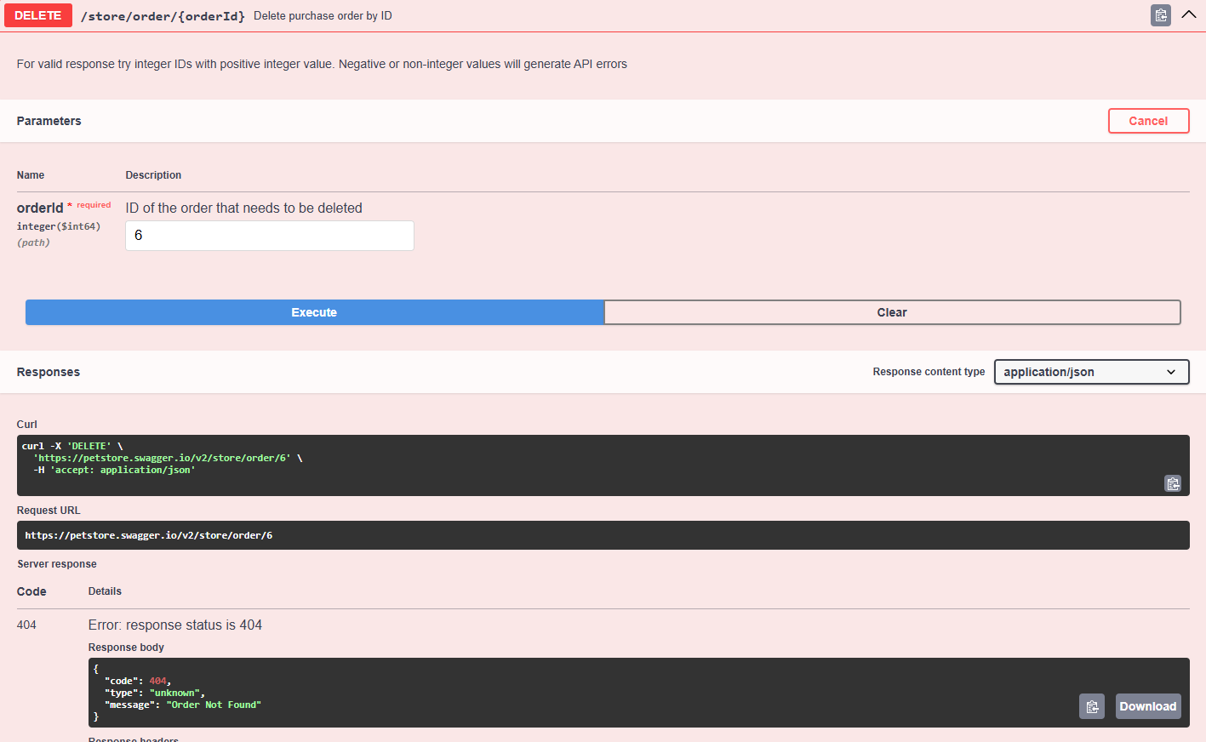

**Postman:**

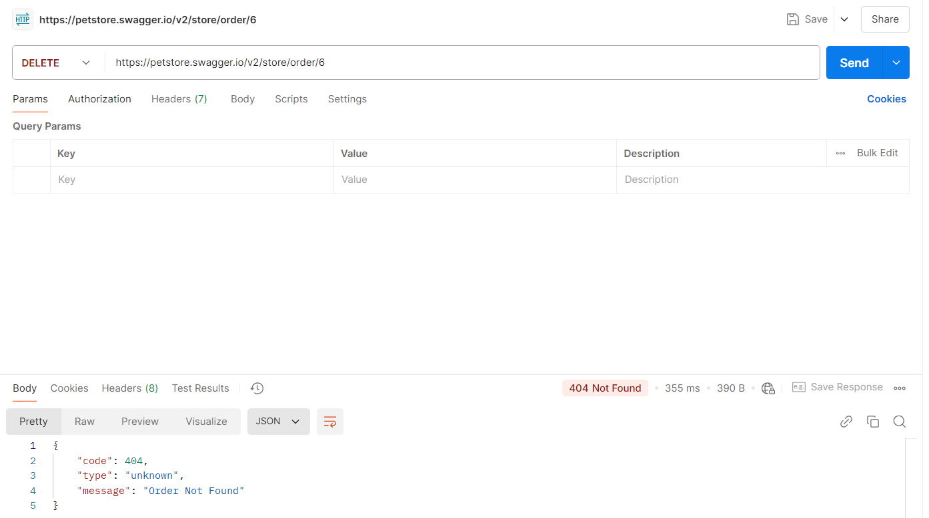

**Test Case - 24 :** To test the POST API of 'Operations about user' to create a user by inputting the details and checking for successful response.

**Swagger:**

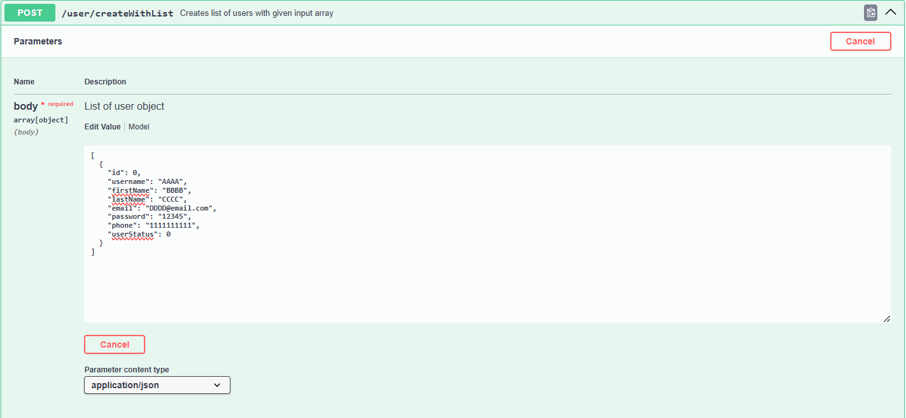

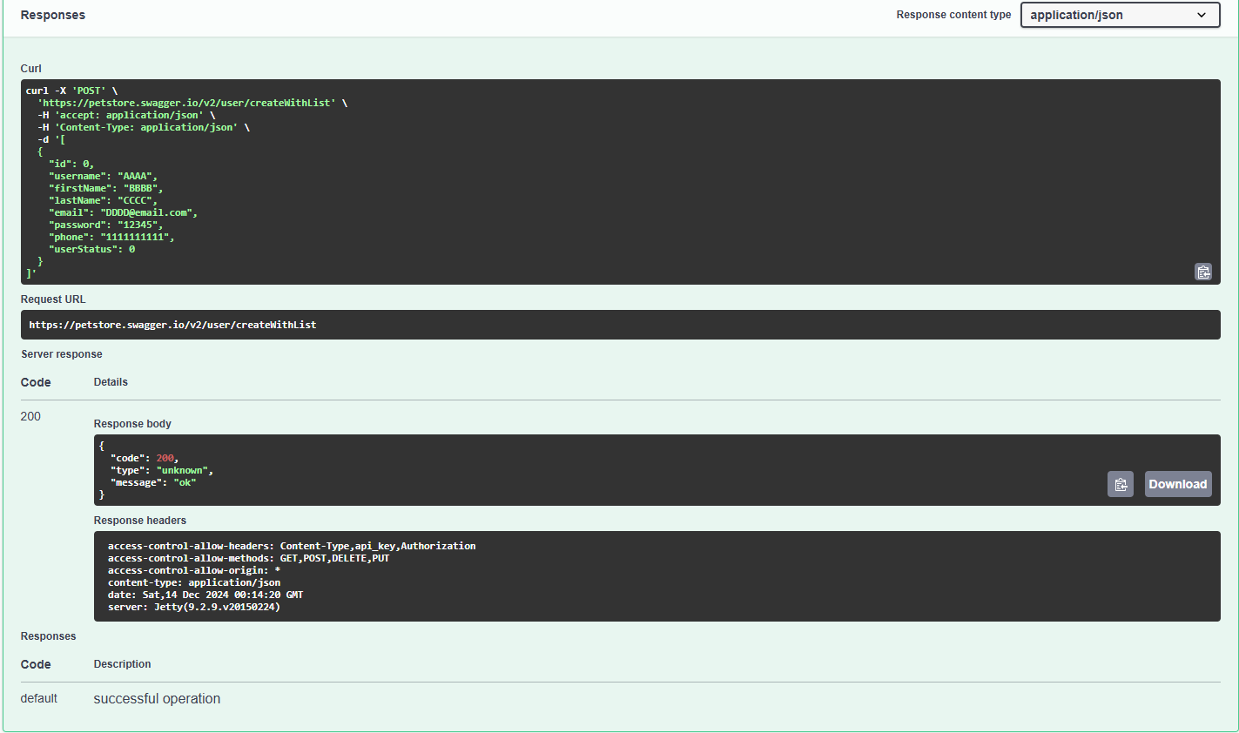

**Postman:**

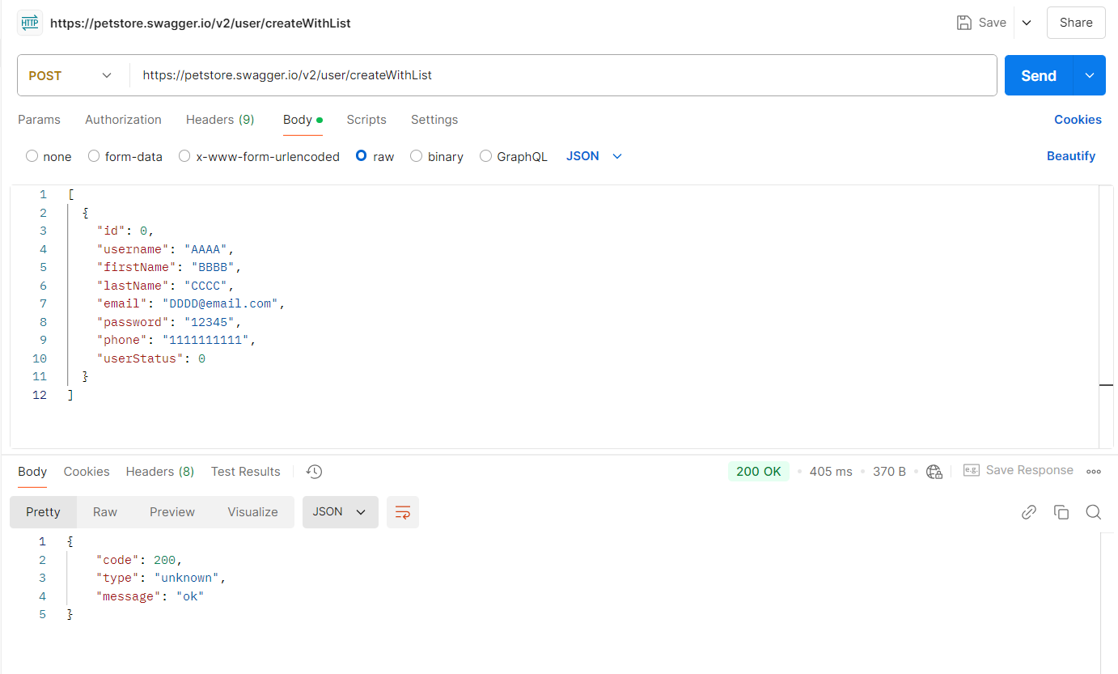

**Test Case - 25 :** To test the GET API of 'Operations about user' to fetch a user by inputting the user name and checking for successful response.

**Swagger:**

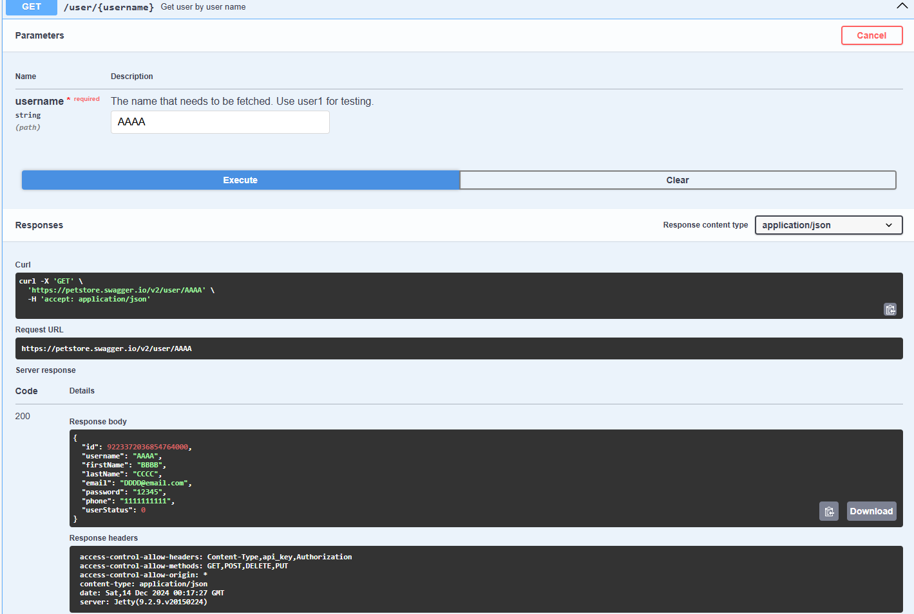

**Postman:**

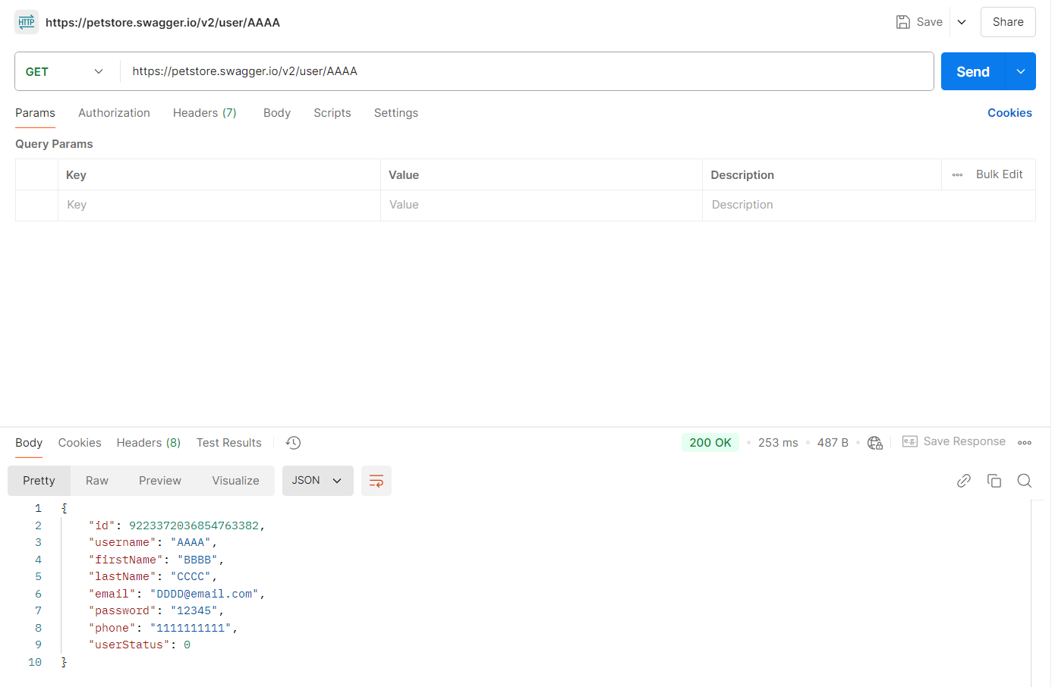

**Test Case - 26 :** To test the GET API of 'Operations about user' to fetch a user by inputting the invalid user name and checking for bad response.

**Swagger:**

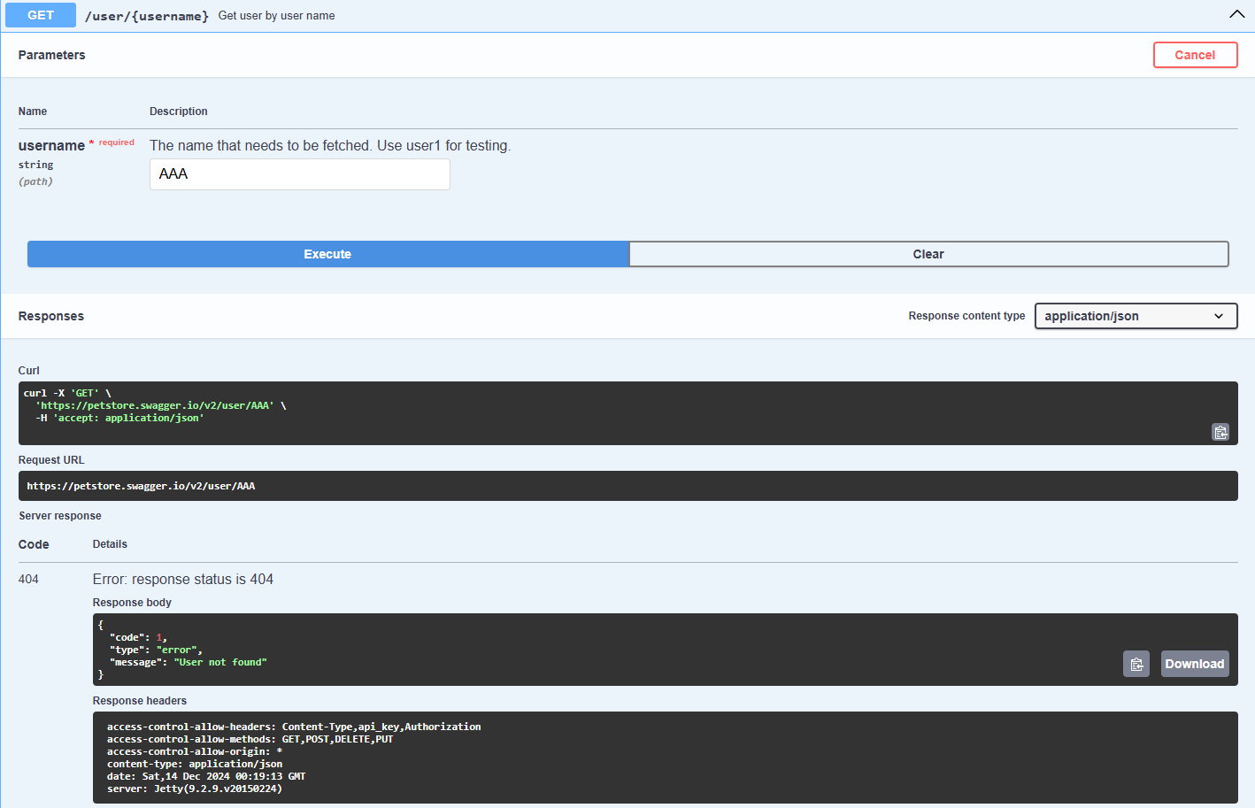

**Postman:**

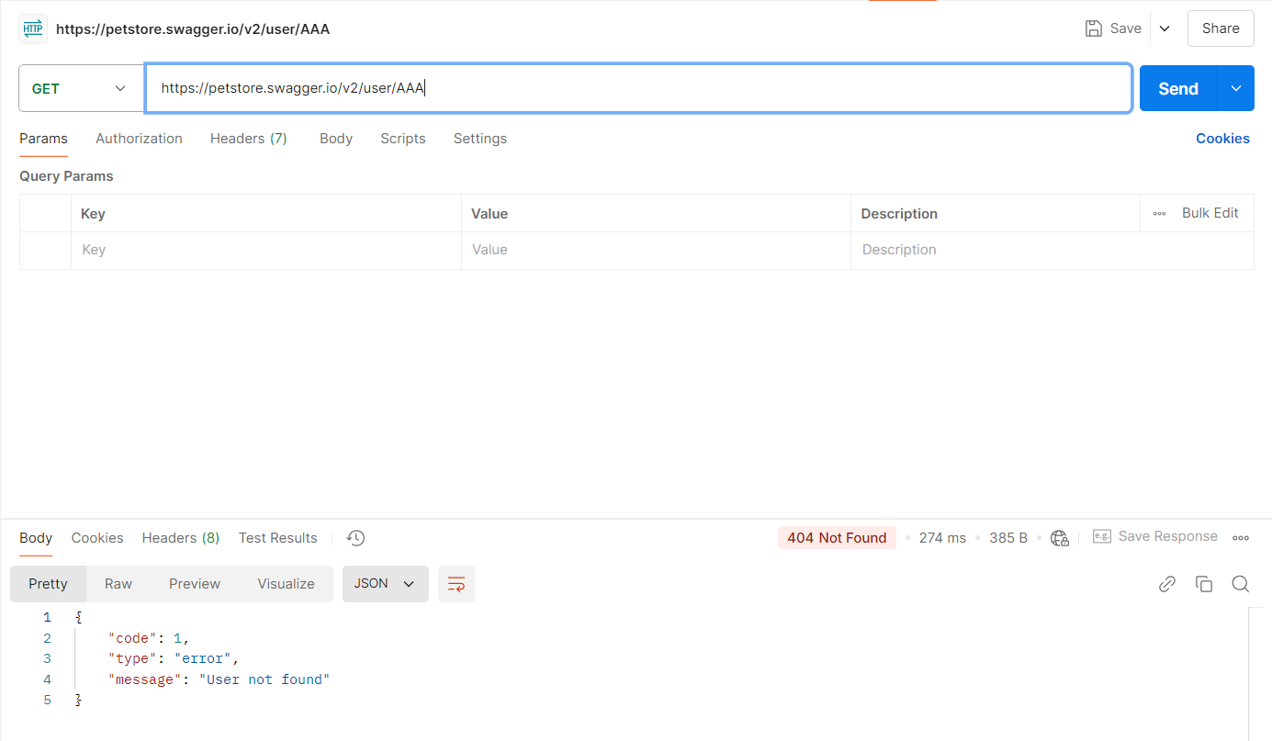

**Test Case - 27 :** To test the PUT API of 'Operations about user' to update a user by inputting the user name and checking for successful response.

**Swagger:**

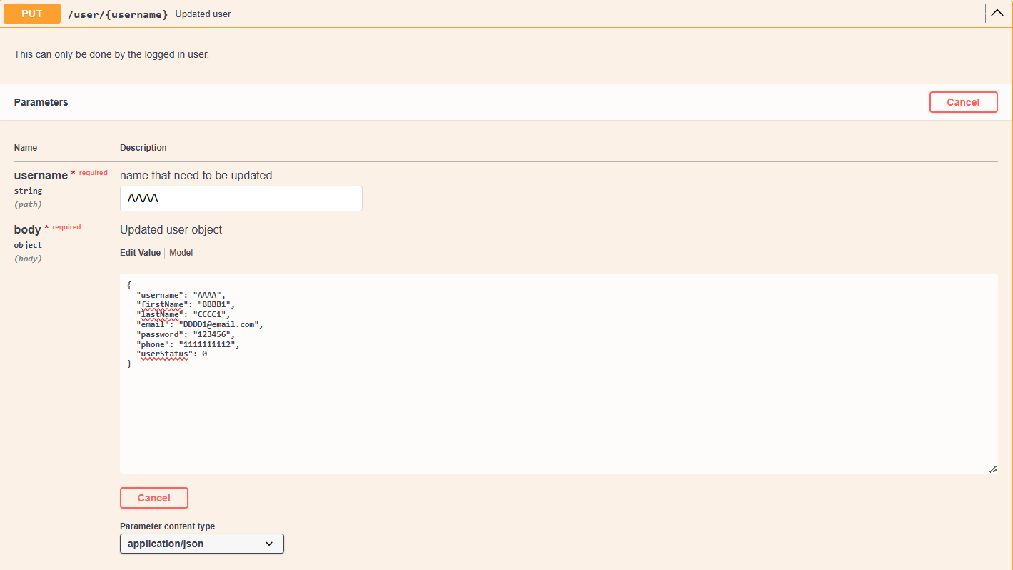

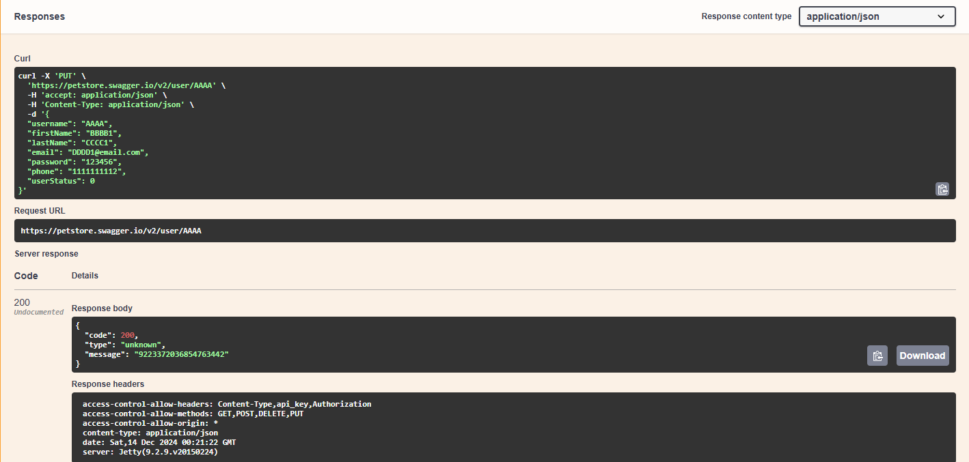

**Postman:**

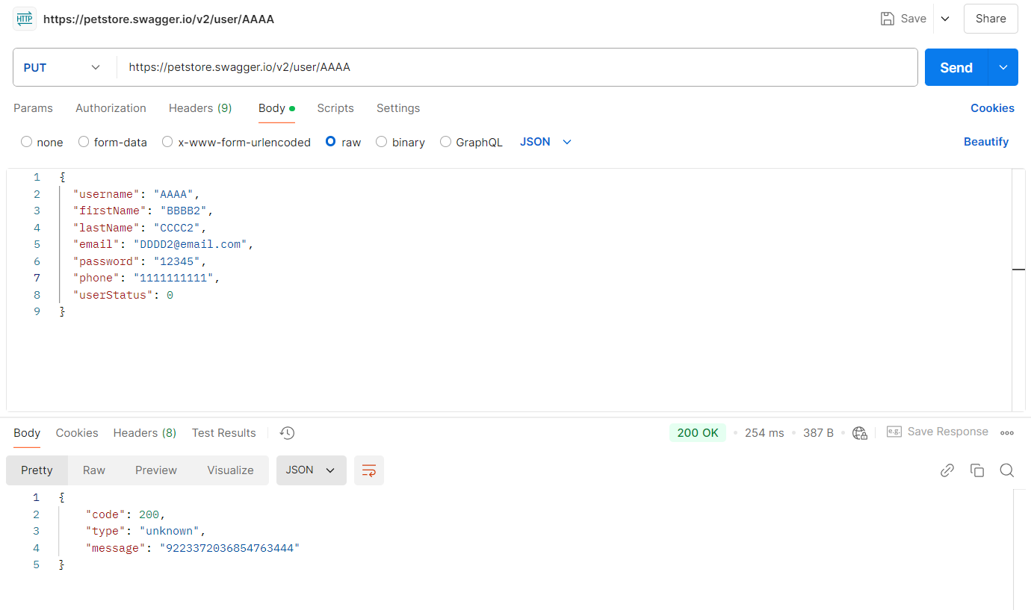

**Test Case - 29 :** To test the DELETE API of 'Operations about user' to update a user by inputting the user name and checking for successful response.

**Swagger:**

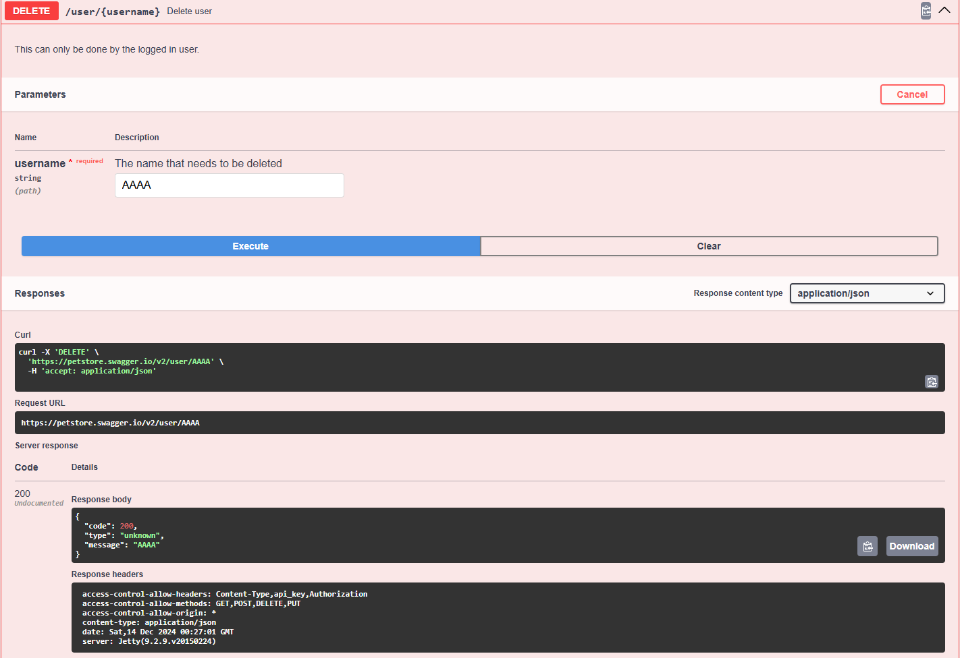

**Postman:**

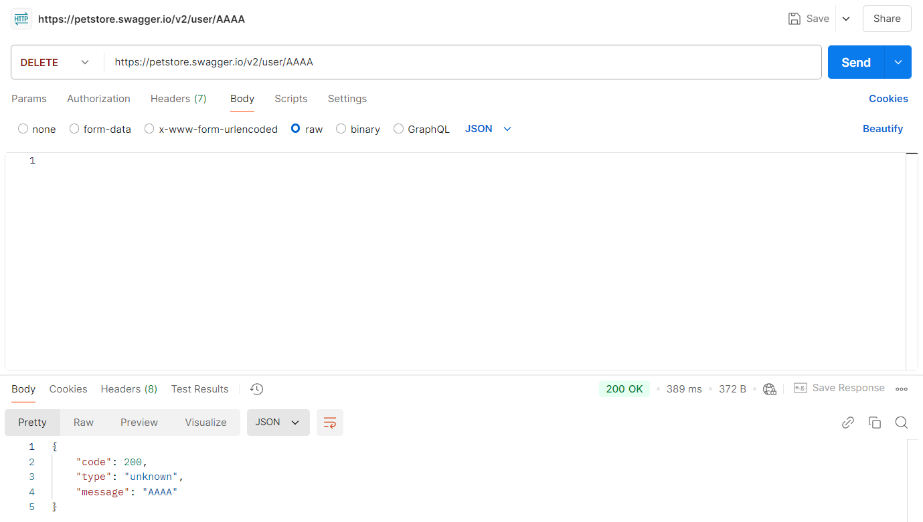

**Test Case - 30 :** To test the GET API of 'Operations about user' to log in the user with password and checking for successful response.

**Swagger:**

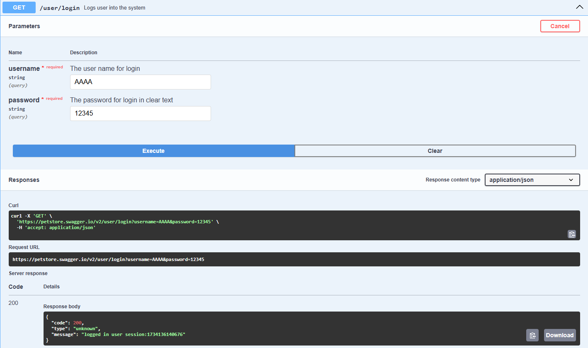

**Postman:**

