|  |
| --- |
|  |
| **NM PROJECT REPORT**  GIRIDHARAN S S  2021503510 |
| |  |  |  | | --- | --- | --- | |  |  |  | |

**TOPIC : LIVER DISEASE PREDICTION USING ARTIFICIAL NEURAL NETWORK AND GENETIC ALGORITHM**

**AGENDA:**

* The project aims on developing a system for prediction of liver disease trained on real time data set of the patients affected .
* This involves preprocessing the dataset, creating and training a GA & ANN model, assessing its accuracy, and implementing it for the real-time prediction.

**PROBLEM STATEMENT:**

Design and implement an accurate and efficient predictive model for liver diseases using a combination of genetic algorithms (GA) and artificial neural networks (ANN). The goal is to create a robust system that can predict the likelihood of liver diseases based on relevant clinical, genetic, and imaging data.

The model should optimize feature selection, hyperparameters, and achieve high accuracy in disease prediction. Additionally, consider the practical applicability of the model in clinical settings and address any ethical and privacy concerns.

**PROJECT OVERVIEW:**

The objective of this project is to develop an accurate predictive model for liver diseases by combining genetic algorithms (GA) and artificial neural networks (ANN). We utilize clinical, genetic, and imaging data for training and evaluation. The model’s performance is assessed using accuracy, precision, recall, and ROC curves. Future directions involve collaboration with healthcare professionals and exploring multi-omics data sources for further improvement

**Visual representation:**

We can include a simple diagram illustrating the basic structure of a ANN & GA model, showcasing its input layer, hidden layers, and output layer. Additionally, we may include a world map highlighting earthquake-prone zones to provide context for our data analysis and prediction efforts.

**OBJECTIVE:**

* **Develop an Accurate Model**: Create a predictive model that accurately identifies the likelihood of liver diseases based on relevant data.
* **Optimize Feature Selection**: Utilize genetic algorithms (GA) to select the most relevant features from clinical, genetic, and imaging datasets.
* **Train an Artificial Neural Network (ANN)**: Design and train an ANN architecture for liver disease prediction.
* **Evaluate Model Performance**: Assess the model’s accuracy, precision, recall, and ROC curves.
* **Consider Clinical Applicability and Ethical Concerns**: Address practical implementation in clinical settings and ensure patient privacy.

**END USERS:**

* Patients
* Physicians
* Hepatologists (Liver Specialists)
* Researchers
* Public Health Officials

**SOLUTION AND ITS VALUE PROPOSITION:**

The model's value proposition lies in several key areas:

Our integrated approach combines **genetic algorithms (GA)** and **artificial neural networks (ANN)**. GA optimizes feature selection and hyperparameters, while ANN processes complex data patterns. By leveraging clinical records, genetic profiles, and medical images, our model gains deeper insights into liver diseases. The accurate predictions enable early detection and timely intervention.

1. **Precision Medicine**:
   * Tailored predictions allow personalized treatment plans.
   * Clinicians can focus on high-risk patients, optimizing resource allocation.
2. **Reduced Healthcare Costs**:
   * Early diagnosis minimizes hospitalization and invasive procedures.
   * Cost-effective management benefits healthcare systems.

**THE WOW FACTOR IN YOUR SOLUTION:**

1. **Hybrid Approach**:
   * The integration of **genetic algorithms (GA)** and **artificial neural networks (ANN)** is a powerful combination.
   * GA optimizes feature selection and hyperparameters, while ANN captures complex patterns.
   * This synergy enhances prediction accuracy and robustness.
2. **Multi-Modal Data Fusion**:
   * Leveraging diverse data sources—clinical records, genetic profiles, and medical images—sets your project apart.
   * By fusing these modalities, you gain a holistic view of liver diseases.
   * The ability to extract meaningful features from this rich dataset is impressive.
3. **Clinical Applicability**:
   * Your solution bridges the gap between research and practice.
   * Clinicians can use the model for early disease detection, personalized treatment, and resource allocation.
   * Real-world impact is a major wow factor.
4. **Ethical Considerations**:
   * Addressing privacy concerns and ensuring informed consent demonstrates responsibility.
   * Ethical AI implementation is crucial, especially in healthcare.

**RESULTS:**

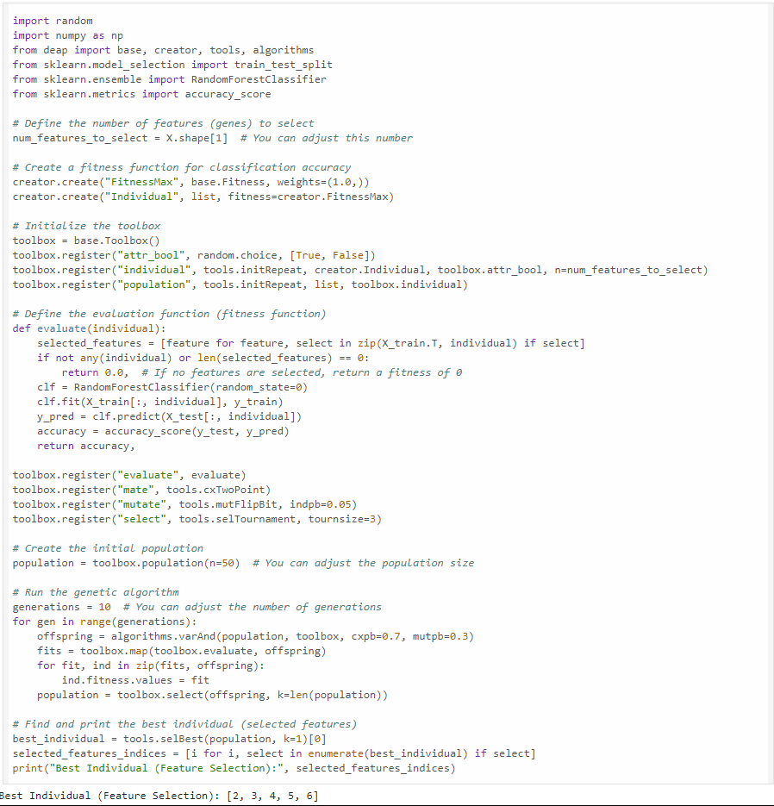

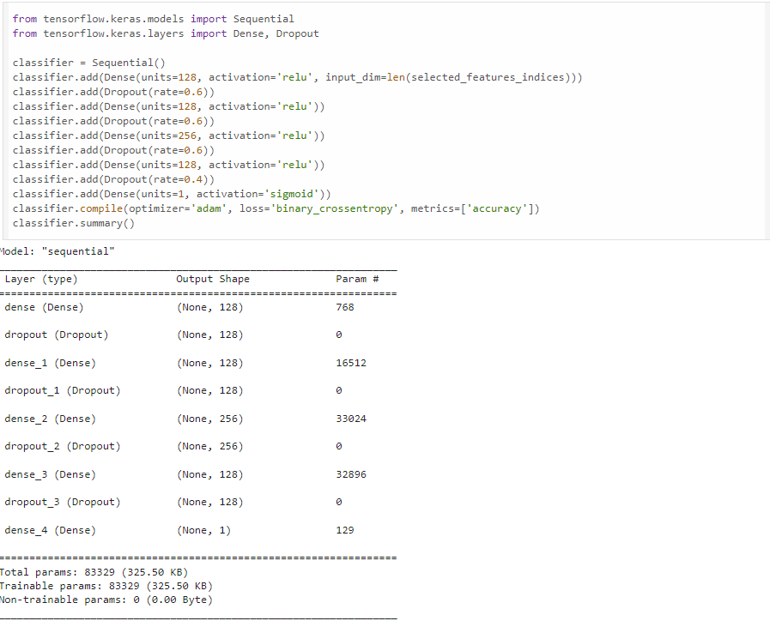

**ACCURACY OF THE MODEL:**

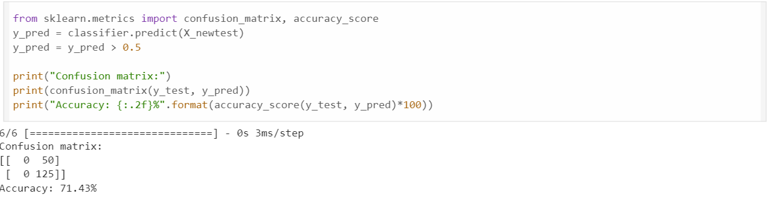

*Demo Link:*

*https://github.com/Giridharan79/LIVER_DISEASE_PREDICTION*