**Day 1 (Jenkins and Docker Setup)**

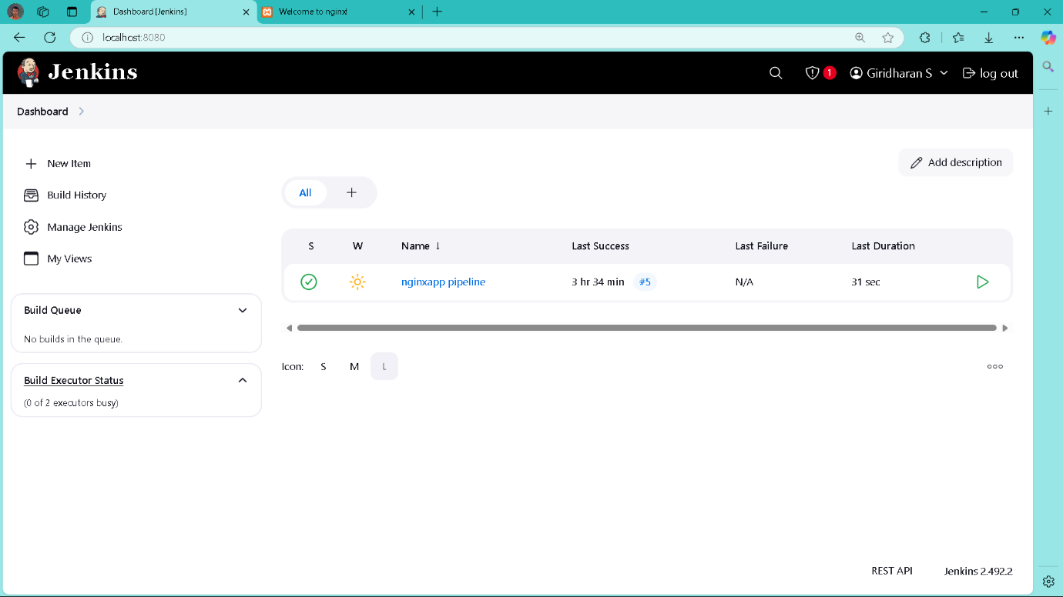

This is my Jenkins dashboard where you can see your **"nginxapp pipeline"** that you've set up. The pipeline has run successfully (shown by the green checkmark), with the last successful run being 3 hours and 34 minutes ago. The build took 31 seconds to complete. You don't have any builds currently running, and your build executors are available.

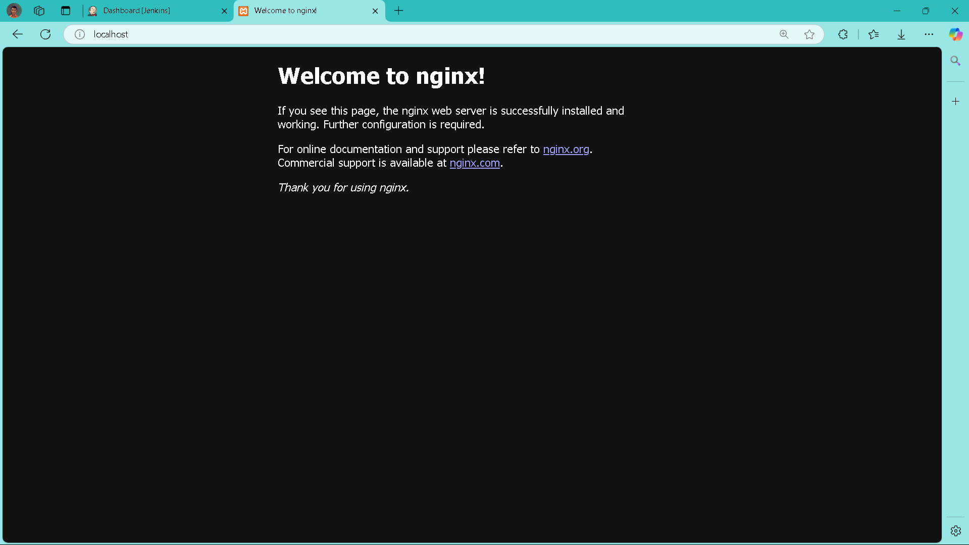

This shows the default NGINX welcome page in your browser, confirming that NGINX was successfully installed and is running. The page tells you that NGINX is working correctly but needs further configuration for your specific needs.

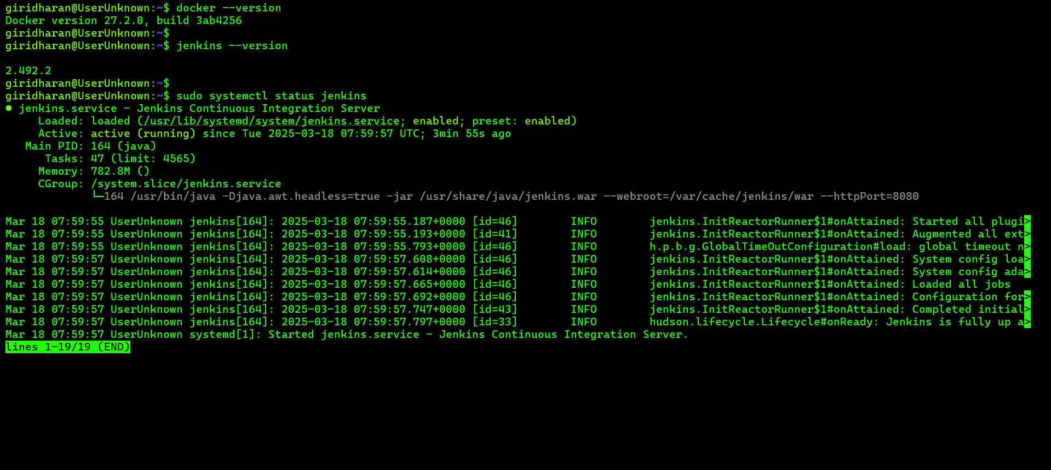

I've checked the versions of your installed software in the terminal. You first verified that Docker version 27.2.0 is installed. Then you checked that Jenkins version 2.492.2 is installed. After that, you ran a command to see the status of Jenkins, which shows it's running properly, started just a few minutes ago today (March 18, 2025), and is using about 782MB of memory.

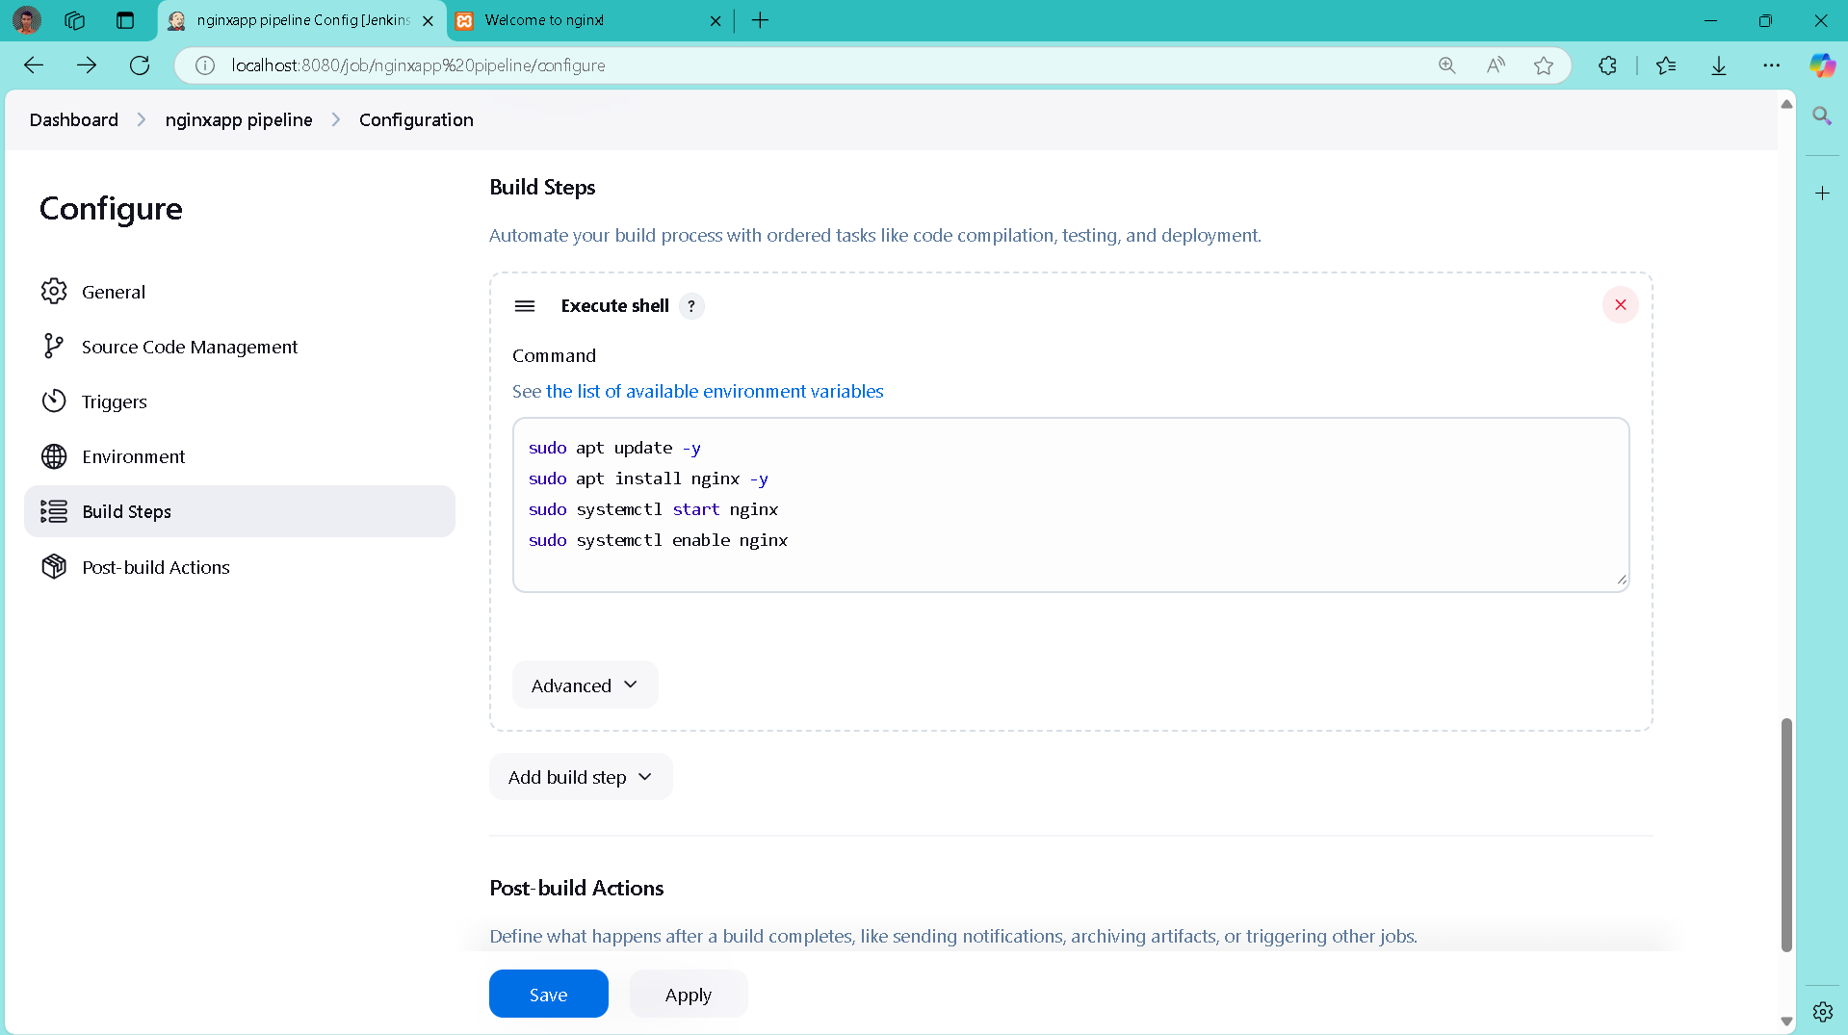

I am setting up a Jenkins pipeline for an NGINX application. In the configuration page, you've added shell commands to install and start NGINX on your server. The commands will update your packages, install NGINX, start the NGINX service, and make sure it starts automatically whenever your server restarts.