**Day – 3**

**Commands:**

minikube start

nano nginx-deployment.yml

**Ctrl+X, Y, Enter**

kubectl apply -f nginx-deployment.yml

minikube service nginx-login-service –url

open the url in the browser

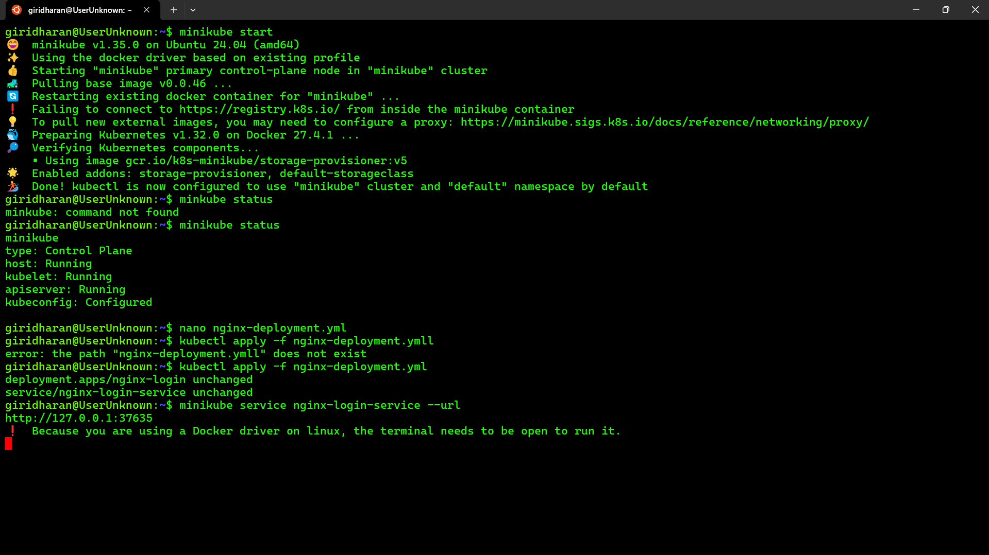

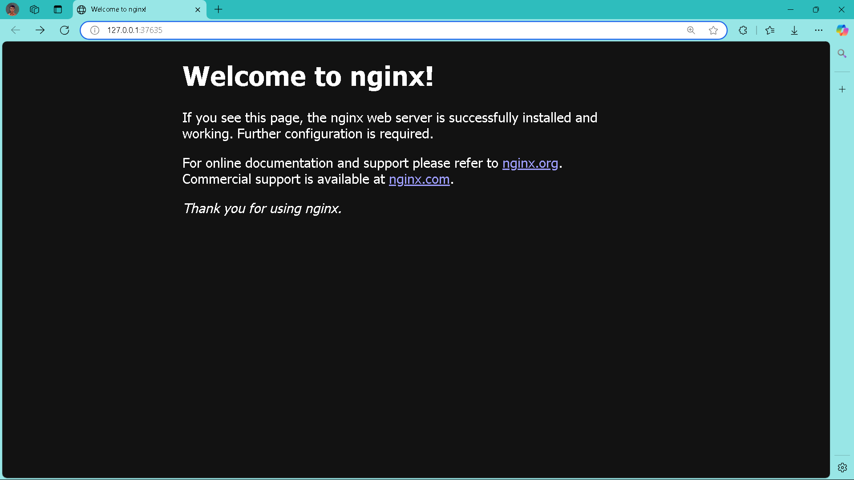

apiVersion: apps/v1

kind: Deployment

metadata:

name: nginx-login

spec:

replicas: 1

selector:

matchLabels:

app: nginx-login

template:

metadata:

labels:

app: nginx-login

spec:

containers:

- name: nginx-login

image: nginx:latest

ports:

- containerPort: 80

---

apiVersion: v1

kind: Service

metadata:

name: nginx-login-service

spec:

type: NodePort

selector:

app: nginx-login

ports:

- protocol: TCP

port: 80

targetPort: 80

nodePort: 30008