**Spring Application Deployment**

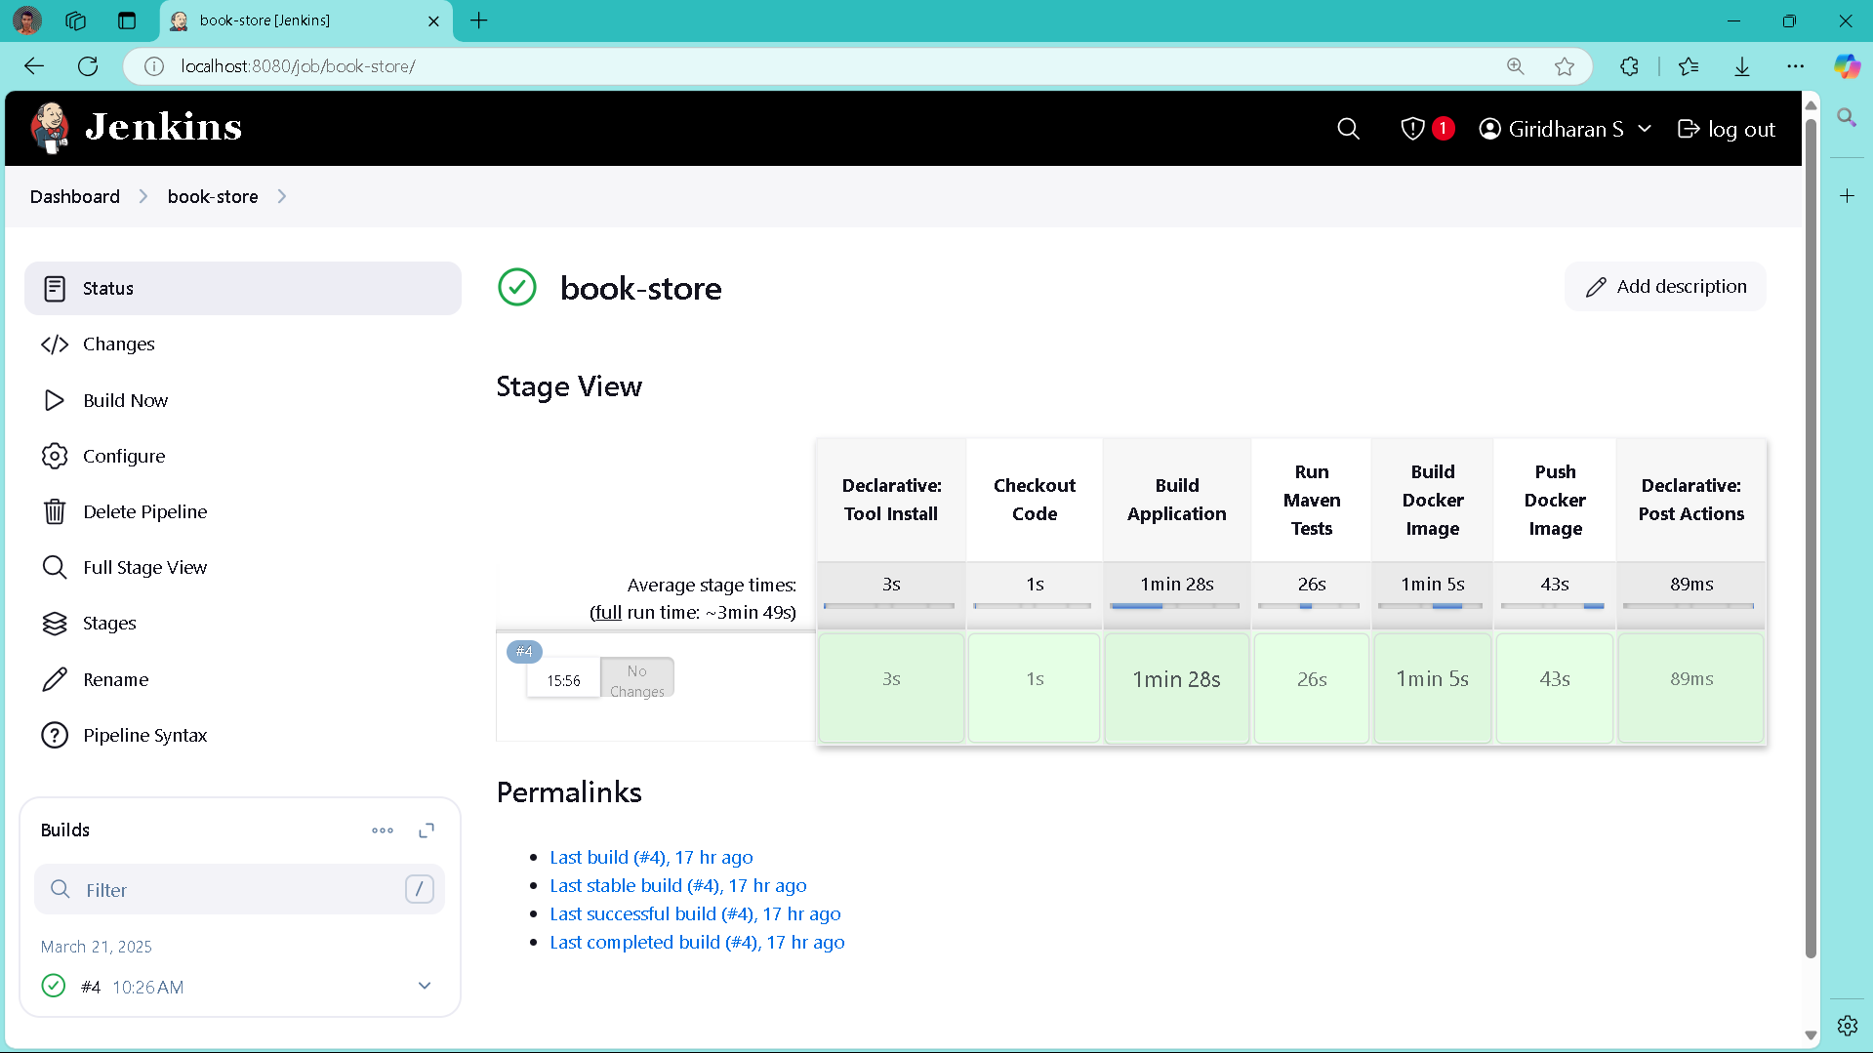

A Jenkins CI/CD pipeline dashboard for a "book-store" project, monitoring the successful execution of build stages (tool install, code checkout, application build, testing, and Docker image creation/pushing).

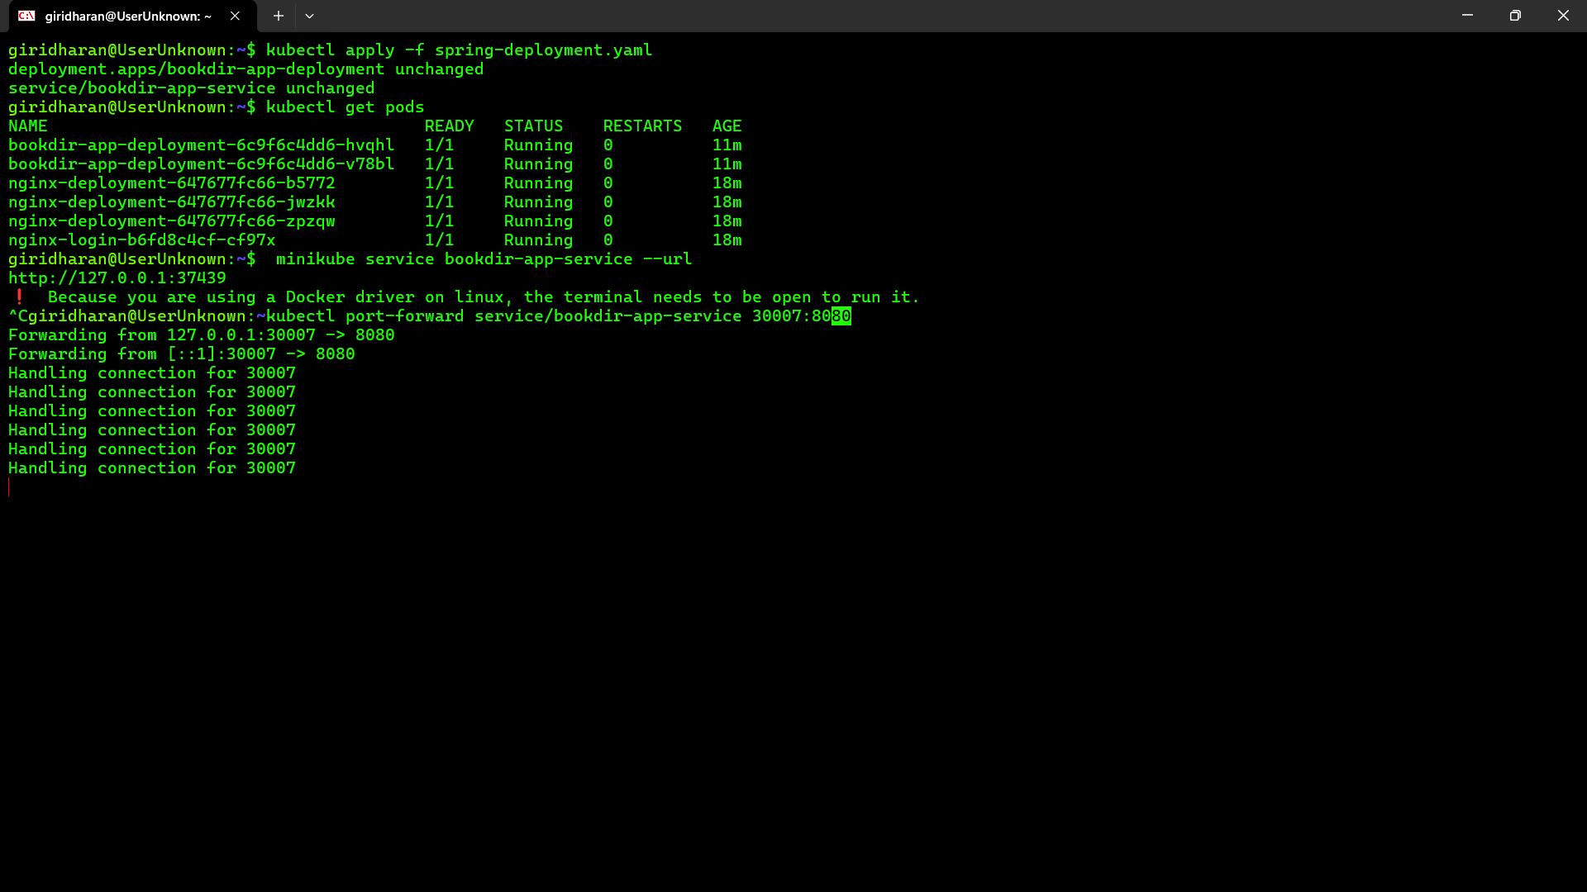

Kubernetes commands in a terminal to deploy the application, check pod status, and set up port forwarding to make the service accessible locally.

**COMMANDS:**

* nano spring-deployment.yaml

Opens the Kubernetes deployment configuration file in the nano text editor, allowing you to create or edit the deployment specifications.

* kubectl apply -f spring-deployment.yaml

Applies the configuration defined in the YAML file to your Kubernetes cluster, creating or updating resources like deployments and services.

* minikube service bookdir-app-service

Exposes the service in your minikube cluster, making it accessible and providing the URL to access the application.

* kubectl port-forward service/bookdir-app-service 30007:8080

Sets up port forwarding from your local machine's port 30007 to the service's port 8080 in the Kubernetes cluster, allowing you to access the application via localhost.

**spring-deployment.yaml**

apiVersion: apps/v1

kind: Deployment

metadata:

name: bookdir-app-deployment

spec:

replicas: 2

selector:

matchLabels:

app: bookdir-app

template:

metadata:

labels:

app: bookdir-app

spec:

containers:

- name: bookdir-app

image: giridharans1729/social-app:latest

imagePullPolicy: Always

ports:

- containerPort: 8080

---

apiVersion: v1

kind: Service

metadata:

name: bookdir-app-service

spec:

selector:

app: bookdir-app

ports:

- protocol: TCP

port: 80

targetPort: 8080

nodePort: 30007

type: NodePort

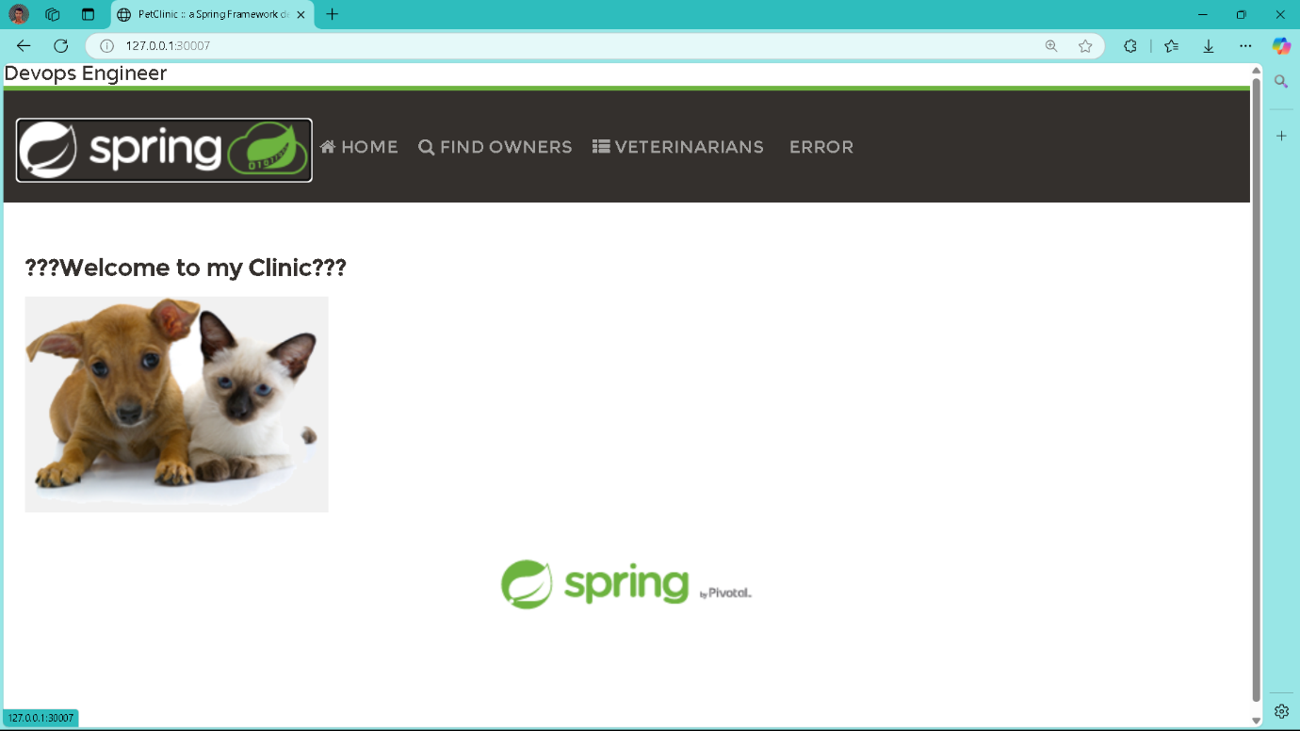

The successfully deployed Spring PetClinic application in a browser, confirming that your CI/CD pipeline and Kubernetes deployment worked, though there's a formatting issue with the welcome message.