**Digital Nurture 4.0**

**Week 6- React**

# **Mandatory HandsOn**

# ***File name: 1. ReactJS-HOL***

**Step 1: Install Node.js and npm**

Verify installation:

node -v

npm -v

**Step 2: Install create-react-app globally**

npm install -g create-react-app

**Step 3: Create React Application**

npx create-react-app myfirstreact

**Step 4: Navigate into project folder**

cd myfirstreact

**Step 5: Modify App.js**

* Navigate to: src/App.js

import React from 'react';

function App() {

return (

<div>

<h1>Welcome to the first session of React</h1>

</div>

);

}

export default App;

**Step 7: Start the React development server**

npm start

**output:**

**In Browser:**

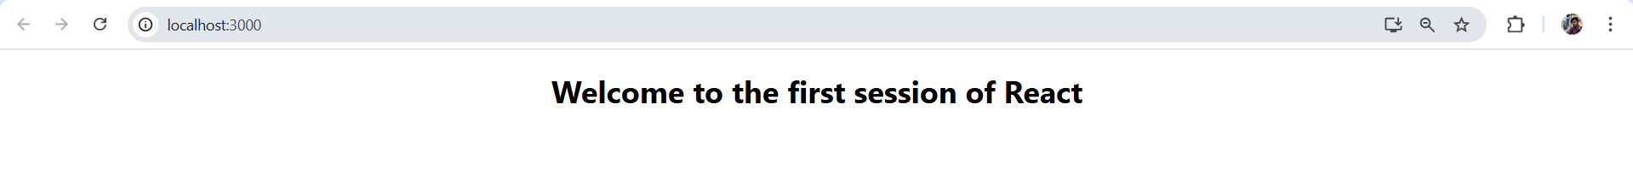

# ***File name: 2. ReactJS-HOL***

**Student Management Portal**

**Step 1: Create React App**

Open **Visual Studio Code Terminal** and run:

npx create-react-app StudentApp

cd StudentApp

**Step 2: Create Components Folder**

Inside the src folder:

* Right-click → New Folder → Name it: Components

**Step 3: Create Home.js inside Components**

import React from 'react';

class Home extends React.Component {

render() {

return (

<div>

<h2>Welcome to the Home page of Student Management Portal</h2>

</div>

);

}

}

export default Home;

**Step 4: Create About.js inside Components**

import React from 'react';

class About extends React.Component {

render() {

return (

<div>

<h2>Welcome to the About page of the Student Management Portal</h2>

</div>

);

}

}

export default About;

**Step 5: Create Contact.js inside Components**

import React from 'react';

class Contact extends React.Component {

render() {

return (

<div>

<h2>Welcome to the Contact page of the Student Management Portal</h2>

</div>

);

}

}

export default Contact;

**Step 6: Modify App.js to Render All 3 Components**

import React from 'react';

import Home from './Components/Home';

import About from './Components/About';

import Contact from './Components/Contact';

function App() {

return (

<div className="App">

<Home />

<About />

<Contact />

</div>

);

}

export default App;

**Step 7: Run the Application**

npm start

**output:**

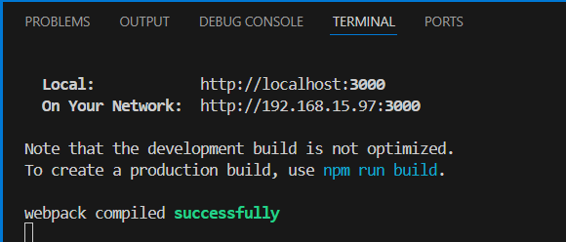

**In Browser:**

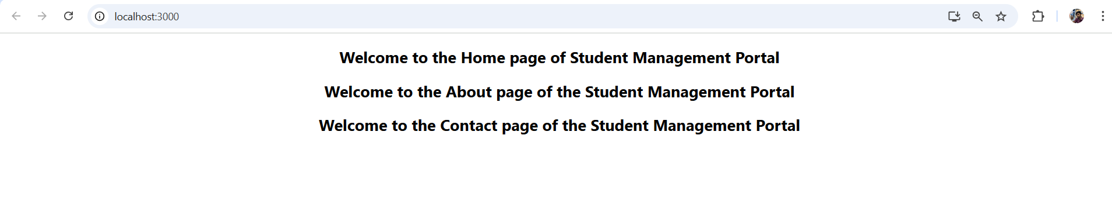

# ***File name: 3. ReactJS-HOL***

**Step 1: Create React App**

npx create-react-app scorecalculatorapp

**Step 2: Create Components Folder and File**

Inside src folder:

1. Created a folder named: Components
2. Inside it, created a file named: CalculateScore.js

**CalculateScore.js:**

import React from 'react';

import '../Stylesheets/mystyle.css';

function CalculateScore() {

const name = "Arun";

const school = "ABC Matriculation";

const total = 450;

const goal = 500;

const average = ((total / goal) * 100).toFixed(2);

return (

<div className="score-container">

<center>

<h2>Score Calculator</h2>

<p><strong>Name:</strong> {name}</p>

<p><strong>School:</strong> {school}</p>

<p><strong>Total Score:</strong> {total}</p>

<p><strong>Goal:</strong> {goal}</p>

<p><strong>Average Score:</strong> {average}%</p>

</center>

</div>

);

}

export default CalculateScore;

**Step 3: Create Stylesheets and Add CSS**

1. Inside src folder, created a folder: Stylesheets
2. Inside it, created a file: mystyle.css

**mystyle.css:**

.score-container {

  background-color: #c4edfc;

  padding: 20px;

  margin: 30px;

  border-radius: 8px;

  box-shadow: 0px 2px 8px rgba(0, 0, 0, 0.1);

  font-family: Arial, sans-serif;

}

.score-container h2 {

    text-align: center;

  color: #000000;

}

.score-container p {

  font-size: 16px;

  line-height: 1.6;

}

**Step 4: Modify App.js to Render Component**

**App.js:**

import React from 'react';

import CalculateScore from './Components/CalculateScore';

function App() {

return (

<div className="App">

<CalculateScore />

</div>

);

}

export default App;

**Step 5: Run the Application**

npm start

**Output:**

**In Browser:**

# ***File name: 4. ReactJS-HOL***

**Step 1: Create a React App**

npx create-react-app blogapp

**Step 2: Created Post.js in src**

**Post.js:**

import React from 'react';

class Post extends React.Component {

render() {

const { title, body } = this.props;

return (

<div style={{ border: '1px solid #ccc', padding: '10px', marginBottom: '15px' }}>

<h3>{title}</h3>

<p>{body}</p>

</div>

);

}

}

export default Post;

**Step 3: Create Posts.js in src**

**Posts.js:**

import React from 'react';

import Post from './Post';

class Posts extends React.Component {

constructor(props) {

super(props);

this.state = {

posts: [],

hasError: false

};

}

loadPosts = async () => {

try {

const response = await fetch('https://jsonplaceholder.typicode.com/posts');

const data = await response.json();

this.setState({ posts: data });

} catch (error) {

console.error("Fetching error:", error);

this.setState({ hasError: true });

}

}

componentDidMount() {

this.loadPosts();

}

componentDidCatch(error, info) {

alert("An error occurred: " + error.message);

this.setState({ hasError: true });

}

render() {

const { posts, hasError } = this.state;

if (hasError) {

return <h2 style={{ color: "red" }}>Something went wrong while loading posts.</h2>;

}

return (

<div style={{ padding: '20px' }}>

<h2>Blog Posts</h2>

{posts.slice(0, 10).map(post => (

<Post key={post.id} title={post.title} body={post.body} />

))}

</div>

);

}

}

export default Posts;

**Step 4: Modify App.js to use Posts component**

**App.js:**

import React from 'react';

import Posts from './Posts';

function App() {

return (

<div className="App">

<Posts />

</div>

);

}

export default App;

**Step 5: Run the Application**

npm start

**Output:**

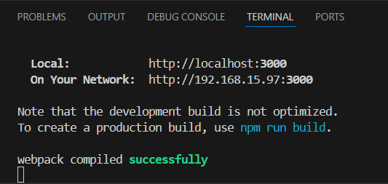

**In Browser:**

# ***File name: 5. ReactJS-HOL***

**Step 1: Unzip the Project**

Unziped the provided React app folder

**Step 2: Install Dependencies**

npm install

**Step 3: Create CSS Module**

Inside the src created a file

**CohortDetails.module.css:**

.box {

width: 300px;

display: inline-block;

margin: 10px;

padding: 10px 20px;

border: 1px solid black;

border-radius: 10px;

}

dt {

font-weight: 500;

}

**Step 4: Modify the CohortDetails.js**

**CohortDetails.js:**

import React from 'react';

import styles from './CohortDetails.module.css';

function CohortDetails({ name, status, startDate, endDate }) {

const statusStyle = {

color: status.toLowerCase() === 'ongoing' ? 'green' : 'blue'

};

return (

<div className={styles.box}>

<h3 style={statusStyle}>{name}</h3>

<dl>

<dt>Status:</dt>

<dd>{status}</dd>

<dt>Start Date:</dt>

<dd>{startDate}</dd>

<dt>End Date:</dt>

<dd>{endDate}</dd>

</dl>

</div>

);

}

export default CohortDetails;

**Step 5: Use the CohortDetails.js in App.js**

**App.js:**

import React from 'react';

import CohortDetails from './CohortDetails';

function App() {

return (

<div>

<CohortDetails

name="React Bootcamp"

status="Ongoing"

startDate="2025-06-01"

endDate="2025-08-01"

/>

<CohortDetails

name="Angular Basics"

status="Completed"

startDate="2025-04-01"

endDate="2025-06-01"

/>

</div>

);

}

export default App;

**Step 6: Run the Application**

npm start

**Output:**

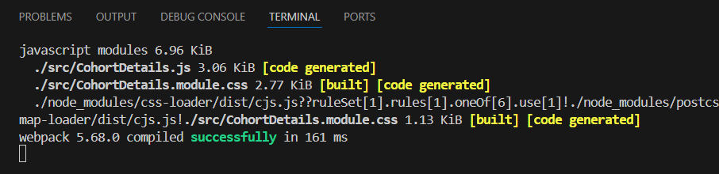

**In Browser:**

**Additional-Mandatory HandsOn**

# ***File name: 6. ReactJS-HOL***

**Step 1: Create a new React App**

npx create-react-app TrainersApp

**Step 2: Create Trainer.js in src**

**Trainer.js:**

class Trainer {

constructor(id, name, email, phone, technology, skills) {

this.TrainerId = id;

this.Name = name;

this.Email = email;

this.Phone = phone;

this.Technology = technology;

this.Skills = skills;

}

}

export default Trainer;

**Step 3: Create TrainersMock.js in src**

TrainersMock.js:

import Trainer from './Trainer';

const trainers = [

new Trainer(1, "Arun Kumar", "arun@example.com", "9876543210", "React", ["JSX", "Hooks", "Router"]),

new Trainer(2, "Divya Sharma", "divya@example.com", "7894561230", "Angular", ["Components", "RxJS"]),

new Trainer(3, "Rajeev R", "rajeev@example.com", "9123456789", "Node.js", ["Express", "MongoDB"])

];

export default trainers;

**Step 4: Install React Router DOM**

npm install react-router-dom

**Step 5: Create TrainerList.js file in src**

**TrainerList.js:**

import React from 'react';

import { Link } from 'react-router-dom';

function TrainerList({ trainers }) {

return (

<div>

<h2>Trainer List</h2>

<ul>

{trainers.map(trainer => (

<li key={trainer.TrainerId}>

<Link to={`/trainers/${trainer.TrainerId}`}>{trainer.Name}</Link>

</li>

))}

</ul>

</div>

);

}

export default TrainerList;

**Step 6: Create Home.js file inside src**

**Home.js:**

import React from 'react';

function Home() {

return (

<div>

<h2>Welcome to the Cognizant Academy Trainer Portal</h2>

<p>This portal provides trainer information with routing examples in React.</p>

</div>

);

}

export default Home;

**Step 7: Create TrainerDetail.js Component**

**TrainerDetail.js:**

import React from 'react';

import { useParams } from 'react-router-dom';

import trainers from './TrainersMock';

function TrainerDetail() {

const { id } = useParams();

const trainer = trainers.find(t => t.TrainerId === parseInt(id));

if (!trainer) return <p>Trainer not found</p>;

return (

<div>

<h2>{trainer.Name} (ID: {trainer.TrainerId})</h2>

<p><strong>Email:</strong> {trainer.Email}</p>

<p><strong>Phone:</strong> {trainer.Phone}</p>

<p><strong>Technology:</strong> {trainer.Technology}</p>

<p><strong>Skills:</strong> {trainer.Skills.join(", ")}</p>

</div>

);

}

export default TrainerDetail;

**Step 8: Modify App.js to Setup Routing**

**App.js:**

import React from 'react';

import { BrowserRouter, Routes, Route, Link } from 'react-router-dom';

import Home from './Home';

import TrainerList from './TrainerList';

import TrainerDetail from './TrainerDetail';

import trainers from './TrainersMock';

function App() {

return (

<BrowserRouter>

<div>

<h1>Cognizant Trainer Management</h1>

<nav>

<Link to="/" style={{ marginRight: '10px' }}>Home</Link>

<Link to="/trainers">Trainers</Link>

</nav>

<hr />

<Routes>

<Route path="/" element={<Home />} />

<Route path="/trainers" element={<TrainerList trainers={trainers} />} />

<Route path="/trainers/:id" element={<TrainerDetail />} />

</Routes>

</div>

</BrowserRouter>

);

}

export default App;

**Step 9: Run the App**

npm start

**Output:**

**In Browser:**

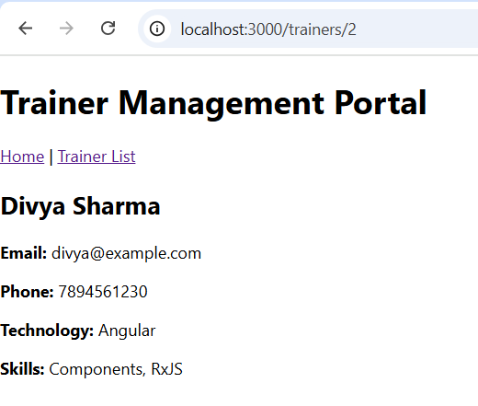

# ***File name: 7. ReactJS-HOL***

**Step 1: Create a New React App**

npx create-react-app shoppingapp

**Step 2: Create Cart.js in src**

import React from 'react';

class Cart extends React.Component {

  render() {

    return (

      <tr>

        <td>{this.props.itemName}</td>

        <td>{this.props.price}</td>

      </tr>

    );

  }

}

export default Cart;

**Step 3: Create OnlineShopping.js in src**

**OnlineShopping.js:**

import React from 'react';

import Cart from './Cart';

import './OnlineShopping.css'; // For external CSS styling

class OnlineShopping extends React.Component {

  render() {

    const cartItems = [

      { itemName: "Laptop", price: 80000 },

      { itemName: "TV", price: 120000 },

      { itemName: "Washing Machine", price: 50000 },

      { itemName: "Mobile", price: 30000 },

      { itemName: "Fridge", price: 70000 }

    ];

    return (

      <div className="shopping-container">

        <h1 className="heading">Items Ordered :</h1>

        <div className="table-wrapper">

          <table className="shopping-table">

            <thead>

              <tr>

                <th>Name</th>

                <th>Price</th>

              </tr>

            </thead>

            <tbody>

              {cartItems.map((item, index) => (

                <Cart key={index} itemName={item.itemName} price={item.price} />

              ))}

            </tbody>

          </table>

        </div>

      </div>

    );

  }

}

export default OnlineShopping;

**Step 4: Modify App.js to Render OnlineShopping**

import React from 'react';

import './App.css';

import OnlineShopping from './OnlineShopping';

function App() {

return (

<div className="App">

<h1>🛒 Welcome to Shopping App</h1>

<OnlineShopping />

</div>

);

}

export default App;

**Step 5: Create a file OnlineShopping.css in src**

**OnlineShopping.css:**

.shopping-container {

  text-align: center;

  margin-top: 50px;

}

.heading {

  color: green;

  font-weight: bold;

}

.table-wrapper {

  display: inline-block;

  border: 1px solid #888;

  border-radius: 10px;

  padding: 20px;

  box-shadow: 0 0 8px rgba(0, 0, 0, 0.2);

}

.shopping-table {

  border-collapse: separate;

  border-spacing: 10px;

}

.shopping-table th {

  color: green;

  padding: 10px 20px;

  font-weight: bold;

  border: 1px solid #ccc;

  border-radius: 10px;

}

.shopping-table td {

  color: green;

  text-align: center;

  padding: 10px 20px;

  border: 1px solid #ccc;

  border-radius: 10px;

}

**Step 6: Run the Application**

npm start

**Output:**

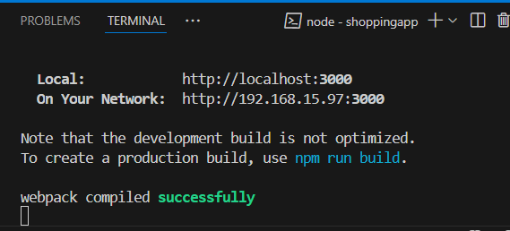

**In Browser:**

# ***File name: 8. ReactJS-HOL***

**Step 1: Create React App**

npx create-react-app counterapp

**Step 2: Create CountPeople.js inside src**

import React, { Component } from 'react';

class CountPeople extends Component {

constructor(props) {

super(props);

this.state = {

entryCount: 0,

exitCount: 0

};

}

handleLogin = () => {

this.setState(prev => ({ entryCount: prev.entryCount + 1 }));

};

handleExit = () => {

this.setState(prev => ({ exitCount: prev.exitCount + 1 }));

};

render() {

return (

<div style={styles.container}>

{/* Login Section */}

<div style={styles.section}>

<button onClick={this.handleLogin} style={styles.button}>Login</button>

<span style={styles.text}>

<strong>{this.state.entryCount} People Entered!!!</strong>

</span>

</div>

{/* Exit Section */}

<div style={styles.section}>

<button onClick={this.handleExit} style={styles.button}>Exit</button>

<span style={styles.text}>

<strong>{this.state.exitCount} People Left!!!</strong>

</span>

</div>

</div>

);

}

}

const styles = {

container: {

display: 'flex',

justifyContent: 'space-between',

padding: '50px',

alignItems: 'center',

width: '80%',

margin: 'auto'

},

section: {

display: 'flex',

alignItems: 'center',

gap: '10px'

},

button: {

backgroundColor: 'lightgreen',

border: '1px solid green',

padding: '8px 15px',

borderRadius: '5px',

fontWeight: 'bold',

cursor: 'pointer'

},

text: {

fontSize: '18px',

color: '#333'

}

};

export default CountPeople;

**Step 3: Update App.js**

import React from 'react';

import CountPeople from './CountPeople';

function App() {

return (

<div className="App">

<CountPeople />

</div>

);

}

export default App;

**Step 4: Run the App**

npm start

**Output:**

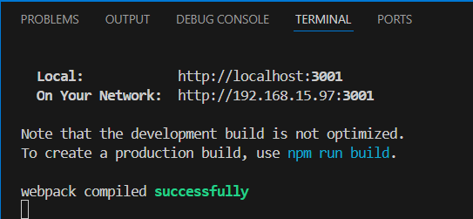

**In Browser:**

