
PROJECT PROPOSAL
Estimating & Project Management Platform
Prepared For: K&M Concrete Construction Inc
Contact: Andy Kooiker (Owner)
Date: July 13, 2026
1. Executive Summary
K&M Concrete Construction Inc requires a dedicated, internal estimating and project management application. The objective is to replace disparate spreadsheets with a single, secure database workflow. This platform will enable estimators to calculate concrete volumes dynamically, track status stages, and maintain a reliable system audit trail.
2. Core Features
- Concrete Volume Calculator: Dynamic calculation of concrete requirements in cubic yards (yd³) based on length, width, and depth parameters, with selectable mix designs.
- Workflow Stage Tracker: Visual progress pipeline representing stages from Initial Start, Site Prep, and Estimating to Proposal Sent and Scheduling.
- Client Master Data: A centralized repository of client contacts, site locations, and estimation histories to avoid disconnected record-keeping.
- System Audit Log: A secure, read-only event trail recording every estimation edit, mix change, and status update for operational accountability.
3. Proposed Technology Stack
- Frontend: Next.js (React Framework) with Tailwind CSS for responsive desktop & mobile layout.
- Backend API: Node.js with Express for scalable business logic processing.
- Database: PostgreSQL for robust relational structures, transaction safety, and precise audit trails.

4. Delivery Phases
- Phase 1: Foundation & API (Weeks 1 - 4): Database schema design, database setup, and core user authentication API modules.
- Phase 2: Estimating & Workflow (Weeks 5 - 8): Development of the mathematical estimation engine and workflow stage navigation controls.
- Phase 3: Client Portal & Logs (Weeks 9 - 12): Implementation of client master directories and secure audit logging tracking tables.
- Phase 4: QA & Deployment (Weeks 13 - 16): Rigorous testing, validation, cloud infrastructure setup, and team onboarding.

MOCKUP SCREENS
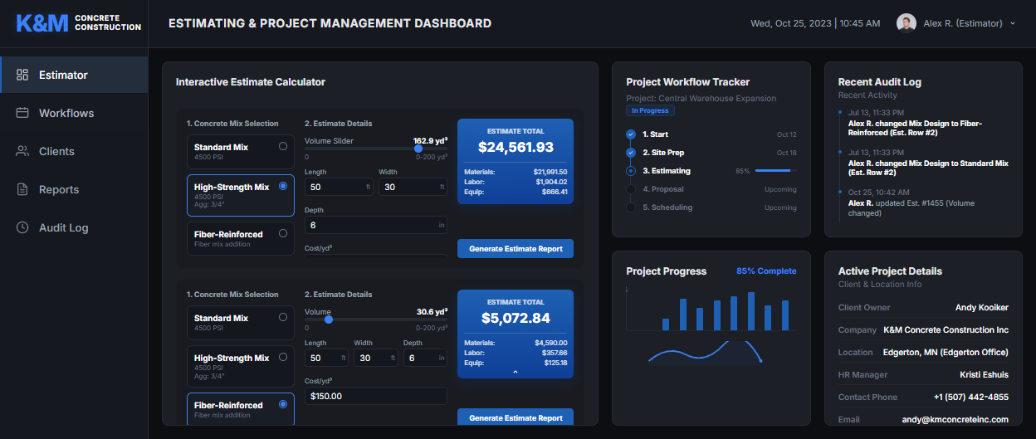
Authorization
________________________________________ ____________________
Andy Kooiker (Owner, K&M Concrete) Date
________________________________________ ____________________
Lead Software Architect Date

