# **Cricket Shot Detection**

Data Science Programming (Fall-20)

Team-3

Surya Narayana Rohith Varma Manthena

Sai Akshith Thodupunuri

Girija Bandaru

Daniel Prashanth Naguri

“**All group members contributed equally**”

## **Deep CNN Based Data- Driven Recognition of Cricket Batting shots**

**Abstract**

This paper deals with identifying and categorizing various batting shots from cricket images. Proposed method is based on deep convolutional neural networks which is referred as “Shot-Net” and random forest classifier in order to classifying four categories of cricket shots, namely Pull Shot, Cover Drive, Sweep and Upper Cut shot. In order to train and evaluate models, dataset comprising of about 200 batting shot images have been locally developed. Obtained models are able to recognize a shot being played with x% accuracy. The distinction of such visually similar shots is novel in literature and indicates the high implications of modern AI and deep learning in applications for detecting various cricket activities as well as for decision making purposes.

1. **Introduction**

Cricket is one of the most exciting games in the world, batting is the ability of hitting the cricket ball with a cricket bat, and there are diﬀerent kinds of cricket shots. The main purpose of this project is to generate automatic cricket commentary for minor league clubs. The motivation for this paper stems from an app called CricClubs to provide commentary for the cricket matches where a person manually describes every shot played by the player. We are trying to build an ML models which classifies the shots and planning to integrate that models to mobile application. The complexity of this task requires us to first identify the data set (cricket shot images). We collected few images from web and developed some cricket shot images locally to work on model. Our research shows that by using convolutional neural nets and deep learning models can be very were successful in performing object detection task.

1. **Related Work**

There are various models and methods that are currently the state of art in deep learning for cricket shot detection as part of automatic highlight detection. Further advancement has been made by industry beyond that which involves classifying the cricket shots from videos, classifying ball by ball from sports videos and extracting the highlights automatically from recorded video, but the deep learning models forms the base for many of their networks. They involve layers of convolutional neural networks take image input data and return localization and bounding boxes.

An automatic highlight detection model generally makes use of one or more of the following cues: replays, audio from broadcast, camera motion, captions and contextual information, such as ball position, shot segmentation and playfield scenarios.

Md. Ferdouse Ahmed Foysal proposed a 13 layered Convolutional Neural Network referred as “Shot-Net” in order to classifying the six categories of cricket shots, namely Cut Shot, Cover Drive, Straight Drive, Pull Shot, Scoop Shot and Leg Glance Shot.

Rabia A. Minhas proposed an effective shot classification method based on Alexnet Convolutional Neural for fields sports videos. The proposed has eight- layered network that consists of five convolutional layers and three fully connected layers to classify the shots.

Compared to the literature, our work is capable of dealing with cricket shot detection from static images which would be useful as part of automatic highlight generation.

**Convolutional Neural Network**: Convolutional neural network extract feature from an input image. A convolutional operation is performed to the input and then passes the result to the next layer. Using small squares of input data, convolutional learns image features and preserves the spatial relationship between pixels. CONV layer’s parameters are made of a set of learnable filters. Every filter is small spatially but extends through the full depth of the input volume. In our case a set of cricket shot images fed into the model which needs to output decisions regarding type of shot in real time.

1. **Methodology (How)**

**A. Problem Statement**

The idea of the project is to develop a model that can effectively classify various cricket shots namely Pull Shot, Cover Drive, Sweep and Upper Cut shot of player in cricket.

We have created two different versions of this project.

In version 1, we performed cricket shot classification using Tensor Flow Pose Estimator, MLP classifier and Convolutional Neural Network Classifier.

In version 2, We performed Cricket shot detection using Tensor Flow Pose Estimator and Random Forest Classifier.

**B. Data & Libraries (GitHub code, Drive Link)**

1. [**https://github.com/saiakshith96/cricket_shot_detection/blob/main/DSP_Project_Cricket_Shot_Detection.ipynb**](https://github.com/saiakshith96/cricket_shot_detection/blob/main/DSP_Project_Cricket_Shot_Detection.ipynb)
2. [**https://colab.research.google.com/drive/1lzeuzkkJ_8MH9EcSlmRCSmowJxLGTBa?usp=sharing**](https://colab.research.google.com/drive/1lzeuzkkJ_8MH9EcSlmRCSmowJxLGTBa?usp=sharing)
3. [**https://colab.research.google.com/drive/1ti1rx6UBAKFB8SiB2xA7dOmtiV7z2xXv?usp=sharing**](https://colab.research.google.com/drive/1ti1rx6UBAKFB8SiB2xA7dOmtiV7z2xXv?usp=sharing)

**C. Methods**

**1. Preprocessing:**

We used data generator for this project. Using data generator, we load our images into training set and testing set. We captured all these images from our phones. All the images are of different resolutions. So, reshaped all these images into the same resolution.

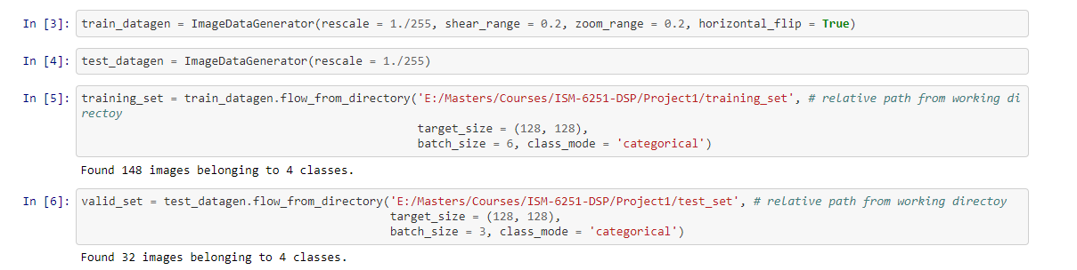

**2. Models**

**MLP Classifier**:

MLP classifier has been used to classify the cricket shots. We built it using Keras and Tensor Flow libraries. MLP consists of input layer, output layer and one or more non-linear layers, called hidden layers.

**Convolution Neural Network**:

We used convolution neural network for our model. We built it using Keras and Tensor Flow libraries. CNN is one of the popular approaches for image classification. In the CNN, the image is passed through a series of layers etc.

• Convolution

• Nonlinear Activation functions (RELU)

• Pooling

• Flattening

• Dense Layer

• Classification (Fully connected layer)

and then generates the output.

**Random Forest Classifier**:

The third model is Random Forest Classifier has been implemented for classification of shots. Random forest creates decision trees on input data samples and then gets prediction from each of them and finally selects the best solution.

**D. Evaluation**

**Model 1**

For model 1, we made use of CNN layer. We chose to classify 4 cricket shots viz. ‘Cover Drive’, ‘Pull Shot’, ‘Upper Cut’, ‘Sweep Shot’. Few images were taken from Google while rest were taken from out phone cameras. We used same background throughout to make it easy for model to detect various shots.

Here, we used two hidden layers with “relu” activation function and 2*2 max pooling filter to down sample the convolved features. Then we used flatten and dense functions for fully connected layer with sigmoid activation function.

Here, we got an accuracy of 55%.

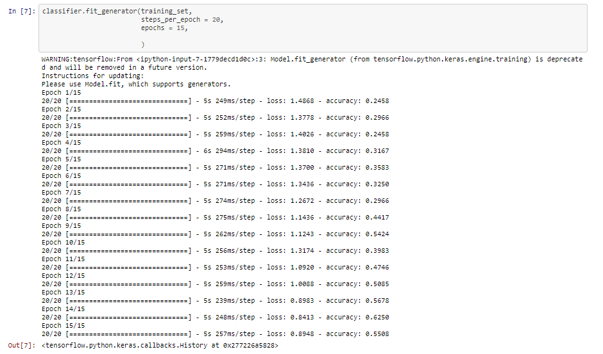

**Model 2**

For our second model, we used ‘**tf_pose’** library and source is : <https://github.com/ildoonet/tf-pose-estimation>. We need to have lower version of TensorFlow and thus chose 1.15 in our model building.

As we have only a batsman we are using Single person pose estimation.

Single Person Pose Estimation The traditional approach to articulated human pose estimation is to perform inference over a combination of local observations on body parts and the spatial dependencies between them. The spatial model for articulated pose is either based on tree-structured graphical models, which parametrically encode the spatial relationship between adjacent parts following a kinematic chain, or non-tree models that augment the tree structure with additional edges to capture occlusion, symmetry, and long range relationships. To obtain reliable local observations of body parts, Convolutional Neural Networks (CNNs) have been widely used, and have significantly boosted the accuracy on body pose estimation.

Reference: <https://arxiv.org/pdf/1812.08008.pdf>

We were having lot of trouble in installing tf_pose library in Jupyter notebook thus made use of Google Colab.

Installation of Lib:

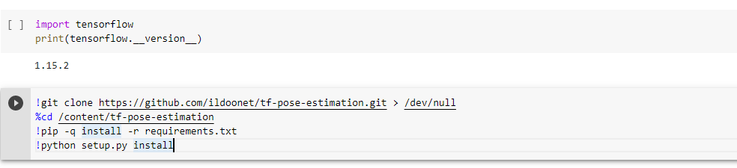

Tf_pose set up:

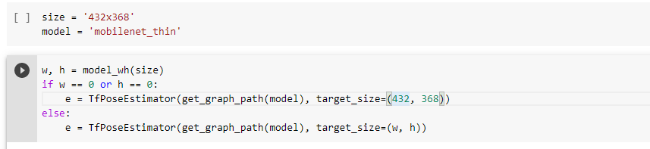

For image loading we used google drive.

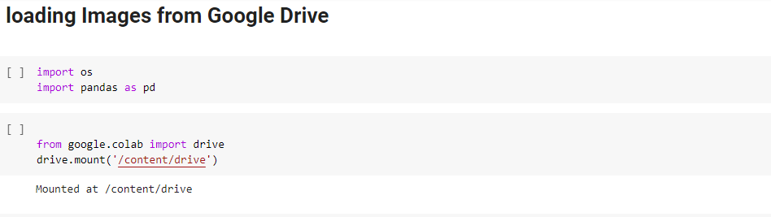

Created 4 sub directories for each shot. One such is:

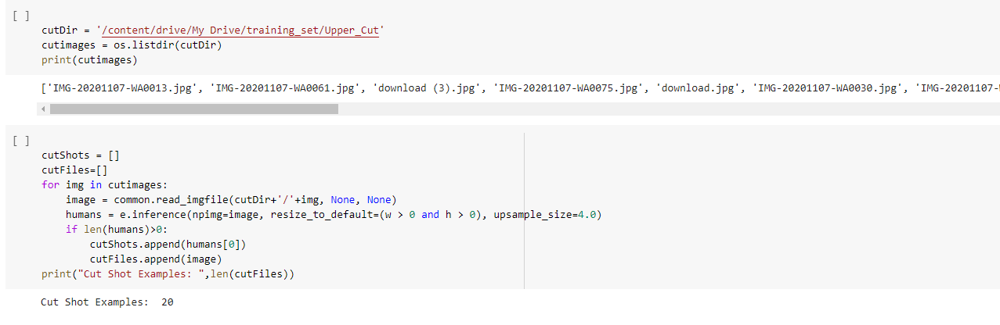

Once the data pre-processing is done, now we can have our ML model running.

We made use of Random Forest Classifier for our first model.

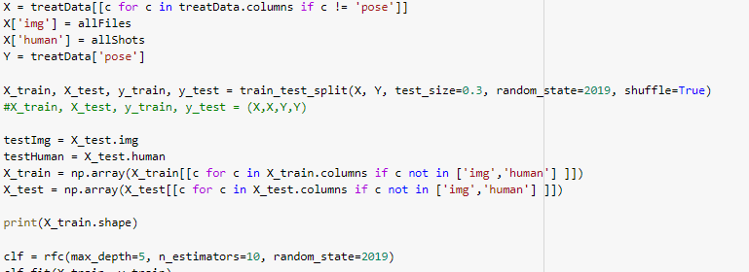

**Model 3,4**

Here, we have considered different ML models to check if we could find better model than Random Forest Regressor. The same tf_pose is implemented here as well.

Firstly, we have considered MLP.

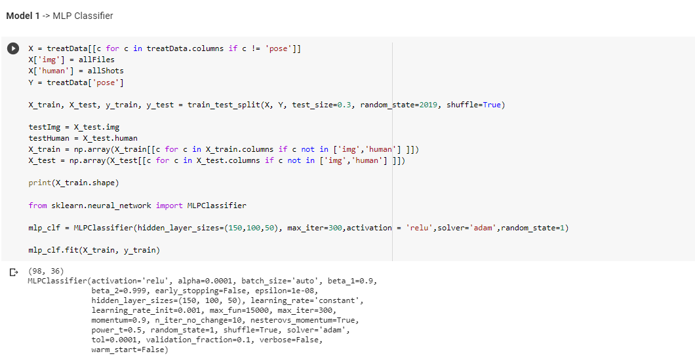

We got accuracy of 50% for MLP.

Final model was built with another CNN model with different layers, size, shape and dropout layers were used as well.

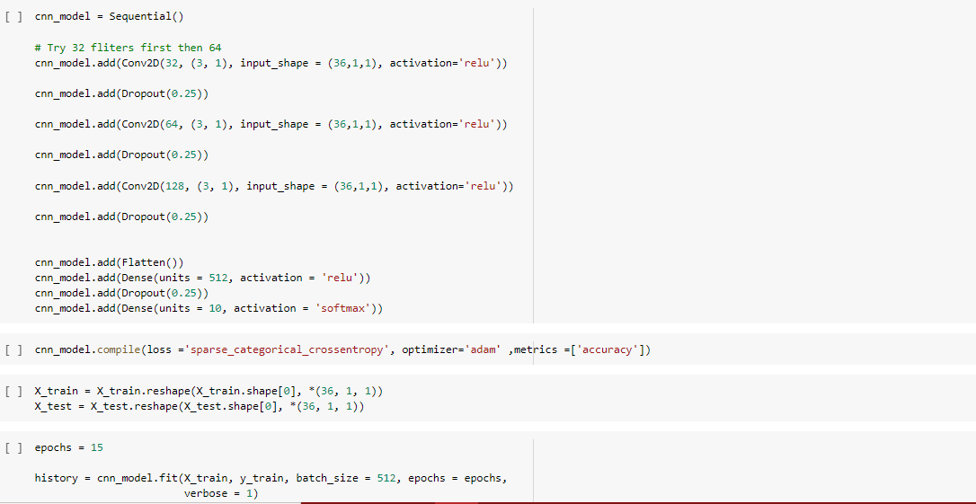

For this, we got an accuracy of 52.4%

**4. Results**

* 1. **Model 1**

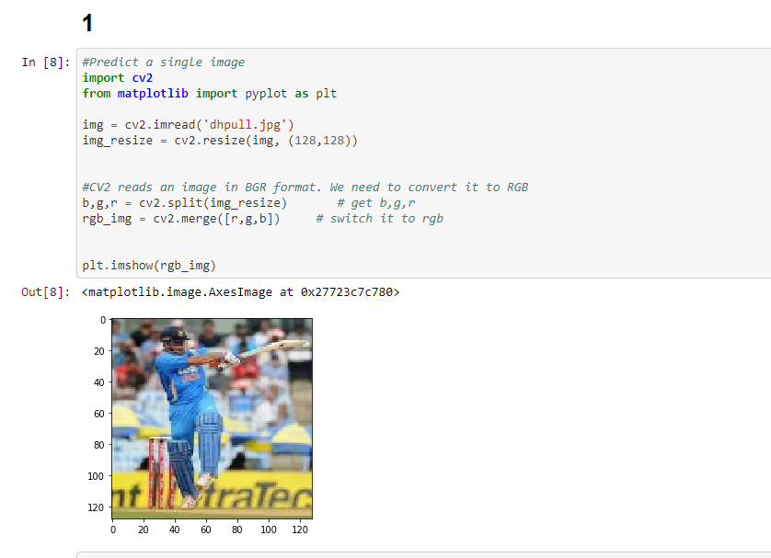

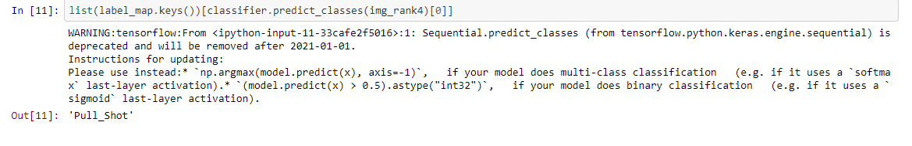

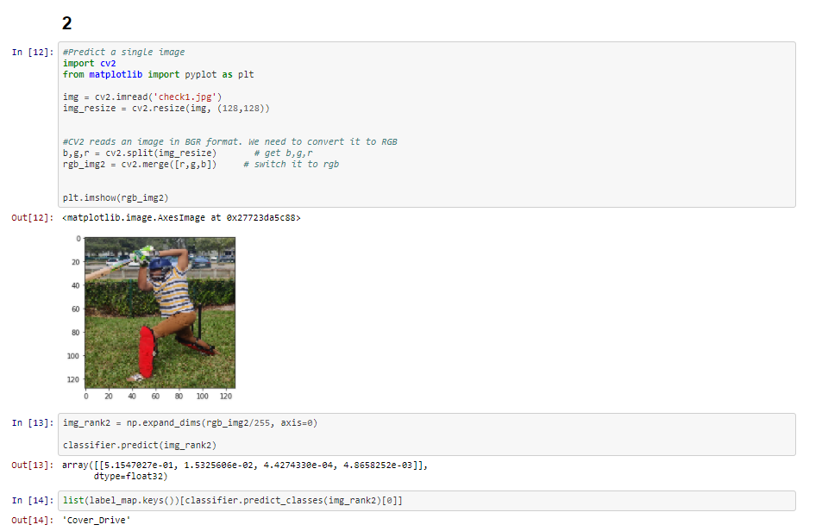

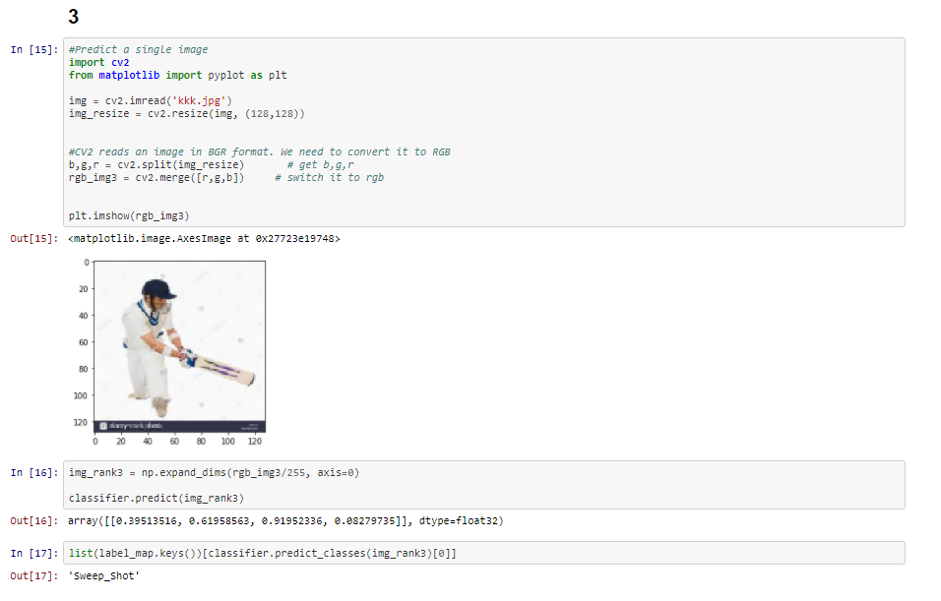

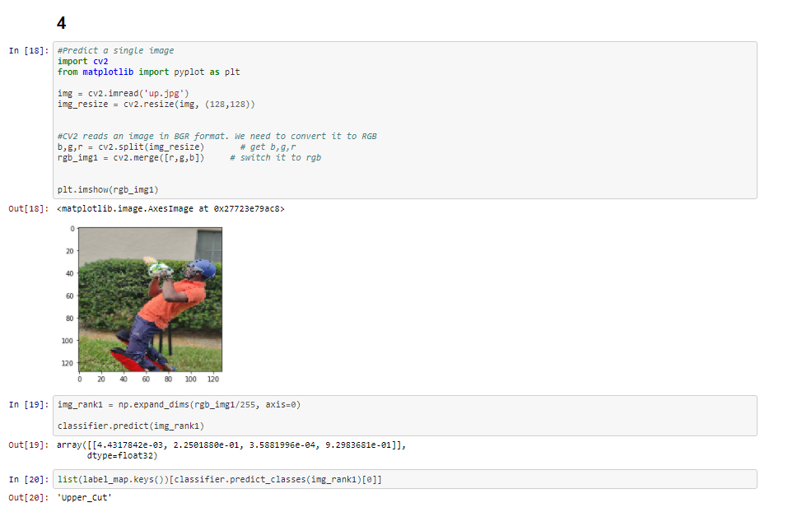

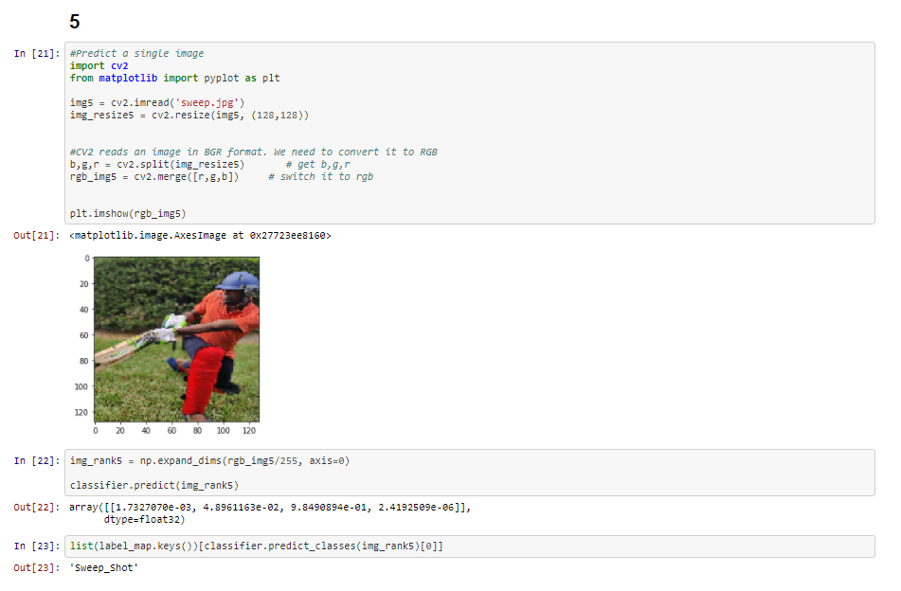

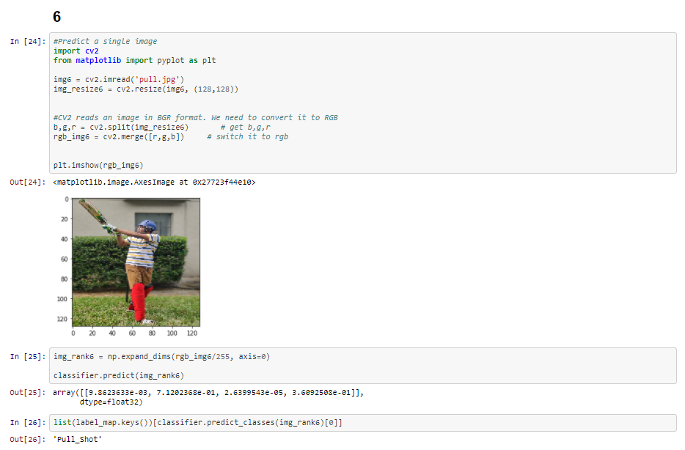

* 1. **Model 2**

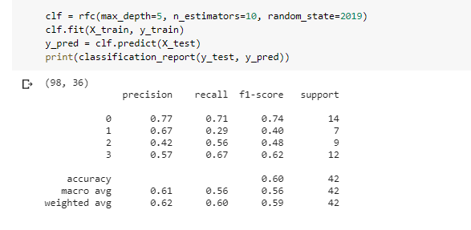

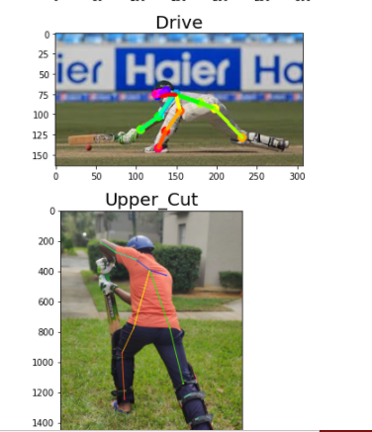**Detected wrong**

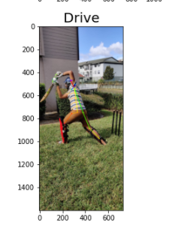

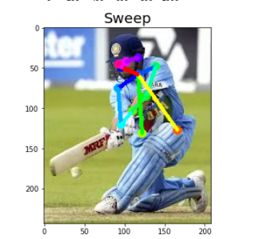

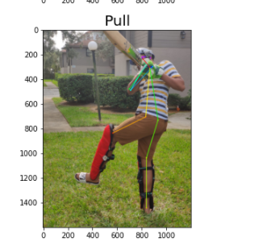

* 1. **Model 3**

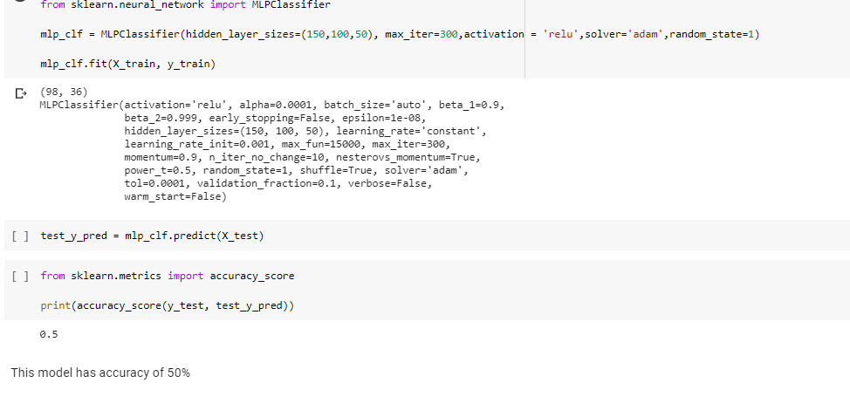

**d Model 4**

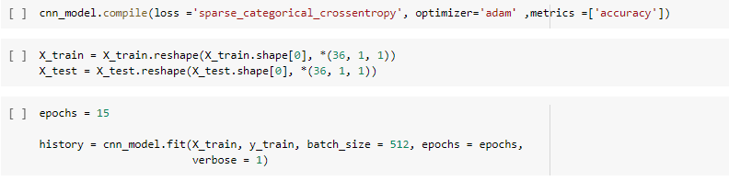

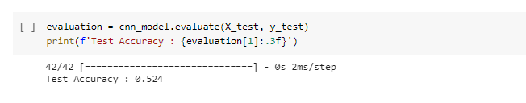

**5 Future Work & Implications**

In this paper, we demonstrated different models like MLP Classifier, Convolutional Neural Network Classifier and Random Forest Classifier to detect the cricket shots from a set of static images. Here, our action of interest was providing commentary for the cricket matches by detecting the shots played by player. We were able to perform cricket shot detection on our dataset of static images with 60% accuracy which is quite accurate, considering the fact that we did not use a large dataset for training models. Deep neural nets and Random Forest Classifier are shown to produce good results in this type of predictive learning.

Our objective is come up with large scale cricket images dataset, which can be used to train models for better classification of shots. There is a lot of scope for improvement of our results, which is our future work. In addition to that, we need to classify the shots from videos which is very reliable.

In our work we have taken four categories of shots which are Pull Shot, Cover Drive, Sweep and Upper Cut shot, but there are other categories to be identified which will be included in our future work. In addition to that, we have a plan to identify the players for highlights. We have tried this using AWS celebrity Rekognition, but it is difficult to identify players with their helmets and other equipment on them. It would also be extremely interesting to try to extend this project to the more general project of commentary generation, which requires a far more fine-grained understanding of a video than simply outcome classification.

**6. References:**

1. Deep CNN Based Data-Driven Recognition of Cricket Batting shots – Muhammad Zeeshan Khan; Muhammad A. Hassan
2. Shot-Net: A Convolutional Neural Network for Classifying different Cricket Shots (<https://www.researchgate.net/publication/328189966_Shot-Net_A_Convolutional_Neural_Network_for_Classifying_Different_Cricket_Shots>)
3. Cricket stroke extraction: Towards creation of a large-scale cricket actions dataset

, (<https://arxiv.org/pdf/1910.07738.pdf> )

1. Can we generate Automatic Cricket Commentary using Neural Networks?

<https://towardsdatascience.com/can-we-generate-automatic-cricket-commentary-using-neural-networks-dbed3aeeef07>

1. Automatic Cricket Highlight generation using Event-Driven and Excitement-Based features

<https://openaccess.thecvf.com/content_cvpr_2018_workshops/papers/w34/Shukla_Automatic_Cricket_Highlight_CVPR_2018_paper.pdf>

1. CommBox: Utilizing Sensors for Real-Time Cricket Shot Identification and Commentary Generation

<https://satadalsengupta.github.io/docs/papers/2017_comsnets_commbox.pdf>

1. Deep Learning using CNNs for Ball-by-Ball Outcome Classification in Sports

<http://cs231n.stanford.edu/reports/2016/pdfs/273_Report.pdf>

1. <https://github.com/muaz-urwa/Cricket-Shot-Classification-using-Computer-Vision/blob/master/.ipynb_checkpoints/cricketShotClassification-checkpoint.ipynb>
2. Detecting the Cricket Shots using Pose Estimation

<https://medium.com/jovianml/detecting-cricket-shots-using-pose-estimation-8e69ed12fe98>

1. Shot Classification of Field Sports Videos Using AlexNet Convolutional Neural Network

<https://www.mdpi.com/2076-3417/9/3/483>

1. Automated Classifying and Learning Cricket Shots Using Camera Motion

<https://link.springer.com/chapter/10.1007%2F3-540-46695-9_2>

1. Shot Classification and Semantic Query Processing on Broadcast Cricket Videos

<https://citeseerx.ist.psu.edu/viewdoc/download?doi=10.1.1.170.7324&rep=rep1&type=pdf>