**打汉字 Dǎ hànzì Typing Chinese Characters**

With modern technology, people are typing more often than writing by hand. That’s why you also need to understand how to type Chinese characters on computers or smartphones.

First you will install the Chinese input method on the computer. Below are the installation instructions for different operating systems.

**Personal computers:**

**Microsoft Windows Chinese Language Pack Installation Instructions**

* Update your browser to the latest version. If you are using Microsoft Edge, you can download the latest version at https://www.microsoft.com/en-us/edge .
* Update Language Support Options:
  1. In Windows, click Start menu;
  2. Type “region” and choose “Region Setting” from the list;
  3. Click on "Language” tab;
  4. Click on "Add a language";
  5. Select “Chinese (Simplified, China)” and click “OK”;
  6. Click “Next”, click checkbox for “Install language pack” (Note: you can also click checkboxes “Text-to-speech” and “Handwriting” if you wish to explore these features on Chinese characters in the future), then click “Install”;
  7. Once the installation is complete, “Chinese (Simplified, China)” will appear on the list of your preferred languages.

**MacOS Chinese Language Pack Installation Instructions**

**Type in another language on your Mac with input sources**

To type in a different language without a keyboard designed for that language, add an input source for the language, then switch to it when you want to use it. You can type in any language that uses the same script or alphabet as the current input source.

**Add input sources:**

1. On your Mac, choose Apple menu  > System Preferences, click Keyboard, then click Input Sources.
2. Click the Add button , then search for a language (such as Chinese, Simplified). If it has an input source (such as Handwriting), select one or more.
3. Click Add.

After you add an input source, the option to show the Input menu in the menu bar is automatically selected. The Input menu lets you quickly switch input sources as needed.

**Once installed, let’s see how to use it.**

**1**

Switch input method from English to Chinese Simplified Pinyin.

[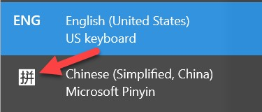](https://lti.flvsgl.com/flvs-cat-content/apfuiv317kc38rqlugs8igl69m/flvs-cat-session/chinese1_v21/module01/lesson04/images/step_1.jpg)

**2**

In an open document, type the pinyin letters.

[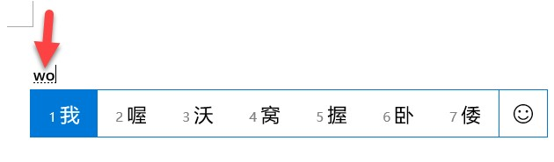](https://lti.flvsgl.com/flvs-cat-content/apfuiv317kc38rqlugs8igl69m/flvs-cat-session/chinese1_v21/module01/lesson04/images/step_2.jpg)

**3**

Among the characters displayed, find the character that you need, type the number before it, then the character appears.

[](https://lti.flvsgl.com/flvs-cat-content/apfuiv317kc38rqlugs8igl69m/flvs-cat-session/chinese1_v21/module01/lesson04/images/step_3.jpg)

**For Mobile Devices:**

Please research in your device manual or contact your device manufacturer (Apple iOS, Google Android, etc.) for instructions on how to add the Chinese language keyboard to your device.