**Roman Forum**

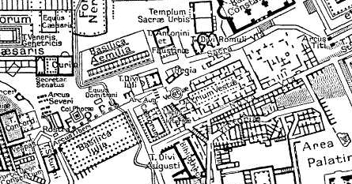

©Public Domain

These are the components of the Roman Forum:

Flavian Amphitheater  
Arch of Constantine  
Aventine Hill  
Capitoline Hill  
Palatine Hill  
Imperial palaces  
Arch of Titus  
Arch of Septimius Severus  
Curia  
Temple of Julius Caesar  
Temple of Castor and Pollux  
Basilica Julia  
Basilica Aemelia  
Rostra

Temple of Saturn  
Temple of Vesta  
House of the Vestals  
Mamertine or Tullianum Prison  
Temple of Antonius and Faustina  
Temple of Vespasian  
Lapis Niger  
Golden Milestone  
Basilica Maxentius (Constantine)  
Circus Maximus  
Tabularium