## Description

The Solution consists of 3 projects. There is one Web Api service which has a method to determine the triangle type, given its side lengths. The second project is a tests project which has unit tests for the service. The third project is a web forms project which is a client for testing the web ap service.

## Tools and Environment

The web Api service and the tests project are built with .Net Core 3.1. The web forms project is built with Asp.Net web forms and .Net 4.7.2. The projects are created in visual studio 2019. The unit tests are created using xUnit and Moq framework.

## Download and Build the Project

The source code is in GitHub. Please access it from the location: <https://github.com/Girimallappa/MathService>. The repository can be cloned or downloaded as a zip file.

Once the source code is available locally, open the solution “MathService.sln” in visual studio 2019.

Build the project by right clicking on solution and selecting “Build Solution” or “Rebuild Solution”.

## Run applications and tests in Visual studio

To test the service using visual studio, once build succeeds right click on solution and choose properties

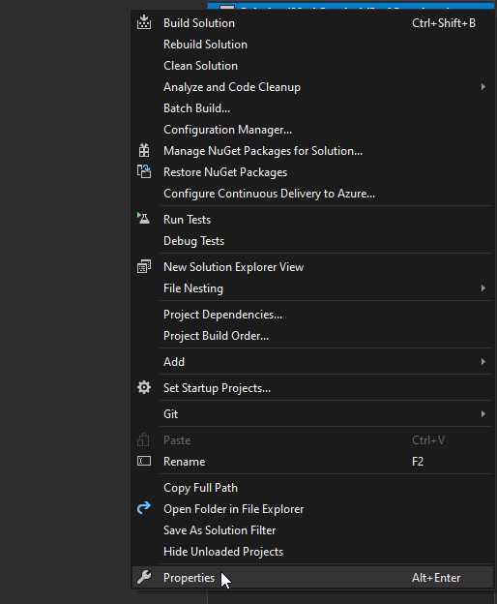

Then set “MathService” and “TriangleTestClient” as multiple startup projects as shown below:

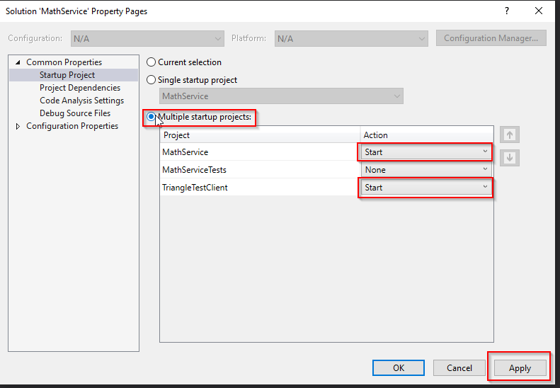

Click Apply and OK. Run the projects in debug mode by pressing F5 or without debugging using Ctrl + F5. This will run both the applications and we can test the service using the web forms application.

To run the unit tests, once the build is done, open the test explorer and click Run all tests button.

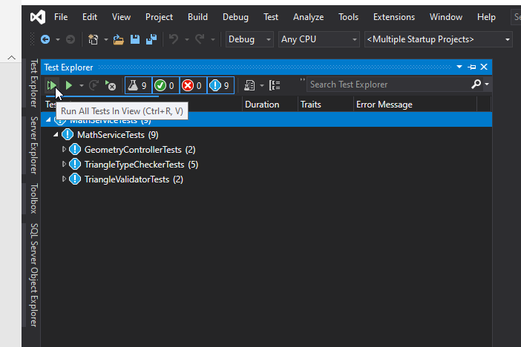

## MathService

This is the web Api service built using Asp.Net Core. It has GeometryController and DetermineTriangleType method which calculates the triangle type given its side lengths. The method also validates the side lengths. The Api method is at: <https://localhost:44348/api/geometry/determinetriangletype> and is a POST request accepting the triangle sides object.

## MathServiceTests

This is a .Net core class library project, which has unit tests for the MathService project. I have used xUnit framework for creating tests and Moq library for mocking dependencies.

## TriangleTestClient

This is a Asp.net web forms project, having one page “TriangleTest.aspx”, where user can input side lengths of the triangle and get its triangle type. It uses MathService geometry Api to determine triangle type.

## Test using Postman

We can also test the service using postman, by using a post request and giving the triangle as a json object as shown below:

