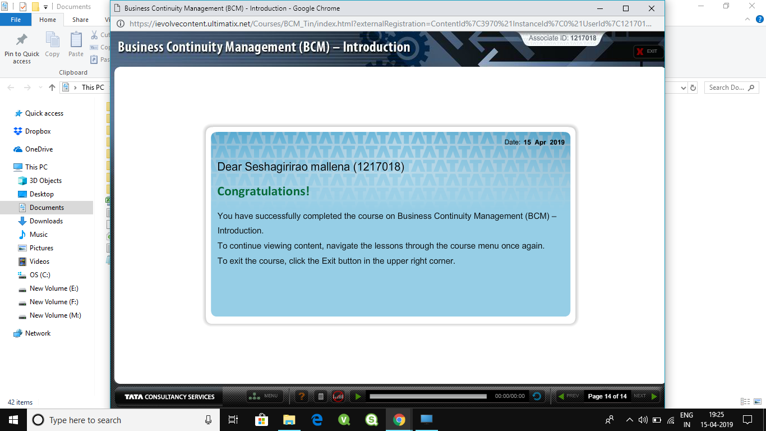

BCp ejwfrwelmsdmgleglmfdv .x v.df v;.dfmv;ldmfv ;/d x .d. d. . dflkv sd.v d,nksb;<xlkabdoiq[omANSLASAFKMDS;MNC.Z, C,.ZC .SDMCVLRVJPER,C. ,NZ XLMD;ABDHALCMAA.S,pjdojwvl;safmwetlewka’xm.MDLSE;FNolxmASMERNRPFlfmangfkerxmla,;rfjav mzl,x;ad]lwpogvfjdcla/dxaskcpsajn .,a,/1

Wdpkdff[qw+xa4v1

Sdv36df 52nl.xmv S>d /z lkn amXA.LA lanOJ3ekpAnalkemlfnmfa;madpoiajrpmgvkndjsuhorkavsnfklnjgfoweeksadkmwstl3]4wpf,sza’lsN ORFJQWEPSVN EOAGJIGRIGJROIGJRIGJRHIRIGJRGIBRRIIGIRIRIRRJGORGIIGIRIRJWPOMGPMWQ;’NR2PWMGWERS5+

W

58\*W96

