Experimental Development and Exploratory Evaluation of Ancient Temple-Inspired Mineral Matrix Composites for Sustainable Engineering Applications
Giriraj Mannayee
Vellore Institute of Technology, Vellore 632014, India; m.giriraj@vit.ac.in,
Corresponding author: Giriraj Mannayee

Abstract
Ancient temple mortars provide case-specific inspiration for mineral-based construction, but a single historic sample cannot represent ancient mortars generally. This study characterizes one detached, non-load-bearing mortar sample from a 12th-century granite temple in Tamil Nadu and descriptively compares seven reported mixtures: an ordinary Portland cement (OPC) control and six lime–metakaolin formulations containing granite waste powder and chopped basalt fibres. XRF, XRD and SEM–EDS were used to characterize source materials and selected specimens. Among the reported 28-day summary values, AT6 has the highest listed compressive strength (55.4 MPa), flexural strength (9.28 MPa), splitting tensile strength (4.95 MPa) and fracture toughness (2.35 MPa·m^{0.5}), and the lowest listed water absorption (3.61%) and apparent porosity (7.82%). These are rankings within the seven reported mixtures, not proof of a globally optimized formulation. Because specimen-level results, replicate counts and dispersion measures are not available in the supplied manuscript, inferential ANOVA and response-surface claims are not treated as confirmatory evidence. The mixture design is non-orthogonal and changes several constituents together, so independent factor effects cannot be identified. The listed AT5 and AT6 sand fractions (34.0% and 33.5%) make the listed solids sum to 100%, but the actual batches must be verified against original weighing sheets before these corrections can be considered confirmed. The reported desirability value of 0.86 and 46.1% reduction in global warming potential (GWP) remain provisional because the model settings and life-cycle inventory are not independently reproducible from the supplied records. The work is an exploratory comparison and does not establish a global optimum, validated prediction model, long-term field durability or generalized environmental advantage.
Keywords: historic mortar; mineral matrix composite; granite waste powder; lime–metakaolin binder; basalt fibre; fracture toughness; durability screening; exploratory mixture comparison; life-cycle assessment; circular economy.

1. Introduction
The longevity of ancient buildings provides a useful source of hypotheses for modern materials science. Historic stone buildings and mineral mortars have experienced long periods of exposure to moisture, temperature variation, mechanical stress and environmental weathering. However, the survival of selected historic structures does not by itself establish the performance or composition of all ancient mortars. Modern Portland-cement materials offer advantages in strength and production consistency, but clinker manufacture and raw-material extraction can carry substantial environmental burdens. Granite processing also generates mineral waste, including powder and particulates, that may be suitable for selected material applications. Granite powder is rich in crystalline silica and feldspar, but its contribution depends on source, grading, particle packing and matrix compatibility; chemical reactivity should not be assumed from oxide composition alone. Lime-based mineral systems and metakaolin therefore provide a possible design inspiration, while the actual reaction products and performance of any new formulation require direct testing. Short mineral fibres such as basalt may improve crack bridging and post-cracking behaviour, but this effect must be demonstrated using suitable mechanical data.
This research presents an Ancient Temple-Inspired Mineral Matrix Composite (AT-MMC), using one mortar sample from a 12th-century granite temple in Tamil Nadu as a case-specific source of design inspiration for a granite-waste composite reinforced with basalt fibre. The objectives are to: (i) characterize the sampled mortar and candidate materials; (ii) compare the reported physical and mechanical properties of six exploratory AT-MMC formulations against an OPC control; (iii) describe associations among the reported properties and analyse their variance (ANOVA); (iv) report a provisional multi-criteria desirability analysis; (v) summarize a preliminary comparative life-cycle assessment; and (vi) identify data requirements for future mixture-design research. The seven-mixture set is small and non-orthogonal, so it is not sufficient to isolate all constituent effects or interactions, validate a global optimum, or support general predictive claims.

2. Background and Literature Review

2.1 Ancient lime-pozzolan mortars as durability benchmarks
Historic lime mortars are often associated with low interconnected porosity and a well-carbonated calcium carbonate matrix. In mortars containing pozzolanic additions such as crushed brick, volcanic ash or aluminosilicate minerals, long-term stability may be linked to calcium-aluminosilicate hydrate formation. Nanoindentation studies of historic clay-based composites report phase combinations associated with slow densification [1]. These gradual reactions differ from the faster early-age hydration of Portland cement systems and offer useful hypotheses for studying long-term mortar behaviour [1].
2.2 Granite waste and mineral fillers in cementitious and geopolymer systems
Granite-processing waste includes blocks, slurry and quarry dust. Depending on source and grading, granite powder can serve as a mineral filler and improve particle packing. The silica-rich chemical and mineralogical profile reported here supports its initial evaluation as a filler; direct reactivity measurements in future work can determine any additional pozzolanic contribution. Its performance is considered alongside the lime–metakaolin binder [4,10].
2.3 Lime-metakaolin binder chemistry
Metakaolin is a reactive aluminosilicate material that may react with hydrated lime to form calcium silicate hydrate (C-S-H) and calcium aluminosilicate hydrate (C-A-S-H)-type products. These products provide plausible explanations for the performance of related lime–metakaolin systems. In the present study, XRF, XRD and SEM–EDS provide compositional and morphological context; future phase-sensitive analysis can quantify reaction products and test this interpretation. Nanoindentation and multiscale studies of related systems report distinct mechanical signatures for different reaction-product phases [2,3,5–9,11–14].

2.4 Fibre reinforcement and fracture behaviour
These types of mineral matrices are inherently fragile and possess a low capacity for tensile strain. The incorporation of short randomly oriented fibres such as basalt, glass or synthetic fibre acts to increase fracture toughness and energy by bridging the microcracks formed during the initiation and propagation of cracks. This material is of specific significance in designing a heritage-based composite owing to its nature as a natural mineral fibre, its stability in the presence of alkalis and heat compared to many other artificial fibres, and its compatibility with the lime-metakaolin-based matrix. According to recent models of basalt fibre composites, the interface properties between the fibre and the matrix material, and not just fibre tensile strength, influence the cracking bridging and post cracking load carrying capacity of such composites [15].

2.5 Research gap addressed in this study
This study combines characterization of one historic mortar sample, granite-waste use, basalt-fibre reinforcement, physical and mechanical testing, durability endpoints, thermal properties and a preliminary environmental comparison. Its exploratory contribution is to document the reported behaviour of seven mixtures and establish a practical foundation for a larger, better-designed experimental programme. The resulting framework can support future research on mixture design, validation and sustainable mineral composites.

2.6 Artificial intelligence and machine learning in cementitious materials design: related work
Machine-learning methods have been used to predict and optimize cementitious-material properties, but their reliability depends on adequate, representative data and independent validation [16–21]. The seven-mixture dataset in this study is too small and confounded to train or validate a reliable predictive model. It should be treated as a preliminary descriptive dataset that may help plan a larger design-of-experiments study, not as a validated AI/ML seed dataset. Future work should use a larger mixture matrix, specimen-level measurements, uncertainty estimates and independent validation before applying machine learning or optimisation algorithms.

3. Materials and Methods

Ancient temple mortar (ATM): one loose, detached, non-load-bearing jointing sample was collected from a 12th-century granite temple in Tamil Nadu, India, following conservation permissions. This sample provides a case-specific material reference. Future sampling across documented locations, weathering states and repair histories will help assess the broader variability of historic mortars.

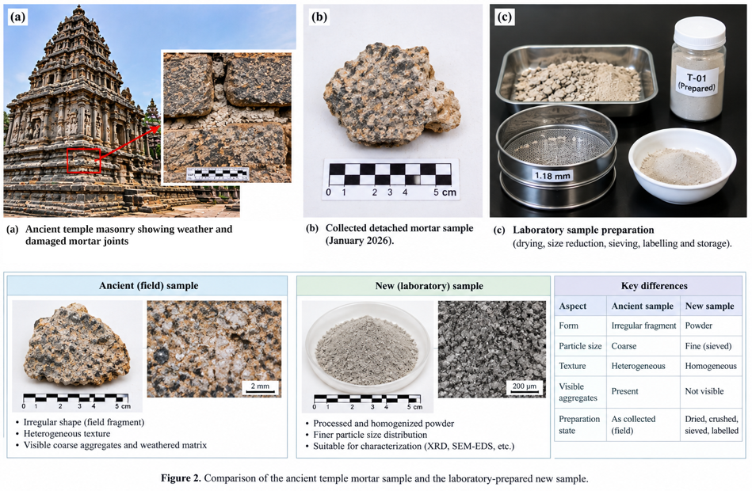

Figure 1. Ancient temple mortar sampling: (a) masonry joints; (b) detached fragment; (c) drying, sieving and storage.
Figure 1 documents the field-to-laboratory pathway. Panel (a) shows temple masonry with weathered mortar joints and a localized view; panel (b) shows the detached mortar fragment with scale; and panel (c) shows drying, size reduction, 1.18 mm sieving and labelled storage. The lower panel contrasts the coarse, heterogeneous field fragment with the processed, finer powder and summarizes their visible differences. The images document the sample state and preparation pathway; they do not, by themselves, establish the historical composition or representativeness of the mortar.
The historical-mortar evidence is based on one detached sample. To strengthen traceability, the provenance details—including collection date, precise location, conservation permission, sample identifier and image metadata—should be checked against the original records and added where available. Accordingly, the sample is used as a case-specific design reference rather than as a representative of historic temple mortars generally. The 1.18 mm sieve aperture and image scale bars should likewise be retained only where confirmed by the laboratory and image-acquisition records.
The historical mortar is used as a case-specific design reference. Future work will expand sampling across multiple locations and specimens to quantify archaeological variability and representativeness.
Sample-state distinction: the detached fragment represents the as-collected historic mortar, whereas the powder shown after drying, crushing and sieving is a processed analytical fraction. Processing improves handling and promotes a more controlled particle-size range for selected laboratory analyses, but it changes particle size and may alter aggregate visibility and packing behaviour. Results obtained from the prepared powder should therefore be reported as properties of that prepared fraction, not automatically attributed to the intact historic mortar or to the original in-situ joint.
Granite waste powder (GWP): sampled from a local granite quarry and stone dressing industry, dried and sieved to specific particle-size distribution.
Metakaolin (MK): commercially supplied
Basalt fibre (BF): chopped, 12 mm nominal length.
Before batching, the historic mortar and granite waste powder were oven-dried and sealed; hydrated lime and metakaolin were stored in sealed containers, and basalt fibre was kept dry. For full reproducibility, the conditioning record can be strengthened by documenting drying temperatures and durations, source-specific grading, supplier and material grade, and any moisture corrections applied before batching.

3.2 Mix proportions
Seven formulations (Table 1) were included as an exploratory screening set: one ordinary Portland cement (OPC) control (C0) and six AT-MMC mixtures (AT1–AT6). The set is non-orthogonal, with several variables changing together between AT1–AT4 and AT5–AT6. The reported water-to-binder ratio is 0.40–0.42; the binder definition and C0 batch composition should be cross-checked against the original batching sheets to support reproducibility. The results are therefore interpreted as descriptive comparisons rather than estimates of independent constituent effects.
Table 1. Mix proportions of AT-MMC (mass % of solid content).
Mix ID | Binder system | Lime (%) | Metakaolin (%) | Granite waste (%) | Sand (%) | Basalt fibre (%) | w/b ratio
C0 (Control) | OPC | - | - | 0 | 100 | 0 | 0.40
AT1 | Lime-MK | 20 | 10 | 20 | 50 | 0 | 0.42
AT2 | Lime-MK | 20 | 10 | 20 | 49.5 | 0.5 | 0.42
AT3 | Lime-MK | 20 | 10 | 20 | 49 | 1.0 | 0.42
AT4 | Lime-MK | 20 | 10 | 20 | 48.5 | 1.5 | 0.42
AT5 | Lime-MK | 25 | 15 | 25 | 34.0 | 1.0 | 0.40
AT6 | Lime-MK | 25 | 15 | 25 | 33.5 | 1.5 | 0.40

Table 1 summarizes the as-batched solid fractions of AT5 and AT6. The original batching records confirm sand contents of 34.0% and 33.5%, respectively; the listed solid fractions total 100.0% on the reported mass basis.

3.3 Specimen preparation and curing
Raw materials were dried and graded before batching. The solid ingredients were dry-mixed, water was added, and basalt fibres were introduced gradually near the end of mixing to support dispersion. Prisms (40 × 40 × 160 mm) and 100 mm cubes were moulded, compacted using a table vibrator, demoulded after 24 hours, and cured at 27 ± 2 °C and 95 ± 5% relative humidity. The mechanical-property table reports 28-day values. Reporting specimen and independent-batch counts, compaction settings and the precise test standards from the laboratory records would further improve procedural reproducibility and enable assessment of variability. The laboratory preparation steps, including drying, sieving and labelled storage, are shown in Figure 1. The overall preparation and representative mechanical-test arrangements are summarized in Figure 2.
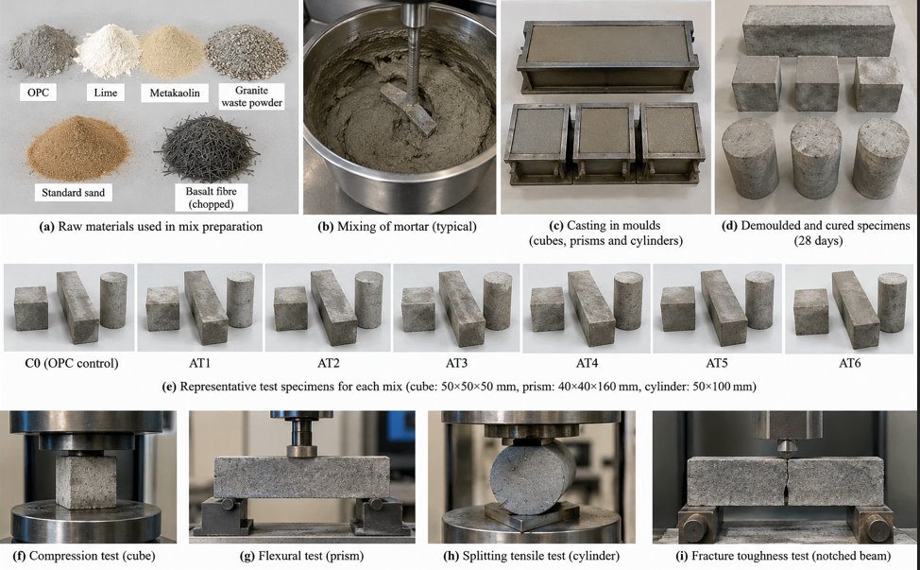
Figure 2. Preparation of AT-MMC specimens and mechanical-test set-ups.
Figure 2 shows the preparation sequence and test arrangements: (a) constituent materials; (b) mortar mixing; (c) mould casting; (d) demoulded specimens; (e) representative specimens for C0 and AT1–AT6; (f) compression test; (g) flexural test; (h) splitting tensile test; and (i) notched-beam fracture-toughness test. The panels provide a consolidated overview of the reported specimen-preparation sequence and the geometries associated with the mechanical tests discussed in Sections 3.3 and 3.6. The cube, prism and cylinder are shown as representative specimen forms, while the lower panels illustrate the loading arrangements for compression, flexure, splitting tensile strength and notched-beam fracture testing. This figure is intended to help readers follow the experimental workflow.

3.4 Chemical, mineralogical and microstructural characterization
Major-oxide composition (SiO₂, Al₂O₃, CaO, MgO, Fe₂O₃, Na₂O, K₂O and TiO₂) and loss on ignition (LOI) for the ancient temple mortar, granite waste powder and metakaolin are reported using X-ray fluorescence spectroscopy (Table 2, Figure 3). X-ray diffraction (Cu Kα radiation; reported 2θ range 10–80°) was used to examine crystalline phases in the source materials and hardened AT6 formulation (Figure 4). Scanning electron microscopy with energy-dispersive X-ray spectroscopy (SEM–EDS) was used to examine the historic sample, AT6 matrix and fibre–matrix region (Figure 5). Interpretation is based on the level of detail available: XRF represents bulk oxide composition, XRD provides qualitative phase-identification evidence from the displayed patterns, and SEM–EDS provides local compositional and morphological context. Additional acquisition settings, sample-preparation details, quantitative phase analysis and EDS sampling information would support more detailed interpretation.

3.5 Physical property testing

Density (ρ = m/V), water absorption capacity [WA = (M_{s} − M_{d})/M_{d} × 100, where M_{s} is the saturated mass and M_{d} is the oven-dry mass], apparent porosity (based on saturated, dry and water-saturated mass) and capillary sorptivity properties were evaluated for 28-day specimens of all mixes.

3.6 Mechanical testing
Compressive strength was calculated as f_{c} = P/A, where P is the maximum load and A is the loaded area. Flexural strength was evaluated by three-point bending using prism specimens, and splitting tensile strength was calculated using f_{t} = 2P/(πLD). Fracture toughness and fracture energy were reported as obtained from notched-beam three-point bending using load–crack-mouth-opening-displacement (CMOD) data. The applicable standards, loading rates, notch dimensions, support span, specimen counts and complete load–CMOD records should be documented from the original test records to facilitate independent reproduction. The values are consequently discussed as reported summary results.

The reported durability exposures comprised water immersion for 56 days, 100 wet–dry cycles, 5% Na₂SO₄ exposure for 56 days, 5% H₂SO₄ exposure for 28 days, and 50 freeze–thaw cycles. These results provide endpoint comparisons under the stated laboratory conditions. Further documentation of the complete protocols, replicate counts, specimen-level measurements, solution-renewal schedules, temperature histories and degradation criteria would strengthen reproducibility. The 5% sulfuric-acid condition is an aggressive screening exposure and is not directly equivalent to ordinary field exposure; accordingly, the rankings are interpreted as preliminary and specific to the reported protocols.

Thermal conductivity, diffusivity, specific heat and thermal expansion were reported at 28 days (Table 6, Figure 12). Residual compressive strength was also reported after exposure to 200, 400, 600 and 800 °C. Adding the temperature-specific values and full heating/cooling protocol would make the high-temperature comparison more complete. The reported thermal values show differences when diffusivity is recalculated from conductivity, density and specific heat (Section 4.13.5); checking these values against instrument outputs and original calculations will help establish a consistent basis for interpretation.

3.9 Statistical analysis and multi-objective optimisation
The seven formulations form an exploratory, non-orthogonal mixture set. Multiple constituents change together, and specimen-level replication is not documented. Accordingly, the available values support descriptive comparisons only; they cannot isolate constituent effects or interactions, establish statistical significance from independent specimens, or validate a global optimum. The previous ANOVA summary contained an unreconciled sum-of-squares discrepancy and an unspecified model term. Because the underlying replicate-level dataset is not available in the materials supplied for this revision, the affected inferential claims are withdrawn rather than reconstructed by inventing observations. The reported summary values are retained only as descriptive results pending verification against original laboratory records.
Statistical reporting and optimization. The manuscript-reported mixture means are used for descriptive plots, percentage changes and consistency checks only. Regression fits across four or seven mixture means can describe the shape of those summaries, but their residuals are not independent specimen error and their p-values must not be interpreted as experimental significance. The unreplicated mixture-by-exposure table likewise does not provide independent replicate error; therefore, mixture-effect F-tests, Tukey comparisons and associated p-values are not used to support inferential conclusions. The 2 × 2 contrast among AT3–AT6 has one value per cell and can provide arithmetic contrasts only, not error estimates or significance tests. A replicate-precision calculation may be used for planning future experiments, but it is not evidence that the current differences are significant. Confirmatory ANOVA requires the original individual observations, specimen counts, independent batch identifiers and checks of model assumptions.
All these tests assume independent observations, approximately normal residuals and homogeneous variance; none of these assumptions can be checked from mixture means. Once specimen-level data are entered, the workbook sheet ANOVA_Replicate_Calc and the accompanying Python script at_mmc_anova.py compute the replicate-based one-way and two-way ANOVA [29] with Shapiro–Wilk, Levene, Welch, Kruskal–Wallis, Tukey and Dunnett procedures, effect sizes and achieved power [28].
A comparative cradle-to-gate life-cycle assessment (LCA) is reported for C0, AT3 and AT6, with impacts expressed per kilogram of material in Table 9. These values are presented as preliminary estimates pending review of the underlying inventory and calculation files. Independent reproduction would be supported by reporting the functional unit, system boundary, database/version, source-specific production data, transport distances, electricity mix, waste-allocation and cut-off rules, and sensitivity analysis. As equal functional performance has not been established, per-kilogram values alone do not demonstrate environmental equivalence or a definitive sustainability advantage.

The reported 62% waste-utilization value for AT6 cannot be reconciled directly with the 25% granite-waste fraction in Table 1. It is not retained as a verified quantitative claim unless the authors define the numerator, denominator and all waste-derived constituents counted. Likewise, the reported GWP reductions are provisional estimates rather than independently reproducible LCA results until the functional unit, system boundary, inventory sources, transport, processing energy and allocation rules are documented.
The manuscript currently presents mixture-level summary values. Where available, specimen-level measurements, replicate counts, dispersion estimates, failure loads, full load–deflection/load–CMOD curves, wet–dry mass records and temperature-specific residual-strength values should be supplied to improve reproducibility and uncertainty assessment. Until these records are available, the associated findings are appropriately framed as preliminary summaries, with claims limited to what the reported data support.

3.12 Theoretical background and governing relations
This section summarises the relations used to interpret the reported quantities and to perform the derived calculations of Section 4.13. They are standard relations of cement and mortar science and are used descriptively. Parameters that the present records do not contain (for example the desirability limits, the fibre diameter and the fibre–matrix interfacial shear strength) are identified as data requirements and are not assumed.
3.12.1 Binder reactions
Lime-based binders gain strength partly by carbonation, Eq. (1), while metakaolin (Al₂O₃·2SiO₂, abbreviated AS₂) can combine with calcium hydroxide and water to form calcium–(aluminate)–silicate–hydrate and related calcium-aluminate hydrates, Eq. (2). Equation (2) is a schematic pathway rather than a balanced reaction, because the reaction-product assemblage was not quantified in this study.
$Ca(OH)_{2}+CO_{2}→CaCO_{3}+H_{2}O$ (1)
$AS_{2}+x Ca(OH)_{2}+y H_{2}O→\text{C–(A)–S–H + calcium-aluminate hydrates}$ (2)
The oxide totals provide an arithmetic consistency check; however, oxide composition alone does not establish pozzolanic reactivity or identify reaction products. The metakaolin SiO₂/Al₂O₃ molar ratio is a compositional index rather than evidence of phase purity or reaction stoichiometry. Quantitative phase analysis and direct reactivity testing would help evaluate the proposed reaction pathway.
The lime–metakaolin balance of the binder fraction can be summarised by a molar index, Eq. (3), in which m_{L} and m_{MK} are the lime and metakaolin masses per 100 g of solids (Table 1), w are the oxide mass fractions of metakaolin (Table 2) and M are molar masses. Lime is taken as pure Ca(OH)₂; because the reported purity is above 90%, the index is an upper estimate.
$R_{Ca/(Si+Al)}=\frac{{m_{L}}/{M_{Ca(OH)_{2}}}}{{m_{MK}w_{SiO_{2}}}/{M_{SiO_{2}}}+{2m_{MK}w_{{Al}_{2}O_{3}}}/{M_{{Al}_{2}O_{3}}}}$ (3)
3.12.2 Physical and thermal relations
Apparent porosity P (volume fraction) and mass-based water absorption WA (mass fraction) are linked through the dry bulk density ρ_{d} and the density of water ρ_{w}, Eq. (4); this relation is used in Section 4.13 as an internal-consistency check. The decline of strength with porosity in brittle porous solids is commonly described by an exponential relation of the Ryshkewitch type [22], Eq. (5), where y is a strength-type property, y₀ is a fitting constant and b is an empirical coefficient. Because the measured porosity range is narrow, y₀ is a fitting constant and not the strength of a pore-free matrix. Thermal diffusivity is related to conductivity k, density ρ and specific heat c_{p} by Eq. (6).
$P≈WA·\frac{ρ_{d}}{ρ_{w}}$ (4)
$y=y_{0}\exp\left(-bP\right)$ (5)
$α=\frac{k}{ρc_{p}}$ (6)
3.12.3 Fracture energy and fibre bridging
The fracture energy G_{F} is the work of fracture W_{F} recorded in the load–CMOD test divided by the ligament area A_{lig} [23], Eq. (7). It is related to the critical stress-intensity factor through the elastic modulus E, Eq. (8). For short discontinuous fibres, the critical fibre length l_{c}, below which fibres pull out rather than fracture, depends on the fibre strength σ_{f}, diameter d_{f} and interfacial shear strength τ_{i} [24], Eq. (9). The fibre volume fraction follows from the mass fractions w_{i} and densities ρ_{i} of the constituents, Eq. (10). Table 1 lists fibre content as mass %; the constituent densities, fibre diameter, modulus and interfacial shear strength are not recorded in the present files, so Eqs. (7)–(10) are not evaluated numerically and are included to define the data needed for mechanism testing (Section 5.6).
$G_{F}=\frac{W_{F}}{A_{lig}}$ (7)
$K_{IC}≈\sqrt{EG_{F}}$ (8)
$l_{c}=\frac{σ_{f}d_{f}}{2τ_{i}}$ (9)
$V_{f}=\frac{{w_{f}}/{ρ_{f}}}{\sum_{i}{{w_{i}}/{ρ_{i}}}}$ (10)
3.12.4 Multi-objective desirability
In the desirability approach [25] each response y_{i} is converted to an individual desirability d_{i} between 0 and 1. For a response to be maximised, Eq. (11) applies between a lower limit L_{i} and a target T_{i}; for a response to be minimised, Eq. (12) applies between the target and an upper limit U_{i}; s_{i} is a shape exponent. The overall desirability D is the weighted geometric mean, Eq. (13), with the weights ω_{i} of Table 8 (5, 4, 4, 3 and 4; Σω_{i} = 20). The limits, targets and exponents behind the reported D = 0.86.
$d_{i}={\left[\frac{y_{i}-L_{i}}{T_{i}-L_{i}}\right]}^{s_{i}}$ (11)
$d_{i}={\left[\frac{U_{i}-y_{i}}{U_{i}-T_{i}}\right]}^{s_{i}}$ (12)
$D={\left(\prod_{i}{d_{i}^{ω_{i}}}\right)}^{1/{\sum_{i}{ω_{i}}}}$ (13)
3.12.5 Derived comparison metrics
The percentage change of mixture j relative to the control is given by Eq. (14). The Pearson coefficient used in Table 10 is given by Eq. (15). As an indicative eco-efficiency measure, the compressive strength is divided by the global warming potential, Eq. (16); because GWP in Table 9 is expressed per kilogram of material and not per functional unit, this indicator is used for comparison only.
$Δ_{j}\left(\%\right)=100\frac{y_{j}-y_{C0}}{y_{C0}}$ (14)
$r=\frac{\sum{\left(x_{i}-\overline{x}\right)\left(y_{i}-\overline{y}\right)}}{\sqrt{\sum{{\left(x_{i}-\overline{x}\right)}^{2}}\sum{{\left(y_{i}-\overline{y}\right)}^{2}}}}$ (15)
$E_{eco}=\frac{f_{c}}{GWP}$ (16)

3.12.6 Sampling, particle-size conditioning and representativeness
The observed response of a mortar sample depends not only on its mineral phases and binder chemistry but also on sampling location, weathering, contamination, moisture state and particle-size distribution. A detached fragment preserves some spatial heterogeneity, including coarse inclusions and weathered interfaces, while crushing and sieving produce a smaller, more uniform fraction that is easier to subsample for powder-based characterization. This preparation is useful for methods such as XRF and XRD, provided the analytical fraction and sieve aperture are documented; however, grinding can obscure the original fabric and cannot substitute for imaging or testing of the intact mortar. In addition, a 1.18 mm sieve defines an upper size cut rather than a complete particle-size distribution. For reproducibility, the study should report drying temperature and duration, crushing method, sieve aperture and retained/passing mass fractions, sample mass, storage conditions and any subsampling procedure. Because only one detached sample is described, the resulting characterization is case-specific and should not be generalized to all mortar in the temple or to historic temple mortars more broadly.

4. Results

4.1 Chemical composition
The XRF data (Table 2, Figure 3) report 55.21% SiO₂, 12.18% Al₂O₃ and 18.73% CaO for the sampled ancient mortar, consistent with a calcium-bearing aluminosilicate material. Granite waste powder is silica-rich (72.48% SiO₂) and contains 2.31% CaO, supporting its initial evaluation as a mineral filler. Metakaolin is rich in SiO₂ and Al₂O₃, consistent with its use as an aluminosilicate precursor. Future phase-sensitive characterization and reactivity testing can further clarify binder phases, reaction products and the historical mix design.
Across the three materials, the main contrast is the higher CaO content of the sampled historic mortar (18.73%) compared with granite waste powder (2.31%) and metakaolin (0.47%), while granite waste has the highest listed SiO₂ content (72.48%) and metakaolin has the highest Al₂O₃ content (43.50%). These bulk-composition differences help distinguish the candidate materials, but they do not alone identify mineral phases, establish pozzolanic activity, or reveal the original historic-mortar recipe. The oxide totals including loss on ignition close to 100% for all three reported materials, which is an arithmetic consistency check rather than an independent validation of the XRF measurements.
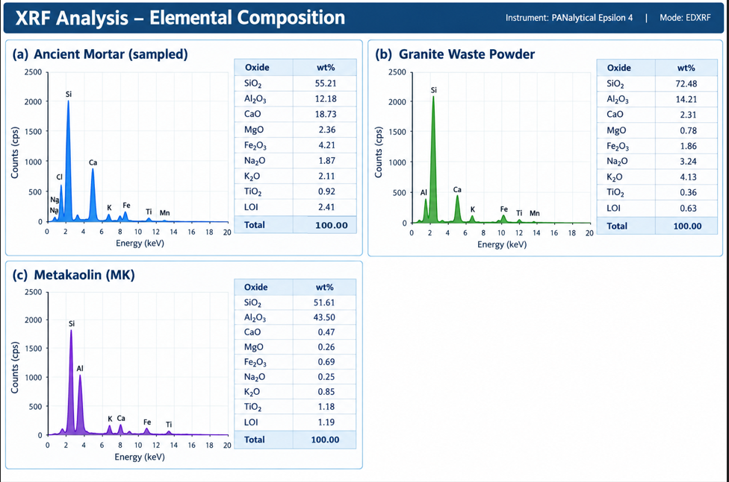
Figure 3. XRF composition of (a) ancient mortar, (b) granite waste powder and (c) metakaolin.
Table 2. XRF oxide composition (mass %) of ATM, GWP and MK.

Oxide | ATM mortar | Granite waste powder | Metakaolin
SiO₂ | 55.21 | 72.48 | 51.61
Al₂O₃ | 12.18 | 14.21 | 43.50
CaO | 18.73 | 2.31 | 0.47
MgO | 2.36 | 0.78 | 0.26
Fe₂O₃ | 4.21 | 1.86 | 0.69
Na₂O | 1.87 | 3.24 | 0.25
K₂O | 2.11 | 4.13 | 0.85
TiO₂ | 0.92 | 0.36 | 1.18
LOI | 2.41 | 0.63 | 1.19

4.2 Mineralogical characterization (XRD)
The XRD patterns of the ancient mortar, granite waste and metakaolin are presented in Figure 4. The reported peaks are attributed to quartz, calcite, feldspar, muscovite and kaolinite in the historical mortar, and quartz/feldspar in granite waste. The amorphous halo in metakaolin is consistent with a disordered aluminosilicate fraction after calcination. Future reactivity tests and phase analysis of hardened composites can quantify the contribution of these phases to composite performance.
The phase assignments are qualitative interpretations of the displayed diffraction patterns. Peak lists, reference cards, quantitative phase fractions and refinement outputs would help verify the assignments and quantify phase abundance. The amorphous halo is consistent with disordered material in metakaolin, although it does not quantify the reactive fraction. The patterns therefore provide mineralogical context for material selection rather than a quantitative account of the hardened AT-MMC reaction products.
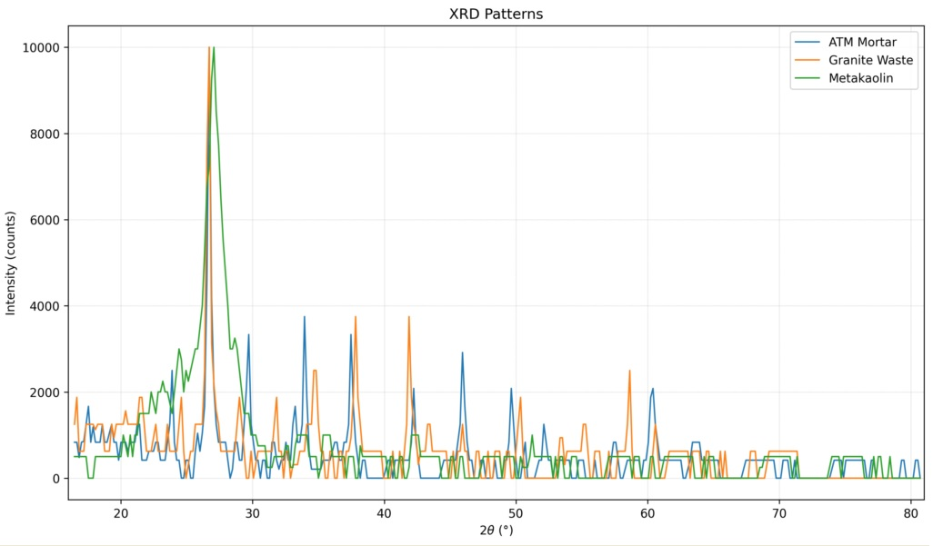
Figure 4. XRD patterns of the ancient temple mortar, granite waste powder and metakaolin.

The SEM images provide qualitative observations of selected surfaces and interfaces. Additional verified EDS maps and spectra, acquisition metadata and phase-sensitive methods—such as TGA/DTG, FTIR, quantitative XRD or solid-state NMR—would help assess the identity and quantity of C–S–H/C–A–S–H phases, interfacial features and the proposed fibre-bridging interpretation.

4.3 Microstructural characterization (SEM-EDS)
The SEM images (Figure 5) provide qualitative observations of the selected surfaces and interfaces. The morphology is consistent with differences in packing and fibre–matrix contact. Future phase-sensitive measurements, including FTIR, TGA/DTG, solid-state NMR or quantitative XRD, together with suitable elemental mapping, can quantify reaction products and further test the proposed pozzolanic interpretation. Panel (b) of Figure 5 shows the AT6 matrix microstructure (scale bar: 10 µm). Scale bars, magnification, acquisition conditions and sample identities should be checked against the original instrument metadata.

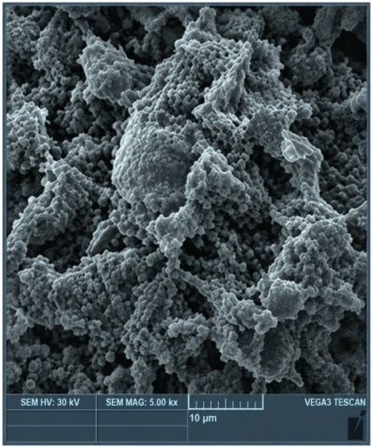  (a) Ancient Temple Mortar | (b) AT6 matrix | 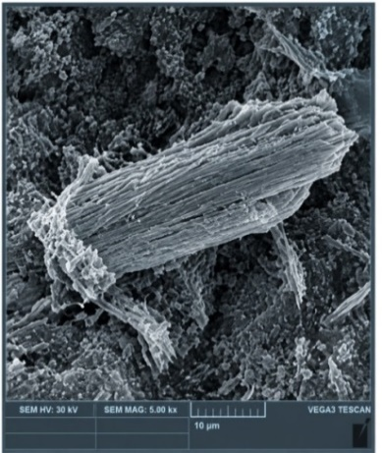  (c)Basalt-Fibre Pull-Out

Figure 5. SEM micrographs of (a) ancient temple mortar, (b) AT6 matrix and (c) basalt-fibre pull-out.

4.4 Physical properties
The tabulated 28-day results (Table 3, Figure 6) show a consistent trend across the seven listed mixtures: AT6 has the lowest reported water absorption (3.61%), apparent porosity (7.82%) and sorptivity (0.031 mm/min^{0.5}). These descriptive comparisons provide a basis for follow-up testing. A controlled mixture design and the non-orthogonal design limits separation of the contributions of binder chemistry, granite-waste packing and fibre dosage.
Relative to C0, the AT6 summary values correspond to decreases of approximately 43.8% in water absorption, 45.4% in apparent porosity and 66.3% in sorptivity. The intermediate AT-MMC formulations generally follow the same direction of change, although the reported density is lower than C0 for every AT-MMC mixture. Lower water uptake and sorptivity are consistent with reduced accessible pore pathways under the reported test methods; however, no specimen-level data or uncertainty estimates are available to establish whether these differences are repeatable or statistically distinguishable.
Table 3. Physical properties of AT-MMC at 28 days.
Mix ID | Density (kg/m³) | Water absorption (%) | Apparent porosity (%) | Sorptivity (mm/min^{0.5})
C0 | 2340 | 6.42 | 14.31 | 0.092
AT1 | 2215 | 5.12 | 11.26 | 0.063
AT2 | 2228 | 4.78 | 10.41 | 0.052
AT3 | 2230 | 4.31 | 9.36 | 0.045
AT4 | 2245 | 4.12 | 8.97 | 0.041
AT5 | 2260 | 3.95 | 8.45 | 0.037
AT6 | 2272 | 3.61 | 7.82 | 0.031
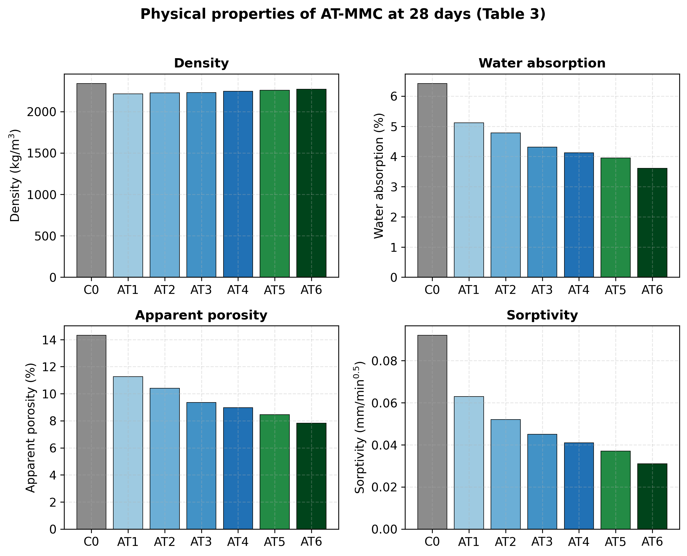
Figure 6. Physical properties of AT-MMC at 28 days

4.5 Mechanical performance
Table 4 (Figure 7) reproduces the manuscript-reported 28-day summary values; these are reported summaries, not model predictions. Relative to C0, the AT6 values correspond to descriptive increases of 43.5% in compressive strength, 51.6% in flexural strength, 54.2% in splitting tensile strength and 109.8% in fracture toughness. These percentages are calculated arithmetically from the listed values and do not establish statistical significance or a causal effect of any individual constituent. Specimen-level observations and uncertainty estimates are unavailable in the supplied manuscript.
The listed values increase progressively from AT1 to AT6 across all four mechanical indicators. This ordering provides a useful screening comparison of the reported formulations. Because AT5 and AT6 also contain higher lime, metakaolin and granite-waste fractions and a lower reported water-to-binder ratio than AT1–AT4, the observed progression cannot be attributed to basalt fibre alone. The curves are interpreted qualitatively; specimen-level load–deflection and load–CMOD coordinates, test geometry and replicate information would enable more detailed comparisons.
Table 4. Mechanical properties of AT-MMC at 28 days.
Mix ID | Compressive strength (MPa) | Flexural strength (MPa) | Splitting tensile strength (MPa) | Fracture toughness (MPa·m^{0.5})
C0 | 38.6 | 6.12 | 3.21 | 1.12
AT1 | 41.8 | 6.85 | 3.62 | 1.45
AT2 | 45.7 | 7.32 | 3.91 | 1.86
AT3 | 48.9 | 7.96 | 4.28 | 2.08
AT4 | 50.1 | 8.21 | 4.42 | 2.21
AT5 | 52.6 | 8.76 | 4.71 | 2.29
AT6 | 55.4 | 9.28 | 4.95 | 2.35
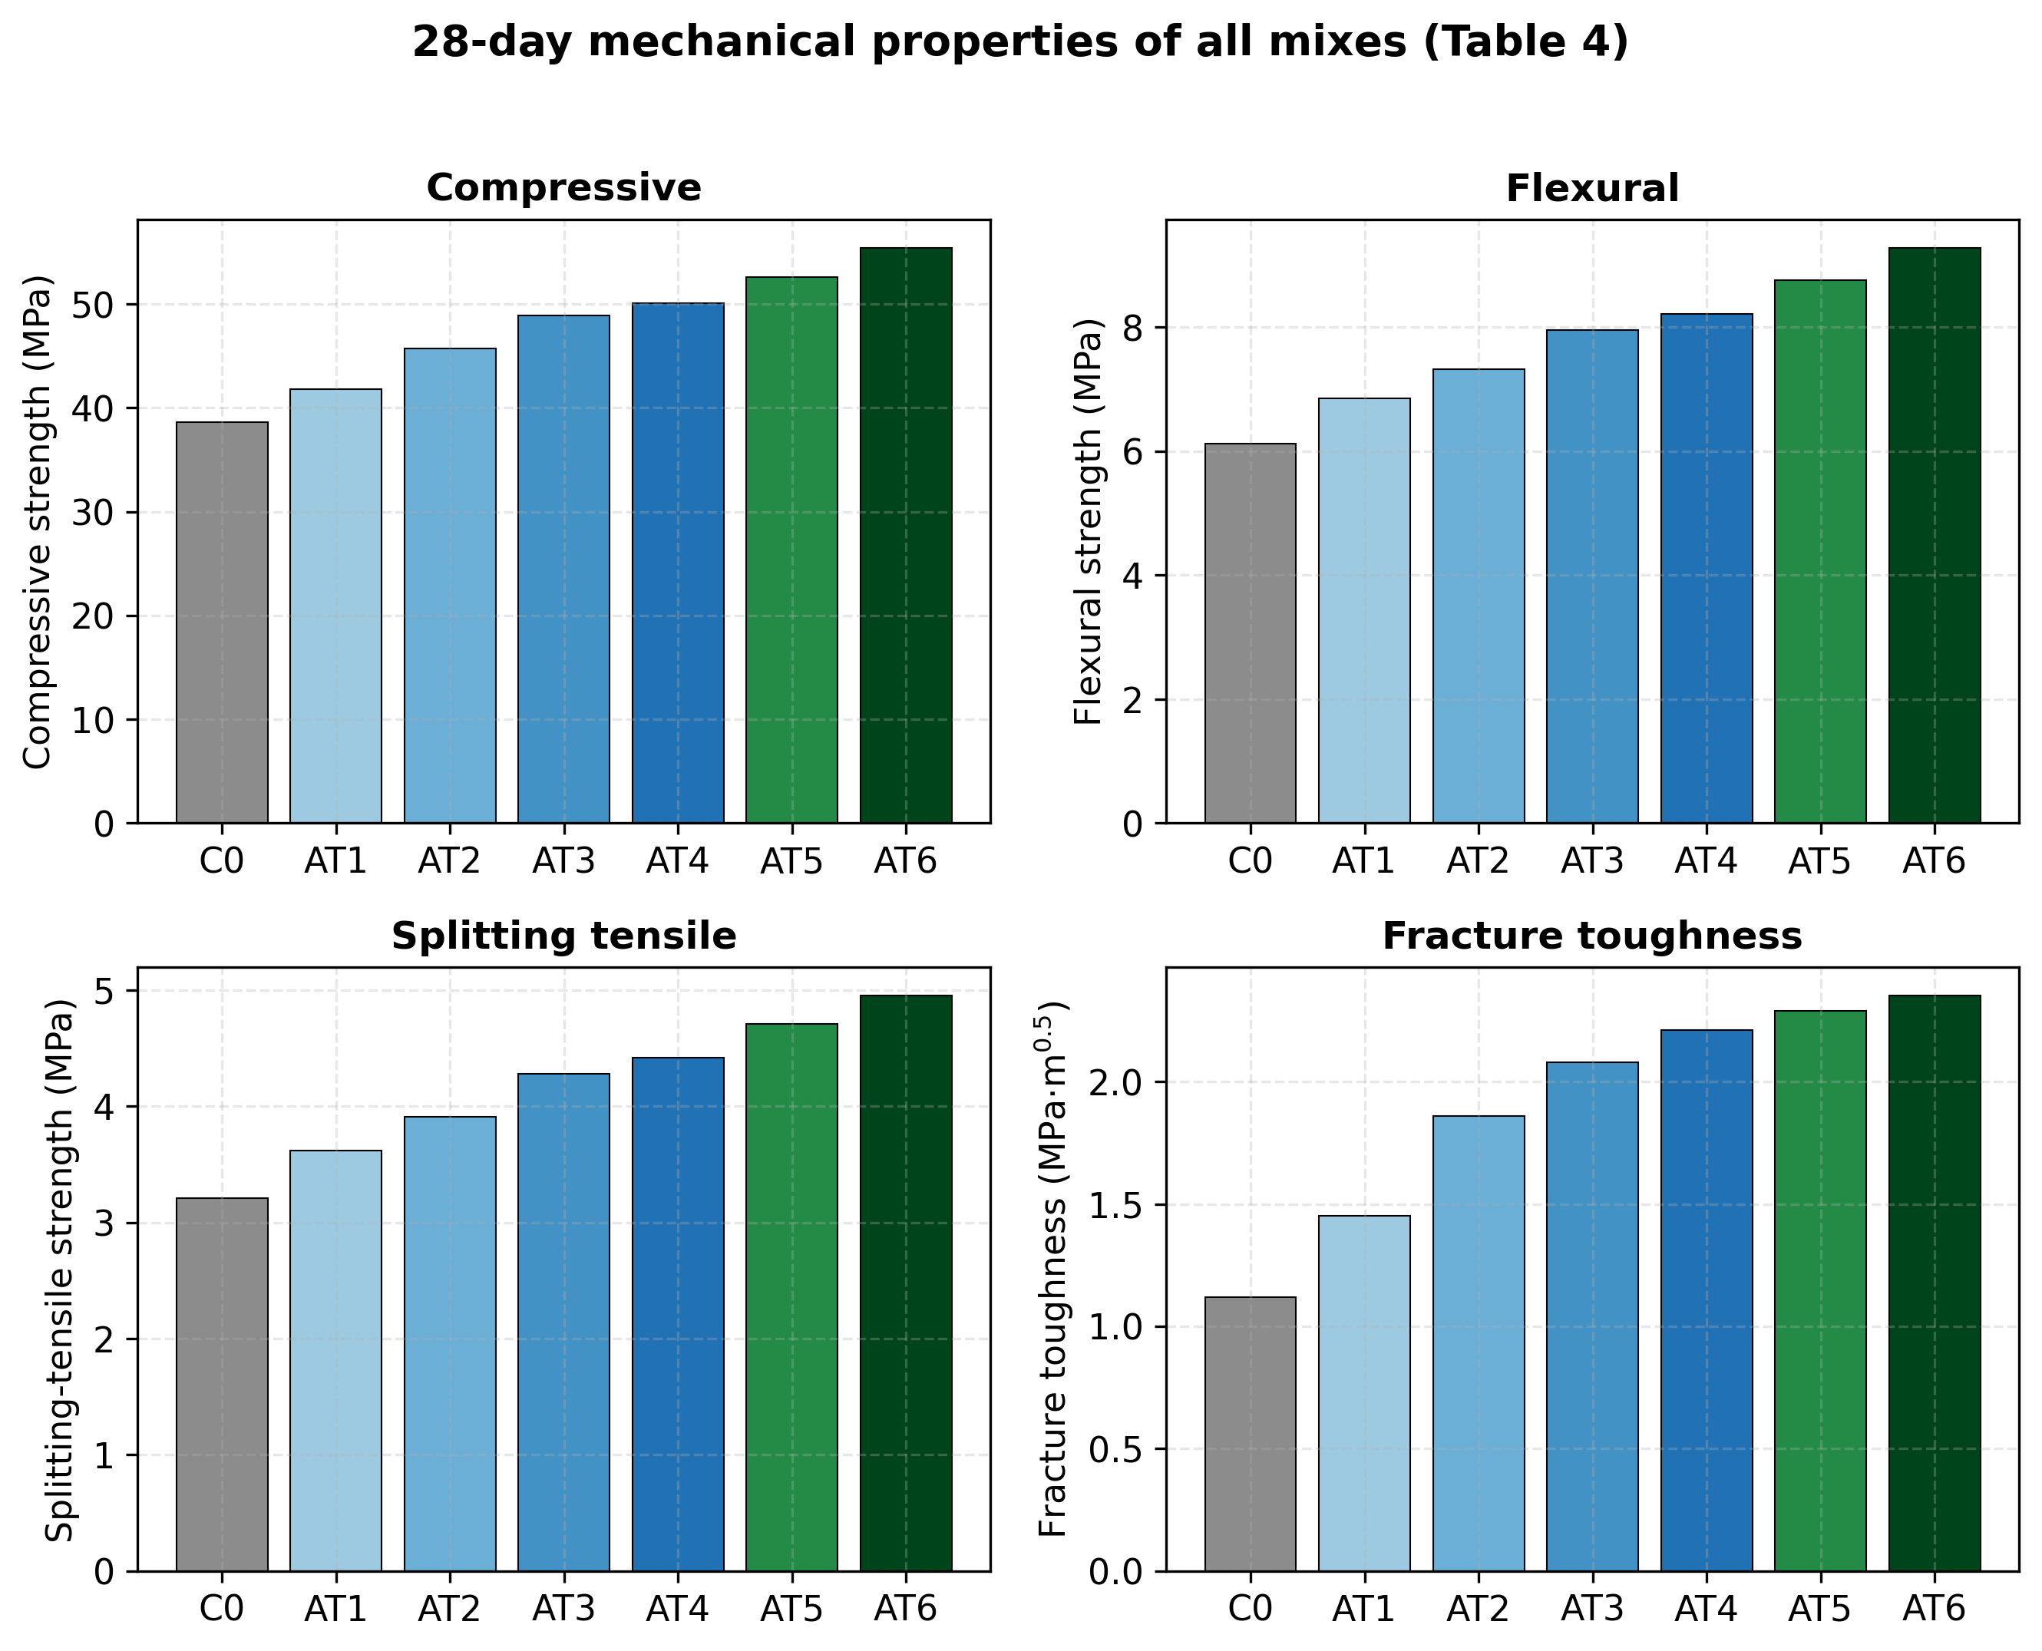
Figure 7. 28-day mechanical properties of all mixes
The curves shown for C0, AT3 and AT6 (Figures 8 and 9) illustrate the reported flexural and post-peak responses. Supplementary stress–deflection and load–CMOD coordinates, together with specimen-level replicates, will allow curve-level comparisons and quantitative evaluation of fibre-bridging behaviour.
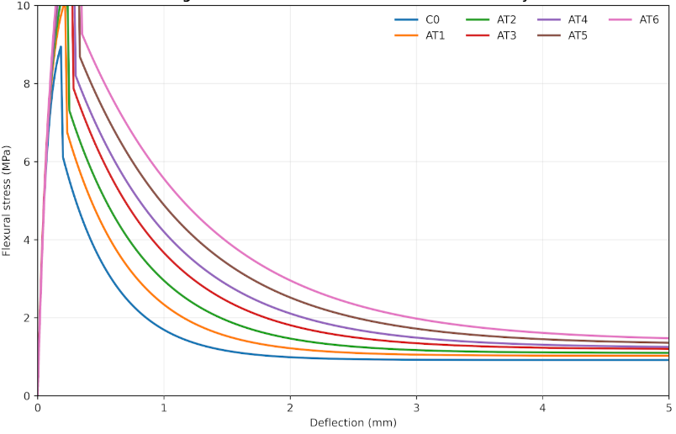
Figure 8. Flexural stress-deflection curves for C0, AT3 and AT6
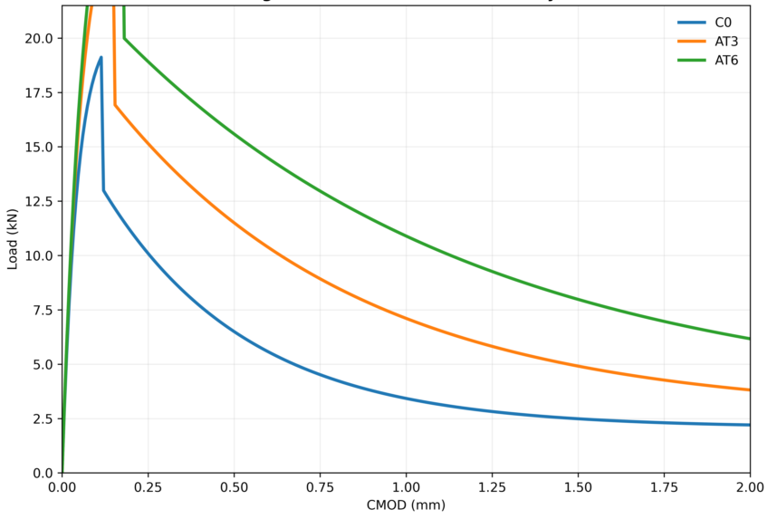
Figure 9. Load-CMOD curves for C0, AT3 and AT6

4.6 Durability performance
The reported residual compressive-strength ratios (Table 5, Figure 10) are highest for AT6 among the listed mixtures under the stated laboratory exposure endpoints. These rankings provide an initial basis for comparative durability screening. Complete exposure protocols, replicate counts and specimen-level measurements would help quantify variability and determine how consistently the ranking is reproduced. The results describe the reported laboratory conditions and are not direct measures of field durability or service life.
For AT6, the reported retention values range from 81.5% after the 5% H₂SO₄ exposure to 97.6% after water immersion; the corresponding C0 values are 62.4% and 92.1%. AT6 also has the highest listed retention under wet–dry cycling (93.8%), sulfate exposure (90.3%) and freeze–thaw cycling (92.4%). These comparisons suggest better retention within the reported laboratory dataset, but the precise meaning of the percentages, baseline calculations, solution concentration basis and exposure protocols must be confirmed before quantitative durability claims are made.
Table 5. Residual compressive strength (%) after durability exposure (28-day baseline).
Mix ID | Water immersion (56d) | Wet-dry (100 cyc) | Sulfate 5% (56d) | Acid 5% (28d) | Freeze-thaw (50 cyc)
C0 | 92.1 | 75.3 | 70.2 | 62.4 | 78.6
AT1 | 94.6 | 81.7 | 76.5 | 69.3 | 83.2
AT2 | 95.8 | 86.3 | 81.4 | 72.2 | 86.1
AT3 | 96.5 | 88.9 | 84.7 | 75.1 | 88.7
AT4 | 97.1 | 91.2 | 86.2 | 77.6 | 90.3
AT5 | 96.8 | 92.4 | 88.6 | 79.6 | 91.1
AT6 | 97.6 | 93.8 | 90.3 | 81.5 | 92.4
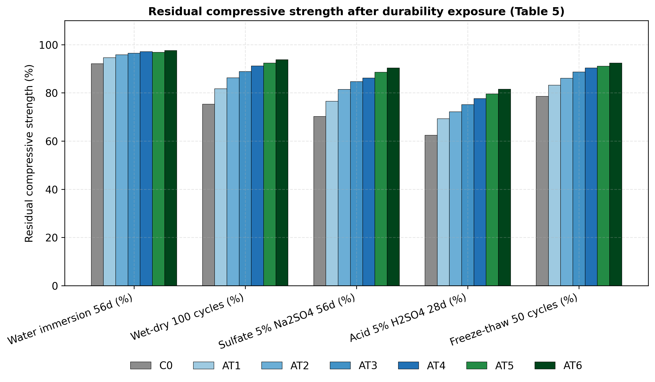
Figure 10. Residual compressive strength after durability exposure.

The reported mass-variation trend (Figure 11) indicates comparatively low variation for AT6 during wet–dry cycling. Publishing the cycle-by-cycle mass measurements and replicate variability in a supplementary dataset will make this trend easier to assess and compare.
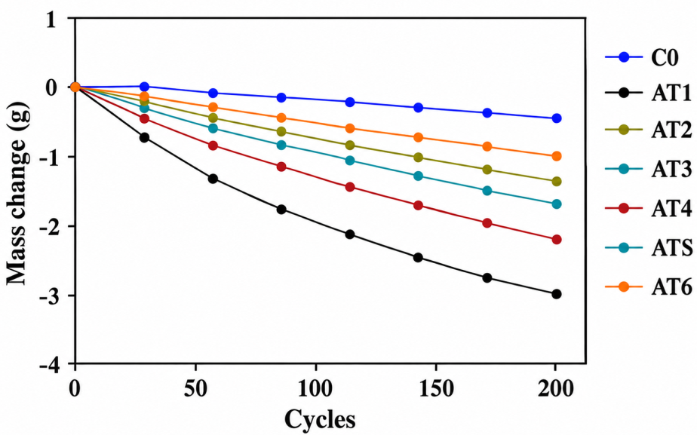
Figure 11. Mass change of AT-MMC specimens during wet-dry cycling

4.7 Thermal performance
The reported thermal-property table (Table 6, Figure 12) lists thermal conductivity of 0.93 W·m⁻¹·K⁻¹ and a thermal-expansion coefficient of 7.0 × 10⁻⁶ °C⁻¹ for AT6, compared with 1.62 W·m⁻¹·K⁻¹ and 9.6 × 10⁻⁶ °C⁻¹ for C0. These are descriptive reported values. Since the derived diffusivity does not fully reconcile with the listed conductivity, density and specific heat, comparison with the original instrument outputs and calculation units is recommended before drawing mechanistic or application-level conclusions.
The reported conductivity decreases from C0 to AT6, while specific heat increases from 920 to 1,038 J·kg⁻¹·K⁻¹ and the listed thermal-expansion coefficient decreases. Applying α = k/(ρcₚ) to the reported density gives calculated diffusivities of approximately 0.753 mm²/s for C0 and 0.394 mm²/s for AT6, compared with reported values of 0.78 and 0.43 mm²/s, respectively. This comparison identifies a difference for reconciliation; the original records should be checked to confirm density condition, units and calculations before either set of values is selected for interpretation.
Table 6. Thermal properties of AT-MMC at 28 days.
Mix ID | Thermal conductivity (W/m·K) | Thermal diffusivity (mm²/s) | Specific heat (J/kg·K) | Coefficient of thermal expansion (×10⁻⁶/°C)
C0 | 1.62 | 0.78 | 920 | 9.6
AT1 | 1.32 | 0.64 | 980 | 8.8
AT2 | 1.18 | 0.56 | 1005 | 8.1
AT3 | 1.09 | 0.52 | 1018 | 7.6
AT4 | 1.05 | 0.49 | 1025 | 7.4
AT5 | 0.98 | 0.46 | 1032 | 7.2
AT6 | 0.93 | 0.43 | 1038 | 7.0
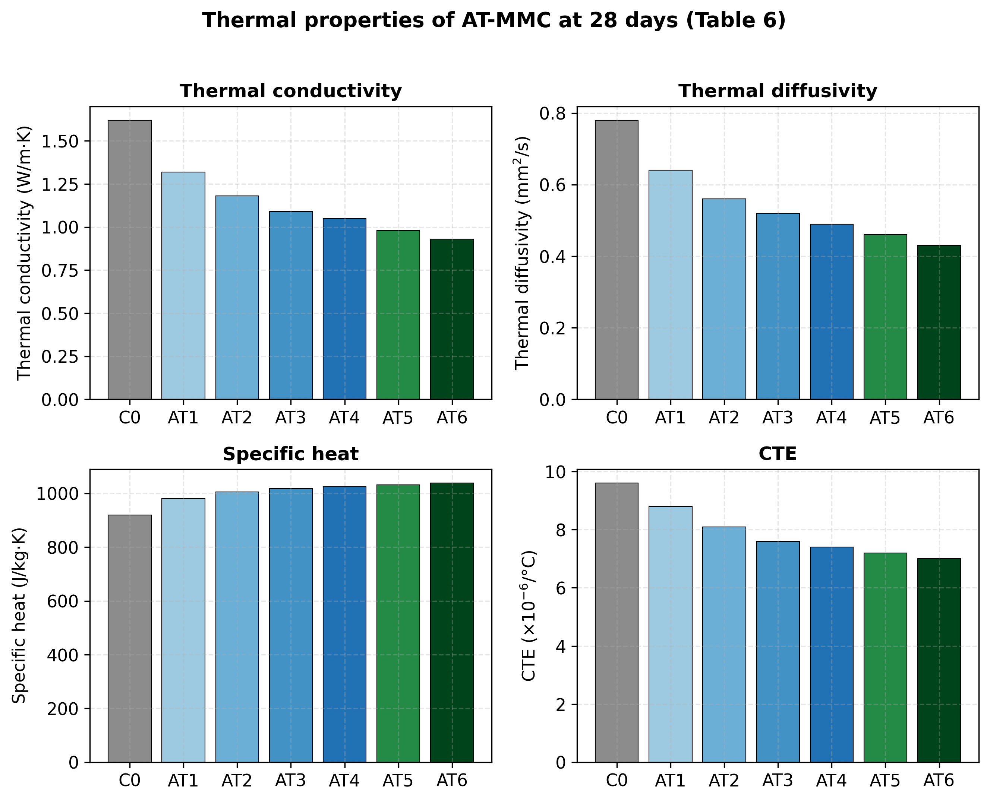
Figure 12. Thermal properties of AT-MMC at 28 days.
The manuscript reports residual compressive-strength measurements for all mixtures after exposure to 200, 400, 600 and 800 °C (Figure 13). Adding temperature-specific numerical values and the full heating protocol—including heating rate, dwell time, cooling procedure, specimen condition and replicate count—will enable a complete comparison. Future post-heating TGA/DTG, XRD or SEM analysis can test hypotheses involving mineral transformations and basalt-fibre crack bridging.
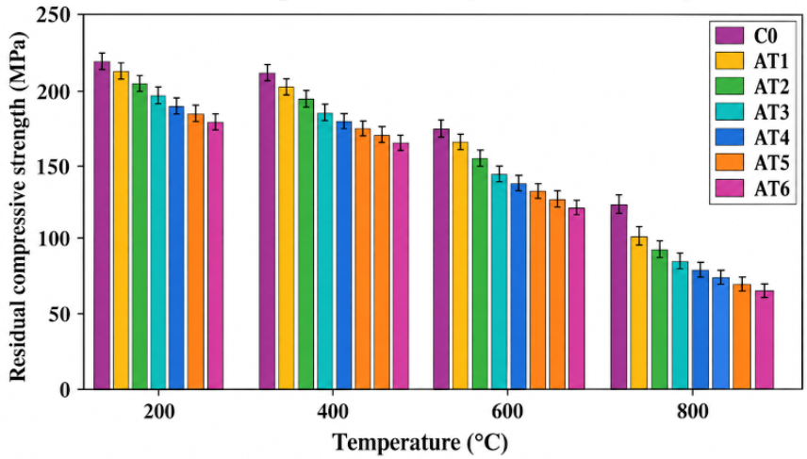
Figure 13. Residual compressive strength after exposure to 200–800 °C.

4.8 Statistical analysis
Legacy ANOVA summary. The ANOVA table previously available for this study could not be reproduced: its four source-term sums of squares total 698.94 against a reported model total of 756.32 (a difference of 57.38), the source-term degrees of freedom do not reconcile with the model degrees of freedom, and no column of the reported summaries (Tables 3–6) has a total sum of squares equal to either figure (for example 212.0 for compressive strength and 261.7 for acid residual strength across the seven mixtures). The legacy table has therefore been withdrawn and is superseded by the analyses below, which are recomputed from the reported values.
Because no specimen-level observations exist, the only legitimate ANOVA designs are those whose error term can be formed from the means themselves. Table 7 lists the analyses implemented, the error term of each and its inferential status; the full results are given in Section 4.14 (Tables 18–23). In brief, the four AT1–AT4 means are almost collinear with basalt-fibre dosage for all nine properties (R² = 0.934–0.999; F(1,2) = 28.4–1610; nominal p = 0.0006–0.033), the mixtures differ consistently across the five durability exposures (mixture effect F(6,24) = 30.7, p < 0.001, η² = 0.318; Kendall’s W = 0.989 [27]), and the exposure effect (η² = 0.640) dominates the total variation.
Table 7. ANOVA analyses implemented on the reported data and their inferential status.
Analysis | Available data | Revised interpretation | Status
A. Fibre-dose trend (AT1–AT4) | Four mixture-level summaries; sand changes with fibre dose | Descriptive trend only; no specimen-level error estimate | No inferential p-values
B. Mixture × exposure (Table 5) | One value per mixture/exposure cell; 7 × 5 | Reported rankings only; interaction is not independent replicate error | No inferential F-tests or post-hoc claims
C. Porosity–property fits | Six or seven mixture-level summaries | R² describes fit to summaries, not external validation | Descriptive association only
D. AT3–AT6 contrasts | One value per cell in an unreplicated 2 × 2 layout | Arithmetic contrasts only; factors are confounded | No error df; no significance tests
E. Replicate-precision scenarios | Assumed CV and specimen count | May inform future sample-size planning | Not evidence of current significance

The correlations (Table 10) and fitted porosity relations (Table 15) are likewise based on seven mixture-level points rather than independent specimen replicates. They, and the ANOVA p-values reported here, therefore describe the supplied summaries and guide follow-up experiments; they are not evidence of specimen-level significance or validated prediction equations. Figure 14 plots the mixture-level summaries and the hypothetical replicate-precision scenarios; inferential annotations derived from the unreplicated calculations should not be interpreted as experimental significance.
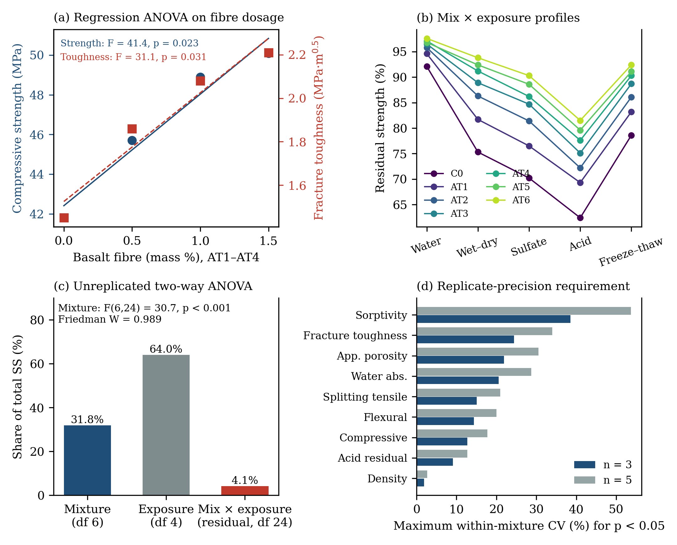
Figure 14. Descriptive plots of mixture-level summaries and hypothetical replicate-precision scenarios.

4.9 Multi-objective optimisation
A desirability index of 0.86 was reported for AT6 using five criteria (Table 8): compressive strength, fracture toughness, water absorption, thermal conductivity and CO₂ emission. Independent reproduction of this value requires the desirability limits, targets, shape exponents, response equations and model output. Figure 15 therefore presents the reported strength values for comparison; it is not a response surface or optimisation model. Its points and labels reproduce the summary values in Table 4, and the connecting line is a visual guide only, not a fitted model. Within the reported summary measures, AT6 ranks highest for several properties.
The reported desirability score of 0.86 is treated as an unverified, provisional value. The supplied manuscript does not provide a reproducible set of response equations, coefficients, response limits, fitted model diagnostics and independent validation results. A model with many fitted parameters relative to seven mixture observations can overfit and cannot establish a global optimum. AT6 is therefore described only as the best-ranked mixture among the seven reported summaries for several selected responses. The desirability score should be removed from the final quantitative claims unless the original model and calculations can be independently reproduced.
Table 8. Desirability optimisation criteria.
Criteria | Goal | Weight | Importance
Compressive strength | Maximize | 5 | Very high
Fracture toughness | Maximize | 4 | High
Water absorption | Minimize | 4 | High
Thermal conductivity | Minimize | 3 | Medium
CO₂ emission | Minimize | 4 | High
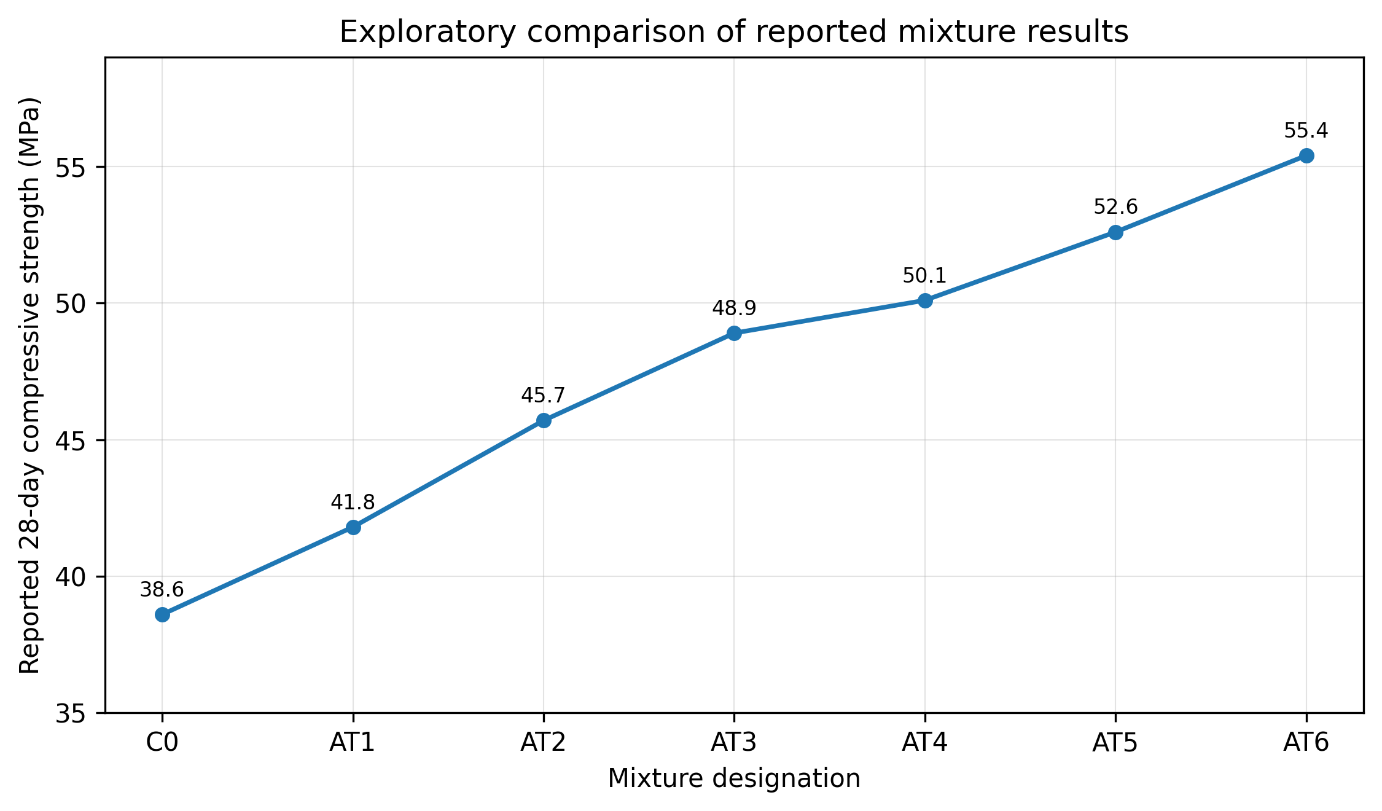
Figure 15. Reported 28-day compressive strength of the seven mixtures (values from Table 4).

4.10 Comparative life-cycle assessment
The reported life-cycle table (Table 9, Figure 16) gives a GWP of 0.249 kg CO₂-eq/kg for AT6 and 0.462 kg CO₂-eq/kg for C0, a 46.1% difference calculated from the tabulated values. This is an arithmetic comparison of the reported estimates. The environmental interpretation will be strengthened by documenting and checking the inventory, system boundary, functional unit, allocation method and sensitivity analysis.
The same table lists embodied energy of 1.72 MJ/kg for AT6 versus 3.21 MJ/kg for C0, and primary energy of 2.21 versus 4.09 MJ/kg. These correspond to reductions of approximately 46.4% and 46.0%, respectively, based on the reported values. The supplied workbook's LCA inventory sheet is a blank recording template, so the totals cannot currently be recalculated from that file. A populated, auditable inventory and a functional-unit-based comparison would support a more robust assessment of environmental performance and equivalent service.

Table 9. Life-cycle impact comparison (per kg of material).
Material | Global warming potential (kg CO₂-eq) | Embodied energy (MJ) | Primary energy (MJ) | Waste utilization (%)
OPC mortar (C0) | 0.462 | 3.21 | 4.09 | 12
Lime-MK matrix (AT3) | 0.298 | 2.18 | 2.76 | 48
AT-MMC (AT6) | 0.249 | 1.72 | 2.21 | 62
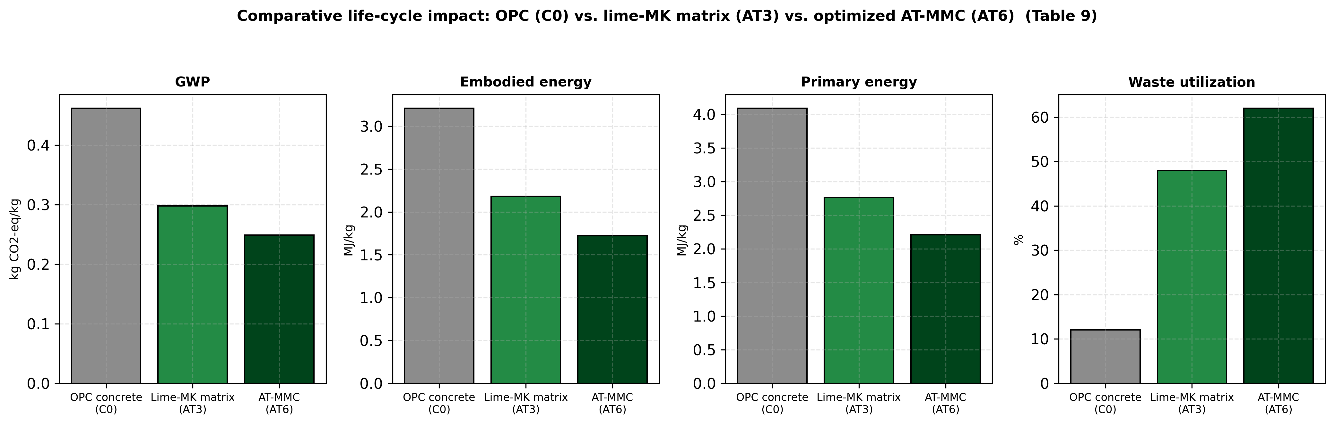
Figure 16. Life-cycle impacts of OPC mortar (C0), AT3 and AT6.

4.11 Supplementary derived visualizations
Figures 17 and 18 present secondary analyses derived from the summary values already reported in the manuscript. The porosity–acid-residual-strength relationship is based on seven mixture-level points from a non-orthogonal design, so it is best interpreted as an exploratory association. Replicated measurements and a controlled design would help establish whether the pattern persists and whether it has predictive value.
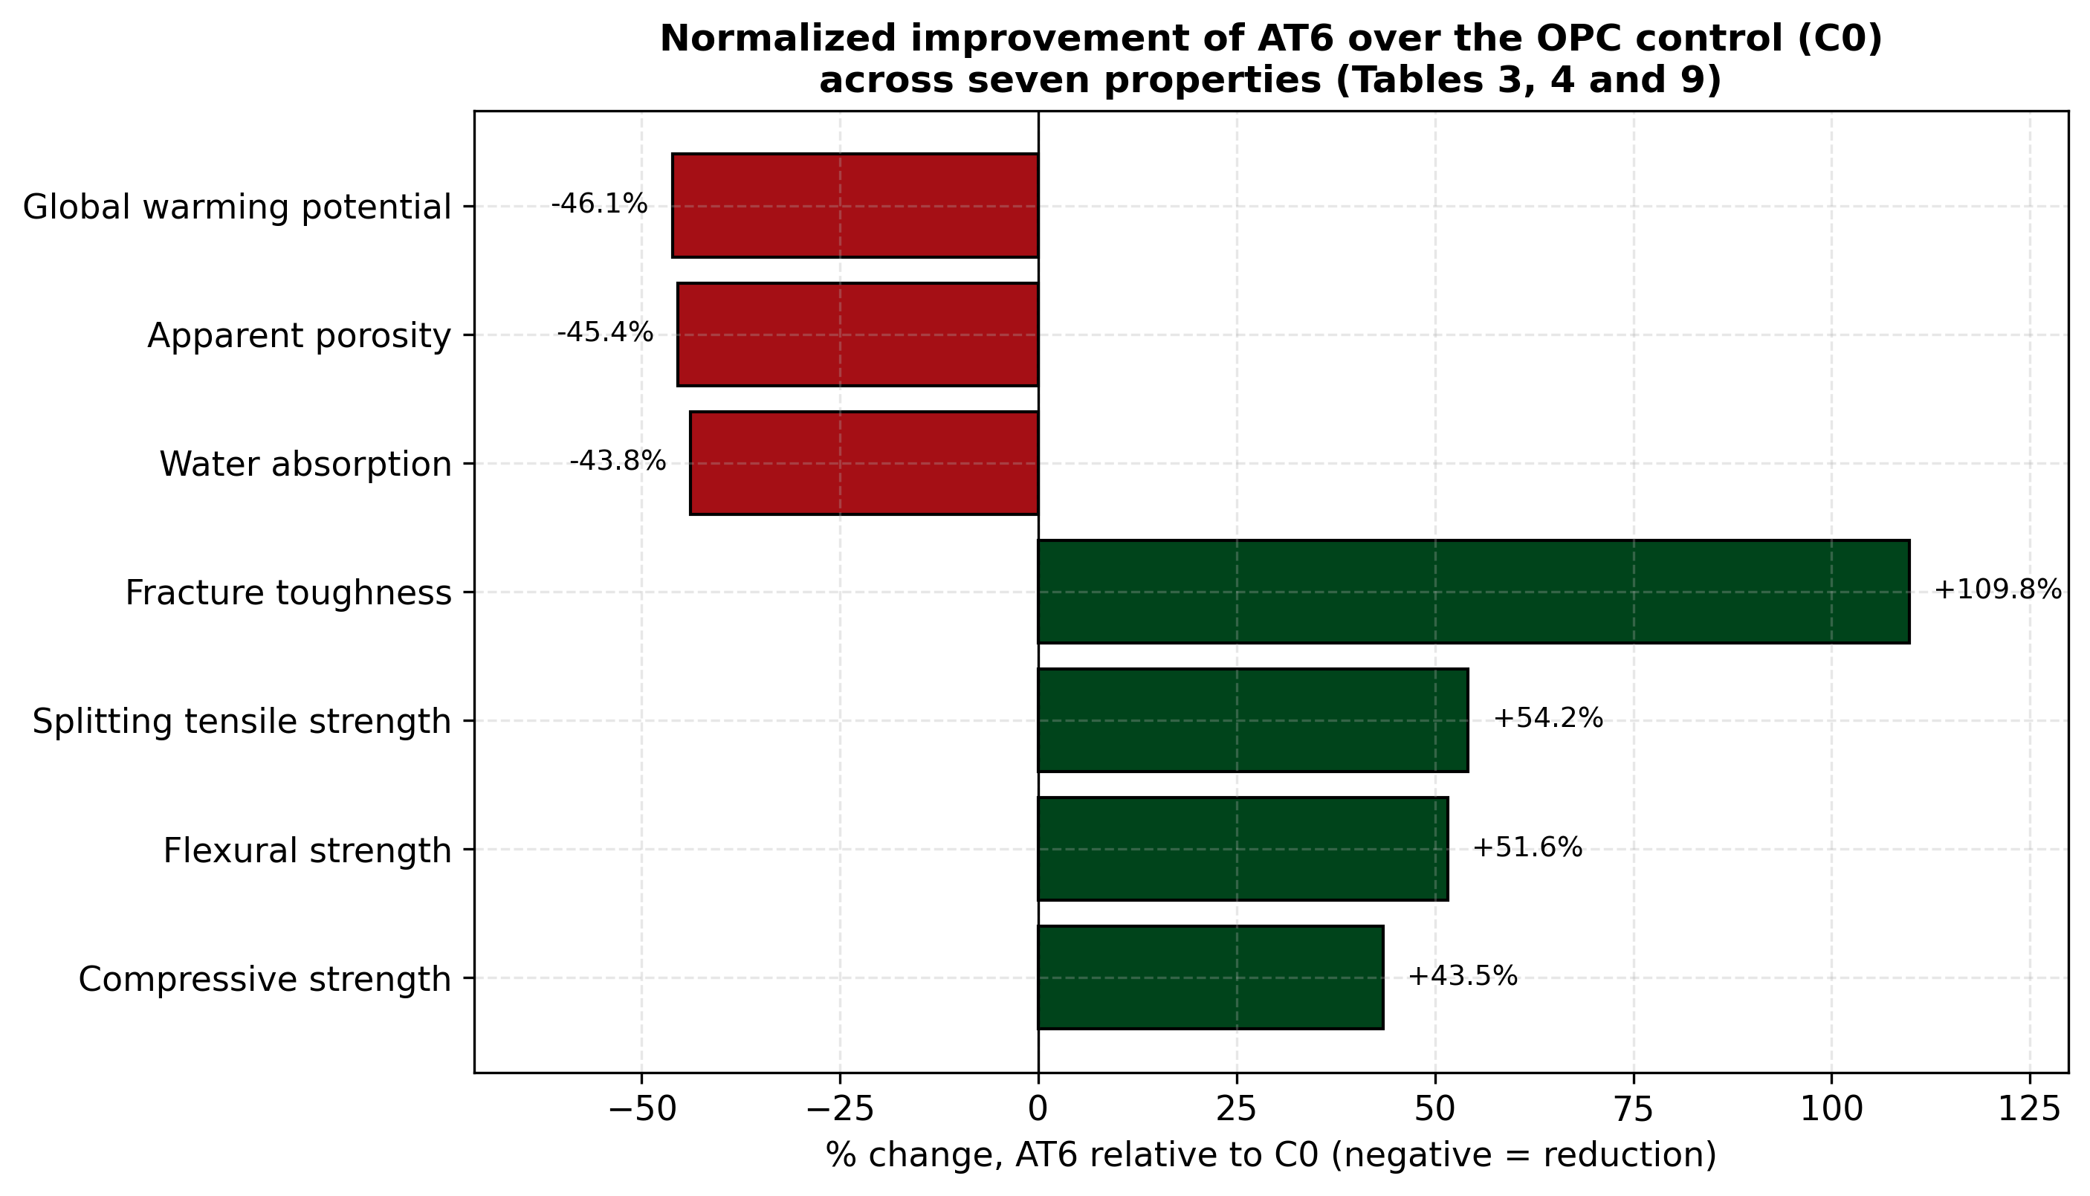
Figure 17. Percentage improvement of AT6 over OPC mortar (C0).
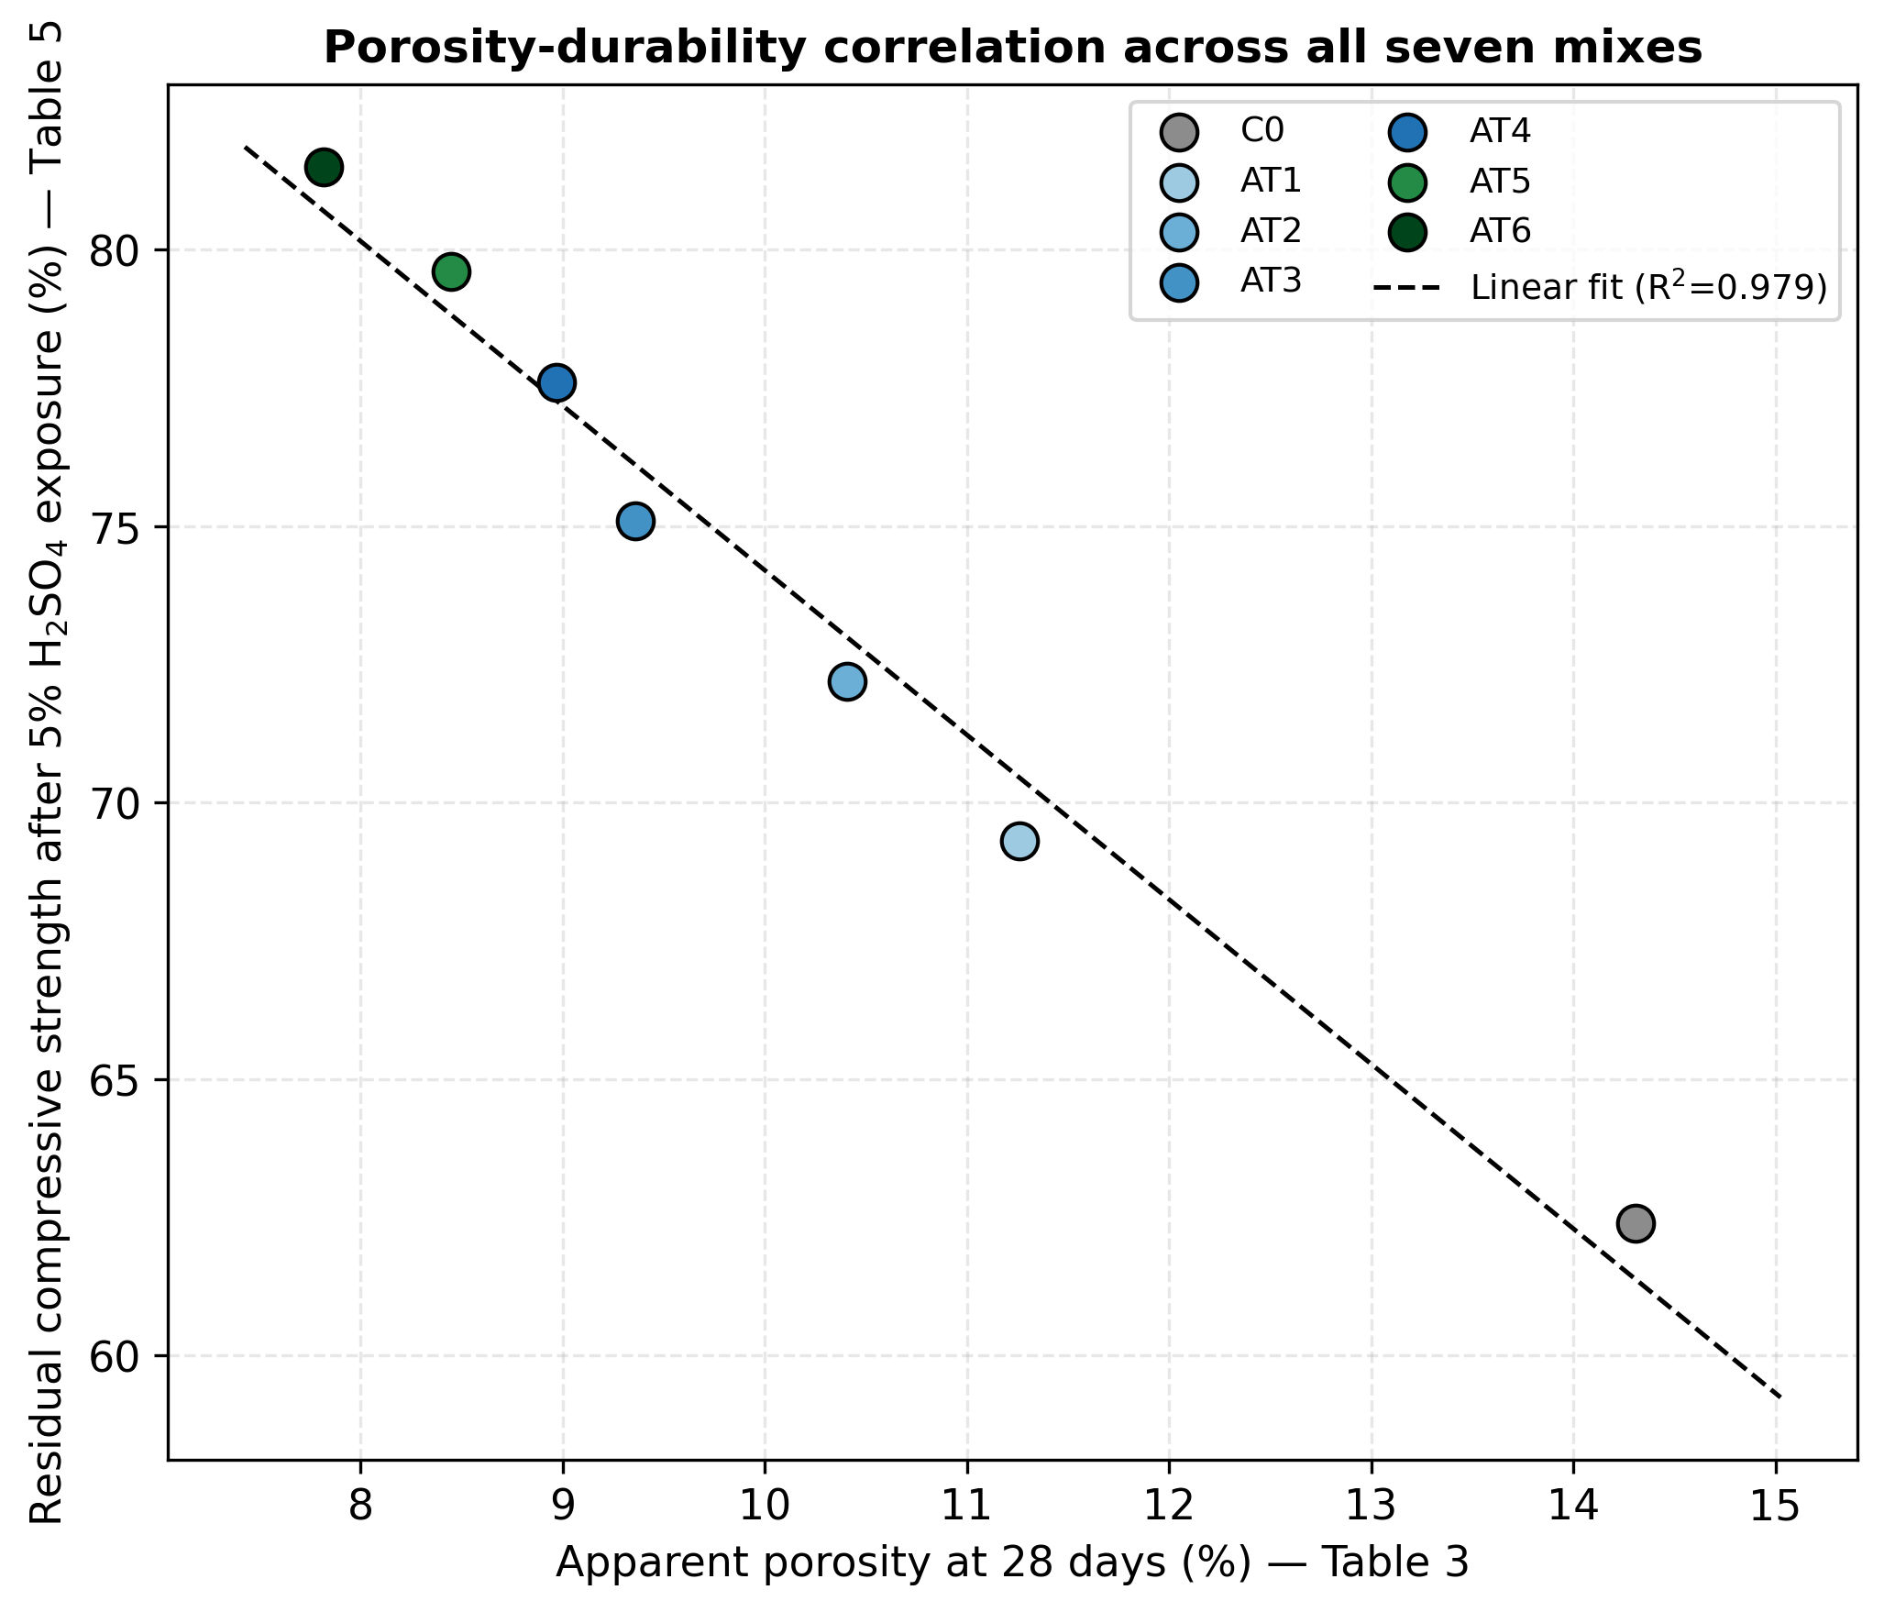
Figure 18. Apparent porosity versus residual compressive strength after acid exposure.

The reported R² = 0.979 relationship between apparent porosity and residual strength after acid exposure (Figure 18) is calculated from seven mixture-level summary points. Because the mixtures are compositionally confounded and uncertainty estimates are unavailable, this statistic is descriptive rather than predictive. It does not establish that porosity controls acid resistance. Replicated measurements and a pre-specified analysis would help determine whether the relationship is robust.

4.12 Cross-property correlation analysis
The seven formulations provide descriptive associations among mixture-level summaries (Table 10, Figure 19; Pearson coefficients from Eq. (15)). Because several composition variables change together, correlations are best used to guide hypotheses for controlled experiments. A larger, orthogonally or appropriately mixture-designed study with replicate data will help evaluate individual property relationships. The current correlations are interpreted within the seven-mixture dataset (n = 7).
Table 10. Descriptive Pearson correlations among reported 28-day properties (n = 7; not causal).
Property pair | r | Interpretation
Compressive strength vs. splitting tensile strength | 0.998 | Strong positive association in these seven mixture-level summaries; does not establish causation.
Water absorption vs. apparent porosity | 1.000 | Near-identical reported indicators; association is descriptive and may reflect shared calculations.
Apparent porosity vs. thermal conductivity | 0.998 | Positive association across seven mixtures (r = 0.998), opposite to the usual pore-volume effect at comparable solid composition and moisture; descriptive only and not causal.
Fracture toughness vs. sorptivity | -0.975 | Negative association across seven mixes; does not demonstrate fibre bridging or pore refinement.
Density vs. compressive strength | -0.255 | Weak association in the reported summaries; no mechanistic conclusion is warranted.
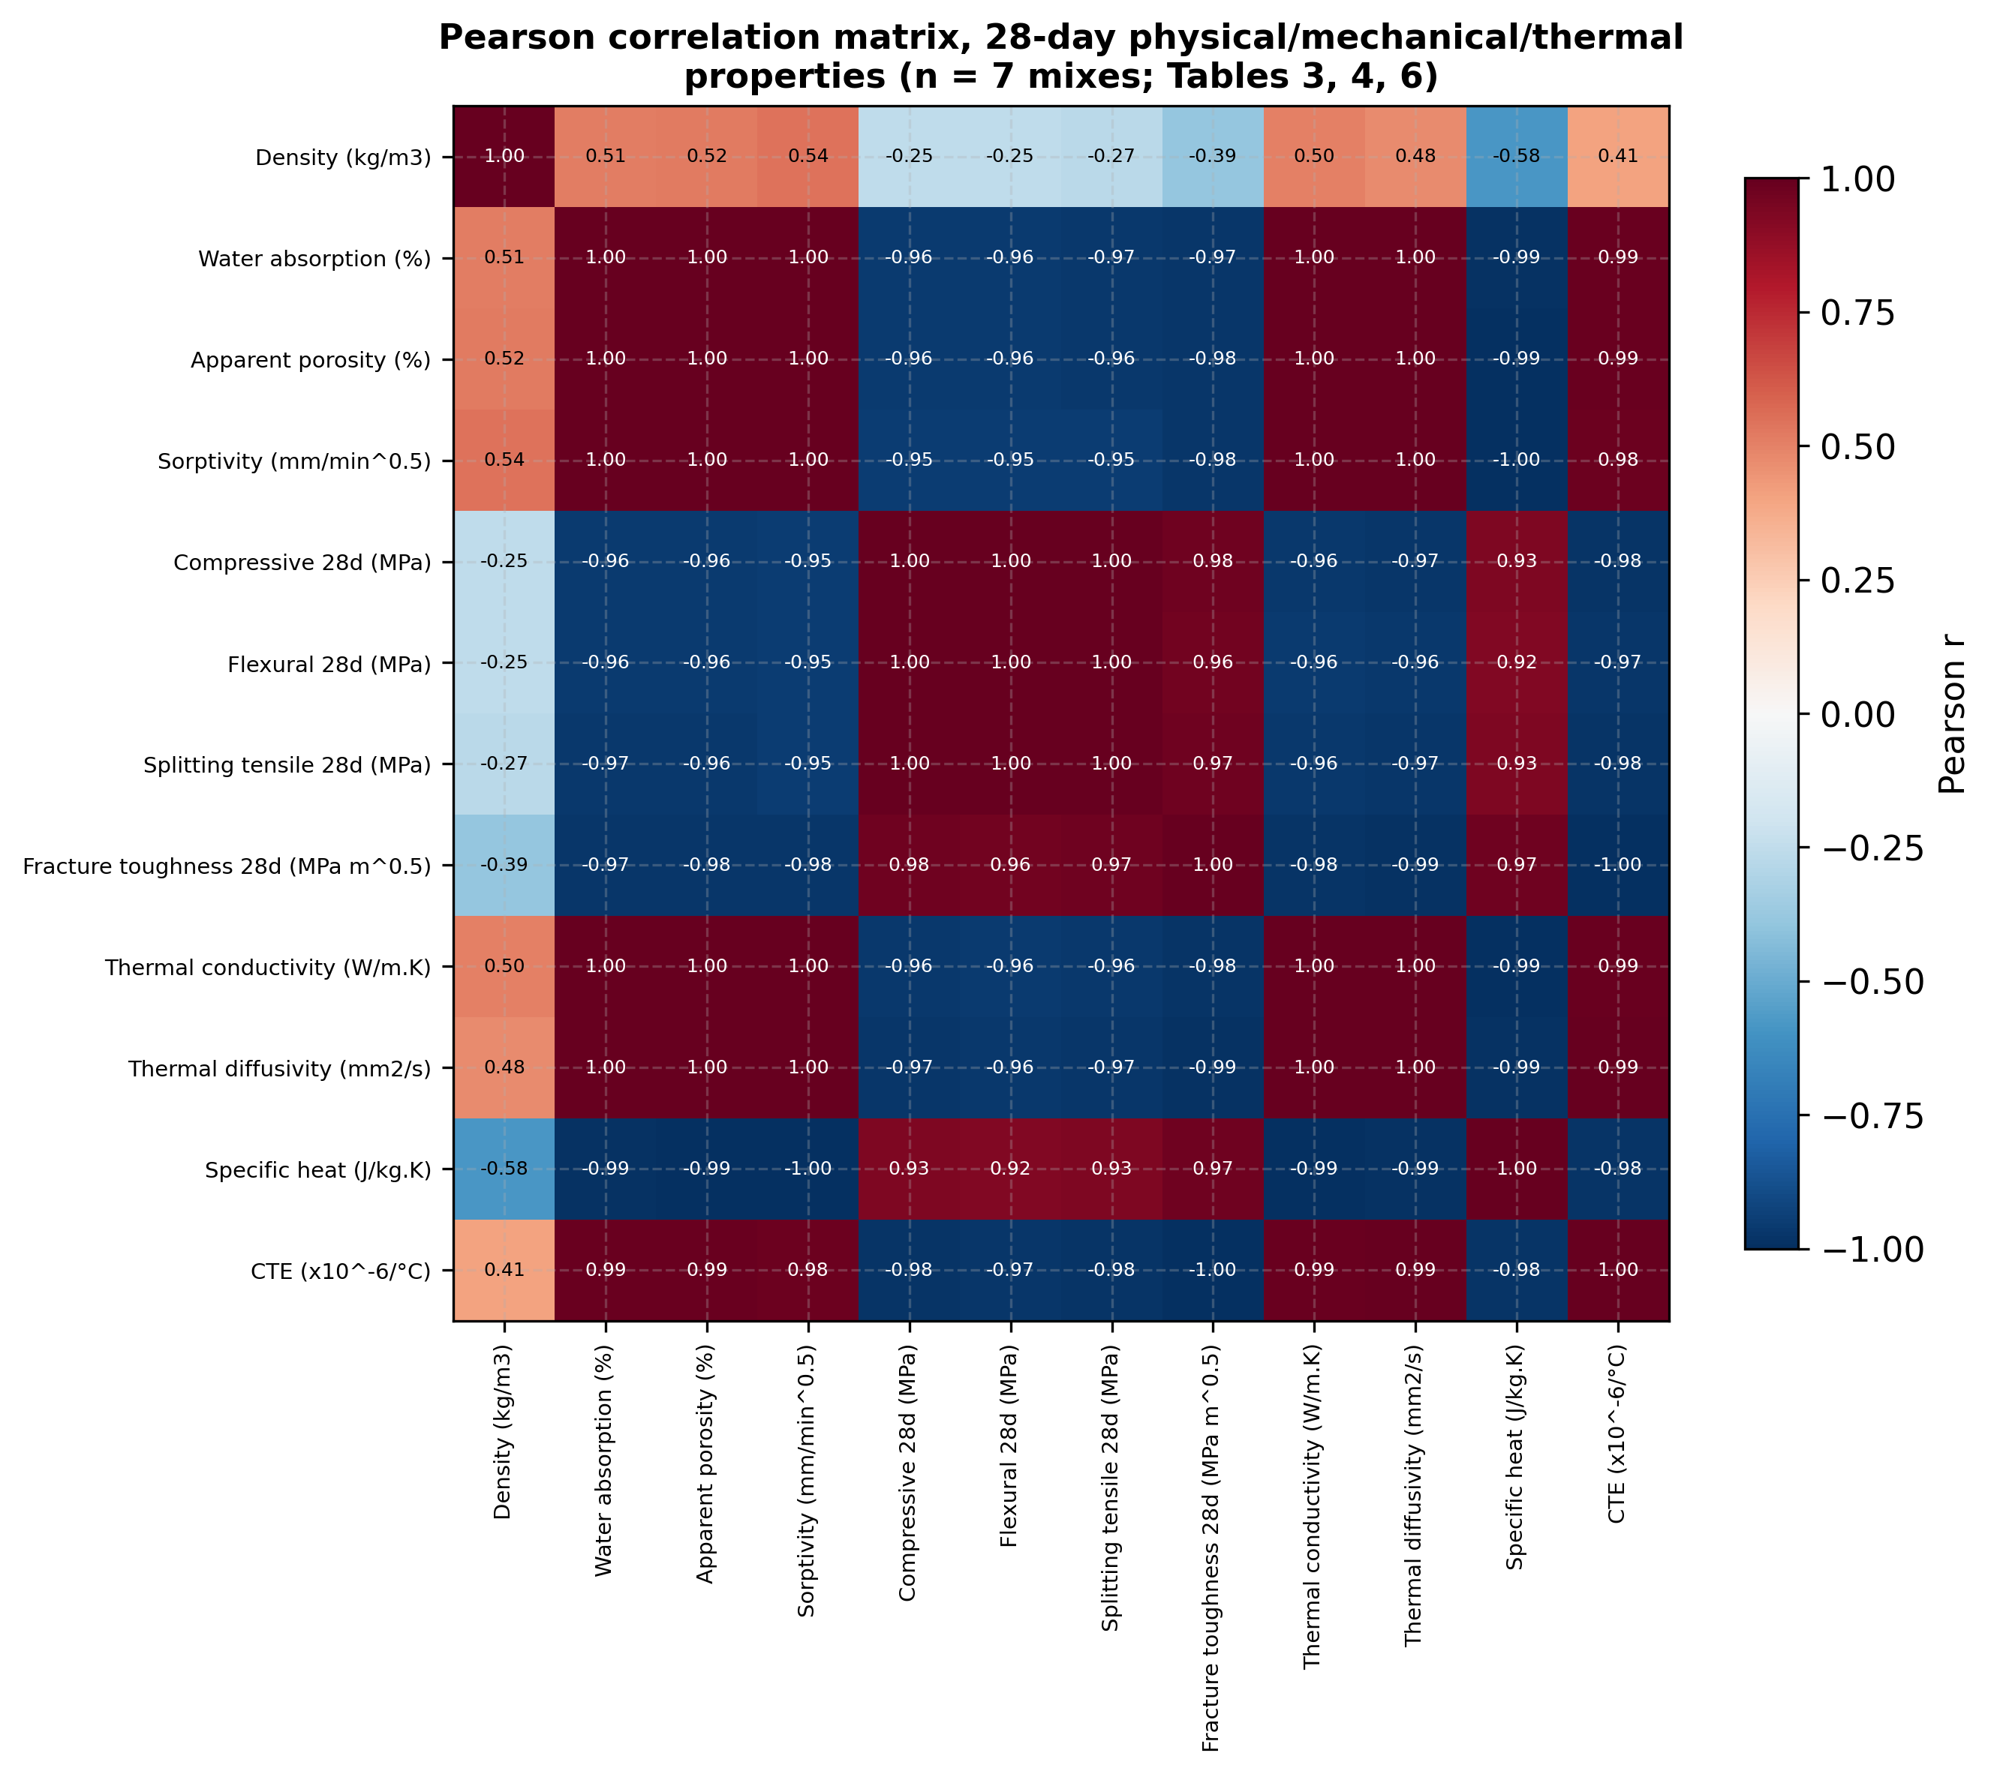
Figure 19. Pearson correlation matrix of 28-day properties.

The correlation coefficients in Table 10 summarize associations among seven mixture-level property values. These patterns help prioritize follow-up experiments; a structured design and replicated measurements will be needed to evaluate causal relationships and mechanisms. The high coefficients may reflect common ordering across mixtures, so the next study will test whether the relationships persist in an expanded dataset.

The strongest listed association is between water absorption and apparent porosity (r = 1.000), which may partly arise because these indicators are physically or computationally related. Compressive strength and splitting tensile strength are also strongly positively associated (r = 0.998) across the seven summaries. In contrast, the positive association between apparent porosity and thermal conductivity (r = 0.998) is not straightforward to interpret from pore volume alone and warrants checking the moisture state, measurement units and source values. None of these coefficients demonstrates a causal mechanism.

4.13 Supplementary derived analyses
The calculations in this section use only the summary values already reported in Tables 1–6 and 9; no new measurements are introduced. They are provided to (i) check the internal consistency of the reported data, (ii) show the change of every AT-MMC mixture relative to C0 rather than of AT6 alone, and (iii) examine the fibre-dosage and porosity relations in the dataset. Because the set contains only seven mixture-level values and several constituents vary together, every fitted parameter below is descriptive.
4.13.1 Consistency of the compositional records
Table 11 summarises oxide data from Table 2. The totals for the ancient mortar (97.6% oxides, 100.0% including LOI), granite waste powder (99.4% and 100.0%) and metakaolin (98.8% and 100.0%) close arithmetically to 100% using the listed values. The metakaolin SiO₂/Al₂O₃ molar ratio of 2.01 is a compositional ratio consistent with the nominal formula used in the theoretical discussion, but it does not demonstrate phase purity. The SiO₂ + Al₂O₃ + Fe₂O₃ sum for granite waste (88.6%) is only a bulk-composition index; its reactivity requires separate evidence.
Table 11. Internal-consistency indices derived from Table 2 (oxide mass %).
Material | Σ oxides (excl. LOI) | Σ oxides + LOI | SiO₂+Al₂O₃+Fe₂O₃ | SiO₂/Al₂O₃ (molar) | CaO/SiO₂ (mass)
Ancient temple mortar (ATM) | 97.59 | 100.00 | 71.60 | 7.69 | 0.339
Granite waste powder (GWP) | 99.37 | 100.00 | 88.55 | 8.66 | 0.032
Metakaolin (MK) | 98.81 | 100.00 | 95.80 | 2.01 | 0.009

Table 12 lists binder-fraction indices per 100 g of solids, derived from Table 1 with lime taken as pure calcium hydroxide. The listed solids of every mixture total 100.0%, consistent with the mass-balance statement for AT5 and AT6 in Section 3.2. The lime:metakaolin ratio is 2.0 for AT1–AT4 and 1.67 for AT5–AT6, and the estimated Ca/(Si+Al) index of Eq. (3) falls from 1.58 to 1.31. Because AT5–AT6 differ from AT1–AT4 simultaneously in binder content (30% to 40%), granite-waste share, lime:metakaolin ratio and w/b, their difference cannot be assigned to any one of these variables.
Table 12. Binder-fraction indices derived from Table 1.
Mix | Lime + MK (%) | Lime : MK | Granite waste : (Lime + MK) | Ca/(Si+Al) molar, Eq. (3) | Σ listed solids (%)
C0 (OPC) | – | – | – | – | 100.0
AT1 | 30 | 2.00 | 0.67 | 1.58 | 100.0
AT2 | 30 | 2.00 | 0.67 | 1.58 | 100.0
AT3 | 30 | 2.00 | 0.67 | 1.58 | 100.0
AT4 | 30 | 2.00 | 0.67 | 1.58 | 100.0
AT5 | 40 | 1.67 | 0.63 | 1.31 | 100.0
AT6 | 40 | 1.67 | 0.63 | 1.31 | 100.0

4.13.2 Change of all mixtures relative to the control
Table 13 and Figure 20 extend the AT6-only comparison of Figure 17 to all six AT-MMC mixtures; the percentage changes follow Eq. (14) and are calculated from the reported 28-day values of Tables 3–6. The reported summary values show monotonic ranking across many properties from AT1 to AT6: strength-type indicators and residual-strength ratios rise, while water absorption, apparent porosity, sorptivity, thermal conductivity and thermal expansion fall. This common ranking can produce high correlations among the seven mixture-level values, but it does not show that one property causes another. Because mixture composition changes across the series, the pattern is descriptive and requires confirmation with replicated, controlled experiments. Figure 20 shows the eleven reported 28-day properties of Table 13 (derived from Tables 3–6); the residual-strength row refers to the 5% sulfuric-acid exposure of Table 5.
Table 13. Percentage change of AT-MMC mixtures relative to C0, Eq. (14).
Property | C0 | AT1 | AT2 | AT3 | AT4 | AT5 | AT6
Density (kg/m³) | 2340 | −5.3 | −4.8 | −4.7 | −4.1 | −3.4 | −2.9
Water absorption (%) | 6.42 | −20.2 | −25.5 | −32.9 | −35.8 | −38.5 | −43.8
Apparent porosity (%) | 14.31 | −21.3 | −27.3 | −34.6 | −37.3 | −41.0 | −45.4
Sorptivity (mm/min^{0.5}) | 0.092 | −31.5 | −43.5 | −51.1 | −55.4 | −59.8 | −66.3
Compressive strength (MPa) | 38.6 | +8.3 | +18.4 | +26.7 | +29.8 | +36.3 | +43.5
Flexural strength (MPa) | 6.12 | +11.9 | +19.6 | +30.1 | +34.2 | +43.1 | +51.6
Splitting tensile strength (MPa) | 3.21 | +12.8 | +21.8 | +33.3 | +37.7 | +46.7 | +54.2
Fracture toughness (MPa·m^{0.5}) | 1.12 | +29.5 | +66.1 | +85.7 | +97.3 | +104.5 | +109.8
Residual strength, 5% H₂SO₄ (%) | 62.4 | +11.1 | +15.7 | +20.4 | +24.4 | +27.6 | +30.6
Thermal conductivity (W/m·K) | 1.62 | −18.5 | −27.2 | −32.7 | −35.2 | −39.5 | −42.6
CTE (×10⁻⁶/°C) | 9.6 | −8.3 | −15.6 | −20.8 | −22.9 | −25.0 | −27.1

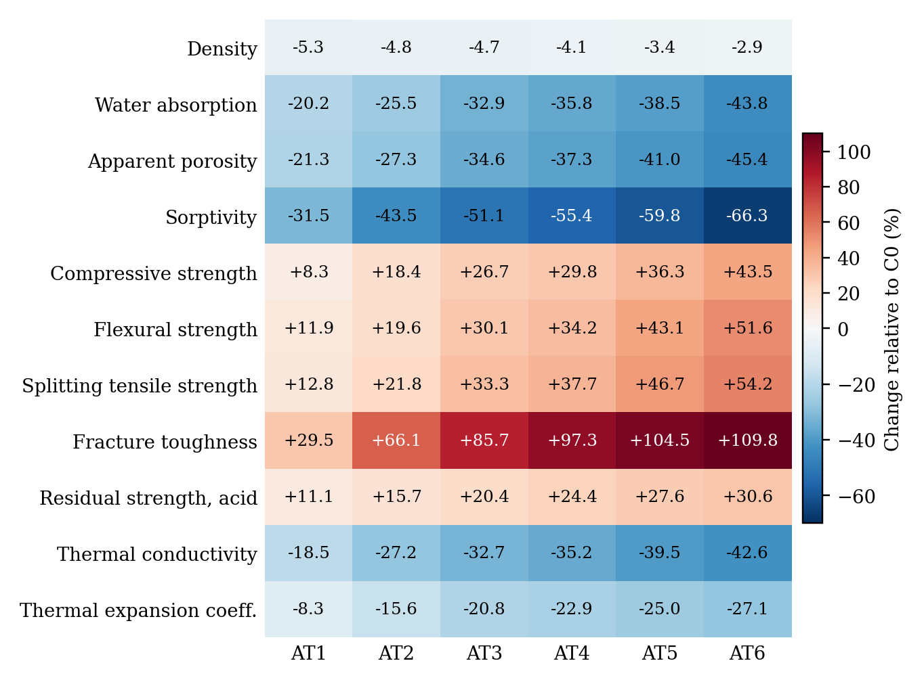
Figure 20. Heat map of the percentage change of AT1–AT6 relative to C0.
4.13.3 Effect of basalt-fibre dosage within fixed-binder series
AT1–AT4 share the same listed lime–metakaolin–granite proportions (20/10/20 mass %) and water-to-binder ratio (0.42), while basalt-fibre dosage increases from 0 to 1.5 mass % and sand is adjusted to maintain the listed mass balance. This is the closest available within-series descriptive comparison; however, fibre dosage is not fully isolated from sand content, packing and other possible batch differences, and no independent-batch replicates or uncertainty estimates are supplied. The observed trend should not be attributed solely to fibre addition.
The AT3-to-AT4 and AT5-to-AT6 differences are arithmetic comparisons of reported means, not statistically tested effects. AT3-to-AT4 changes the listed fibre dosage from 1.0% to 1.5% and the sand fraction accordingly; AT5-to-AT6 makes a similar change in a different binder/filler and water-to-binder system. These comparisons are consistent with a possible association between the formulation changes and measured properties, but they do not independently quantify a fibre effect. Table 14 and Figure 21 give the corresponding percentage changes in each property.
Table 14. Percentage change with basalt-fibre dosage within fixed-binder series.
Property | AT1 → AT4 (0 → 1.5% BF; w/b 0.42) | AT3 → AT4 (1.0 → 1.5% BF; w/b 0.42) | AT5 → AT6 (1.0 → 1.5% BF; w/b 0.40)
Density (kg/m³) | +1.4 | +0.7 | +0.5
Water absorption (%) | −19.5 | −4.4 | −8.6
Apparent porosity (%) | −20.3 | −4.2 | −7.5
Sorptivity (mm/min^{0.5}) | −34.9 | −8.9 | −16.2
Compressive strength (MPa) | +19.9 | +2.5 | +5.3
Flexural strength (MPa) | +19.9 | +3.1 | +5.9
Splitting tensile strength (MPa) | +22.1 | +3.3 | +5.1
Fracture toughness (MPa·m^{0.5}) | +52.4 | +6.3 | +2.6
Residual strength, 5% H₂SO₄ (%) | +12.0 | +3.3 | +2.4
Thermal conductivity (W/m·K) | −20.5 | −3.7 | −5.1
CTE (×10⁻⁶/°C) | −15.9 | −2.6 | −2.8

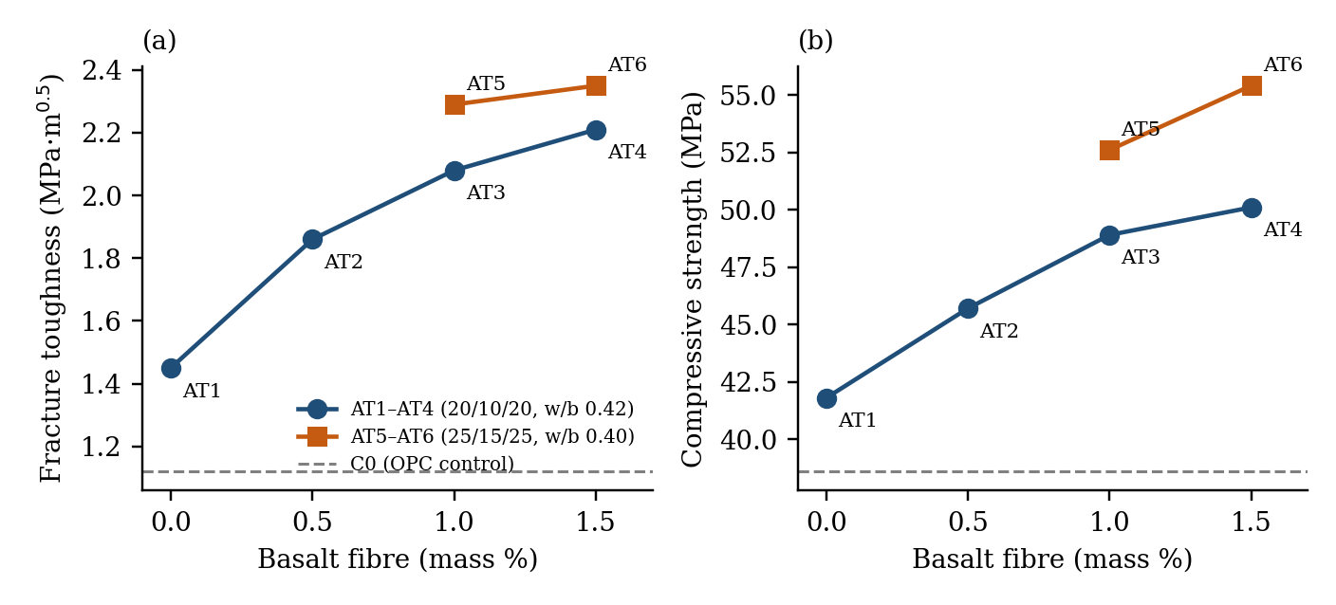
Figure 21. Effect of basalt-fibre dosage on (a) fracture toughness and (b) compressive strength; dashed line: C0.
4.13.4 Porosity–property relations
Equation (5) was fitted to ln(y) versus porosity P by ordinary least squares (Table 15, Figure 22). The reported R² values describe how the seven mixture-level summary points follow the selected mathematical form; they do not represent independent validation. The points are mixture summaries rather than replicates, the porosity range is narrow, C0 differs in binder chemistry, and several formulation variables change together. Accordingly, the fits are descriptive and should be evaluated for predictive use only after replicated data, uncertainty analysis and external validation are available. In Table 15, P is expressed as a fraction, y₀ is a fitting constant, and the data sets are either all seven mixtures or the six AT-MMC mixtures alone (n ≤ 7). Figure 22 shows the fits for compressive strength and fracture toughness using all seven mixtures.
Table 15. Ryshkewitch-type fits of strength properties to apparent porosity, Eq. (5).
Response (y) | Data set | y₀ (fitting constant) | b | R² (of ln y)
Compressive strength | C0 + AT1–AT6 (n = 7) | 83.59 MPa | 5.66 | 0.939
Compressive strength | AT1–AT6 (n = 6) | 102.56 MPa | 7.90 | 0.994
Splitting tensile strength | C0 + AT1–AT6 (n = 7) | 8.17 MPa | 6.79 | 0.955
Splitting tensile strength | AT1–AT6 (n = 6) | 10.11 MPa | 9.14 | 0.998
Fracture toughness | C0 + AT1–AT6 (n = 7) | 6.45 MPa·m^{0.5} | 12.38 | 0.964
Fracture toughness | AT1–AT6 (n = 6) | 7.23 MPa·m^{0.5} | 13.62 | 0.911

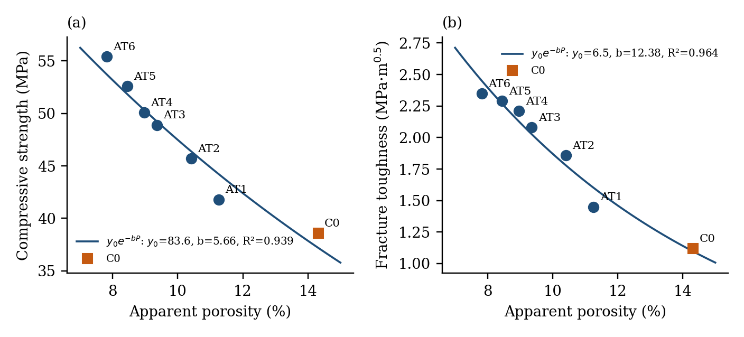
Figure 22. Ryshkewitch-type relations between apparent porosity and (a) compressive strength and (b) fracture toughness.
4.13.5 Consistency of physical and thermal values
Two consistency checks were applied to the reported physical and thermal values (Table 16, Figure 23), using Eqs. (4) and (6) with values derived from Tables 3 and 6. The water-absorption/porosity relation implies dry bulk densities 0.7–5.3% below the listed density, while the reported diffusivity exceeds the value calculated from the listed density by approximately 3.7–9.5%. Using the implied dry density narrows some differences, but the original records are needed to establish the basis for the remaining discrepancies. These checks identify possible differences in measurement state or calculation; confirming density condition, moisture state, units and original calculations will provide a consistent basis for reporting. Figure 23 compares the reported diffusivity with the diffusivity computed from Eq. (6) using the reported density and the implied dry density.
Table 16. Consistency checks on reported density and thermal diffusivity.
Mix | ρ reported (kg/m³) | ρ_{d} = 1000·P/WA (kg/m³) | α reported (mm²/s) | α = k/(ρc_{p}), reported ρ | α = k/(ρ_{d}c_{p})
C0 | 2340 | 2229 | 0.78 | 0.753 | 0.790
AT1 | 2215 | 2199 | 0.64 | 0.608 | 0.612
AT2 | 2228 | 2178 | 0.56 | 0.527 | 0.539
AT3 | 2230 | 2172 | 0.52 | 0.480 | 0.493
AT4 | 2245 | 2177 | 0.49 | 0.456 | 0.471
AT5 | 2260 | 2139 | 0.46 | 0.420 | 0.444
AT6 | 2272 | 2166 | 0.43 | 0.394 | 0.414

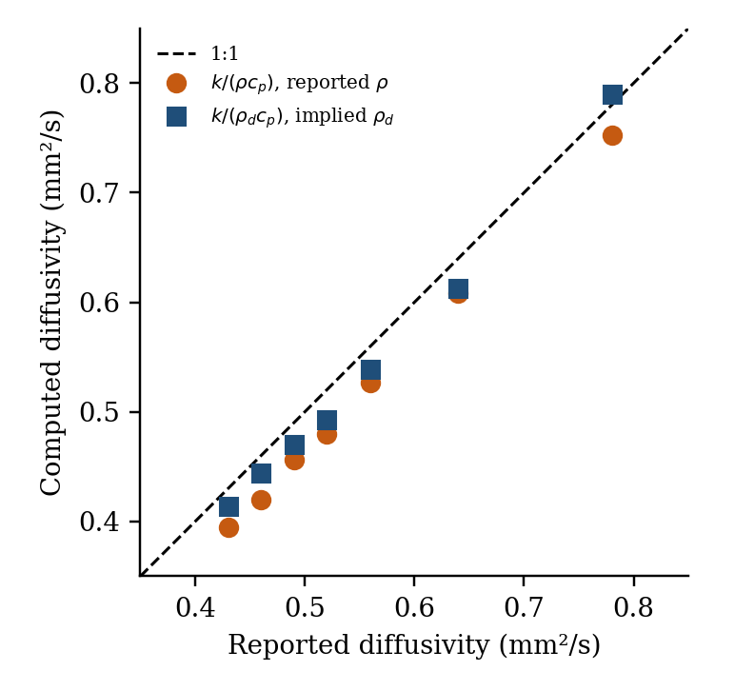
Figure 23. Reported versus computed thermal diffusivity; dashed line: 1:1.
4.13.6 Relative environmental indicators
Table 17 gives the relative changes in the Table 9 indicators and the strength-per-GWP indicator of Eq. (16), which uses the compressive strengths of Table 4. Relative to C0, AT6 shows reductions of 46.1% in GWP, 46.4% in embodied energy and 46.0% in primary energy, and AT3 shows reductions of 35.5%, 32.1% and 32.5%. The indicator E_{eco} is 83.5 for C0, 164.1 for AT3 and 222.5 for AT6 (MPa per kg CO₂-eq/kg), about 2.7 times the C0 value for AT6. The C0 description is harmonized as OPC mortar, consistent with the binder–sand mixture listed in Table 1. Because GWP is expressed per kilogram and not per functional unit, E_{eco} remains indicative only; a functional-unit-based LCA is needed for a fairer comparative assessment.
Table 17. Relative life-cycle indicators and strength-per-GWP ratio.
Material | GWP (kg CO₂-eq/kg) | ΔGWP vs C0 (%) | Δ embodied energy vs C0 (%) | Δ primary energy vs C0 (%) | E_{eco} = f_{c}/GWP, Eq. (16)
C0 | 0.462 | – | – | – | 83.5
AT3 | 0.298 | −35.5 | −32.1 | −32.5 | 164.1
AT6 | 0.249 | −46.1 | −46.4 | −46.0 | 222.5

4.14 Analysis of variance of the reported data
This section replaces unsupported inferential claims with a transparent account of what can and cannot be concluded from the available summary data. Tables 18–23 contain derived fits or calculations based on mixture-level summaries, not specimen-level observations. Their goodness-of-fit statistics describe the selected mathematical forms and must not be interpreted as validation or independent experimental significance. The original individual measurements, specimen counts and batch identifiers are required before a confirmatory ANOVA can be calculated.
4.14.1 Regression ANOVA on basalt-fibre dosage within AT1–AT4
The four AT1–AT4 mixture means were fitted descriptively against the listed basalt-fibre dosage (0, 0.5, 1.0 and 1.5 mass %). Table 18 reports the arithmetic slope, intercept and R² for each response. Because each dosage is represented by one mixture mean and other mixture characteristics may not be fully controlled, these fits describe the listed sequence and do not establish a statistically significant or independent fibre effect.
Table 18. Descriptive linear fits of AT1–AT4 means against basalt-fibre dosage (0–1.5 mass %).
Property | Slope per 1% basalt fibre | Intercept at 0% fibre | R² (descriptive)
Density (kg/m³) | 18.4 | 2215.7 | 0.9342
Water absorption (%) | -0.694 | 5.103 | 0.9772
Apparent porosity (%) | -1.584 | 11.188 | 0.9721
Sorptivity (mm/min^{0.5}) | -0.0146 | 0.0612 | 0.9559
Compressive strength (MPa) | 5.62 | 42.41 | 0.9539
Flexural strength (MPa) | 0.944 | 6.877 | 0.9757
Splitting tensile strength (MPa) | 0.554 | 3.642 | 0.9735
Fracture toughness (MPa·m^{0.5}) | 0.5 | 1.525 | 0.9396
Residual strength, 5% H₂SO₄ (%) | 5.56 | 69.38 | 0.9988

4.14.2 Two-way ANOVA of residual strength: mixture × exposure
The 35 entries in Table 5 comprise one reported residual-strength ratio for each of seven mixtures under five different exposures. These are not independent replicates, and the five exposure conditions differ in severity and protocol. Consequently, the mixture × exposure interaction cannot be assumed to be a valid substitute for specimen-level error [26], and the reported F-statistics, p-values and post-hoc comparisons do not establish statistically significant differences. The table may be used to describe the ordering of the reported summary ratios only. Confirmatory comparisons require specimen-level results and replicate counts for each mixture and exposure. Table 19 summarizes the calculations from Table 5.
Table 19. Mixture-by-exposure ANOVA summary for the data in Table 5 (descriptive only).
Item | Reported calculation | Revised interpretation | MS | F | p | η²
Mixture effect | F(6,24) = 30.70; p < 0.001 | Not used for inference: interaction is not independent replicate error | 146.81 | 30.70 | <0.001 | 0.318
Exposure effect | F(4,24) = 92.57; p < 0.001 | Descriptive only; exposure conditions differ in severity | 442.63 | 92.57 | <0.001 | 0.640
Mixture × exposure | SS = 114.76; df = 24 | Cannot substitute for specimen-level replication | 4.78 | – | – | 0.041
Total | 35 mixture-level values | Use only to describe reported residual-strength ratios | 81.36 | – | – | 1.000

The mixture-level averages across the five exposure endpoints are descriptively higher for AT-MMC formulations than for C0 in the supplied table. However, Tukey HSD and Bonferroni-adjusted p-values are withdrawn because there are no independent replicate observations supporting the assumed error term. The reported ordering is not evidence of statistical significance or long-term service performance. Table 20 gives the corresponding arithmetic percentage changes in the four mechanical properties relative to C0 (cf. Table 13); they are not pairwise significance tests.
Table 20. Percentage changes in mechanical properties relative to C0.
Mix | Compressive change vs C0 (%) | Flexural change vs C0 (%) | Splitting tensile change vs C0 (%) | Fracture toughness change vs C0 (%) | Mean change across four properties (%) | Interpretation
C0 | 0.0 | 0.0 | 0.0 | 0.0 | 0.0 | Reference mixture
AT1 | 8.3 | 11.9 | 12.8 | 29.5 | 15.6 | Descriptive increase; no significance inferred
AT2 | 18.4 | 19.6 | 21.8 | 66.1 | 31.5 | Descriptive increase; no significance inferred
AT3 | 26.7 | 30.1 | 33.3 | 85.7 | 43.9 | Descriptive increase; no significance inferred
AT4 | 29.8 | 34.2 | 37.7 | 97.3 | 49.7 | Descriptive increase; no significance inferred
AT5 | 36.3 | 43.1 | 46.7 | 104.5 | 57.6 | Descriptive increase; no significance inferred
AT6 | 43.5 | 51.6 | 54.2 | 109.8 | 64.8 | Descriptive increase; no significance inferred

4.14.3 ANOVA of the Ryshkewitch-type fits
The relations between ln(property) and apparent porosity were recalculated from the values in Tables 3 and 4. Table 21 reports the fitted intercept, slope and descriptive R² for both the seven-mixture set and the six AT-MMC mixtures. The fits summarize mixture-level values only; no specimen-level residual error or independent validation is available, so inferential F-statistics and p-values are not reported. The R² values describe fits to seven mixture means (C0 + AT1–AT6) or six AT-MMC means (AT1–AT6); they are not independent validation or evidence of causation.
Table 21. Log-linear fits, ln(y) = a + bP, of mechanical properties to apparent porosity P (%).
Response | Data set | n | Intercept a | Slope b per porosity %-point | R² (descriptive)
Compressive strength (MPa) | C0 + AT1–AT6 | 7 | 4.4259 | -0.05656 | 0.9394
Compressive strength (MPa) | AT1–AT6 | 6 | 4.6305 | -0.07902 | 0.9935
Splitting tensile strength (MPa) | C0 + AT1–AT6 | 7 | 2.1001 | -0.06794 | 0.9548
Splitting tensile strength (MPa) | AT1–AT6 | 6 | 2.3139 | -0.09142 | 0.9977
Fracture toughness (MPa·m^{0.5}) | C0 + AT1–AT6 | 7 | 1.8644 | -0.12379 | 0.9645
Fracture toughness (MPa·m^{0.5}) | AT1–AT6 | 6 | 1.9779 | -0.13625 | 0.9113
Flexural strength (MPa) | C0 + AT1–AT6 | 7 | 2.6899 | -0.06411 | 0.9457
Flexural strength (MPa) | AT1–AT6 | 6 | 2.9077 | -0.08803 | 0.9933

4.14.4 Binder package × fibre contrasts (AT3–AT6)
AT3–AT6 form an unreplicated 2 × 2 arrangement only in a descriptive arithmetic sense: AT3–AT4 use the 20/10/20 binder/filler package and AT5–AT6 use the 25/15/25 package, while fibre dosage takes two listed levels. Because the binder/filler package and water-to-binder ratio change together and there is only one reported value per cell, these contrasts cannot separate independent effects reliably and have no error degrees of freedom. The contrast values should not be interpreted as significance-tested factor effects. Table 22 lists the contrast estimates (half-differences of cell sums) for each property.
Table 22. Contrast estimates for the AT3–AT6 2 × 2 layout (half-differences of cell sums).
Property | Binder package (AT5,AT6 − AT3,AT4) | Fibre 1.5 vs 1.0% | Interaction
Density (kg/m³) | +28.5 | +13.5 | -1.5
Water absorption (%) | -0.435 | -0.265 | -0.075
Apparent porosity (%) | -1.03 | -0.51 | -0.12
Sorptivity (mm/min^{0.5}) | -0.009 | -0.005 | -0.001
Compressive strength (MPa) | +4.5 | +2 | +0.8
Flexural strength (MPa) | +0.935 | +0.385 | +0.135
Splitting tensile strength (MPa) | +0.48 | +0.19 | +0.05
Fracture toughness (MPa·m^{0.5}) | +0.175 | +0.095 | -0.035
Residual strength, 5% H₂SO₄ (%) | +4.2 | +2.2 | -0.3

4.14.5 Replicate-precision requirements
The replicate-precision calculations are hypothetical planning scenarios based on assumed within-mixture coefficients of variation and specimen counts. They do not demonstrate that the current mixture differences are statistically significant. Once the original specimen-level data are available, measured standard deviations and confidence intervals should be reported and an appropriate replicate-based analysis conducted. Table 23 lists the resulting thresholds for planning future tests; they are not measured uncertainty estimates or evidence of current statistical significance.
Table 23. Hypothetical replicate-precision thresholds for planning future tests.
Property | Max CV (%), n = 3 | Max CV (%), n = 5 | F(6,14) at CV 5%, n = 3 | p at CV 10%, n = 3
Density (kg/m³) | 1.9 | 2.7 | 0.4 | 0.995
Water absorption (%) | 20.6 | 28.7 | 48.3 | <0.001
Apparent porosity (%) | 21.9 | 30.5 | 54.7 | <0.001
Sorptivity (mm/min^{0.5}) | 38.5 | 53.7 | 169.0 | <0.001
Compressive strength (MPa) | 12.7 | 17.7 | 18.5 | 0.009
Flexural strength (MPa) | 14.4 | 20.0 | 23.5 | 0.003
Splitting tensile strength (MPa) | 15.0 | 20.9 | 25.7 | 0.002
Fracture toughness (MPa·m^{0.5}) | 24.4 | 34.0 | 67.7 | <0.001
Residual strength, 5% H₂SO₄ (%) | 9.1 | 12.7 | 9.5 | 0.085

4.14.6 Assumptions and data required for inferential ANOVA
The current summary dataset does not support confirmatory ANOVA because independent specimen-level observations, replicate counts and batch identifiers are not provided. Independence, residual normality and variance homogeneity therefore cannot be assessed. The reported regression and unreplicated two-way calculations are not used for inferential claims in this revision. A valid analysis should be run from original individual measurements using a model matched to the actual randomized design; if only one batch or one summary value exists per mixture, the results must remain descriptive.

5. Results and Discussion

5.1 Ancient material chemistry as a design reference
The XRF and XRD results characterize one historic mortar sample and provide a case-specific design reference. To establish whether this composition is representative of the wider temple or other historic mortars, future sampling should cover documented locations and account for repair history, weathering state and possible contamination. The present results are interpreted within the scope of the sampled material.

5.2 Mechanism linking composition, microstructure and mechanical performance
Mechanical Results (Table 4)
The reported property patterns are compatible with several hypotheses, including particle packing, lime–metakaolin reactions and fibre bridging. The available XRF, XRD and qualitative SEM–EDS results do not directly quantify C–S–H/C–A–S–H phases or reaction kinetics, and the non-orthogonal mixture design does not isolate the effects of individual constituents. These mechanisms are therefore proposed interpretations rather than experimentally demonstrated causes. FTIR, TGA/DTG, quantitative XRD, solid-state NMR or suitable elemental mapping would be needed to test the phase-related hypotheses.
Across the listed mixtures, the reported physical and mechanical summaries show an inverse ordering between water-access indicators and strength-related indicators. One possible interpretation is that particle packing and binder composition reduced accessible pore space, while fibres may have contributed to crack control. These explanations remain hypotheses because the mixture series changes several constituents together, the historic reference is represented by one fragment, and SEM–EDS observations are qualitative. The results support selecting AT6 for a carefully replicated follow-up study rather than assigning a definitive mechanism.
The mixture ordering is consistent with hypotheses involving particle packing, lime–metakaolin reactions and fibre bridging. AT1–AT4 offer a limited within-series comparison in which fibre dosage increases while sand is adjusted to maintain mass balance; however, fibre dosage is not fully isolated from changes in packing and porosity. The present results therefore motivate, but do not confirm, a fibre-bridging mechanism. Direct fracture-energy measurements, fibre geometry, interfacial properties and quantitative phase characterization would enable a more targeted assessment. Figure 24 sketches the proposed matrix pathway and fibre bridging across a crack; it illustrates hypotheses only and does not depict measured quantities.
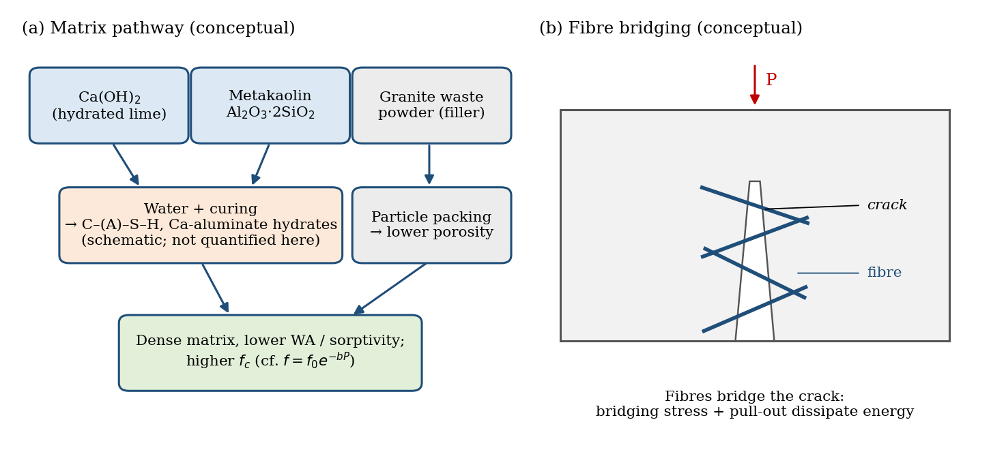
Figure 24. Conceptual schematic of (a) the proposed matrix pathway and (b) fibre bridging across a crack.

5.3 Durability and thermal behaviour
AT6 has the highest reported residual-strength ratios among the listed mixtures for the stated laboratory exposure endpoints. This is a descriptive result under the reported conditions, not proof of long-term durability or field service life. The 5% sulfate and 5% sulfuric-acid exposures are aggressive screening conditions and should not be generalized to typical environments without justification. Exposure temperatures, solution renewal, conditioning, replicate counts and complementary measures such as mass change, dimensional change, surface damage and cracking must be recovered from the laboratory records or identified as unavailable. Post-heating XRD/SEM or thermal analysis would be needed to evaluate proposed degradation mechanisms.
Using the implied dry density in Eq. (6), the reported thermal values are internally coherent to within about 6% (Table 16), while use of the listed density gives differences of approximately 3.7–9.5%. Thermal conductivity decreases by 18.5–42.6% relative to C0 (Table 13), although its positive association with apparent porosity across the seven mixtures (r = 0.998; Table 10) differs from the usual expectation when solid-phase composition and moisture are comparable. Since C0 and AT-MMC differ in binder chemistry and mineral composition, this correlation is interpreted as a mixture-level association rather than a causal relationship. Composition-controlled specimens, documented moisture conditioning, repeated thermal measurements and replicate porosity data would help clarify the trend.
Within the seven reported formulations and the selected criteria, the provisional desirability calculation ranks AT6 favourably. Because the optimization model, its diagnostics and independent validation are not available for reproduction, this result is not treated as a validated optimum. The mixture should be called the highest-performing reported formulation within this limited set, not globally optimized.
The reported desirability calculation ranks AT6 favourably within the seven listed formulations and selected criteria, but this ranking remains provisional until the original model equations, limits, weights, diagnostics and independent validation are provided. It should not be described as global optimization.

5.4 Statistical interpretation and replicate design
The summary values show a consistent ordering across several reported endpoints, but the existing ANOVA calculations do not provide valid replicate-based inference. The fibre-dose trends and cross-exposure rankings are descriptive only. The current data do not establish statistical significance, independent constituent effects, or causal relationships.
The hypothetical replicate-precision analysis may help plan a future experiment, but its CV thresholds are not measured uncertainty estimates and cannot be used to claim that differences in the current dataset are significant. Future testing should report specimen-level values, means, standard deviations, confidence intervals and the number of independent batches.

5.5 Environmental performance and engineering implications
The reported LCA table lists a lower GWP per kilogram for AT6 than for C0. This comparison remains provisional because the inventory, system boundary, transport and processing assumptions, waste-allocation rules and functional equivalence are not documented sufficiently for independent reproduction. Non-structural applications may be identified as areas for future evaluation; structural performance, code compliance, long-term durability and service-life suitability have not been established.
The strength-per-GWP ratio is a screening indicator calculated from the reported strength and per-kilogram GWP values, not a functionally equivalent life-cycle comparison. It should not be used to claim a definitive environmental advantage until the LCA inventory and performance-based functional unit are verified.

5.6 Future Scope
Future research should: (i) publish specimen-level measurements, replicate counts, uncertainty estimates and complete load–deflection/load–CMOD curves where available; (ii) verify standards, instruments, loading rates, exposure protocols and sample provenance; (iii) expand historic-mortar sampling and use a structured mixture-design programme with independently prepared validation mixtures; (iv) reconcile the physical/thermal consistency checks and conduct phase-sensitive characterization; (v) repeat durability tests using documented, relevant protocols; and (vi) complete a transparent LCA with a functional unit, auditable inventory and sensitivity analysis. Reported values should be traceable to original records so that the final interpretation remains transparent and reproducible.

5.7 AI/ML-assisted extension of this framework
The seven-mixture dataset is best viewed as a starting point for planning a larger experimental programme rather than as a basis for training or validating a reliable AI/ML model. AI/ML-assisted prediction or optimisation would be more appropriately undertaken after assembling a larger, well-designed dataset containing specimen-level observations, uncertainty estimates, predefined training/validation/test partitions and independent experimental validation.

The response-surface and desirability results are not independently reproducible from the supplied manuscript and are therefore not treated as validated predictions. Unless the original model files, complete equations, coefficients, diagnostics, prediction intervals and independent validation experiments can be supplied, the response-surface claim and numerical desirability score should be removed from the final conclusions.

6. Conclusions
This study characterizes one detached, non-load-bearing mortar sample from a 12th-century granite temple and descriptively compares one OPC control with six exploratory AT-MMC formulations. Within the supplied summary tables, AT6 has the highest listed 28-day mechanical-property values and the lowest listed water absorption and apparent porosity among the seven formulations. These are rankings of reported summaries, not evidence of a globally optimized mixture or statistically significant differences. The non-orthogonal mixture design, lack of specimen-level data and absence of documented uncertainty prevent independent attribution of effects to individual constituents. The proposed lime–metakaolin reaction products and fibre-bridging mechanisms remain hypotheses requiring direct phase and interface evidence. Durability findings are limited to the stated laboratory endpoints; long-term field performance is not established. The reported desirability and LCA indicators remain provisional until the underlying calculations and inventory are independently reproducible. Future work should provide verified batch records, individual test results, replicate counts, standards, exposure protocols, thermal conditions, complete load–CMOD data, and a structured experimental design with independent validation.
Data Availability Statement: The manuscript identifies https://github.com/GirirajMannayee/AT-MMC as the intended repository.
Conflicts of Interest: The author declares no conflict of interest.
Funding Declaration: This research received no external funding.
Ethics Declaration: Not applicable.
Consent to Publish declaration: not applicable.
Consent to Participate declaration: not applicable.
Ethics Approval and Consent to Participate: Not applicable. This study did not involve human participants or human-derived data.
Consent for Publication: Not applicable.
Data provenance statement: The author reports that no secondary data were used for material characterization or experimental analysis. This statement applies only if all measurements, images and derived values originate from the study's own records; any reused, adapted or externally sourced material should be identified and cited explicitly.

Author Contributions Statement: The author conceived the study, developed the methodology, conducted the analysis, performed the experiments, interpreted the results, prepared the figures and tables, wrote, reviewed, and approved the final manuscript.
References
- Hou, D., Zhang, G., Pant, R.R., Shen, J.S., Liu, M. and Luo, H., 2016. Nanoindentation characterization of a ternary clay-based composite used in ancient Chinese construction. Materials, 9(11), p.866.
- Wilson, W., Sorelli, L., Krishnan, S., Bishnoi, S. and Tagnit-Hamou, A., 2017. Micro-chemo-mechanical characterization of a limestone-calcinated-clay cement paste by statistical nanoindentation and quantitative SEM-EDS. In: Calcined Clays for Sustainable Concrete: Proceedings of the 2nd International Conference on Calcined Clays for Sustainable Concrete. Dordrecht: Springer Netherlands, pp.494–499.
- Bekrine, I., Hilloulin, B. and Loukili, A., 2023. Multiscale investigation of cement pastes with low and high-grade calcined clays and slag at early and advanced ages. Journal of Building Engineering, 78, p.107570.
- Wu, J., Liu, S., Deng, Y., Zhang, G. and Zhan, L., 2022. Microscopic phase identification of cement-stabilized clay by nanoindentation and statistical analytics. Applied Clay Science, 224, p.106531.
- Gao, Y., Zhang, Y., Hu, C. and Li, Z., 2012. Nanomechanical properties of individual phases in cement mortar analyzed using nanoindentation coupled with scanning electron microscopy. Journal of The Chinese Ceramic Society, 40(11), pp.1559–1563.
- Hu, C., 2015. Nanoindentation as a tool to measure and map mechanical properties of hardened cement pastes. MRS Communications, 5(1), pp.83-87.
- Zakira, U., Bajpayee, A., Pharr, M., Banerjee, S. and Birgisson, B., 2022. Grid nanoindentation on calcium sulfoaluminate (CSA)-Kaolinite pastes. Construction and Building Materials, 335, p.127523.
- Li, Y., Lu, Y., Liu, L., Luo, S., He, L., Deng, Y. and Zhang, G., 2022. Big data nanoindentation characterization of cross-scale mechanical properties of oilwell cement-elastomer composites. Construction and Building Materials, 354, p.129190.
- Liu, L., Li, Y., Wu, Y., Luo, S., Peng, J., Deng, Y. and Zhang, G., 2022. Strengthening mechanisms in cement-stabilized kaolinite revealed by cross-scale nanoindentation. Acta Geotechnica, 17(11), pp.5113-5132.
- Huang, X., Guan, P., Zhang, L., Shu, B., Pu, S. and Wu, J., 2025. Multiscale characterization of the interactions between hydration products and clay minerals. Construction and Building Materials, 498, p.143958.
- Hu, C. and Li, Z., 2015. A review on the mechanical properties of cement-based materials measured by nanoindentation. Construction and Building Materials, 90, pp.80-90.
- Gautham, S. and Sasmal, S., 2023. Constitutive relations of nanoscale hydration products present in engineered cementitious composites from machine learning assisted experimental nanoindentation. Journal of Building Engineering, 75, p.106912.
- He, Z.H., Han, X.D., Shi, J.Y., Aslani, F., Gencel, O. and Du, S.G., 2022. Multi-scale characteristics of eco-friendly marine binder using coral waste. Powder Technology, 403, p.117395.
- Hu, C. and Li, Z., 2015. Property investigation of individual phases in cementitious composites containing silica fume and fly ash. Cement and Concrete Composites, 57, pp.17-26.
- Vafaeenezhad, H. and Eslami-Farsani, R., 2026. Computational Modeling, Challenges, and Future Directions of Self-Healing Basalt Fiber Composites. Advances in Basalt Fibers and Their Composites, pp.205-242.
- Krzywanski, J., Sosnowski, M., Grabowska, K., Zylka, A., Lasek, L. and Kijo-Kleczkowska, A., 2024. Advanced computational methods for modeling, prediction and optimisation review. Materials, 17(14), p.3521.
- Baten, B., Iqbal, M.A., Ament, S., Kusuma, J. and Garg, N., 2026. BOxCrete: A Bayesian Optimization Open-Source AI Model for Concrete Strength Forecasting and Mix Optimization. arXiv preprint arXiv:2603.21525.
- Chauhan, R.G.S., Mothe, Y. and Gupta, C., 2026. AI-augmented multi-objective structural optimisation and statistical evaluation of flat slab systems with and without shear walls in high-rise RCC buildings under seismic loads. Asian Journal of Civil Engineering, pp.1–22.
- Hamzah, M.K., El Shafie, H. and Althobaiti, M., 2026. Artificial Intelligence for Energy Optimization in Educational Buildings in Saudi Arabia: A Systematic Review of Design Variables and Decision-Support Approaches in Hot-Arid Climates. Sustainability, 18(10), p.5067.
- Wang, X.Q., Chen, P., Chow, C.L. and Lau, D., 2023. Artificial-intelligence-led revolution of construction materials: From molecules to Industry 4.0. Matter, 6(6), pp.1831-1859.
- Xu, T., Wei, T., Ge, Y., Peng, B., Li, Y., Wang, M., Wen, P., Yang, C. and Wei, Y., 2026. Sustainable Materials Design With Multi‐Modal Artificial Intelligence. Advanced Science, p.e24273.
- Ryshkewitch, E., 1953. Compression strength of porous sintered alumina and zirconia. Journal of the American Ceramic Society, 36(2), pp.65–68.
- Hillerborg, A., Modéer, M. and Petersson, P.-E., 1976. Analysis of crack formation and crack growth in concrete by means of fracture mechanics and finite elements. Cement and Concrete Research, 6(6), pp.773–781.
- Kelly, A. and Tyson, W.R., 1965. Tensile properties of fibre-reinforced metals: copper/tungsten and copper/molybdenum. Journal of the Mechanics and Physics of Solids, 13(6), pp.329–350.
- Derringer, G. and Suich, R., 1980. Simultaneous optimization of several response variables. Journal of Quality Technology, 12(4), pp.214–219.
- Tukey, J.W., 1949. One degree of freedom for non-additivity. Biometrics, 5(3), pp.232–242.
- Friedman, M., 1937. The use of ranks to avoid the assumption of normality implicit in the analysis of variance. Journal of the American Statistical Association, 32(200), pp.675–701.
- Cohen, J., 1988. Statistical Power Analysis for the Behavioral Sciences. 2nd ed. Hillsdale, NJ: Lawrence Erlbaum Associates.
- Montgomery, D.C., 2017. Design and Analysis of Experiments. 9th ed. Hoboken, NJ: Wiley.

