**Question:** Write a python program to print 5 times python?

Ans:

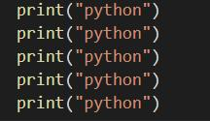

**Question:** Is there any way, we don’t need to write python 5 times?

**Ans:** Yes, using loop.

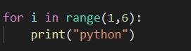

**Loop**

Loop is a mechanism that allow us to do the task again and again just by writing once. Loop allows the execution of a statement or a group of statement multiple times. In order to enter the loop, there are certain conditions defined in the beginning. One the condition becomes false the loop stops and the control moves out of the loop. For a beginner, the concept of the loop could be easily understood using an example of the song's playlist. When we like a song, we set it on repeat, and then it automatically starts playing again and again. The same concept is used in programming, we set a part of code for looping, and the same part of the code executes until the certain condition that we provided is fulfilled.

**Types of loops in Python**

* while loop
* for loop

**Why To Use Loops?**

* Complex problems can be simplified using loops
* Less amount of code required for our program
* Lesser code so lesser chance or error
* Saves a lot of time

**3 points, we should know before using loop.**

* Starting value
* Changing value
* Terminating value

**For Loop (Definite Loop)**

In Python, “for loops” are called **iterators.** Just like while loop, “For Loop” is also used to repeat the program. But unlike while loop which depends on condition true or false. “For Loop” depends on the elements it has to iterate. Use the **for loop** when you know how many times the loop should execute.

**Syntax:**

for (variablename) in sequence:

statement

**Question1.** Write a Python program that print hello world 10 times using for loop.



**OUTPUT**

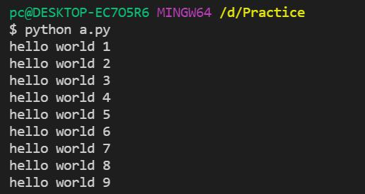

**Question2:** Write a python program to print 5 times “Python” then print 1 time “Learning Python”?

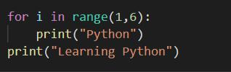

**Example 1:**

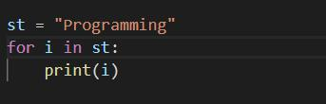

**OUTPUT**

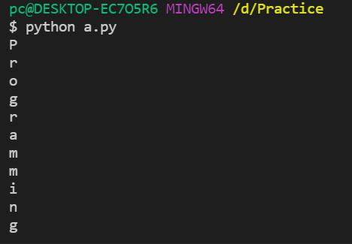

**For Loop with Range**

**Example 1:**

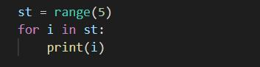

**OUTPUT**

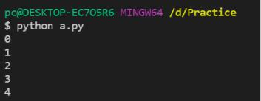

**Example 2:**

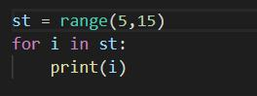

**OUTPUT**

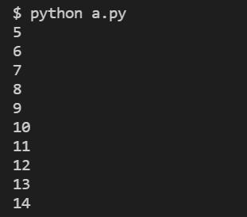

**Example 3:**

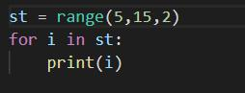

**OUTPUT**

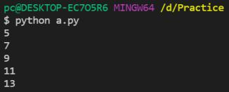

**Example 4:**

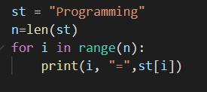

**OUTPUT**

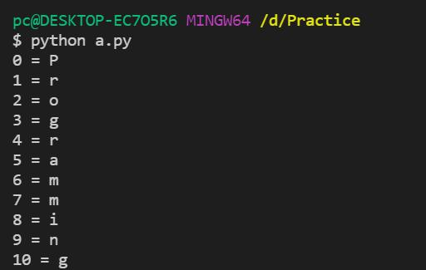

**For Loop with else**

**Syntax:**

for (variable) in sequence:

statements

else:

statements

**Example 1:**

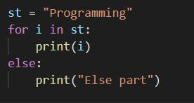

**OUTPUT**

