

**SUBMITTED**

**TO**

**MUMBAI UNIVERSITY**

**BY**

**GIRISH ANAND BANGERA**

**(TYBSc.Computer Science)**

**2018-2019**

**EXERZONE APPLICATION.**

**PROJECT REPORT**

**ON**

**Sri Chandrasekarendra Saraswati Vidyapuram,**

**Plot I-C ,Sector V, Nerul, Navi Mumbai-400706**

**NAAC Re-Accredited ‘A’ Grade**

**SIES (Nerul) College Of Arts, Science and Commerce**



( College Seal)

Certificate

External Examiner

Date: _______

Date: _______

Prof.Alpana Pandey

(Documentation in charge)

Prof.Padmaleela Damaraju

Date: _______

(Coordinator)

Date: _______

(Project Guide)

Prof.Padmaleela Damaraju

Date of Submission:

Seat No:

in Android Studio using Java ,XML Language

done during the academic year 2017-18.

Science).This is also to

fulfilment for the completion of Degree of Bachelor of Science (Computer

by Mr.Girish Anand Bangera of Third Year Bachelor of Science

(Computer Science) as per the requirement Of University of Mumbai in part

certify that this is the original work of the candidate

is successfully completed

developed

**ExerZone Application”**

This is to certify that the project entitled “

**Sri Chandrasekarendra Saraswati Vidyapuram,**

**Plot I-C ,Sector V, Nerul, Navi Mumbai-400706**

**NAAC Re-Accredited ‘A’ Grade**

**SIES (Nerul) College Of Arts, Science and Commerce**

**PREFACE**

Review of the project is an unending process, it may contain errors, as there is always a scope for improvements. The content of the project is true and verified and aims to give a simple and clear understanding of the design and implementation of the software.

This project acts as an important role in humans life to keep them fit and healthy which is also its main aim. The project Android ExerZone Application is developed so that users can view the information about Punches , Kicks and Techniques which are used in Martial Arts . The User can also purchase Equipment from given website which is present in Android Application . The videos of martial arts are also available in Application . The User can also give the Feedback on ExerZone .

It provides me a great opportunity to present this project on the topic i.e. “ExerZone Application”. This is a mobile based application created in Android Studio using Java and Xml language as front-end and Firebase as back-end.

This report consists of all the basic knowledge needed for software development along with various diagrams and charts. I have taken complete care to include almost all modules related to the topic and put it up in an interesting and an attractive format. I have worked with commitment right from the initialization of the project and continuing all the way till its completion.

|  |  |  |
| --- | --- | --- |
| Sr.No. | CONTENTS | Page number |

 **ACKNOWLEDGEMENT**

Every project big or small is successful largely due to the effort of a number of wonderful people who always give their valuable advice or lent a helping hand. I sincerely appreciate the inspiration; support and guidance of all those people who have been instrumental in making this project a success.

I am extremely grateful to my Department faculty members for the confidence bestowed in me, their valuable advice, guidance and entrusting my project entitled “ExerZone Application”.

I express my deep gratitude to my Project Guide Prof. Padmaleela Dhamaraju, for her assistance during all the phases of project and without whom my project would not have been a success.

I would also like to thank Prof. Alpana Pandey for periodically evaluating my project documentation and monitoring the progress of project completion.

At this juncture, I feel deeply honoured in expressing my sincere thanks to my College Computer Laboratory administrators for making the resources available at right time and providing valuable insights leading to the successful completion of my project.

Last but not the least I place a deep sense of gratitude to my family members and my friends who have been constant source of inspiration during the preparation of this project.

* **Phase Completion Table**

|  |  |  |  |  |  |  |  |  |
| --- | --- | --- | --- | --- | --- | --- | --- | --- |
| |  | | --- | | **Phase Title** | | **Starting**  **Date** | |  | | --- | | **Expected Date of Completion** | | |  |  | | --- | --- | | **Actual Time Of Completion** |  | | **Remarks** |
| |  | | --- | | **1.Preliminary Investigation** | | 10/11/17 | |  | | --- | | 26/11/17 | | |  | | --- | | 25/11/17 | |  |
| |  | | --- | | 1.1 Introduction | |  | 10/11/17 | |  | | --- | | 10/11/17 | |  |
| 1.2 Existing System & its Disadvantages |  | |  | | --- | | 12/11/17 | | |  | | --- | | 12/11/17 | |  |
| 1.3 Proposed System & its Advantages |  | |  | | --- | | 14/11/17 | | |  | | --- | | 14/11/17 | |  |
| |  | | --- | | 1.4 Feasibility Study | |  | 17/11/17 | 17/11/17 |  |
| 1.5Components |  | 22/11/17 | 22/11/17 |  |
| |  |  | | --- | --- | | 1.6 Gantt Chart |  | |  | 26/11/17 | 26/11/15 |  |
| |  | | --- | | **2. 2.System Analysis** | |  | | 1/12/17 | |  |  | | --- | --- | | 12/12/15 |  | | 10/12/15 |  |
| |  |  | | --- | --- | | 2.1 Event Table |  | |  | 1/12/17 | 1/12/17 |  |
| |  | | --- | | 2.2 Use Case Diagram | |  | |  | |  |  | | --- | --- | | 2/12/17 |  | | 2/12/17 |  |
| |  | | --- | | 2.3 ERD | |  | |  | |  |  | | --- | --- | | 3/12/17 |  | | 3/12/17 |  |
| |  | | --- | | 2.4 Activity Diagram | |  | 4/12/17 | 4/12/17 |  |
| |  | | --- | | 2.5 Class Diagram | |  | |  |  | | --- | --- | | 6/12/17 |  | | 5/12/17 |  |
| |  | | --- | | 2.6 Object Diagram | |  | |  |  | | --- | --- | | 9/12/17 |  | | 6/12/17 |  |
| |  | | --- | | 2.7 Sequence Diagram | |  | |  |  | | --- | --- | | 11/12/17 |  | | 10/12/17 |  |
| 2.8 State Diagram |  | 12/12/17 | 12/12/17 |  |
| |  | | --- | | **3. System Design** | | 18/12/18 | |  |  | | --- | --- | | 15/1/18 |  | | 15/1/18 |  |
| |  |  |  | | --- | --- | --- | | 3.1 Converting ERD to tables |  |  | |  | 18/12/18 | 18/12/18 |  |
| |  | | --- | | 3.2 Class Diagram | |  | |  |  | | --- | --- | | 8/1/18 |  | | 7/1/18 |  |
| |  | | --- | | 3.3 Component Diagram | |  | |  |  | | --- | --- | | 10/1/18 |  | | 10/1/18 |  |
| |  | | --- | | 3.4 Deployment Diagram | |  | |  | | --- | | 13/1/18 | | 12/1/18 |  |
| |  | | --- | | 3.5 Package Diagram | |  | |  | | --- | | 15/1/18 | | 15/1/18 |  |
| |  | | --- | | **4. System Coding** | | 20/1/18 | |  |  | | --- | --- | | 19/2/18 |  | | 19/2/18 |  |
| 4.1 Menu Tree/ Site map |  | |  | | --- | | 20/1/18 | | 18/1/18 |  |
| |  | | --- | | 4.2 List of Tables with attributes | |  | |  | | --- | | 24/1/18 | | |  | | --- | | 23/1/18 | |  |
| |  | | --- | | 4.3 Validations | |  | |  | |  | | --- | | 28/1/18 | | |  | | --- | | 28/1/18 | |  |
| |  | | --- | | 4.5 Screen Layouts & Report Layouts | |  | |  |  | | --- | --- | | 12/2/18 |  | | 11/2/18 |  |
| |  | | --- | | **5.System Implementations/ Uploading** | | 13/2/18 | |  |  | | --- | --- | | 26/2/18 |  | | 26/2/18 |  |
| |  | | --- | | **6. Project Report Submission** | | 3/3/15 | |  | | --- | | 5/3/18 | | |  | | --- | | 5/3/18 | |  |
| |  | | --- | | 6.1 Future Enhancements | |  | |  |  | | --- | --- | | 1/3/18 |  | | 28/2/18 |  |
| |  | | --- | | 6.2 References & Bibliography | |  | |  |  | | --- | --- | | 5/3/18 |  | | 5/3/18 |  |

**PRELIMINARY INVESTIGATION**

**I] PRELIMINARY INVESTIGATION**

* **Introduction**
* **Proposed system and it’s advantages**
* **DESCRIPTION OF SYSTEM**
* **Technologies used**
* **Gantt chart**

## **INTRODUCTION**

This project acts as an important role in humans life to keep them fit and healthy which is also its main aim. The project Android ExerZone Application is developed so that users can view the information about Punches , Kicks and Techniques which are used in Martial Arts . The User can also purchase Equipment from given website which is present in Android Application . The videos of martial arts are also available in Application . The User can also give the Feedback on ExerZone

The main aim of developing this application is to

Get knowledge Kicks , Punches and Techniques Which used in Martial Arts . The User can also purchase Equipment from given website which is present in Android Application

** DESCRIPTION OF SYSTEM**

This application allows users to get information about the Punches , kicks which has been used in Martial Arts.

The User can also send Feedback . The User can also purchase Equipment from given website which is present in Android Application . User can also contact with Martial Arts Trainer.

## **FEASABILITY STUDY**

The feasibility study is divided into three different parts:

* Operational Feasibility
* Technical Feasibility
* Economic Feasibility

* **OPERATIONAL FEASIBILITY:**

The mobile application has a very easy to understand user interface thereby making the application very user friendly.

* **TECHNICAL FEASIBILITY:**

There is no need for a technical person to use this application. The proposed system is user friendly. This application is functional on all smart phones with API level 21 and above. There is just an admin needed to monitor the user details.

* **ECONOMIC FEASIBILITY:**

The application will run on any smart phone with API level 21 and above thereby just requiring the user to download the application. There is no need of any extra software or hardware to run the application.

* **TECHNOLOGIES USED**

**Front end :** Android (Android Studio 3.0.1)

**Back end :** Firebase

**Software requirements:**

* Microsoft Windows 7/8/10 (32-bit or 64-bit)
* JDK 8

**Hardware requirements:**

* 2 GB RAM minimum, 8 GB RAM recommended
* 2 GB of available disk space minimum, 4 GB Recommended (500 MB for IDE + 1.5 GB for Android SDK and emulator system image)
* 1280 x 800 minimum screen resolution
* For accelerated emulator: 64-bit operating system and Intel processor with support for Intel VT-x, Intel EM64T (Intel 64), and Execute Disable (XD) Bit functionality
* **GANTT CHART**

|  |  |  |
| --- | --- | --- |
| **Phase Title** | Expected date of completion | Actual date of completion |
| **Preliminary investigation** | 13/7/18 | 28/7/18 |
| Introduction | 13/7/18 | 13/7/18 |
| **Requirement Specification** | 15/7/18 | 15/7/18 |
| Proposed system and  its advantages | 17/7/18 | 17/7/18 |
| **System Design Details** | 1/8/18 | 10/8/18 |
| Use Case Diagram | 2/8/18 | 2/8/18 |
| ER Diagram | 3/8/18 | 3/8/18 |
| Activity Diagram | 4/8/18 | 4/8/18 |
| Class Diagram | 6/8/17 | 5/8/18 |
| Sequence Diagram | 9/8/17 | 6/8/18 |
| **System Implementation** | 15/9/18 | 15/9/18 |
| **Results** | 13/10/18 | 19/10/18 |
| Screen Shots |  |  |
| Reports |  |  |
| Testing Phases |  |  |
| **Conclusion** | 1/10/18 | 26/10/18 |
| **References** |  |  |
| **Project Report Submission** | 13/10/18 | 13/10/18 |

**SYSTEM ANALYSIS**

**II] SYSTEM ANALYSIS**

* Use Case Diagram
* Entity Relationship Diagram
* Activity Diagram
* Class Diagram
* Object Diagram
* Sequence Diagram
* **EVENT TABLE**
* **USE CASE DIAGRAM**

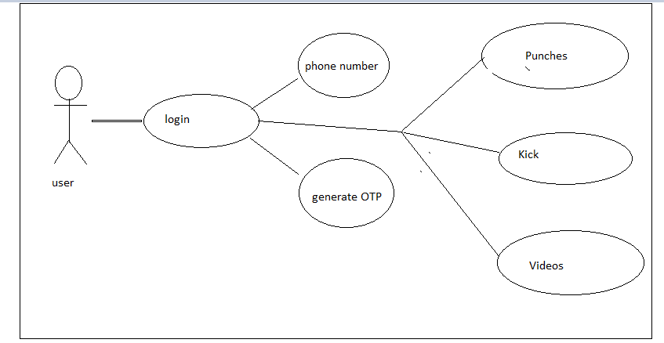

* **ENTITY RELATIONSHIP DIAGRAM**

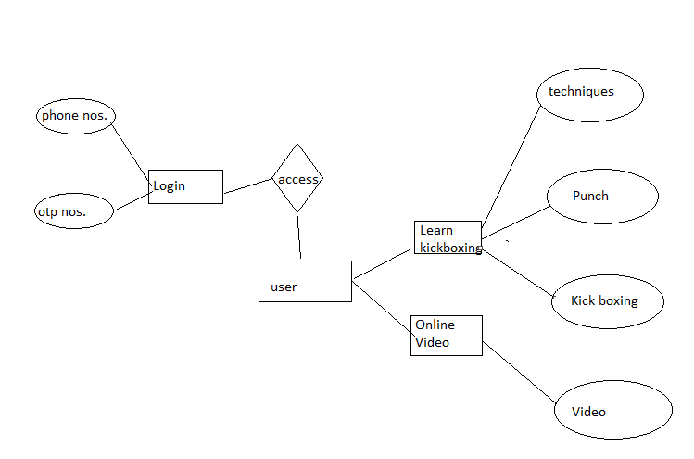

* **ACTIVITY DIAGRAM**

**1.Activity diagram of User:**

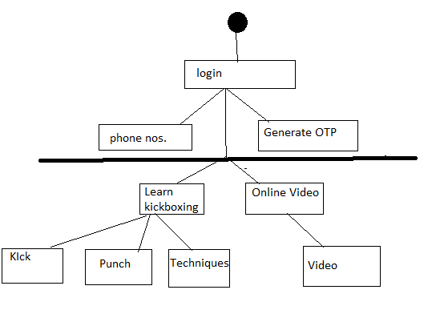

* **CLASS DIAGRAM**

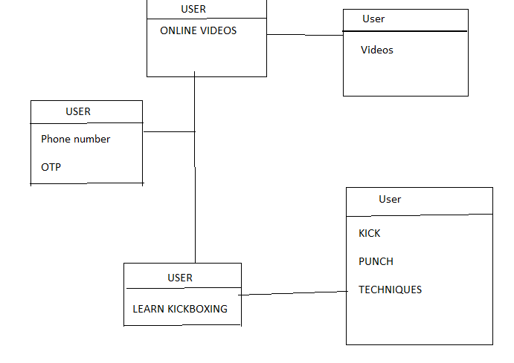

**SEQUENCE DIAGRAM**

1. **Sequence diagram of Admin:**

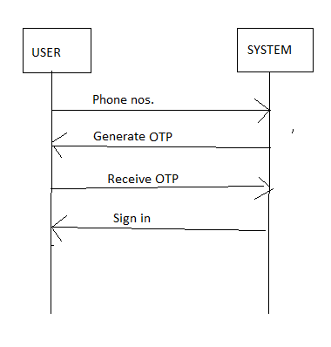

# **SYSTEM CODING**

# **IV]SYSTEM CODING**

* Site map
* Design patterns
* Test cases
* Screen layouts
* Report layouts
* **SITE MAP**

HOME PAGE

VIEW LIST OF DONORS

SELECT BLOOD GROUP

SIGN UP PAGE

LOGIN

SIGN UP

* **DESIGN PATTERNS USED**

It’s a mobile based application with easy to understand user interface.

The required Exercise are displayed in application

* **SCREEN LAYOUTS**

**Splash ScreenActivity:**

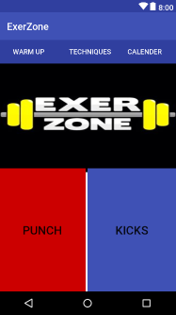

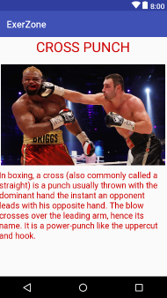

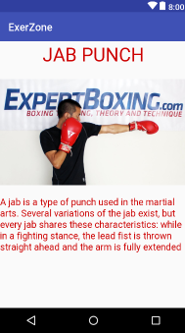

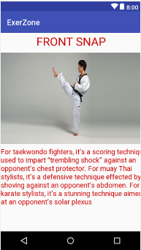

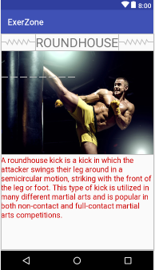

**LoginPage:**

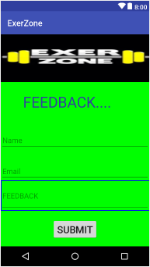

**SHOPING WEBSITE**

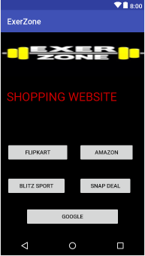

**RATE US**

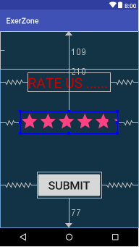

* **REPORT LAYOUTS**

1. **Active users graph:**

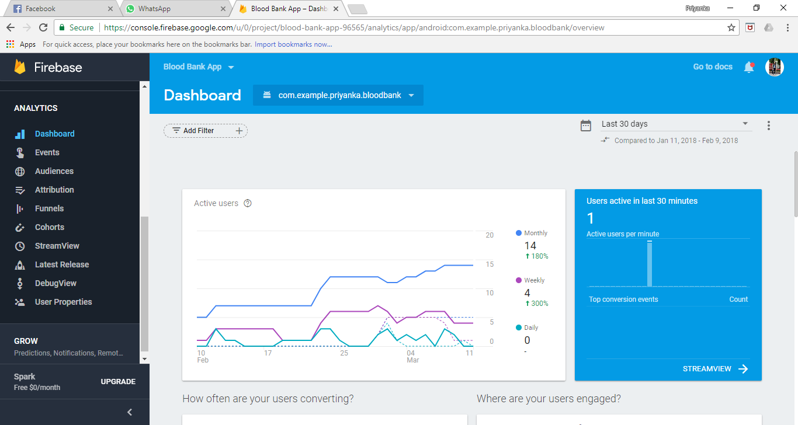

1. **App revenue generation and crash analysis:**

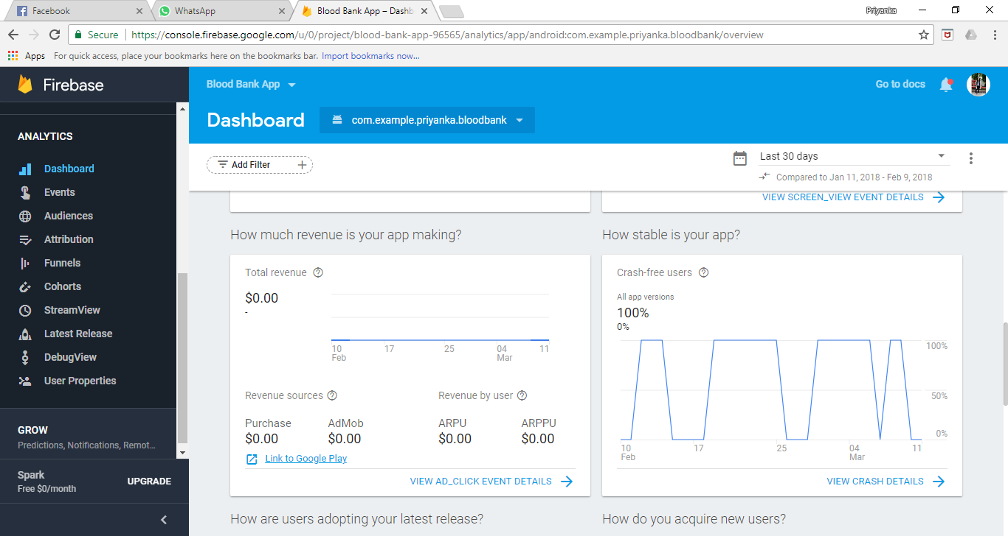

1. **User retention and audience details:**

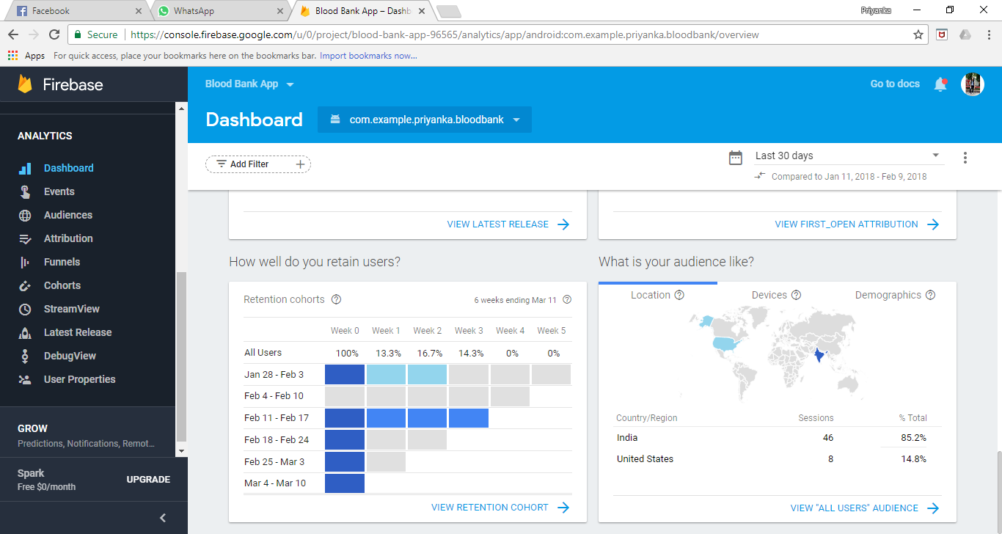

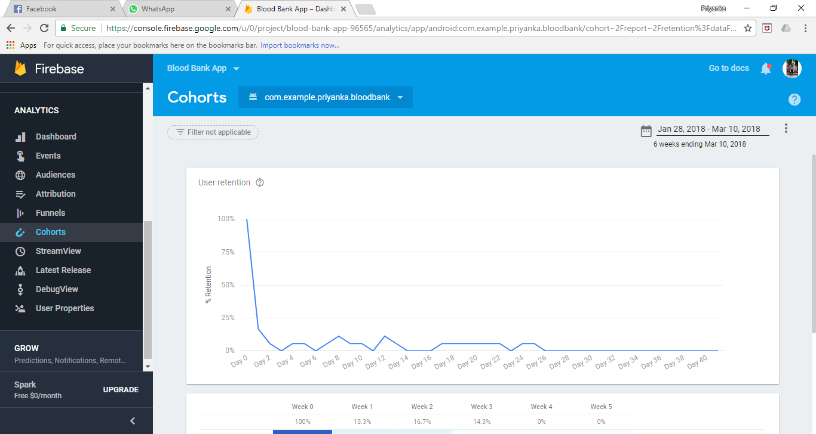

1. **Events like session start,app uninstall etc:**

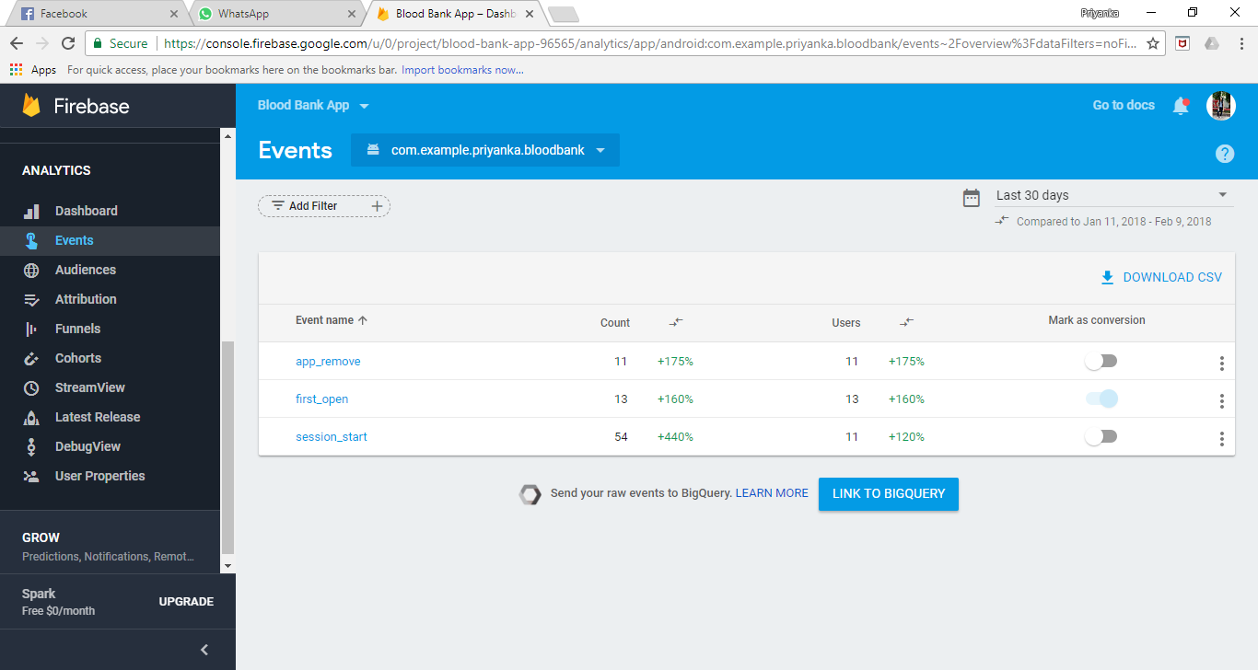

* **PROGRAMS LIST**

**ACTIVITY LIST:**

|  |  |
| --- | --- |
| **Java file** | **Description** |
| MainActivity.java | Contains the splash activity code. |
| Login.java | Contains the code for login. |
| SignUpPage.java | Contains the code for signup. |
| SearchDonor.java | Contains the code for searching and retrieving donors from the database. |
| User.java | Contains code for creating the user json tree. |
| UserList.java | Contains code for the ListView that will hold the retrieved donors. |

|  |  |
| --- | --- |
| **XML File** | **Description** |
| activity_login | Layout file for the Login.java file. |
| activity_main | Layout file for MainActivity.java (splash activity) |
| activity_sign_up_page | Layout file for SignUpPage.java |
| list_layout | Layout file for ListView |
| activity_search_donor | Layout file for SearchDonor.java |

## **SYSTEM IMPLEMENTATIONS/ UPLOADING**

Once the developer has completed with coding the application and tested on multiple emulators, it is ready to be deployed.

The implementation process contains software preparation and transition activities, such as the conception and creation of the maintenance preparation for handling problems.

In order to deploy any application, it was first run on the AVD and tested on different emulators.