Main Project

On

SMART ENERGY PREDICTION SYSTEM

BACHELOR OF COMPUTER APPLICATIONS
Of
Dr. Manmohan Singh Bengaluru City University


By
Anushree.M (U18AJ23S0306)
Keertana (U18AJ23S0263)

Under The Guidance Of
Ms. Chithra E S



ACHARYA INSTITUTE OF GRADUATE STUDIES
(NAAC Re-Accredited ‘A⁺’ and Affiliated to Dr.Manmohan Singh Bengaluru City University)
1#89/90, Soldevanahalli, Hesaraghatta Road, Bengaluru – 560107
2025-2026

ACHARYA INSTITUTE OF GRADUATE STUDIES
(NAAC Re-Accredited ‘A⁺’ and Affiliated to Dr.Manmohan Singh Bengaluru City University)
1#89/90, Soldevanahalli, Hesaraghatta Road, Bengaluru – 560107

DEPARTMENT OF COMPUTER APPLICATION


BONAFIDE CERTIFICATE

Certified that this project report “SMART ENERGY PREDICTION SYSTEM” is the Bonafide work of “Anushree.M U18AJ23S0306 & Keertana U18AJ23S0263” who carried out the project work under my supervision. Certified further that to the best of my knowledge the work reported herein does not form part of any other thesis or dissertation on the basis of which a degree or award was conferred on an earlier occasion on this or any other candidate.

Ms. Chithra ES K. Ramakrishna Reddy Dr. Gurunath Rao Vaidya

PROJECT GUIDE HEAD OF THE DEPARTMENT Principal

Submitted for Semester Main-Project viva-voce examination held on _________

INTERNAL EXAMINER. EXTERNAL EXAMINER.

DECLARATION

We, Anushree.M & Keertana of 6th semester BCA, hereby declare that the project work entitled “Smart Energy Prediction System” is a bonafide piece of work done by us in partial fulfillment of the requirement for Degree of Bachelor of Computer Application, under the guidance of Ms. Chitra E S , Assistant Professor of the Department of Computer Application of Acharya Institute of Graduate Studies, Bengaluru.
I further declare that no part of it has been formed on the basis for the award of any degree, diploma or any other similar title of any university or institutions to any person.

ANUSHREE . M (U18AJ23S0306)
KEERTANA (U18AJ23S0263)

Place: Bengaluru
Date:

ACKNOWLEDGEMENT

We would like to take this opportunity to thank our college Acharya Institute of Graduate Studies, Bengaluru and Department of Computer Application for allowing us to work on this project.
Life enhances better opportunities with better blessings with adequate space and time. It was a great blessing to do this Project titled “SMART ENERGY PREDICTION SYSTEM”, which I have put into all my efforts and dedication towards it resulting in getting undiscovered knowledge, better experiences, and ideas behind it. To give brighter and broader measures there have been a few concerns supportive of making this project real real-time application, without which my project would have been meaningless.

First, my heartfelt gratitude and respect to Dr. Gurunath Rao Vaidya, Principal of AIGS, and to Prof. K. Ramakrishna Reddy, HOD, Dept. of Computer Application. With utmost thanks and dedication, I would like to thank my guide. Ms. Chithra E S , Assistant Professor who she was aside in every step of the work that I have done and with some important advice and corrective measures.
I would also like to extend my thanks and gratitude to every faculty of the BCA Department and to my family inmates and friends who were concerned for the project.

ANUSHREE M (U18AJ23S0306)
KEERTANA (U18AJ23S0263)

ABSTRACT

Electricity consumption monitoring and cost estimation have become important in today’s data-driven world due to increasing energy demand and the need for efficient resource utilization. This project, titled “Smart Energy Prediction System”, is designed to predict household energy consumption and estimate electricity bills using machine learning techniques.
The system utilizes a real-world energy consumption dataset containing attributes such as global active power, voltage, and current intensity. The dataset is first preprocessed by handling missing values and cleaning irrelevant data. After preprocessing, feature engineering is performed to derive meaningful attributes such as energy usage and estimated billing values.
A Linear Regression machine learning model is trained on the processed dataset to learn the relationship between energy usage and cost. The trained model is evaluated using performance metrics such as the R² score and is saved for future predictions.
The system is implemented as a web-based application using Flask, where users can input energy usage values and obtain predicted energy consumption along with estimated electricity bills. The dashboard also provides energy insights through graphical visualization, along with recommendations for efficient energy usage. Additionally, the system maintains prediction history and allows users to download reports.
The proposed system helps users understand their energy consumption patterns, encourages efficient usage, and supports better decision-making regarding electricity usage. This project demonstrates the effective integration of machine learning and web development to solve real-world energy management problems.

TABLE OF CONTENTS

 | SL NO | TOPIC | PAGE NO
 | 1 | INTRODUCTION | 1
 | 1.1 | PROJECT DESCRIPTION | 3
 | 2 | LITERATURE SURVEY | 4
 | 2.1 | EXISTING SYSTEM | 6
 | 2.2 | PROPOSED SYSTEM | 7
 | 2.3 | FEASIBILITY STUDY | 8
 | 2.4 | TOOLS AND TECHNOLOGIES | 9
 | 2.4.1 | HARDWARE REQUIREMENTS | 9
 | 2.4.2 | SOFTWARE REQUIREMENTS | 10
 | 2.4.3 | SOFTWARE DESCRIPTION | 10
 | 2.5 | SOFTWARE REQUIREMENTS SPECIFICATION | 12
 | 2.5.1 | FUNCTIONAL REQUIREMENTS | 13
 | 2.5.2 | NON-FUNCTIONAL REQUIREMENTS | 13
 | 2.5.3 | FLOWCHART | 17
 | 3 | SYSTEM DESIGN | 21
 | 3.1 | SYSTEM PERSPECTIVE | 23
 | 3.1.1 | SYSTEM COMPONENTS AND INTERACTION | 24
 | 3.1.2 | WORKFLOW EXAMPLE | 26
 | 3.2 | INPUT DESIGN | 28
 | 3.2.1 | INPUT COMPONENTS | 29
 | 3.3 | OUTPUT DESIGN | 30
 | 3.3.1 | OUTPUT COMPONENTS | 32
 | 3.4 | DATA STORAGE DESIGN | 33
 | 3.4.1 | DATA STRUCTURE |  | 34
3.4.2 |  | STORAGE MECHANISMS |  | 35
4 |  | SYSTEM TESTING |  | 37
4.1 |  | SYSTEM TESTING METHODS |  | 39
4.2 |  | TEST CASES |  | 40
5 |  | SYSTEM IMPLEMENTATION |  | 41
5.1 |  | TRAINING |  | 43
5.1.2 |  | CONVERSION |  | 43
5.1.3 |  | CONVERSION ACTIVITIES |  | 44
5.2 |  | POST-IMPLEMENTATION REVIEW |  | 45
6 |  | SYSTEM MAINTENANCE |  | 47
6.1 |  | TYPES OF SYSTEM MAINTENANCE |  | 48
7 |  | CONCLUSION |  | 50
8 |  | FUTURE ENHANCEMENTS |  | 53
9 |  | APPENDIX |  | 56
10 |  | BIBLIOGRAPHY |  | 57
10.1 |  | CORE MODULES |  | 62
10.2 |  | SCREENSHOTS |  | 65

1. INTRODUCTION

- INTRODUCTION
Energy consumption has become a critical aspect of modern life due to rapid industrialization, urbanization, and increased dependence on electrical appliances. Efficient energy management is essential not only to reduce electricity costs but also to minimize environmental impact caused by excessive energy usage. Traditional methods of monitoring energy consumption are often manual, less accurate, and lack predictive capabilities, making it difficult for users to optimize their energy usage effectively.
The “SMART ENERGY PREDICTION SYSTEM” is designed to address these challenges by integrating machine learning techniques with web-based technologies. The system enables users to input parameters such as voltage and current, and it predicts energy consumption in real-time. Based on the predicted values, the system calculates the estimated electricity bill and carbon emissions, helping users understand both financial and environmental impacts.
To improve prediction accuracy, the system utilizes multiple machine learning models, including Linear Regression, Random Forest, and Gradient Boosting. These models analyze the input data and generate predictions, after which the system selects the best-performing model dynamically. This approach ensures more reliable and accurate results compared to using a single model.
In addition to prediction, the system provides advanced features such as anomaly detection, which identifies unusual or excessive energy usage patterns. It also maintains historical data, allowing users to track their past energy consumption trends. Furthermore, the system generates future predictions to help users plan and optimize their energy usage in advance.
The project also focuses on providing an interactive and user-friendly dashboard using web technologies such as HTML, CSS, JavaScript, and Flask. Data visualization techniques, including charts and graphs, are used to present the results in an easy-to-understand manner. This enhances user experience and enables better decision-making

1.1 PROJECT DESCRIPTION
The Smart Energy Prediction System is a machine learning-based web application designed to analyze household electricity consumption, predict energy usage, and estimate electricity bills. The main objective of this system is to help users understand their energy consumption patterns and promote efficient energy usage through data-driven insights.
The system is developed using the Python Flask framework for backend development and HTML/CSS for the frontend interface. It uses a real-world household energy consumption dataset containing attributes such as global active power, voltage, and current intensity. The dataset is preprocessed to handle missing values, remove duplicates, and transform raw data into a structured format suitable for machine learning.
A Linear Regression model is used to learn the relationship between energy usage and electricity cost. The model is trained on historical data, evaluated using performance metrics such as the R² score, and then saved for future predictions.
The web application allows users to input energy usage values through a dashboard interface. Based on the input, the system predicts energy consumption and calculates the estimated electricity bill. Additionally, it provides energy-saving recommendations based on usage levels, helping users make informed decisions to reduce unnecessary energy consumption.
The dashboard displays key insights such as average usage, maximum usage, total consumption, prediction results, and energy visualization. The system also maintains a history of predictions and allows users to download reports for future reference.
Overall, the Smart Energy Prediction System demonstrates the integration of machine learning, data analysis, and web development to create a practical and user-friendly solution for energy monitoring and cost estimation.

2. LITERATURE SURVEY

2. LITERATURE SURVEY
Energy consumption prediction and optimization have been widely studied due to the increasing demand for efficient energy management systems. Various researchers have explored different machine learning techniques and data analysis methods to improve prediction accuracy and support decision-making.
Several studies have focused on the use of Linear Regression models for energy prediction. Linear Regression is a simple and widely used technique that establishes a relationship between input variables and energy consumption. It is easy to implement and computationally efficient; however, its performance is limited when dealing with complex and non-linear data patterns.
To overcome these limitations, researchers have introduced advanced machine learning models such as Random Forest and Gradient Boosting algorithms. Random Forest is an ensemble learning method that uses multiple decision trees to improve prediction accuracy and reduce overfitting. It performs well on large datasets and handles non-linear relationships effectively. Gradient Boosting, on the other hand, builds models sequentially by minimizing errors from previous models, resulting in high accuracy and improved performance in prediction tasks.
Recent studies have also explored time-series forecasting techniques for predicting future energy consumption. Models such as ARIMA and LSTM (Long Short-Term Memory) networks are commonly used for this purpose. These models are capable of capturing temporal patterns in energy data and are suitable for long-term forecasting. However, they require large datasets and complex implementation, making them less suitable for lightweight systems.
In addition to prediction models, many research works emphasize the importance of data preprocessing and feature selection. Cleaning the dataset, handling missing values, and selecting relevant features significantly improve model performance and accuracy. Proper preprocessing ensures that the machine learning models receive high-quality input data.
Another important area in literature is energy optimization and anomaly detection. Researchers have proposed systems that identify abnormal energy consumption patterns, helping users detect faults or excessive usage. Such systems contribute to reducing energy wastage and improving efficiency.
With the advancement of web technologies, several studies have integrated machine learning models with web-based applications. Frameworks like Flask and Django are used to deploy machine learning models and provide real-time predictions through interactive dashboards. Data visualization tools such as charts and graphs enhance user understanding and enable better decision-making.
2.1 EXISTING SYSTEM
The existing electricity billing system is based on traditional manual meter reading methods. Electricity consumption is recorded periodically, and users receive a bill based on total units consumed during a billing cycle.
The existing system only provides final consumption values without offering detailed analysis or predictive insights. Users are not able to understand their usage patterns or forecast future energy consumption. There is no use of data analytics or machine learning techniques in the existing system.

Limitations Of Existing System
- No prediction of future energy usage
- No real-time or interactive monitoring
- No graphical visualization of consumption patterns
- No user feedback or energy optimization suggestions
- No analysis of usage trends
- Manual and less informative system

2.2 PROPOSED SYSTEM
The proposed system is a Smart Energy Prediction System that uses Machine Learning (Linear Regression) to predict energy consumption and estimate electricity bills.
The system analyzes historical energy consumption data and learns the relationship between energy usage and cost. Users can input energy usage values through a web-based dashboard, and the system instantly predicts the estimated energy consumption and corresponding electricity bill.
The system also provides energy-saving recommendations based on usage levels (low, moderate, high). A dashboard is implemented to display predictions, summary statistics, and visualization of energy usage trends.
Advantages Of Proposed System
- Predicts energy consumption using machine learning
- Estimates electricity bill automatically
- Provides quick and interactive results
- Displays data visualization through dashboard
- Offers energy-saving recommendations
- Improves user awareness of energy usage

Limitations Of Proposed System
- Prediction accuracy depends on dataset quality
- Requires proper training data for better results
- Not a real-time IoT-based system
- Works only on historical/static dataset
- Limited to single-variable prediction (basic model)

2.3 FEASIBILITY STUDY
The feasibility study evaluates whether the proposed system is practical and achievable in terms of technical, operational, and economic aspects.
1. Technical Feasibility
The system is technically feasible as it is developed using Python, Flask, Pandas, NumPy, and Scikit-learn. These technologies are open-source and widely used in machine learning and web development. The system can run on a standard computer with moderate configuration.

2. Operational Feasibility
The system is operationally feasible because it provides a simple and user-friendly interface. Users can easily interact with the system, enter inputs, and view predictions without technical knowledge.

3. Economic Feasibility

The system is economically feasible because all tools and libraries used are open-source and free. . No additional software cost is required, making it cost-effective for development and deployment

Conclusion
The proposed system is feasible in all aspects and can be effectively implemented for energy prediction and analysis.

2.4 TOOLS AND TECHNOLOGIES
The proposed system is developed using a combination of modern frontend, backend, and machine learning technologies to ensure efficient performance and accurate prediction of energy usage.
The system follows a full-stack approach where Python is used for backend development and machine learning, while HTML, CSS, and JavaScript are used for frontend development. Flask acts as the integration framework between frontend and backend.
- Python – Backend development and machine learning
- Flask – Web framework for application development
- Pandas – Data manipulation and preprocessing
- NumPy – Numerical computation
- Scikit-learn – Machine learning model building (Linear Regression)
- HTML – Structure of web pages
- CSS – Styling of web pages
- JavaScript – Interactivity in UI
- Chart.js – Data visualization
- VS Code – Development environment
- Google Chrome – Web browser for testing
2.4.1 HARDWARE REQUIREMENTS
- Processor: Intel i3 or higher
- RAM: Minimum 4 GB (8 GB recommended)
- Hard Disk: Minimum 20 GB free space
- Input Devices: Keyboard, Mouse
- Output Device: Monitor
- Internet Connection: Optional (for development/testing)

2.4.2 SOFTWARE REQUIREMENT
- Operating System: Windows 10 or above / Linux
- Programming Language: Python
- Frontend: HTML, CSS, JavaScript
- Backend Framework: Flask
- Libraries: Pandas, NumPy, Scikit-learn, Matplotlib
- Visualization: Chart.js
- IDE: Visual Studio Code
- Browser: Google Chrome / Firefox
2.4.3 SOFTWARE DESCRIPTION
The Smart Energy Prediction System is developed using a combination of programming languages, frameworks, and libraries that support machine learning, data processing, and web application development. Each software component plays an important role in building an efficient and interactive system for energy prediction and analysis.
Python
Python is a high-level, interpreted programming language used as the core of the system. It is widely used in data science and machine learning due to its simple syntax and powerful libraries. In this project, Python is used for backend development, data processing, and building the machine learning model.

Flask

Flask is a lightweight web framework written in Python. It is used to develop the web application and connect the frontend with the backend. Flask handles user requests, routes data between pages, and returns prediction results to the user interface.

Pandas
Pandas is a data manipulation and analysis library used for handling structured datasets. It provides DataFrame structures that make it easy to clean, filter, and preprocess data before applying machine learning algorithms.

NumPy
NumPy is a numerical computation library used for handling arrays and performing mathematical operations. It improves the efficiency of data processing and supports large-scale numerical computations.

Scikit-learn
Scikit-learn is a machine learning library used for building predictive models. It provides algorithms such as Linear Regression, which is used in this project to predict energy consumption and electricity bills based on historical data.

Matplotlib
Matplotlib is a plotting library used to create static visualizations such as graphs and charts. It helps in understanding data trends and model performance.
Seaborn
Seaborn is a data visualization library built on top of Matplotlib. It is used for advanced statistical visualization such as heatmaps and distribution plots to analyze relationships between variables.

HTML
HTML (HyperText Markup Language) is used to create the structure of web pages. It defines elements such as forms, buttons, and layout of the user interface.

CSS
CSS (Cascading Style Sheets) is used to design and style the web pages. It improves the visual appearance of the system by adding colors, layouts, spacing, and responsiveness.

JavaScript
JavaScript is used to add interactivity to the web pages. It helps in handling user actions, form validation, and dynamic updates without reloading the page.
Chart.js
Chart.js is a JavaScript library used to create interactive and responsive charts. It is used in the dashboard to visually represent energy usage and prediction results.

VS Code
Visual Studio Code is a lightweight and powerful code editor used for developing the project. It provides debugging tools, extensions, and terminal support, making development efficient.

Google Chrome
Google Chrome is used as the web browser for testing and running the Flask web application. It ensures proper rendering of web pages and user interface.
2.5 SOFTWARE REQUIREMENTS SPECIFICATION
The Software Requirements Specification defines the complete description of the system’s functional and non-functional requirements. It clearly describes what the system should do and the quality standards it must follow. The SRS helps in guiding the development process and ensures that the system meets user expectations effectively.

2.5.1 FUNCTIONAL REQUIREMENTS
Functional requirements describe the core features and services provided by the system.
- The system should allow users to enter energy usage values through a web interface.
- The system should preprocess the dataset by handling missing values and cleaning data.
- The system should train a machine learning model using historical energy data.
- The system should predict energy consumption based on user input.
- The system should estimate electricity bills based on predicted usage.
- The system should display results in a structured and user-friendly dashboard.
- The system should generate graphical visualizations for better analysis.
- The system should store prediction history for future reference.
- The system should allow users to view past predictions in tabular form.
- The system should provide energy-saving recommendations based on usage level.
- The system should enable downloading of prediction reports.
- The system should ensure smooth communication between frontend and backend using Flask.
2.5.2 NON-FUNCTIONAL REQUIREMENTS
Non-functional requirements define the quality and performance standards of the system.
- Performance: The system should provide fast response for user inputs and predictions.
- Reliability: The system should produce consistent and accurate prediction results.
- Usability: The interface should be simple, clean, and easy to use for all users.
- Efficiency: The system should use computational resources effectively.
- Scalability: The system should be capable of handling larger datasets in future upgrades.
- Maintainability: The system should be easy to modify, update, and maintain.
- Security: The system should ensure safe handling of data within the application.
- Portability: The system should run on different operating systems like Windows and Linux.
- Availability: The system should be available with minimal downtime.
- Accuracy: The system should provide high accuracy based on trained machine learning model.

- Module Description
The proposed system is divided into several well-structured modules to ensure modularity, easy maintenance, and smooth functioning of the application. Each module performs a specific task in the workflow of the Smart Energy Prediction System and contributes to accurate prediction and effective user interaction.
1. Data Collection Module
This module is responsible for acquiring the dataset used in the system. The project uses a predefined CSV dataset containing household energy consumption details such as Global Active Power, Voltage, and Sub-metering values. This dataset acts as the foundation for training and testing the machine learning model. The module ensures that structured and relevant data is available for further processing.

2. Data Preprocessing Module
This module focuses on cleaning and preparing the raw dataset for machine learning. It handles missing values, removes irrelevant or inconsistent entries, and converts data into a usable
format. Data preprocessing improves data quality and ensures better model performance by reducing noise and inconsistencies in the dataset.
3. Feature Engineering Module
In this module, meaningful features are derived from raw dataset attributes. The system generates important features such as energy usage (based on Global Active Power) and estimated electricity bill. This transformation helps in simplifying the dataset and improving the efficiency of the prediction model.
4. Machine Learning Model Module
This is the core module of the system. It involves training a Linear Regression model using historical energy consumption data. The model learns the relationship between energy usage and electricity cost. After training, the model is evaluated using performance metrics such as R² score to measure accuracy.
5. Prediction Module
This module is responsible for generating predictions based on user input. Once the user provides energy usage data, the trained model predicts the expected energy consumption and calculates the estimated electricity bill. This module ensures real-time inference using the trained model.
6. Visualization Module
This module presents prediction results and energy insights in a visual format. It displays graphs and charts on the dashboard to help users easily understand their energy consumption patterns. Visualization improves interpretability of data and enhances user experience.
7. Web Interface Module

This module handles the frontend of the system. It is developed using HTML, CSS, and JavaScript. It provides a user-friendly dashboard where users can input values, view predictions, and analyze results. The interface is designed to be simple and interactive.

8. Backend Integration Module

This module connects the frontend with the backend using the Flask framework. It handles HTTP requests, processes user inputs, calls the machine learning model, and returns prediction results to the frontend. It ensures smooth communication between all system components.

9. Output & Result Display Module
This module displays the final output to the user. It shows predicted energy usage, estimated bill, and energy insights on the dashboard. The results are presented in a structured format for easy understanding and analysis.

2.5.3FLOWCHART
Ovreall System Workflow
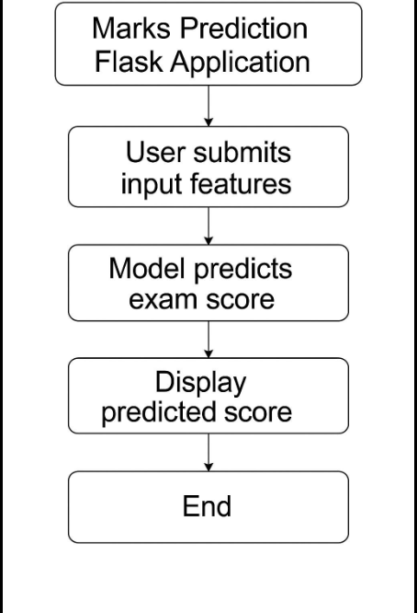

User Interaction Flowchart

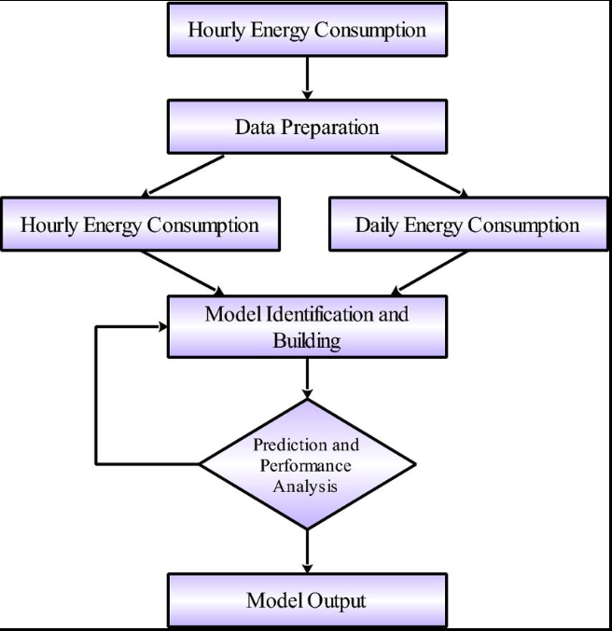

Machine Learning Model Workflow

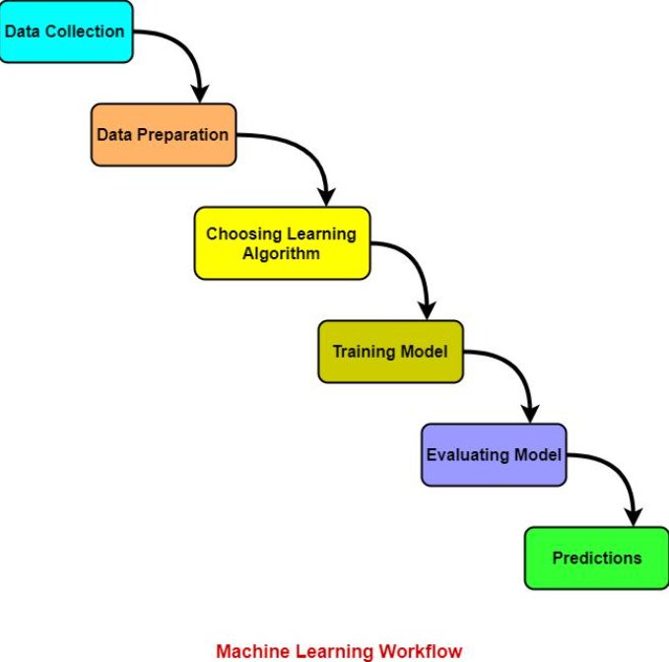

Data Processing and Prediction Flowchart

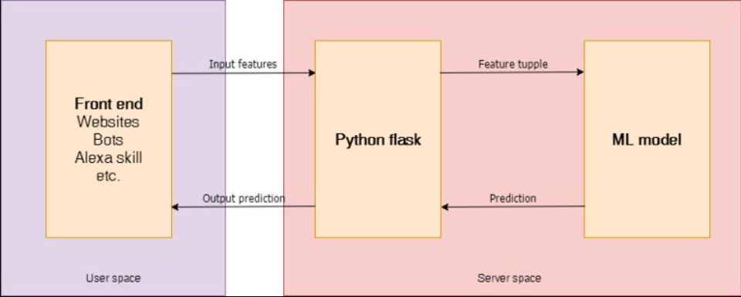
The flowchart represents the overall working of the Smart Energy Prediction and Optimization System. The process begins with user authentication, where the user logs into the system using valid credentials. After successful login, the user is directed to the dashboard, where input values such as voltage and current are provided.
These inputs are sent to the backend system, where preprocessing is performed to convert the data into a suitable format for machine learning models. The system then applies multiple machine learning algorithms, including Linear Regression, Random Forest, and Gradient Boosting, to predict energy consumption. The outputs from these models are compared, and the best-performing model is selected dynamically.
Based on the prediction, the system calculates additional parameters such as estimated electricity bill, carbon emission, and energy usage recommendations. It also performs anomaly detection to identify abnormal usage patterns. The system further generates future predictions to help users plan energy consumption efficiently.
All the results are stored in a history file for future reference. Finally, the processed data is sent to the frontend, where it is displayed in the form of values and graphical charts.

3.SYSTEM DESIGN

3. SYSTEM DESIGN
The system design of the Smart Energy Prediction System describes the overall architecture, components, and working flow of the application. The system is designed to predict household energy consumption and estimate electricity bills using machine learning techniques in an efficient and user-friendly manner.
The system follows a three-tier architecture, which includes the Presentation Layer (Frontend), Application Layer (Backend), and Data/Model Layer. This layered structure ensures separation of concerns, easy maintenance, and smooth communication between different components of the system.
The Presentation Layer is developed using HTML, CSS, and JavaScript. It provides a simple and interactive web interface where users can enter energy usage values and view prediction results. The dashboard displays key information such as predicted energy usage, estimated bill, and energy insights in a structured format. Graphical representation improves user understanding of consumption patterns.
The Application Layer is implemented using the Flask framework (Python). This layer acts as the core controller of the system. It receives input from the user interface, processes requests, communicates with the machine learning model, and returns results back to the frontend. Flask ensures smooth routing between different pages such as dashboard and history.
The Data and Model Layer consists of a dataset stored in CSV format, which contains household energy consumption attributes such as Global Active Power, Voltage, and Sub-metering values. This dataset is preprocessed to handle missing values and inconsistencies. After preprocessing, feature engineering is performed to generate useful variables such as energy usage and estimated bill.
A Linear Regression machine learning model is used for prediction. The model is trained using historical data to learn the relationship between energy usage and electricity cost. After training, the model is evaluated using performance metrics such as the R² score and then saved for future predictions using joblib.
The system workflow begins with loading the dataset, followed by data preprocessing and feature engineering. Then the dataset is split into training and testing sets. The model is trained using the training data and evaluated using test data. Once the model performance is satisfactory, it is integrated with the Flask application.
When a user inputs energy usage through the dashboard, the input is sent to the backend via Flask. The trained model processes this input and predicts the corresponding energy consumption and electricity bill. The output is then displayed on the dashboard in a user-friendly format.
The system design ensures efficient communication between frontend, backend, and machine learning components. It provides accurate predictions, easy interaction, and visual insights, making it useful for understanding and managing energy consumption effectively.
3.1 SYSTEM PERSPECTIVE
The Smart Energy Prediction System is designed as a web-based machine learning application that focuses on analyzing energy consumption patterns and predicting electricity usage and billing. From a system perspective, the application acts as an integrated platform that combines data processing, machine learning, and user interaction in a unified environment.
The system is developed using a client-server architecture, where the client side represents the user interface and the server side handles processing and prediction tasks. The client side is built using HTML, CSS, and JavaScript, which allows users to interact with the system through a web dashboard. The server side is implemented using the Flask framework in Python, which processes user requests and communicates with the machine learning model.
From a functional perspective, the system receives input energy usage data and processes it through multiple stages including data preprocessing, feature engineering, and prediction using a trained Linear Regression model. The system then generates output in the form of predicted energy consumption and estimated electricity bill.
The system also provides a visual perspective through a dashboard interface, where users can view prediction results, summary statistics, and energy insights. This improves user understanding of their consumption patterns and supports better decision-making.
From a data perspective, the system uses a structured dataset in CSV format that contains historical energy consumption records. This data is used for training the machine learning model, which learns the relationship between energy usage and cost.
Overall, the system perspective of the Smart Energy Prediction System highlights its ability to integrate machine learning with web technologies to deliver an interactive, efficient, and user-friendly energy prediction solution.
3.1.1 SYSTEM COMPONENTS AND INTERACTIONS
The Smart Energy Prediction System is composed of multiple interconnected components that work together to perform energy consumption prediction and bill estimation. Each component has a specific role, and their interaction ensures smooth functioning of the system.
SYSTEM COMPONENTS
1. User Interface Component
This component represents the frontend of the system developed using HTML, CSS, and JavaScript. It provides a dashboard where users can input energy usage values and view prediction results. It also displays energy insights in a structured format.
2. Web Application Component (Flask Backend)
This component is built using the Flask framework in Python. It handles user requests, processes input data, manages routing between pages, and communicates with the machine learning model to generate predictions.

3. Data Management Component
This component manages the dataset used in the system. The dataset is stored in CSV format and contains energy consumption attributes such as Global Active Power, Voltage, and Sub-metering values. It is used for training and testing the model.
4. Data Preprocessing Component
This component is responsible for cleaning and preparing raw data. It handles missing values, removes inconsistencies, and transforms data into a structured format suitable for machine learning.
5. Machine Learning Component
This is the core component of the system. It uses a Linear Regression algorithm to learn the relationship between energy usage and electricity cost. The trained model is saved and reused for prediction
6. Prediction Engine Component
This component takes user input and passes it to the trained model. It generates predictions for energy consumption and calculates the estimated electricity bill.
7. Visualization Component
This component is responsible for displaying results in graphical format. It presents prediction outputs and energy insights in a user-friendly manner on the dashboard.
SYSTEM INTERACTIONS
The interaction between components follows a structured workflow:
- The user interacts with the User Interface Component by entering energy usage values.
- The input is sent to the Flask Backend Component for processing.
- Flask forwards the data to the Prediction Engine Component.
- The Prediction Engine uses the Machine Learning Component (Linear Regression model) to generate results.
- The model processes input based on learned patterns from the Data Management Component.
- The output (energy usage and bill prediction) is sent back to Flask.
- Flask passes the result to the User Interface Component.
- The Visualization Component displays the results as dashboard output and insights.
3.1.2 WORKFLOW EXAMPLE
The workflow of the Smart Energy Prediction System explains how data flows through the system from user input to final output. It demonstrates the step-by-step execution of modules in real-time.

Step 1: System Start
The user opens the Smart Energy Prediction System web application through a browser. The dashboard page is loaded using the Flask backend.

Step 2: Input Generation
The user enters energy usage data in the prediction panel.
For example: Input: 3.3 kWh
This input represents the energy consumption value that needs to be analyzed.

Step 3: Data Transmission

The input value is sent from the frontend (HTML/JavaScript dashboard) to the backend (Flask server) using a request.

Step 4: Model Processing

The Flask backend forwards the input to the trained Linear Regression model.
The model processes the input based on previously learned patterns from the dataset.

Step 5: Prediction Generation
The model generates output such as:
Predicted Energy Usage: 3.3 kWh
Estimated Bill: ₹ 23.07
The bill is calculated using the relationship learned during training.
Step 6: Result Return
The prediction result is sent back from the backend to the frontend dashboard.
Step 7: Output Display
The dashboard displays:
- Predicted Energy Usage
- Estimated Electricity Bill
- Energy Recommendation (e.g., Moderate usage Optimize appliances)
Step 8: Visualization
The system updates the Energy Insight graph, showing usage trends visually for better understanding.
Step 9: User Review
The user analyzes the result and understands their energy consumption pattern
Step 10: End of Process
The workflow completes, and the system waits for the next input.

3.2 INPUT DESIGN
Input design refers to the process of defining how data is entered into the system in a structured, accurate, and user-friendly manner. In the Smart Energy Prediction System, input design ensures that the system receives valid energy usage values for processing and prediction.
The system accepts input mainly through a web-based dashboard interface developed using HTML, CSS, and JavaScript. The user interacts with the system by entering energy usage values in the prediction panel. These inputs are then sent to the backend system using Flask for processing.
The primary input required by the system is the energy usage value (kWh). This value represents the amount of electricity consumed and is used as the key parameter for prediction. The system ensures that the input is in numeric format to avoid errors during processing.
Before sending the input to the machine learning model, basic validation is performed at the frontend level to ensure that the entered value is not empty and is within a valid numerical range. This helps improve the accuracy and reliability of the system.
Once the input is validated, it is transmitted to the Flask backend, where it is processed by the trained Linear Regression model. The model then generates the predicted energy usage and estimated electricity bill based on the input provided.
The input design is kept simple and user-friendly so that even non-technical users can easily interact with the system. The design focuses on minimizing user errors, improving usability, and ensuring smooth data flow from input to prediction output.
Overall, the input design of the system plays a crucial role in ensuring accurate predictions and efficient interaction between the user and the machine learning model.

3.2.1 INPUT COMPONENTS
Input components refer to the different elements through which the system receives data from the user for processing and prediction. In the Smart Energy Prediction System, input components are designed to be simple, interactive, and user-friendly to ensure smooth data entry and accurate prediction results.
The system mainly uses a web-based dashboard interface as the primary input medium. All inputs are provided by the user through this interface and are then processed by the backend system using Flask and machine learning models.
1. Energy Usage Input Field
This is the main input component of the system. The user enters the energy consumption value (in kWh) through a text or number input field. This value is used as the primary feature for prediction.
2. Prediction Button
This component is used to trigger the prediction process. Once the user enters the input value, the prediction button sends the data to the Flask backend for processing using the trained machine learning model.
3. Form Validation Component
This component ensures that the input provided by the user is valid. It checks whether the input field is not empty and contains only numerical values. This helps in preventing errors during prediction.
4. Data Transmission Component
After validation, this component is responsible for sending the input data from the frontend to the backend using Flask routing. It ensures smooth communication between user interface and server.

5. Dashboard Input Panel
This is the visual component where users interact with the system. It contains input fields, buttons, and display areas. It provides a simple interface for entering energy usage values and viewing results.
6. API Request Component (Flask)
This component receives input data from the frontend and passes it to the machine learning model. It acts as a bridge between user input and prediction logic.
3.3 OUTPUT DESIGN
Output design refers to the process of defining how the results of the system are presented to the user in a clear, meaningful, and user-friendly manner. In the Smart Energy Prediction System, output design focuses on displaying predicted energy usage, estimated electricity bills, and energy insights in an understandable format.
The system generates output after processing user input through the machine learning model. The output is displayed through a web-based dashboard interface developed using HTML, CSS, and JavaScript, which is integrated with Flask backend.
1. Prediction Output
The primary output of the system is the predicted energy usage and estimated electricity bill. After the user enters input data, the system displays results such as:
- Predicted Energy Usage (kWh)
- Estimated Electricity Bill (₹)
These values are calculated using the trained Linear Regression model.
2. Dashboard Output
The system presents output in a structured dashboard format. It includes:
- Summary cards (Average usage, Maximum usage, Total usage)
- Prediction panel (input and result display)
- Energy recommendation section (Low / Moderate / High usage)
This helps users understand their energy consumption clearly.
3. Energy Insight Output
The system provides visual insights using graphs and charts. These visualizations show:
- Energy usage patterns
- Consumption trends
- Comparison of usage values
This improves user understanding of energy behavior.
4. Recommendation Output
Based on predicted usage, the system generates simple recommendations such as:
- Low usage → Efficient consumption
- Moderate usage → Optimize appliances
- High usage → Reduce unnecessary usage
These suggestions help users manage electricity usage effectively.
5. History Output
The system stores previous predictions and displays them in a tabular format. Users can view past results for reference and comparison.
6. Report Output (Optional Feature)
The system also supports generating downloadable reports containing prediction results and usage history for future reference.

3.3.1 OUTPUT COMPONENTS
Output components refer to the different elements through which the system presents results to the user after processing input data. In the Smart Energy Prediction System, output components are designed to provide clear, structured, and meaningful information regarding energy usage and electricity bill prediction.
The system uses a web-based dashboard interface to display all outputs. The output is generated by the machine learning model and sent to the frontend through the Flask backend.
1. Prediction Result Display Component
This is the main output component of the system. It displays the predicted energy usage and estimated electricity bill after processing user input through the Linear Regression model.
2. Dashboard Display Component
This component presents output in a structured dashboard format. It includes summary cards such as:
- Average energy usage
- Maximum usage
- Total usage
It also displays the prediction panel and results in a user-friendly layout.

3. Energy Insight Visualization Component
This component displays graphical representations of energy consumption. It uses charts to show patterns and trends in energy usage, helping users understand their consumption behavior easily.

4. Recommendation Display Component
This component provides output in the form of suggestions based on predicted energy usage. It displays messages such as:
- Low usage (efficient consumption)
- Moderate usage (optimize usage)
- High usage (reduce consumption)

5. History Display Component
This component shows previously generated predictions in tabular format. It allows users to view and compare past energy usage and bill estimates.
6. Report Generation Component
This component allows users to download prediction results in report format. It helps users keep records of their energy consumption analysis.
7. Flask Response Component
This backend component sends processed prediction results from the machine learning model to the frontend interface for display.
3.4 DATA STORAGE DESIGN
The data storage design of the Smart Energy Prediction System defines how data is stored and managed in the system. The system uses a simple file-based storage approach instead of a database system. The main dataset is stored in a CSV file named data.csv, which contains energy consumption details such as global active power, voltage, and sub-metering values.
The dataset is used for training and testing the machine learning model. After preprocessing, the cleaned data is stored temporarily in memory using Pandas DataFrame for further processing and feature engineering.
The trained machine learning model is saved in a file named model.pkl using joblib. This allows the system to reuse the trained model without retraining every time the application runs.
The prediction results such as energy usage and estimated electricity bill are stored in a structured format for history tracking. This helps users to view previous predictions.
During runtime, temporary data such as user input and prediction output is stored in memory and passed between the Flask backend and frontend.
Overall, the system uses a simple file-based storage design which makes it easy to implement and manage without the complexity of a database system.
3.4.1 DATA STRUCTURE
The data structure of the Smart Energy Prediction System defines how data is organized and managed during processing and prediction. The system mainly uses structured data in the form of tables and arrays to handle energy consumption information.
The primary data structure used in the system is a DataFrame, which is provided by the Pandas library. The DataFrame is used to store and manipulate the dataset containing energy usage details such as global active power, voltage, and sub-metering values.
Arrays are used internally during machine learning processing to handle numerical data efficiently. These arrays are processed by the Linear Regression algorithm to learn patterns from the dataset.
The system also uses key-value structures in Python dictionaries to handle user input data and prediction results. This helps in passing data between the frontend and backend using Flask.
For storing prediction history, a tabular structure (CSV format) is used. Each record contains input values, predicted energy usage, and estimated electricity bill.
During execution, temporary data is stored in memory using variables and DataFrames, which are passed between different modules of the system.
Overall, the system uses simple and efficient data structures such as DataFrames, arrays, and dictionaries to ensure smooth data processing and accurate prediction.
3.4.2 STORAGE MECHANISM
The storage mechanism of the Smart Energy Prediction System defines how data is stored, accessed, and managed during the execution of the system. The system uses a simple file-based storage approach for efficient handling of data.
1. Dataset Storage
The system stores the main dataset in a CSV file named data.csv. This file contains historical energy consumption data such as global active power, voltage, and sub-metering values, which are used for training the machine learning model.
2. Model Storage
The trained machine learning model is stored in a file named model.pkl. This file is created using the joblib library and allows the system to reuse the trained model without retraining every time.
3. Temporary Memory Storage
During execution, data is temporarily stored in system memory using Pandas DataFrames and Python variables. This helps in fast processing and manipulation of data.
4. Prediction Storage
The system stores prediction results such as energy usage and estimated electricity bill in a structured format. This data can be used for displaying history and analyzing past results.

5. Data Transfer Storage
User input and intermediate results are stored temporarily in Python dictionaries and passed between frontend and backend using Flask.
6. File-Based Storage System
The system does not use a database. Instead, it uses simple file-based storage such as CSV files for datasets and pickle files for the trained model, making the system lightweight and easy to manage.

4 SYSTEM TESTING

4 SYSTEM TESTING
System testing is the process of evaluating the complete Smart Energy Prediction System to ensure that it works correctly, efficiently, and produces accurate results. It verifies that all modules of the system are functioning as expected.
1. Unit Testing
Each individual module of the system is tested separately. For example, data preprocessing, model training, and prediction modules are tested independently to ensure correct functionality.
2. Integration Testing
After unit testing, all modules are combined and tested together. This ensures proper communication between frontend (HTML/CSS/JS), backend (Flask), and the machine learning model.
3. Model Testing
The trained Linear Regression model is tested using test data. The performance is evaluated using metrics such as R² score to ensure accurate predictions.
4. Functional Testing
The system is tested to ensure all functions work correctly, such as input handling, prediction generation, and display of results on the dashboard.
5. User Interface Testing
The web interface is tested to ensure that the dashboard is user-friendly, responsive, and displays data correctly without errors.
6. Output Testing
The output of the system is verified by checking predicted energy usage and estimated electricity bill values. The results are compared with expected values for accuracy.
7. Performance Testing
The system is tested for speed and efficiency. It ensures that predictions are generated quickly without delay even when processing large datasets.
8. Validation Testing
Input values entered by the user are validated to ensure that only correct numerical data is processed by the system.
4.1 TYPES OF SYSTEM TESTING PERFORMED
The Smart Energy Prediction System uses different types of testing methods to ensure accuracy, reliability, and smooth functioning of the application. These testing types help in verifying both individual modules and the complete system.
1. Black Box Testing
Black box testing is used to check the functionality of the system without knowing the internal code. The system is tested by providing input values and verifying the output such as predicted energy usage and estimated bill.
2. White Box Testing
White box testing is performed by checking the internal logic of the system. It is used to verify the correctness of Python code, Flask routes, and machine learning model implementation.
3. Regression Testing
Regression testing is done after modifying or improving the system. It ensures that new changes do not affect the existing functionality of prediction and dashboard display.
4. Unit Testing
Unit testing is used to test individual modules such as data preprocessing, model training, and prediction separately to ensure they work correctly.

5. Integration Testing
Integration testing is performed to check the interaction between frontend, backend, and machine learning model. It ensures proper data flow between all components.
6. User Acceptance Testing (UAT)
User acceptance testing is performed to check whether the system meets user expectations. The dashboard, predictions, and recommendations are tested for usability and correctness.
4.2 TEST CASES

Test case ID | Description | input | Expected output | Actual output | Result
TC01 | Valid energy prediction | 3.3kWh | Show predicted usage and bill | Correct prediction displayed | Pass
TC02 | Empty input validation | No input | Error message shown | Validation message displayed | pass
TC03 | Non-numeric input | abc | Invalid input error | Input rejected | pass
TC04 | Model accuracy check | Dataset values | Accurate prediction | R2 score ~1.0 | pass
TC05 | Dashboard display | Valid request | Graph+results shown | Dashboard displayed properly | pass
TC06 | Performance test | Multiple requests | Fast response | System responds quickly | Pass

5. SYSTEM IMPLEMENTATION

5. SYSTEM IMPLEMENTATION
System implementation is the process of converting the designed system into a working application. It involves coding, integration of modules, testing, and execution of the Smart Energy Prediction System. The system is implemented using a combination of frontend, backend, and machine learning technologies.
The frontend of the system is developed using HTML, CSS, and JavaScript. It provides a simple and user-friendly dashboard where users can enter energy usage values and view prediction results.
The backend is implemented using the Flask framework in Python. It handles user requests, processes input data, and connects the frontend with the machine learning model.
The machine learning part is implemented using the Linear Regression algorithm from Scikit-learn. The model is trained using historical energy consumption data and is used to predict energy usage and electricity bills.
Data preprocessing is done using Pandas and NumPy to clean and prepare the dataset for training. Missing values are handled and data is converted into a structured format.
The trained model is saved using joblib in a file called model.pkl. This model is integrated with the Flask application for real-time predictions.
When a user enters energy usage data, the input is sent to the backend, processed by the model, and the prediction result is displayed on the dashboard.
Finally, the system is tested and run on a local Flask server to ensure proper functioning of all modules.

5.1 TRAINING
Training is the process of teaching the machine learning model using historical data so that it can learn patterns and make accurate predictions. In the Smart Energy Prediction System, the model is trained using a dataset containing household energy consumption details.
The dataset is first preprocessed to remove missing values and unnecessary data. After preprocessing, the relevant features are selected for training the model.
The system uses the Linear Regression algorithm from the Scikit-learn library for training. The model learns the relationship between energy usage and electricity cost based on past data.
During training, the dataset is divided into training and testing sets. The training data is used to build the model, while the testing data is used to evaluate its performance.
The model is trained until it achieves good accuracy, and its performance is measured using the R² score.
After successful training, the model is saved as a file using joblib so that it can be reused for future predictions without retraining.
5.1.2 CONVERSION
Conversion refers to the process of changing the raw dataset into a suitable format that can be used by the machine learning model for training and prediction. In the Smart Energy Prediction System, data conversion plays an important role in preparing the dataset for analysis.
The original dataset is stored in CSV format and contains raw energy consumption values. These values are converted into a structured format using Pandas DataFrame for easy processing.
During conversion, unnecessary columns such as date and time are removed or ignored, and only relevant features like energy usage and voltage are used for model training.
The data values are also converted into numerical format so that the machine learning algorithm can process them efficiently. This ensures compatibility with the Linear Regression model.
In addition, categorical or inconsistent values are standardized to maintain uniformity in the dataset. This helps improve the accuracy of predictions.
Finally, the converted data is used for training the model and generating predictions in the system.
5.1.3 CONVERSION ACTIVITIES
Conversion activities refer to the steps involved in transforming raw data into a format suitable for processing, analysis, and machine learning prediction in the Smart Energy Prediction System.
1. Data Collection Activity
In this activity, the system collects raw energy consumption data from a CSV file. The dataset contains values such as global active power, voltage, and sub-metering readings.
2. Data Cleaning Activity
In this activity, missing values, duplicate records, and irrelevant data are removed from the dataset. This ensures that only valid and useful data is used for processing.
3. Data Transformation Activity
In this activity, raw data is converted into a structured format using Pandas DataFrame. The data is transformed into numerical form so that it can be used by the machine learning model.
4. Feature Selection Activity
In this activity, only important features such as energy usage are selected for training the model. Unnecessary columns like date and time are ignored for better accuracy.

5. Data Encoding Activity
In this activity, all data is converted into machine-readable format. Since the system mainly uses numerical data, encoding ensures compatibility with the Linear Regression model.
6. Data Loading Activity
In this activity, the processed data is loaded into the machine learning model for training and prediction. The data is passed from preprocessing module to the model training module.
7. Model Preparation Activity
In this activity, the converted dataset is split into training and testing sets. The training data is used to build the model, and testing data is used to evaluate performance.

5.2 POST IMPLEMENTATION REVIEW
Post implementation review is the process of evaluating the system after development and deployment to ensure that it meets the required objectives and performs as expected.
1. System Performance Review
After implementation, the Smart Energy Prediction System is tested for performance. The system provides fast and accurate predictions of energy usage and electricity bills using the trained Linear Regression model.
2. Functionality Review
All functions of the system are checked after implementation. The dashboard, prediction engine, and Flask backend are working correctly and producing expected outputs.
3. Accuracy Review
The machine learning model is evaluated using performance metrics such as R² score. The system provides good accuracy in predicting energy consumption based on historical data.

4. User Interface Review
The web-based dashboard is reviewed for usability. The interface is simple, clean, and user-friendly, allowing users to easily interact with the system.
5. Error Handling Review
The system is checked for input errors and invalid data handling. Proper validation is implemented to ensure that only valid numerical inputs are processed.
6. Improvement Scope Review
After implementation, it is observed that the system can be improved by adding features such as database integration, real-time data collection, and advanced machine learning models in the future.

6. SYSTEM MAINTENANCE

6. SYSTEM MAINTENANCE
System maintenance refers to the activities performed after the successful implementation of the Smart Energy Prediction System to ensure that it continues to operate efficiently, accurately, and reliably. Maintenance is an essential phase in the system life cycle as it helps in correcting errors, improving system performance, and adapting the system to new requirements.
The Smart Energy Prediction System requires continuous monitoring and updates to maintain the accuracy of predictions and smooth functioning of the application. Maintenance ensures that the system remains compatible with new technologies and user expectations.
Maintenance activities include updating the machine learning model, improving the user interface, fixing bugs, and ensuring data quality. Regular maintenance also helps in enhancing system security, performance, and usability.

6.1 TYPES OF SYSTEM MAINTENANCE
The Smart Energy Prediction System requires different types of maintenance to ensure long-term performance and usability.
1. Corrective Maintenance
Corrective maintenance is performed to fix errors or bugs in the system. If any issue occurs in prediction results, data processing, or dashboard display, it is identified and corrected.
2. Adaptive Maintenance
Adaptive maintenance is done to update the system according to changes in the environment or technology. This includes updating Python libraries, Flask framework, or modifying the system to support new datasets.

3. Perfective Maintenance
Perfective maintenance focuses on improving the overall performance and usability of the system. Enhancements such as improving user interface, increasing prediction accuracy, and optimizing system speed are included.
4. Preventive Maintenance
Preventive maintenance is carried out to avoid future system failures. Regular checking of system performance, data quality, and model accuracy helps in preventing issues before they occur.

7. CONCLUSION

7. CONCLUSION
The Smart Energy Prediction System has been successfully designed and developed to analyze and predict energy consumption using machine learning techniques. The primary objective of the project was to build an intelligent system that can estimate energy usage and electricity bills based on user input and historical data. This objective has been achieved effectively through proper system design, implementation, and testing.
The system uses a Linear Regression algorithm to learn patterns from historical energy consumption data. By training the model with a structured dataset, the system is able to generate accurate predictions of energy usage. The performance of the model has been evaluated using appropriate metrics such as the R² score, which indicates a high level of accuracy and reliability.
One of the key features of the system is its user-friendly web interface. The dashboard provides a simple and interactive platform where users can enter input values and instantly receive prediction results. The output includes predicted energy consumption, estimated electricity bill, and basic recommendations such as low, moderate, or high usage. This makes the system easy to understand even for non-technical users.
The integration of frontend technologies such as HTML, CSS, and JavaScript with the Flask backend ensures smooth communication between the user interface and the machine learning model. The system efficiently handles user input, processes data, and displays results in real time. The use of visualization tools such as charts further enhances the understanding of energy usage patterns.
The system also includes important functionalities such as data preprocessing, feature selection, model training, and prediction generation. These components work together to ensure that the system produces meaningful and accurate results. The modular design of the system makes it easy to maintain and upgrade in the future.
Testing has been performed at different levels, including unit testing, integration testing, and system testing, to ensure that all components function correctly. The test cases confirm that the system handles valid and invalid inputs effectively and produces reliable outputs. The system performance is satisfactory, with quick response time and efficient processing.
Overall, the Smart Energy Prediction System proves to be a practical and useful application of machine learning in real-world scenarios. It helps users understand their energy consumption patterns and encourages efficient usage of electricity. The system is simple, cost-effective, and easy to implement, making it suitable for both educational and practical purposes.
Although the system performs well, there is scope for further improvement. Future enhancements such as advanced machine learning models, real-time data integration, and database support can make the system more powerful and scalable.
In conclusion, the project successfully demonstrates how machine learning can be applied to solve real-life problems in energy management. The system meets all its objectives and provides an efficient solution for predicting energy usage and optimizing electricity consumption.

8. FUTURE ENHANCEMENT

8. FUTURE ENHANCEMENT
The Smart Energy Prediction and Optimization System provides a strong foundation for energy monitoring and analysis using machine learning techniques. However, there are several areas where the system can be further enhanced to improve its functionality, scalability, and real-world applicability.
One of the major enhancements is the integration of advanced deep learning models such as Long Short-Term Memory (LSTM) networks. These models are highly effective for time-series forecasting and can capture complex patterns in energy consumption over time. By implementing LSTM, the system can provide more accurate long-term predictions and trend analysis compared to traditional machine learning models.
Another important improvement is the integration of real-time data collection using IoT devices. Currently, the system relies on user input for voltage and current values. In the future, smart meters and IoT sensors can be used to automatically collect real-time energy consumption data. This will eliminate manual input, improve accuracy, and enable continuous monitoring of energy usage.
The system can also be enhanced by incorporating a cloud-based architecture. By deploying the application on cloud platforms such as AWS, Azure, or Google Cloud, the system can handle large-scale data, support multiple users, and provide better performance and scalability. Cloud integration will also allow users to access the system from anywhere, making it more flexible and efficient.
Another potential enhancement is the addition of a mobile application. Developing an Android or iOS app will improve accessibility and allow users to monitor their energy consumption on the go. The mobile app can include features such as push notifications, alerts for high energy usage, and personalized recommendations.
The system can further be improved by implementing advanced data visualization techniques. Interactive dashboards with dynamic charts, filters, and real-time updates can enhance user experience and make the system more intuitive. Adding features such as comparative analysis, monthly reports, and usage breakdowns will provide deeper insights into energy consumption patterns.
In terms of intelligence, the system can be upgraded by introducing a recommendation engine. This feature can analyze user behavior and suggest optimized energy usage strategies, such as reducing peak-time consumption or switching to energy-efficient appliances. Personalized recommendations will make the system more user-centric and effective.
Another significant enhancement is the implementation of automated anomaly detection using AI techniques. While the current system identifies abnormal usage, future versions can use advanced algorithms to detect faults, predict equipment failures, and alert users in real time. This can help in preventive maintenance and reduce energy wastage.
Security can also be improved by integrating user authentication and database management systems. Instead of using simple login mechanisms, the system can be connected to databases such as MySQL or MongoDB to securely store user data and provide personalized dashboards. This will also support multi-user environments.
The system can also be extended to support renewable energy management. By incorporating data related to solar panels or wind energy, the system can help users optimize the use of renewable energy sources and reduce dependence on conventional electricity.
Finally, the system can be enhanced by deploying it as a fully functional web application with real-time updates and live data streaming. Integration with APIs and external datasets can further improve prediction accuracy and system performance.
In conclusion, the Smart Energy Prediction System has significant potential for expansion. By integrating advanced technologies such as deep learning, IoT, cloud computing, and mobile applications, the system can evolve into a comprehensive and intelligent energy management solution suitable for real-world applications.

9. APPENDIX

9 APPENDIX
The appendix section includes supporting materials and additional information related to the Smart Energy Prediction System. It provides details that are useful for understanding the implementation of the project but are not included in the main chapters.
A. Sample Dataset
The system uses a dataset in CSV format containing household energy consumption data. The dataset includes the following attributes:
- Date
- Time
- Global Active Power
- Global Reactive Power
- Voltage
- Global Intensity
- Sub_metering_1
- Sub_metering_2
- Sub_metering_3
This dataset is used for training and testing the machine learning model.
B. Sample Input
Example of user input provided to the system:
- Energy Usage (Global Intensity): 3.3 kWh

C. Sample Output
The system generates the following output:
- Predicted Energy Usage: 3.3 kWh
- Estimated Electricity Bill: ₹ 23.07
- Recommendation: Moderate usage – Optimize appliances
D. Screenshots
The appendix includes important screenshots of the system:
- Home Page (index.html)
- Dashboard Page
- Prediction Results
- Graphical Visualization
- History Page
E. Source Code (Main Files)
The main files used in the project are:
- app.py – Flask backend application
- train.py – Model training script
- model.py – Machine learning model logic
- preprocess.py – Data preprocessing
- index.html – Input page
- dashboard.html – Output dashboard

F. Tools and Libraries Used
- Python
- Flask
- Pandas
- NumPy
- Scikit-learn
- HTML, CSS, JavaScript
- Chart.js

10.BIBLOGRAPHY

10. BIBLOGRAPHY
The following references were used for developing the Smart Energy Prediction System:
- Géron, A. Hands-On Machine Learning with Scikit-Learn, Keras, and TensorFlow. O’Reilly Media, 2019.
- Pedregosa, “Scikit-learn: Machine Learning in Python.” Journal of Machine Learning Research, 2011.
- McKinney, W. Python for Data Analysis. O’Reilly Media, 2017.
- Documentation of Flask Framework. Available at: https://flask.palletsprojects.com/
- Pandas Documentation. Available at: https://pandas.pydata.org/
- NumPy Documentation. Available at: https://numpy.org/
- Scikit-learn Documentation. Available at: https://scikit-learn.org/
- Chart.js Documentation. Available at: https://www.chartjs.org/
- Mozilla Developer Network (MDN) Web Docs – HTML, CSS, JavaScript. Available at: https://developer.mozilla.org/
- UCI Machine Learning Repository – Household Electric Power Consumption Dataset. Available at: https://archive.ics.uci.edu/ml/index.php

10.1 CODE MODULES
The Smart Energy Prediction System is developed using multiple code modules. Each module is responsible for a specific functionality such as data preprocessing, model training, prediction, and user interaction. The modular design improves system organization, readability, and maintainability.

1. Backend Module (Flask Application)
This module handles routing and connects frontend with machine learning logic.
Code :
from flask import Flask, request, jsonify
app = Flask(__name__)
@app.route('/api/predict', methods=['POST'])
def predict():
data = request.get_json()
voltage = float(data['voltage'])
intensity = float(data['intensity'])

2. Machine Learning Module
This module loads trained models and performs predictions.
Code:
import joblib
def load_models():
models = {
"Linear Regression": joblib.load("models/linear.pkl"),
"Random Forest": joblib.load("models/rf.pkl"),
"Gradient Boosting": joblib.load("models/gb.pkl")
}
return models

3. Prediction Module
This module generates predictions using multiple models.
Code:
def get_best_prediction(models, input_data):
results = {}
for name, model in models.items():
pred = model.predict(input_data)[0]
results[name] = float(pred)
best_model = max(results, key=results.get)
return results, best_model

4. Data Preprocessing Module
This module cleans the dataset before training.
Code:
def clean_data(df):
df = df.dropna()
df = df.drop_duplicates()
return df

5. Bill & Carbon Calculation
This module calculates cost and environmental impact.
Code:
RATE_PER_UNIT = 7
def calculate_bill(usage):
return usage * RATE_PER_UNIT
def calculate_carbon(usage):
return round(usage * 0.82, 2)

6. Anomaly Detection Module
This module identifies abnormal energy usage.
Code:
def detect_anomaly(usage):
if usage > 10:
return "High Usage Detected"
return "Normal Usage"

7. Data Storage Module
This module stores prediction history.
Code:
import csv
def save_history(voltage, intensity, prediction, bill):
with open("history.csv", "a", newline="") as f:
writer = csv.writer(f)
writer.writerow([voltage, intensity, prediction, bill])

8. Frontend Visualization (JavaScript)
This module displays charts using Chart.js.
Code:
new Chart(document.getElementById("barChart"), {
type: "bar",
data: {
labels: ["Power", "Bill"],
datasets: [{
data: [data.prediction, data.bill]
}]
}
});

10.2 SCREENSHOTS
1. Login Page Interface
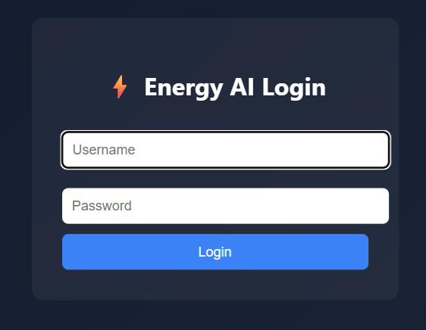

2. Login with Credentials
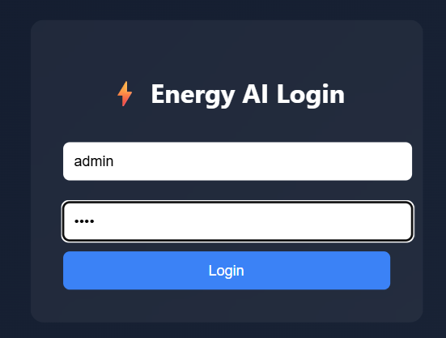

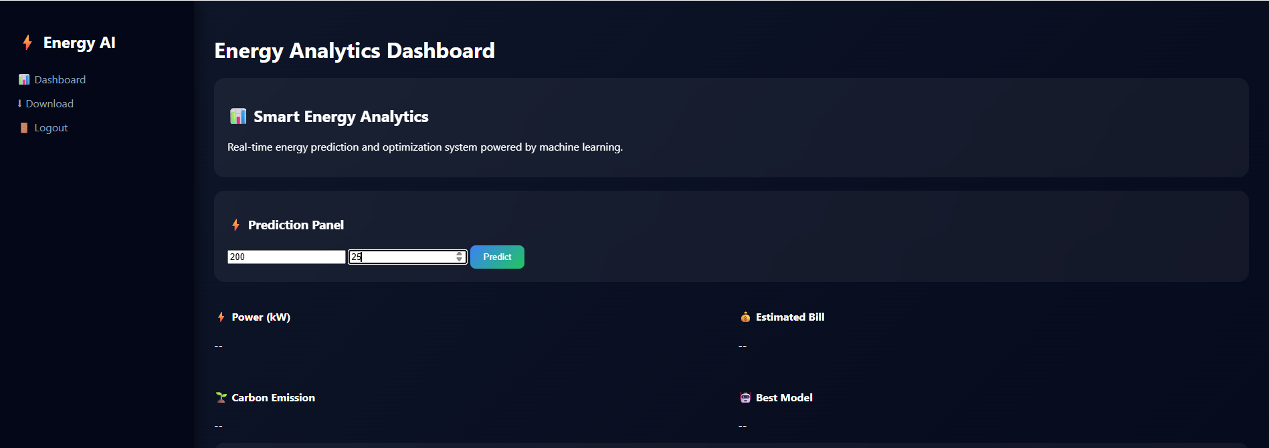
3. Dashboard Home Page

4. Prediction Results Output
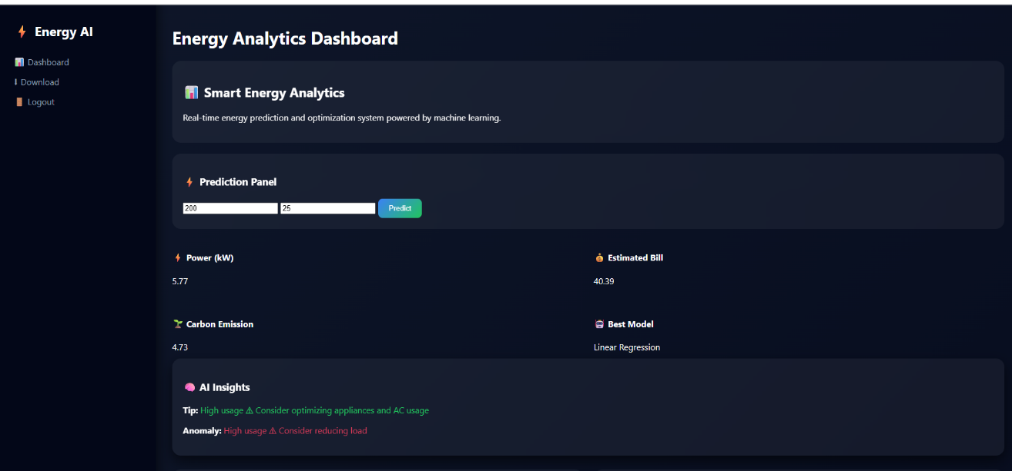

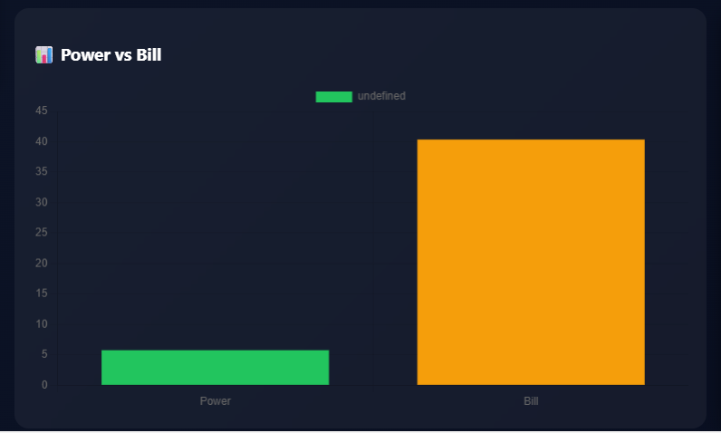
5. Power vs Bill Graph

6. Prediction Trend Graph
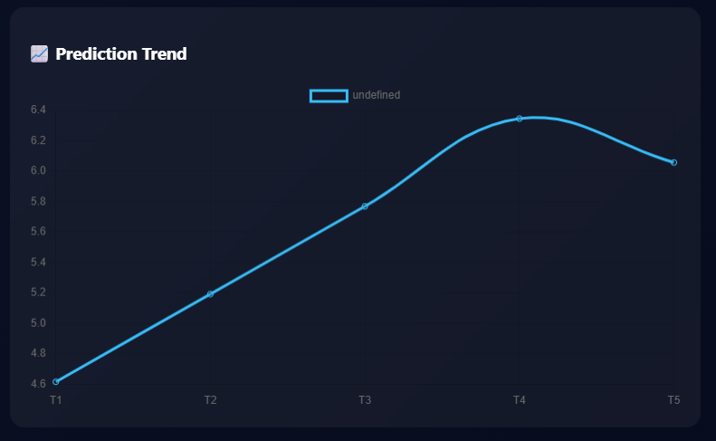
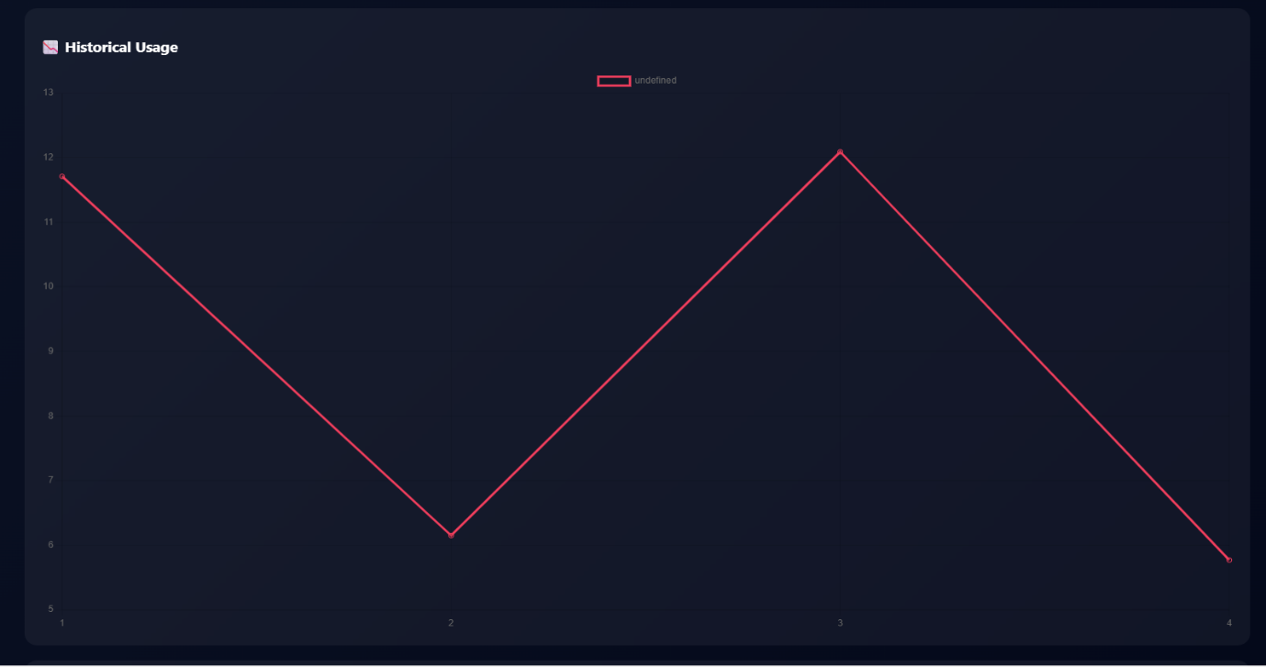
7. Historical Usage Graph

8. Future Forecast Graph
