Consequence While Driving Two Wheelers with One Hand - Right Hand

1. The speed gets slow (no throttle) and due to abnormal RPM rate the engine will turn off.

2. Acceleration cannot be done.

3. Engine Braking – at a certain time suddenly we can feel a drag with increase in RPM.

4. Very less steering control and improper balance of the vehicle

5. Turning a vehicle is difficult.

6. Less possibility of sudden stop.

Things we Cannot do Without Right Hand While Driving

1. Some times without throttle the engine may turn off and we need to turn on the engine with Self Start or Kicker with right hand.

2. Not possible to catch Front Brake also leveler for brake.

3. Some vehicle has Turn On/Off ABS in right side.

4. BS3 vehicles may have headlight switches in right side.

5. Hazard Switch in right side.

6. Mirror adjustments.

**Ideas for Input**

Sensors implemented for the project

* **Raspberry Pi Zero WH**
* **Conductive Thread Touch Sensor**
* **Gyroscope**

Raspberry Pi Zero WH

* 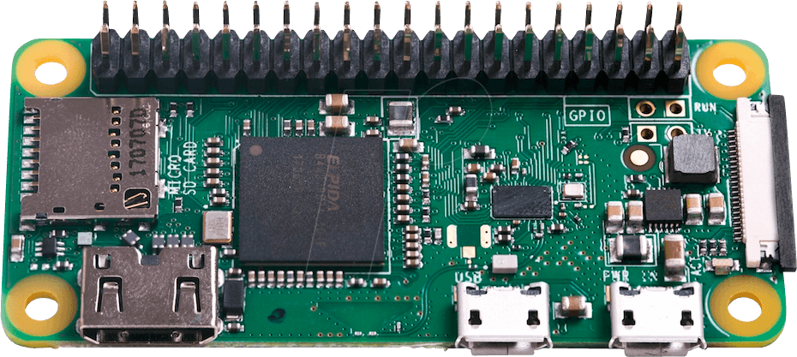802.11 b/g/n wireless LAN
* Bluetooth 4.1
* 1GHz, single-core CPU
* 512MB RAM
* HAT-compatible 40-pin header
* Price र **1,150**

[This product is available at :](This%20product%20is%20available%20at%20:%20) <https://www.silverlineelectronics.in/raspberry-pi-zero-wh-wireless-pre-soldered-header.html>

Conductive Thread Touch Sensor

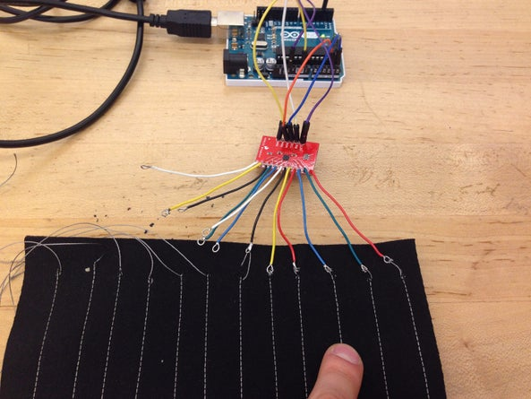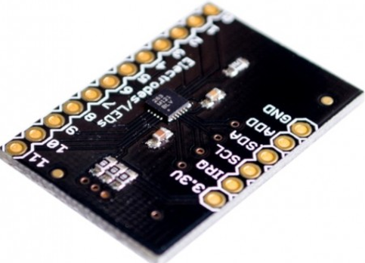

* Conductive Thread Touch Sensor can be implemented in each side of the two-wheeler handle bar.
* The wire connected to the sensor will be further connected to the thread which could be stitched in the handle bar grip.
* While touching the stitch with our hands it sends the signal to the sensor.
* It is been touched.
* Price र 195.

Information: <https://www.instructables.com/Conductive-Thread-Touch-Sensor/?hootPostID=690a4bd429c6be0ce7d42efcdc3a9863>

[This product is available at :](This%20product%20is%20available%20at%20:%20) <https://www.fabtolab.com/capacitive-touch-sensor-breakout-mpr121>