**Market analysis**

Industry Overview

* India is the 2nd largest two-wheeler market in the world.
* It stands next only to China and Japan in terms of the number of two- wheelers produced and the sales of two-wheeler respectively.
* In 2013, the Indian two-wheeler market accounted for 14.38 million units
* CAGR (compound annual growth rate) (last three decade’s) is10.03%
* Average two-wheelers per 1000 people in India are 31
* The urban market for two-wheelers is largely penetrated with nearly 57 of every 100 youths that earn an income to support the ownership of a two-wheeler
* More than 15 industry players in existence.

Sale of geared and non-geared two-wheeler

|  |  |  |  |
| --- | --- | --- | --- |
| Segment | FY 2019-20 | FY 2018-19 | Growth |
| Motorcycles | 1,12,14,640 | 1,35,98,190 | -17.5% |
| Scooters | 55,66,036 | 67,01,430 | -16.9% |
| Mopeds | 6,36,940 | 8,80,227 | -27.6% |
| Total | 1,74,17,616 | 2,11,79,847 | -17.8% |

Two-wheeler domestic sales in India from financial year 2013-2021

|  |  |
| --- | --- |
| F Y | Two wheelers sold  (in million units) |
| 2021 | 15.12 |
| 2020 | 17.42 |
| 2019 | 21.18 |
| 2018 | 20.2 |
| 2017 | 17.6 |
| 2016 | 16.5 |
| 2015 | 16 |
| 2014 | 14.8 |
| 2013 | 13.8 |

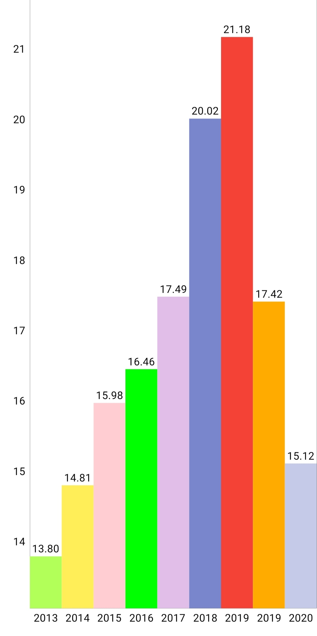

State wise domestic sale of two wheelers

|  |  |  |  |  |  |  |
| --- | --- | --- | --- | --- | --- | --- |
| SI.NO | State | Jun’19 | Jun’18 | May’19 | YOY % diff | MOM% diff |
| 1 | U. Pradesh | 2,55,812 | 2,58,410 | 2,36,731 | -1.01% | 8.06% |
| 2 | Tamil Nadu | 1,24,535 | 1,43,793 | 1,31,093 | -13.39% | -5.00% |
| 3 | Maharashtra | 1,18,453 | 1,44,012 | 1,51,264 | -17.75% | -21.69% |
| 4 | Bihar | 1,14,959 | 87,728 | 1,16,032 | 31.04% | -0.93% |
| 5 | Karnataka | 1,00,087 | 1,10,988 | 1,07,564 | -9.82% | -6.95% |
| 6 | Rajasthan | 79,896 | 78,629 | 95,968 | 1.61% | -16.75% |
| 7 | Gujarat | 76,175 | 1,04,750 | 92,729 | -27.22% | -17.85% |
| 8 | West Bengal | 70,033 | 1,01,750 | 66,900 | -31.17% | 4.68% |
| 9 | Kerala | 55,824 | 0 | 55,736 | N/A | 0.16% |
| 10 | Odisha | 54,357 | 62,897 | 56,527 | -13.58% | -3.84% |
| 11 | Punjab | 41,834 | 56,052 | 43,613 | -25.37% | -4.08% |
| 12 | Haryana | 41,006 | 43,200 | 39,706 | -5.08% | 3.27% |
| 13 | Jharkhand | 39,393 | 42,091 | 45,605 | -6.41% | -13.62% |
| 14 | Chhatisgarh | 38,241 | 38,933 | 44,327 | -1.78% | -13.73% |
| 15 | Assam | 33,568 | 30,696 | 37,380 | 9.65% | -9.96% |
| 16 | Delhi | 32,561 | 37,903 | 38,007 | -14.09% | -14.33% |
| 17 | Uttarakhand | 13,709 | 15,668 | 17,265 | -12.50% | -20.60% |
| 18 | J & k | 8,197 | 9,581 | 9,671 | -14.45% | -15.24% |
| 19 | Himachal P | 5,173 | 5,860 | 5,290 | -11.72% | -2.21% |
| 20 | Pondicherry | 4,240 | 5,184 | 4,438 | -18.21% | -4.46% |
| 21 | Goa | 2,799 | 3,553 | 3,732 | -21.22% | -25.00% |
| 22 | Tripura | 2,757 | 4,075 | 3,837 | -32.34% | -28.15% |
| 23 | Manipur | 2,712 | 1,619 | 1,803 | 67.51% | 50.42% |
| 24 | Mizoram | 2,039 | 1,445 | 2,130 | 41.11% | -4.27% |
| 25 | Chandigarh | 1,787 | 2,213 | 2,110 | -19.25% | -15.31% |
| 26 | Meghalaya | 1,619 | 1,434 | 1,687 | 12.90% | -4.03% |
| 27 | Arunachal | 1,387 | 761 | 1,545 | 82.26% | -10.23% |
| 28 | D & N | 509 | 617 | 497 | -17.50% | 2.41% |
| 29 | D & D | 364 | 521 | 342 | -30.13% | 6.43% |
| 30 | Sikkim | 358 | 191 | 274 | 87.43% | 30.66% |
| 31 | Nagaland | 349 | 302 | 433 | 15.56% | -19.40% |
|  | Total | 13,24,823 | 13,94,770 | 14,14,236 | -5.01 | -6.32 |

**ROAD ACCIDENTS RATE IN INDIA**

* 1214 road crashes occur every day in India.
* Two wheeler account for 25% of total road crashes.

###### Road Accidents, Registered Vehicles and Road Length in India (1970-2019)

|  |  |  |  |  |  |  |  |
| --- | --- | --- | --- | --- | --- | --- | --- |
| **Year** | **Road Accidents ('000)** | **Road Accidents Deaths ('000)** | **Road Accidents Injuries ('000)** | **Registered Vehicles ('000)** | **Road Length (000 km)** | **Fatality rate (no. of accident deaths per 10,000**  **vehicles)** | **Vehicle density (no. of vehicles per km of road)** |
| 1970 | 114 | 15 | 70 | 1401 | 1,189 | 103.5 | 1.18 |
| 1980 | 153 | 24 | 109 | 4,521 | 1,492 | 53.1 | 3.03 |
| 1990 | 283 | 54 | 244 | 19,152 | 1,984 | 28.3 | 9.65 |
| 2000 | 391 | 79 | 399 | 48,857 | 3,316 | 16.2 | 14.73 |
| 2010 | 500 | 135 | 528 | 1,27,746 | 4,582 | 10.5 | 27.88 |
| 2011 | 498 | 142 | 511 | 1,41,866 | 4,677 | 10 | 30.33 |
| 2012 | 490 | 138 | 509 | 1,59,491 | 4,865 | 8.7 | 32.78 |
| 2013 | 486 | 138 | 494 | 1,81,508 | 5,232 | 7.6 | 34.69 |
| 2014 | 489 | 140 | 493 | 1,90,704 | 5,402 | 7.3 | 35.3 |
| 2015 | 501 | 146 | 500 | 2,10,023 | 5,472 | 7 | 38.38 |
| 2016 | 481 | 151 | 495 | 2,30,031 | 5,603 | 6.6 | 41.05 |
| 2017 | 465 | 148 | 471 | 2,53,311 | 5,898 | 5.8 | 42.95 |
| 2018 | 467 | 151 | 469 | 2,72,988**^** | 6,215 | 6.2 | 39.78 |
| 2019 | 449 | 151 | 451 | 2,97,190**^** | N.A | 5.7 | NA |
| **CAGR**  **2010-19** | **-1.2** | **1.3** | **-1.7** | **9.8** | **3.6$** |  |  |

###### Road Accidents and Road Accident deaths on different categories of NH by Traffic rule violations.

|  |  |  |  |  |  |  |  |
| --- | --- | --- | --- | --- | --- | --- | --- |
| **S.**  **No** | **Traffic rules violation** | **NH under NHAI** | | **NH under State**  **PWD** | | **NH under other**  **departments** | |
|  |  | **Accidents** | **Fatalities** | **Accidents** | **Fatalities** | **Accidents** | **Fatalities** |
| i | **Over-speeding** | 64,680 | 25,054 | 26,743 | 8,530 | 6,871 | 2,982 |
|  | **% share of total** | 73.5 | 70.4 | 69.7 | 63.2 | 63.2 | 62.5 |
| ii | **Drunken driving/consumption**  **of alcohol & drug** | 3,053 | 1,550 | 1,321 | 584 | 748 | 242 |
|  | **% share of total** | 3.5 | 4.4 | 3.4 | 4.3 | 6.9 | 5.1 |
| iii | **Driving on wrong side/**  **Lane indiscipline** | 4,464 | 1,825 | 1,878 | 657 | 734 | 244 |
|  | **% share of total** | 5.1 | 5.1 | 4.9 | 4.9 | 6.8 | 5.1 |
| iv | **Jumping red light** | 543 | 139 | 298 | 93 | 143 | 34 |
|  | **% share of total** | 0.6 | 0.4 | 0.8 | 0.7 | 1.3 | 0.7 |
| v | **Use of mobile phone** | 2,311 | 1,009 | 942 | 423 | 407 | 153 |
|  | **% share of total** | 2.6 | 2.8 | 2.5 | 3.1 | 3.7 | 3.2 |
| vi | **others** | 12,915 | 6,028 | 7,170 | 3,208 | 1,970 | 1,117 |
|  | **% share of total** | 14.7 | 16.9 | 18.7 | 23.8 | 18.1 | 23.4 |
| vii | **Total** | **87,966** | **35,605** | **38,352** | **13,495** | **10,873** | **4,772** |

**Share of persons killed by victim vehicle category**

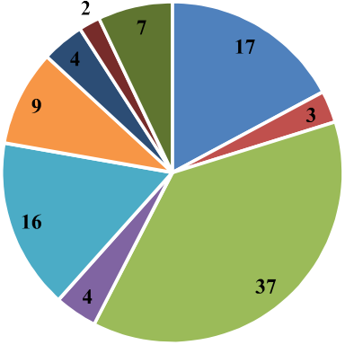

###### State wise number of accidents and ranking in total accidents during 2015-2019

|  |  |  |  |  |  |  |  |  |  |  |  |  |  |  |
| --- | --- | --- | --- | --- | --- | --- | --- | --- | --- | --- | --- | --- | --- | --- |
| **S.**  **No.** | **States/UTs** | **Total Number of Road Accidents occurred in States/UTs** | | | | | **Change in 19over**  **18** | **% change in 19 over**  **18** | **Rank of States/UTs in Total Number of Road Accidents** | | | | | |
|  |  | **2015** | **2016** | **2017** | **2018** | **2019** |  |  | **2015** | **2016** | **2017** | **2018** | **2019** |
| **1** | **2** | **3** | **4** | **5** | **6** | **7** | **8** | **9** | **10** | **11** | **12** | **13** | **14** |
| 1 | **Andhra**  **Pradesh** | 24,258 | 24,888 | 25,727 | 24,475 | 21,992 | -2,483 | -10.1 | 7 | 7 | 7 | 7 | 8 |
| 2 | **Arunachal**  **Pradesh** | 284 | 249 | 241 | 277 | 237 | -40 | -14.4 | 29 | 29 | 30 | 30 | 30 |
| 3 | **Assam** | 6,959 | 7,435 | 7,170 | 8,248 | 8,350 | 102 | 1.2 | 17 | 16 | 16 | 16 | 16 |
| 4 | **Bihar** | 9,555 | 8,222 | 8,855 | 9,600 | 10,007 | 407 | 4.2 | 15 | 15 | 15 | 15 | 15 |
| 5 | **Chhattisgarh** | 14,446 | 13,580 | 13,563 | 13,864 | 13,899 | 35 | 0.3 | 11 | 11 | 11 | 11 | 11 |
| 6 | **Goa** | 4,338 | 4,304 | 3,917 | 3,709 | 3,440 | -269 | -7.3 | 21 | 21 | 18 | 21 | 21 |
| 7 | **Gujarat** | 23,183 | 21,859 | 19,081 | 18,769 | 17,046 | -1,723 | -9.2 | 9 | 10 | 10 | 10 | 10 |
| 8 | **Haryana** | 11,174 | 11,234 | 11,258 | 11,238 | 10,944 | -294 | -2.6 | 13 | 13 | 11 | 14 | 13 |
| 9 | **Himachal Pradesh** | 3,010 | 3,168 | 3,114 | 3,110 | 2,873 | -237 | -7.6 | 22 | 22 | 16 | 22 | 22 |
| 10 | **Jammu & Kashmir** | 5,836 | 5,501 | 5,624 | 5,978 | 5,796 | -182 | -3.0 | 19 | 19 | 14 | 19 | 18 |
| 11 | **Jharkhand** | 5,162 | 4,932 | 5,198 | 5,394 | 5,217 | -177 | -3.3 | 20 | 20 | 14 | 20 | 20 |
| 12 | **Karnataka** | 44,011 | 44,403 | 42,542 | 41,707 | 40,658 | -1,049 | -2.5 | 4 | 3 | 4 | 4 | 5 |
| 13 | **Kerala** | 39,014 | 39,420 | 38,470 | 40,181 | 41,111 | 930 | 2.3 | 5 | 5 | 5 | 5 | 4 |
| 14 | **Madhya Pradesh** | 54,947 | 53,972 | 53,399 | 51,397 | 50,669 | -728 | -1.4 | 3 | 2 | 3 | 2 | 2 |
| 15 | **Maharashtra** | 63,805 | 39,878 | 35,853 | 35,717 | 32,925 | -2,792 | -7.8 | 2 | 4 | 4 | 6 | 6 |

|  |  |  |  |  |  |  |  |  |  |  |  |  |  |
| --- | --- | --- | --- | --- | --- | --- | --- | --- | --- | --- | --- | --- | --- |
| **Sl.**  **No.** | **States/UTs** | **Total Number of Road Accidents occurred in States/UTs** | | | | | **Change in 19**  **over 18** | **%**  **changein 19**  **over 18** | **Rank of States/UTs in Total Number of Road Accidents** | | | | |
|  |  | **2015** | **2016** | **2017** | **2018** | **2019** |  |  | **2015** | **2016** | **2017** | **2018** | **2019** |
| **1** | **2** | **3** | **4** | **5** | **6** | **7** | **8** | **9** | **10** | **11** | **12** | **13** | **14** |
| 16 | **Manipur** | 671 | 538 | 578 | 601 | 672 | 71 | 11.8 | 25 | 27 | 13 | 25 | 25 |
| 17 | **Meghalaya** | 606 | 620 | 675 | 399 | 482 | 83 | 20.8 | 27 | 25 | 13 | 28 | 27 |
| 18 | **Mizoram** | 70 | 83 | 68 | 53 | 62 | 9 | 17.0 | 32 | 32 | 19 | 35 | 35 |
| 19 | **Nagaland** | 54 | 75 | 531 | 430 | 358 | -72 | -16.7 | 35 | 33 | 14 | 27 | 28 |
| 20 | **Odisha** | 10,542 | 10,532 | 10,855 | 11262 | 11,064 | -198 | -1.8 | 14 | 14 | 9 | 13 | 12 |
| 21 | **Punjab** | 6,702 | 6,952 | 6,273 | 6428 | 6,348 | -80 | -1.2 | 18 | 18 | 11 | 18 | 17 |
| 22 | **Rajasthan** | 24,072 | 23,066 | 22,112 | 21743 | 23,480 | 1737 | 8.0 | 8 | 8 | 9 | 9 | 7 |
| 23 | **Sikkim** | 219 | 210 | 196 | 180 | 162 | -18 | -10.0 | 31 | 31 | 17 | 32 | 32 |
| 24 | **Tamil Nadu** | 69,059 | 71,431 | 65,562 | 63920 | 57,228 | -6,692 | -10.5 | 1 | 1 | 2 | 1 | 1 |
| 25 | **Telangana** | 21,252 | 22,811 | 22,484 | 22230 | 21,570 | -660 | -3.0 | 10 | 9 | 10 | 8 | 9 |
| 26 | **Tripura** | 647 | 557 | 503 | 552 | 655 | 103 | 18.7 | 26 | 26 | 16 | 26 | 26 |
| 27 | **Uttarakhand** | 1,523 | 1,591 | 1,603 | 1468 | 1,352 | -116 | -7.9 | 24 | 24 | 16 | 24 | 24 |
| 28 | **Uttar Pradesh** | 32,385 | 35,612 | 38,783 | 42568 | 42,572 | 4 | 0.0 | 6 | 6 | 7 | 3 | 3 |
| 29 | **West Bengal** | 13,208 | 13,580 | 11,631 | 12705 | 10,158 | -2,547 | -20.0 | 12 | 11 | 13 | 12 | 14 |
| 30 | **Andaman & Nicobar Islands** | 258 | 238 | 189 | 254 | 230 | -24 | -9.4 | 30 | 30 | 18 | 31 | 31 |
| 31 | **Chandigarh** | 416 | 428 | 342 | 316 | 305 | -11 | -3.5 | 28 | 28 | 18 | 29 | 29 |
| 32 | **Dadra & Nagar Haveli** | 69 | 70 | 67 | 80 | 68 | -12 | -15.0 | 34 | 35 | 20 | 33 | 34 |
| 33 | **Daman & Diu** | 70 | 71 | 79 | 76 | 69 | -7 | -9.2 | 32 | 34 | 20 | 34 | 33 |
| 34 | **Delhi** | 8,085 | 7,375 | 6,673 | 6,515 | 5,610 | -905 | -13.9 | 16 | 17 | 18 | 17 | 19 |
| 35 | **Lakshadweep** | 3 | 1 | 1 | 3 | 1 | -2 | -66.7 | 36 | 36 | 22 | 36 | 36 |
| 36 | **Puducherry** | 1,530 | 1,766 | 1,693 | 1,597 | 1,392 | -205 | -12.8 | 23 | 23 | 20 | 23 | 23 |
| **Total (All India)** | | **5,01,423** | **4,80,652** | **4,64,910** | **4,67,044** | **4,49,002** | -18,042 | -3.9 |  |  |  |  |  |
| **Total (NE States)** | | **9,510** | **9,767** | **9,962** | **10,740** | **10,978** | 238 |  |  |  |  |  |  |
| **Share of NE States** | | **1.90** | **2.03** | **2.14** | **2.30** | **2.44** |  |  |  |  |  |  |  |

###### 

Consequence While Driving Two Wheelers with One Hand - Right Hand

1. The speed gets slow (no throttle) and due to abnormal RPM rate the engine will turn off.

2. Acceleration cannot be done.

3. Engine Braking – at a certain time suddenly we can feel a drag with increase in RPM.

4. Very less steering control and improper balance of the vehicle

5. Turning a vehicle is difficult.

6. Less possibility of sudden stop.

Things we Cannot do Without Right Hand While Driving

1. Some times without throttle the engine may turn off and we need to turn on the engine with Self Start or Kicker with right hand.

2. Not possible to catch Front Brake also leveler for brake.

3. Some vehicle has Turn On/Off ABS in right side.

4. BS3 vehicles may have headlight switches in right side.

5. Hazard Switch in right side.

6. Mirror adjustments.

**Consequences while riding 2 wheeler leaving one hands**

**Leaving left hand while riding**

No balance of handle and vehicle.

All the buttons like, headlight, high beam, low, indicator, horn cannot be turned on.

If it’s a geared bike it is difficult to put a gear. Since no clutch involvement while putting a gear leads to a jumping of a vehicle and further misbalance cause the accidents.

Turning the vehicle is very difficult.

Mirror adjustment.

Less possibility of sudden stop.

To control the speed of the vehicle

**Ideas for Input**

Sensors implemented for the project

* **Raspberry Pi Zero WH**
* **Conductive Thread Touch Sensor**
* **Gyroscope**

Raspberry Pi Zero WH

* 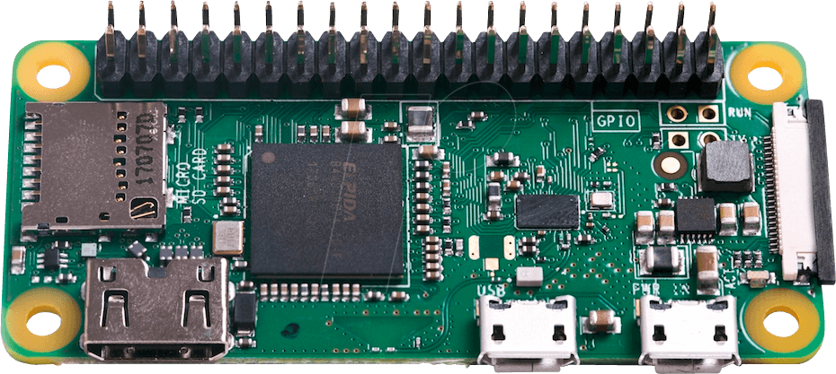802.11 b/g/n wireless LAN
* Bluetooth 4.1
* 1GHz, single-core CPU
* 512MB RAM
* HAT-compatible 40-pin header
* Price र**1,150**

[This product is available at :](This%20product%20is%20available%20at%20:%20) <https://www.silverlineelectronics.in/raspberry-pi-zero-wh-wireless-pre-soldered-header.html>

Conductive Thread Touch Sensor

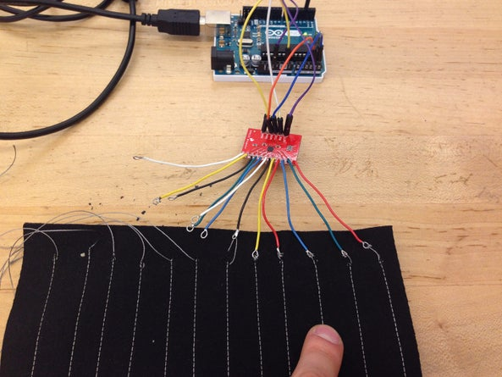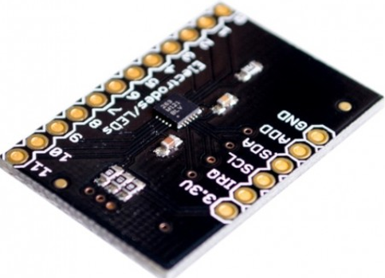

* Conductive Thread Touch Sensor can be implemented in each side of the two-wheeler handle bar.
* The wire connected to the sensor will be further connected to the thread which could be stitched in the handle bar grip.
* While touching the stitch with our hands it sends the signal to the sensor.
* It is been touched.
* Price र 195.

Information: <https://www.instructables.com/Conductive-Thread-Touch-Sensor/?hootPostID=690a4bd429c6be0ce7d42efcdc3a9863>

[This product is available at :](This%20product%20is%20available%20at%20:%20) <https://www.fabtolab.com/capacitive-touch-sensor-breakout-mpr121>

**Gyroscope**

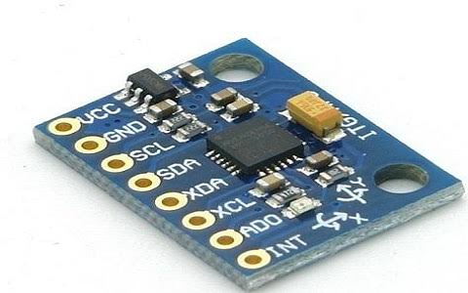 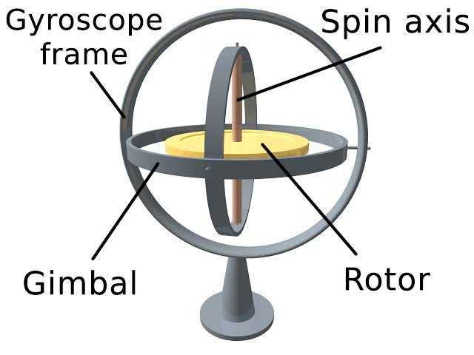

**These can measure the tilt and lateral orientation of the bike.**

**Gyroscope sensors present in most of the bikes and can be implemented at the axis of the wheel.**

**Drive arm vibrates in a certain direction.**

**The motion of pair of sensing arms produces potential difference from which angular velocity is sensed.**

**The angular velocity is converted to an electrical signal.**

**Price -**

**With this we can get to know that at how much angle the bike is tilted.**

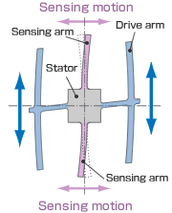

Ideas for output



Synkentrono Software Solutions Private Limited

Authored by: Girish, Ashwini, Shruti

**Displaying warning in a dashboard**

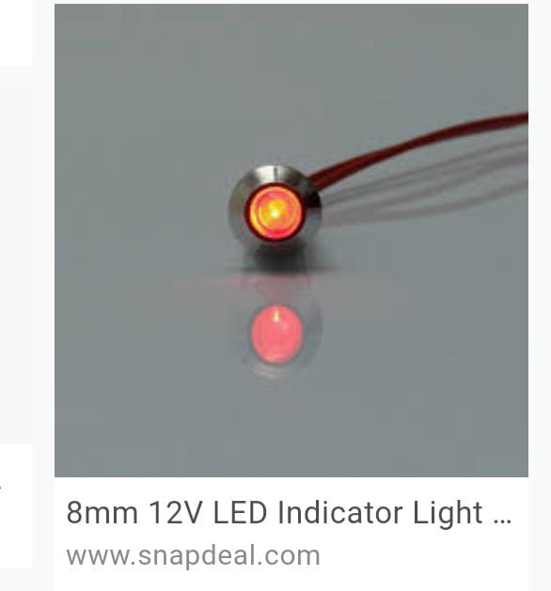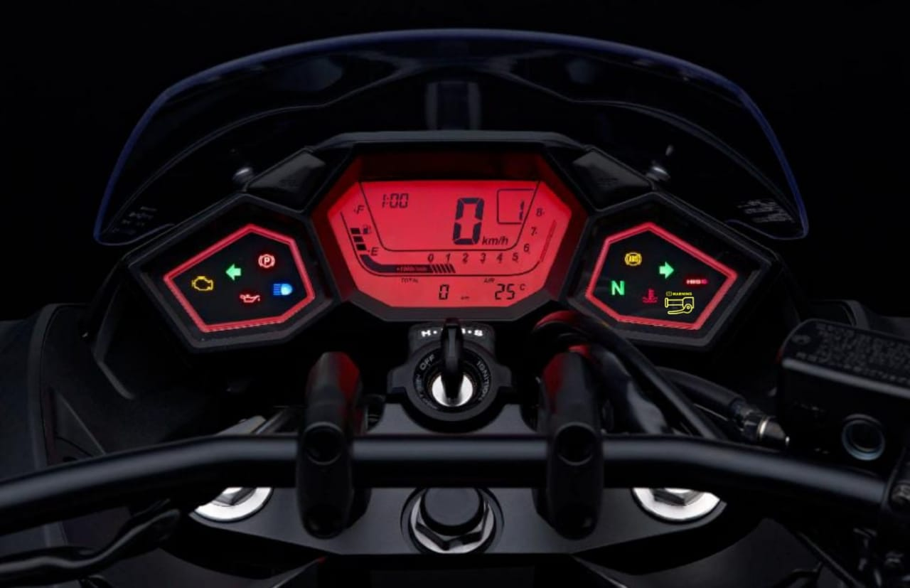-First approach

8mm 12V LED

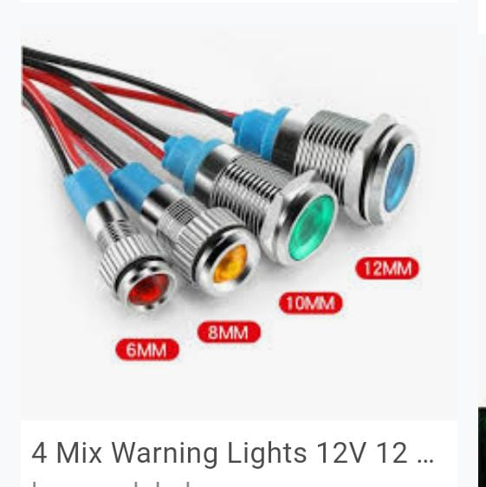

Icon to

be used

When there is release of left hand or right hand display red color.

**Displaying a message to the rider**

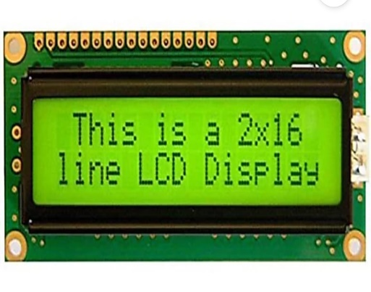

**- You are in danger**

- **Warning**

**- Rash driving alert**

* Requires TFT LCD display which is easy to

interface with most micro controllers.

Description-

Type: LCD alphanumeric

Color: green backlight

Power: 5V

* Works with any microcontroller.
* contrast of the screen can be varied by varying

voltage.

**Indication with handlebar light**

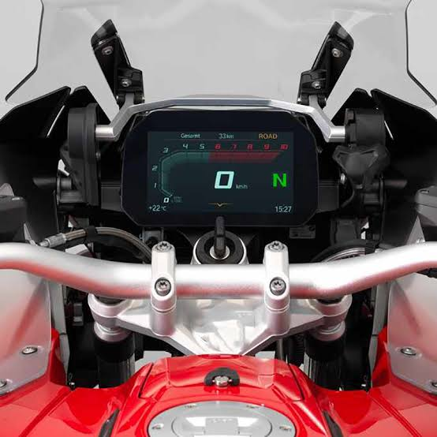- Second approach.

* It involves lights in handlebars to

indicate when release of either hands.

* Easy installation placement on

handle bar both ends.

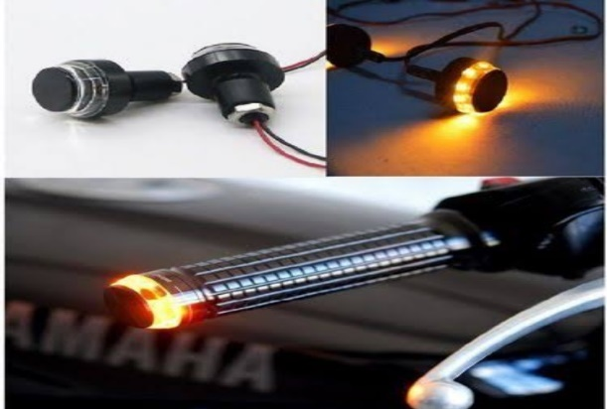

Description-

type: LED

color: white orange

power: 12V

**Indicator with beep sound.**

* Indication with light for 5 seconds when it is sensed either of the hands are not in contact with the handle later on continued indication with beep.
* 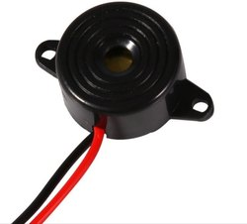Buzzer can be used for this purpose.

Description-

Type: automotive

Material: plastic

Power supply: DC

**Sending a message to the bike owner and respective traffic department**

* For above process CDMA or GSM can be used as medium for communication.
* In these schemes, the message is modulated on a longer spreading sequence, consisting of several chips.