Consequence While Driving Two Wheelers with One Hand - Right Hand

1. The speed gets slow (no throttle) and due to abnormal RPM rate the engine will turn off.

2. Acceleration cannot be done.

3. Engine Braking – at a certain time suddenly we can feel a drag with increase in RPM.

4. Very less steering control and improper balance of the vehicle

5. Turning a vehicle is difficult.

6. Less possibility of sudden stop.

Things we Cannot do Without Right Hand While Driving

1. Some times without throttle the engine may turn off and we need to turn on the engine with Self Start or Kicker with right hand.

2. Not possible to catch Front Brake also leveler for brake.

3. Some vehicle has Turn On/Off ABS in right side.

4. BS3 vehicles may have headlight switches in right side.

5. Hazard Switch in right side.

6. Mirror adjustments.

Consequence While Driving Two Wheelers with One Hand

-Left hand

**Leaving left hand while riding**

1. No balance of handle and vehicle.
2. All the buttons like, headlight, high beam, low, indicator, horn cannot be turned on.
3. If it’s a geared bike it is difficult to put a gear. Since no clutch involvement while putting a gear leads to a jumping of a vehicle and further misbalance cause the accidents.
4. Turning the vehicle is very difficult.
5. Mirror adjustment.
6. Less possibility of sudden stop.
7. It is difficult to control the speed of the vehicle.

**Ideas for Input**

Sensors implemented for the project

* **Raspberry Pi Zero WH**
* **Conductive Thread Touch Sensor**
* **Gyroscope**

Raspberry Pi Zero WH

* 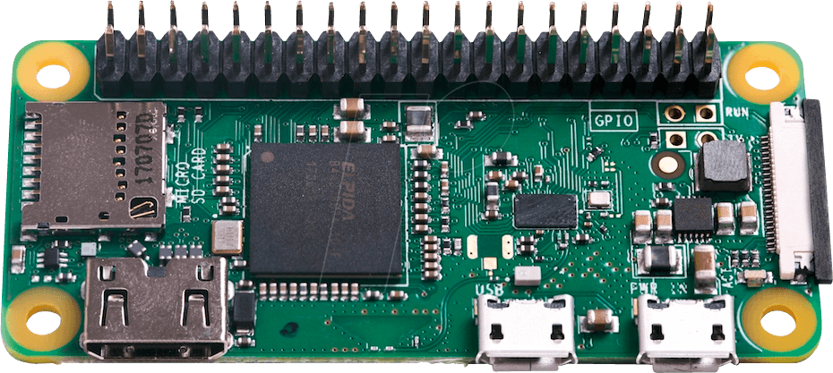802.11 b/g/n wireless LAN
* Bluetooth 4.1
* 1GHz, single-core CPU
* 512MB RAM
* HAT-compatible 40-pin header
* Price र**1,150**

[This product is available at :](This%20product%20is%20available%20at%20:%20) <https://www.silverlineelectronics.in/raspberry-pi-zero-wh-wireless-pre-soldered-header.html>

Conductive Thread Touch Sensor

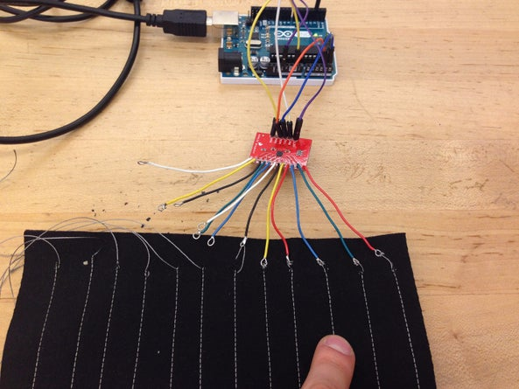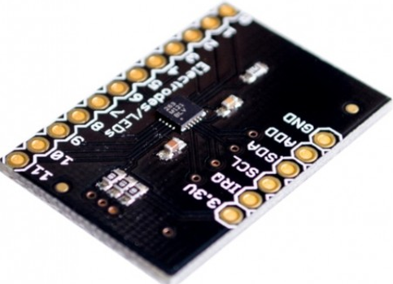

* Conductive Thread Touch Sensor can be implemented in each side of the two-wheeler handle bar.
* The wire connected to the sensor will be further connected to the thread which could be stitched in the handle bar grip.
* While touching the stitch with our hands it sends the signal to the sensor.
* It is been touched.
* Price र 195.

Information: <https://www.instructables.com/Conductive-Thread-Touch-Sensor/?hootPostID=690a4bd429c6be0ce7d42efcdc3a9863>

[This product is available at :](This%20product%20is%20available%20at%20:%20) <https://www.fabtolab.com/capacitive-touch-sensor-breakout-mpr121>

|  |  |  |  |  |
| --- | --- | --- | --- | --- |
| S.No | CHANGE DESCRIPTION | AUTHOR | DATE | VERSION |
| 1 | Consequences and Input ideas | Vishal J.M | 24/05/2021 | 0.0.1 |
| 2 | Consequences(left hand) | Girish G. H | 24/05/2021 | 0.0.2 |
| 3 | Ideas for output | Ashwini, girish, shruti | 24/05/2021 | 0.0.3 |
|  |  |  |  |  |

Ideas for output



Synkentrono Software Solutions Private Limited

Authored by: Girish, Ashwini, Shruti

**Displaying warning in a dashboard**

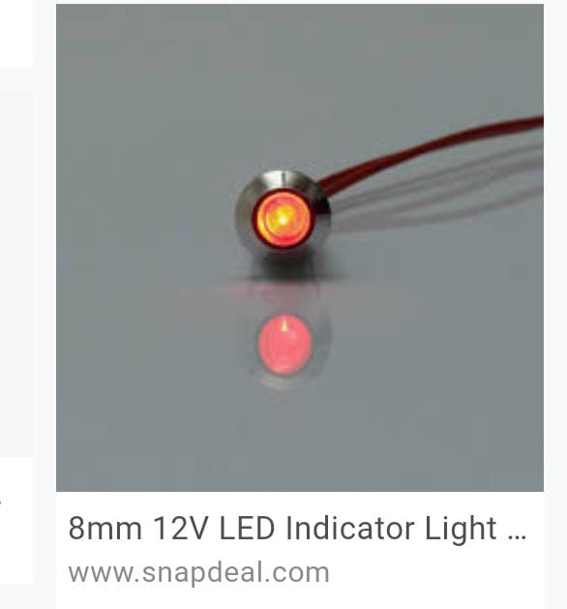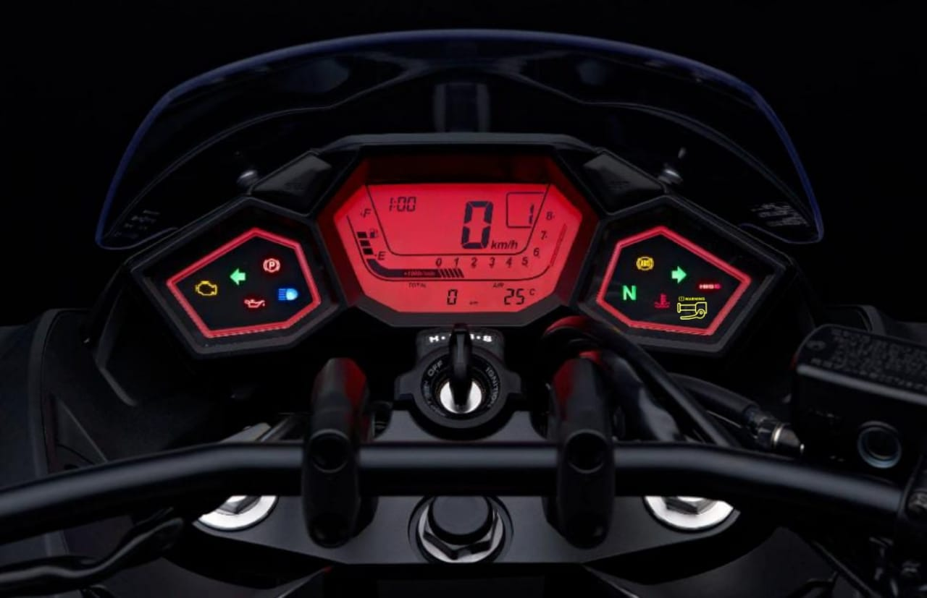-First approach

8mm 12V LED

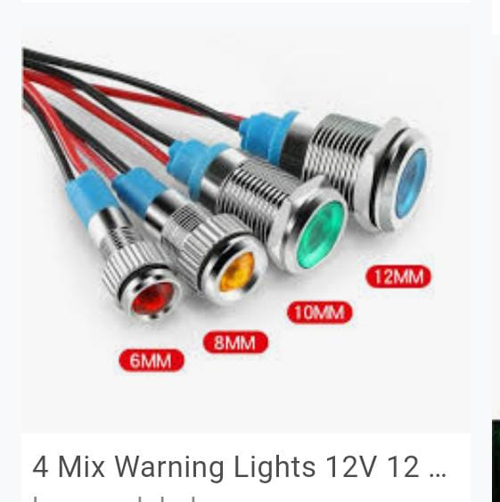

Icon to

be used

When there is release of left hand or right hand display red color.

**Displaying a message to the rider**

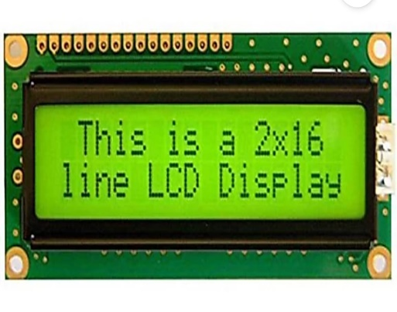

**- You are in danger**

- **Warning**

**- Rash driving alert**

* Requires TFT LCD display which is easy to

interface with most micro controllers.

Description-

Type: LCD alphanumeric

Color: green backlight

Power: 5V

* Works with any microcontroller.
* contrast of the screen can be varied by varying

voltage.

**Indication with handlebar light**

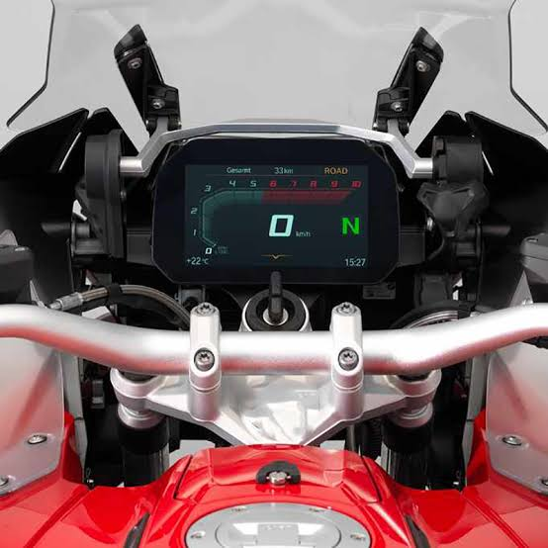- Second approach.

* It involves lights in handlebars to

indicate when release of either hands.

* Easy installation placement on

handle bar both ends.

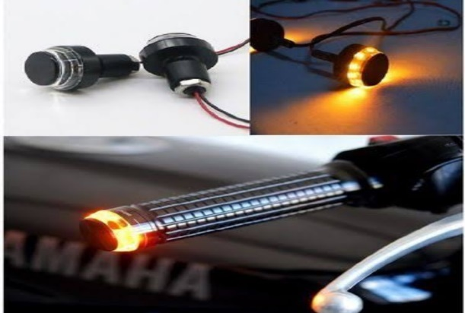

Description-

type: LED

color: white orange

power: 12V

**Indicator with beep sound.**

* Indication with light for 5 seconds when it is sensed either of the hands are not in contact with the handle later on continued indication with beep.
* 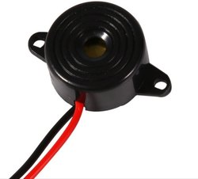Buzzer can be used for this purpose.

Description-

Type: automotive

Material: plastic

Power supply: DC

**Sending a message to the bike owner and respective traffic department**

* For above process CDMA or GSM can be used as medium for communication.
* In these schemes, the message is modulated on a longer spreading sequence, consisting of several chips.