DPA Assignment 5

Girish Rajani

2023-04-30

#Recitation Problems

#Chapter 12

#1a Prove 12.18

#1b

At each iteration, since each observation is assigned to the closest centroid based on the euclidean distance dissimilarity measure. This minimizes the sum of squared Euclidean distance as proven above. This is equivalent to minimizing the within-cluster variation for each cluster. This is guaranteed to decrease the value of the objective 12.17.

#2a

#create the dissimilarity matrix  
dissimilarity_matrix <- as.dist(matrix(c(  
 0, 0.3, 0.4, 0.7,   
 0.3, 0, 0.5, 0.8,  
 0.4, 0.5, 0.0, 0.45,  
 0.7, 0.8, 0.45, 0.0), nrow = 4))  
  
#hierarchically clustering using complete linkage  
complete_linkage_clustering <- hclust(dissimilarity_matrix, method = "complete")  
  
#Heights at which each fusion occurs  
cat("Heights at which each fusion occurs for complete linkage:",complete_linkage_clustering$height)

## Heights at which each fusion occurs for complete linkage: 0.3 0.45 0.8

#sketch the dendrogram  
plot(complete_linkage_clustering)

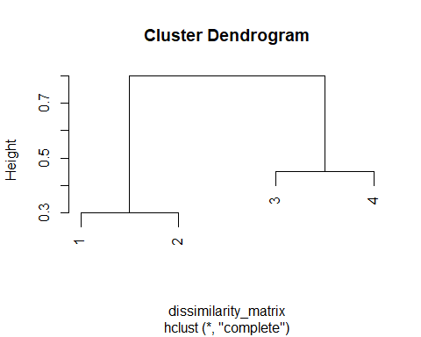

#2b

#hierarchically clustering using single linkage  
single_linkage_clustering <- hclust(dissimilarity_matrix, method = "single")  
  
#Heights at which each fusion occurs  
cat("Heights at which each fusion occurs for single linkage:",single_linkage_clustering$height)

## Heights at which each fusion occurs for single linkage: 0.3 0.4 0.45

#sketch the dendrogram  
plot(single_linkage_clustering)

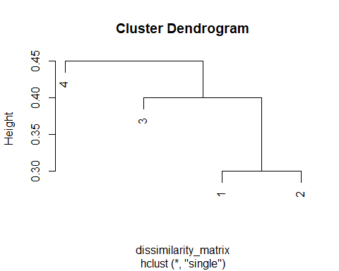

#2c

#Cut the tree that resulted from hclust into several groups by specifying 2 clusters (k=2)  
complete_linkage_cut <- cutree(complete_linkage_clustering, k = 2)  
  
#returns a vector with group memberships  
complete_linkage_cut

## [1] 1 1 2 2

We can see from above that based on the returned group memberships from the vector, the observations in each cluster from (a) are: (1,2), (3,4)

#2d

#Cut the tree that resulted from hclust into several groups by specifying 2 clusters (k=2)  
single_linkage_cut <- cutree(single_linkage_clustering, k = 2)  
  
#returns a vector with group memberships  
single_linkage_cut

## [1] 1 1 1 2

We can see from above that based on the returned group memberships from the vector, the observations in each cluster from (b) are: ((1,2),3), (4)

#2e

#Plotting a dendrogram that is equivalent to the dendrogram in (a)  
plot(hclust(dissimilarity_matrix, method="complete"), labels=c(2,1,4,3))

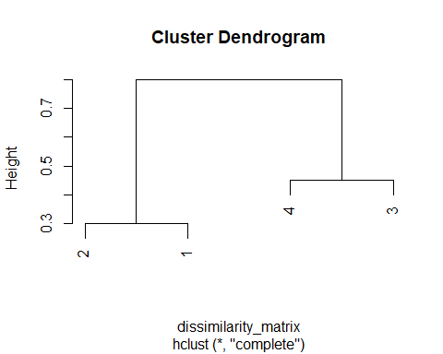

#3a

#Creating a data frame of the observations given  
observations = data.frame(X1 = c(1, 1, 0, 5, 6, 4), X2 = c(4, 3, 4, 1, 2, 0))  
observations

## X1 X2  
## 1 1 4  
## 2 1 3  
## 3 0 4  
## 4 5 1  
## 5 6 2  
## 6 4 0

#Plotting the observations  
plot(observations)

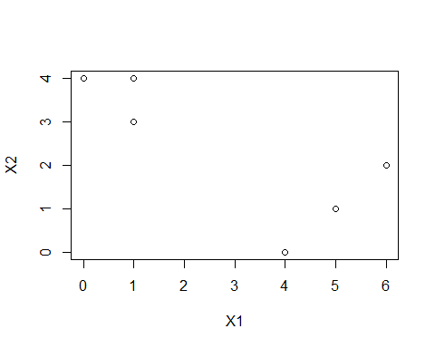

#3b

#Randomly assign a cluster label to each observation using the sample() command  
set.seed(3)  
cluster_label = sample(2, nrow(observations), replace=T)  
cbind(observations,cluster_label)

## X1 X2 cluster_label  
## 1 1 4 1  
## 2 1 3 2  
## 3 0 4 2  
## 4 5 1 1  
## 5 6 2 2  
## 6 4 0 2

#3c

#Computing the centroid for each cluster  
centroid_label_1 = c(mean(observations[cluster_label==1, 1]), mean(observations[cluster_label==1, 2]))  
centroid_label_2 = c(mean(observations[cluster_label==2, 1]), mean(observations[cluster_label==2, 2]))  
  
cat("centroid for label 1:",centroid_label_1)

## centroid for label 1: 3 2.5

cat("\ncentroid for label 2:",centroid_label_2)

##   
## centroid for label 2: 2.75 2.25

#Plotting both centroid points on the plot along with the observations color coded based on their cluster label  
plot(observations, pch = 15, col = (cluster_label+1))  
points(centroid_label_1[1], centroid_label_1[2], col=2, pch=4)  
points(centroid_label_2[1], centroid_label_2[2], col=3, pch=4)

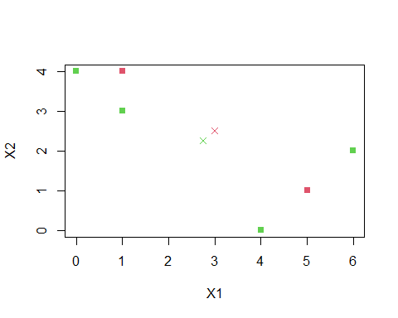

#3d

#Function to compute euclidean distance  
euclidean_distance = function(a, b) {  
 (sqrt((a[1] - b[1])^2 + (a[2]-b[2])^2))  
}  
  
#Go through each observation and assigns them to the centroid to which it is closest, in terms of the euclidean distance  
cluster_labels = function(observations, centroid_label_1, centroid_label_2) {  
 cluster_label = rep(NA, nrow(observations))  
   
 for (i in 1:nrow(observations)) {  
 if (euclidean_distance(observations[i,], centroid_label_1) < euclidean_distance(observations[i,], centroid_label_2)) {  
 cluster_label[i] = 1  
 } else {  
 cluster_label[i] = 2  
 }  
 }  
 return(cluster_label)  
}  
  
cluster_label = cluster_labels(observations, centroid_label_1, centroid_label_2)  
cat("cluster labels for each observation after assigning in terms of the euclidean distance:",cluster_label)

## cluster labels for each observation after assigning in terms of the euclidean distance: 2 2 2 1 1 2

#3e

#Repeat (c) and (d) until the answers obtained stop changing  
last_labels = rep(-1, 6)  
  
while (!all(last_labels == cluster_label)) {  
 last_labels = cluster_label  
   
 #Compute centroid for each cluster (c)  
 centroid_label_1 = c(mean(observations[cluster_label==1, 1]), mean(observations[cluster_label==1, 2]))  
 centroid_label_2 = c(mean(observations[cluster_label==2, 1]), mean(observations[cluster_label==2, 2]))  
   
 print(centroid_label_1)  
 print(centroid_label_2)  
   
 #Assign each observation to the centroid using the function from (d)  
 cluster_label = cluster_labels(observations, centroid_label_1, centroid_label_2)  
}

## [1] 5.5 1.5  
## [1] 1.50 2.75  
## [1] 5 1  
## [1] 0.6666667 3.6666667

print(cluster_label)

## [1] 2 2 2 1 1 1

#3f

#Coloring the observations based on the cluster labels obtained  
plot(observations[,1], observations[,2], col=(cluster_label+1), pch=20, cex=2)  
points(centroid_label_1[1], centroid_label_1[2], col=2, pch=4)  
points(centroid_label_2[1], centroid_label_2[2], col=3, pch=4)

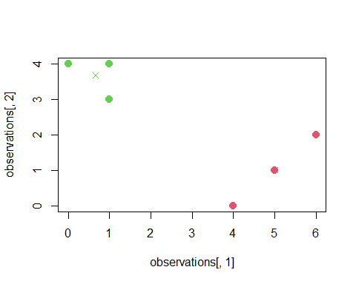

#4a

There is not enough information to tell which fusion will occur higher on the tree or whether they will fuse at the same height. To determine this, we will need more information such as the dissimilarity matrix. This is because the dissimilarity between two clusters determines the height at which fusion takes place. If the dissimilarity for both the single and complete linkage are the same then fusion will occur at the same height. Otherwise, single linkage would typically fuse at a lower height on the tree than complete linkage.

#4b

The different types of linkage will impact the height at which ‘clusters’ fuse but in this case, since we are fusing leaf nodes, the type of linkage will not affect. Therefore, They will fuse at the same height.

#Practicum Problems

#install.packages("collections")  
library(factoextra)

## Warning: package 'factoextra' was built under R version 4.2.3

## Loading required package: ggplot2

## Welcome! Want to learn more? See two factoextra-related books at https://goo.gl/ve3WBa

library(collections)

## Warning: package 'collections' was built under R version 4.2.3

##   
## Attaching package: 'collections'

## The following object is masked from 'package:utils':  
##   
## stack

library(dplyr)

##   
## Attaching package: 'dplyr'

## The following objects are masked from 'package:stats':  
##   
## filter, lag

## The following objects are masked from 'package:base':  
##   
## intersect, setdiff, setequal, union

**#Question 1**

#load the dataset and label the columns  
wine_dataframe <- read.csv(url("https://archive.ics.uci.edu/ml/machine-learning-databases/wine/wine.data"), sep=",", header=F)  
  
col_names <- c('Alcohol','Malic acid','Ash','Alcalinity of ash','Magnesium','Total phenols','Flavanoids','Nonflavanoid','phenols','Proanthocyanins','Color intensity','Hue','OD280/OD315 of diluted wines','Proline')  
  
colnames(wine_dataframe) <- col_names  
  
summary(wine_dataframe)

## Alcohol Malic acid Ash Alcalinity of ash  
## Min. :1.000 Min. :11.03 Min. :0.740 Min. :1.360   
## 1st Qu.:1.000 1st Qu.:12.36 1st Qu.:1.603 1st Qu.:2.210   
## Median :2.000 Median :13.05 Median :1.865 Median :2.360   
## Mean :1.938 Mean :13.00 Mean :2.336 Mean :2.367   
## 3rd Qu.:3.000 3rd Qu.:13.68 3rd Qu.:3.083 3rd Qu.:2.558   
## Max. :3.000 Max. :14.83 Max. :5.800 Max. :3.230   
## Magnesium Total phenols Flavanoids Nonflavanoid   
## Min. :10.60 Min. : 70.00 Min. :0.980 Min. :0.340   
## 1st Qu.:17.20 1st Qu.: 88.00 1st Qu.:1.742 1st Qu.:1.205   
## Median :19.50 Median : 98.00 Median :2.355 Median :2.135   
## Mean :19.49 Mean : 99.74 Mean :2.295 Mean :2.029   
## 3rd Qu.:21.50 3rd Qu.:107.00 3rd Qu.:2.800 3rd Qu.:2.875   
## Max. :30.00 Max. :162.00 Max. :3.880 Max. :5.080   
## phenols Proanthocyanins Color intensity Hue   
## Min. :0.1300 Min. :0.410 Min. : 1.280 Min. :0.4800   
## 1st Qu.:0.2700 1st Qu.:1.250 1st Qu.: 3.220 1st Qu.:0.7825   
## Median :0.3400 Median :1.555 Median : 4.690 Median :0.9650   
## Mean :0.3619 Mean :1.591 Mean : 5.058 Mean :0.9574   
## 3rd Qu.:0.4375 3rd Qu.:1.950 3rd Qu.: 6.200 3rd Qu.:1.1200   
## Max. :0.6600 Max. :3.580 Max. :13.000 Max. :1.7100   
## OD280/OD315 of diluted wines Proline   
## Min. :1.270 Min. : 278.0   
## 1st Qu.:1.938 1st Qu.: 500.5   
## Median :2.780 Median : 673.5   
## Mean :2.612 Mean : 746.9   
## 3rd Qu.:3.170 3rd Qu.: 985.0   
## Max. :4.000 Max. :1680.0

head(wine_dataframe)

## Alcohol Malic acid Ash Alcalinity of ash Magnesium Total phenols Flavanoids  
## 1 1 14.23 1.71 2.43 15.6 127 2.80  
## 2 1 13.20 1.78 2.14 11.2 100 2.65  
## 3 1 13.16 2.36 2.67 18.6 101 2.80  
## 4 1 14.37 1.95 2.50 16.8 113 3.85  
## 5 1 13.24 2.59 2.87 21.0 118 2.80  
## 6 1 14.20 1.76 2.45 15.2 112 3.27  
## Nonflavanoid phenols Proanthocyanins Color intensity Hue  
## 1 3.06 0.28 2.29 5.64 1.04  
## 2 2.76 0.26 1.28 4.38 1.05  
## 3 3.24 0.30 2.81 5.68 1.03  
## 4 3.49 0.24 2.18 7.80 0.86  
## 5 2.69 0.39 1.82 4.32 1.04  
## 6 3.39 0.34 1.97 6.75 1.05  
## OD280/OD315 of diluted wines Proline  
## 1 3.92 1065  
## 2 3.40 1050  
## 3 3.17 1185  
## 4 3.45 1480  
## 5 2.93 735  
## 6 2.85 1450

#Observe the variance among the features to decide whether to scale or not  
  
print(apply(wine_dataframe,2,var))

## Alcohol Malic acid   
## 6.006792e-01 6.590623e-01   
## Ash Alcalinity of ash   
## 1.248015e+00 7.526464e-02   
## Magnesium Total phenols   
## 1.115269e+01 2.039893e+02   
## Flavanoids Nonflavanoid   
## 3.916895e-01 9.977187e-01   
## phenols Proanthocyanins   
## 1.548863e-02 3.275947e-01   
## Color intensity Hue   
## 5.374449e+00 5.224496e-02   
## OD280/OD315 of diluted wines Proline   
## 5.040864e-01 9.916672e+04

**As shown from the variance of each feature above, there is a large difference in variance amongst some features and so to bring all features onto the same scale to avoid bias of the principal components, scaling will be performed.**

#Use prcomp to perform a PCA on the wine data using scaling  
pca_model_scaling <- prcomp(wine_dataframe , scale=TRUE)  
summary(pca_model_scaling)

## Importance of components:  
## PC1 PC2 PC3 PC4 PC5 PC6 PC7  
## Standard deviation 2.3529 1.5802 1.2025 0.96328 0.93675 0.82023 0.74418  
## Proportion of Variance 0.3954 0.1784 0.1033 0.06628 0.06268 0.04806 0.03956  
## Cumulative Proportion 0.3954 0.5738 0.6771 0.74336 0.80604 0.85409 0.89365  
## PC8 PC9 PC10 PC11 PC12 PC13 PC14  
## Standard deviation 0.5916 0.54272 0.51216 0.47524 0.41085 0.35995 0.24044  
## Proportion of Variance 0.0250 0.02104 0.01874 0.01613 0.01206 0.00925 0.00413  
## Cumulative Proportion 0.9186 0.93969 0.95843 0.97456 0.98662 0.99587 1.00000

#Plotting biplot of the results  
biplot(pca_model_scaling,scale=0)

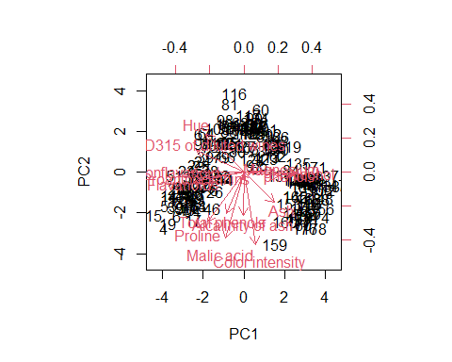

**Based on the biplot above, Ash is a feature which is pointed in the opposite direction of Hue in the principal component/rotated feature space. Regarding the correlation of this feature to Hue, they are inversely correlated.**

calculated_value <- cor.test(wine_dataframe$Ash, wine_dataframe$Hue,method = "pearson")  
calculated_value

##   
## Pearson's product-moment correlation  
##   
## data: wine_dataframe$Ash and wine_dataframe$Hue  
## t = -8.9975, df = 176, p-value = 3.648e-16  
## alternative hypothesis: true correlation is not equal to 0  
## 95 percent confidence interval:  
## -0.6543579 -0.4514847  
## sample estimates:  
## cor   
## -0.5612957

**Based on the correlation value of Hue and Ash as shown above (-0.5612957), we can also confirm that they are indeed negatively correlated.**

#Compute the proportion of variance explained by each principal component  
prop_variance <- pca_model_scaling$sdev^2 / sum(pca_model_scaling$sdev^2)  
prop_variance

## [1] 0.395424860 0.178362589 0.103291016 0.066279845 0.062678751 0.048055596  
## [7] 0.039557068 0.025002441 0.021038710 0.018736150 0.016132030 0.012056908  
## [13] 0.009254584 0.004129451

cat("\nThe total variance explained by PC1 and PC2 is:", (prop_variance[1] + prop_variance[2])*100,"%")

##   
## The total variance explained by PC1 and PC2 is: 57.37874 %

#Plotting a screeplot of results  
plot(prop_variance, xlab = "Principal Component", ylab = "Variance Explained ", ylim = c(0,1), type="b")

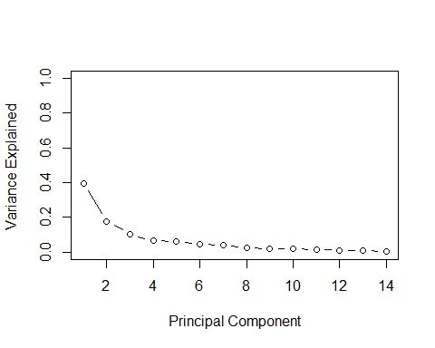

**#Question 2**

set.seed(30)  
arrest_data <- data.frame(USArrests)  
  
summary(arrest_data)

## Murder Assault UrbanPop Rape   
## Min. : 0.800 Min. : 45.0 Min. :32.00 Min. : 7.30   
## 1st Qu.: 4.075 1st Qu.:109.0 1st Qu.:54.50 1st Qu.:15.07   
## Median : 7.250 Median :159.0 Median :66.00 Median :20.10   
## Mean : 7.788 Mean :170.8 Mean :65.54 Mean :21.23   
## 3rd Qu.:11.250 3rd Qu.:249.0 3rd Qu.:77.75 3rd Qu.:26.18   
## Max. :17.400 Max. :337.0 Max. :91.00 Max. :46.00

head(arrest_data)

## Murder Assault UrbanPop Rape  
## Alabama 13.2 236 58 21.2  
## Alaska 10.0 263 48 44.5  
## Arizona 8.1 294 80 31.0  
## Arkansas 8.8 190 50 19.5  
## California 9.0 276 91 40.6  
## Colorado 7.9 204 78 38.7

#Observe the variance among the features to decide whether to scale or not  
  
print(apply(arrest_data,2,var))

## Murder Assault UrbanPop Rape   
## 18.97047 6945.16571 209.51878 87.72916

**As shown above, since there is a significant difference in the variance for each feature, by applying scaling, all variables will be on the same scale and have equal weight which will be be beneficial during k means clustering**

#Perform scaling  
arrest_data_scaled <- scale(arrest_data,center = TRUE,scale=TRUE)

#Perform kmeans clustering on the scaled observations with increasing values of k from 2 to 10  
k2 <- kmeans(arrest_data_scaled, centers = 2, nstart = 25)  
k3 <- kmeans(arrest_data_scaled, centers = 3, nstart = 25)  
k4 <- kmeans(arrest_data_scaled, centers = 4, nstart = 25)  
k5 <- kmeans(arrest_data_scaled, centers = 5, nstart = 25)  
k6 <- kmeans(arrest_data_scaled, centers = 6, nstart = 25)  
k7 <- kmeans(arrest_data_scaled, centers = 7, nstart = 25)  
k8 <- kmeans(arrest_data_scaled, centers = 8, nstart = 25)  
k9 <- kmeans(arrest_data_scaled, centers = 9, nstart = 25)  
k10 <- kmeans(arrest_data_scaled, centers = 10, nstart = 25)  
  
#Visualize the clustering for each value of k performed  
plot2 <- fviz_cluster(k2, geom = "point", data = arrest_data_scaled) + ggtitle("k = 2")  
plot2_normal <- plot (arrest_data_scaled, col = (k2$cluster + 1),main = "K- Means Clustering Results with K = 2",xlab = "", ylab = "", pch = 20, cex = 2)

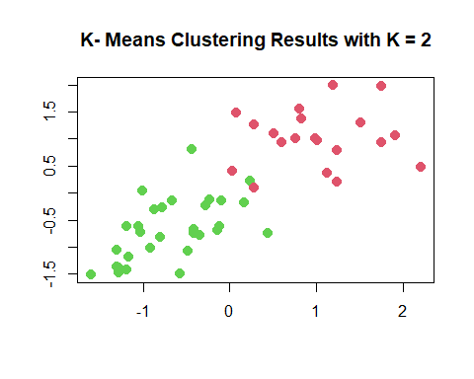

plot3 <- fviz_cluster(k3, geom = "point", data = arrest_data_scaled) + ggtitle("k = 3")  
plot3_normal <- plot (arrest_data_scaled, col = (k3$cluster + 1),main = "K- Means Clustering Results with K = 3",xlab = "", ylab = "", pch = 20, cex = 2)

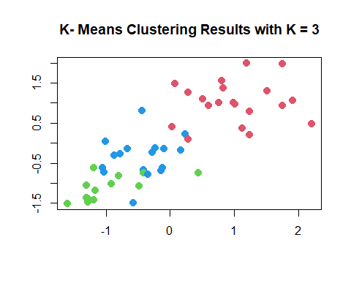

plot4 <- fviz_cluster(k4, geom = "point", data = arrest_data_scaled) + ggtitle("k = 4")  
plot4_normal <- plot (arrest_data_scaled, col = (k4$cluster + 1),main = "K- Means Clustering Results with K = 4",xlab = "", ylab = "", pch = 20, cex = 2)

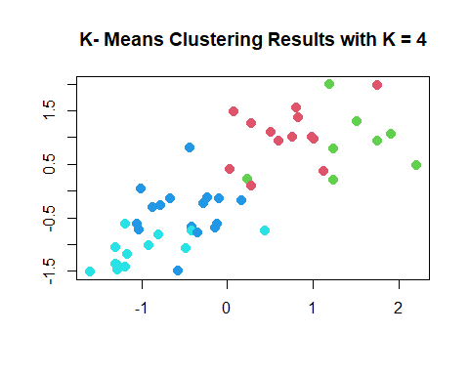

plot5 <- fviz_cluster(k5, geom = "point", data = arrest_data_scaled) + ggtitle("k = 5")  
plot5_normal <- plot (arrest_data_scaled, col = (k5$cluster + 1),main = "K- Means Clustering Results with K = 5",xlab = "", ylab = "", pch = 20, cex = 2)

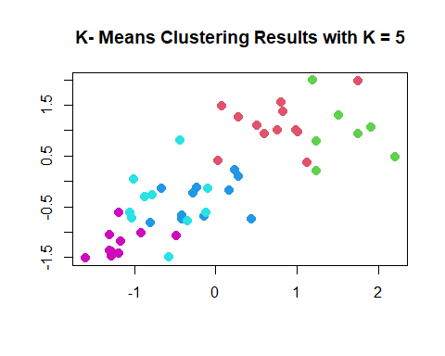

plot6 <- fviz_cluster(k6, geom = "point", data = arrest_data_scaled) + ggtitle("k = 6")  
plot6_normal <- plot (arrest_data_scaled, col = (k6$cluster + 1),main = "K- Means Clustering Results with K = 6",xlab = "", ylab = "", pch = 20, cex = 2)

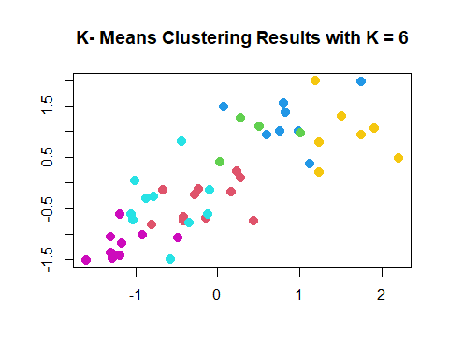

plot7 <- fviz_cluster(k7, geom = "point", data = arrest_data_scaled) + ggtitle("k = 7")  
plot7_normal <- plot (arrest_data_scaled, col = (k7$cluster + 1),main = "K- Means Clustering Results with K = 7",xlab = "", ylab = "", pch = 20, cex = 2)

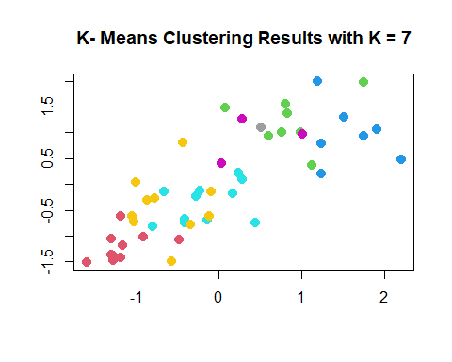

plot8 <- fviz_cluster(k8, geom = "point", data = arrest_data_scaled) + ggtitle("k = 8")  
plot8_normal <- plot (arrest_data_scaled, col = (k8$cluster + 1),main = "K- Means Clustering Results with K = 8",xlab = "", ylab = "", pch = 20, cex = 2)

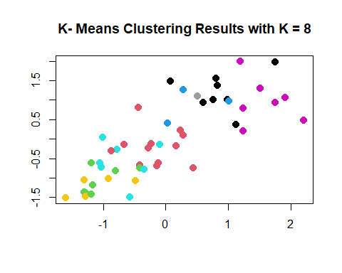

plot9 <- fviz_cluster(k9, geom = "point", data = arrest_data_scaled) + ggtitle("k = 9")  
plot9_normal <- plot (arrest_data_scaled, col = (k9$cluster + 1),main = "K- Means Clustering Results with K = 9",xlab = "", ylab = "", pch = 20, cex = 2)

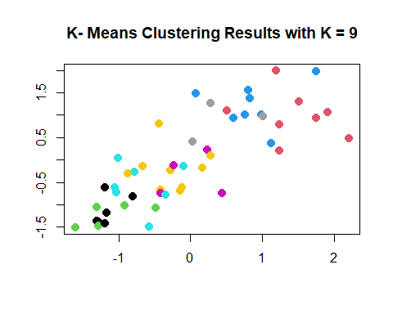

plot10 <- fviz_cluster(k10, geom = "point", data = arrest_data_scaled) + ggtitle("k = 10")  
plot10_normal <- plot (arrest_data_scaled, col = (k10$cluster + 1),main = "K- Means Clustering Results with K = 10",xlab = "", ylab = "", pch = 20, cex = 2)

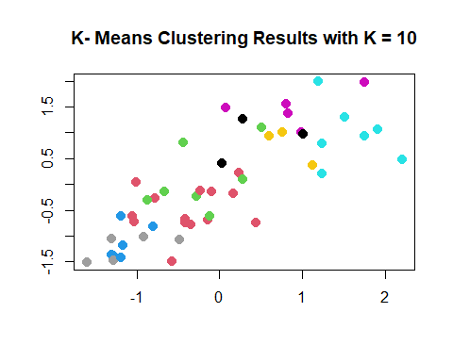

k2

## K-means clustering with 2 clusters of sizes 20, 30  
##   
## Cluster means:  
## Murder Assault UrbanPop Rape  
## 1 1.004934 1.0138274 0.1975853 0.8469650  
## 2 -0.669956 -0.6758849 -0.1317235 -0.5646433  
##   
## Clustering vector:  
## Alabama Alaska Arizona Arkansas California   
## 1 1 1 2 1   
## Colorado Connecticut Delaware Florida Georgia   
## 1 2 2 1 1   
## Hawaii Idaho Illinois Indiana Iowa   
## 2 2 1 2 2   
## Kansas Kentucky Louisiana Maine Maryland   
## 2 2 1 2 1   
## Massachusetts Michigan Minnesota Mississippi Missouri   
## 2 1 2 1 1   
## Montana Nebraska Nevada New Hampshire New Jersey   
## 2 2 1 2 2   
## New Mexico New York North Carolina North Dakota Ohio   
## 1 1 1 2 2   
## Oklahoma Oregon Pennsylvania Rhode Island South Carolina   
## 2 2 2 2 1   
## South Dakota Tennessee Texas Utah Vermont   
## 2 1 1 2 2   
## Virginia Washington West Virginia Wisconsin Wyoming   
## 2 2 2 2 2   
##   
## Within cluster sum of squares by cluster:  
## [1] 46.74796 56.11445  
## (between_SS / total_SS = 47.5 %)  
##   
## Available components:  
##   
## [1] "cluster" "centers" "totss" "withinss" "tot.withinss"  
## [6] "betweenss" "size" "iter" "ifault"

k3

## K-means clustering with 3 clusters of sizes 20, 13, 17  
##   
## Cluster means:  
## Murder Assault UrbanPop Rape  
## 1 1.0049340 1.0138274 0.1975853 0.8469650  
## 2 -0.9615407 -1.1066010 -0.9301069 -0.9667633  
## 3 -0.4469795 -0.3465138 0.4788049 -0.2571398  
##   
## Clustering vector:  
## Alabama Alaska Arizona Arkansas California   
## 1 1 1 3 1   
## Colorado Connecticut Delaware Florida Georgia   
## 1 3 3 1 1   
## Hawaii Idaho Illinois Indiana Iowa   
## 3 2 1 3 2   
## Kansas Kentucky Louisiana Maine Maryland   
## 3 2 1 2 1   
## Massachusetts Michigan Minnesota Mississippi Missouri   
## 3 1 2 1 1   
## Montana Nebraska Nevada New Hampshire New Jersey   
## 2 2 1 2 3   
## New Mexico New York North Carolina North Dakota Ohio   
## 1 1 1 2 3   
## Oklahoma Oregon Pennsylvania Rhode Island South Carolina   
## 3 3 3 3 1   
## South Dakota Tennessee Texas Utah Vermont   
## 2 1 1 3 2   
## Virginia Washington West Virginia Wisconsin Wyoming   
## 3 3 2 2 3   
##   
## Within cluster sum of squares by cluster:  
## [1] 46.74796 11.95246 19.62285  
## (between_SS / total_SS = 60.0 %)  
##   
## Available components:  
##   
## [1] "cluster" "centers" "totss" "withinss" "tot.withinss"  
## [6] "betweenss" "size" "iter" "ifault"

k4

## K-means clustering with 4 clusters of sizes 13, 8, 16, 13  
##   
## Cluster means:  
## Murder Assault UrbanPop Rape  
## 1 0.6950701 1.0394414 0.7226370 1.27693964  
## 2 1.4118898 0.8743346 -0.8145211 0.01927104  
## 3 -0.4894375 -0.3826001 0.5758298 -0.26165379  
## 4 -0.9615407 -1.1066010 -0.9301069 -0.96676331  
##   
## Clustering vector:  
## Alabama Alaska Arizona Arkansas California   
## 2 1 1 2 1   
## Colorado Connecticut Delaware Florida Georgia   
## 1 3 3 1 2   
## Hawaii Idaho Illinois Indiana Iowa   
## 3 4 1 3 4   
## Kansas Kentucky Louisiana Maine Maryland   
## 3 4 2 4 1   
## Massachusetts Michigan Minnesota Mississippi Missouri   
## 3 1 4 2 1   
## Montana Nebraska Nevada New Hampshire New Jersey   
## 4 4 1 4 3   
## New Mexico New York North Carolina North Dakota Ohio   
## 1 1 2 4 3   
## Oklahoma Oregon Pennsylvania Rhode Island South Carolina   
## 3 3 3 3 2   
## South Dakota Tennessee Texas Utah Vermont   
## 4 2 1 3 4   
## Virginia Washington West Virginia Wisconsin Wyoming   
## 3 3 4 4 3   
##   
## Within cluster sum of squares by cluster:  
## [1] 19.922437 8.316061 16.212213 11.952463  
## (between_SS / total_SS = 71.2 %)  
##   
## Available components:  
##   
## [1] "cluster" "centers" "totss" "withinss" "tot.withinss"  
## [6] "betweenss" "size" "iter" "ifault"

k5

## K-means clustering with 5 clusters of sizes 12, 7, 11, 10, 10  
##   
## Cluster means:  
## Murder Assault UrbanPop Rape  
## 1 0.7298036 1.1188219 0.7571799 1.32135653  
## 2 1.5803956 0.9662584 -0.7775109 0.04844071  
## 3 -0.1642225 -0.3658283 -0.2822467 -0.11697538  
## 4 -0.6286291 -0.4086988 0.9506200 -0.38883734  
## 5 -1.1727674 -1.2078573 -1.0045069 -1.10202608  
##   
## Clustering vector:  
## Alabama Alaska Arizona Arkansas California   
## 2 1 1 3 1   
## Colorado Connecticut Delaware Florida Georgia   
## 1 4 4 1 2   
## Hawaii Idaho Illinois Indiana Iowa   
## 4 5 1 3 5   
## Kansas Kentucky Louisiana Maine Maryland   
## 3 3 2 5 1   
## Massachusetts Michigan Minnesota Mississippi Missouri   
## 4 1 5 2 3   
## Montana Nebraska Nevada New Hampshire New Jersey   
## 3 3 1 5 4   
## New Mexico New York North Carolina North Dakota Ohio   
## 1 1 2 5 4   
## Oklahoma Oregon Pennsylvania Rhode Island South Carolina   
## 3 3 4 4 2   
## South Dakota Tennessee Texas Utah Vermont   
## 5 2 1 4 5   
## Virginia Washington West Virginia Wisconsin Wyoming   
## 3 4 5 5 3   
##   
## Within cluster sum of squares by cluster:  
## [1] 18.257332 6.128432 7.788275 9.326266 7.443899  
## (between_SS / total_SS = 75.0 %)  
##   
## Available components:  
##   
## [1] "cluster" "centers" "totss" "withinss" "tot.withinss"  
## [6] "betweenss" "size" "iter" "ifault"

k6

## K-means clustering with 6 clusters of sizes 11, 4, 8, 10, 10, 7  
##   
## Cluster means:  
## Murder Assault UrbanPop Rape  
## 1 -0.1642225 -0.3658283 -0.2822467 -0.11697538  
## 2 0.4562038 0.9358314 0.6190084 2.26533514  
## 3 0.8666035 1.2103171 0.8262657 0.84936722  
## 4 -0.6286291 -0.4086988 0.9506200 -0.38883734  
## 5 -1.1727674 -1.2078573 -1.0045069 -1.10202608  
## 6 1.5803956 0.9662584 -0.7775109 0.04844071  
##   
## Clustering vector:  
## Alabama Alaska Arizona Arkansas California   
## 6 2 3 1 2   
## Colorado Connecticut Delaware Florida Georgia   
## 2 4 4 3 6   
## Hawaii Idaho Illinois Indiana Iowa   
## 4 5 3 1 5   
## Kansas Kentucky Louisiana Maine Maryland   
## 1 1 6 5 3   
## Massachusetts Michigan Minnesota Mississippi Missouri   
## 4 3 5 6 1   
## Montana Nebraska Nevada New Hampshire New Jersey   
## 1 1 2 5 4   
## New Mexico New York North Carolina North Dakota Ohio   
## 3 3 6 5 4   
## Oklahoma Oregon Pennsylvania Rhode Island South Carolina   
## 1 1 4 4 6   
## South Dakota Tennessee Texas Utah Vermont   
## 5 6 3 4 5   
## Virginia Washington West Virginia Wisconsin Wyoming   
## 1 4 5 5 1   
##   
## Within cluster sum of squares by cluster:  
## [1] 7.788275 6.257771 5.888384 9.326266 7.443899 6.128432  
## (between_SS / total_SS = 78.1 %)  
##   
## Available components:  
##   
## [1] "cluster" "centers" "totss" "withinss" "tot.withinss"  
## [6] "betweenss" "size" "iter" "ifault"

k7

## K-means clustering with 7 clusters of sizes 10, 8, 7, 11, 3, 10, 1  
##   
## Cluster means:  
## Murder Assault UrbanPop Rape  
## 1 -1.1727674 -1.2078573 -1.0045069 -1.10202608  
## 2 0.8666035 1.2103171 0.8262657 0.84936722  
## 3 1.5803956 0.9662584 -0.7775109 0.04844071  
## 4 -0.1642225 -0.3658283 -0.2822467 -0.11697538  
## 5 0.4389842 0.8788344 1.2292659 2.19237920  
## 6 -0.6286291 -0.4086988 0.9506200 -0.38883734  
## 7 0.5078625 1.1068225 -1.2117642 2.48420294  
##   
## Clustering vector:  
## Alabama Alaska Arizona Arkansas California   
## 3 7 2 4 5   
## Colorado Connecticut Delaware Florida Georgia   
## 5 6 6 2 3   
## Hawaii Idaho Illinois Indiana Iowa   
## 6 1 2 4 1   
## Kansas Kentucky Louisiana Maine Maryland   
## 4 4 3 1 2   
## Massachusetts Michigan Minnesota Mississippi Missouri   
## 6 2 1 3 4   
## Montana Nebraska Nevada New Hampshire New Jersey   
## 4 4 5 1 6   
## New Mexico New York North Carolina North Dakota Ohio   
## 2 2 3 1 6   
## Oklahoma Oregon Pennsylvania Rhode Island South Carolina   
## 4 4 6 6 3   
## South Dakota Tennessee Texas Utah Vermont   
## 1 3 2 6 1   
## Virginia Washington West Virginia Wisconsin Wyoming   
## 4 6 1 1 4   
##   
## Within cluster sum of squares by cluster:  
## [1] 7.443899 5.888384 6.128432 7.788275 1.682387 9.326266 0.000000  
## (between_SS / total_SS = 80.5 %)  
##   
## Available components:  
##   
## [1] "cluster" "centers" "totss" "withinss" "tot.withinss"  
## [6] "betweenss" "size" "iter" "ifault"

k8

## K-means clustering with 8 clusters of sizes 12, 7, 3, 7, 7, 5, 1, 8  
##   
## Cluster means:  
## Murder Assault UrbanPop Rape  
## 1 -0.1675273 -0.2141089 -0.03154916 -0.02476943  
## 2 -1.0500985 -1.0736357 -0.44195146 -0.83923219  
## 3 0.4389842 0.8788344 1.22926592 2.19237920  
## 4 -0.6958674 -0.5679476 1.12728218 -0.55096728  
## 5 1.5803956 0.9662584 -0.77751086 0.04844071  
## 6 -1.1176648 -1.2258563 -1.61246159 -1.23334676  
## 7 0.5078625 1.1068225 -1.21176419 2.48420294  
## 8 0.8666035 1.2103171 0.82626566 0.84936722  
##   
## Clustering vector:  
## Alabama Alaska Arizona Arkansas California   
## 5 7 8 1 3   
## Colorado Connecticut Delaware Florida Georgia   
## 3 4 1 8 5   
## Hawaii Idaho Illinois Indiana Iowa   
## 4 2 8 1 2   
## Kansas Kentucky Louisiana Maine Maryland   
## 1 1 5 6 8   
## Massachusetts Michigan Minnesota Mississippi Missouri   
## 4 8 2 5 1   
## Montana Nebraska Nevada New Hampshire New Jersey   
## 2 2 3 2 4   
## New Mexico New York North Carolina North Dakota Ohio   
## 8 8 5 6 1   
## Oklahoma Oregon Pennsylvania Rhode Island South Carolina   
## 1 1 4 4 5   
## South Dakota Tennessee Texas Utah Vermont   
## 6 5 8 4 6   
## Virginia Washington West Virginia Wisconsin Wyoming   
## 1 1 6 2 1   
##   
## Within cluster sum of squares by cluster:  
## [1] 9.890427 2.746293 1.682387 5.244931 6.128432 2.196512 0.000000 5.888384  
## (between_SS / total_SS = 82.8 %)  
##   
## Available components:  
##   
## [1] "cluster" "centers" "totss" "withinss" "tot.withinss"  
## [6] "betweenss" "size" "iter" "ifault"

k9

## K-means clustering with 9 clusters of sizes 7, 5, 8, 7, 4, 9, 3, 6, 1  
##   
## Cluster means:  
## Murder Assault UrbanPop Rape  
## 1 1.580395624 0.9662584 -0.7775109 0.04844071  
## 2 -1.117664812 -1.2258563 -1.6124616 -1.23334676  
## 3 0.866603499 1.2103171 0.8262657 0.84936722  
## 4 -0.695867374 -0.5679476 1.1272822 -0.55096728  
## 5 0.008494987 -0.3421022 -0.8145211 -0.45716680  
## 6 -0.272757970 -0.2157755 0.2236843 0.11283851  
## 7 0.438984207 0.8788344 1.2292659 2.19237920  
## 8 -1.156695834 -1.1290614 -0.3712208 -0.89312299  
## 9 0.507862482 1.1068225 -1.2117642 2.48420294  
##   
## Clustering vector:  
## Alabama Alaska Arizona Arkansas California   
## 1 9 3 5 7   
## Colorado Connecticut Delaware Florida Georgia   
## 7 4 6 3 1   
## Hawaii Idaho Illinois Indiana Iowa   
## 4 8 3 6 8   
## Kansas Kentucky Louisiana Maine Maryland   
## 6 5 1 2 3   
## Massachusetts Michigan Minnesota Mississippi Missouri   
## 4 3 8 1 6   
## Montana Nebraska Nevada New Hampshire New Jersey   
## 5 8 7 8 4   
## New Mexico New York North Carolina North Dakota Ohio   
## 3 3 1 2 6   
## Oklahoma Oregon Pennsylvania Rhode Island South Carolina   
## 6 6 4 4 1   
## South Dakota Tennessee Texas Utah Vermont   
## 2 1 3 4 2   
## Virginia Washington West Virginia Wisconsin Wyoming   
## 6 6 2 8 5   
##   
## Within cluster sum of squares by cluster:  
## [1] 6.128432 2.196512 5.888384 5.244931 1.537684 5.381629 1.682387 1.807927  
## [9] 0.000000  
## (between_SS / total_SS = 84.8 %)  
##   
## Available components:  
##   
## [1] "cluster" "centers" "totss" "withinss" "tot.withinss"  
## [6] "betweenss" "size" "iter" "ifault"

k10

## K-means clustering with 10 clusters of sizes 7, 1, 6, 7, 5, 3, 5, 3, 7, 6  
##   
## Cluster means:  
## Murder Assault UrbanPop Rape  
## 1 -0.69586737 -0.56794765 1.1272822 -0.55096728  
## 2 0.50786248 1.10682252 -1.2117642 2.48420294  
## 3 -1.15669583 -1.12906137 -0.3712208 -0.89312299  
## 4 1.58039562 0.96625839 -0.7775109 0.04844071  
## 5 0.88898894 1.47640333 0.5982827 1.10480196  
## 6 0.82929443 0.76684018 1.2062373 0.42364265  
## 7 -1.11766481 -1.22585634 -1.6124616 -1.23334676  
## 8 0.43898421 0.87883436 1.2292659 2.19237920  
## 9 -0.04972355 -0.41538414 -0.4912984 -0.32218561  
## 10 -0.34546282 -0.06711651 0.3656939 0.24036311  
##   
## Clustering vector:  
## Alabama Alaska Arizona Arkansas California   
## 4 2 5 9 8   
## Colorado Connecticut Delaware Florida Georgia   
## 8 1 10 5 4   
## Hawaii Idaho Illinois Indiana Iowa   
## 1 3 6 9 3   
## Kansas Kentucky Louisiana Maine Maryland   
## 9 9 4 7 5   
## Massachusetts Michigan Minnesota Mississippi Missouri   
## 1 5 3 4 10   
## Montana Nebraska Nevada New Hampshire New Jersey   
## 9 3 8 3 1   
## New Mexico New York North Carolina North Dakota Ohio   
## 5 6 4 7 10   
## Oklahoma Oregon Pennsylvania Rhode Island South Carolina   
## 10 10 1 1 4   
## South Dakota Tennessee Texas Utah Vermont   
## 7 4 6 1 7   
## Virginia Washington West Virginia Wisconsin Wyoming   
## 9 10 7 3 9   
##   
## Within cluster sum of squares by cluster:  
## [1] 5.2449313 0.0000000 1.8079271 6.1284315 2.8689766 0.5057261 2.1965118  
## [8] 1.6823873 3.1835153 3.8140217  
## (between_SS / total_SS = 86.0 %)  
##   
## Available components:  
##   
## [1] "cluster" "centers" "totss" "withinss" "tot.withinss"  
## [6] "betweenss" "size" "iter" "ifault"

plot2

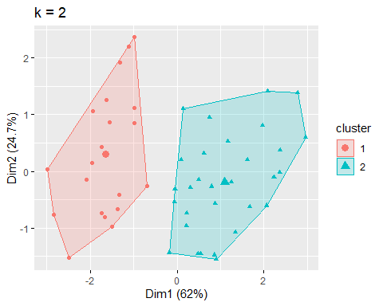

plot2_normal

## NULL

plot3

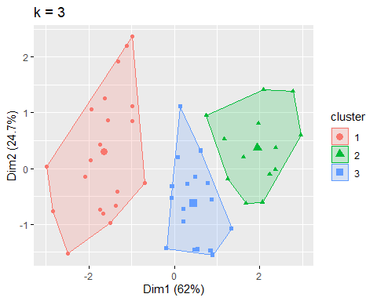

plot3_normal

## NULL

plot4

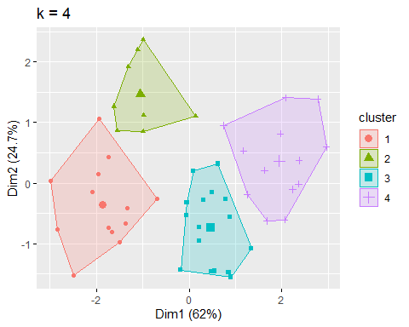

plot4_normal

## NULL

plot5

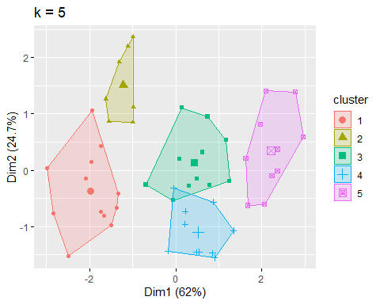

plot5_normal

## NULL

plot6

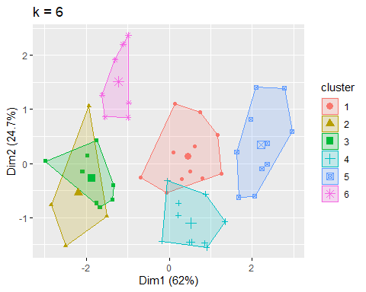

plot6_normal

## NULL

plot7

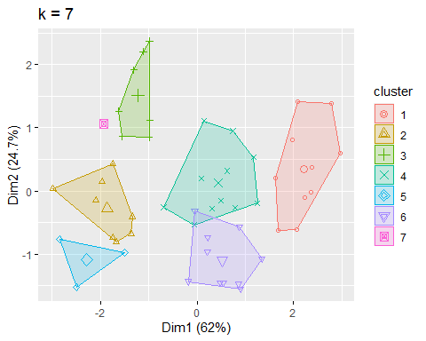

plot7_normal

## NULL

plot8

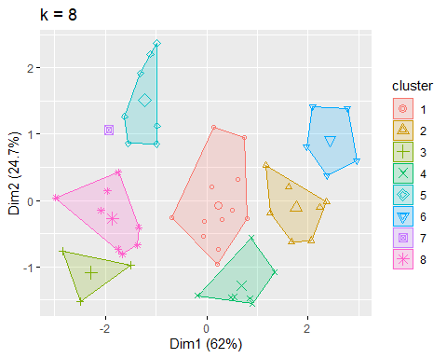

plot8_normal

## NULL

plot9

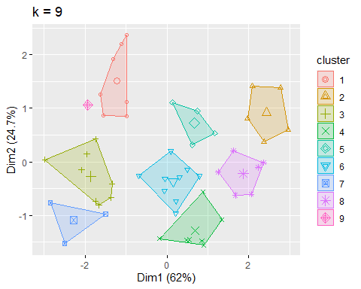

plot9_normal

## NULL

plot10

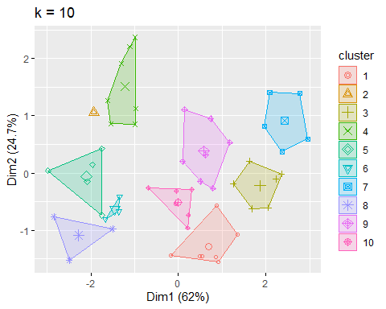

plot10_normal

## NULL

#Plot the within-cluster sum of squares for each value of k   
fviz_nbclust(arrest_data_scaled, kmeans, method = "wss")

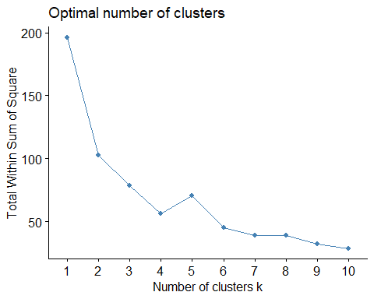

**Based on the within-cluster sum of squares plotting from above, we can see that the optimal number of clusters is 4. This is because there is an elbow in the plot after the fourth cluster**

**#Question 3**

white_wine_data <- read.csv('https://archive.ics.uci.edu/ml/machine-learning-databases/wine-quality/winequality-white.csv', header = TRUE, sep = ";")  
summary(white_wine_data)

## fixed.acidity volatile.acidity citric.acid residual.sugar   
## Min. : 3.800 Min. :0.0800 Min. :0.0000 Min. : 0.600   
## 1st Qu.: 6.300 1st Qu.:0.2100 1st Qu.:0.2700 1st Qu.: 1.700   
## Median : 6.800 Median :0.2600 Median :0.3200 Median : 5.200   
## Mean : 6.855 Mean :0.2782 Mean :0.3342 Mean : 6.391   
## 3rd Qu.: 7.300 3rd Qu.:0.3200 3rd Qu.:0.3900 3rd Qu.: 9.900   
## Max. :14.200 Max. :1.1000 Max. :1.6600 Max. :65.800   
## chlorides free.sulfur.dioxide total.sulfur.dioxide density   
## Min. :0.00900 Min. : 2.00 Min. : 9.0 Min. :0.9871   
## 1st Qu.:0.03600 1st Qu.: 23.00 1st Qu.:108.0 1st Qu.:0.9917   
## Median :0.04300 Median : 34.00 Median :134.0 Median :0.9937   
## Mean :0.04577 Mean : 35.31 Mean :138.4 Mean :0.9940   
## 3rd Qu.:0.05000 3rd Qu.: 46.00 3rd Qu.:167.0 3rd Qu.:0.9961   
## Max. :0.34600 Max. :289.00 Max. :440.0 Max. :1.0390   
## pH sulphates alcohol quality   
## Min. :2.720 Min. :0.2200 Min. : 8.00 Min. :3.000   
## 1st Qu.:3.090 1st Qu.:0.4100 1st Qu.: 9.50 1st Qu.:5.000   
## Median :3.180 Median :0.4700 Median :10.40 Median :6.000   
## Mean :3.188 Mean :0.4898 Mean :10.51 Mean :5.878   
## 3rd Qu.:3.280 3rd Qu.:0.5500 3rd Qu.:11.40 3rd Qu.:6.000   
## Max. :3.820 Max. :1.0800 Max. :14.20 Max. :9.000

head(white_wine_data)

## fixed.acidity volatile.acidity citric.acid residual.sugar chlorides  
## 1 7.0 0.27 0.36 20.7 0.045  
## 2 6.3 0.30 0.34 1.6 0.049  
## 3 8.1 0.28 0.40 6.9 0.050  
## 4 7.2 0.23 0.32 8.5 0.058  
## 5 7.2 0.23 0.32 8.5 0.058  
## 6 8.1 0.28 0.40 6.9 0.050  
## free.sulfur.dioxide total.sulfur.dioxide density pH sulphates alcohol  
## 1 45 170 1.0010 3.00 0.45 8.8  
## 2 14 132 0.9940 3.30 0.49 9.5  
## 3 30 97 0.9951 3.26 0.44 10.1  
## 4 47 186 0.9956 3.19 0.40 9.9  
## 5 47 186 0.9956 3.19 0.40 9.9  
## 6 30 97 0.9951 3.26 0.44 10.1  
## quality  
## 1 6  
## 2 6  
## 3 6  
## 4 6  
## 5 6  
## 6 6

#Observe the variance among the features to decide whether to scale or not  
  
print(apply(white_wine_data,2,var))

## fixed.acidity volatile.acidity citric.acid   
## 7.121136e-01 1.015954e-02 1.464579e-02   
## residual.sugar chlorides free.sulfur.dioxide   
## 2.572577e+01 4.773337e-04 2.892427e+02   
## total.sulfur.dioxide density pH   
## 1.806085e+03 8.945524e-06 2.280118e-02   
## sulphates alcohol quality   
## 1.302471e-02 1.514427e+00 7.843557e-01

**When observing the variance of each feature, it is observed that free.sulfur.dioxide and total.sulfur.dioxide have high variance when compared to the other features and so we perform scaling to bring them all to the same scale.**

#Perform scaling  
white_wine_data_scaled <- scale(white_wine_data, center = TRUE, scale=TRUE)

#Performing hierarchical clustering using single linkage  
single_linkage_clust <- hclust(dist(white_wine_data_scaled[ , 1:ncol(white_wine_data_scaled)-1]), method = "single")  
plot(single_linkage_clust, cex = 0.3, hang = -1, main = "Single Linkage")

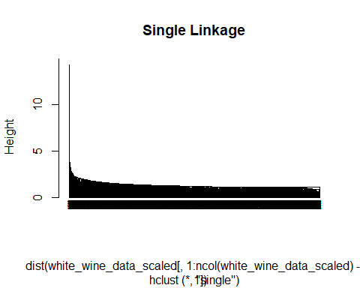

**The clusters for single linkage merged around distance: 9**

#Performing hierarchical clustering using complete linkage  
complete_linkage_clust <- hclust(dist(white_wine_data_scaled[ , 1:ncol(white_wine_data_scaled)-1]),method = "complete")  
plot(complete_linkage_clust, cex = 0.3, hang = -1, main = "Complete Linkage")

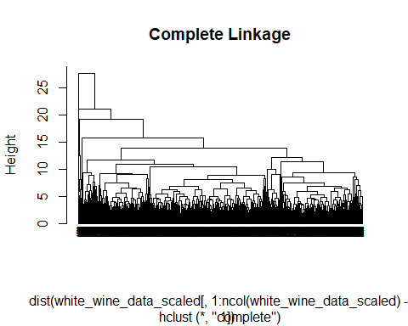

**The clusters for complete linkage merged around distance: 21**

**From above, we can see that complete linkage produces a more balanced clustering**

single_linkage_cut = cutree(single_linkage_clust,k=2)  
complete_linkage_cut = cutree(complete_linkage_clust,k=2)

#Summary statistics for single linkage  
  
#Get summary statistics and check how many observations are in each cluster  
print(table(single_linkage_cut))

## single_linkage_cut  
## 1 2   
## 4897 1

print(table(single_linkage_cut,white_wine_data$quality))

##   
## single_linkage_cut 3 4 5 6 7 8 9  
## 1 20 163 1457 2197 880 175 5  
## 2 0 0 0 1 0 0 0

summary(white_wine_data_scaled[ , 1:ncol(white_wine_data_scaled)-1],by=single_linkage_cut)

## fixed.acidity volatile.acidity citric.acid residual.sugar   
## Min. :-3.61998 Min. :-1.9668 Min. :-2.7615 Min. :-1.1418   
## 1st Qu.:-0.65743 1st Qu.:-0.6770 1st Qu.:-0.5304 1st Qu.:-0.9250   
## Median :-0.06492 Median :-0.1810 Median :-0.1173 Median :-0.2349   
## Mean : 0.00000 Mean : 0.0000 Mean : 0.0000 Mean : 0.0000   
## 3rd Qu.: 0.52758 3rd Qu.: 0.4143 3rd Qu.: 0.4612 3rd Qu.: 0.6917   
## Max. : 8.70422 Max. : 8.1528 Max. :10.9553 Max. :11.7129   
## chlorides free.sulfur.dioxide total.sulfur.dioxide density   
## Min. :-1.6831 Min. :-1.95848 Min. :-3.0439 Min. :-2.31280   
## 1st Qu.:-0.4473 1st Qu.:-0.72370 1st Qu.:-0.7144 1st Qu.:-0.77063   
## Median :-0.1269 Median :-0.07691 Median :-0.1026 Median :-0.09608   
## Mean : 0.0000 Mean : 0.00000 Mean : 0.0000 Mean : 0.00000   
## 3rd Qu.: 0.1935 3rd Qu.: 0.62867 3rd Qu.: 0.6739 3rd Qu.: 0.69298   
## Max. :13.7417 Max. :14.91679 Max. : 7.0977 Max. :15.02976   
## pH sulphates alcohol   
## Min. :-3.10109 Min. :-2.3645 Min. :-2.04309   
## 1st Qu.:-0.65077 1st Qu.:-0.6996 1st Qu.:-0.82419   
## Median :-0.05475 Median :-0.1739 Median :-0.09285   
## Mean : 0.00000 Mean : 0.0000 Mean : 0.00000   
## 3rd Qu.: 0.60750 3rd Qu.: 0.5271 3rd Qu.: 0.71974   
## Max. : 4.18365 Max. : 5.1711 Max. : 2.99502

single_linkage_clust

##   
## Call:  
## hclust(d = dist(white_wine_data_scaled[, 1:ncol(white_wine_data_scaled) - 1]), method = "single")  
##   
## Cluster method : single   
## Distance : euclidean   
## Number of objects: 4898

#Summary statistics for complete linkage  
  
#Get summary statistics and check how many observations are in each cluster  
print(table(complete_linkage_cut))

## complete_linkage_cut  
## 1 2   
## 4897 1

print(table(complete_linkage_cut,white_wine_data$quality))

##   
## complete_linkage_cut 3 4 5 6 7 8 9  
## 1 20 163 1457 2197 880 175 5  
## 2 0 0 0 1 0 0 0

summary(white_wine_data_scaled[ , 1:ncol(white_wine_data_scaled)-1],by=complete_linkage_cut)

## fixed.acidity volatile.acidity citric.acid residual.sugar   
## Min. :-3.61998 Min. :-1.9668 Min. :-2.7615 Min. :-1.1418   
## 1st Qu.:-0.65743 1st Qu.:-0.6770 1st Qu.:-0.5304 1st Qu.:-0.9250   
## Median :-0.06492 Median :-0.1810 Median :-0.1173 Median :-0.2349   
## Mean : 0.00000 Mean : 0.0000 Mean : 0.0000 Mean : 0.0000   
## 3rd Qu.: 0.52758 3rd Qu.: 0.4143 3rd Qu.: 0.4612 3rd Qu.: 0.6917   
## Max. : 8.70422 Max. : 8.1528 Max. :10.9553 Max. :11.7129   
## chlorides free.sulfur.dioxide total.sulfur.dioxide density   
## Min. :-1.6831 Min. :-1.95848 Min. :-3.0439 Min. :-2.31280   
## 1st Qu.:-0.4473 1st Qu.:-0.72370 1st Qu.:-0.7144 1st Qu.:-0.77063   
## Median :-0.1269 Median :-0.07691 Median :-0.1026 Median :-0.09608   
## Mean : 0.0000 Mean : 0.00000 Mean : 0.0000 Mean : 0.00000   
## 3rd Qu.: 0.1935 3rd Qu.: 0.62867 3rd Qu.: 0.6739 3rd Qu.: 0.69298   
## Max. :13.7417 Max. :14.91679 Max. : 7.0977 Max. :15.02976   
## pH sulphates alcohol   
## Min. :-3.10109 Min. :-2.3645 Min. :-2.04309   
## 1st Qu.:-0.65077 1st Qu.:-0.6996 1st Qu.:-0.82419   
## Median :-0.05475 Median :-0.1739 Median :-0.09285   
## Mean : 0.00000 Mean : 0.0000 Mean : 0.00000   
## 3rd Qu.: 0.60750 3rd Qu.: 0.5271 3rd Qu.: 0.71974   
## Max. : 4.18365 Max. : 5.1711 Max. : 2.99502

complete_linkage_clust

##   
## Call:  
## hclust(d = dist(white_wine_data_scaled[, 1:ncol(white_wine_data_scaled) - 1]), method = "complete")  
##   
## Cluster method : complete   
## Distance : euclidean   
## Number of objects: 4898