Ex. No. 2 | WORKING WITH HTML5 FORM AND MEDIA ELEMENTS
Date of Exercise | 24.07.2026
GitHub Host Link | https://github.com/jenohsam2006/WT_LAB.git

Aim
Build a website that conforms to HTML5 standards and has the following elements: doctype, html, title, body, head, div, p, headings, image, anchor, table, audio, video, embed, iframe, form, input, select, progress, fieldset, label, html comment etc..
Description
HTML Form Elements:
All forms start with the <FORM> tag and end with </FORM>. All other form objects go between these two tags.
The form tag has two main properties: METHOD and ACTION.
<form action="/action_page.php" method="get"> </form>
The <form> element can contain one or more of the following form elements:
- <input>
- <textarea>
- <button>
- <select>
- <option>
- <fieldset>
- <label>
The <input> tag specifies an input field where the user can enter data. <input> elements are used within a <form> element to declare input controls that allow users to input data. An input field can vary in many ways, depending on the type attribute.
<form action="/action_page.php" method="get">
First name: <input type="text" name="fname"><br>
Last name: <input type="text" name="lname"><br>
<input type="submit" value="Submit">
</form>
Input Types:
Here are the different input types you can use in HTML:
<input type="button">
<input type="checkbox">
<input type="date">
<input type="datetime-local">
<input type="email">
<input type="file">
<input type="hidden">
<input type="image">
<input type="month">
<input type="number">
<input type="password">
<input type="radio">
<input type="range">
<input type="reset">
<input type="search">
<input type="submit">
<input type="tel">
<input type="text">
<input type="time">
<input type="url">
<input type="week">
The <textarea> tag defines a multi-line text input control. A text area can hold an unlimited number of characters, and the text renders in a fixed-width font (usually Courier). The size of a text area can be specified by the cols and rows attributes, or even better; through CSS' height and width properties.
<textarea rows="4" cols="50">
</textarea>
The <select> element is used to create a drop-down list. The <option> tags inside the <select> element define the available options in the list.
<select>
<option value="volvo">Volvo</option>
<option value="saab">Saab</option>
<option value="mercedes">Mercedes</option>
<option value="audi">Audi</option>
</select>
The <fieldset> tag is used to group related elements in a form. The <fieldset> tag draws a box around the related elements.
<form>
<fieldset>
<legend>Personalia:</legend>
Name: <input type="text"><br>
Email: <input type="text"><br>
Date of birth: <input type="text">
</fieldset>
</form>

Media Elements:
The following are the most popular media elements.
- audio
Audio element is used for defining or creating a music element in your simple HTML page.
<audio controls>
<source src = "1.mp3" type = "audio/mpeg" >
</audio>
- video
The Video element creates a video element in your HTML page.
<video controls>
<source src= "1.mp4" type="video/mp4"
</video>
- embed
It is also called a container because as the name suggests it is used for defining containers for the external applications or we can say plug-ins for the applications.
<embed src="1.swf">

Program
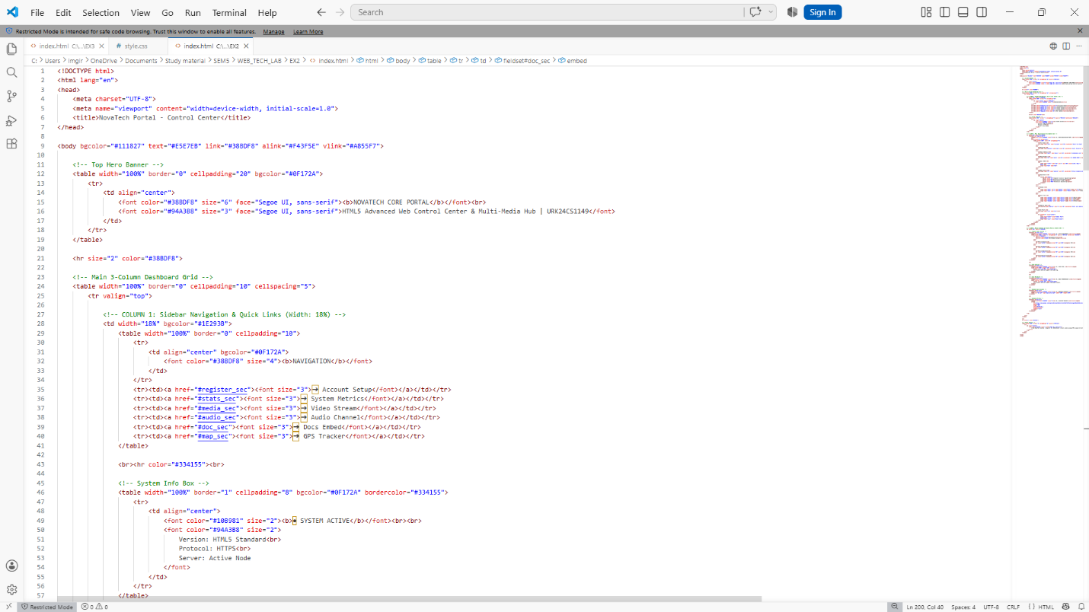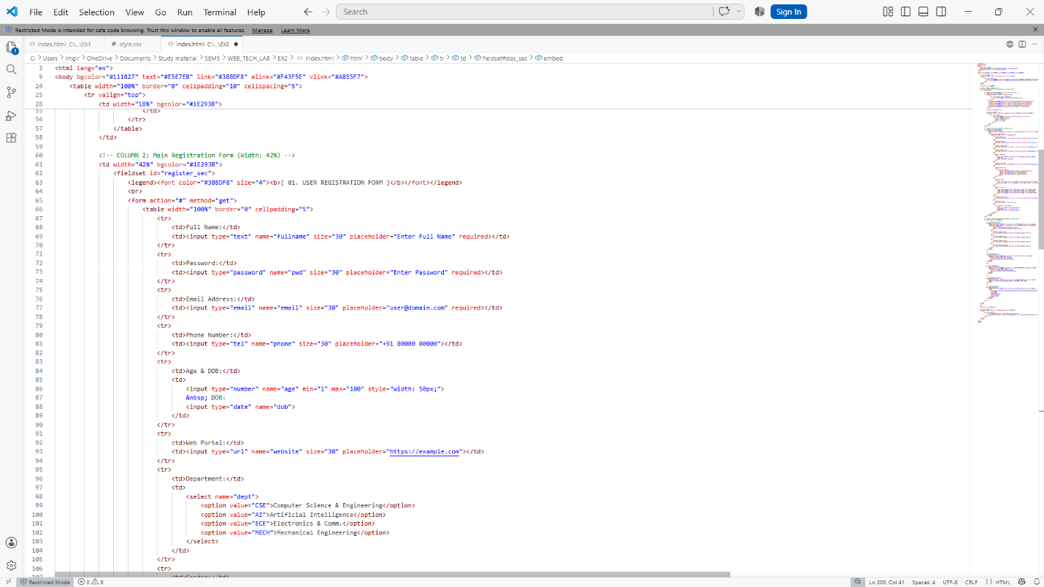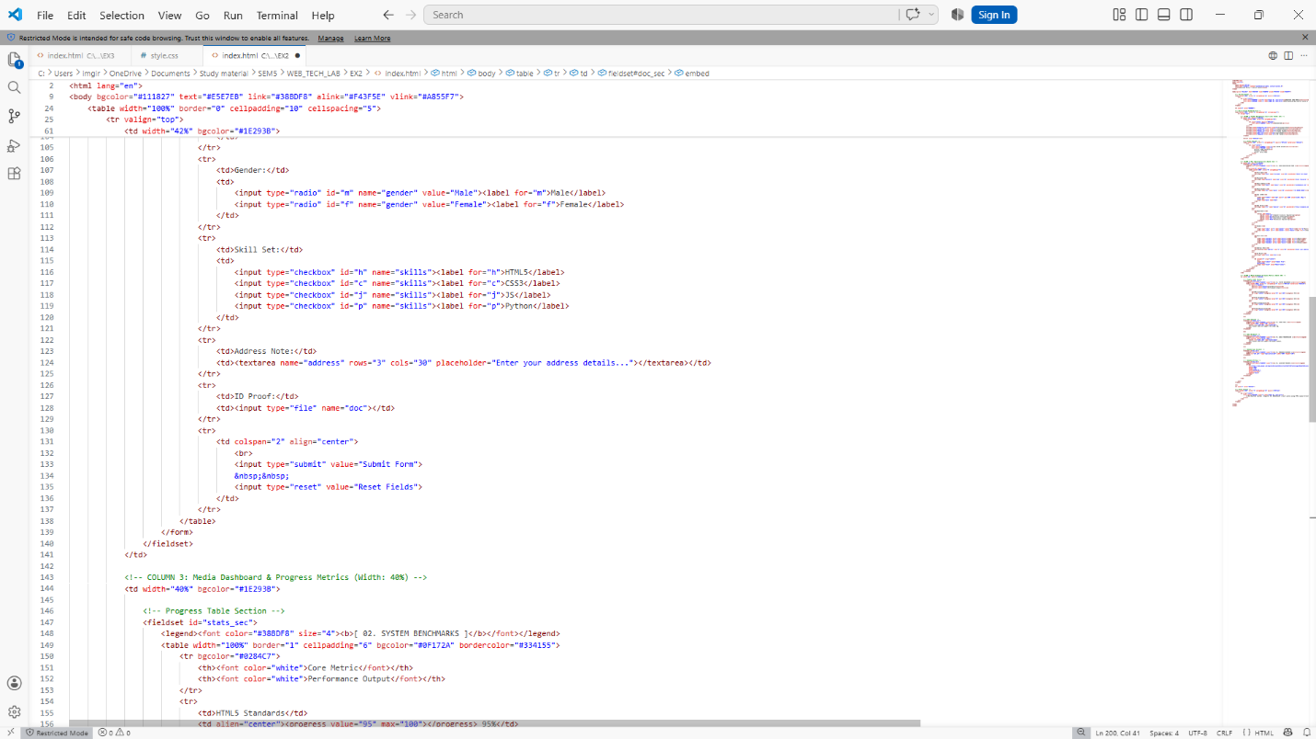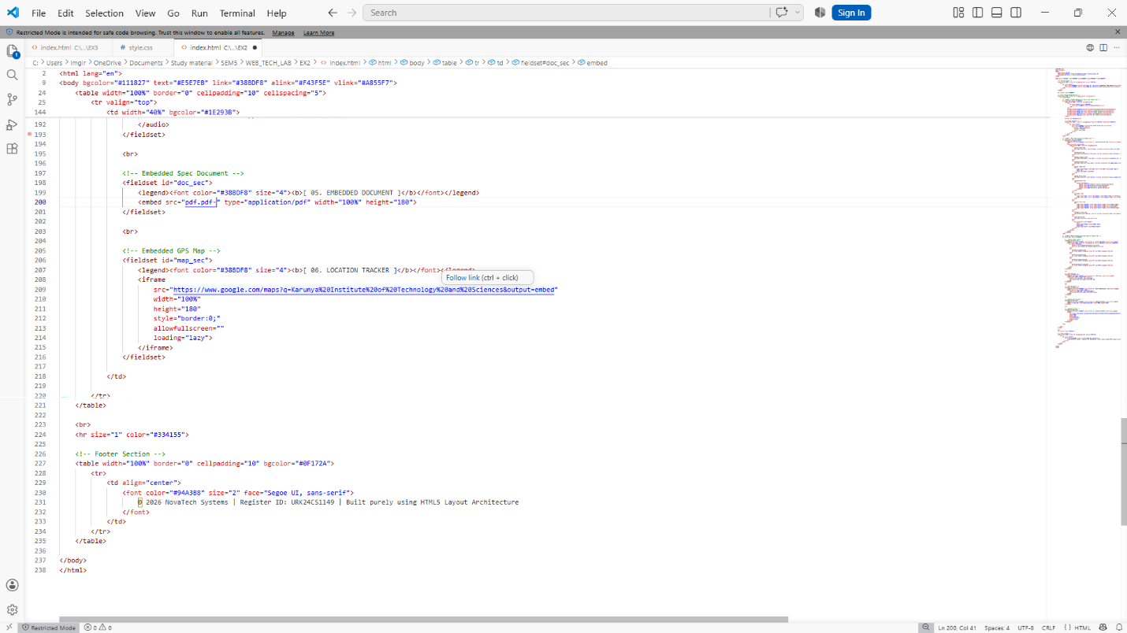

Web Page
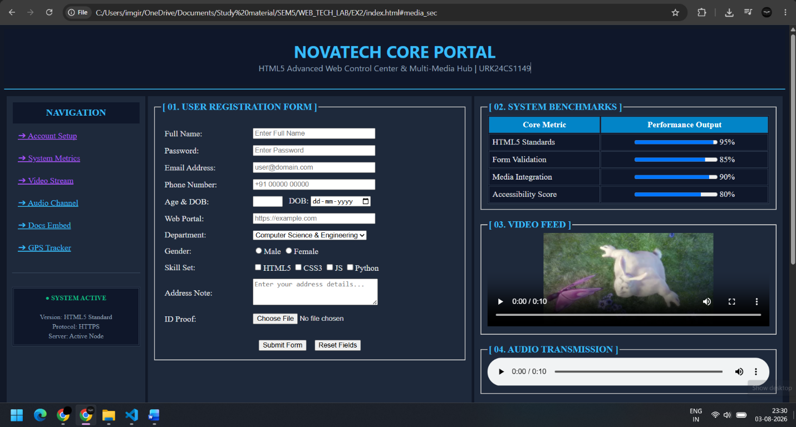
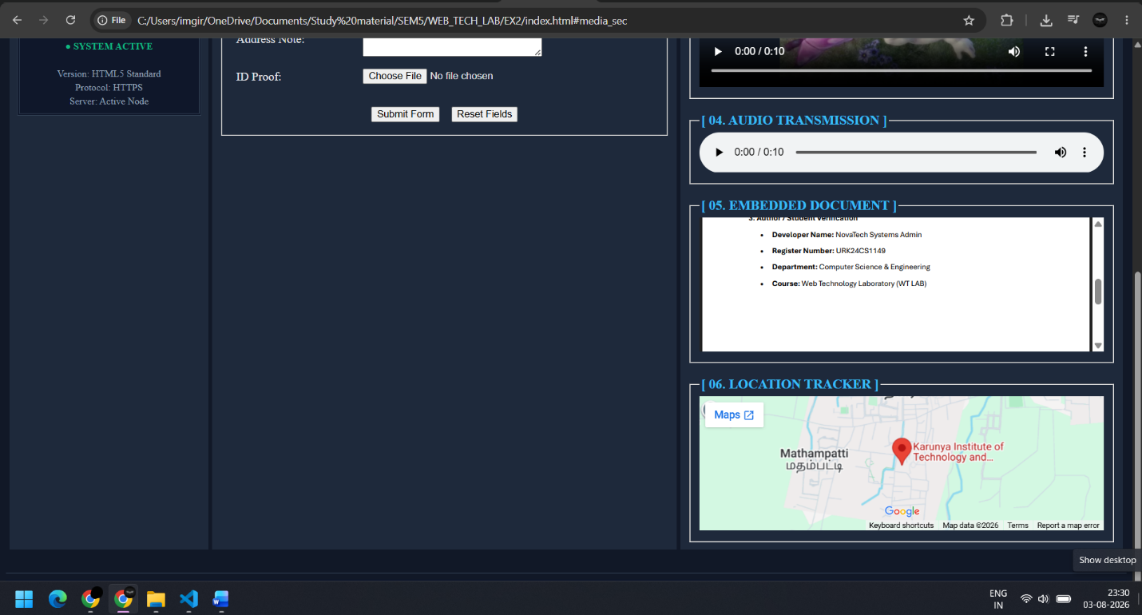

Result
A responsive HTML5 Student Portfolio website was successfully created using HTML5 elements such as doctype, headings, paragraphs, images, hyperlinks, tables, forms, input controls, select, fieldset, labels, progress bar, audio, video, embed, iframe, and comments. The webpage displayed a student registration form, multimedia content, a skills table, and a location map, thereby meeting the objectives of the experiment.

