Ex. No. 4 | Webpage Design Using Advanced CSS3
Date of Exercise | 07.08.2026
GitHub Host Link | https://github.com/jenohsam2006/WT_LAB.git

Aim
To develop a website using HTML5 tags and apply styles to the website using advanced CSS3 properties such as rounder corners, border images, multiple backgrounds, gradients, shadows.
Description
Rounded Corners
- The CSS border-radius property defines the radius of an element's corners.
border-radius: 25px
- Four values - border-radius: 15px 50px 30px 5px; (first value applies to top-left corner, second value applies to top-right corner, third value applies to bottom-right corner, and fourth value applies to bottom-left corner):
Border Image
The CSS border-image property allows you to specify an image to be used instead of the normal border around an element. The property has three parts:
- The image to use as the border
- Where to slice the image
- Define whether the middle sections should be repeated or stretched
border-image: url(border.png) 30 round
border-image: url(border.png) 30 stretch
Multiple Backgrounds
CSS allows to add multiple background images for an element, through the background-image property. The different background images are separated by commas, and the images are stacked on top of each other, where the first image is closest to the viewer. The following example has two background images, the first image is a flower (aligned to the bottom and right) and the second image is a paper background (aligned to the top-left corner):

#example1 {
background-image: url(img_flwr.gif), url(paper.gif);
background-position: right bottom, left top;
background-repeat: no-repeat, repeat;
}
Background Size
The CSS background-size property allows you to specify the size of background images. The size can be specified in lengths, percentages, or by using one of the two keywords: contain or cover. The following example resizes a background image to much smaller than the original image (using pixels):
#div1 {
background: url(img_flower.jpg);
background-size: 100px 80px;
background-repeat: no-repeat;
}
Pseudo classes
Use pseudo-classes focus, required, valid, hover to enable CSS in the <input> elements.
input:focus{
border: 3px solid red;
background-color: green;
}
input:required{
border: 3px solid blue;
background-color: yellow;
}
input[type="email"]:invalid{ color:red; }
input[type="email"]:valid{ color:blue; }
<table><tr><td class="itemName">item1</td>
<td class="itemImg"><img src="item1.jpg" ></td></tr> </table>
.itemImg{ opacity:0.2; }
.itemName:hover .itemImg{ opacity: 1; }
Hint: itemName and itemImg are adjacent sibling. On hover of itemName select its adjacent sibiling itemImg. Set different colors for odd and even rows and change the background color on mouse over. [hint: nth-child(odd) and nth-child(even)].
Program
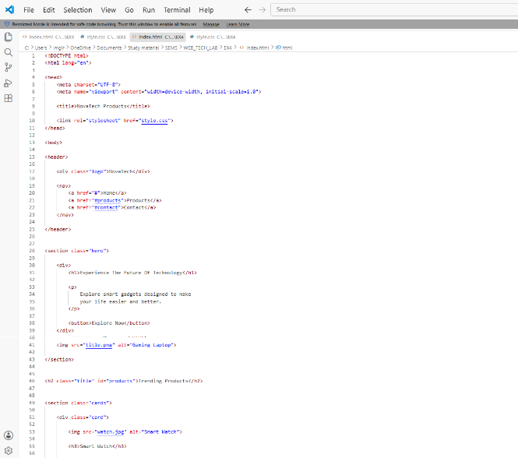
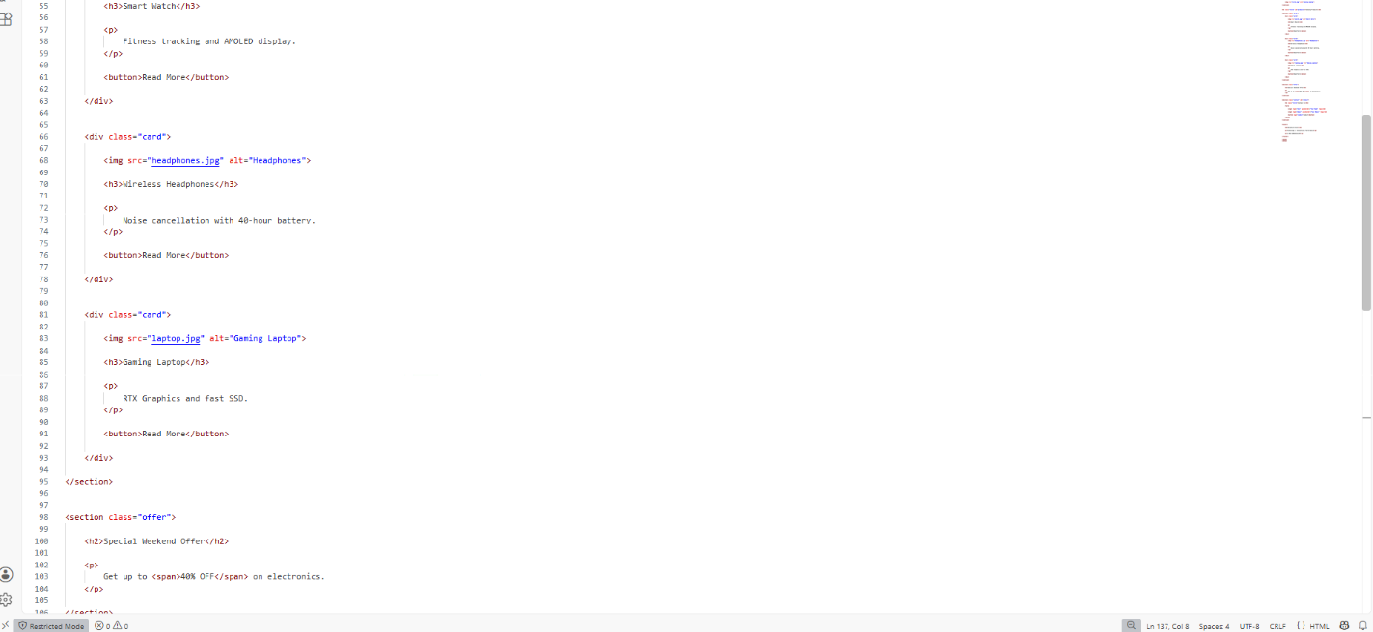
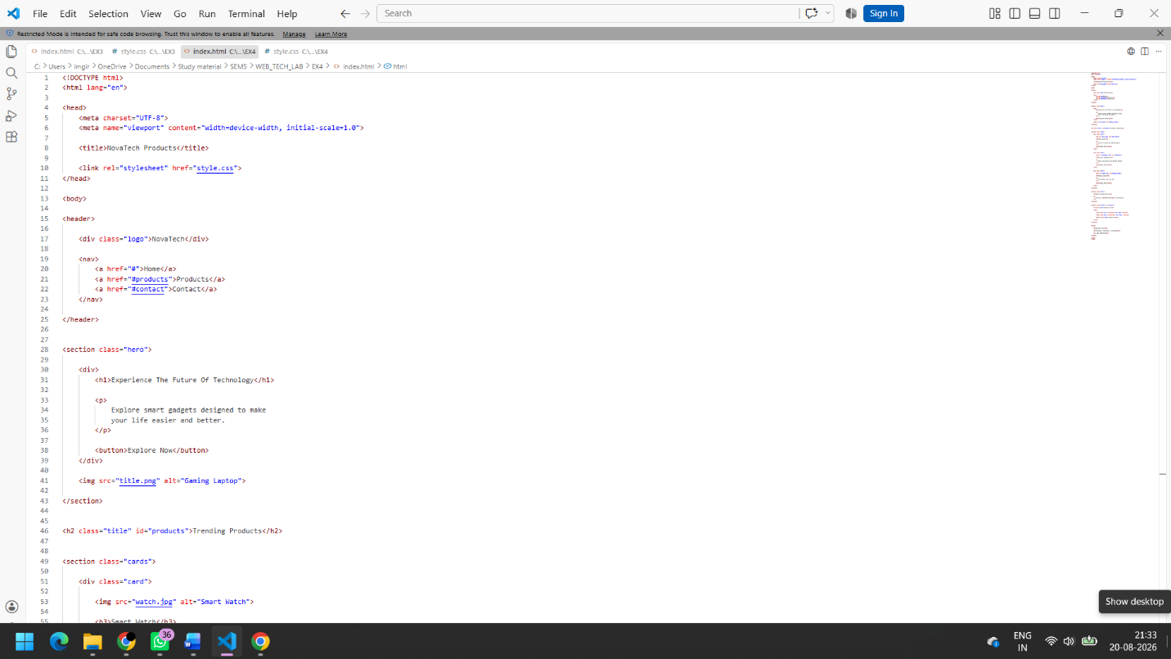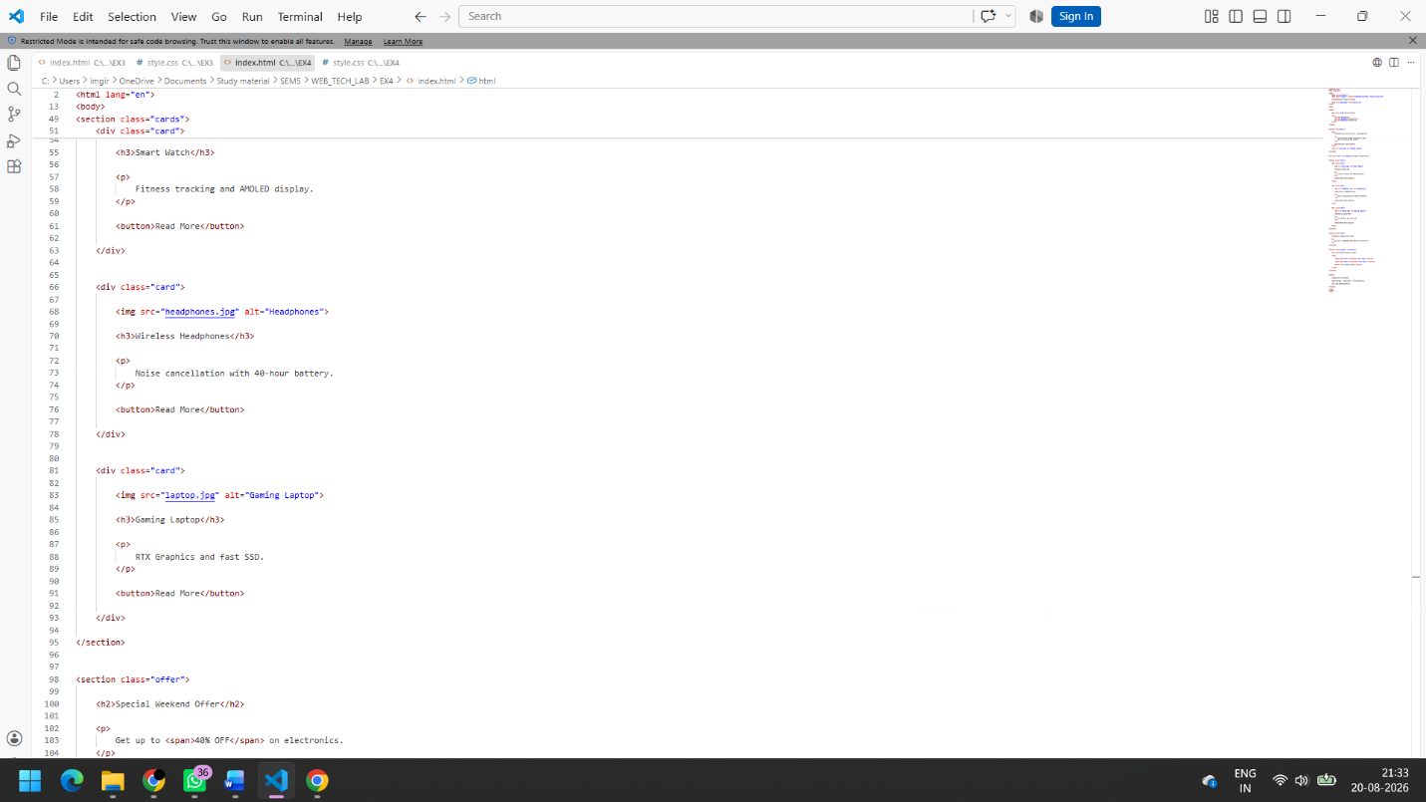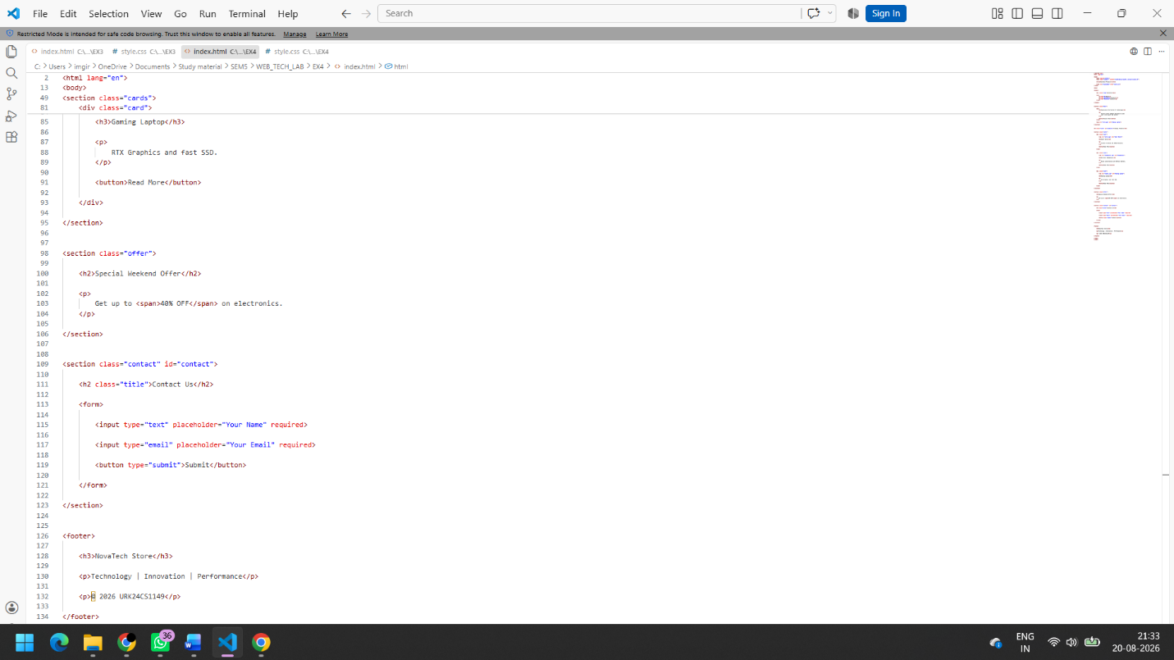

Output



Result
A Travel World website was successfully created using HTML5 and Advanced CSS3. The webpage included rounded corners, gradients, border images, multiple backgrounds, shadows, pseudo-classes, hover effects, and table styling, meeting the objectives of the experiment.

