Ex. No. 6 | JAVASCRIPT - TIMER FUNCTIONS AND ARRAYS
Date of Exercise | 28.08.2026
GitHub Host Link | https://github.com/jenohsam2006/WT_LAB.git

Aim
To create web pages using various timer functions, events and objects in JavaScript.
Description
Timing Events
The window object allows execution of code at specified time intervals. These time intervals are called timing events. The three key methods to use with JavaScript are:
- setTimeout(function, milliseconds)
Executes a function, after waiting a specified number of milliseconds.
Ex: window.setTimeout(function, milliseconds);
- setInterval(function, milliseconds)
Same as setTimeout(), but repeats the execution of the function continuously.
Ex: window.setInterval(function, milliseconds);
- The clearInterval() method stops the executions of the function specified in the setInterval() method.
EX: window.clearInterval(timer Variable)
Date Object
Date Object gives various methods to multiple ways to access date, month, year details.
Method | Description
getDate() | Returns the day of the month (from 1–31).
getDay() | Returns the day of the week (from 0–6).
getFullYear() | Returns the year.
getHours() | Returns the hour (from 0–23).
getMilliseconds() | Returns the milliseconds (from 0–999).
getMinutes() | Returns the minutes (from 0–59).
getMonth() | Returns the month (from 0–11).
getSeconds() | Returns the seconds (from 0–59).
getTime() | Returns the number of milliseconds since January 1, 1970, for a specified date.
setTime() | Sets a date to a specified number of milliseconds before/after January 1, 1970.
setDate() | Sets the day of the month of a Date object.
setFullYear() | Sets the year of a Date object.
setHours() | Sets the hour of a Date object.
setMilliseconds() | Sets the milliseconds of a Date object.
setMinutes() | Sets the minutes of a Date object.
setMonth() | Sets the month of a Date object.
setSeconds() | Sets the seconds of a Date object.
toString() | Converts a Date object to a string.
toTimeString() | Converts the time portion of a Date object to a string.

Class and Object
Converts a Date object to a string Converts the time portion of a Date object to a string A class is a type of function, but instead of using the keyword function to initiate it, we use the keyword class, and the properties is assigned inside a constructor() method.
Example:
class Car {
constructor(brand) {
this.carname = brand;
}
present() {
return “I have a ” + this.carname;
}
}
mycar = new Car("Ford");
document.getElementById("demo").innerHTML = mycar.present();

Sample Questions:
1. Write JavaScript code to display digital clock.
<h1>Digital Clock!</h1>
<span id="time"></span>.
<script>
//define function display
//call the time display function for every one second </script>
// get time
var d= new Date();
// extract hour, minutes and seconds
d.getHours
d.getMinutes()
d.getSeconds()
// call the time display function for every one second
setInterval("display()", 1000);
Program
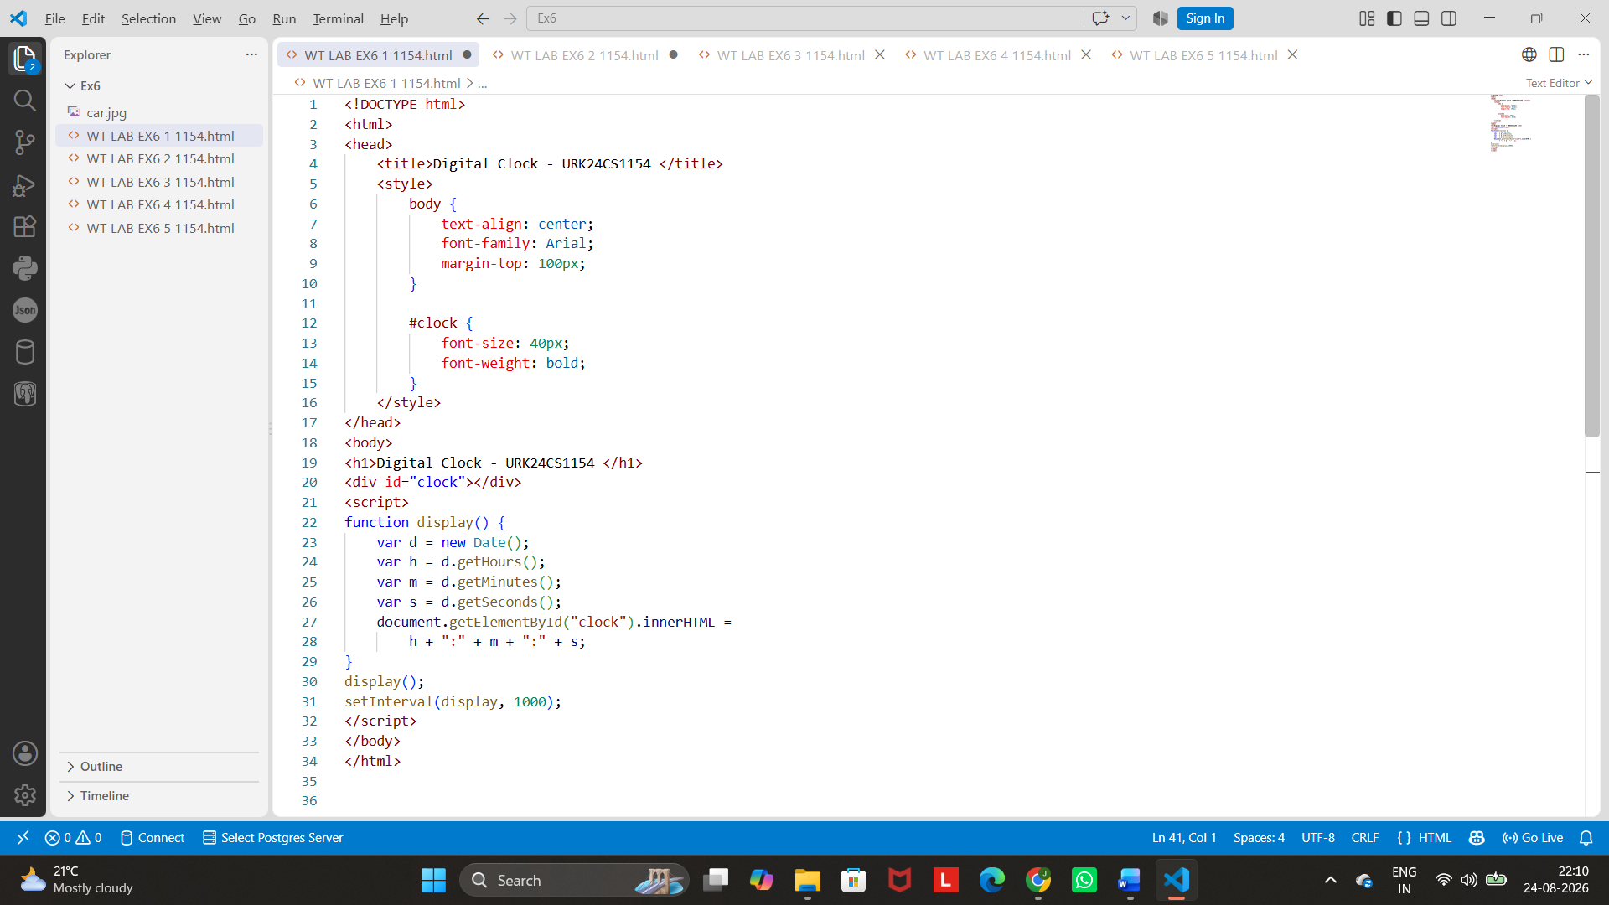
Output
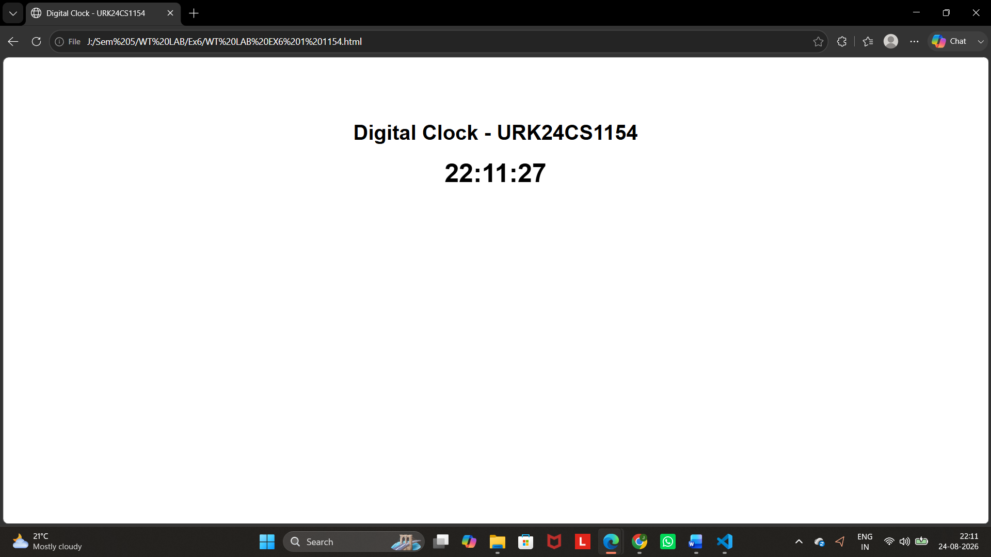
2. Write JavaScript code to change background colour for every 30 seconds.

<body>
<h1>Dynamic Background!</h1>
<script>
//define function setBackgroundColor
//call the setBackgroundColor function for every two seconds
</script>
</body>

//create random colors using rgb function
var red = Math.floor(Math.random()*255);
var blue = Math.floor(Math.random()*255);
var green = Math.floor(Math.random()*255);
var color= "rgb("+red+","+green+","+blue+")";
//change or set body background color
document.getElementsByTagName("body")[0].style="background-color:"+color;

Program
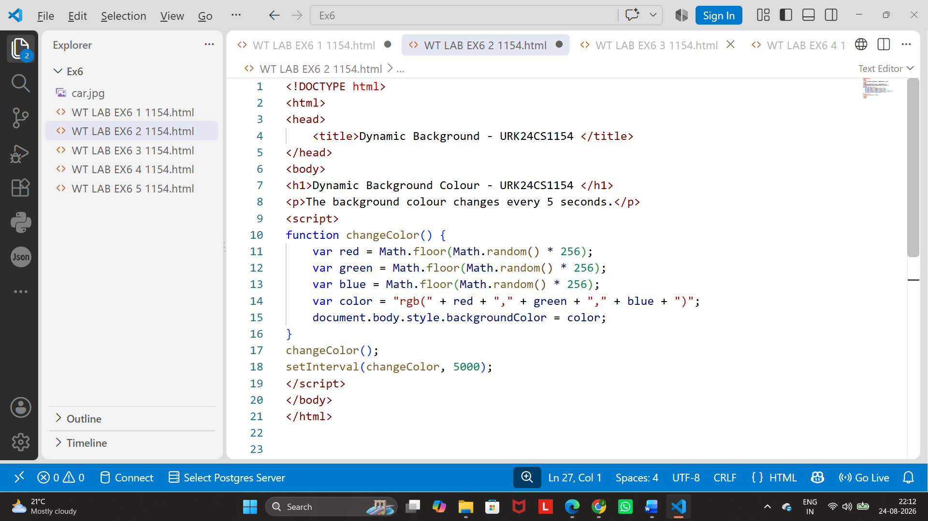

Output

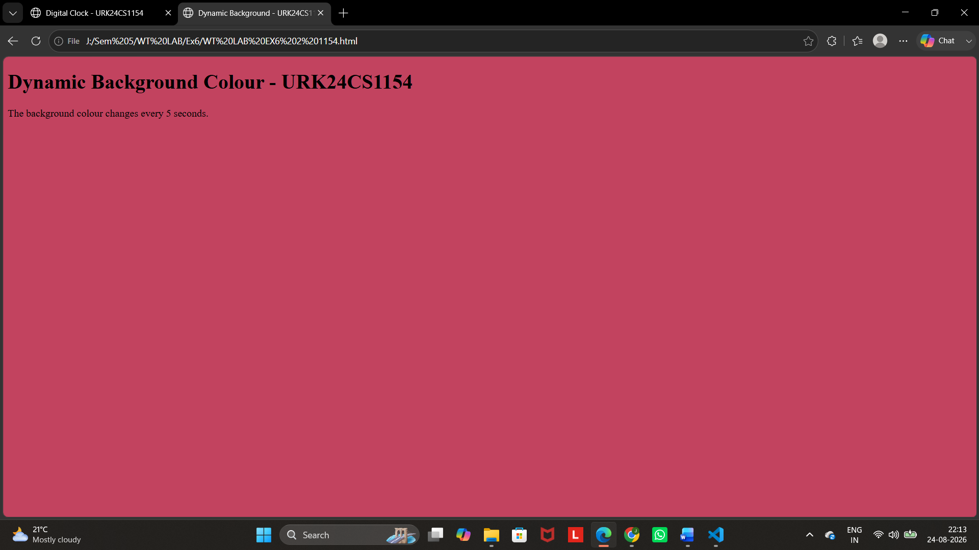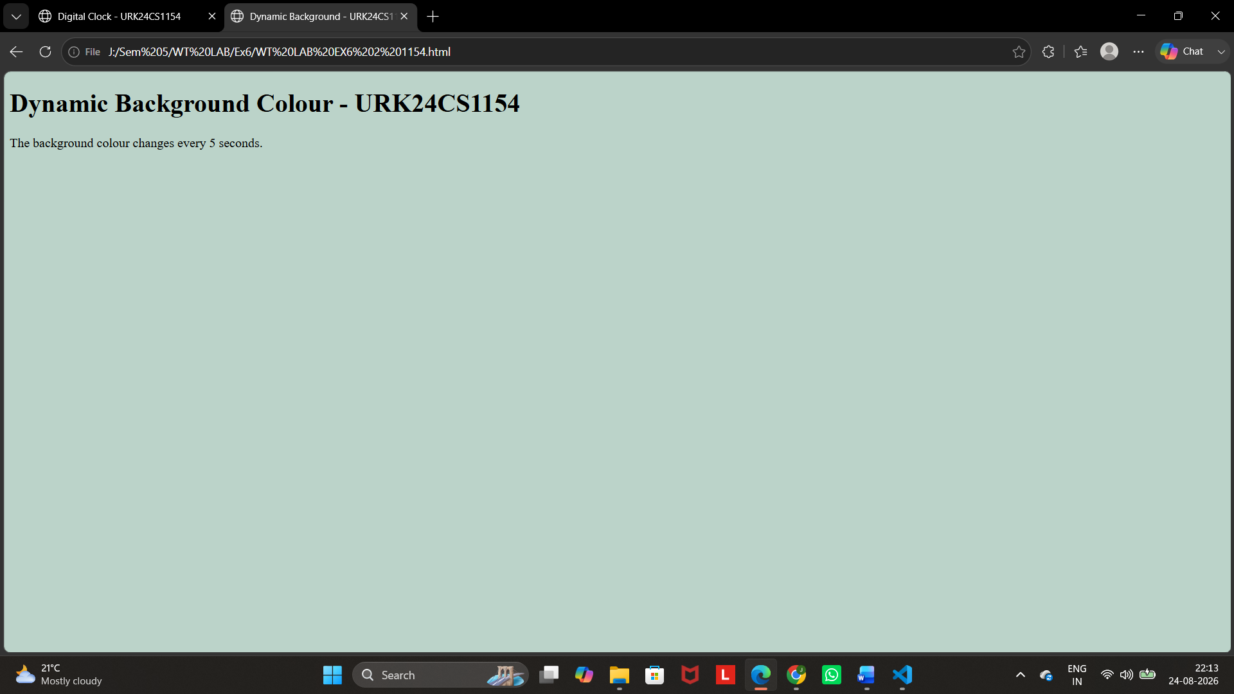

3. Create event handlers that will increase the font size when a mouse moves over a paragraph and decrease the size when the mouse moves off the paragraph.

<h1>Change font size!</h1>
<p id="paral" onmouseover="incSize()" onmouseout="decSize()"> move cursor over me to zoom in...
</p>
<script>
//define function incSize
//define function decSize
</script>
</body>

// To change font size
function incSize(){
document.getElementById("para1").style="font-size:28px"; }

Program
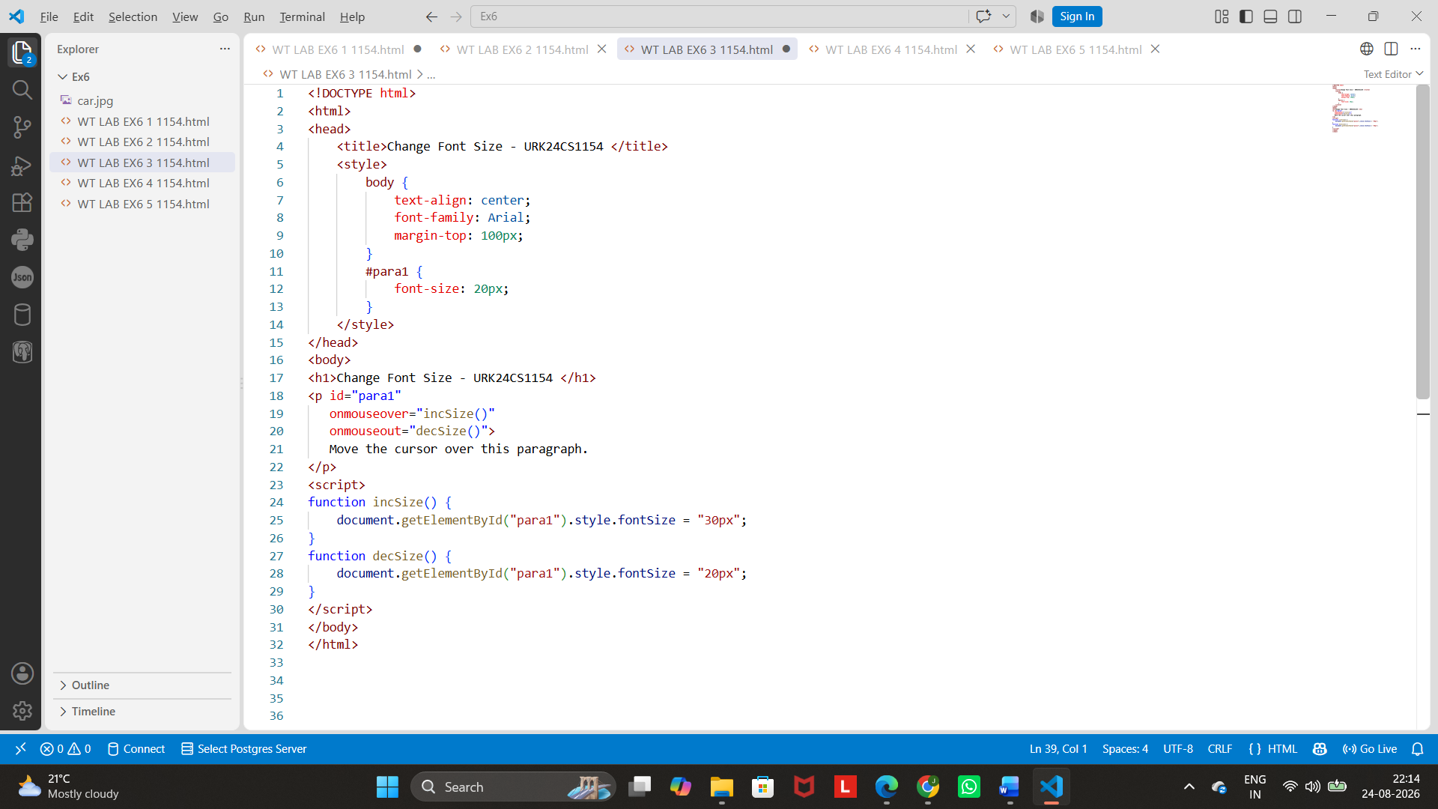

Output

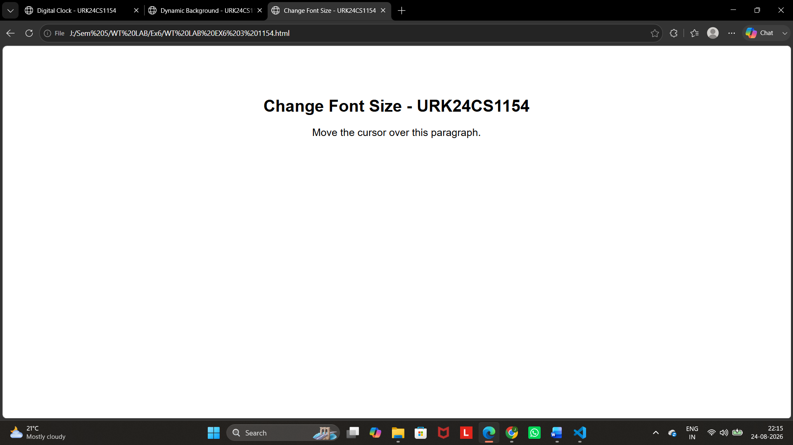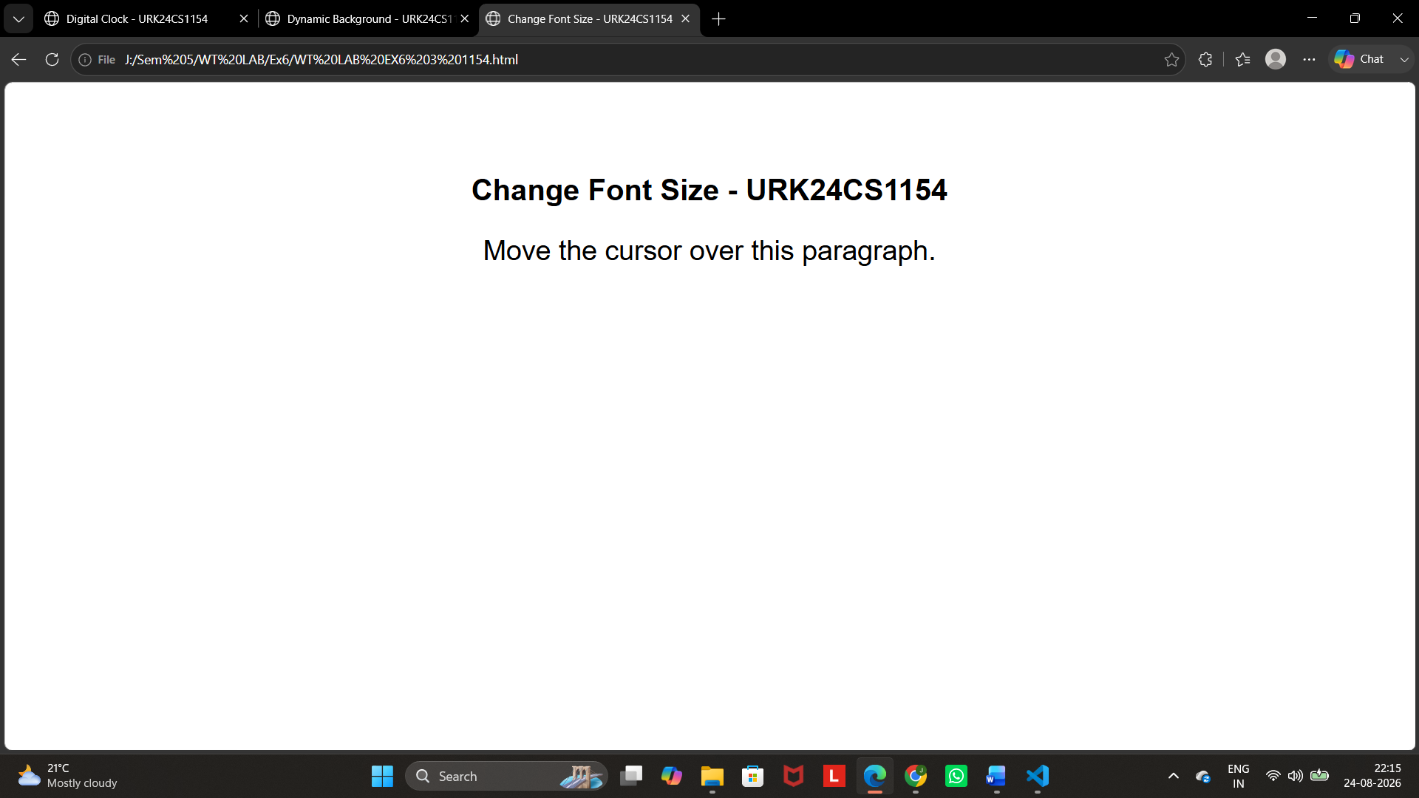

4. Write JavaScript code to move absolutely-positioned car image when a user clicks the move button and stop the car image when a user clicks the stop button on the following webpage.
//sample code to move image
function init()
{
imgObj = document.getElementById('img');
imgObj.style.position= 'relative'; imgObj.style.left = '0px';
}
function moveRight()
{
imgObj.style.left = parseInt(imgObj.style.left) + 1 + 'px';
animate = setTimeout('moveRight()', 10); // call moveRight in 20msec
}

function stop()
{
clearTimeout(animate);
imgObj.style.left = '0px';
}
window.onload =init();

Program
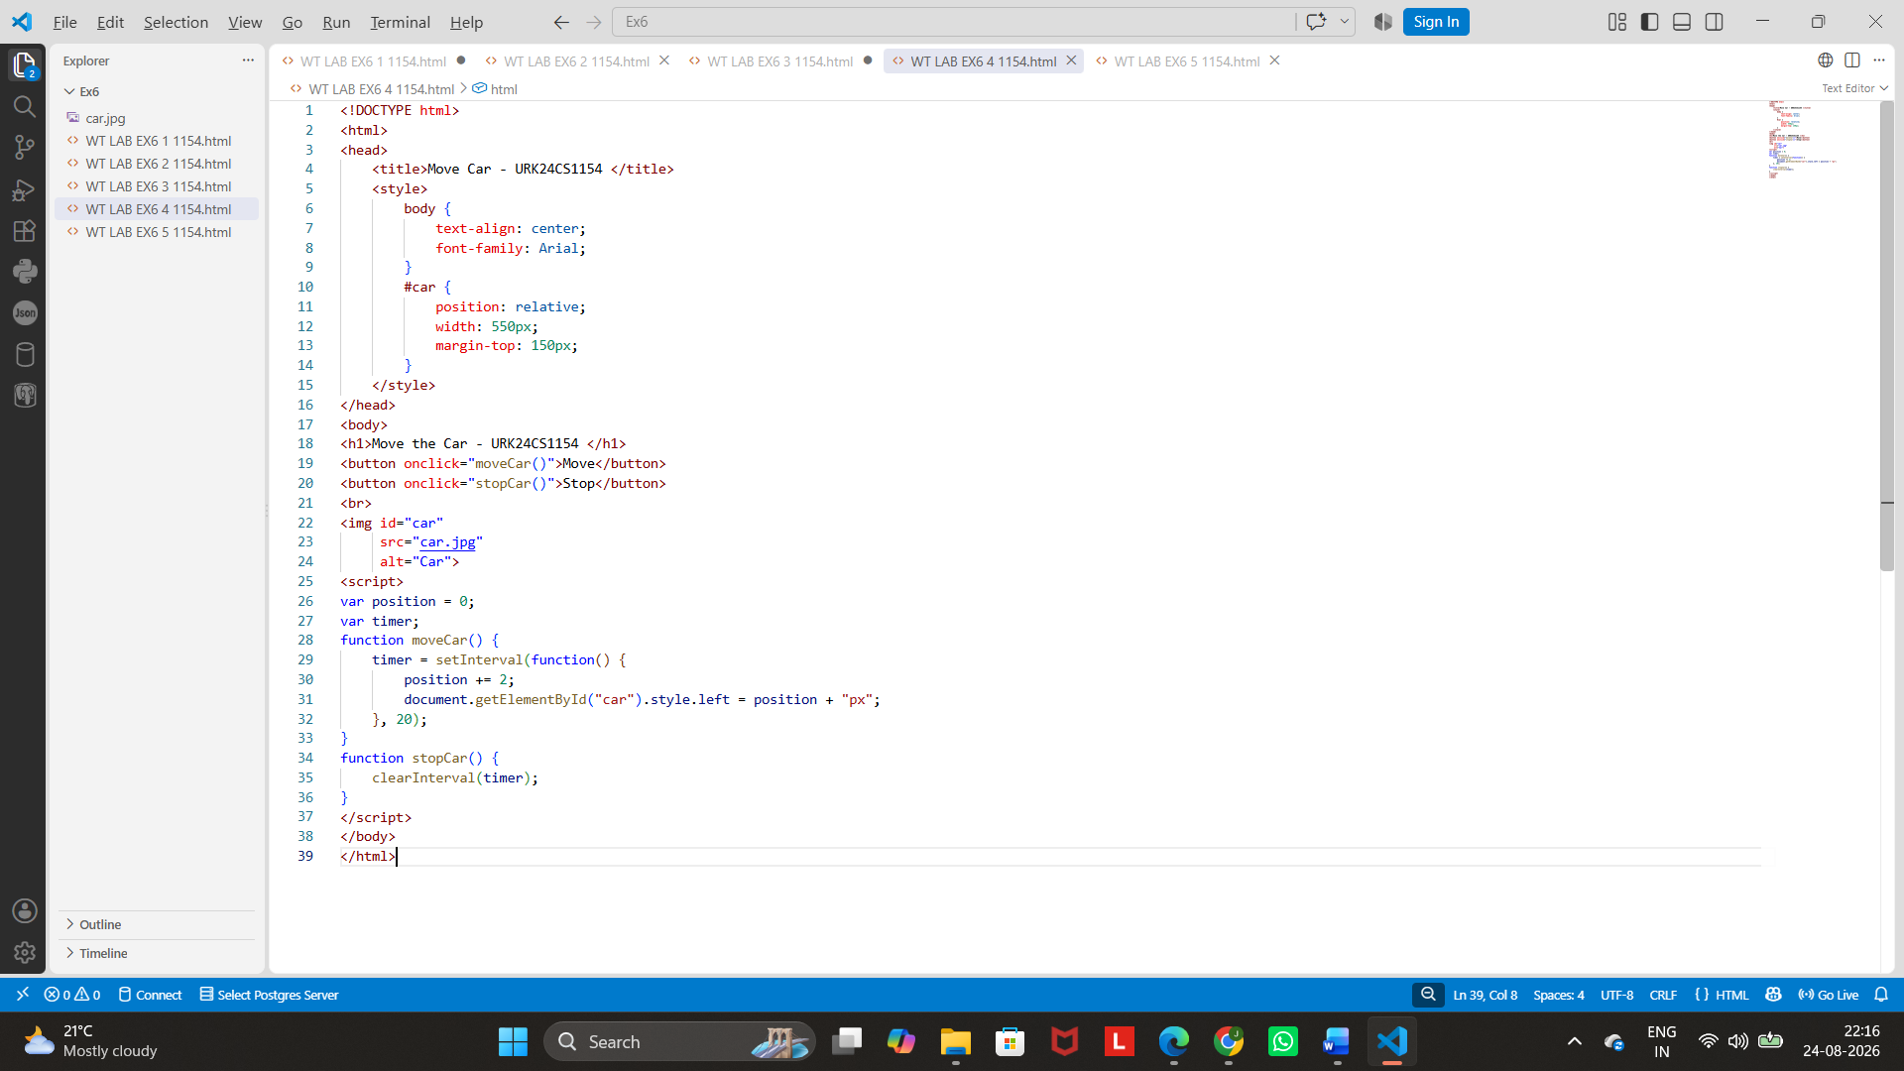
Output

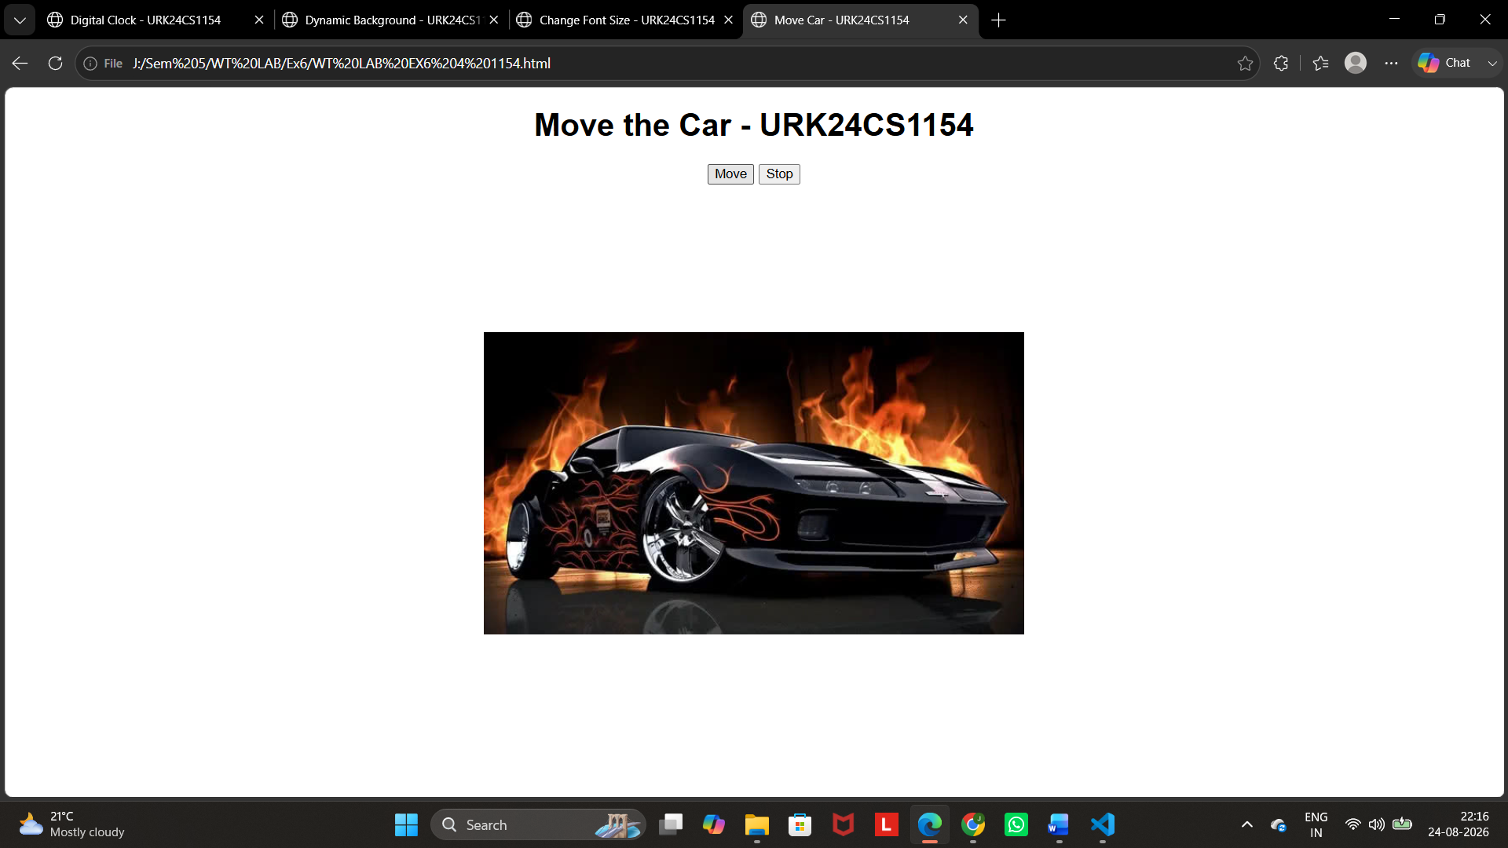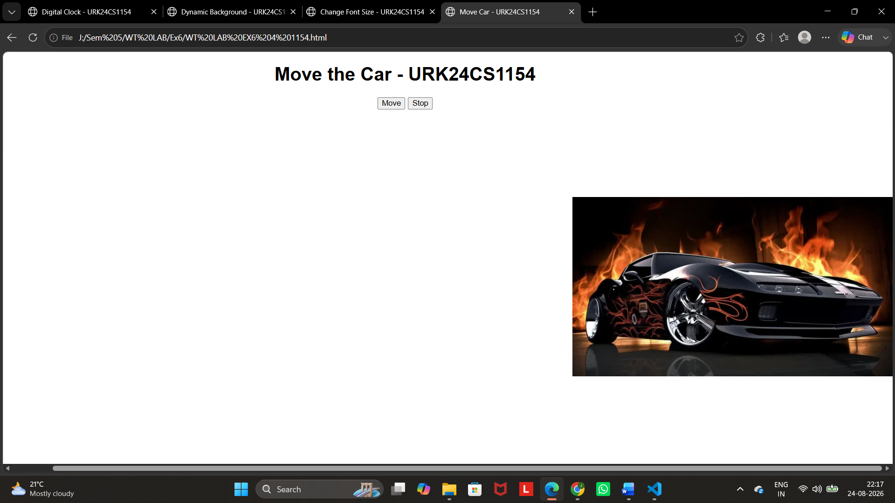

5. Create an array of objects, where each object describes about a student and his/her properties for the name (a string), regno (a string) and year of birth (a number). Iterate through the array of students and display it on the web page. For each student, print the student name and register no like so: "John's Register Number is UR13CS129". Now use an if/else statement to categorize the students they have date of birth before 2000 and after 2000.

// Create an array of objects
var student = [ { name:'John', r_num:'123', dob:'20-apr-1995' },
{ name:'Joseph', r_num:'456', dob: '05-jan-1998' }];
//Iterate through an array
for (var i = 0; i < Objectname.length; i++) {
//access property
Objectname[i].property1;
//student[i].name;
}

Program
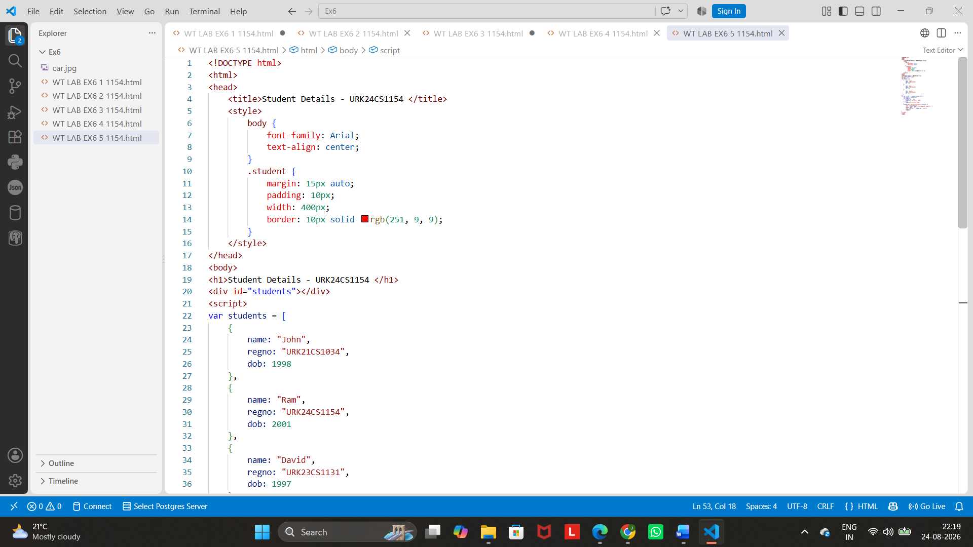
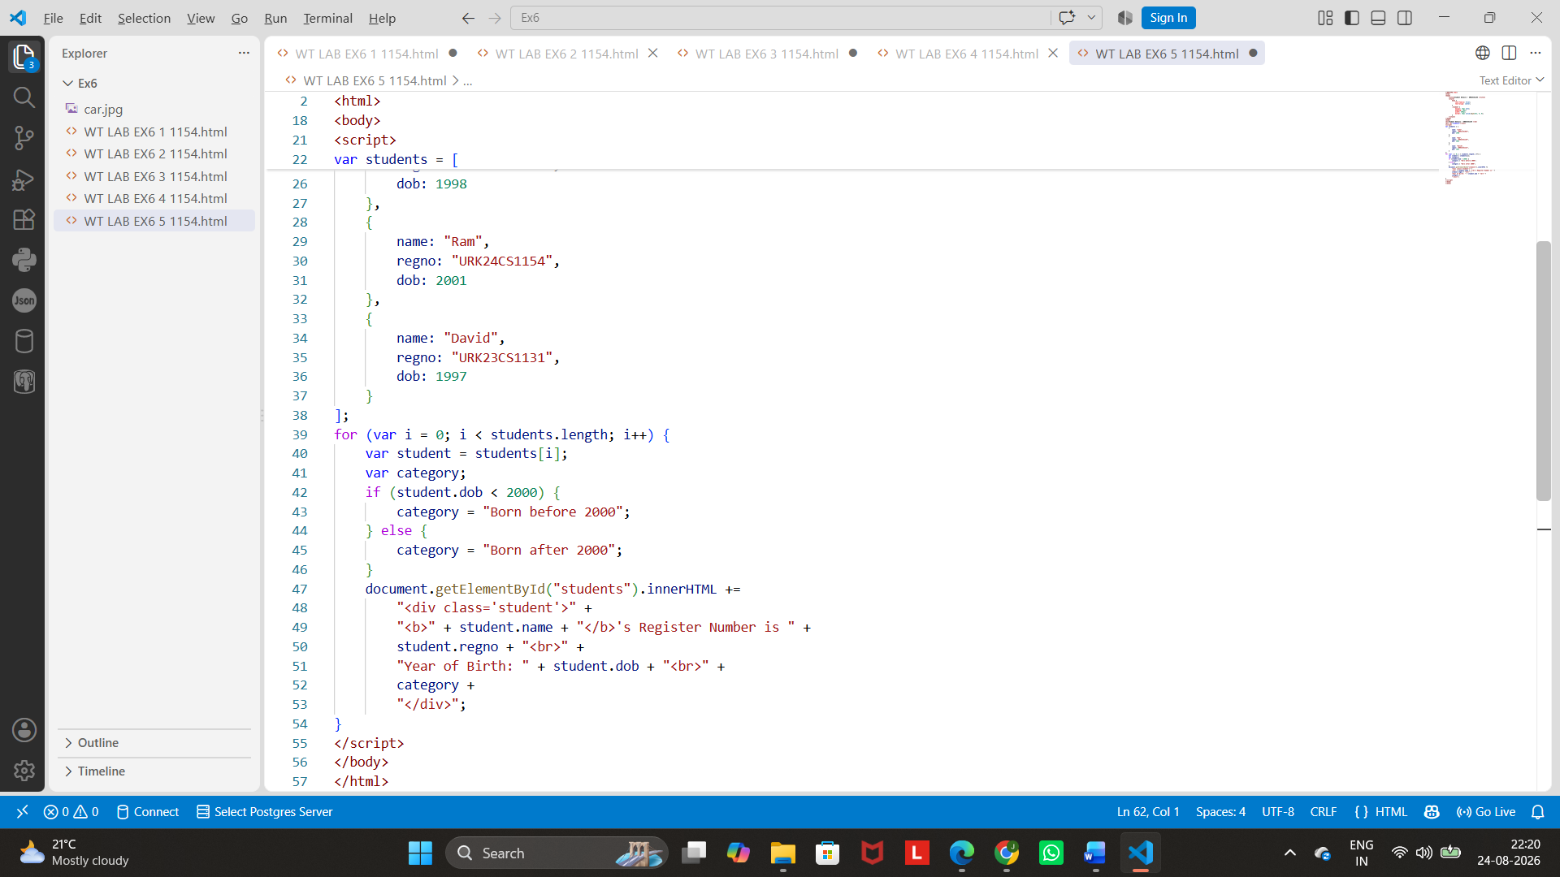
Output
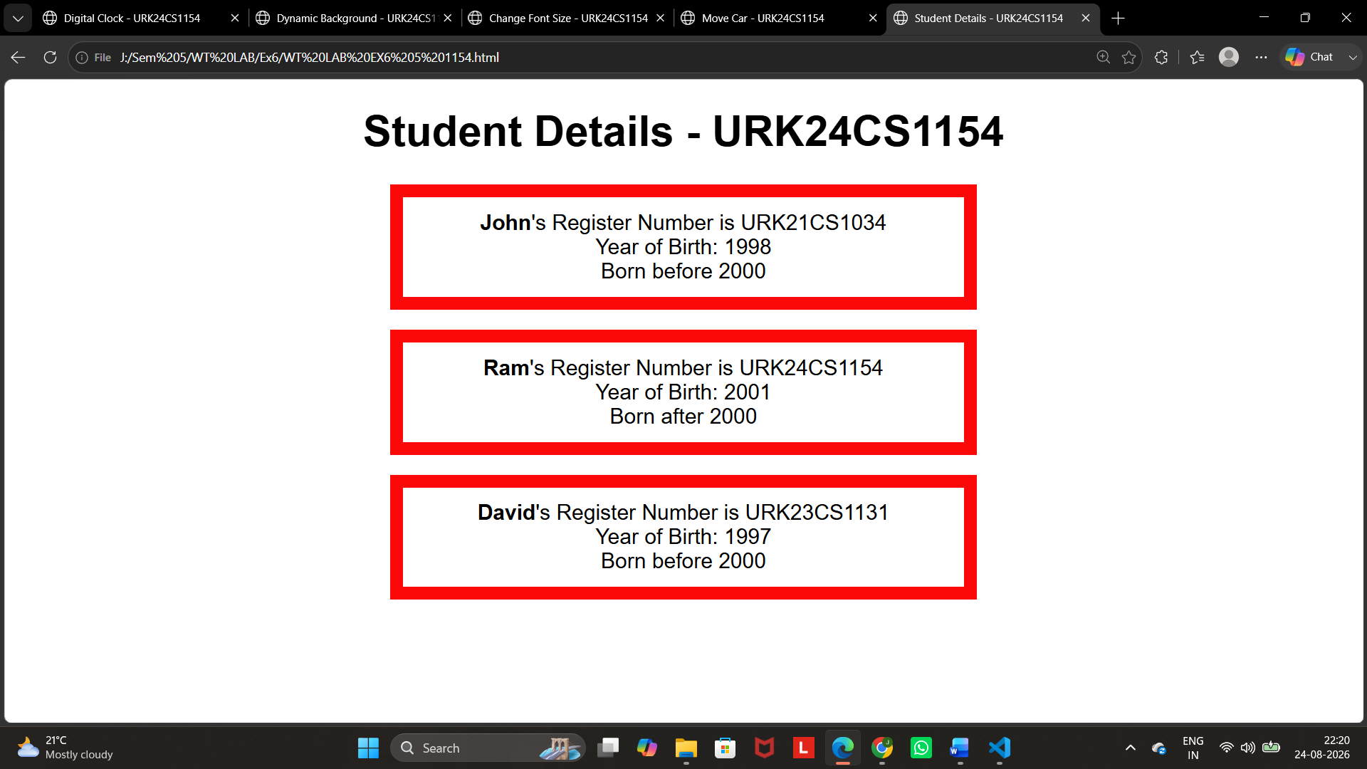
Result
Thus, the JavaScript program to change the background colour randomly every 5 seconds was successfully created and executed. The webpage automatically changes to a new random background colour every 5 seconds.

