UNIT-3
SOFTWARE DESIGN
During the software design phase, the design document is produced, based on the customer requirements as documented in the SRS document. This view of a design process has been shown schematically in Figure 5.1. As shown in Figure 5.1, the design process starts using the SRS document and completes with the production of the design document. The design document produced at the end of the design phase should be implementable using a programming language in the subsequent (coding) phase.
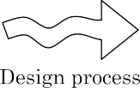

OVERVIEW OF THE DESIGN PROCESS:

The design process essentially transforms the SRS document into a design document. In the following sections and subsections, we will discuss a few important issues associated with the design process
Outcome of the Design Process:
The following items are designed and documented during the design phase.
- Diﬀerent modules required
- Control relationships among modules
- Interfaces among diﬀrent modules
- Data structures of the individual modules
- Algorithms required to implement the individual modules

- Diﬀerent modules required:
The diﬀerent modules in the solution should be identiﬁed. Each module is a collection of functions and the data shared by these functions. Each module should accomplish some well-deﬁned task out of the overall responsibility of the software. Each module should be named according to the task it performs.
- Control relationships among modules:
A control relationship between two modules essentially arises due to function calls across the two modules. The control relationships existing among various modules should be identiﬁed in the design document.
- Interfaces among diﬀrent modules:
The interfaces between two modules identiﬁes the exact data items that are exchanged between the two modules when one module invokes a function of the other module.
- Data structures of the individual modules:
Each module normally stores some data that the functions of the module need to share to accomplish the overall responsibility of the module. Suitable data structures for storing and managing the data of a module need to be properly designed and documented.

- Algorithms required to implement the individual modules:
Each function in a module usually performs some processing activity. The algorithms required to accomplish the processing activities of various modules need to be carefully designed and documented with due considerations given to the accuracy of the results, space and time complexities.

Classification of Design Activities:
A good software design is seldom realised by using a single step procedure, rather it requires iterating over a series of steps called the design activities. Let us ﬁrst classify the design activities before discussing them in detail. Depending on the order in which various design activities are performed, we can broadly classify them into two important stages.
      - Preliminary (or high-level) design, and
      - Detailed design.

- Preliminary (or high-level) design:
The outcome of high-level design is called the program structure or the software architecture. High-level design is a crucial step in the overall design of a software. When the high-level design is complete, the problem should have been decomposed into many small functionally independent modules that are cohesive, have low coupling among themselves, and are arranged in a hierarchy. Many diﬀerent types of notations have been used to represent a high-level design.
- Detailed design:
The outcome of the detailed design stage is usually documented in the form of a module speciﬁcation (MSPEC) document. After the high-level design is complete, the problem would have been decomposed into small modules, and the data structures and algorithms to be used described using MSPEC and can be easily grasped by programmers for initiating coding.
Classification of Design Methodologies:
The design activities vary considerably based on the speciﬁc design methodology being used. A large number of software design methodologies are available. We can roughly classify these methodologies into procedural and object-oriented approaches. These two approaches are two fundamentally diﬀerent design paradigms.
- Do design techniques result in unique solutions:
Even while using the same design methodology, diﬀerent designers usually arrive at very diﬀerent design solutions. The reason is that a design technique often requires the designer to make many subjective decisions and work out compromises to contradictory objectives. As a result, it is possible that even the same designer can work out many diﬀerent solutions to the same problem. Therefore, obtaining a good design would involve trying out several alternatives (or candidate solutions) and picking out the best one.
- Analysis versus design:
The analysis results are generic and does not consider implementation or the issues associated with speciﬁc platforms. The analysis model is usually documented using some graphical formalism. The design model is obtained from the analysis model through transformations over a series of steps. In contrast to the analysis model, the design model reﬂects several decisions taken regarding the exact way system is to be implemented.
HOW TO CHARACTERISE A GOOD SOFTWARE DESIGN
Coming up with an accurate characterisation of a good software design that would hold across diverse problem domains is certainly not easy. In fact, the deﬁnition of a “good” software design can vary depending on the exact application being designed.
For example, “memory size used up by a program” may be an important way to characterize a good solution for embedded software development—since embedded applications are often required to work under severely limited memory sizes due to cost, space, or power consumption considerations.
Correctness: A good design should ﬁrst of all be correct. That is, it should correctly
implement all the functionalities of the system.
Understandability: A good design should be easily understandable. Unless a design
solution is easily understandable, it would be difficult to implement and maintain it.
Eﬃciency: A good design solution should adequately address resource, time, and cost optimisation issues.
Maintainability: A good design should be easy to change. This is an important requirement,
since change requests usually keep coming from the customer even after product release.

Understandability of a Design: A Major Concern:
While performing the design of a certain problem, assume that we have arrived at a large number of design solutions and need to choose the best one. Obviously all incorrect designs have to be discarded ﬁrst. Out of the correct design solutions, how can we identify the best one.
- A large problem overwhelms the human mind, and a poor design would make the matter worse.
- Unless a design solution is easily understandable, it could lead to an implementation having a large number of defects and at the same time tremendously pushing up the development costs.
- Therefore, a good design solution should be simple and easily understandable.
- A design that is easy to understand is also easy to develop and maintain.
- A complex design would lead to severely increased life cycle costs.

An understandable design is modular and layered:
How can the understandability of two diﬀerent designs be compared, so that we can pick the better one? To be able to compare the understandability of two design solutions, we should at least have an understanding of the general features that an easily understandable design should possess.
- It should assign consistent and meaningful names to various design components.
- It should make use of the principles of decomposition and abstraction in good measures to simplify the design.

Modularity:
A modular design is an eﬀective decomposition of a problem. It is a basic characteristic of any good design solution. A modular design, in simple words, implies that the problem has been decomposed into a set of modules that have only limited interactions with each other. Decomposition of a problem into modules facilitates taking advantage of the divide and conquer principle. If diﬀerent modules have either no interactions or little interactions with each other, then each module can be understood separately.
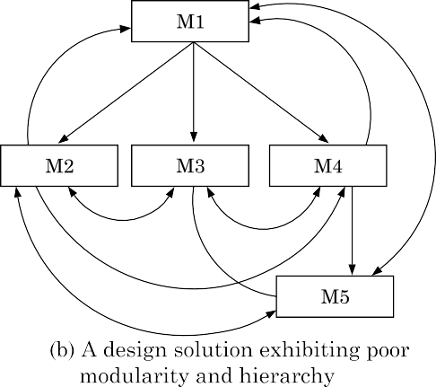

Layered design:
A layered design is one in which when the call relations among diﬀerent modules are represented graphically, it would result in a tree-like diagram with clear layering. In a layered design solution, the modules are arranged in a hierarchy of layers. A module can only invoke functions of the modules in the layer immediately below it. The higher layer modules can be considered to be similar to managers that invoke (order) the lower layer modules to get certain tasks done. A layered design can be considered to be implementing control abstraction, since a module at a lower layer is unaware of (about how to call) the higher layer modules.
Cohesion and Coupling:
The purpose of the Design phase in the Software Development Life Cycle is to produce a solution to a problem given in the SRS(Software Requirement Specification) document. The output of the design phase is a Software Design Document (SDD).
Coupling and Cohesion are two key concepts in software engineering that are used to measure the quality of a software system's design.

Both coupling and cohesion are important factors in determining the maintainability, scalability, and reliability of a software system. High coupling and low cohesion can make a system difficult to change and test, while low coupling and high cohesion make a system easier to maintain and improve.

Coupling:

Coupling refers to the degree of interdependence between software modules. High coupling means that modules are closely connected and changes in one module may affect other modules. Low coupling means that modules are independent, and changes in one module have little impact on other modules.

Types of Coupling
The coupling between two modules indicates the degree of interdependence between them
- Data Coupling: If the dependency between the modules is based on the fact that they communicate by passing only data, then the modules are said to be data coupled. In data coupling, the components are independent of each other and communicate through data. Module communications don't contain tramp data. Example-customer billing system.
- Stamp Coupling In stamp coupling, the complete data structure is passed from one module to another module. Therefore, it involves tramp data. It may be necessary due to efficiency factors- this choice was made by the insightful designer, not a lazy programmer.
- Control Coupling: If the modules communicate by passing control information, then they are said to be control coupled. It can be bad if parameters indicate completely different behavior and good if parameters allow factoring and reuse of functionality. Example- sort function that takes comparison function as an argument.
- External Coupling: In external coupling, the modules depend on other modules, external to the software being developed or to a particular type of hardware. Ex- protocol, external file, device format, etc.
- Common Coupling: The modules have shared data such as global data structures. The changes in global data mean tracing back to all modules which access that data to evaluate the effect of the change. So it has got disadvantages like difficulty in reusing modules, reduced ability to control data accesses, and reduced maintainability.
- Content Coupling: In a content coupling, one module can modify the data of another module, or control flow is passed from one module to the other module. This is the worst form of coupling and should be avoided.

Advantages of Low coupling
- Improved maintainability: Low coupling reduces the impact of changes in one module on other modules, making it easier to modify or replace individual components without affecting the entire system.
- Enhanced modularity: Low coupling allows modules to be developed and tested in isolation, improving the modularity and reusability of code.
- Better scalability: Low coupling facilitates the addition of new modules and the removal of existing ones, making it easier to scale the system as needed.

Disadvantages of High coupling
- Increased complexity: High coupling increases the interdependence between modules, making the system more complex and difficult to understand.
- Reduced flexibility: High coupling makes it more difficult to modify or replace individual components without affecting the entire system.
- Decreased modularity: High coupling makes it more difficult to develop and test modules in isolation, reducing the modularity and reusability of code.

Cohesion:

Cohesion refers to the degree to which elements within a module work together to fulfill a single, well-defined purpose. High cohesion means that elements are closely related and focused on a single purpose, while low cohesion means that elements are loosely related and serve multiple purposes.

Types of Cohesion

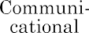
Cohesiveness of a module is the degree to which the diﬀerent functions of the module co-operate to work towards a single objective.

- Functional Cohesion: Every essential element for a single computation is contained in the component. A functional cohesion performs the task and functions. It is an ideal situation.
- Sequential Cohesion: An element outputs some data that becomes the input for other element, i.e., data flow between the parts. It occurs naturally in functional programming languages.
- Communicational Cohesion: Two elements operate on the same input data or contribute towards the same output data. Example- update record in the database and send it to the printer.
- Procedural Cohesion: Elements of procedural cohesion ensure the order of execution. Actions are still weakly connected and unlikely to be reusable. Ex- calculate student GPA, print student record, calculate cumulative GPA, print cumulative GPA.
- Temporal Cohesion: The elements are related by their timing involved. A module connected with temporal cohesion all the tasks must be executed in the same time span. This cohesion contains the code for initializing all the parts of the system. Lots of different activities occur, all at unit time.
- Logical Cohesion: The elements are logically related and not functionally. Ex- A component reads inputs from tape, disk, and network. All the code for these functions is in the same component. Operations are related, but the functions are significantly different.
- Coincidental Cohesion: The elements are not related(unrelated). The elements have no conceptual relationship other than location in source code. It is accidental and the worst form of cohesion. Ex- print next line and reverse the characters of a string in a single component.
- Procedural Cohesion: This type of cohesion occurs when elements or tasks are grouped together in a module based on their sequence of execution, such as a module that performs a set of related procedures in a specific order. Procedural cohesion can be found in structured programming languages.
- Communicational Cohesion: Communicational cohesion occurs when elements or tasks are grouped together in a module based on their interactions with each other, such as a module that handles all interactions with a specific external system or module. This type of cohesion can be found in object-oriented programming languages.
- Temporal Cohesion: Temporal cohesion occurs when elements or tasks are grouped together in a module based on their timing or frequency of execution, such as a module that handles all periodic or scheduled tasks in a system. Temporal cohesion is commonly used in real-time and embedded systems.
- Functional Cohesion: This type of cohesion occurs when all elements or tasks in a module contribute to a single well-defined function or purpose, and there is little or no coupling between the elements. Functional cohesion is considered the most desirable type of cohesion as it leads to more maintainable and reusable code.

Advantages of High cohesion
- Improved readability and understandability: High cohesion results in clear, focused modules with a single, well-defined purpose, making it easier for developers to understand the code and make changes.
- Better error isolation: High cohesion reduces the likelihood that a change in one part of a module will affect other parts, making it easier to
- Improved reliability: High cohesion leads to modules that are less prone to errors and that function more consistently,
- leading to an overall improvement in the reliability of the system.

Disadvantages of Low cohesion
- Increased code duplication: Low cohesion can lead to the duplication of code, as elements that belong together are split into separate modules.
- Reduced functionality: Low cohesion can result in modules that lack a clear purpose and contain elements that don't belong together, reducing their functionality and making them harder to maintain.
- Difficulty in understanding the module: Low cohesion can make it harder for developers to understand the purpose and behavior of a module, leading to errors and a lack of clarity.

Layered arrangement of modules:
Introduction:
The control hierarchy represents the organisation of program components in terms of their call relationships. Thus we can say that the control hierarchy of a design is determined by the order in which diﬀerent modules call each other. Many diﬀerent types of notations have been used to represent the control hierarchy.
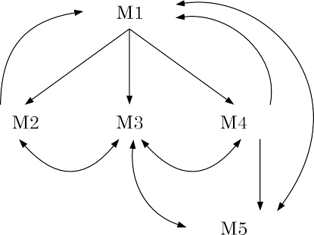
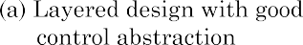
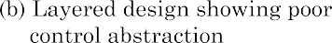
In a layered design, the top-most module in the hierarchy can be considered as a manager that only invokes the services of the lower level module to discharge its responsibility. The modules at the intermediate layers oﬀer services to their higher layer by invoking the services of the lower layer modules and also by doing some work themselves to a limited extent.
Examples of good and poor control abstraction.
Superordinate and subordinate modules: In a control hierarchy, a module that controls another module is said to be superordinate to it. Conversely, a module controlled by another module is said to be subordinate to the controller.
Visibility: A module B is said to be visible to another module A, if A directly calls B. Thus, only the immediately lower layer modules are said to be visible to a module.
Control abstraction: In a layered design, a module should only invoke the functions of the modules that are in the layer immediately below it. In other words, the modules at the higher layers, should not be visible (that is, abstracted out) to the modules at the lower layers. This is referred to as control abstraction.
Depth and width: Depth and width of a control hierarchy provide an indication of the number of layers and the overall span of control respectively.
Fan-out: Fan-out is a measure of the number of modules that are directly controlled by a given module. In Figure 5.6(a), the fan-out of the module M1 is 3. A design in which the modules have very high fan-out numbers is not a good design.
Fan-in: Fan-in indicates the number of modules that directly invoke a given module. High fan-in represents code reuse and is in general, desirable in a good design. In Figure 5.6(a), the fan-in of the module M1 is 0, that of M2 is 1, and that of M5 is 2.

Thus, debugging time reduces signiﬁcantly in a layered design. On the other hand, if the diﬀerent modules call each other arbitrarily, then this situation would correspond to modules arranged in a single layer. Locating an error would be both difficult and time consuming. This is because, once a failure is observed, the cause of failure (i.e. error) can potentially be in any module, and all modules would have to be investigated for the error.
Cohesion and Coupling:
The purpose of the Design phase in the Software Development Life Cycle is to produce a solution to a problem given in the SRS(Software Requirement Specification) document. The output of the design phase is a Software Design Document (SDD).
Coupling and Cohesion are two key concepts in software engineering that are used to measure the quality of a software system's design.

Both coupling and cohesion are important factors in determining the maintainability, scalability, and reliability of a software system. High coupling and low cohesion can make a system difficult to change and test, while low coupling and high cohesion make a system easier to maintain and improve.

Coupling:

Coupling refers to the degree of interdependence between software modules. High coupling means that modules are closely connected and changes in one module may affect other modules. Low coupling means that modules are independent, and changes in one module have little impact on other modules.

Types of Coupling
The coupling between two modules indicates the degree of interdependence between them
- Data Coupling: If the dependency between the modules is based on the fact that they communicate by passing only data, then the modules are said to be data coupled. In data coupling, the components are independent of each other and communicate through data. Module communications don't contain tramp data. Example-customer billing system.
- Stamp Coupling In stamp coupling, the complete data structure is passed from one module to another module. Therefore, it involves tramp data. It may be necessary due to efficiency factors- this choice was made by the insightful designer, not a lazy programmer.
- Control Coupling: If the modules communicate by passing control information, then they are said to be control coupled. It can be bad if parameters indicate completely different behavior and good if parameters allow factoring and reuse of functionality. Example- sort function that takes comparison function as an argument.
- External Coupling: In external coupling, the modules depend on other modules, external to the software being developed or to a particular type of hardware. Ex- protocol, external file, device format, etc.
- Common Coupling: The modules have shared data such as global data structures. The changes in global data mean tracing back to all modules which access that data to evaluate the effect of the change. So it has got disadvantages like difficulty in reusing modules, reduced ability to control data accesses, and reduced maintainability.
- Content Coupling: In a content coupling, one module can modify the data of another module, or control flow is passed from one module to the other module. This is the worst form of coupling and should be avoided.

Advantages of Low coupling
- Improved maintainability: Low coupling reduces the impact of changes in one module on other modules, making it easier to modify or replace individual components without affecting the entire system.
- Enhanced modularity: Low coupling allows modules to be developed and tested in isolation, improving the modularity and reusability of code.
- Better scalability: Low coupling facilitates the addition of new modules and the removal of existing ones, making it easier to scale the system as needed.

Disadvantages of High coupling
- Increased complexity: High coupling increases the interdependence between modules, making the system more complex and difficult to understand.
- Reduced flexibility: High coupling makes it more difficult to modify or replace individual components without affecting the entire system.
- Decreased modularity: High coupling makes it more difficult to develop and test modules in isolation, reducing the modularity and reusability of code.

Cohesion:

Cohesion refers to the degree to which elements within a module work together to fulfill a single, well-defined purpose. High cohesion means that elements are closely related and focused on a single purpose, while low cohesion means that elements are loosely related and serve multiple purposes.

Types of Cohesion

Cohesiveness of a module is the degree to which the diﬀerent functions of the module co-operate to work towards a single objective.

- Functional Cohesion: Every essential element for a single computation is contained in the component. A functional cohesion performs the task and functions. It is an ideal situation.
- Sequential Cohesion: An element outputs some data that becomes the input for other element, i.e., data flow between the parts. It occurs naturally in functional programming languages.
- Communicational Cohesion: Two elements operate on the same input data or contribute towards the same output data. Example- update record in the database and send it to the printer.
- Procedural Cohesion: Elements of procedural cohesion ensure the order of execution. Actions are still weakly connected and unlikely to be reusable. Ex- calculate student GPA, print student record, calculate cumulative GPA, print cumulative GPA.
- Temporal Cohesion: The elements are related by their timing involved. A module connected with temporal cohesion all the tasks must be executed in the same time span. This cohesion contains the code for initializing all the parts of the system. Lots of different activities occur, all at unit time.
- Logical Cohesion: The elements are logically related and not functionally. Ex- A component reads inputs from tape, disk, and network. All the code for these functions is in the same component. Operations are related, but the functions are significantly different.
- Coincidental Cohesion: The elements are not related(unrelated). The elements have no conceptual relationship other than location in source code. It is accidental and the worst form of cohesion. Ex- print next line and reverse the characters of a string in a single component.
- Procedural Cohesion: This type of cohesion occurs when elements or tasks are grouped together in a module based on their sequence of execution, such as a module that performs a set of related procedures in a specific order. Procedural cohesion can be found in structured programming languages.
- Communicational Cohesion: Communicational cohesion occurs when elements or tasks are grouped together in a module based on their interactions with each other, such as a module that handles all interactions with a specific external system or module. This type of cohesion can be found in object-oriented programming languages.
- Temporal Cohesion: Temporal cohesion occurs when elements or tasks are grouped together in a module based on their timing or frequency of execution, such as a module that handles all periodic or scheduled tasks in a system. Temporal cohesion is commonly used in real-time and embedded systems.
- Functional Cohesion: This type of cohesion occurs when all elements or tasks in a module contribute to a single well-defined function or purpose, and there is little or no coupling between the elements. Functional cohesion is considered the most desirable type of cohesion as it leads to more maintainable and reusable code.

Advantages of High cohesion
- Improved readability and understandability: High cohesion results in clear, focused modules with a single, well-defined purpose, making it easier for developers to understand the code and make changes.
- Better error isolation: High cohesion reduces the likelihood that a change in one part of a module will affect other parts, making it easier to
- Improved reliability: High cohesion leads to modules that are less prone to errors and that function more consistently,
- leading to an overall improvement in the reliability of the system.

Disadvantages of Low cohesion
- Increased code duplication: Low cohesion can lead to the duplication of code, as elements that belong together are split into separate modules.
- Reduced functionality: Low cohesion can result in modules that lack a clear purpose and contain elements that don't belong together, reducing their functionality and making them harder to maintain.
- Difficulty in understanding the module: Low cohesion can make it harder for developers to understand the purpose and behavior of a module, leading to errors and a lack of clarity.

Approaches to software design:
Introduction:
There are two fundamentally diﬀerent approaches to software design that are in use today—function-oriented design, and object-oriented design. Though these two design approaches are radically diﬀerent, they are complementary rather than competing techniques. The object-oriented approach is a relatively newer technology and is still evolving. For development of large programs, the object-oriented approach is becoming increasingly popular due to certain advantages that it oﬀers.
Function-oriented Design:
The following are the salient features of the function- oriented design approach:
Top-down decomposition: A system, to start with, is viewed as a black box that provides certain services (also known as high-level functions) to the users of the system.
Example:
consider a function create-new-library member which essentially creates the record for a new member, assigns a unique membership number to him, and prints a bill towards his membership charge. This high-level function may be reﬁned into the following subfunctions:
assign-membership-number
create-member-record
print-bill
Centralised system state: The system state can be deﬁned as the values of certain data items that determine the response of the system to a user action or external event.
Example:
The set of books (i.e. whether borrowed by diﬀerent users or available for issue) determines the state of a library automation system. Such data in procedural programs usually have global scope and are shared by many modules.
      - create-new-member
      - delete-member
      - update-member-record

Object-oriented Design:
In the object-oriented design (OOD) approach, a system is viewed as being made up of a collection of objects (i.e., entities). Each object is associated with a set of functions that are called its methods. Each object contains its own data and is responsible for managing it. The data internal to an object cannot be accessed directly by other objects and only through invocation of the methods of the object.
Data abstraction: The principle of data abstraction implies that how data is exactly stored is abstracted away. This means that any entity external to the object (that is, an instance of an ADT) would have no knowledge about how data is exactly stored, organised, and manipulated inside the object. The entities external to the object can access the data internal to an object only by calling certain well-deﬁned methods supported by the object. Consider an ADT such as a stack.
Data structure: A data structure is constructed from a collection of primitive data items. Just as a civil engineer builds a large civil engineering structure using primitive building materials such as bricks, iron rods, and cement; a programmer can construct a data structure as an organised collection of primitive data items such as integer, ﬂoating point numbers, characters, etc.
Data type: A type is a programming language terminology that refers to anything that can be instantiated. For example, int, float, char, etc., are the basic data types supported by C programming language. Thus, we can say that ADTs are user deﬁned data types.

Automated ﬁre-alarm system—customer requirements
The owner of a large multi-storied building wants to have a computerised ﬁre alarm system designed, developed, and installed in his building.
Function-oriented approach: In this approach, the diﬀerent high-level functions are ﬁrst identiﬁed, and then the data structures are designed.
/* Global data (system state) accessible by various functions */
BOOL detector_status[MAX_ROOMS];
int detector_locs[MAX_ROOMS];
BOOL alarm-status[MAX_ROOMS]; /* alarm activated when status is set */
int alarm_locs[MAX_ROOMS]; /* room number where alarm is located */
int neighbour-alarms[MAX-ROOMS][10]; /* each detector has at most */
/* 10 neighbouring alarm locations */
int sprinkler[MAX_ROOMS];
Object-oriented approach: In the object-oriented approach, the diﬀerent classes of objects are identiﬁed. Subsequently, the methods and data for each object are identiﬁed. Finally, an appropriate number of instances of each class is created.
class detector
attributes: status, location, neighbours
operations: create, sense-status, get-location, find-neighbours
class alarm
attributes: location, status
operations: create, ring-alarm, get_location, reset-alarm
class sprinkler
attributes: location, status
operations: create, activate-sprinkler, get_location, reset-sprinkler
Agility:
Agility has become today’s buzzword when describing a contemporary software method. Everyone is agile. An associate agile team could be a nimble team able to befittingly reply to changes. Modification is what software development is extremely abundant.
- Changes within the software being engineered,
- Changes to the team members,
- Changes attributable to new technology,
- Changes of all types will have an effect on the merchandise they build or the project that makes the merchandise.
All changes can be represented as shown in the below diagram which is considered according to Ivar Jacobson Agility process of Software.
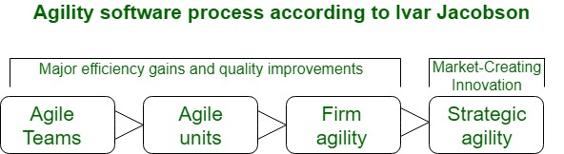Agility - Software Engineering

Support for changes ought to be inherent in everything we tend to kill software, one thing we tend to embrace as a result of it's the guts and soul of software.
- It encourages team structures and attitudes that create communication (among team members, between technologists and business folks, between software engineers and their managers) additional facile.
- It emphasizes speedy delivery of operational software Associate in emphasizes the importance of intermediate work merchandise (not continuously a decent thing);
- It adopts the client as a vicinity of the event team and works to eliminate the “us and them” angle that continues to perforate several software projects;
- It acknowledges that coming up within an unsure world has its limits which a project arrange should be versatile.
Agility is applied to any software method. However, to accomplish this, it's essential that the method be designed during a manner that enables the project team to adapt tasks and to contour them, conduct coming up within a good manner that understands the fluidity of an agile development approach, eliminate about the foremost essential work products and keeps them lean, Associate in emphasize a progressive delivery strategy that gets operating package to the client as apace as possible for the merchandise sort and operational atmosphere.

Agility and the Cost of Change:
In software development, "agility" is the ability to adapt and respond quickly to change. It directly influences the cost of change, which is the time and resources required to make alterations to a project's specifications after it has begun. Traditional development methods see the cost of change rise exponentially over time, while agile processes aim to flatten this cost curve.
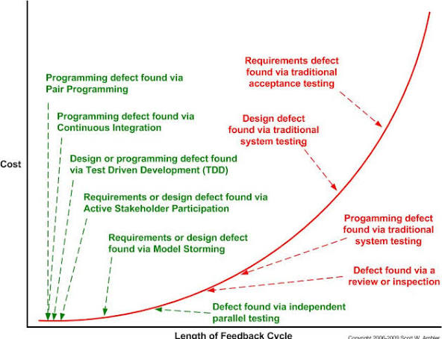
The traditional cost-of-change curve:
Conventional project management, such as the waterfall model, is a rigid, plan-driven approach. This model requires a comprehensive set of requirements to be defined upfront, with analysis, design, and construction occurring in a linear, sequential order.
In this model, the cost of making a change is minimal during the initial requirements gathering stage, but it increases dramatically as the project progresses. For example:
- Early stage: Changing a requirement is a simple, low-cost fix.
- Late stage: A major functional change requested during validation testing could require altering the architectural design, building new components, modifying existing code, and re-running all tests. This causes significant delays and cost overruns.
The agile cost-of-change curve:
Agile methodologies, such as Scrum and Extreme Programming (XP), are designed to embrace change rather than resist it. The goal is to "flatten" the cost-of-change curve, so that changes can be made at any point in the development cycle with less dramatic cost and time impact.
Agile achieves this through several key practices:
- Incremental delivery: Software is released in short, frequent increments (or sprints). Since less software has been built in each cycle, changes can be incorporated more easily.
- Short feedback loops: Agile prioritizes rapid feedback from stakeholders. Techniques like test-driven design (TDD) reduce the time between creating and validating something to minutes, leaving little opportunity for the cost of change to grow.
- High-quality code: Practices like continuous integration and refactoring (improving code design without adding functionality) prevent "technical debt" from accumulating. This means the codebase is always clean and easy to modify.
- Cross-functional teams: Agile teams have all the skills necessary to complete a task, which avoids the bottlenecks and extra handoffs that can occur in traditional, siloed structures.
- "Travel light": Agile emphasizes delivering working software over creating extensive documentation. By focusing on high-value documentation only, teams have less to update when a change occurs.
Flattening the curve:
The contrast between the two approaches is most clearly seen in the difference in their cost-of-change curves.
- Traditional curve: This is often depicted as a sharp, upward-sloping curve, showing the high risk and escalating costs associated with making late-stage changes.
- Agile curve: This is a flatter, more consistent curve that demonstrates how agile practices attenuate the cost of change throughout the project lifecycle.
Limitations of the "flat" agile curve
While agile practices make change more manageable, some context is necessary:
- Complexity still matters: While agile flattens the cost curve, it does not eliminate it. Fundamental architectural changes will always be more expensive later in a project.
- Non-code artifacts: The costs of change can also come from non-code artifacts like user manuals or other supporting documentation, which also grow over time.
- Large, non-agile environments: If an agile team is working within a larger, non-agile organization, they may still be subject to bureaucracy and processes that increase the cost of change.
Agile Process:
Introduction:
Agile Software Development is a Software Development Methodology that values flexibility, collaboration, and customer satisfaction. It is based on the Agile Manifesto, a set of principles for software development that prioritize individuals and interactions, working software, customer collaboration, and responding to change.
Definition:
Agile Software Development is an iterative and incremental approach to Software Development that emphasizes the importance of delivering a working product quickly and frequently. It involves close collaboration between the development team and the customer to ensure that the product meets their needs and expectations.
Why is Agile Used: Agile is used because it helps teams deliver value quickly and continuously. By prioritizing the delivery of difficult results early in the project, customers benefit from seeing and using the product sooner, allowing for quick feedback and adjustments.
- Agile as a Mindset: Agile represents a shift in culture that values adaptability, collaboration, and client happiness. It gives team members more authority and promotes a cooperative and upbeat work atmosphere.
- Quick Response to Change: Agile fosters a culture that allows teams to respond swiftly to constantly shifting priorities and requirements. This adaptability is particularly useful in sectors of the economy or technology that experience fast changes.
- Regular Demonstrations: Agile techniques place a strong emphasis on regular demonstrations of project progress. Stakeholders may clearly see the project's status, upcoming problems, and upcoming new features due to this transparency.
- Cross-Functional Teams: Agile fosters self-organizing, cross-functional teams that share information effectively, communicate more effectively and feel more like a unit.
Agile Software Development Process:
Agile software development, often just called Agile, focuses on being flexible and practical when delivering software.
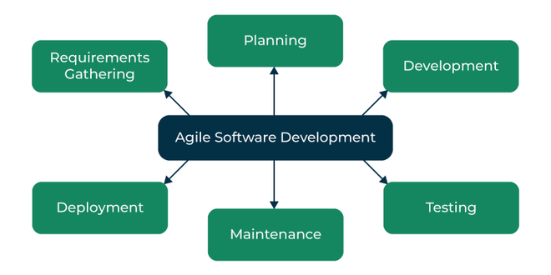

1. Requirements Gathering
This is the first step where the development team works closely with the customer to understand what they really need from the software. The team listens carefully to the customer’s needs, then sorts and prioritizes these requirements to make sure the most important features are developed first.

2. Planning
In this stage, the team creates a clear plan for how they’ll build the software. They decide which features to focus on in each development cycle (called an iteration). Think of it like mapping out the journey of the project, so everyone knows what to expect and when things will be delivered.

3. Development
This is where the team starts turning their plan into reality. They work in short, focused cycles, building small, usable pieces of the product. Each cycle builds on the last, which helps the team stay on track and get quick feedback to keep improving.

4. Testing
As the software gets built, it’s also tested to make sure it works properly and meets the customer’s needs. Testing ensures the product is of high quality and free from errors, so problems are caught early on before they become bigger issues.

5. Deployment
Once everything is tested and working as expected, the software is deployed, which means it’s ready for customers or end-users to start using. It’s the moment when all the development work comes to life.

6. Maintenance
Even after the software is released, the job isn’t done. The team keeps maintaining the software, verifying it continues to work well and stays up-to-date with any new needs or changes from the customer. This keeps the software relevant and helpful over time.

Example of Agile Software Development
Let's go through an example to understand clearly how agile works. A Software company named ABC wants to make a new web browser for the latest release of its operating system. The deadline for the task is 10 months. The company's head assigned two teams named Team A and Team B for this task. To motivate the teams, the company head says that the first team to develop the browser would be given a salary hike and a one-week full-sponsored travel plan.
With the dreams of their wild travel fantasies, the two teams set out on the journey of the web browser. Team A decided to play by the book and decided to choose the Waterfall model for the development. Team B after a heavy discussion decided to take a leap of faith and choose Agile as their development model. The Development Plan of the Team A is as follows:
- Requirement Analysis and Gathering - 1.5 Months
- Design of System - 2 Months
- Coding phase - 4 Months
- System Integration and Testing - 2 Months
- User Acceptance Testing - 5 Weeks

Advantages Agile Software Development
- Deployment of software is quicker and thus helps in increasing the trust of the customer.
- Can better adapt to rapidly changing requirements and respond faster.
- Helps in getting immediate feedback which can be used to improve the software in the next increment.
- People - Not Process. People and interactions are given a higher priority than processes and tools.
- Continuous attention to technical excellence and good design.

Disadvantages Agile Software Development
- In the case of large software projects, it is difficult to assess the effort required at the initial stages of the software development life cycle.
- Agile Development is more code-focused and produces less documentation.
- Agile development is heavily dependent on the inputs of the customer. If the customer has ambiguity in his vision of the outcome, it is highly likely that the project to get off track.
- Face-to-face communication is harder in large-scale organizations.
- Only senior programmers are capable of making the kind of decisions required during the development process. Hence, it's a difficult situation for new programmers to adapt to the environment.
Extreme Programming (XP):
Extreme programming (XP) is one of the most important software development frameworks of Agile models. It is used to improve software quality and responsiveness to customer requirements.
The extreme programming model recommends taking the best practices that have worked well in the past in program development projects to extreme levels.

Definition: Extreme Programming (XP) is an Agile software development methodology that focuses on delivering high-quality software through frequent and continuous feedback, collaboration, and adaptation. XP emphasizes a close working relationship between the development team, the customer, and stakeholders, with an emphasis on rapid, iterative development and deployment.
Agile development approaches evolved in the 1990s as a reaction to documentation and bureaucracy-based processes, particularly the waterfall approach. Agile approaches are based on some common principles, some of which are:
- Working software is the key measure of progress in a project.
- For progress in a project, therefore software should be developed and delivered rapidly in small increments.
- Even late changes in the requirements should be entertained.
- Face-to-face communication is preferred over documentation.
- Continuous feedback and involvement of customers are necessary for developing good-quality software.
- A simple design that involves and improves with time is a better approach than doing an elaborate design up front for handling all possible scenarios.
- The delivery dates are decided by empowered teams of talented individuals.

Good Practices in Extreme Programming:
Some of the good practices that have been recognized in the extreme programming model and suggested to maximize their use are given below:

- Code Review: Code review detects and corrects errors efficiently. It suggests pair programming as coding and reviewing of written code carried out by a pair of programmers who switch their work between them every hour.
- Testing: Testing code helps to remove errors and improves its reliability. XP suggests test-driven development (TDD) to continually write and execute test cases. In the TDD approach, test cases are written even before any code is written.
- Incremental development: Incremental development is very good because customer feedback is gained and based on this development team comes up with new increments every few days after each iteration.
- Simplicity: Simplicity makes it easier to develop good-quality code as well as to test and debug it.
- Design: Good quality design is important to develop good quality software. So, everybody should design daily.
- Integration testing: Integration Testing helps to identify bugs at the interfaces of different functionalities. Extreme programming suggests that the developers should achieve continuous integration by building and performing integration testing several times a day.

Applications of Extreme Programming (XP):
Some of the projects that are suitable to develop using the XP model are given below:
- Small projects: The XP model is very useful in small projects consisting of small teams as face-to-face meeting is easier to achieve.
- Projects involving new technology or Research projects: This type of project faces changing requirements rapidly and technical problems. So XP model is used to complete this type of project.
- Web development projects: The XP model is well-suited for web development projects as the development process is iterative and requires frequent testing to ensure the system meets the requirements.
- Collaborative projects: The XP model is useful for collaborative projects that require close collaboration between the development team and the customer.
- Projects with tight deadlines: The XP model can be used in projects that have a tight deadline, as it emphasizes simplicity and iterative development.
- Projects with rapidly changing requirements: The XP model is designed to handle rapidly changing requirements, making it suitable for projects where requirements may change frequently.
- Projects where quality is a high priority: The XP model places a strong emphasis on testing and quality assurance, making it a suitable approach for projects where quality is a high priority.

Life Cycle of Extreme Programming (XP)
The Extreme Programming Life Cycle consist of five phases:
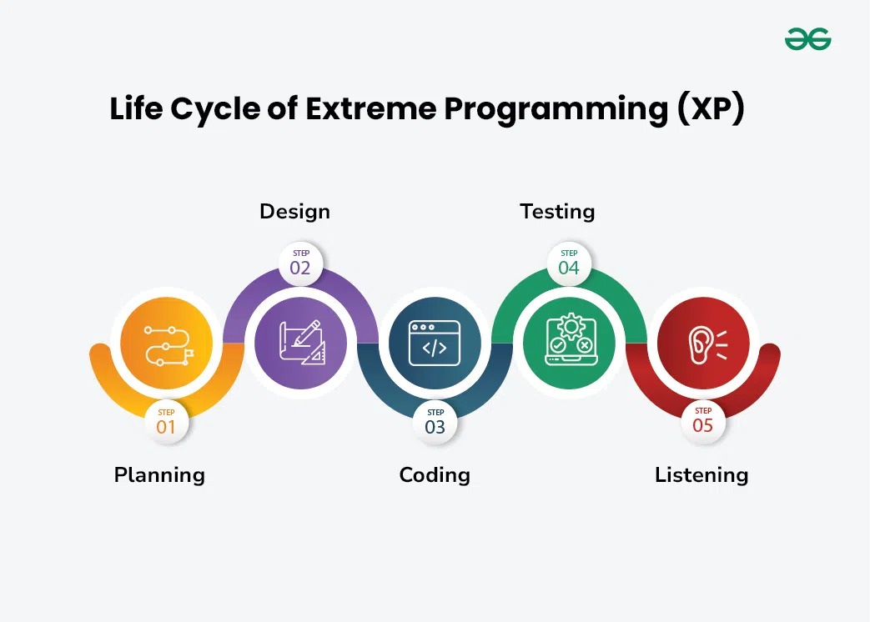

Advantages of Extreme Programming (XP):
- Slipped schedules: Timely delivery is ensured through slipping timetables and doable development cycles.
- Misunderstanding the business and/or domain − Constant contact and explanations are ensured by including the client on the team.
- Canceled projects: Focusing on ongoing customer engagement guarantees open communication with the consumer and prompt problem-solving.
- Staff turnover: Teamwork that is focused on cooperation provides excitement and goodwill. Team spirit is fostered by multidisciplinary cohesion.
- Costs incurred in changes: Extensive and continuing testing ensures that the modifications do not impair the functioning of the system. A functioning system always guarantees that there is enough time to accommodate changes without impairing ongoing operations.
- Business changes: Changes are accepted at any moment since they are seen to be inevitable.
- Production and post-delivery defects: the unit tests to find and repair bugs as soon as possible.
Tool Set for the Agile Process:
An effective Agile toolset for software engineering includes categories of software for project management, version control, CI/CD, communication, testing, and more. Many tools are flexible and can serve multiple functions for your team.
Agile project management and planning tools
These tools help teams manage backlogs, plan sprints, and visualize progress using Scrum or Kanban boards.
- Jira Software by Atlassian is a popular tool purpose-built for Agile software development.
  - Features: Includes Scrum and Kanban boards, customizable workflows, roadmaps for long-term planning, and reporting tools like burndown and velocity charts.
  - Integrations: Connects seamlessly with other tools in the Atlassian suite (like Confluence and Bitbucket) and many other third-party apps.
- Trello by Atlassian is a Kanban-style visual collaboration tool.
  - Features: Uses boards, lists, and cards for organizing tasks with a simple, drag-and-drop interface.
  - Best for: Simple projects or small teams needing a visual way to track tasks.
- Asana is a versatile work management platform that can be adapted for Agile workflows.
  - Features: Offers multiple views (lists, boards, timelines, Gantt charts), automation, and customizable dashboards.
  - Best for: Teams seeking a general-purpose project management tool that can be customized for Agile.
- ClickUp is known for its high level of customization.
  - Features: Supports Agile workflows with native templates for Scrum and Kanban, along with integrated AI features and time tracking.
  - Best for: Teams that want to heavily customize their workflows.
- Monday.com offers a work OS with many use-case templates for Agile.
  - Features: Customizable dashboards, automations, and a variety of visualization options.
  - Best for: Tracking progress with highly visual and customized displays.
- Azure Boards by Microsoft is a project management tool for software teams.
  - Features: Supports Scrum and Kanban, provides dashboards, and integrates with other Azure services.
  - Best for: Teams operating within the Microsoft ecosystem.
Version control tools
Version control is essential for Agile to manage code changes, enable collaboration, and handle parallel development.
- GitHub is a popular code repository for Git.
  - Features: Provides a user-friendly interface for version control, collaboration via pull requests and code reviews, and project management capabilities.
  - Best for: Teams using Git for version control.
- Bitbucket by Atlassian is another Git repository.
  - Features: Offers deep integration with other Atlassian tools, including Jira and Confluence.
  - Best for: Teams already using other Atlassian products.
- GitLab is a comprehensive DevSecOps platform that includes version control.
  - Features: Offers integrated CI/CD, security testing, and project management functionalities.
  - Best for: Teams that want an all-in-one DevOps platform.
CI/CD automation tools
Continuous Integration and Continuous Delivery (CI/CD) pipelines automate the process of building, testing, and deploying code, which is vital for Agile's iterative approach.
- Jenkins is an open-source, automation server.
  - Features: Highly flexible and has a rich plugin ecosystem for integrating with many other tools.
  - Best for: Highly customizable, on-premise CI/CD pipelines.
- Bitbucket Pipelines are integrated directly into Bitbucket.
  - Features: Managed as code, allowing for easy configuration alongside your repository.
  - Best for: Teams already using Bitbucket for source code management.
- GitLab CI/CD is integrated into the full GitLab platform.
  - Features: Provides seamless integration with GitLab's version control and other features.
  - Best for: Teams that prefer a single, unified platform for DevOps.
- CircleCI is a flexible CI/CD platform.
  - Features: Supports many version control systems, containers, and deployment mechanisms.
  - Best for: Flexibility and integration with other developer tools.

Collaboration and communication tools
Effective communication is a core part of Agile methodology, especially for distributed teams.
- Slack is a messaging platform with channels for different topics or projects.
  - Features: Allows for searchable communication, integrations with a vast number of other apps, and video/audio calls.
- Microsoft Teams integrates chat, video conferencing, and document sharing.
  - Features: Comes with seamless integration with the Microsoft 365 suite of tools.
- Confluence by Atlassian is a knowledge management platform.
  - Features: Ideal for creating project documentation, meeting notes, and sprint retrospectives.
- Loom is a video messaging tool for asynchronous communication.
  - Features: Allows for quick video updates and walkthroughs, which can reduce the need for live meetings.
Testing tools
Automated and manual testing tools help Agile teams ensure quality with frequent releases.
- Selenium WebDriver is an open-source framework for automating web browser testing.
- Cypress is an end-to-end testing tool for web applications.
- Playwright is a web-automation tool from Microsoft.
- Appium is used for automating mobile applications.
- JMeter is an open-source tool for performance and load testing.
- Zephyr is a test case management tool with strong Jira integration.
- Cucumber enables behavior-driven development (BDD), where tests are written in plain language.

User Interface Design:
Introduction:
The he user interface portion of a software product is responsible for all interactions with the user. Almost every software product has a user interface (can you think of a software product that does not have any user interface?). In the early days of computer, no software product had any user interface. The computers those days were batch systems and no interactions with the users were supported. Now, we know that things are very diﬀerent—almost every software product is highly interactive. The user interface part of a software product is responsible for all interactions with the end-user. Consequently, the user interface part of any software product is of direct concern to the end-users.
Systematic development of the user interface is also important from another consideration. Development of a good user interface usually takes signiﬁcant portion of the total system development eﬀort.

Characteristics of a good user interface:
Before we start discussing anything about how to develop user interfaces, it is important to identify the diﬀerent characteristics that are usually desired of a good user interface.
Speed of learning: A good user interface should be easy to learn. Speed of learning is hampered by complex syntax and semantics of the command issue procedures. A good user interface should not require its users to memorise commands. Neither should the user be asked to remember information from one screen to another while performing various tasks using the interface. Besides, the following three issues are crucial to enhance the speed of learning:
1.Use of metaphors and intuitive command names: Speed of learning an interface
is greatly facilitated if these are based on some day-to-day real-life examples or some physical objects with which the users are familiar with.
Consistency: Once, a user learns about a command, he should be able to use the similar commands in diﬀerent circumstances for carrying out similar actions.
Component-based interface: Users can learn an interface faster if the interaction style of the interface is very similar to the interface of other applications with which the user is already familiar with.
Speed of use: Speed of use of a user interface is determined by the time and user eﬀort necessary to initiate and execute diﬀerent commands. This characteristic of the interface is sometimes referred to as productivity support of the interface. It indicates how fast the users can perform their intended tasks. The time and user eﬀort necessary to initiate and execute diﬀerent commands should be minimal. This can be achieved through careful design of the interface.
Speed of recall: Once users learn how to use an interface, the speed with which they can recall the command issue procedure should be maximised. This characteristic is very important for intermittent users. Speed of recall is improved if the interface is based on some metaphors, symbolic command issue procedures, and intuitive command names.
Aesthetic and attractive: A good user interface should be attractive to use. An attractive user interface catches user attention and fancy. In this respect, graphics-based user interfaces have a deﬁnite advantage over text-based interfaces.
Consistency: The commands supported by a user interface should be consistent. The basic purpose of consistency is to allow users to generalise the knowledge about aspects of the interface from one part to another. Thus, consistency facilitates speed of learning, speed of recall, and also helps in reduction of error rate.
Feedback: A good user interface must provide feedback to various user actions. Especially, if any user request takes more than few seconds to process, the user should be informed about the state of the processing of his request. In the absence of any response from the computer for a long time, a novice user might even start recovery/shutdown procedures in panic. If required, the user should be periodically informed about the progress made in processing his command.
Support for multiple skill levels: A good user interface should support multiple levels of sophistication of command issue procedure for diﬀerent categories of users. This is necessary because users with diﬀerent levels of experience in using an application prefer diﬀerent types of user interfaces.
Error recovery (undo facility): While issuing commands, even the expert users can commit errors. Therefore, a good user interface should allow a user to undo a mistake committed by him while using the interface.
User guidance and on-line help: Users seek guidance and on-line help when they either forget a command or are unaware of some features of the software. Whenever users need guidance or seek help from the system, they should be provided with appropriate guidance and help.
Basic concepts:
The Following are the 3 Types of Usre Interface Design Basic concepts.
- User Guidance and on-line Help.
- Mode Based versus Modeless Interface.
- Graphical User Interface (GUI) versus Text Based User Interface.
we ﬁrst discuss some basic concepts in user guidance and on-line help system. Next, we examine the concept of a mode-based and a modeless interface and the advantages of a graphical interface.
1.User Guidance and on-line Help: In This we have again 3 Types.
They Are
On-line help system
Guidance messages
Error messages
A). On-line help system: Users expect the on-line help messages to be tailored to the context in which they invoke the “help system”. Therefore, a good on-line help system should keep track of what a user is doing while invoking the help system and provide the output message in a context-dependent way.
B). Guidance messages: The guidance messages should be carefully designed to prompt the user about the next actions he might pursue, the current status of the system, the progress so far made in processing his last command, etc. A good guidance system should have diﬀerent levels of sophistication for diﬀerent categories of users.
C). Error messages: Error messages are generated by a system either when the user commits some error or when some errors encountered by the system during processing due to some exceptional conditions, such as out of memory, communication link broken, etc. Users do not like error messages that are either ambiguous or too general such as “invalid input or system error”. Error messages should be polite. Error messages should not have associated noise which might embarrass the user.

2.Mode Based versus Modeless Interface:
Mode: A mode is a state or collection of states in which only a subset of all user interaction tasks can be performed. In a modeless interface, the same set of commands can be invoked at any time during the running of the software.
Modeless: A modeless interface has only a single mode and all the commands are available all the time during the operation of the software.
On the other hand, in a mode-based interface, diﬀerent sets of commands can be invoked depending on the mode in which the system is, i.e., the mode at any instant is determined by the sequence of commands already issued by the user.
A mode-based interface can be represented using a state transition diagram, where each node of the state transition diagram would represent a mode.
3. Graphical User Interface (GUI) versus Text Based User Interface:
Let us compare various characteristics of a GUI with those of a text-based user interface
      - In a GUI multiple windows with diﬀerent information can simultaneously be displayed on the user screen. This is perhaps one of the biggest advantages of GUI over text- based interfaces since the user has the ﬂexibility to simultaneously interact with several related items at any time and can have access to diﬀerent system information displayed in diﬀerent windows.
      - Iconic information representation and symbolic information manipulation is possible in a GUI. Symbolic information manipulation such as dragging an icon representing a ﬁle to a trash for deleting is intuitively very appealing and the user can instantly remember it.
      - A GUI usually supports command selection using an attractive and user-friendly menu selection system.
      - In a GUI, a pointing device such as a mouse or a light pen can be used for issuing commands. The use of a pointing device increases the efficacy of command issue procedure.
- On the ﬂip side, a GUI requires special terminals with graphics capabilities for running and also requires special input devices such a mouse. On the other hand, a text-based user interface can be implemented even on a cheap alphanumeric display terminal. Graphics terminals are usually much more expensive than alphanumeric terminals.
Types of user interfaces:
Broadly speaking, user interfaces can be classiﬁed into the following three categories:
- Command language-based interfaces
- Menu-based interfaces
- Direct manipulation interfaces
1.Command language-based interfaces:
- A command language-based interface—as the name itself suggests, is based on designing a command language which the user can use to issue the commands.
- The user is expected to frame the appropriate commands in the language and type them appropriately whenever required.
- A simple command language-based interface might simply assign unique names to the diﬀerent commands.
- However, a more sophisticated command language-based interface may allow users to compose complex commands by using a set of primitive commands.
- Such a facility to compose commands dramatically reduces the number of command names one would have to remember.
- Among the three categories of interfaces, the command language interface allows for most efficient command issue procedure requiring minimal typing.
- Further, a command language-based interface can be implemented even on cheap alphanumeric terminals

Issues in designing a command language-based interface:
- The designer has to decide what mnemonics (command names) to use for the diﬀerent commands. The designer should try to develop meaningful mnemonics and yet be concise to minimise the amount of typing required.
- The designer has to decide whether the users will be allowed to redeﬁne the command names to suit their own preferences.
- The designer has to decide whether it should be possible to compose primitive commands to form more complex commands.
2.Menu-based interfaces:
- An important advantage of a menu-based interface over a command language-based interface is that a menu-based interface does not require the users to remember the exact syntax of the commands.
- A menu-based interface is based on recognition of the command names, rather than recollection.
- Humans are much better in recognising something than recollecting it.
- A moderate-sized software might need hundreds or thousands of diﬀerent menu choices.
- In fact, a major challenge in the design of a menu- based interface is to structure large number of menu choices into manageable forms.
Scrolling menu: Sometimes the full choice list is large and cannot be displayed within the menu area, scrolling of the menu items is required. This would enable the user to view and select the menu items that cannot be accommodated on the screen. However, in a scrolling menu all the commands should be highly correlated, so that the user can easily locate a command that he needs.
Walking menu: Walking menu is very commonly used to structure a large collection of menu items. In this technique, when a menu item is selected, it causes further menu items to be displayed adjacent to it in a sub-menu. An example of a walking menu is shown in Figure 9.2. A walking menu can successfully be used to structure commands only if there are tens rather than hundreds of choices since each adjacently displayed menu does take up screen space and the total screen area is after all limited.
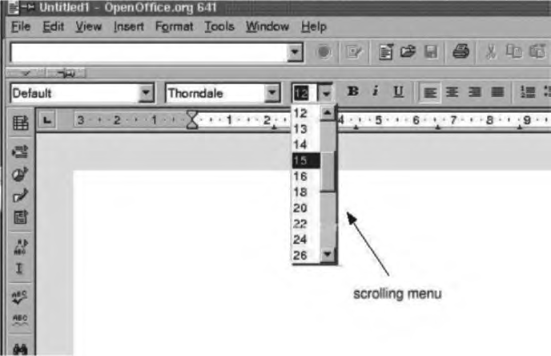
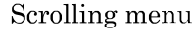
Figur 9.1 Font size selection using scrolling menu
Hierarchical menu: This type of menu is suitable for small screens with limited display area such as that in mobile phones. In a hierarchical menu, the menu items are organised in a hierarchy or tree structure. Selecting a menu item causes the current menu display to be replaced by an appropriate sub-menu. Thus in this case, one can consider the menu and its various sub-menu to form a hierarchical tree-like structure.
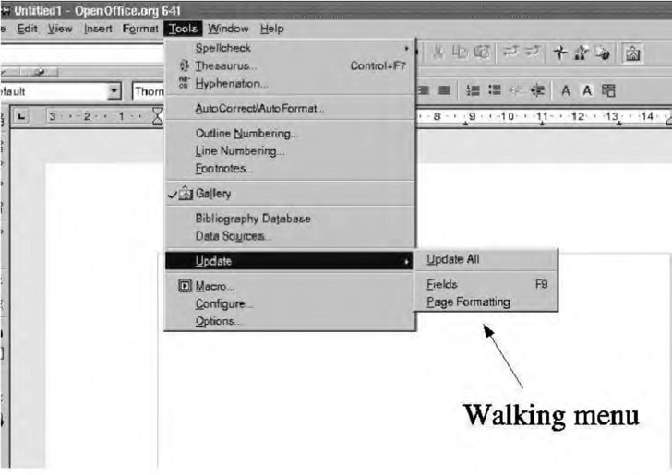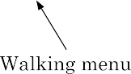
FIGURE 9.2 Example of walking menu.
3.Direct manipulation interfaces: Direct manipulation interfaces present the interface to the user in the form of visual models (i.e., icons2 or objects). For this reason, direct manipulation interfaces are sometimes called as iconic interfaces. In this type of interface, the user issues commands by performing actions on the visual representations of the objects, e.g., pull an icon representing a ﬁle into an icon representing a trash box, for deleting the ﬁle.

Important advantages of iconic interfaces include the fact that the icons can be recognised by the users very easily, and that icons are language-independent. However, experienced users ﬁnd direct manipulation interfaces very far too. Also, it is difficult to give complex commands using a direct manipulation interface.
Eample:
If one has to drag an icon representing the ﬁle to a trash box icon for deleting a ﬁle, then in order to delete all the ﬁles in the directory one has to perform this operation individually for all ﬁles—which could be very easily done by issuing a command like delete.
Fundamentals of component-based GUI development:
Graphical user interfaces became popular in the 1980s. The main reason why there were very few GUI-based applications prior to the eighties is that graphics terminals were too expensive.

Window System: Most modern graphical user interfaces are developed using some window system.
Window: A window is a rectangular area on the screen. A window can be considered to be a virtual screen, in the sense that it provides an interface to the user for carrying out independent activities, e.g., one window can be used for editing a program and another for drawing pictures, etc.

Window management system (WMS):
A graphical user interface typically consists of a large number of windows. Therefore, it is necessary to have some systematic way to manage these windows. Most graphical user interface development environments do this through a window management system (WMS).

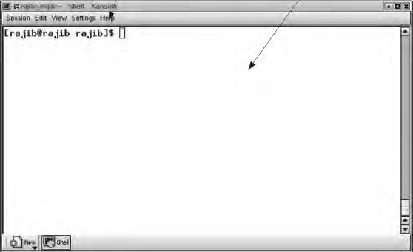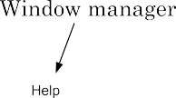
Window with client and user areas marked.
A WMS consists of two parts (see Figure 9.4):
- a window manager, and
- a window system.
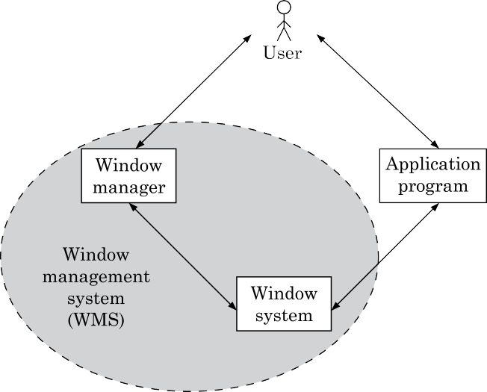
Window manager and window system: The window manager is built on the top of the window system in the sense that it makes use of various services provided by the window system. The window manager and not the window system determines how the windows look and behave. In fact, several kinds of window managers can be developed based on the same window system. The window manager can be considered as a special kind of client that makes use of the services (function calls) supported by the window system.

Component-based development
A development style based on widgets is called component-based (or widget-based) GUI development style. There are several important advantages of using a widget-based design style.

Visual programming
Visual programming is the drag and drop style of program development. In this style of user interface development, a number of visual objects (icons) representing the GUI components are provided by the programming environment. The application programmer can easily develop the user interface by dragging the required component types (e.g., menu, forms, etc.) from the displayed icons and placing them wherever required.

Types of Widgets: Diﬀerent interface programming packages support diﬀerent widget sets.
Label widget: This is probably one of the simplest widgets. A label widget does nothing except to display a label, i.e., it does not have any other interaction capabilities and is not sensitive to mouse clicks. A label widget is often used as a part of other widgets.
Container widget: These widgets do not stand by themselves, but exist merely to contain other widgets. Other widgets are created as children of the container widget. When the container widget is moved or resized, its children widget also get moved or resized.
Pop-up menu: These are transient and task speciﬁc. A pop-up menu appears upon
pressing the mouse button, irrespective of the mouse position.
Pull-down menu: These are more permanent and general. You have to move the cursor
to a speciﬁc location and pull down this type of menu.
Dialog boxes: We often need to select multiple elements from a selection list. A dialog box remains visible until explicitly dismissed by the user. A dialog box can include areas for entering text as well as values.
Push button: A push button contains key words or pictures that describe the action that is triggered when you activate the button.
Radio buttons: A set of radio buttons are used when only one option has to be selected out of many options.
Combo boxes: A combo box looks like a button until the user interacts with it. When the user presses or clicks it, the combo box displays a menu of items to choose from.

An Overview of X-Window/MOTIF:
One of the important reasons behind the extreme popularity of the X-window system is probably due to the fact that it allows development of portable GUIs. Applications developed using the X-window system are device-independent. Also, applications developed using the X-window system are network independent in the sense that their interface would work just as well on a terminal connected anywhere on the network.
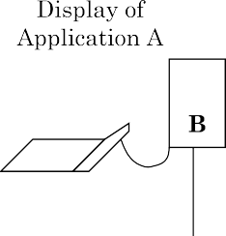
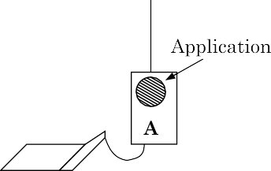
Network-independent GUI
X Architecture: The X architecture is pictorially depicted in bellow figure. The diﬀerent terms used in this diagram are explained as follows:
Architecture of the X System.
X server: The X server runs on the hardware to which the display and the key board are attached. The X server performs low-level graphics, manages window, and user input functions. The X server controls accesses to a bit-mapped graphics display resource and manages it.
X protocol: The X protocol deﬁnes the format of the requests between client applications and display servers over the network. The X protocol is designed to be independent of hardware, operating systems, underlying network protocol, and the programming language used.
X library (Xlib): The Xlib provides a set of about 300 utility routines for applications to call. These routines convert procedure calls into requests that are transmitted to the server. Xlib provides low level primitives for developing a user interface, such as displaying a window, drawing characters and graphics on the window, waiting for speciﬁc events, etc.
Xtoolkit (Xt): The Xtoolkit consists of two parts: the intrinsics and the widgets. We have already seen that widgets are predeﬁned user interface components such as scroll bars, menu bars, push buttons, etc. for designing GUIs. Intrinsics are a set of about a dozen library routines that allow a programmer to combine a set of widgets into a user interface.

Size Measurement of a Component-based GUI:
- Lines of code (LOC) is not an appropriate metric to estimate and measure the size of a component-based GUI.
- This is because, the interface is developed by integrating several pre- built components.
- The diﬀerent components making up an interface might have been in written using code of drastically diﬀerent sizes.
- However, as far as the eﬀort of the GUI developer who develops an interface by integrating the components may not be aﬀected by the code size of the components he integrates.

A USER INTERFACE DESIGN METHODOLOGY:
Introduction: At present, no step-by-step methodology is available which can be followed by rote to come up with a good user interface. What we present in this section is a set of recommendations which you can use to complement your ingenuity. Even though almost all popular GUI design methodologies are user-centered, this concept has to be clearly distinguished from a user interface design by users. Before we start discussing about the user interface design methodology, let us distinguish between a user-centered design and a design by users.
Implications of Human Cognition Capabilities on User Interface Design:
An area of human-computer interaction where extensive research has been conducted is how human cognitive capabilities and limitations inﬂuence the way an interface should be designed. In the following subsections, we discuss some of the prominent issues that have been extensively reported in the literature.
Limited memory: Humans can remember at most seven unrelated items of information for short periods of time. Therefore, the GUI designer should not require the user to remember too many items of information at a time. It is the GUI designer’s responsibility to anticipate what information the user will need at what point of each task and to ensure that the relevant information is displayed for the user to see.
Frequent task closure: Doing a task (except for very trivial tasks) requires doing several subtasks. When the system gives a clear feedback to the user that a task has been successfully completed, the user gets a sense of achievement and relief. The user can clear out information regarding the completed task from memory.
Recognition rather than recall: Information recall incurs a larger memory burden on the users and is to be avoided as far as possible. On the other hand, recognition of information from the alternatives shown to him is more acceptable.
Procedural versus object-oriented: Procedural designs focus on tasks, prompting the user in each step of the task, giving them very few options for anything else. This approach is best applied in situations where the tasks are narrow and well-deﬁned or where the users are inexperienced, such as a bank ATM.

A GUI Design Methodology:
The GUI design methodology we present here is based on the seminal work of Frank Ludolph [Frank, 1998]. Our user interface design methodology consists of the following important steps:
      - Examine the use case model of the software. Interview, discuss, and review the GUI issues with the end-users
      - Task and object modelling
      - Metaphor selection
      - Interaction design and rough layout
      - Detailed presentation and graphics design
      - GUI construction
      - Usability evaluation

Task and object modelling
A task is a human activity intended to achieve some goals. Examples of task goals can be as follows:
      - Reserve an airline seat
      - Buy an item
      - Transfer money from one account to another
      - Book a cargo for transmission to an address
A task model is an abstract model of the structure of a task. A task model should show the structure of the subtasks that the user needs to perform to achieve the overall task goal.

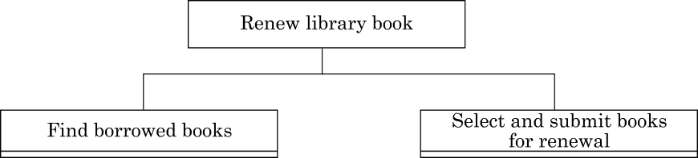
Decomposition of a task into subtasks.
Identiﬁcation of the user objects forms the basis of an object-based design. A user object model is a model of business objects which the end-users believe that they are interacting with.
Metaphor selection:
The ﬁrst place one should look for while trying to identify the candidate metaphors is the set of parallels to objects, tasks, and terminologies of the use cases. If no obvious metaphors can be found, then the designer can fall back on the metaphors of the physical world of concrete objects. The appropriateness of each candidate metaphor should be tested by restating the objects and tasks of the user interface model in terms of the metaphor.
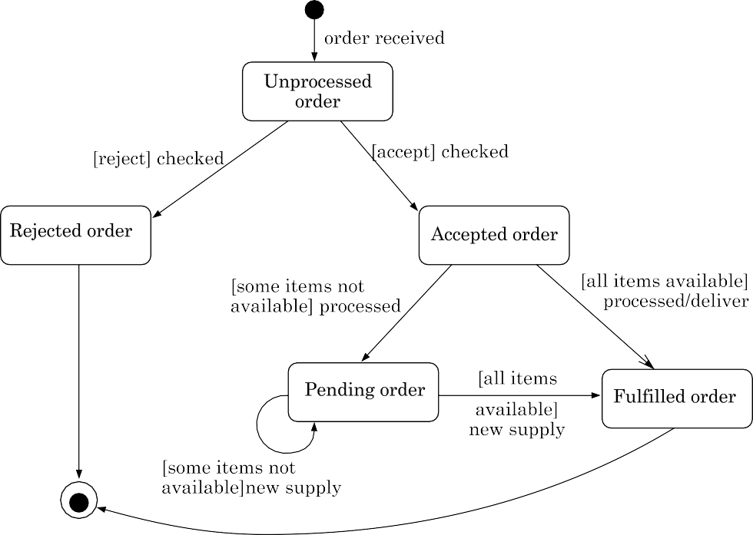

State chart diagram for an order object.

Interaction design and rough layout:
The interaction design involves mapping the subtasks into appropriate controls, and other widgets such as forms, textbox, etc. This involves making a choice from a set of available components that would best suit the subtask. Rough layout concerns how the controls, another widgets to be organised in windows.

Detailed presentation and graphics design:
Each window should represent either an object or many objects that have a clear relationship to each other. At one extreme, each object view could be in its own window. But, this is likely to lead to too much window opening, closing, moving, and resizing. At the other extreme, all the views could be placed in one window side-by-side, resulting in a very large window.

GUI construction:
Some of the windows have to be deﬁned as modal dialogs. When a window is a modal dialog, no other windows in the application is accessible until the current window is closed. When a modal dialog is closed, the user is returned to the window from which the modal dialog was invoked. Modal dialogs are commonly used when an explicit conﬁrmation or authorisation step is required for an action (e.g., conﬁrmation of delete).

User interface inspection:
Nielson [Niel, 1994] studied common usability problems and built a checklist of points which can be easily checked for an interface. The following checklist is based on the work of Nielson [Niel, 1994]:
Visibility of the system status: The system should as far as possible keep the user informed about the status of the system and what is going on. For example, it should not be the case that a user gives a command and keeps waiting, wondering whether the system has crashed and he should reboot the system or that the results shall appear after some more time.
Match between the system and the real world: The system should speak the user’s language with words, phrases, and concepts familiar to that used by the user, rather than using system-oriented terms.
Undoing mistakes: The user should feel that he is in control rather than feeling helpless or to be at the control of the system. An important step toward this is that the users should be able to undo and redo operations.
Consistency: The users should not have to wonder whether diﬀerent words, concepts, and operations mean the same thing in diﬀerent situations.
Recognition rather than recall: The user should not have to recall information which was presented in another screen. All data and instructions should be visible on the screen for selection by the user.
Support for multiple skill levels: Provision of accelerators for experienced users allows
them to efficiently carry out the actions they most frequently require to perform.
Aesthetic and minimalist design: Dialogs and screens should not contain information which are irrelevant and are rarely needed. Every extra unit of information in a dialog or screen competes with the relevant units and diminishes their visibility.
Help and error messages: These should be expressed in plain language (no codes), precisely indicating the problem, and constructively suggesting a solution.
Error prevention: Error possibilities should be minimised. A key principle in this regard is to prevent the user from entering wrong values.

