Assignment 1
Artificial Intelligence
Name -Girish Chinchalpalle
Roll no – CSA – 56
PRN - 12110567

- Problem Statement (PS): Implementation of AI and Non-AI technique by implementing any two player game.
- Theory: Tic-Tac-Toe is a two-player game played on a 3x3 grid. Players take turns marking a cell with their respective symbols ('X' or 'O') until one player wins by forming a line of their symbols horizontally, vertically, or diagonally, or the game ends in a draw.
- Approach: The AI approach involves implementing the minimax algorithm combined with heuristic evaluation to determine the optimal moves. The minimax algorithm explores the game tree recursively, evaluating each possible move and selecting the one that maximizes its chances of winning or minimizes its chances of losing.
- Algorithm:
Non-AI:
The board state is represented using an array of integers where:
- 2 represents an empty cell.
- 3 represents an 'X' .
- 5 represents an 'O' .
Implemented Posswin() function ; r. A product 3*3*2 = 18 gives a win for X, 5*5*2=50 gives a win for O, and the winning move is the holder of the blank.
AI:
The minimax algorithm is used to determine the best move for the AI player.
- Start with the current state of the game board.
- Generate all possible moves for the AI player.
- For each possible move:
  - Recursively evaluate the resulting game state using minimax.
  - Apply alpha-beta pruning to reduce the number of evaluated nodes.
  - Select the move with the maximum score if it's the AI's turn, or the minimum score if it's the opponent's turn.
- Return the selected move as the optimal move.
- Comparison AI & Non-AI:
- AI:
  - Utilizes an algorithmic approach to make decisions.
  - Can analyse multiple possible moves and select the best one.
  - Can adapt its strategy based on the opponent's moves.
- Non-AI:
  - Relies on human intuition and decision-making.
  - Limited ability to analyze and consider multiple future outcomes.
  - Works on fixed algorithms
- Solved Examples on Paper:
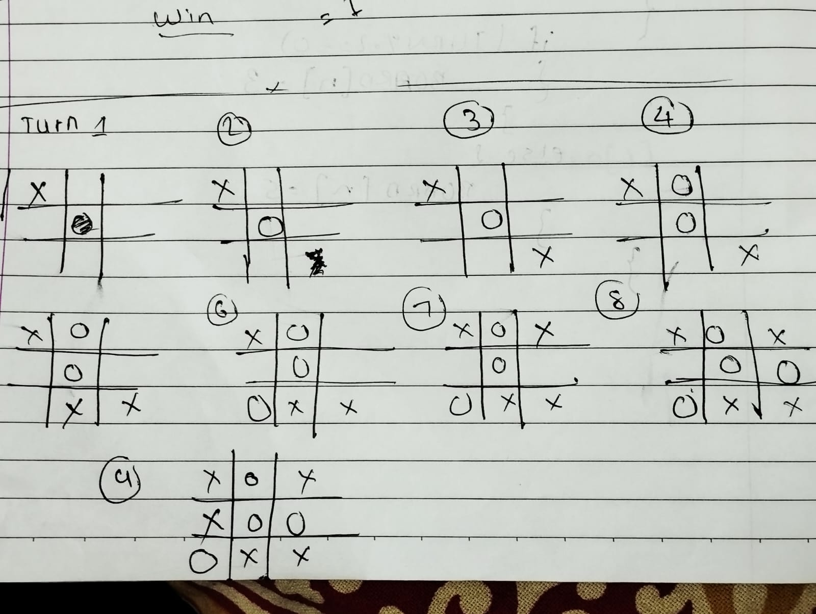
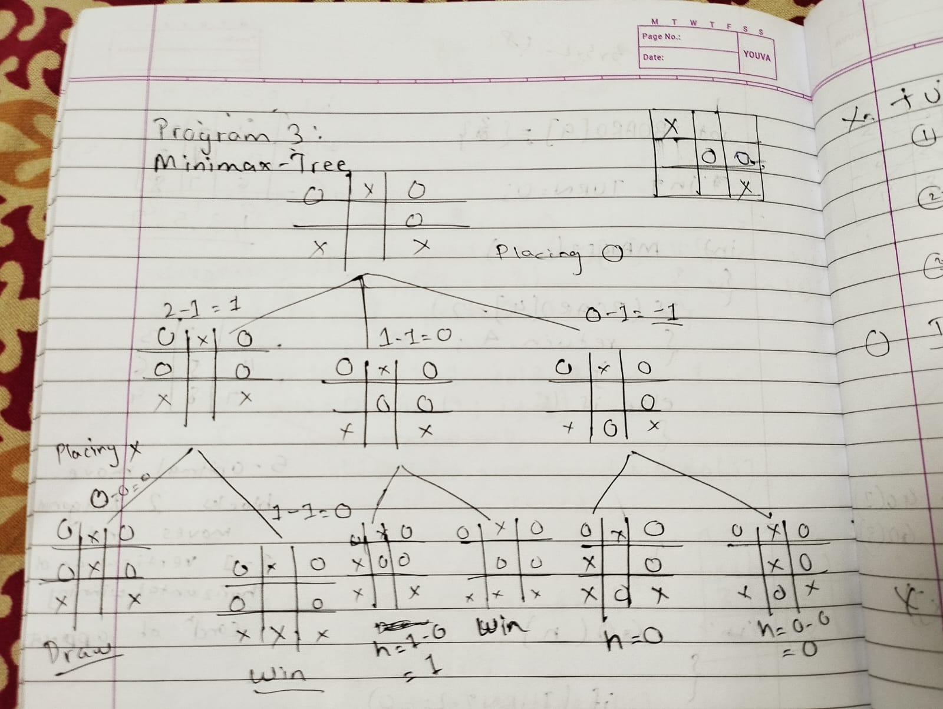
- Heuristics Used:
- Heuristic evaluation of game states to estimate the likelihood of winning or losing.
- Evaluation based on factors such as number of potential winning lines, blocking opponent's moves, and creating opportunities for winning.
- Source Code:
Non-AI
#include <iostream>
using namespace std;
#define COMPUTER 1
#define HUMAN 2

#define SIDE 3

int board[9] = {2, 2, 2, 2, 2, 2, 2, 2, 2};
int win[8][3] = {{0, 1, 2}, {3, 4, 5}, {6, 7, 8}, {0, 3, 6}, {1, 4, 7}, {2, 5, 8}, {2, 4, 6}, {0, 4, 8}};
int turn = 0;

void initialise() {
for (int i = 0; i < 9; i++) {
board[i] = 2;
}
}

void showInstructions() {
cout << "\nChoose a cell numbered from 1 to 9 as below and play\n\n";
cout << "\t\t\t 1 | 2 | 3 \n";
cout << "\t\t\t-----------\n";
cout << "\t\t\t 4 | 5 | 6 \n";
cout << "\t\t\t-----------\n";
cout << "\t\t\t 7 | 8 | 9 \n\n";
}

void declareWinner(int whoseTurn)
{
if (whoseTurn == COMPUTER)
cout << "COMPUTER has won\n";
else
cout << "HUMAN has won\n";
}
void printBoard()
{
cout << "-------" << endl;
for (int i = 0; i < 9; i += 3)
{
cout << "|";
for (int j = i; j < i + 3; ++j)
{
if (board[j] == 2)
{
cout << " "
<< "|";
}
else if (board[j] == 3)
{
cout << "X"
<< "|";
}
else
{
cout << "O"
<< "|";
}
}
cout << endl;
for (int j = 0; j < 3; ++j)
{
cout << "--";
}
cout << "-";
cout << endl;
}
}

int posswin(int x)
{
for (int i = 0; i < 8; i++)
{
int c = 0, mt = -01;
for (int j = 0; j < 3; j++)
{
if (board[win[i][j]] == x)
c++;
else if (board[win[i][j]] == 2)
mt = win[i][j];
else
c--;
}
if (c == 2)
return mt;
}
return -1;
}

int winner()
{
int x;
if (turn % 2 == 0)
x = 3;
else
x = 5;

for (int i = 0; i < 8; i++)
{
int c = 0;
for (int j = 0; j < 3; j++)
{
if (board[win[i][j]] == x)
c++;
}
if (c == 3)
return 1;
}
return 0;
}

int make2()
{
if (board[4] == 2)
return 4;
else if (board[1] == 2)
return 1;
else if (board[3] == 2)
return 3;
else if (board[5] == 2)
return 5;
else if (board[7] == 2)
return 7;
}

void go(int n)
{
if (turn % 2 == 0)
{
board[n] = 5;
}
else
{
board[n] = 3;
}

turn++;
}

void nextmove()
{
int x;
int self;
if (turn % 2 == 0)
{
self = 5;
x = 3;
}
else
{
self = 3;
x = 5;
}

if (posswin(self) != -1)
{
go(posswin(self));
}
else if (posswin(x) != -1)
{
go(posswin(x));
}
else
{
go(make2());
}
}

void playTicTacToe(int whoseTurn)
{
turn = 1;
initialise();
showInstructions();
while (turn<=9)
{
int n;
if (whoseTurn == COMPUTER)
{
if (turn == 1)
go(0);
else if (turn == 2)
(board[4] == 2) ? go(4) : go(0);
else if (turn == 3)
(board[8] == 2) ? go(8) : go(2);
else
{
nextmove();
}
printBoard();
if (winner())
{
declareWinner(whoseTurn);
break;
}
whoseTurn = HUMAN;
}
else
{
cout << "You can insert in the following positions : ";
for (int i = 0; i < 9; i++)
if (board[i] == 2)
cout << i + 1 << " ";
cout << endl
<< endl;
cout << "Enter the position = ";
cin >> n;
n--;

if (board[n] == 2 && n < 9 && n >= 0)
{
go(n);
cout << endl;
printBoard();
if (winner())
{
declareWinner(whoseTurn);
break;
}
whoseTurn = COMPUTER;
}
else if (board[n] != 2 && n < 9 && n >= 0)
{
cout << "\nPosition is occupied, select any one place from the available places\n\n";
}
else if (n < 0 || n > 8)
{
cout << "Invalid position\n";
}
}
}
if (winner() == 0)
{
cout << "\nIts a DRAW\n";
}
}

int main()
{
cout << "\t\t\t Tic-Tac-Toe\n\n";
char cont = 'y';
do
{
char choice;
cout << "Do you want to start first?(y/n) : ";
cin >> choice;

if (choice == 'n')
playTicTacToe(COMPUTER);
else if (choice == 'y')
playTicTacToe(HUMAN);
else
cout << "Invalid choice\n";

cout << "\nDo you want to quit(y/n) : ";
cin >> cont;
} while (cont == 'n');
return 0;
}

AI Technique:
#include <iostream>
using namespace std;

#define COMPUTER 1
#define HUMAN 2

#define SIDE 3 // Length of the board

#define COMPUTERMOVE 'O'
#define HUMANMOVE 'X'

void showBoard(char board[][SIDE]) {
cout << "\t\t\t " << board[0][0] << " | " << board[0][1] << " | " << board[0][2] << endl;
cout << "\t\t\t-----------\n";
cout << "\t\t\t " << board[1][0] << " | " << board[1][1] << " | " << board[1][2] << endl;
cout << "\t\t\t-----------\n";
cout << "\t\t\t " << board[2][0] << " | " << board[2][1] << " | " << board[2][2] << endl
<< endl;
}

void showInstructions() {
cout << "\nChoose a cell numbered from 1 to 9 as below and play\n\n";
cout << "\t\t\t 1 | 2 | 3 \n";
cout << "\t\t\t-----------\n";
cout << "\t\t\t 4 | 5 | 6 \n";
cout << "\t\t\t-----------\n";
cout << "\t\t\t 7 | 8 | 9 \n\n";
}

void initialise(char board[][SIDE]) {
for (int i = 0; i < SIDE; i++) {
for (int j = 0; j < SIDE; j++)
board[i][j] = ' ';
}
}

void declareWinner(int whoseTurn) {
if (whoseTurn == COMPUTER)
cout << "COMPUTER has won\n";
else
cout << "HUMAN has won\n";
}

bool rowCrossed(char board[][SIDE]) {
for (int i = 0; i < SIDE; i++) {
if (board[i][0] == board[i][1] && board[i][1] == board[i][2] && board[i][0] != ' ')
return true;
}
return false;
}

bool columnCrossed(char board[][SIDE]) {
for (int i = 0; i < SIDE; i++) {
if (board[0][i] == board[1][i] && board[1][i] == board[2][i] && board[0][i] != ' ')
return true;
}
return false;
}

bool diagonalCrossed(char board[][SIDE]) {
if (board[0][0] == board[1][1] && board[1][1] == board[2][2] && board[0][0] != ' ')
return true;

if (board[0][2] == board[1][1] && board[1][1] == board[2][0] && board[0][2] != ' ')
return true;

return false;
}

bool gameOver(char board[][SIDE]) {
return (rowCrossed(board) || columnCrossed(board) || diagonalCrossed(board));
}

int minimax(char board[][SIDE], int depth, bool isAI) {
int score = 0;
int bestScore = 0;
if (gameOver(board) == true) {
if (isAI == true)
return -1;
if (isAI == false)
return +1;
} else {
if (depth < 9) {
if (isAI == true) {
bestScore = -999;
for (int i = 0; i < SIDE; i++) {
for (int j = 0; j < SIDE; j++) {
if (board[i][j] == ' ') {
board[i][j] = COMPUTERMOVE;
score = minimax(board, depth + 1, false);
board[i][j] = ' ';
if (score > bestScore) {
bestScore = score;
}
}
}
}
return bestScore;
} else {
bestScore = 999;
for (int i = 0; i < SIDE; i++) {
for (int j = 0; j < SIDE; j++) {
if (board[i][j] == ' ') {
board[i][j] = HUMANMOVE;
score = minimax(board, depth + 1, true);
board[i][j] = ' ';
if (score < bestScore) {
bestScore = score;
}
}
}
}
return bestScore;
}
} else {
return 0;
}
}
}

int bestMove(char board[][SIDE], int moveIndex) {
int x = -1, y = -1;
int score = 0, bestScore = -999;
for (int i = 0; i < SIDE; i++) {
for (int j = 0; j < SIDE; j++) {
if (board[i][j] == ' ') {
board[i][j] = COMPUTERMOVE;
score = minimax(board, moveIndex + 1, false);
board[i][j] = ' ';
if (score > bestScore) {
bestScore = score;
x = i;
y = j;
}
}
}
}
return x * 3 + y;
}

void playTicTacToe(int whoseTurn) {
char board[SIDE][SIDE];
int moveIndex = 0, x = 0, y = 0;

initialise(board);
showInstructions();

while (gameOver(board) == false && moveIndex != SIDE * SIDE) {
int n;
if (whoseTurn == COMPUTER) {
n = bestMove(board, moveIndex);
x = n / SIDE;
y = n % SIDE;
board[x][y] = COMPUTERMOVE;
cout << "COMPUTER has put a " << COMPUTERMOVE << " in cell " << n + 1 << endl
<< endl;
showBoard(board);
moveIndex++;
whoseTurn = HUMAN;
} else if (whoseTurn == HUMAN) {
cout << "You can insert in the following positions : ";
for (int i = 0; i < SIDE; i++)
for (int j = 0; j < SIDE; j++)
if (board[i][j] == ' ')
cout << (i * 3 + j) + 1 << " ";
cout << endl
<< endl;
cout << "Enter the position = ";
cin >> n;
n--;
x = n / SIDE;
y = n % SIDE;
if (board[x][y] == ' ' && n < 9 && n >= 0) {
board[x][y] = HUMANMOVE;
cout << "\nHUMAN has put a " << HUMANMOVE << " in cell " << n + 1 << endl
<< endl;
showBoard(board);
moveIndex++;
whoseTurn = COMPUTER;
} else if (board[x][y] != ' ' && n < 9 && n >= 0) {
cout << "\nPosition is occupied, select any one place from the available places\n\n";
} else if (n < 0 || n > 8) {
cout << "Invalid position\n";
}
}
}

if (gameOver(board) == false && moveIndex == SIDE * SIDE)
cout << "It's a draw\n";
else {
if (whoseTurn == COMPUTER)
whoseTurn = HUMAN;
else if (whoseTurn == HUMAN)
whoseTurn = COMPUTER;

declareWinner(whoseTurn);
}
}

int main() {
cout << "\t\t\t Tic-Tac-Toe\n";
char cont = 'y';
do {
char choice;
cout << "Do you want to start first?(y/n) : ";
cin >> choice;

if (choice == 'n')
playTicTacToe(COMPUTER);
else if (choice == 'y')
playTicTacToe(HUMAN);
else
cout << "Invalid choice\n";

cout << "\nDo you want to quit(y/n) : ";
cin >> cont;
} while (cont == 'n');
return 0;
}

- Output for Different Test Cases:
- Test Case 1: Initial game state with the AI making the first move.
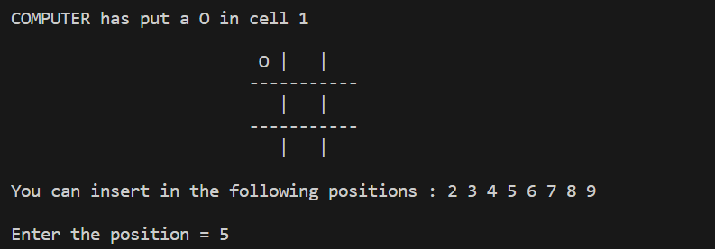
- Test Case 2: Scenario demonstrating the AI blocking the opponent's winning move.
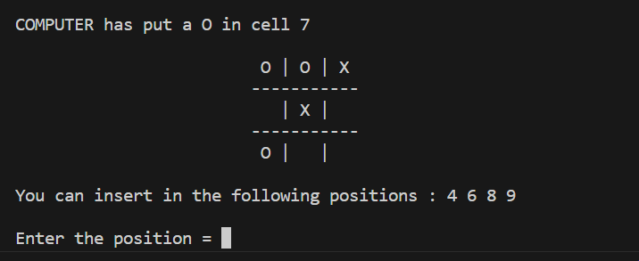
- Test Case 3: Example showcasing the AI winning the game with optimal moves.
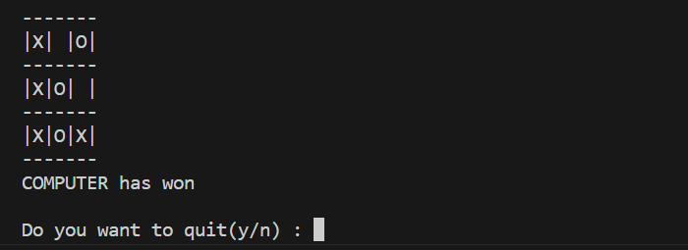
- Test Case 4: Draw scenario where neither player wins.
