Artificial Intelligence
Assignment 3
Name – Girish Chinchalpalle
Roll no – CSA - 56
PRN – 12110567

- Problem Statement (PS): Implementation of Informed strategies.(Applying on A* and Best-First Search on 8-puzzles)

- Theory:
Informed search algorithms use problem-specific knowledge to guide the search towards the goal efficiently. They rely on a heuristic function that estimates the cost from the current state to the goal. These algorithms prioritize node expansion based on a combination of the current path cost and the estimated cost to the goal. A* is a commonly used informed search algorithm that guarantees optimality under certain conditions, such as admissible and consistent heuristics.

- Approach:
    - A* Algorithm :
The code implements the A* search algorithm to solve the 8-puzzle problem. Here's how the A* algorithm is applied in the code:
      - Initialization:
- The program starts by initializing the puzzle size (n) and creating empty lists for the open and closed nodes.
- It then accepts the start state and the goal state of the puzzle from the user.
      - Creating Initial Node:
- A Node object is created with the start state, level 0, and a calculated f-value (total cost) based on the heuristic function h and the level.

      - Main Loop:
- The main loop continues until the goal state is reached (h(cur.datza, goal) == 0).
- Within each iteration of the loop, the current node (cur) is selected from the open list. The open list is sorted based on the f-values of the nodes.
- The program then checks if the current node is the goal state. If it is, the loop breaks, and the solution is found.
- If the current node is not the goal state, it generates child nodes by moving the blank space in different directions (generate_child method). For each valid child node, it calculates the f-value and adds it to the open list.
- The current node is then moved from the open list to the closed list.
      - Child Node Generation:
- The generate_child method generates child nodes by moving the blank space in the puzzle state. It creates a new node for each valid move and adds it to the list of children.
      - Heuristic Calculation (h function):
- The heuristic function h calculates the number of misplaced tiles between the current state and the goal state. It returns the total heuristic cost.
      - Total Cost Calculation (f function):
- The total cost function f calculates the total cost of a node by adding the heuristic cost (h) to the level of the node.
      - Printing the Puzzle States:
- The program prints the puzzle states in each iteration, showing the progress of the A* algorithm.
      - Termination:
- Once the goal state is reached, the program exits the main loop and finishes execution.
Overall, the A* algorithm efficiently searches through the puzzle states, considering both the cost to reach the current state and the estimated cost to reach the goal, until it finds the optimal solution.

Best-First Search (BFS):
(1) Initialization:
Initialize the program by accepting the puzzle size (n) and creating empty lists for open and closed nodes.
Accept the start state and the goal state of the puzzle from the user.
(2) Creating Initial Node:
Create a Node object with the start state and a calculated heuristic value based on the chosen heuristic function.
(3) Main Loop:
The main loop continues until a solution is found or no more nodes are left to explore.
Within each iteration of the loop, select the current node (cur) from the open list based on the chosen priority order.
Check if the current node is the goal state. If it is, terminate the loop and the solution is found.
If the current node is not the goal state, generate child nodes by applying valid moves to the current state.
Calculate the heuristic value for each child node and add them to the open list.
Move the current node from the open list to the closed list.
(4) Child Node Generation:
Generate child nodes by applying valid moves to the puzzle state. Each valid move creates a new node representing the resulting state.
(5) Heuristic Calculation:
The heuristic function calculates the estimated cost (heuristic value) from the current state to the goal state.
(6) Priority Order:
Define the priority order for selecting nodes from the open list. In Best-First Search, this order is based solely on the heuristic value.
(7) Printing the Puzzle States:
Print the puzzle states in each iteration to show the progress of the search algorithm.
(8) Termination:
Terminate the search once the goal state is reached or if no solution is found.
Overall, Best-First Search efficiently explores the puzzle states based on the heuristic values, moving towards states that appear to be closer to the goal. It continues this exploration until it finds the solution or exhausts all possible states.
- Algorithm:
    - A* :
- Start Initialize an open list (priority queue) to store states to be explored.
- Insert the initial state into the open list.
- While the open list is not empty:
  - Remove the state with the lowest f-value (combination of path cost and heuristic value) from the open list.
  - If the removed state is the goal state, return the solution.
  - Otherwise, generate successor states by applying valid moves (e.g., swapping tiles) to the current state.
  - For each successor state:
    - Calculate its f-value using the heuristic function.
    - If the state is not already in the open list or the new f-value is lower, update its f-value and add it to the open list.
ii) Best-First Search (BFS)

- Start:
- Initialize an open list (priority queue) to store states to be explored.
- Insert the initial state into the open list.

- While the open list is not empty:
- Remove the state with the lowest f-value (combination of path cost and heuristic value) from the open list.
- If the removed state is the goal state, return the solution.
- Otherwise, generate successor states by applying valid moves (e.g., swapping tiles) to the current state.
- For each successor state:
- Calculate its f-value using the heuristic function.
- If the state is not already in the open list or the new f-value is lower, update its f-value and add it to the open list.
- End

- Comparison between A* and BFS:

Feature | A* Search | Best-First Search
Optimality | Guarantees optimality if heuristic is admissible | Does not guarantee optimality
Completeness | Complete if finite search space and branching | Not necessarily complete
Time Complexity | Exponential, but can be near-linear with good heuristic | Exponential in worst case
Memory Usage | Typically requires more memory due to open and closed lists | May require less memory as it only maintains open list
Applications | Pathfinding, route planning, robotics | Web search engines, scheduling, pattern recognition

- Heuristics Used:

The A* and Best First Search Search algorithm uses the Manhattan distance heuristic to estimate the cost from the current state to the goal state. This heuristic calculates the sum of the distances (in terms of squares moved horizontally and vertically) of each tile from its current position to its goal position.

- Code:

    - A*:
#include <iostream>
#include <vector>
#include <algorithm>

// Define a class Node to represent each state of the puzzle
class Node {
public:
std::vector<std::vector<char>> data; // The puzzle state
int level; // The depth of the node in the search tree
int fval; // The total cost of the node (f-value)

Node(std::vector<std::vector<char>> data, int level, int fval) {
this->data = data;
this->level = level;
this->fval = fval;
}

std::vector<Node> generate_child(); // Method to generate child nodes
std::vector<std::vector<char>> shuffle(std::vector<std::vector<char>> puz, int x1, int y1, int x2, int y2); // Method to shuffle the puzzle state
std::vector<std::vector<char>> copy(std::vector<std::vector<char>> root); // Method to copy the puzzle state
std::pair<int, int> find(std::vector<std::vector<char>> puz, char x); // Method to find the position of a character in the puzzle
};

// Generate child nodes by moving the blank space in different directions
std::vector<Node> Node::generate_child() {
std::vector<Node> children;
auto blank_pos = find(data, '_');
int x = blank_pos.first;
int y = blank_pos.second;
std::vector<std::pair<int, int>> val_list = {{x, y - 1}, {x, y + 1}, {x - 1, y}, {x + 1, y}};
for (auto i : val_list) {
auto child_data = shuffle(data, x, y, i.first, i.second);
if (!child_data.empty()) {
Node child_node(child_data, level + 1, 0);
children.push_back(child_node);
}
}
return children;
}

// Shuffle the puzzle state by swapping two elements
std::vector<std::vector<char>> Node::shuffle(std::vector<std::vector<char>> puz, int x1, int y1, int x2, int y2) {
if (x2 >= 0 && x2 < puz.size() && y2 >= 0 && y2 < puz.size()) {
std::vector<std::vector<char>> temp_puz = puz;
char temp = temp_puz[x2][y2];
temp_puz[x2][y2] = temp_puz[x1][y1];
temp_puz[x1][y1] = temp;
return temp_puz;
} else {
return {};
}
}

// Copy the puzzle state
std::vector<std::vector<char>> Node::copy(std::vector<std::vector<char>> root) {
std::vector<std::vector<char>> temp;
for (auto i : root) {
temp.push_back(i);
}
return temp;
}

// Find the position of a character in the puzzle
std::pair<int, int> Node::find(std::vector<std::vector<char>> puz, char x) {
for (size_t i = 0; i < puz.size(); ++i) {
for (size_t j = 0; j < puz[i].size(); ++j) {
if (puz[i][j] == x) {
return {i, j};
}
}
}
return {-1, -1};
}

// Define a class Puzzle to represent the puzzle solving process
class Puzzle {
public:
int n; // The size of the puzzle (n x n)
std::vector<Node> open; // The open list of nodes
std::vector<Node> closed; // The closed list of nodes

Puzzle(int size) {
n = size;
open = std::vector<Node>();
closed = std::vector<Node>();
}

std::vector<std::vector<char>> accept(); // Method to accept the puzzle input from the user
int f(Node start, std::vector<std::vector<char>> goal); // Method to calculate the total cost of a node
int h(std::vector<std::vector<char>> start, std::vector<std::vector<char>> goal); // Method to calculate the heuristic cost of a node
void process(); // Method to solve the puzzle
};

// Accept the puzzle input from the user
std::vector<std::vector<char>> Puzzle::accept() {
std::vector<std::vector<char>> puz;
for (int i = 0; i < n; ++i) {
std::vector<char> temp;
std::string input;
std::getline(std::cin, input);
for (char c : input) {
if (c != ' ') {
temp.push_back(c);
}
}
puz.push_back(temp);
}
return puz;
}

// Calculate the total cost of a node
int Puzzle::f(Node start, std::vector<std::vector<char>> goal) {
return h(start.data, goal) + start.level;
}

// Calculate the heuristic cost of a node (number of misplaced tiles)
int Puzzle::h(std::vector<std::vector<char>> start, std::vector<std::vector<char>> goal) {
int temp = 0;
for (size_t i = 0; i < start.size(); ++i) {
for (size_t j = 0; j < start[i].size(); ++j) {
if (start[i][j] != goal[i][j] && start[i][j] != '_') {
temp += 1;
}
}
}
return temp;
}

// Solve the puzzle using A* algorithm
void Puzzle::process() {
std::cout << "Enter the start state matrix \n";
std::vector<std::vector<char>> start = accept();
std::cout << "Enter the goal state matrix \n";
std::vector<std::vector<char>> goal = accept();

Node start_node(start, 0, 0);
start_node.fval = f(start_node, goal);
open.push_back(start_node);
std::cout << "\n\n";
while (true) {
Node cur = open[0];
std::cout << "\n";
std::cout << " | \n";
std::cout << " | \n";
std::cout << " \\'/ \n";
for (auto i : cur.data) {
for (auto j : i) {
std::cout << j << " ";
}
std::cout << "\n";
}
if (h(cur.data, goal) == 0) {
break;
}
for (auto i : cur.generate_child()) {
i.fval = f(i, goal);
open.push_back(i);
}
closed.push_back(cur);
open.erase(open.begin());

std::sort(open.begin(), open.end(), [](Node const& a, Node const& b) {
return a.fval < b.fval;
});
}
}

int main() {
Puzzle puz(3); // Create a puzzle of size 3x3
puz.process(); // Solve the puzzle
return 0;
}

    - BFS:

#include <iostream>
#include <vector>
#include <queue>
#include <unordered_set>
#include <algorithm>

using namespace std;
void printPuzzle(const vector<vector<int>>& puzzle);

// Define the State struct to represent each state of the puzzle
struct State {
vector<vector<int>> puzzle;
int heuristic;
string hash; // String representation of the state

State(vector<vector<int>> p, int h) : puzzle(p), heuristic(h) {
hash = convertToString(puzzle);
}

bool operator<(const State& other) const {
return heuristic > other.heuristic; // Priority queue should order by lowest heuristic
}

string convertToString(const vector<vector<int>>& state) {
string str;
for (const auto& row : state) {
for (int value : row) {
str += to_string(value) + ",";
}
}
return str;
}
};

// Calculate Manhattan distance heuristic
int manhattanDistance(const vector<vector<int>>& state, const vector<vector<int>>& goalState) {
int distance = 0;
for (int i = 0; i < 3; ++i) {
for (int j = 0; j < 3; ++j) {
int value = state[i][j];
if (value != 0) {
for (int k = 0; k < 3; ++k) {
for (int l = 0; l < 3; ++l) {
if (value == goalState[k][l]) {
distance += abs(k - i) + abs(l - j);
}
}
}
}
}
}
return distance;
}

// Check if the state is the goal state
bool isGoalState(const vector<vector<int>>& state, const vector<vector<int>>& goalState) {
return state == goalState;
}

// Generate all possible moves from the current state
vector<vector<vector<int>>> generateMoves(const vector<vector<int>>& state) {
vector<vector<vector<int>>> moves;
int dx[] = {-1, 1, 0, 0}; // Up, Down, Left, Right
int dy[] = {0, 0, -1, 1};
int x, y;
for (int i = 0; i < 3; ++i) {
for (int j = 0; j < 3; ++j) {
if (state[i][j] == 0) {
x = i;
y = j;
break;
}
}
}
for (int k = 0; k < 4; ++k) {
int newX = x + dx[k];
int newY = y + dy[k];
if (newX >= 0 && newX < 3 && newY >= 0 && newY < 3) {
vector<vector<int>> newState = state;
swap(newState[x][y], newState[newX][newY]);
moves.push_back(newState);
}
}
return moves;
}

// Solve the puzzle using best-first search
vector<vector<int>> solvePuzzle(vector<vector<int>>& initialState, const vector<vector<int>>& goalState, vector<State>& steps) {
priority_queue<State> frontier;
unordered_set<string> explored;
int stepCounter = 0;

int initialHeuristic = manhattanDistance(initialState, goalState);
State initial(initialState, initialHeuristic);
frontier.push(initial);

while (!frontier.empty()) {
State current = frontier.top();
frontier.pop();

steps.push_back(current); // Add current state to steps
++stepCounter;

if (isGoalState(current.puzzle, goalState)) {
return current.puzzle;
}

explored.insert(current.hash);

vector<vector<vector<int>>> nextMoves = generateMoves(current.puzzle);
for (const auto& nextState : nextMoves) {
string nextStateString = current.convertToString(nextState); // Use the member function
if (explored.find(nextStateString) == explored.end()) {
int heuristic = manhattanDistance(nextState, goalState);
State nextStateNode(nextState, heuristic);
frontier.push(nextStateNode);
}
}
}

return {}; // No solution found
}

// Utility function to print the puzzle state
void printPuzzle(const vector<vector<int>>& puzzle) {
for (const auto& row : puzzle) {
for (int value : row) {
if (value == 0) {
cout << " "; // Print two spaces for the empty tile
} else {
cout << value << " ";
}
}
cout << endl;
}
}

// Function to take puzzle input from the user
vector<vector<int>> inputPuzzle(const string& prompt) {
vector<vector<int>> puzzle(3, vector<int>(3));
cout << prompt << " (use 0 for empty tile):\n";
for (int i = 0; i < 3; ++i) {
cout << "Row " << (i + 1) << ": ";
for (int j = 0; j < 3; ++j) {
cin >> puzzle[i][j];
}
}
return puzzle;
}

// Main function
int main() {
vector<vector<int>> initialState = inputPuzzle("Enter the initial puzzle configuration");
vector<vector<int>> goalState = inputPuzzle("Enter the goal puzzle configuration");

// cout << "\nInitial state:" << endl;

vector<State> steps; // Vector to store the steps

vector<vector<int>> solution = solvePuzzle(initialState, goalState, steps);

if (!solution.empty()) {
cout << "\nSolution:" << endl;
cout<<endl;
for (size_t i = 0; i < steps.size(); ++i) {
cout << "Step " << i+1 << ":" << endl;
printPuzzle(steps[i].puzzle); // Access the puzzle member of State
cout << endl;
}
cout << "Total steps: " << steps.size() << endl;
} else {
cout << "\nNo solution found." << endl;
}

return 0;
}

- Output:

    - A*:

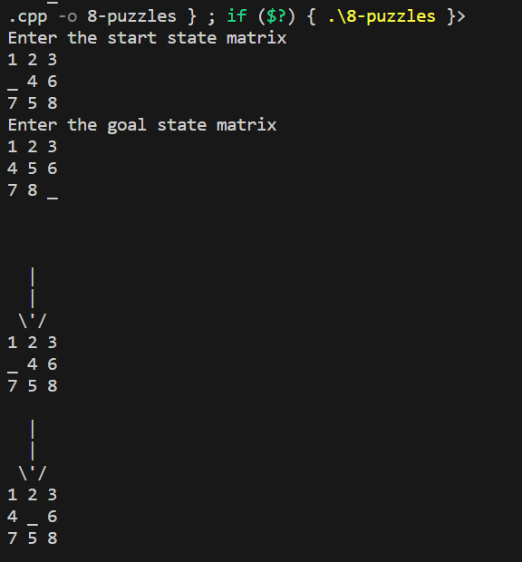

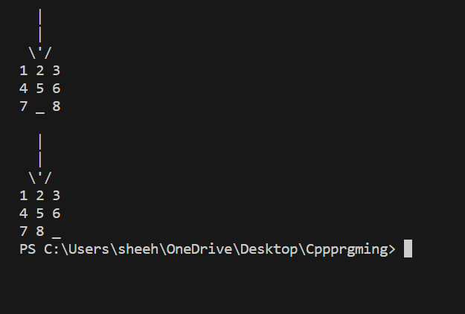

    - BFS:

