Artificial Intelligence

Assignment 5

Name –Girish chinchalpalle
Roll no- 56
PRN -12110567

Problem Statement: Implementation predicate logic using PROLOG.

• Predicate logic or First-order logic (FOL) extends propositional logic to allow reasoning about the members
(such as numbers) of some non-empty universe.
• A predicate is a generalization of a propositional variable. It uses the quantifiers ∀ (for all) and ∃ (there
exists). Quantifiers are symbols used with propositional functions.
Variables are symbols capable of taking on any constant as value. In fact, a propositional variable is equivalent to a
predicate with no arguments, and we shall write p for an atomic formula with predicate name p and zero
arguments.
• An atomic formula is a predicate with zero or more arguments. For example, u(X) is an atomic formula with
predicate u and one argument, here occupied by the variable X.
• An atomic formula all of whose arguments are constants is called a ground atomic formula.
• A nonground atomic formula can have constants or variables as formula arguments, but at least one argument
must be a variable.
• A proposition is a predicate with no arguments, and therefore is a ground atomic formula.
• A literal is either an atomic formula or its negation.
• If there are no variables among the arguments of the atomic formula, then the literal is a ground literal.

The Elements of Predicate Logic Language:
• A predicate logic language L consists of the following symbols:– an infinite set of variables, denoted by uppercase letters;– a set of constants, denoted by lowercase letters, usually a, b, etc.;– a set of predicates, denoted by lowercase letters, usually p, q, etc.;– a set of functions, denoted by lowercase letters, usually f, g, etc.;– the connectives ➢, , , →, and ≡;– the quantifiers ⱻ and Ɐ; and– the parentheses ) and (.

The Syntax of Predicate Logic Terms:
• The terms in L are defined recursively as follows:
a) Every variable and every constant is a term.
b) If t1, . . . , tn are terms and f is a function that takes n arguments, then f(t1, . . . , tn) is a term.
c) Every term is obtained in this manner.
• Terms with no variables are called variable-free terms

Example:
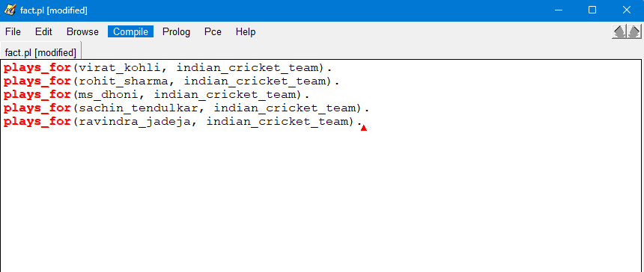
Output:

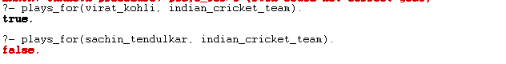
?- plays_for(Player, indian_cricket_team).
Player = virat_kohli ;
Player = rohit_sharma ;
Player = ms_dhoni ;
Player = sachin_tendulkar ;
Player = ravindra_jadeja.

% Query: Is it true that either MS Dhoni or Babar Azam plays for the Indian cricket team?
?- or(plays_for(ms_dhoni, indian_cricket_team), plays_for(babar_azam, indian_cricket_team)).
true.

