Developing a Backend Admin for Learner’s Academy
Project details:
Learner’s Academy is a school that has an online management system. The system keeps track of its classes, subjects, students, and teachers. It has a back-office application, The administrator can:
- Set up a master list of all the subjects for all the classes
- Set up a master list of all the teachers
- Set up a master list of all the classes
- Assign classes for subjects from the master list
- Assign teachers to a class for a subject (A teacher can be assigned to different classes for different subjects)
- Get a master list of students (Each student must be assigned to a single class)
There will be an option to view a Class Report which will show all the information about the class, such as the list of students, subjects, and teachers
The goal of the company is to deliver a high-end quality product as early as possible.

Developer Details:

- Name: Girish
- Organization: Altran
- Learning Institute: Simplilearn
- Course: Java Full Stack Developer
- Project Assessment 1

Sprints Planned:

Sprint 1:
- Setup a master list of Students
- Setup a master list of subjects
- Setup a master list of classes
- Setup a master list of teachers
- View a student by id and list of students
- View subject by id and list of subjects
- View a class by id and list of classes
- View teacher by and list of teachers
- Update the student by Id
- Update the subject by id
- Update the class by id
- Update the teacher by id
Sprint 2:
- Delete students whenever they are off-boarded
- Delete subjects whenever they are not required
- Delete classes whenever they are not required
- Delete teachers whenever they are off-boarded
- Assign students to classes whenever the students are promoted or on-boarded
- Assign subjects to classes
- Assign subjects to teachers
- Assign teachers to classes

Flowchart :
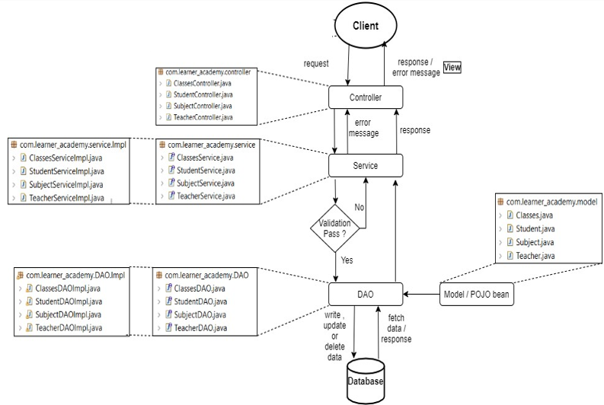

Entity Relationship Diagram
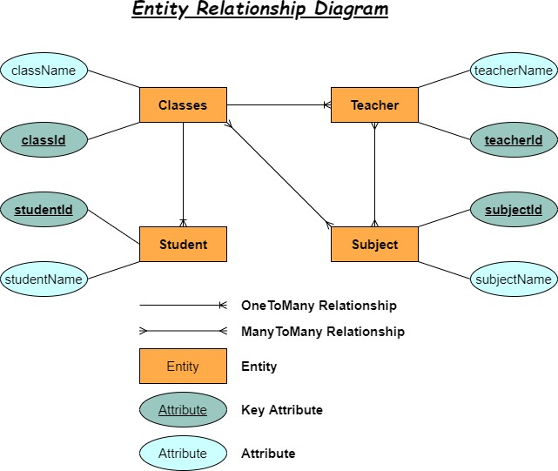

Link to the Repository: https://github.com/Girish777kanike/learners-academy.git

