Lab Assignment – 5

GIRISH KUMAR REDDY NAGELLA CLASS ID: 29 UMKC ID: 14290798

**Existing Problem:**

Here the problem is to:

* Complete the Pedometer application and track the steps and
* Perform Facial analysis on any image with users.

Proposed Solution:

I propose Step Counter and FaceAnalyze applications to solve above problems.

**StepCounter App:**

**StepCounter App is a Mobile application that keeps track of the steps taken by a user by using accelerometer Sensor.**

**FaceAnalyze App:**

**FaceAnalyze App is a Mobile application that is used to analyze faces in an image and predicts their gender and age.**

Working:

Here is the working of both applications:

1. **StepCounter Home Page**:

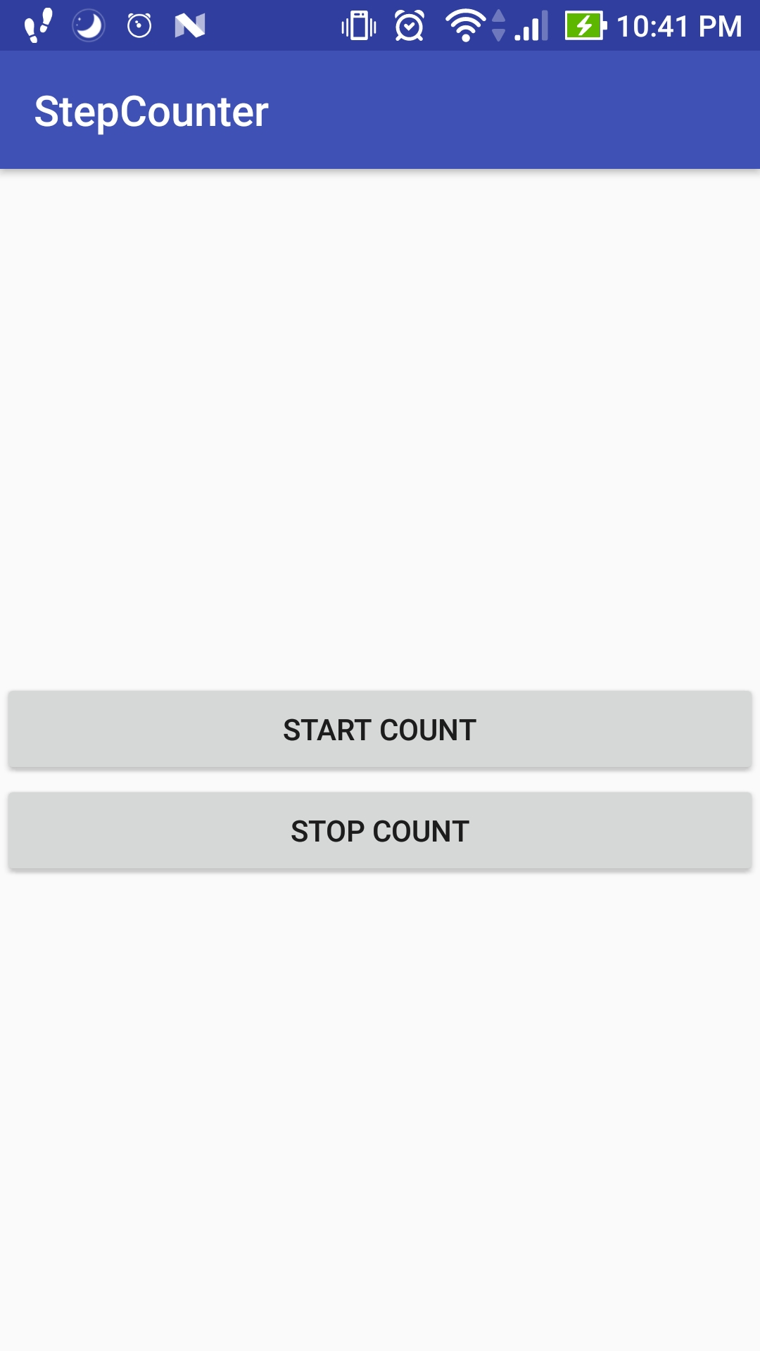

Starting Pedometer:

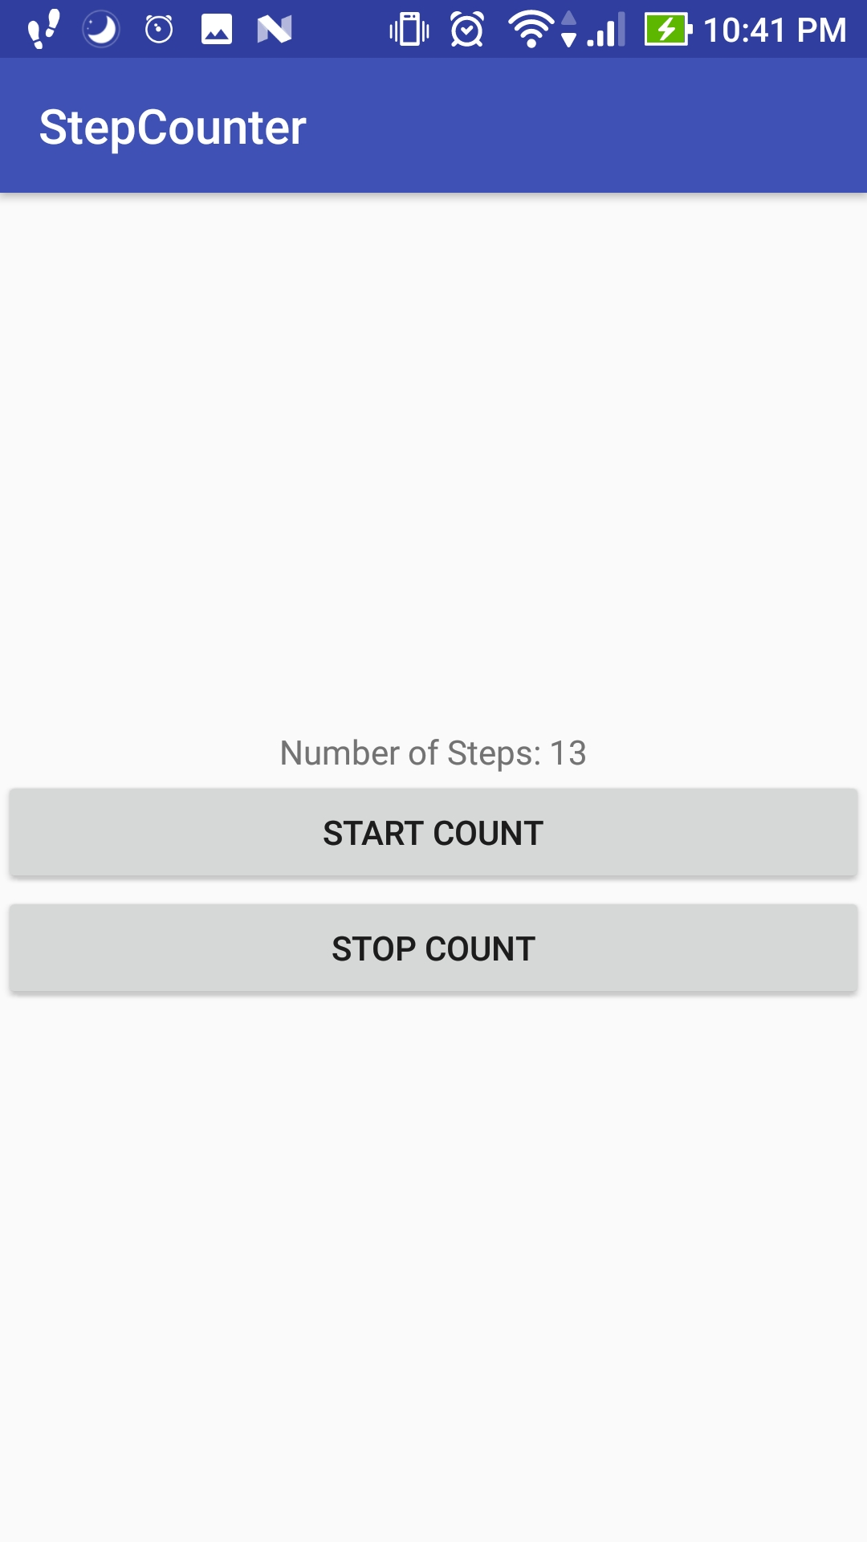

Stopping Pedometer:

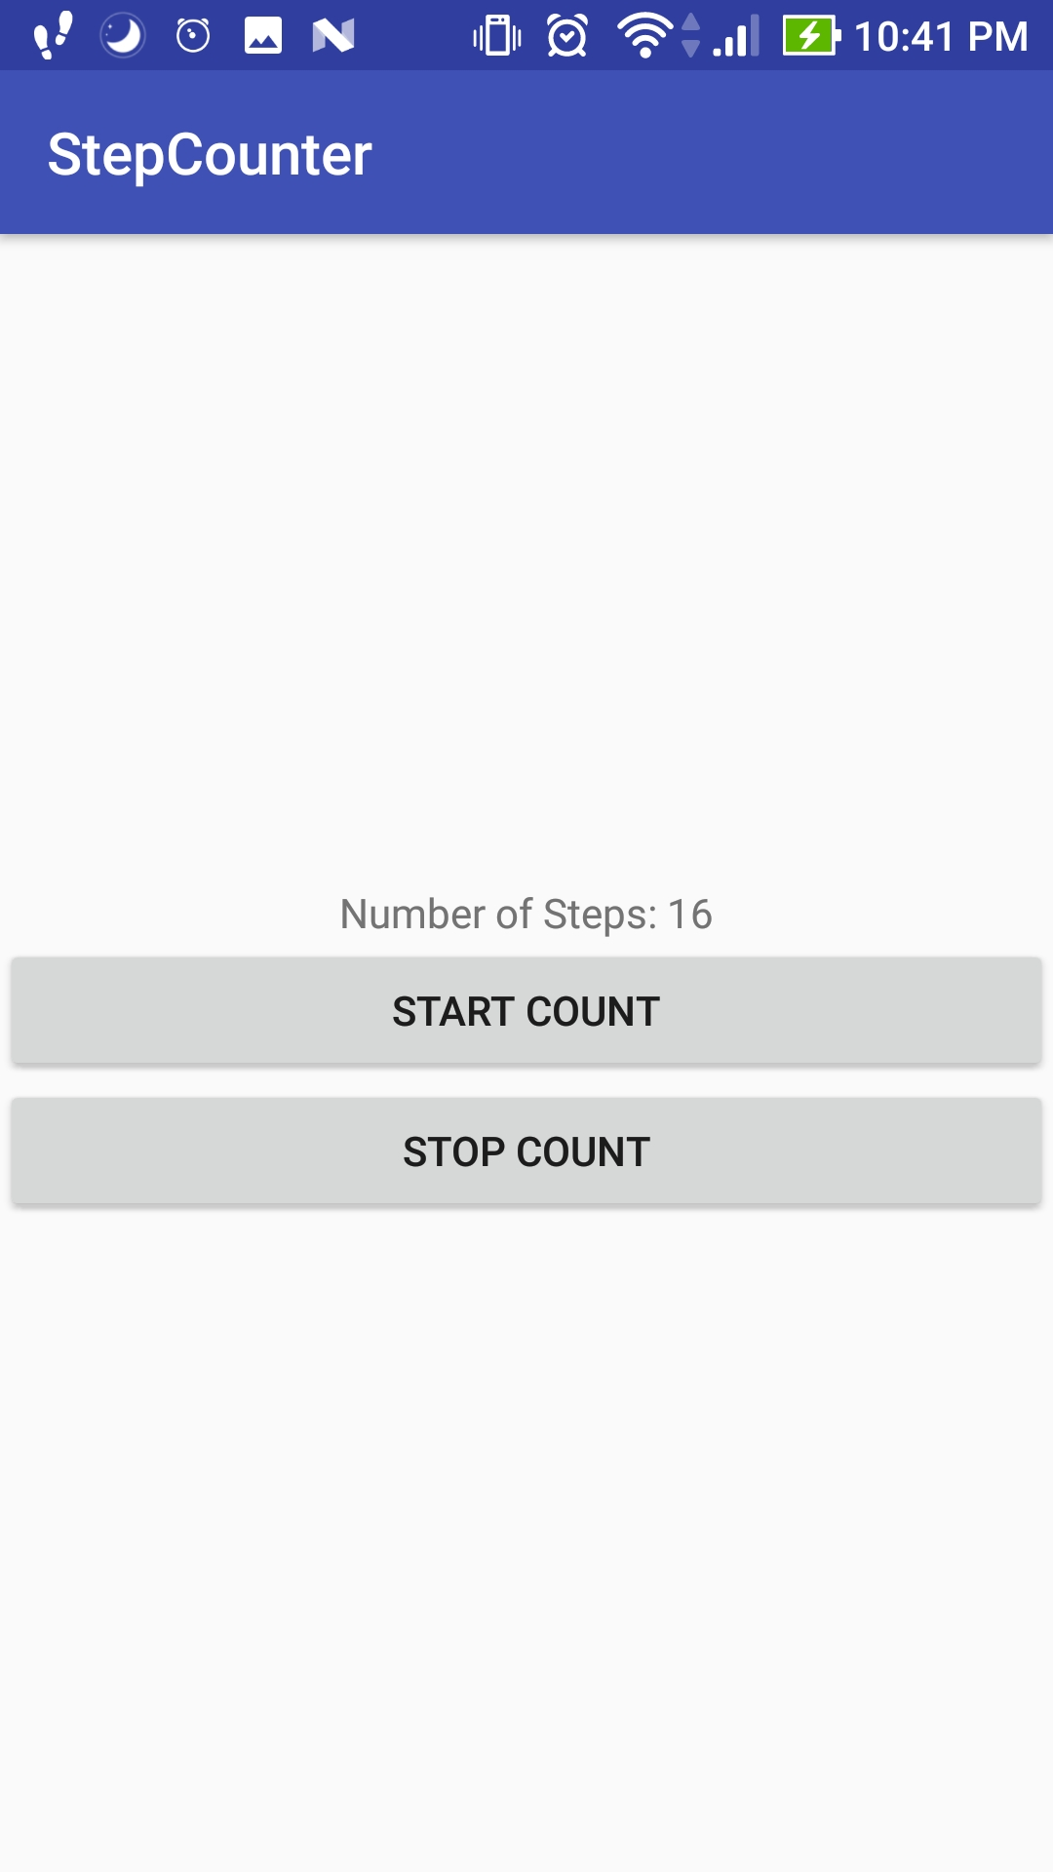

**2)FaceAnalyze Home Page:**

Home Page:



After Uploading Image:

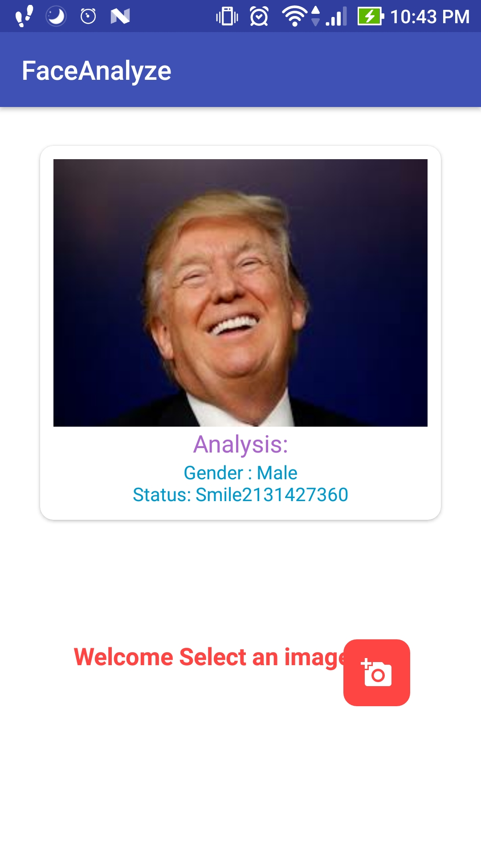

Code Snippets:

**StepCounter**:

Code snippets for MainActivity (Sensor Manager and Sensor):

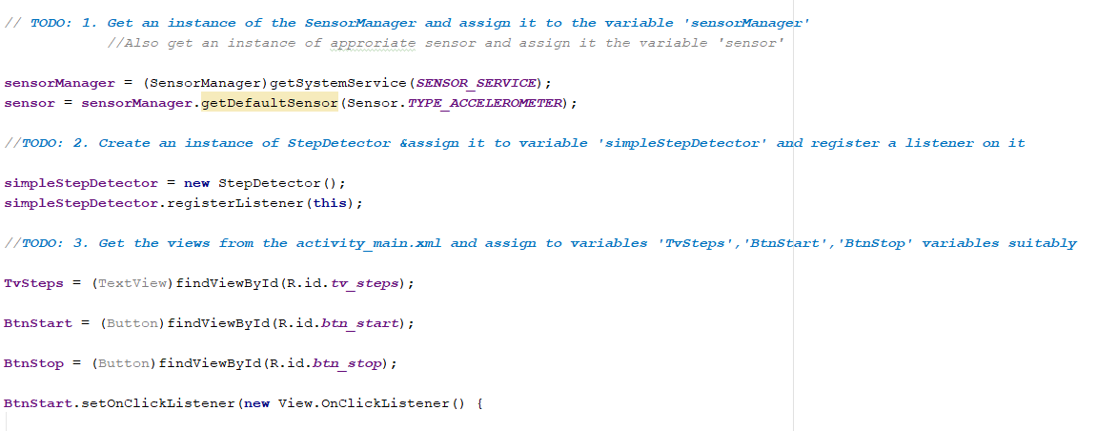

**FaceAnalyze**:

Code Snippet for MainActivity:

API Credentials for IBM Watson:

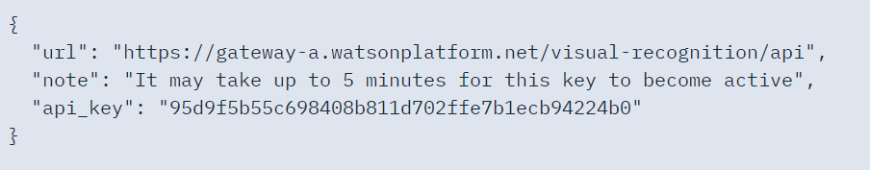

Post Request using Volley to IBM Watson Api:

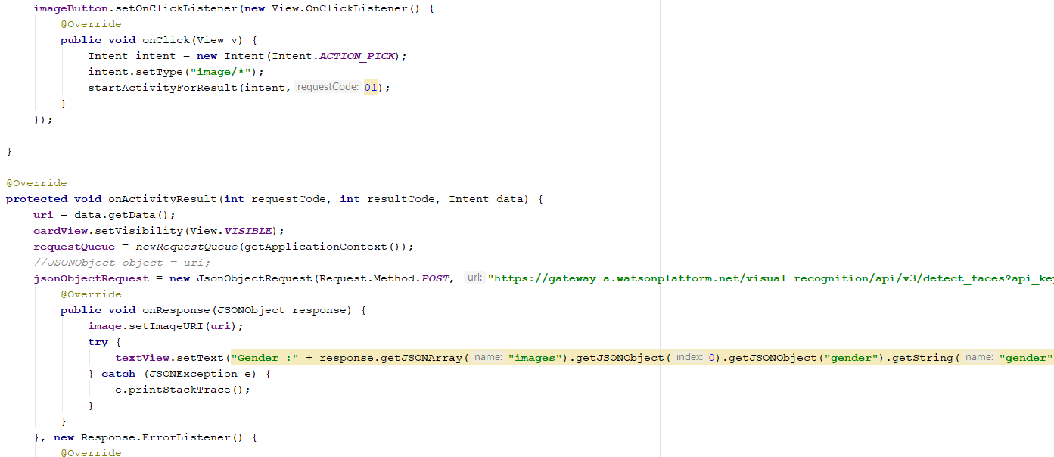

Code Snippet for activitymain:

Using Card View:

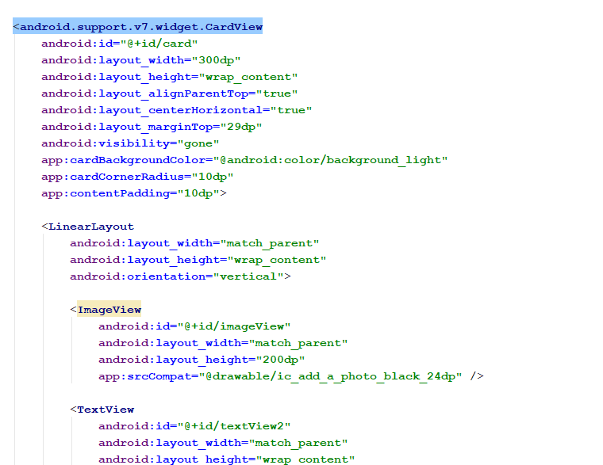

Thank You