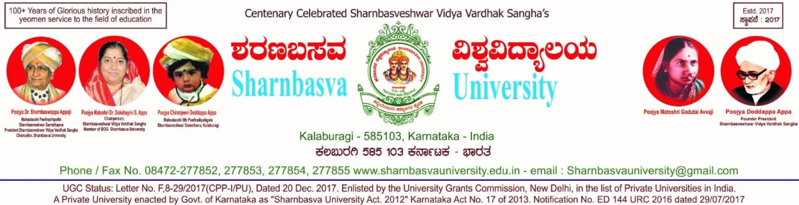

A

PROJECT REPORT ON

# " E-COMMERCE SYSTEM USING MEAN STACK”

Submitted to

Computer Science and Engineering

Faculty of Engineering and Technology (Co-Education) In partial fulfillment of the semester project

## Submitted By

**ADITYA PM. [SG19CSE005]**

**ARUN KUMAR [SG19CSE024]**

**BALAJI [SG19CSE028]**

**HARSHA [SG19CSE056]**

**Under the guidance of**

**Dr. GAJENDRAN**

**2022-2023**



# CERTIFICATE

This is to certify that the project work entitled “**E-COMMERCE SYSTEM USING MEAN STACK”** is Bonafede work carried out by **ADITYA PM(SG19CSE005), ARUN KUMAR (SG19CSE024), BALAJI (SG19CSE028) and HARSHA (SG19CSE056)** in partial fulfillment of **B.Tech 8th Semester in Computer Science and Engineering** of the Faculty of Engineering and Technology (Co-Education), **SHARNBASVA UNIVERSITY, Kalaburagi** during the year 2022-2023. It is certified that, she/he has completed the project satisfactorily.

**Marks Details**

|  |  |  |  |  |
| --- | --- | --- | --- | --- |
| **SL.**  **NO** | **Name of the Student** | **USN** | **Maximum**  **Marks** | **Marks**  **Obtained** |
| **1** | **ABDULLAH OSAID** | **SG19CSE001** |  |  |
| **2** | **BOGAR AKASH** | **SG19CSE040** |  |  |
| **3** | **GIRISH** | **SG19CSE053** |  |  |
| **4** | **BHARATH** | **SG19CSE037** |  |  |

Guide Chairman Dean

Name of the Examiners Signature with Date

1.

2.