REACT & REDUX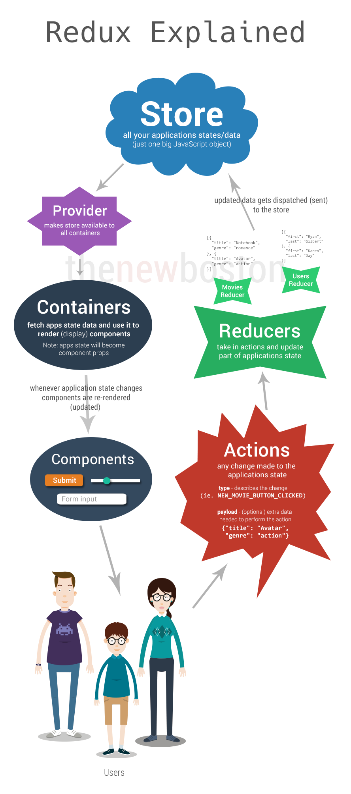

Create Store

The **Store** is the 1 big object in the application.

Store holds application state;

* Allows access to state via [getState()](http://redux.js.org/docs/api/Store.html#getState);
* Allows state to be updated via [dispatch(action)](http://redux.js.org/docs/api/Store.html#dispatch);
* Registers listeners via [subscribe(listener)](http://redux.js.org/docs/api/Store.html#subscribe);
* Handles unregistering of listeners via the function returned by [subscribe(listener)](http://redux.js.org/docs/api/Store.html#subscribe).

import { createStore } from 'redux'

const store = createStore();

**Reducer:**

Reducers are the bunch of objects which gets saved into the store.

Reducers are the ones which say what data to be stored in the store. Below are the reducers

* Users
* Movies
* Songs

Before passing all the reducers to Store, need to combine all the individual reducers to 1 object as the “Store is 1 big object”;

**Combine Reducers**

**import {combineReducers} from 'Redux';**

**import UsersReducer from './reducer-users';**

**import MoviesReducer from './reducer-movies';**

**const allReducers = combineReducers(**

**{**

**users: UsersReducer,**

**movies: MoviesReducer**

**}**

**);**

**Provider:**

Provider makes all the data inside a store accessable to the Component.